22AIE204: Introduction to Computer Networks
Project Report
QoS Optimization in Video Streaming
TEAM – D15
- Poornima Paidy (CB.SC.U4AIE24343)
- Akhilan S(CB.SC.U4AIE24362)
- Rohith Ravi (CB.SC.U4AIE24350)
- Aparna Bharani (CB.SC.U4AIE24304)

- INTRODUCTION

In the age of digital media, uninterrupted and high-quality video streaming remains a technical challenge, especially as network conditions fluctuate. Adaptive streaming addresses this by dynamically adjusting playback quality in response to real-time bandwidth availability—minimizing buffering and maximizing user experience. Our project demonstrates the principles behind this system: implementing a client-server architecture where the client automatically adapts video quality based on internally simulated bandwidth variance. This mirrors the mechanisms in major commercial platforms and provides foundational insights into adaptive media delivery.

- PROJECT SCOPE
This project features two core components:
- Server: Implemented in Python using Flask, the server offers MJPEG video streams in four quality levels (360p, 720p, 720p60, 1080p60). Each stream is accessed via a dedicated HTTP endpoint and delivered at a fixed frame rate.
- Client: The client, also implemented in Python, connects to the server to fetch and display video frames using OpenCV. It simulates varying network bandwidth internally and applies an adaptive selection algorithm to determine the most suitable video quality throughout playback. The adaptation process is visualized using real-time plots of bandwidth against quality.

- REAL WORLD APPLICATIONS
The strategies explored mirror the foundations behind adaptive protocols such as DASH and HLS, which are used by YouTube, Netflix, and similar platforms. Beyond entertainment, lessons from this simulation apply in online education, telemedicine, real-time surveillance, and any scenario where media must reach users with diverse and changing connection qualities.

- KEY NETWORK CONCEPTS USED IN OUR PROJECT

- Bandwidth:

Bandwidth is the measure of the maximum data rate the network can support, typically expressed in kilobits per second (kbps) or megabits per second (Mbps). High bandwidth enables smooth transmission of high-definition content, while low bandwidth can cause interruptions or necessitate downscaling of video quality.

- Adaptive Quality Selection:
Based on the current simulated bandwidth, the client automatically selects the optimal video quality from several available options (360p, 720p, 720p60, 1080p60). A threshold-based algorithm matches the simulated bandwidth to the most appropriate quality, ensuring playback remains as smooth and uninterrupted as possible.

- Real-Time Visualization:
The client visualizes both the simulated bandwidth and the selected video quality in real time using graphical plots. This enables intuitive monitoring and demonstration of how adaptation works under varying bandwidth conditions during streaming.

- MJPEG Video Streaming over HTTP:
The server streams video frames as MJPEG (Motion JPEG) using HTTP endpoints. Each video quality is available via a dedicated URL, allowing the client to connect and fetch JPEG frames continuously at a fixed frame rate.

- Client-Server Architecture:
The entire system is built on a client-server model, with the server delivering video streams and the client managing playback, adaptation, and visualization.

- METHODOLOGY

Server Implementation
- The Flask server streams video files at four qualities using MJPEG, with each quality mapped to a unique HTTP endpoint (e.g., /video/720p).
- Frames are delivered at a consistent 24 frames per second (fps). When the end of a file is reached, playback resumes from the beginning for seamless recurrence.
Client Implementation
- The client requests a selected video quality stream, decodes incoming JPEG frames, and displays them using OpenCV.
- To model network unreliability, a dedicated thread simulates fluctuating network bandwidth, updating a sim_bw variable over time.
- After every frame, the client recalculates the bandwidth and applies a threshold-based adaptation algorithm:
  - Bandwidth > 2000 kbps: Select 1080p60
  - Bandwidth > 1000 kbps: Select 720p60
  - Bandwidth > 500 kbps: Select 720p
  - Bandwidth ≤ 500 kbps: Select 360p
- Every adaptation is logged and displayed in real time, offering clear feedback on how the system responds to the simulated network.
Visualization
- Graphs generated using Matplotlib and Seaborn depict both the simulated bandwidth and the current video quality selection throughout playback.
- Python threading ensures these visualizations, bandwidth simulation, and playback operate concurrently.

- TOOLS USED

- Programming Language: Python

- Frameworks: Flask (server), OpenCV (client video display)

- Visualization: Matplotlib & Seaborn

- Concurrency: Python threading module for simultaneous simulation and graphing

- Adaptation Algorithm: Simple rule-based mapping from bandwidth range to video quality

- ALGORITHMS USED

- Bandwidth Simulation Algorithm:
A dedicated thread in the client continuously updates the simulated bandwidth variable. Every few milliseconds, a random value within a defined range (e.g., 300–4000 kbps) is added or subtracted, emulating realistic fluctuations found in actual network traffic such as congestion or wireless instability. This ongoing change is the driving factor for adaptation in the system.

- Threshold-Based Quality Selection Algorithm:
For every received video frame, the client evaluates the current simulated bandwidth and selects the most suitable quality using fixed threshold values:
- If bandwidth > 2000 kbps: Select 1080p60
- If bandwidth > 1000 kbps: Select 720p60
- If bandwidth > 500 kbps: Select 720p
- If bandwidth ≤ 500 kbps: Select 360p
The selected quality is visualized in real time on adaptation charts. This approach mimics the adaptive logic used in commercial streaming applications like DASH or HLS, but in simplified form.

- IMPLEMENTATION

Server-Side Implementation:

- The server is built using Flask and OpenCV.

- Each video file (of varying quality) is read, encoded into JPEG frames, and streamed via dedicated HTTP endpoints in the MJPEG format.

- Frames are sent at a consistent rate (e.g., 24 fps). If the end of a video file is reached, the playback loops seamlessly.

Client-Side Implementation:

- The client connects to the server and fetches the MJPEG frame stream corresponding to the initial selected quality.

- Simulated bandwidth is varied in real time using a thread, representing network changes.

- After each frame is received, the client recalculates the available (simulated) bandwidth and updates quality selection according to the threshold-based algorithm above.

- Adaptation decisions are plotted live along with the bandwidth, using Matplotlib and Seaborn for meaningful visualization.

- Threading is used extensively, ensuring that video playback, bandwidth simulation, and plotting occur concurrently without interruption.

- RESULTS

- The client application successfully matches video quality selection to simulated bandwidth conditions, switching between streams in line with the real-time network estimate.
- Graphs show an intuitive and immediate relationship between drops and rises in bandwidth and the selection of more appropriate video qualities.
- While the stream selection logic is fully functional and visually clear, note that the client’s video stream remains continuously connected at the original quality; adaptation is reflected in statistics and visualization.
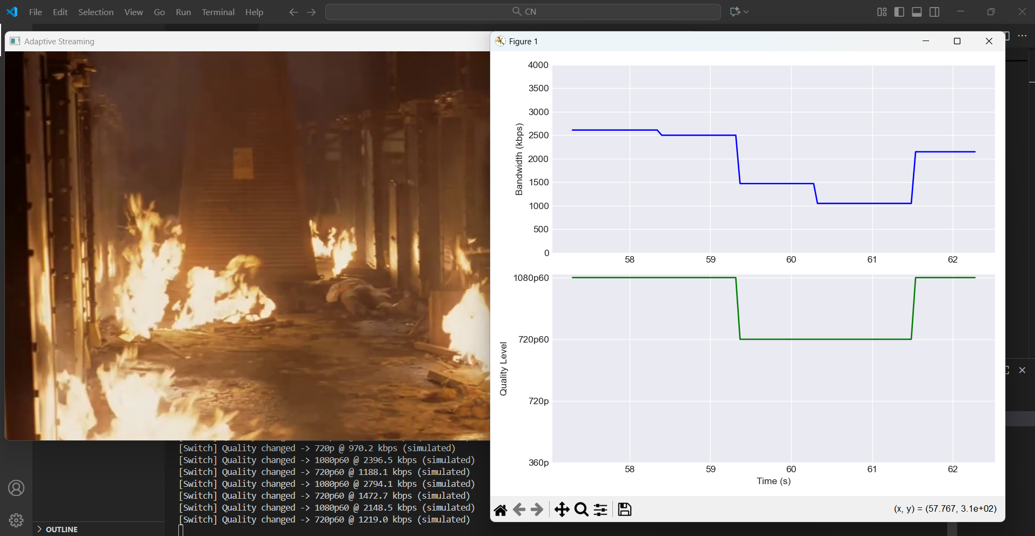
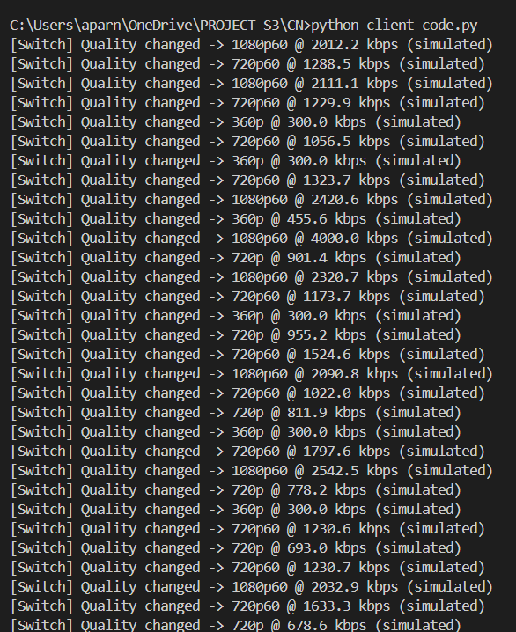
- REFERENCES

K. Miller, E. Quacchio, G. Gennari and A. Wolisz, "Adaptation algorithm for adaptive streaming over HTTP," 2012 19th International Packet Video Workshop (PV), Munich-Garching, Germany, 2012, pp. 173-178, doi: 10.1109/PV.2012.6229732. keywords: {Throughput;Streaming media;Heuristic algorithms;Delay;Radio frequency;Bandwidth;Switches},
Link: https://ieeexplore.ieee.org/document/6229732

