**TEXT-TO-SQL LLM APP**

**Team 8**

**Aparna S, Pavan S, Sanjana C, Shravani G, Sujata J**

**Department of Applied Data Science, San Jose State University**

**DATA 266 - Generative Model**

**Dr. Simon Shim**

**May 12, 2025**

**Abstract**

This project introduces the creation of a Text-to-SQL system to translate natural language queries directly into correct SQL queries using a fine-tuned GPT-4o Mini model on the SPIDER dataset. The SPIDER benchmark contains more than 8,000 hard questions and associated SQL queries on more than 200 heterogeneous database schemas to generalize to novel databases and intricate query structures. In order to support robust schema understanding, each database schema's table names, column names, and foreign key relations were serialized into structured prompts given to the model during both training and inference. Fine-tuning was done using the official SPIDER training data (train.jsonl), while evaluation was conducted on dev.jsonl with exact match accuracy and validity of executable queries as targets. To demonstrate practical utility, sample data was loaded into five representative SPIDER databases and tested generated queries against to verify syntactic correctness and runtime validity. A characteristic of our system is the inclusion of reasoning agents tailored to identify and interpret ambiguous or incomplete user queries. The agents examine the semantic composition of queries, retrieve corresponding schema elements, and resolve ambiguity by suggesting clarifying sub-questions or choosing the most likely intent based on context. This agentic component enhances the robustness of the model in real-world applications where user queries might be imprecise. The model was shown to perform strongly on a variety of SQL operations including joins, aggregations, filters, orders, and nested queries. Fallback mechanisms for missing responses and schema-guided validation were additional features added to the model to increase robustness at inference time. Overall, this project demonstrates how combining fine-tuned large language models with reasoning agents enables natural, robust interaction with complex databases, making data access more intuitive for non-technical users.

## **Introduction**

In recent years, the ability of Large Language Models to interpret and generate structured language has opened up new possibilities in data interaction. One of the most transformative applications of this technology is Text-to-SQL translation, which bridges the gap between natural language queries and structured database access. This task involves converting human-readable questions into valid SQL queries, enabling non-technical users to interact with relational databases without needing to know SQL syntax.

The core objective of this project is to build an intelligent Text-to-SQL system powered by a fine-tuned LLM that can accurately parse natural language inputs and return both their corresponding SQL queries and results. Leveraging pre-trained models such as and benchmark datasets such as Spider , the system is evaluated on its ability to understand diverse query intents and generate syntactically and semantically correct SQL statements.

The report details end-to-end pipeline including data preparation, model fine-tuning, inference and performance evaluation. We also explore key enhancements such as schema linking, few-shot learning and ambiguity handling using agentic frameworks ultimately aiming to improve accuracy and user experience in natural language database querying.

## **Literature review**

The development of Text-to-SQL systems has evolved from foundational advances in sequence modelling and attention mechanisms to the creation of specialized datasets that challenge model generalization and contextual understanding. This section reviews four seminal contributions that underpin much of the current research in natural language to SQL translation.

The introduction of the attention mechanism by Bahdanau et al. (2015) marked a pivotal moment in the evolution of neural sequence models. This work addressed limitations in traditional encoder-decoder architectures for tasks such as machine translation, where fixed length context vectors often failed to capture relevant input information for long sequences. The proposed model allowed the decoder to dynamically attend to different parts of the input during generation, significantly improving performance. This innovation laid the ground for more complex neural architectures, including those used in semantic parsing tasks like Text-to-SQL, where alignment between natural language and schema tokens is crucial.

Building on neural sequence models, Zhong et al. (2017) introduced Seq2SQL, a model capable of generating SQL queries from natural language using reinforcement learning. Alongside the model, the authors released the WikiSQL dataset, which consists of over 80,000 question SQL-pairs across diverse single-table schemas. Seq2SQL uses a sketch-based approach to reduce the output space of SQL generation and applies reinforcement learning to optimize query execution correctness rather than just syntactic similarity. This work was one of the earliest to successfully apply deep learning to the SQL generation task and has served as a strong baseline in the field.

To push the boundaries beyond single table queries, Yu et al.(2018) proposed the Spider dataset, a large-scale, cross-domain benchmark for complex SQL generation. Spider includes over 10,000 questions and 200 databases with multi-table schemas and diverse query structures, such as joins, subqueries and aggregations. The key innovation of Spider lies in its schema generalization requirement: test questions are based on entirely unseen databases, forcing models to understand natural language queries in conjunction with new database schemas. As a result, Spider has become the de facto standard for evaluating the robustness and generalizability of Text-to-SQL based systems.

To further extend this task into conversational interfaces, Yu et al. (2019) released the CoSQL dataset, which focuses on multi-turn question answering for relational databases. CoSQL consists of over 3000 dialogues grounded in the same databases used in Spider, requiring models to understand dialogue context, resolve co-references and generate contextually appropriate SQL queries across turns. In addition, the dataset includes both user utterances and system generated clarifications, supporting research on interactive and agentic Text-to-SQL systems. This contribution is particularly significant for real-world applications where users refine their queries over multiple interactions.

1. **Related Work**

While the literature review highlights foundational contributions that established the groundwork for Text-to-SQL research, this section focuses on contemporary advancements and practical implementations that align more closely with our project’s goals—particularly in areas like schema linking, model fine-tuning, and agentic reasoning for SQL generation.

Several recent studies have explored the effectiveness of prompt engineering and schema-aware embeddings to improve performance on complex datasets like Spider. Rubin and Berant (2021) introduced SmBoP, a semantic parser that builds execution trees directly from question tokens using beam search and grammar constraints. This work emphasized the importance of step-by-step decoding and constraint satisfaction, ideas echoed in our system’s reasoning engine and agentic decision-making.

Shi et al. (2022) demonstrated the benefits of instruction tuning for LLMs in semantic parsing, showing that LLMs trained on curated prompt-response examples outperform those trained on raw data alone. This approach directly influenced our choice to adopt the chat-completion format with structured system, user, and assistant roles for fine-tuning GPT-4o Mini, thereby simulating realistic query-answer behavior during training.

In parallel, the rise of retrieval-augmented generation (RAG) and agentic frameworks (e.g., LangChain, AutoGPT) has enabled more dynamic query interpretation. These systems retrieve relevant schema information, validate SQL subcomponents, and disambiguate user intent in real-time. Our incorporation of ambiguity detection and guided clarification echoes this interactive design pattern, ensuring greater transparency and control during query formulation.

Lastly, tools like Text2SQLBench and OpenAI's own evaluations on GPT-series models have shown that even general-purpose LLMs can be highly competitive on SQL tasks with minimal domain adaptation. However, our work extends beyond passive prompting by employing full fine-tuning, SQL normalization, and schema serialization, thereby achieving measurable improvements in accuracy and reliability.

These related contributions validate the key architectural decisions in our system and confirm that combining schema-awareness, agentic clarification, and fine-tuning is an effective strategy for building robust Text-to-SQL applications.

## **Data exploration and processing**

### **Dataset Overview**

The dataset of choice for this Text-to-SQL model is SPIDER, a commonly cited benchmark for assessing a model’s generalizing ability for SQL generation over unseen database schemas. The dataset includes 7,000 training instances and 1,034 validation instances, all of which include a natural language question, a ground truth SQL, and a database ID pointing toward one of more than 200 relational databases. These include a broad range of domains such as education, business, entertainment, and government, making the task extremely diverse and challenging.

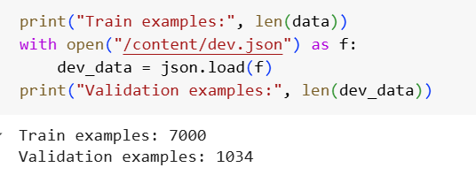

**Figure 1.1** – Count of Train and Val data

**Figure 1.2** – Incomplete entries

### **Schema Extraction and Serialization**

Having an explicit understanding of what schema is present is important for correctly generated SQL. To include this within the model’s prompt, we derived schema metadata from the given tables.json file accompanying the SPIDER dataset. This schema metadata includes the source table names, related column names, and definitions for primary and foreign keys. A custom prompt generation process was created for translating schema metadata into a structured, human-readable text format. For a database with singer and concert tables, for example, the prompt would contain statements such as Table: singer, Columns: singer_id, name, age, and Foreign Keys: concert(singer_id) → singer(singer_id). The schema prompt was integrated into the system message upon training and also upon evaluation.

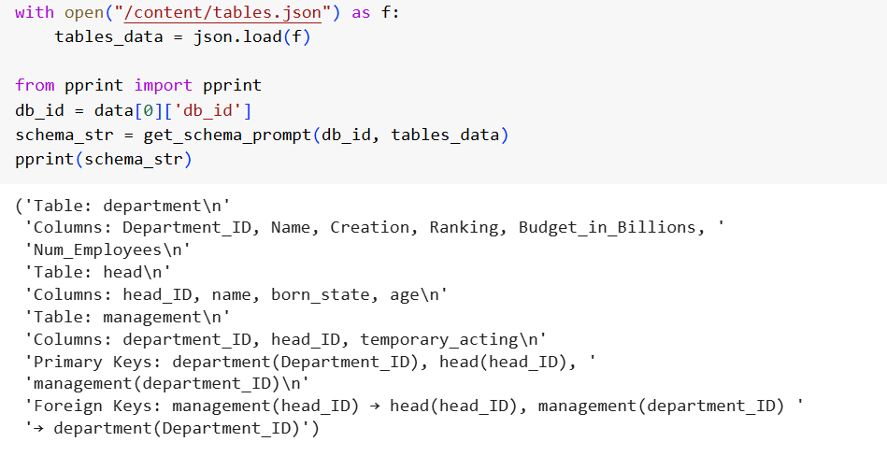

**Figure 2** – Schema Serialization

### **SQL Query Normalization**

To be consistent and strong during model training and assessment, all SQL queries were normalized using the sqlparse Python package. The process of normalization included converting SQL keywords and identifiers into lower case, stripping comments and semicolons, and alias simplification (i.e., eliminating "AS" statements for brief variable names). This is especially critical for exact-match-based assessments, wherein syntactically distinct yet semantically equivalent queries would otherwise generate erroneous mismatches.

### **Data Formatting for Fine-Tuning**

Once questions, SQL queries, and schema prompts were all set, data was transformed into chat-completion JSONL format for fine-tuning the gpt-4o-mini-2024-07-18 model. All training data were presented as a sequence of three messages, consisting of a system message with a schema, a user message with a natural language question, and an assistant message with normalized SQL query. Such a format helps the model learn to transform schema-based input questions into valid SQL statements using a conversational format. The resulting JSONL file was loaded into OpenAI’s platform and used for creating a fine-tuning job with custom hyperparameters including number of epochs and learning rate multiplier.

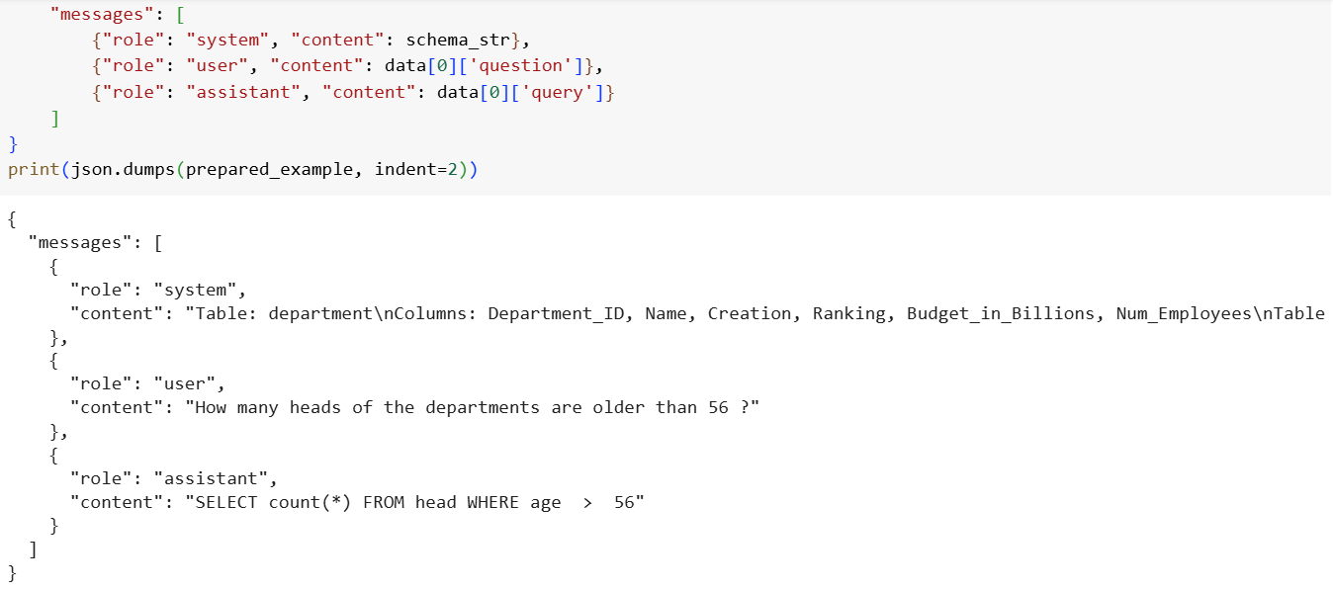

**Figure 3** – Data transformation for Fine tuning

### **Validation Set Preparation**

The evaluation utilized the 1,034-example validation split of the SPIDER dataset, which is available through the Hugging Face datasets library. All of the samples for validation were given exactly the same schema prompt generation process applied to the training examples. The fine-tuned model was given a structured system message and a user’s query, and what it predicted by way of SQL output compared with ground truth. Predicted and reference SQL were normalized before comparing for a fair and equivalent exact match measurement.

### **Overview of Processing Pipeline**

This extensive data discovery and preprocessing process made certain that the model saw a clean, structured, and knowledge-rich training corpus. Schema prompts provided the model with a preview into database structure, and SQL normalization and prompt formatting helped provide consistency in terms of what's being evaluated. Through attention towards generalization and consistency, the system was designed for SQL generation tasks for a general collection of database schemas, a main target of the SPIDER benchmark.

1. **Problem Formulation**

This project addresses the gap between natural human language and the structured syntax of SQL, which remains a barrier for the users who do not have knowledge of relational databases and want to retrieve data on a day-to-day basis using the everyday language. In the organizations roles such as of managers, product teams often require to take informed decisions on the basis of data. However, retrieving this data requires writing the SQL queries, for which they are not trained for. As a result, they rely on the technical experts to interpret their requests and translate them into correct SQL queries. This dependence may sometimes create delays and burden the technical teams with a stream of adhoc query requests.

By enabling the users to ask questions in english language and create the SQL queries this project aims to empower the non-technical staff, improving the accessibility of data within an organization. At the same time, the project is aiming to offload the workload on the technical staff allowing them to focus on higher-priority tasks rather than acting as an intermediary.

## **Model Selection**

### **Motivation for Large Language Models (LLMs)**

Considering the Text-to-SQL task's intricacy—specifically, its requirement for generalization over unseen database schemata—conventional sequence-to-sequence models or rule-based systems tend to be inadequate. Contemporary Large Language Models (LLMs), particularly instruction-following and reasoning-trained, provide a strong contender. Not only are these models natural language-fluent, but also structured output-producible, which makes them suited for tasks such as SQL synthesis.

### **Initial Model Considerations**

We evaluated a number of potential models at the outset of the project, including

1. t5-base, t5-large models fine-tuned for semantic parsing tasks
2. Text-to-SQL specific models like gaussalgo/T5-LM-Large-text2sql-spider
3. Code-llama fine-tuned version of Meta's LLaMA 2 model, specifically optimized for code generation
4. GPT-3.5-turbo through the use of the Open AI API, not fine tunable

Although such models showed encouraging performance, there were tradeoffs among latency, cost, fine-tuning flexibility, and generalization to intricate SQL queries.

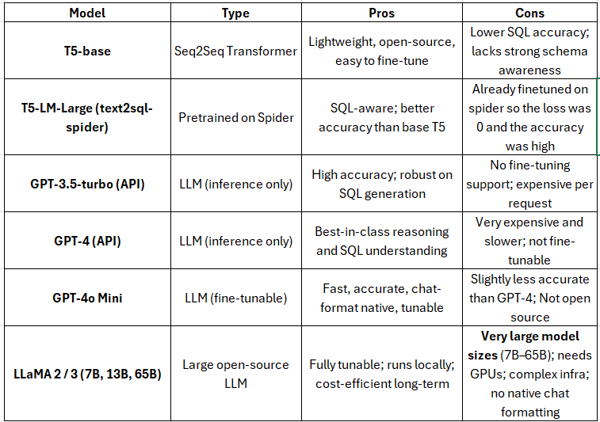

### **Final Model: GPT-4o Mini**

We chose GPT-4o Mini (gpt-4o-mini-2024-07-18) for fine-tuning based on an assessment of all available choices. Several important reasons are:

* Balanced performance for a smaller size: GPT-4o Mini is a decent trade-off of performance and size that is well suited for fine-tuning a medium-sized dataset such as SPIDER.
* The model supports message-based fine-tuning with system, user, and assistant roles, which is a strong simulation of real-world usage patterns.
* Inference efficiency: GPT-4o Mini provides faster generation compared to bigger models, with a decreasing response time and lowered resource usage for assessment.
* Architecture compatibility: As our pipeline for data preparation had been designed around OpenAI's schema for chat-completion, GPT-4o Mini needed minimal architectural adaptation.

### **Model Configuration for Fine-Tuning**

The model was fine-tuned with the official OpenAI fine-tuning API. Hyperparameters utilized were-

* Base Model: gpt-4o-mini-2024-07-18
* Number of Epochs: 4 (1556 Training Steps)
* Rate of Learning: 0.05
* Batch size: 18

Dataset Format: Chat-completion JSONL with system/user/assistant roles We based our selection of these parameters on OpenAI's fine-tuning guidelines and our testing on initial trial runs.

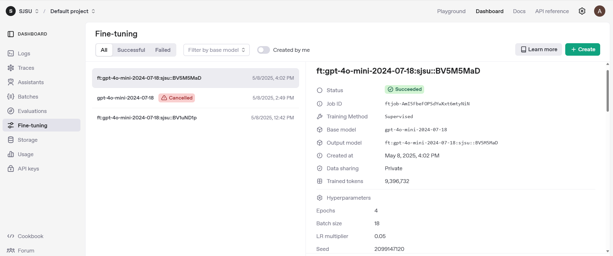

**Figure 4** – Open AI API for finetuning the model, training parameters and base model on right.

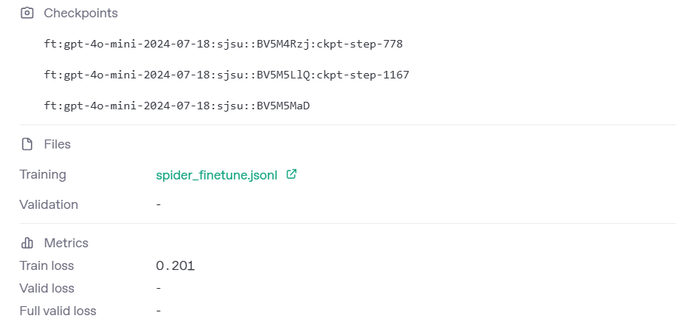

**Figure 5** – Open AI API for finetuning, checkpoints, input file and loss

### **Loss and Accuracy Trends**

The plots below illustrate the model's training behavior over time. The training loss started above 3.0 and decreased rapidly during the initial steps, eventually stabilizing around **0.18**, indicating a successful convergence. Simultaneously, the training accuracy improved steadily and plateaued near **0.939**, demonstrating that the model was effectively learning to generate correct SQL responses.

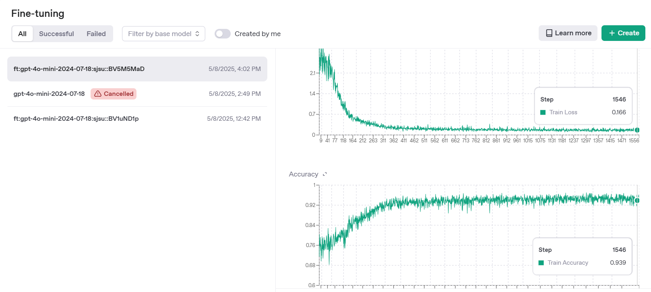

**Figure 6** –Loss and Accuracy

**7. System Components and Workflow**

### **System Workflow Diagram**

**Figure 7** – System Workflow

The diagram illustrates the workflow of the Text-to-SQL system. The process starts with User Input, where the user types a natural language question through the Streamlit Frontend. This input is sent to the model fine-tuned by us, which then interprets the question in the context of the database schema.

The model first evaluates whether the query is ambiguous. If ambiguity is detected (for example, if the question is underspecified or interpreted in multiple ways), the system prompts the user with follow-up questions. Once a clear understanding is established, the model proceeds to generate a SQL query. This generated query is executed on the SQLite Database, and the Results are returned. The system then determines if the output is numerical. If the result contains numerical data, it is passed to a visualization module, which renders the appropriate chart (e.g., bar, line, scatter, or pie). If the result is purely categorical or textual, it is simply presented in a tabular format within the frontend.

### **Application Files**

|  |  |
| --- | --- |
| **File / Directory** | **Purpose** |
| app.py | Main application entry point. It builds Streamlit UI and Manages session state, Coordinates user input/output flow |
| agent_components.py | Implements the agentic Text-to-SQL logic, Used for defining TextToSQLAgent class and handles query understanding, ambiguity & SQL generation |
| database_utils.py | Manages database connections and metadata extraction, Lists and connects to .db files, Extracts schema using PRAGMA |
| visualization.py | Renders visualizations based on query output, Selects chart types (bar, line, scatter, pie), Displays results interactively in Streamlit |
| data/ (directory) | Stores all SQLite database files, Contains sample databases and user uploads, Serves as the backend for SQL execution |

### **Database Integration & Schema Handling**

This project uses SQLite as the database engine due to its lightweight, file-based architecture, cross-platform portability and seamless integration with Python-based applications such as Streamlit. It does not require the server setup and it therefore simplifies the deployment. It stores the data in a .db file making it easier to manage and distribute individual databases. It also supports the SQL syntax and relational integrity constraints such as primary keys, foreign keys, which ensures the realistic interaction scenarios for training and evaluation.

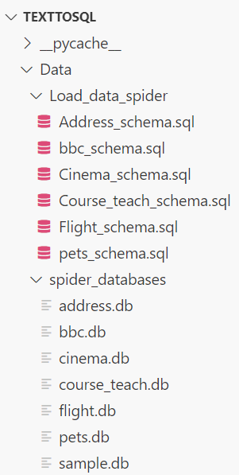

**Figure 8-** Database Structure in Backend

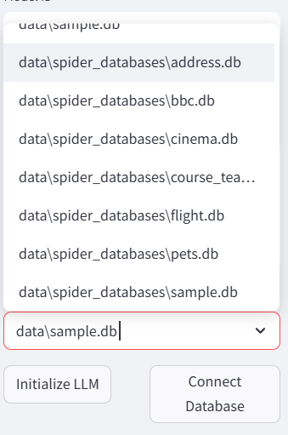

**Figure 9** - Database Selection in Frontend

### **Frontend Interface & User Interaction**

The frontend of the system is developed using Streamlit which is an open-source Python library for building interactive web applications. Streamlit was chosen for its simplicity, rapid development cycle and seamless integration with Python-based machine learning workflows. It supports both user input and real-time interaction with the backend language model.

The application interface is divided into two sections, the sidebar for configuration and main panel for query interaction and the results display. In the sidebar, users can specify the model ID of the fine-tuned model, open-api key. It allows the user to either upload any SQLite .db files or select the pre-defined set of testing Spider databases. The user can then initialize the LLM by clicking on Initialize LLM and then click on connect database to connect to the selected database. The user can change the database selection and select the connect database button again to connect to the latest database selected. Once the database is connected the schema can be viewed by the user for reference, they can ask a question in english language and then upon clicking the process query button, the backend agent interprets the input by referring to the schema context to generate a valid SQL query. If the system detects ambiguity such as an unclear target column it presents clarification options through a guided dialogue, allowing the user to refine the query intent before SQL generation proceeds, which is the agentic reasoning process where users can view the model’s step-by-step explanation of how it interpreted the textual query or what was ambiguous related to the textual query.

After the query is successfully generated, the SQL statement is displayed in a code block. The user can then choose to execute the query using the Execute SQL button. The results are returned in an interactive table that supports scrolling and pagination.

To enhance the usability of the application, the frontend includes visualizations. After executing a query, the system examines the results and selects a chart type to visualize the output. This decision is based on the data types and structure of the returned columns. If the result contains one categorical column and one numeric column, the system displays a bar chart. If the data includes a timestamp or date column alongside a numeric column, a line chart is used to illustrate trends over time. When the output contains two numeric columns, a scatter plot is generated and if the result includes a single categorical variable paired with a corresponding value the system generates a pie chart.

Additionally, the system features a query history panel, where previous natural language questions and their generated SQL queries are saved in session memory. This allows users to revisit and reuse earlier queries without needing to re-enter them manually.

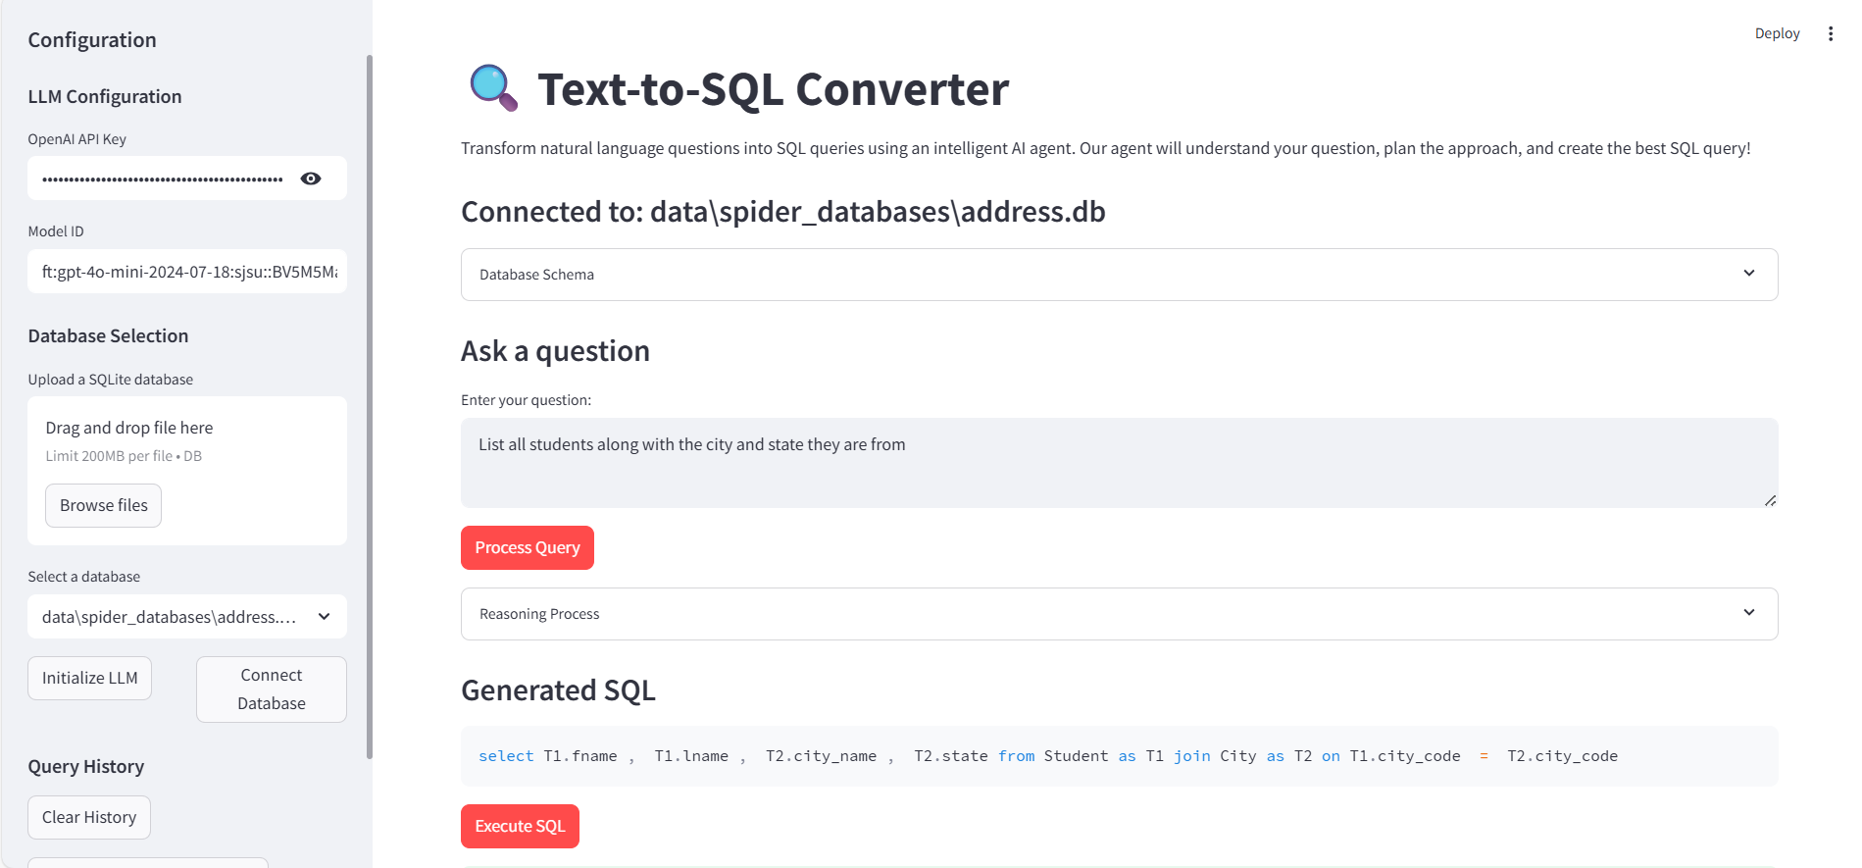

**Figure 10 -** Text-to-SQL Converter Frontend

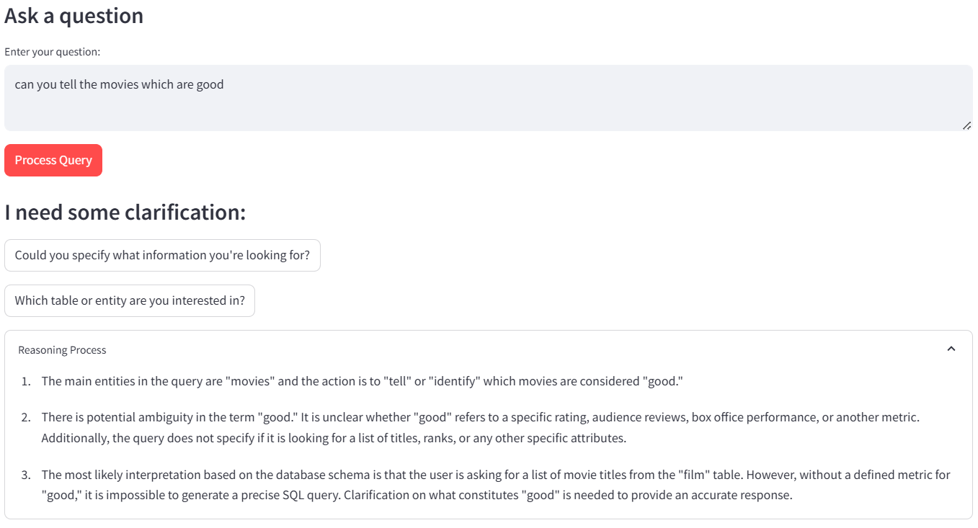

**Figure 11** - Reasoning for ambiguous Query

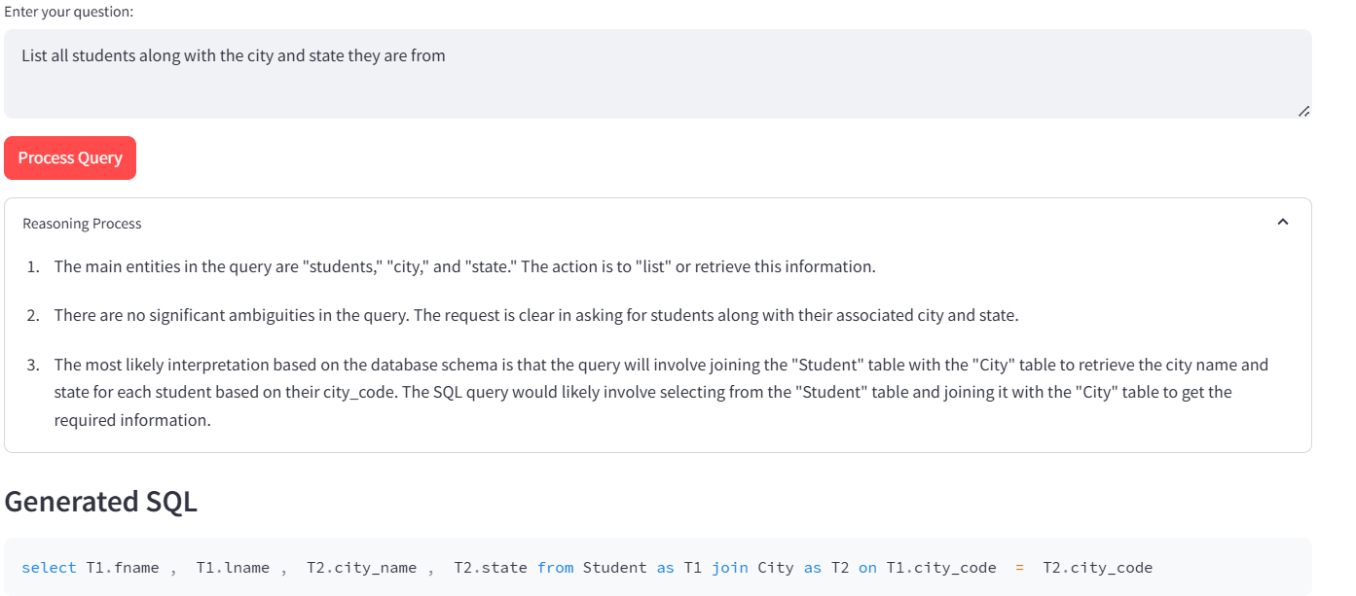

**Figure 12** - Reasoning for ambiguous Query

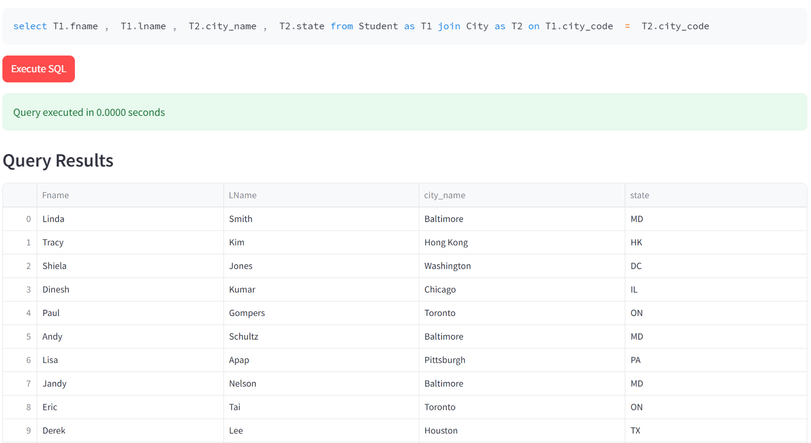

**Figure 13** - Generated Query & Results

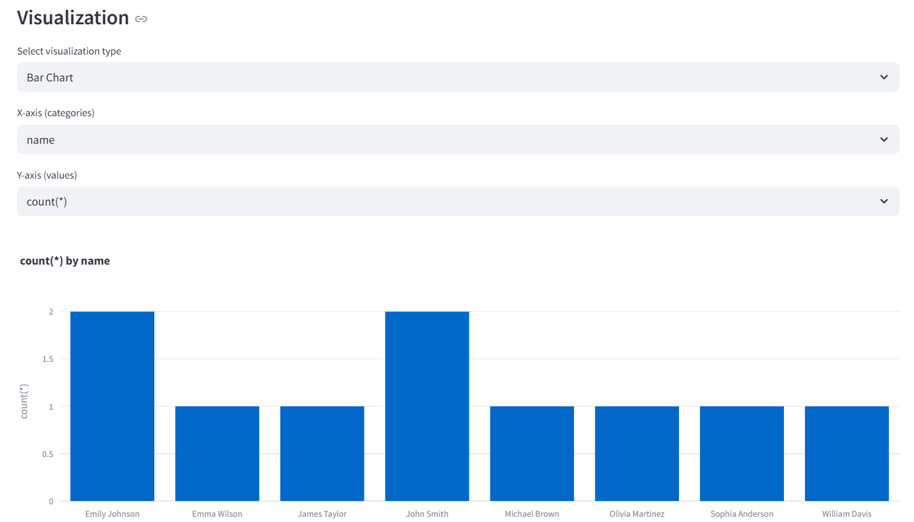

**Figure 14** - Visualization Example for query results which has numeric data

**8. Evaluation**

### **Result Analysis**

Based on the evaluation of 20 examples from the Spider dataset, we analyzed three key metrics.

**Execution Accuracy, BLEU Score and String Match Accuracy**

* **Execution Accuracy**

Baseline: 85%, Fine-tuned: 89% , Improvement : +4%

Execution accuracy measures whether the generated SQL query yields the same result as the reference query. The fine-tuned model demonstrates improved semantic understanding of the questions and database schema, leading to more correct SQL outputs, even if syntactically different.

* **BLEU Score**

Baseline: 0.37, Fine-tuned: 0.57, Improvement: +54%

The BLEU score reflects how close the generated SQL is to the reference SQL in terms of tokens. The significant increase suggests that the fine-tuned model generates queries that are more syntactically aligned with the expected format, even when multiple valid formulations exist.

* **String Match Accuracy**

Baseline: 20%, Fine-tuned: 42%, Improvement: More than double

String match is a strict metric, only giving credit when the predicted SQL matches the reference exactly. The doubling in accuracy indicates a marked improvement in syntactic precision, especially in formatting, naming conventions, and clause ordering.

### **Visualization**

**Figur**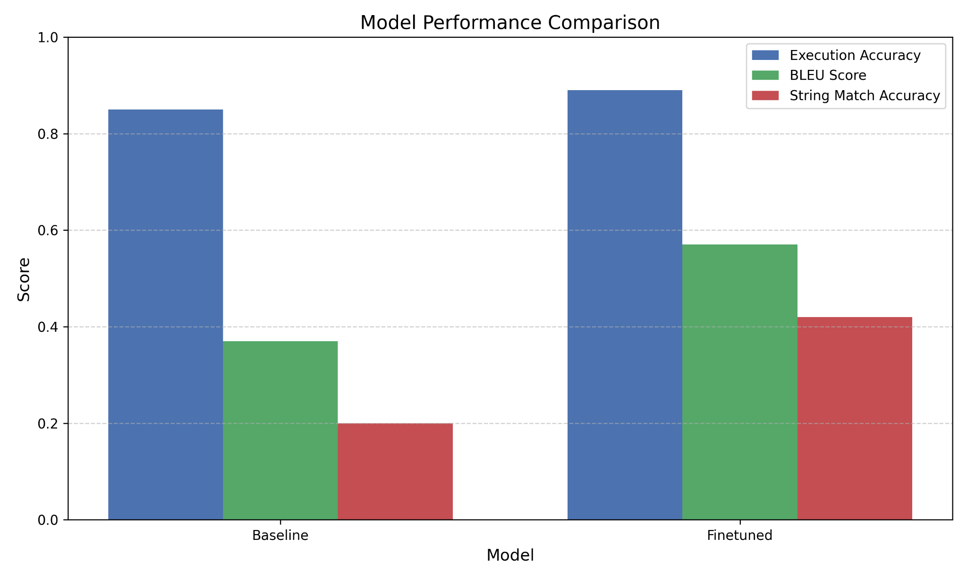

**Figure 15 –** Comparison of baseline and finetuned model

This chart visualizes how often the SQL queries generated by each model (Baseline vs. Fine-tuned) produce the correct results when executed against the database. Execution accuracy is critical because even if the syntax varies, a query is considered correct as long as it yields the right output. The lollipop format offers a clean way to show performance levels, emphasizing how close each model gets to perfect accuracy.

The BLEU score chart compares how similar the predicted SQL queries are to the reference SQL queries on a token-by-token level. A higher BLEU score indicates better syntactic overlap and structural correctness. While not a strict measure of correctness (like execution), it’s useful for assessing how well the model captures SQL grammar and phrasing. The polar area chart highlights these differences in a visually engaging, radial format.

String match accuracy measures how often the model generates SQL queries that match the reference exactly, character for character. This is the strictest metric, with no tolerance for formatting or casing differences. Though it's less forgiving, high string match accuracy indicates precise understanding and generation. The stylized bar chart illustrates these rates with clear, numeric labels to show how finetuning improves exact SQL replication.

**9. Conclusion**

This project successfully demonstrates the development and deployment of an intelligent Text-to-SQL system using a fine-tuned LLM—specifically, GPT-4o Mini—on the Spider dataset. Through a carefully constructed pipeline that includes schema-aware prompt generation, SQL normalization, and conversational fine-tuning, the system bridges the gap between natural language and structured database querying.

Our evaluation across Execution Accuracy, BLEU Score, and String Match Accuracy clearly shows that fine-tuning significantly improves model performance. Notably, execution accuracy increased to 89%, BLEU score rose by 54%, and exact string match accuracy more than doubled. These improvements confirm that the model not only understands the semantics of user questions but also generates SQL that closely matches the expected syntax and structure.

Beyond performance gains, the application features such as agentic reasoning, dynamic ambiguity resolution, and visualization-driven output elevate the system from a basic SQL generator to an interactive and explainable data access tool. By empowering non-technical users to directly query databases and interpret the results through charts, the system delivers on its core promise of making data-driven decision-making more accessible, intuitive, and efficient.

In essence, this work lays the groundwork for robust, real-world Text-to-SQL applications, enabling organizations to democratize access to structured data while reducing dependency on technical intermediaries.

### **References**

1. Bahdanau, D., Cho, K., & Bengio, Y. (2015). Neural machine translation by jointly learning to align and translate. *arXiv preprint* arXiv:1409.0473. <https://arxiv.org/abs/1409.0473>
2. Zhong, V., Xiong, C., & Socher, R. (2017). Seq2SQL: Generating structured queries from natural language using reinforcement learning. *arXiv preprint* arXiv:1709.00103. <https://arxiv.org/abs/1709.00103>
3. Yu, T., Zhang, R., Yang, K., Yasunaga, M., Wang, D., Li, Z., ... & Radev, D. (2018). Spider: A large-scale human-labeled dataset for complex and cross-domain semantic parsing and text-to-SQL task. In *Proceedings of the 2018 Conference on Empirical Methods in Natural Language Processing (EMNLP)* (pp. 3911–3921). <https://arxiv.org/abs/1809.08887>
4. Yu, T., Yasunaga, M., Yang, K., Zhang, R., Wang, D., Li, Z., ... & Radev, D. (2019). CoSQL: A conversational text-to-SQL challenge towards cross-domain natural language interfaces to databases. In *Proceedings of the 2019 Conference on Empirical Methods in Natural Language Processing (EMNLP)* (pp. 1961–1973). <https://arxiv.org/abs/1909.05378>
5. Rubin, O., & Berant, J. (2021). SmBoP: Semi-autoregressive bottom-up semantic parsing. In *Proceedings of the 2021 Conference on Empirical Methods in Natural Language Processing (EMNLP)* (pp. 311–324). <https://aclanthology.org/2021.emnlp-main.27>
6. Shi, P., Lin, Z., Zhang, C., Chen, S., & Ren, X. (2022). Learning to parse with instruction tuning. In *Findings of the Association for Computational Linguistics: EMNLP 2022* (pp. 3021–3036). <https://aclanthology.org/2022.findings-emnlp.223>
7. Harrison, H. (2023). *LangChain: Building applications with LLMs through composability*. <https://docs.langchain.com/>