HOL – Universal Windows Platform Apps and Azure App Services



Contents

Overview 4

Lab 1: Authenticating Facebook in your UWP app using mobile services 5

# Overview

This hands-on lab builds on the content of the breakout session and will provide depth information to the participants about using Azure services while developing Universal Windows Apps on Windows using VS2015.

Below are the topics covered in the session.

1. Authenticating Facebook in your UWP app using mobile services.

This lab will help participants develop a greater understanding of the capabilities of UWP Apps on Windows 10 and how Azure services can be leveraged.

# Lab 1: Adding Facebook Authentication in your UWP app using Azure App services

**Completion Time : ~20 minutes**

Lets create an App on facebook..

1. Go to <https://developers.facebook.com/apps/> and Login using your facebook account credentials.
2. Click on **Add a New App**

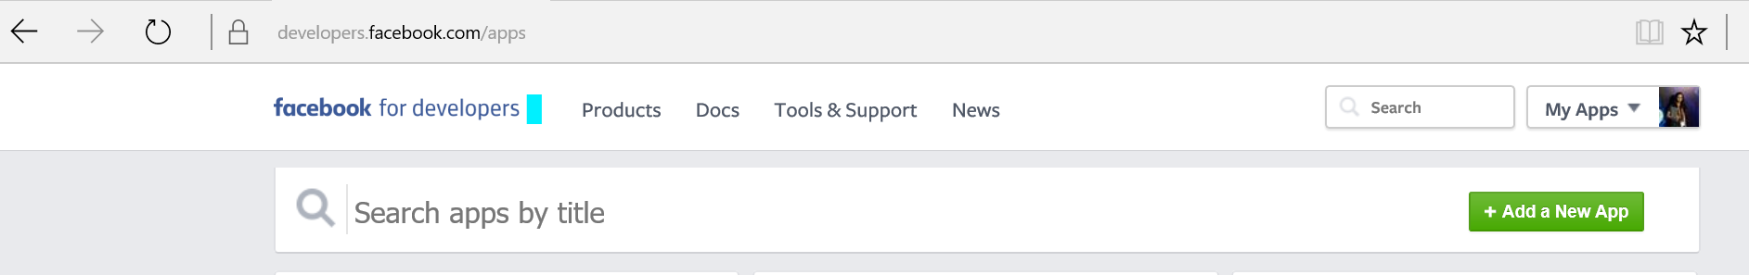

1. Choose **Websites**

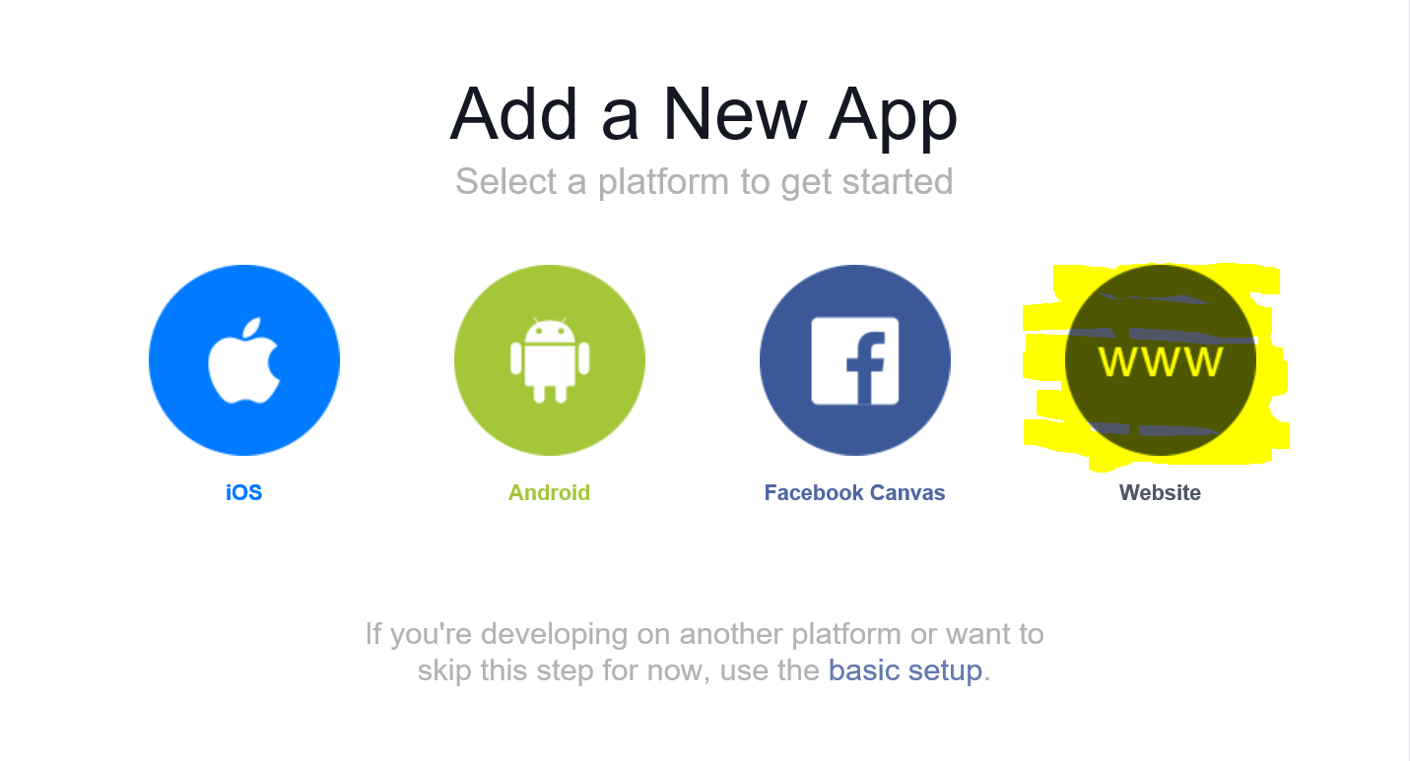

1. Choose a **Name** for your app > **Create new Favebook App ID** > Choose a **category** > Click on **Create App ID**

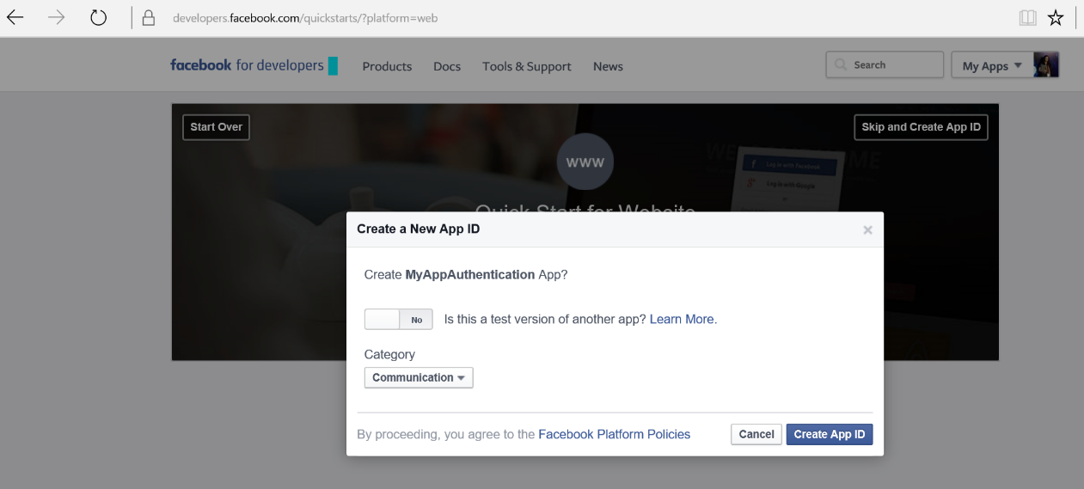

1. Click on **Skip Quick Start**

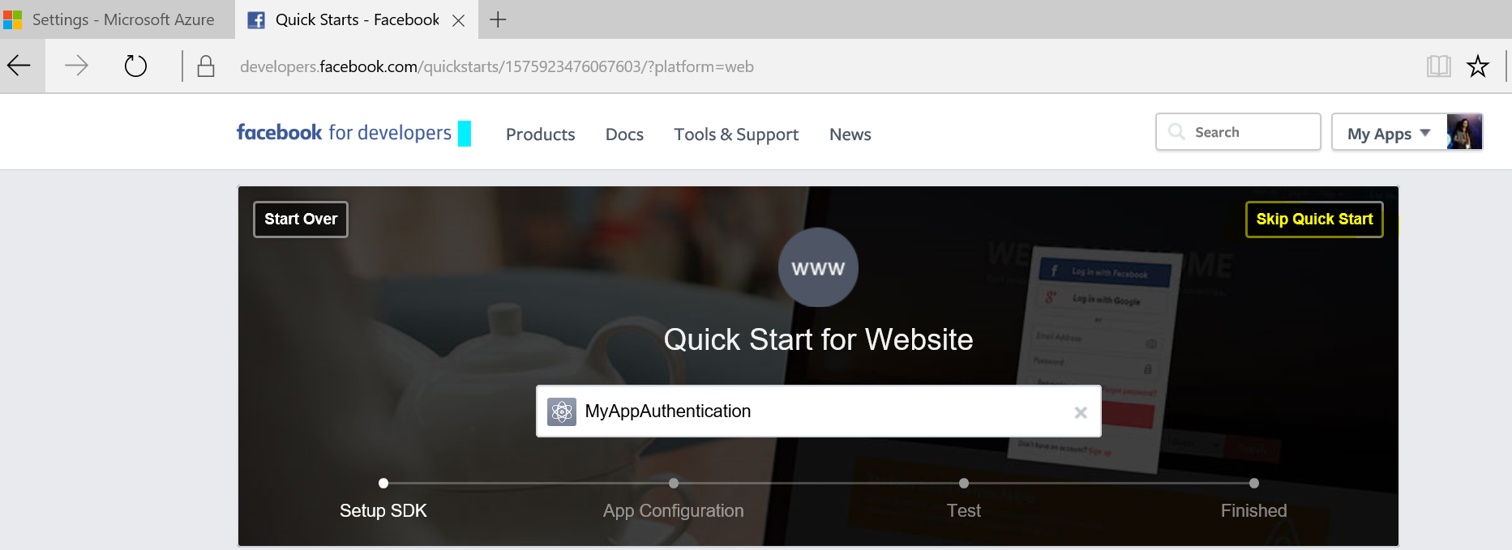

1. 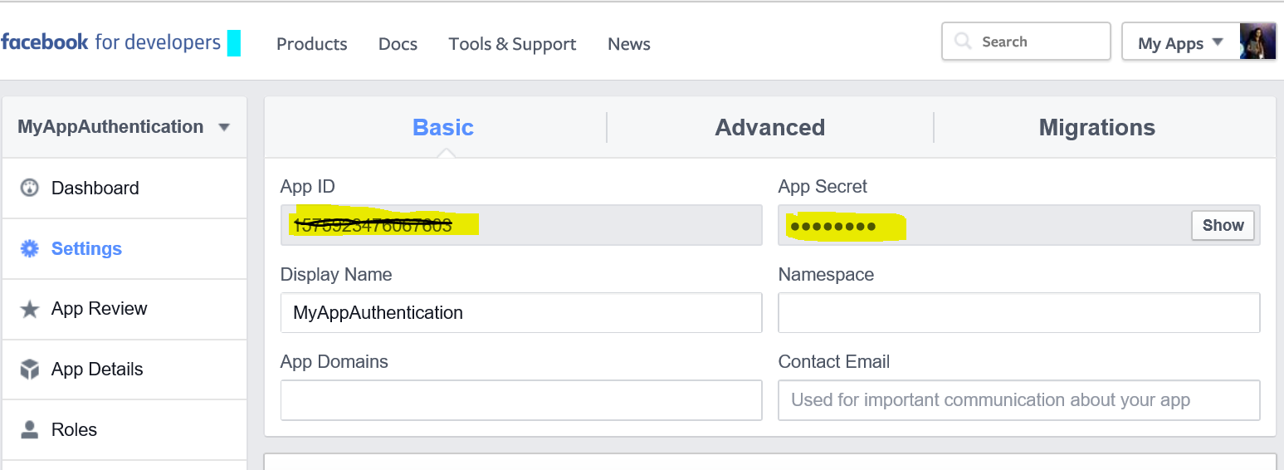Copy your **AppID** and **Secret** in a notepad

You have an app created on facebook now. Hold on a bit, we’ll get back here again!

Here comes the Azure part. . .

1. Go to <https://ms.portal.azure.com/>
2. Choose **NEW** > **Web +Mobile** > **Mobile App**

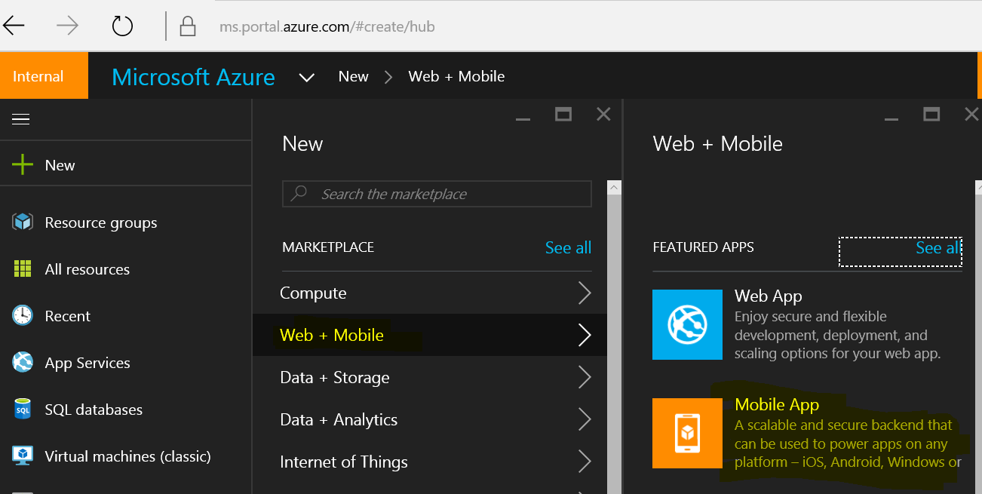

1. Give a unique name for your app and click Create (You can leave the rest of the settings to default or if it is null, choose the appropriate options).

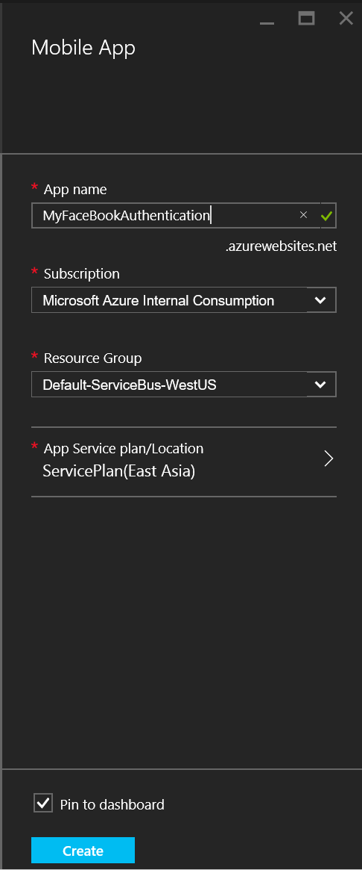

1. Go to **Authentication / Authorization** > Click **ON** for App Service Authentication > **Facebook Configure**

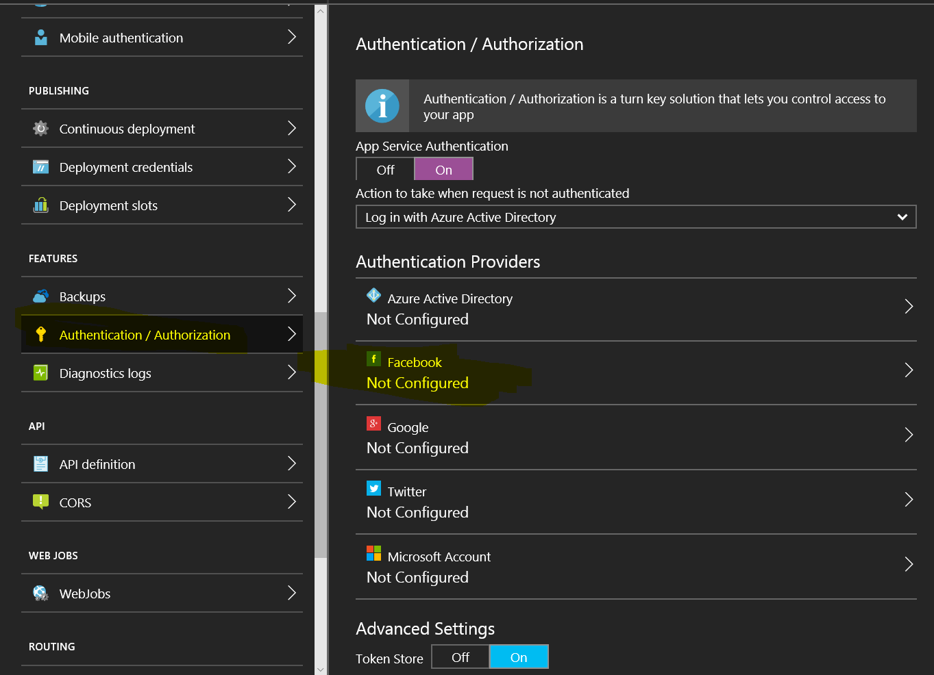

1. Enter your App ID and App Secret which you have copied from Facebook App settings > **OK**.

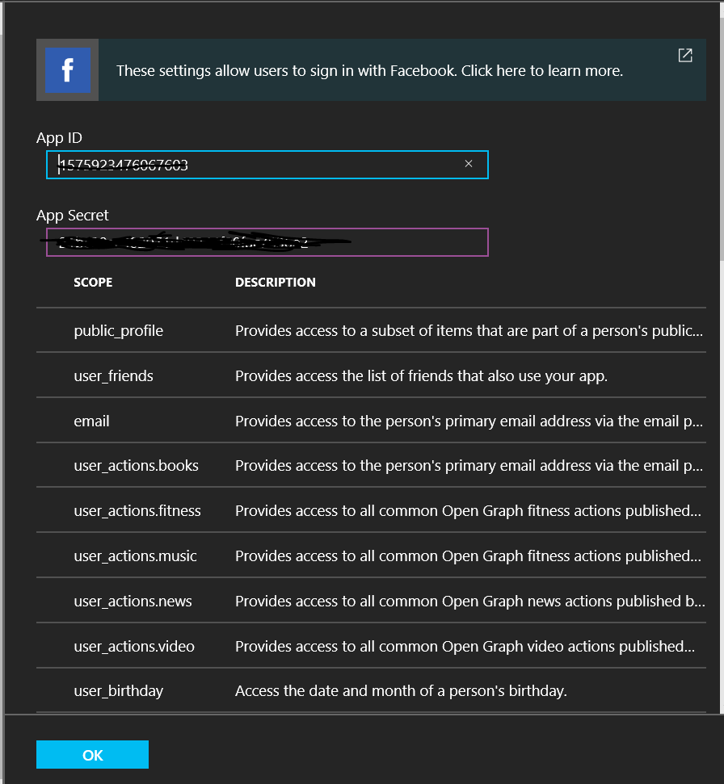

You should see **Configured** for Facebook now.

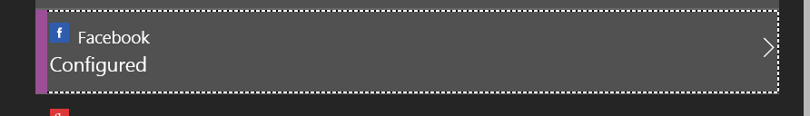

1. Go back to your <https://developers.facebook.com/apps/> and choose your app which you created.
2. Give the **name** of the Mobile app which you just created under App Domain name.

Add a **Platform** and choose **Website. Save changes.**

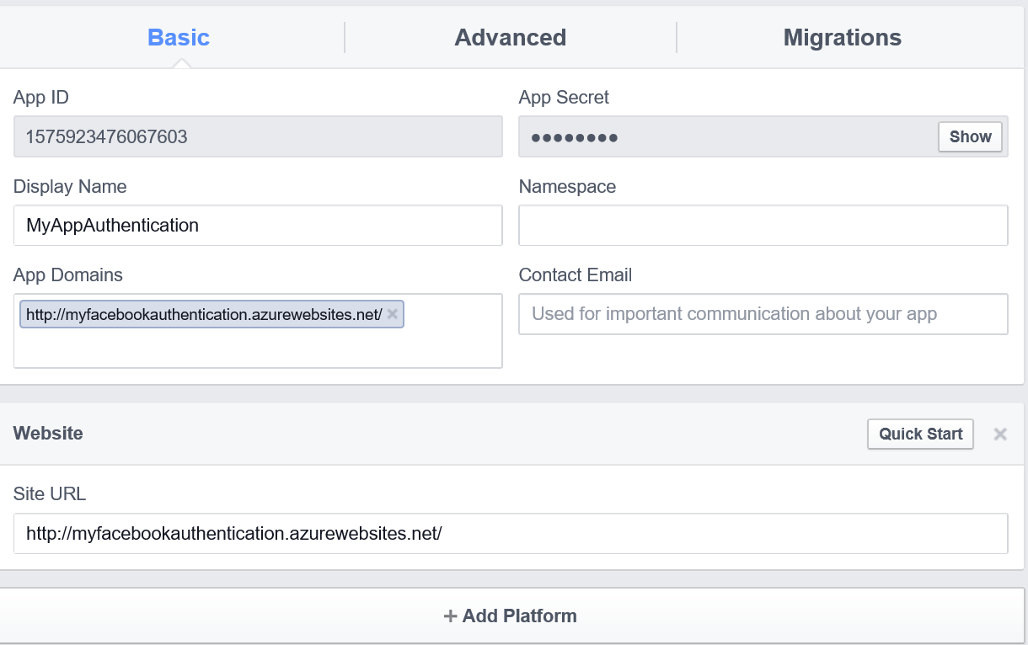

1. Go to **Advanced** tab **> Valid OAuth redirect URIs > Add your Mobile App URL append with *.auth/login/facebook/callback***

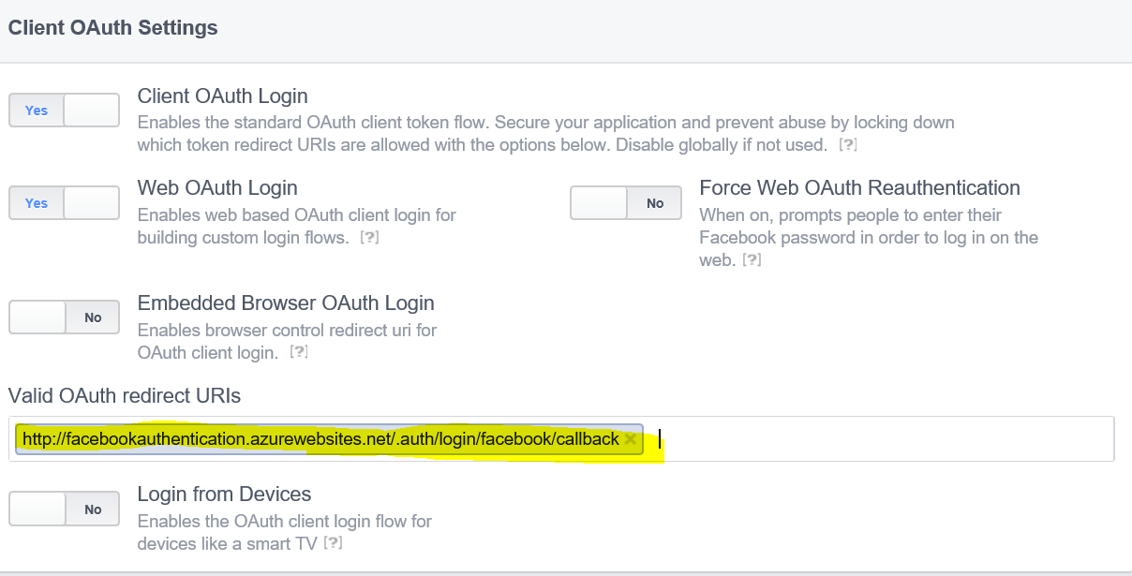

Now we have Azure and Facebook part ready.. Lets start our UWP app.

1. Start **Visual Studio 2015 > File > New > Project > Visual C# Universal (template)**
2. Create a blank app and give it a Name-  
   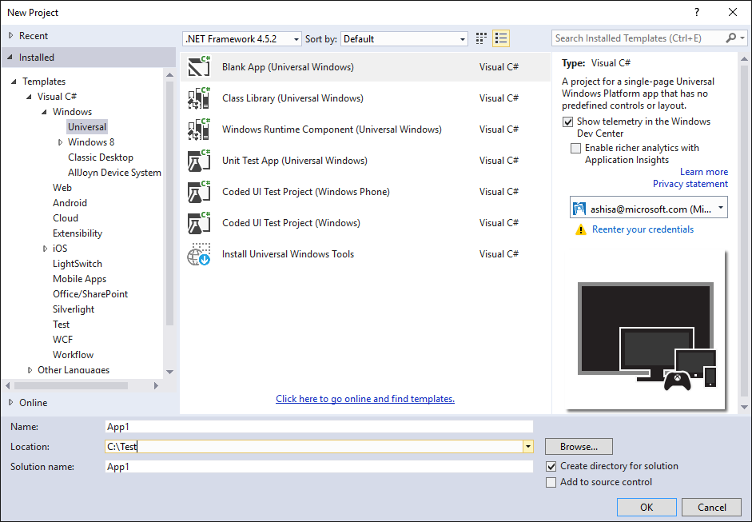
3. Right Click the project from Solution Explorer> **Manage Nuget Packages** > Browse – “**WindowsAzure.MobileServices”** and Install it.

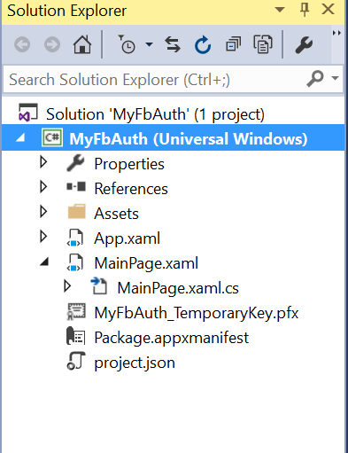

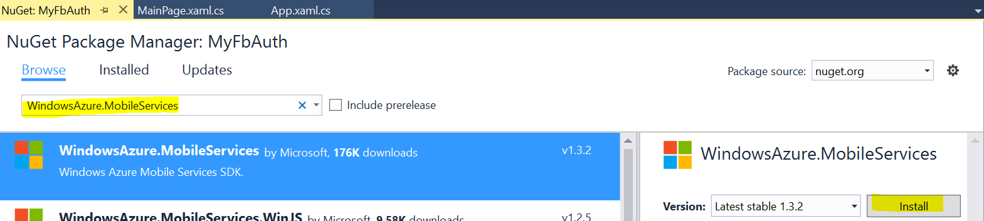

1. Go to MainPage.xaml.cs and paste the below code inside your MainPage **class** :

private MobileServiceUser user;

public static MobileServiceClient MobileService =

new MobileServiceClient("https://<Your Azure website URL>.azurewebsites.net");

private async System.Threading.Tasks.Task<bool> AuthenticateAsync()

{

string message;

bool success = false;

try

{

user = await MobileService.LoginAsync(MobileServiceAuthenticationProvider.Facebook);

message =

string.Format("You are now signed in - {0}", user.UserId);

success = true;

}

catch (InvalidOperationException)

{

message = "You must log in. Login Required";

}

var dialog = new MessageDialog(message);

dialog.Commands.Add(new UICommand("OK"));

await dialog.ShowAsync();

return success;

}

1. Add th below NameSpaces : -

using Microsoft.WindowsAzure.MobileServices;

using Windows.UI.Popups;

1. Go to MainPage.xaml and insert the below code inside the grid

<Button Name="ButtonLogin" Click="ButtonLogin_Click"

Visibility="Visible" HorizontalAlignment="Center" VerticalAlignment="Center">Sign in</Button>

1. Add the below code for ButtonClick inside MainPage.xaml.cs

private async void ButtonLogin_Click(object sender, RoutedEventArgs e)

{

if (await AuthenticateAsync())

{

ButtonLogin.Visibility = Windows.UI.Xaml.Visibility.Collapsed;

}

}

1. Run the app (Press F5) > Click on Sign In – You’ll see that Facebook Login appears in the app.

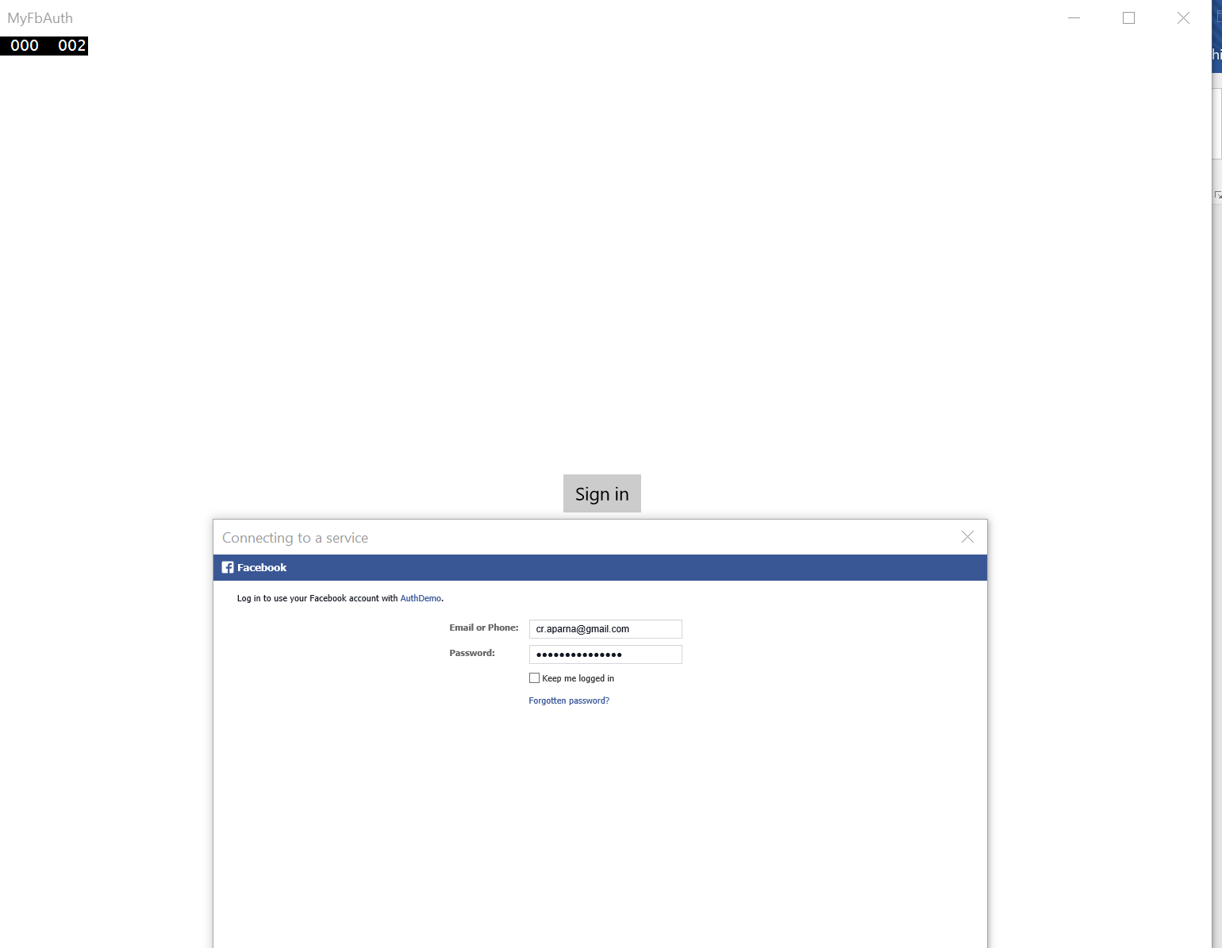

** Try on further experiments to check how you can store the logged in user and get details like – Users posts / Status / Friends etc in your app! **

Reference Links: <https://azure.microsoft.com/en-us/documentation/articles/mobile-services-how-to-register-facebook-authentication/>