HOL: Develop Universal Windows Apps on Windows 10



Contents

Overview 4

Lab 1: Writing Adaptive Code for UWP Apps 6

Lab 2a: XAML Live Visual Tree and XAML Performance 10

Lab 3: Designing Adaptive Tiles 10

Lab 4: Adding Interactive Toast Notifications 11

Lab 5: Adding Context Menu 13

Lab 6: a. Background Tasks 16

Lab 6: b. Background Downloaders 18

Lab 7: a. Target contracts 19

Lab 7: b. Share Source 19

Lab 8: Cortana Integration for your app 20

# Overview

This hands-on lab builds on the content of the breakout session and will provide depth information to the participants about developing Universal Windows Apps on Windows using VS2015. The session includes plenty of demos, code samples and discussions to benefit the developers attending the session –

1. Developing Adaptive Code for UWP Apps
2. XAML Controls and Performance
3. Designing Adaptive UI and tailored design
   1. Adaptive triggers
   2. SplitView control
   3. RelativePanel
4. Delighting the users
   1. Live Tiles
   2. Interactive Notifications
   3. Background Tasks & Background transfers
   4. Context Menu
   5. Cortana
   6. Share Contracts

This lab will help participants develop a greater understanding of the capabilities of UWP Apps on Windows 10. They will also learn how and when they should target specific device families and what steps can they take to make sure their apps behave properly at all times. The session will also provide guidance on how to leverage the unique and delightful features on the UWP platform to keep the users engaged.

Set up:

1. **Windows 10 PC** running **Visual Studio 2015** and **Windows 10 SDK**
2. Configure **VS2015** to use code snippets for this HOL –
   1. Click on **Tools** menu
   2. Click on **Code Snippets Manager**
   3. Click on **Add…**
   4. Select **CSharp** as the language and add the Csharp folder which is downloaded from this link- <https://github.com/AparnaChinya/UWP-Lab>
   5. Repeat the dteps for **XAML**. 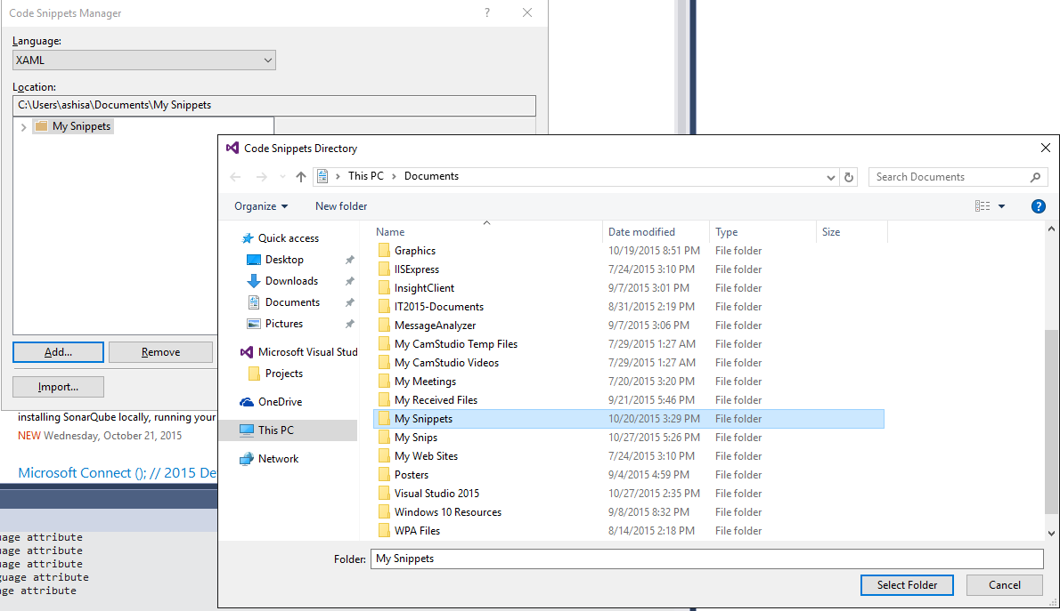

# Lab 1: Writing Adaptive Code for UWP Apps

1. Start **Visual Studio 2015**
2. Create a blank app -  
   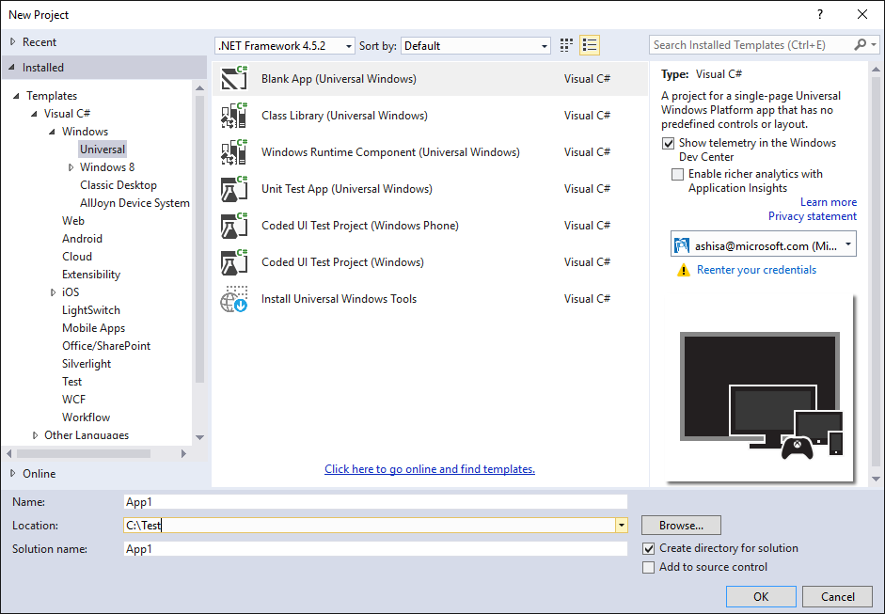
3. Click on **Assets** folder in the project, right click, click on **Add…,** click on **Existing Item…** and select all the file from the downloaded **Assets** folder
4. Open **MainPage**.**xaml**.**cs** and add the Camera Button handler in the constructor –
   1. Type **mainpagecamerabutton** and press tab **twice.**
   2. Now, right click on the project and add references to –
      1. **Windows Desktop Extensions for the UWP**
      2. **Windows Mobile Extensions for the UWP**

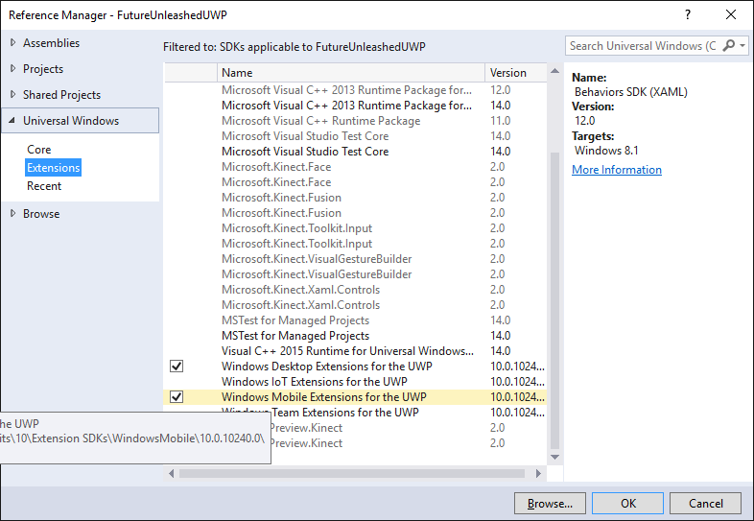

* 1. Delete the line added in the step (a) above and add the adaptive code for camera button handler –
     1. Type **adaptivecamerabutton** and press tab twice. **OR,**

Right click under the Grid control, click on **Insert snippet…** and select “**Adaptive code for camera button handler**”

1. Add the BackRequest event handler to the MainPage.xaml.cs –
   1. In the constructor, register the BackRequested event handler –
      1. Type **BackButtonEventHandler** and press tab twice. **OR**,

Right click, click on **Insert snippet…,** click on **My Snippets** and select “**Register BackButton event handler in MainPage.xaml.cs**”  
ii. Generate the BackRequest method.

* 1. Add the event handler code –
     1. Type **BackButtonFunction** and press tab twice. **OR**,

Right click, click on **Insert snippet…,** click on **My Snippets** and select “**BackButton Event Handler Function in MainPage.xaml.cs**”

* 1. Add code to enable/disable back button visibility in **App.xaml.cs** –
     1. Under the OnLaunched method in App.xaml.cs, find the line that says –

rootFrame.Navigate(typeof(MainPage), e.Arguments);  
  
Add code to toggle the visibility of the back button before this line –

* + - 1. Type **BackButtonVisibility** and press tab twice. **OR**,

Right click, click on **Insert snippet…,** click on **My Snippets** and select “**Enable BackButton visibility in App.xaml.cs**”

1. Open **MainPage.xaml** and insert the grid and row definitions XAML snippet under the Grid control –
   1. Type **mainpagegriddef** and press tab. **OR**,

Right click under the Grid control, click on **Insert snippet…** and select “**Row/Column definition for MainPage.xaml**”

1. Add the XAML for the page header Text Block –
   1. Type **mainpagetitletext** and press tab. **Or**,

Right click under the Grid control, click on **Insert snippet…** and select “**Title text block for MainPage.xaml**”

1. Add Visual State Groups to the page –
   1. Type **mainpagevsgroups** and press tab. **Or**,

Right click under the Grid control, click on **Insert snippet…** and select “**Visual State Groups for MainPage.xaml**”

1. Add Buttons on the MainPage for the rest of the labs –
   1. Type **mainpagebuttonsxaml** and press tab. **Or**,

Right click under the Grid control, click on **Insert snippet…** and select “**HOL buttons - MainPage**”

1. In MainPage.xaml.cs, add the button click event handler and wire the page navigation etc. –
   1. Open **MainPage.xaml.cs**
   2. Add the Button Click handler **after** the constructor –
   3. Type **mainpagebuttonclickcode** and press tab twice. **Or**,

Right click, click on **Insert snippet…,** click **My Snippets** and select “**Button click handler in MainPage.xaml.cs**”

1. Add a Blank XAML page named **RPanel.xaml** to the project
2. In the MainPage.xaml.cs, uncomment the following line of code –  
     
   this.Frame.Navigate(typeof(RPanel));
3. Open RPanel.xaml in designer and add the XAML to set up the page similar to the MainPage –
   1. Under the Grid control –
      1. Type **mainpagesetupxaml** and press tab. Or,
      2. Right click under the Grid control, click on **Insert snippet…** and select “**XAML Page Setup**”
4. Add the XAML code for RelativePanel
   1. Type **rpanelxaml** and press tab. **Or**,

Right click, click on **Insert snippet…** and select “**RelativePanel XAML Code**”

* 1. Change the first nested **Stack Panel** in to a **Relative Panel**
  2. Move the Image and the Text Block from the second **Stack Panel** to the **Relative Panel**
  3. Remove the second **Stack Panel** now
  4. Add the Setters to the Wide visual state group using the **rpanelsetterswide** code snippet
  5. Add the Setters to the NarrowView visual state group using the **rpanelsettersnarrow** snippet

# Lab 2: XAML Live Visual Tree and XAML Performance

1. Add a new XAML page and name it **DeferLoad.xaml**
2. Open MainPage.xaml.cs and add a case for “DeferLoad” by adding the following line   
   this.Frame.Navigate(typeof(DeferLoad));
3. Open **DeferLoad**.xaml in designer and add the snippet for the page setup –
   1. Type **DeferLoad** and press tab. **OR**,
   2. Right click, click on **Insert snippet…** and select “**HOL Buttons - DeferLoad**”

# Lab 3: Designing Adaptive Tiles

1. Open MainPage.xaml.cs and uncomment the following line –  
     
   **LaunchNVApps();**
2. Also uncomment the **LaunchNVApps()** function
3. Run the app and click on the **Tiles** button

# Lab 4: Adding Interactive Toast Notifications

1. Add a new XAML page and name it **ToastPage.xaml**
2. Open MainPage.xaml.cs and add a case for “Toasts” by adding the following line   
   this.Frame.Navigate(typeof(ToastPage));
3. Open ToastPage.xaml in designer and add the snippet for the page setup –
   1. Type **mainpagesetupxaml** and press tab. **OR**,
   2. Right click, click on **Insert snippet…** and select “**HOL Buttons - Toasts**”  
      Type **toastbuttonsxaml** and press tab. **OR**,

Right click, click on **Insert snippet…** and select “**XAML for adding buttons for UWP HOL**”

1. Open ToastPage.xaml.cs and after the constructor, add the button click handler –
   1. Type **toastswitchcasecode** and press tab twice. Or,

Right click, click on **Insert snippet…** and click on **“C# Code for Toast Switch..Case”**

1. After this button click handler function, add the code for Normal Toast –
   1. Type **normaltoastcode** and press tab twice. Or,
   2. Right click, click on **Insert snippet…** and select “**C# Code for normal toasts”**
2. After this button click handler function, add the code for Toast with actions –
   1. Type **actiontoastcode** and press tab twice. Or,
   2. Right click, click on **Insert snippet…** and select “**C# Code for toasts with action”**
3. After this button click handler function, add the code for toast with inputs –
   1. Type **inputtoastcode** and press tab twice. Or,
   2. Right click, click on **Insert snippet…** and select “**C# Code for toasts with inputs”**
4. After this button click handler function, add the code for another toast with inputs –
   1. Type **inputtoast2code** and press tab twice. Or,
   2. Right click, click on **Insert snippet…** and select “**C# Code for toasts with inputs 2”**
5. After this button click handler function, add the code for toast with selection –
   1. Type **selecttoastcode** and press tab twice. Or,
   2. Right click, click on **Insert snippet…** and select “**C# Code for toasts with selection”**
6. After this button click handler function, add the code for reminder toast –
   1. Type **remindtoastcode** and press tab twice. Or,
   2. Right click, click on **Insert snippet…** and select “**C# Code for reminder toast”**
7. After this button click handler function, add the code for a snooze toast –
   1. Type **snoozetoastcode** and press tab twice. Or,
   2. Right click, click on **Insert snippet…** and select “**C# Code for snooze and dismiss toast”**
8. After this button click handler function, add the code for another snooze toast –
   1. Type **snoozetoast2code** and press twice. Or,
   2. Right click, click on **Insert snippet…** and select “**C# Code for snooze and dismiss toast 2”**

# Lab 5: Adding Context Menu

1. Open MainPage.xaml.cs and add a case to navigate to ContextMenu Page by adding the following line –  
   this.Frame.Navigate(typeof(ContextMenu));
2. Add a new XAML page and name it ContextMenu.xaml
3. Open ContextMenu.xaml in designer and add the code to set up the page –
   1. Type **mainpagesetupxaml** and press tab. Or,
   2. Right click, click on **Insert snippet…** and select “**XAML Page Setup**”
4. Add the code to add a variable size wrap grid and a tested stack panel –
   1. Type **contextmenupanels** and press tab. Or,
   2. Right click, click on **Insert snippet…** and select “**Containers for context menu lab**”
5. Under the stack panel, add a button that has a flyout menu attached to itself
   1. Type **contextmenubutton** and press tab. Or,
   2. Right click, click on **Insert snippet…** and select “**C# code for flyout event handler**”
6. Open ContextMenu.xaml.cs and add button click handler after the constructor -
   1. Type **contextmenubuttoncode** and press tab twice. Or,
   2. Right click, click on **Insert snippet…** and select “**C# Code for Button Flyout Event Handlers**”
7. Open ContextMenu.xaml and add an image control that has a flyout menu attached to itself
   1. Type **contextmenuimage** and press tab. Or,
   2. Right click, click on **Insert snippet…** and select “**Image with a flyout menu**”
8. Just above the Grid control on this page, add the flyout resource XAML for the image flyout menus –
   1. Type **contextmenupageresource** and press tab. Or,
   2. Right click, click on **Insert snippet…** and select “**Flyout page resource**”
9. Open ContextMenu.xaml.cs and add image click handlers after the button click handlers-
   1. Type **contextmenuimagecode** and press tab twice. Or,
   2. Right click, click on **Insert snippet…** and select “**C# Code for Image Flyout Event Handlers**”
10. Open ContextMenu.xaml and add a command bar in that has a flyout menu attached to itself -
    1. Type **contextmenucmdbar** and press tab. Or,
    2. Right click, click on **Insert snippet…** and select “**Command bar with a flyout menu**”
11. Open ContextMenu.xaml.cs and add the code for command bar click handlers after other event handlers -
    1. Type **contextmenucmdbarcode** and press tab twice. Or,
    2. Right click, click on **Insert snippet…** and select “**C# Code for Command Bar Flyout Event Handlers**”

# Lab 6: a. Background Tasks

1. a. Right Click on Solution > Add > New Project > **Windows Runtime Component**

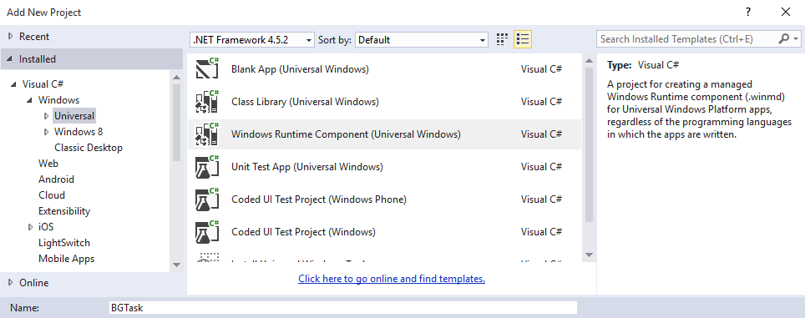b. Give it a name – BGTasks.

1. Implement the **IBackgroundTask** interface to **BG** class. It is under the namespace Windows.ApplicationModel.Background. Create the **RUN** function.
2. Code Snippet : **BGTaskClass**
3. Go to Package.appmanifest > Declarations > Background Tasks > Add.
4. Check **System event**
5. 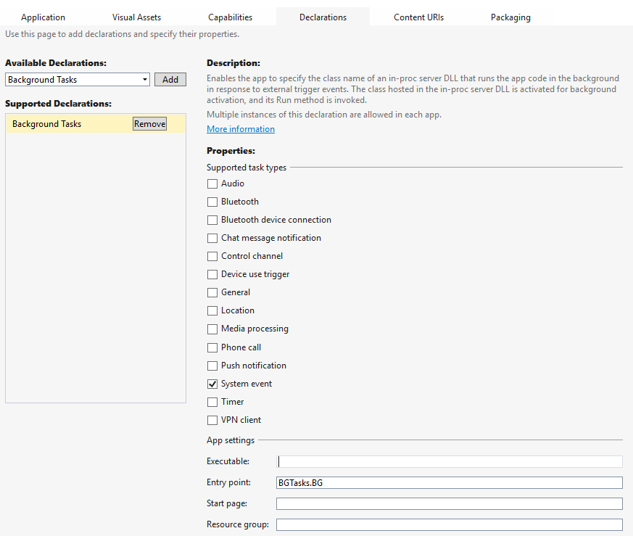Enter **BGTasks.BG** in the **Entry point**
6. Right Click on the **HackathonDemo** Project > Add new item > BlankPage > name it **BGTaskPage**
7. Right click on References in **HackathonDemo** Project > Add Reference > Projects > Solution > check **BGTasks** > Ok
8. Open **BGTaskPage.xaml**. Add the below code inside the Grid element.

<TextBlock Style="{StaticResource HeaderTextBlockStyle}" x:Name="BGText"/>

1. Open BGTaskPage.xaml.cs

Code Snippet: **BGTaskPage**

1. Pin the **HackathonDemo** Project to start > **Disconnect** the computer from Network > You can now see the live tile being updated with the last access time of network.

# Lab 6: b. Background Downloaders

1. Right Click on **HackathonDemo** project > Add New Item > Blank Page > name it BackGroundTransfer.xaml
2. Open BackGroundTransfer.xaml

codesnippet : **BGTransferXaml**

1. a. Open **BackgroundTransfer.xaml.cs** Code Snippet: **BGTransferButton**b. Uncomment the last line  
    ( await download.StartAsync().AsTask(cts.Token,progressCallback); )  
   c. Comment this line : // await download.StartAsync();  
   d. Call the DownloadProgress as shown below:  
   Progress<DownloadOperation> progressCallback = new Progress<DownloadOperation>(DownloadProgress);
2. a. Code Snippet **– BGTransferProgress**b.Create a new object of **CancellationTokenSource** by adding the below line in the constructor.  
   cts = new CancellationTokenSource();
3. Go to Package.appxmanifest > Capabilities > **Picture Library**.

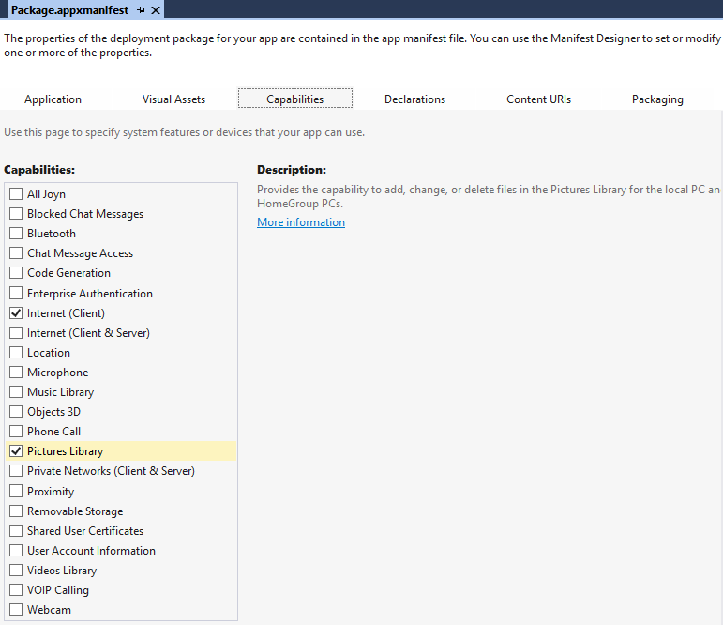

# Lab 7: a. Target contracts

1. Right click on HackathonDemo project > File > New > Blank Page > name it **ShareTarget.xaml**
2. a. Go to **Package.appmanifest** > Declarations > **ShareTarget** > Add
3. Add new **DataFormat** – **Text** , **html** , **storagefiles** (seperately)
4. Check **Support Any File** type checkbox
5. Go to App.xaml.cs

Code Snippet : **OnShareTargetActivated**

1. Go to **ShareTarget**.xaml  
   Code snippet : **ShareTargetXaml**
2. Go to **ShareTarget**.xaml.cs  
   Code snippet : **ShareTarget**

# Lab 7: b. Share Source

1. Right Click on HackathonDemo > Add New Item > Blank Page > Name it ShareSource.xaml
2. Open ShareSource.xaml

Code snippet : **ShareSourceXAML**

1. Open ShareSource.xaml.cs

Code snippet:

a. **ShareButtonCSharp**

b. **ShareSourceOnNavigatedTo**  
c. **ShareHandler**

4. Uncomment the lines to test different data format sharing.

# Lab 8: Cortana Integration for your app

1. Right Click on HackathonDemo project > Add New Item > **XML File** > name it **VoiceCommandDefinition.xml**
2. Open Package.manifest > Capabilities > **Microphone**
3. Code Snippet : **VCD**
4. Open App.xaml.cs

Code snippet : **CortanaRegister** and **CortanaOnActivated**Add : **this.Register();** under App().

1. Right click HackathonDemo > Add New Item > Blank Page > Name it CortanaPage.xaml

Open CortanaPage.xaml

Code snippet : **CortanaXaml**

1. Open CortanaPage.xaml.cs

Code snippet : **CortanaPage**