FUNCTIONAL REQUIREMENTS

Product Name: BrowserStack Demo (Frontend)

Prepared By: Aparna K

Date: 29-9-2023

Overview

Browser Stack is free open source e-commerce platform for online merchants. BrowserStack provides a professional and reliable foundation from which to build a successful online store. This foundation appeals to a wide variety of users; ranging from seasoned web developers looking for a user-friendly interface to use, to shop owners just launching their business online for the first time. BrowserStack has an extensive amount of features that gives you a strong hold over the customization of your store. With BrowserStack’s tools, you can help your online shop live up to its fullest potential.

Requirements

BrowserStack requires certain technical requirements to be met for the store to operate properly. First, a web server must be created to make the BrowserStack store publicly available on the web. Domain names and hosting services can easily be purchased for an affordable price. When selecting a hosting service, you should check to see that these server requirements are provided and installed on their web servers: These extensions must be enabled for BrowserStack to install properly on the web server.

* PHP 5.4
* jQuery 2.1.1
* JavaScript
* Database (MySQL suggested)
* Web Server (Apache suggested)

BrowserStack Frontend

This Document is intended to be used as an introduction to the BrowserStack default store front. The store front reveals how the customer views and interacts with the store.

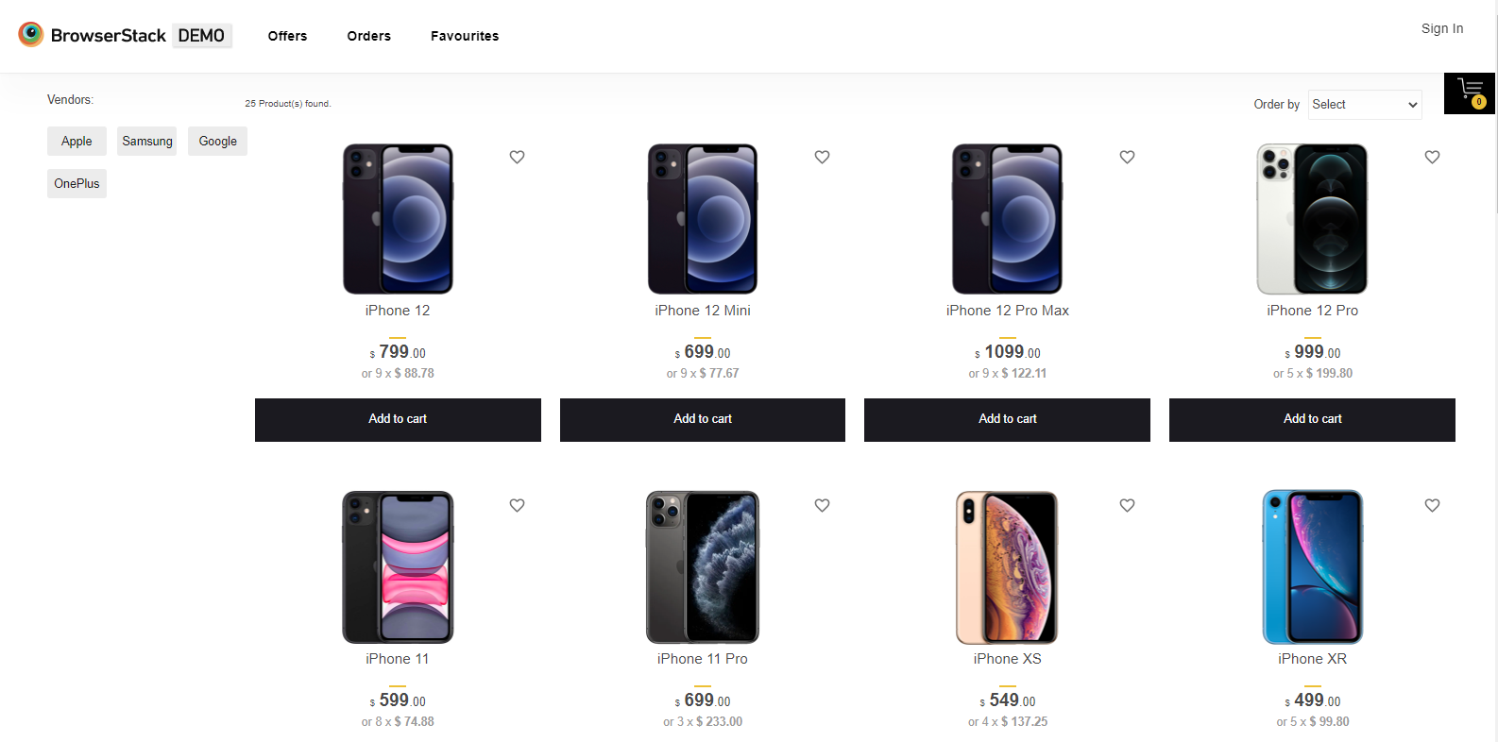

The products seen above are included as sample data with the BrowserStack installation. These products can easily be removed and replaced with the shop's products later.

Navigating the shop

The BrowserStack default theme makes navigating a shop's products easily accessible to its customers.

**Home page**

The home page is arguably the most important page in the shop, in terms of presentation. In most cases, this will be the first page that a customer interacts with (especially if they are directed to the store site from a search engine). The shop's homepage needs to be user-friendly, while at the same time highlighting the shop's products. The first step in becoming familiar with the store front is in understanding the anatomy of the BrowserStack default homepage.

**The header**

The header will be displayed at the top of the page, on Home page, Order Page, and Favorites Page of the store. The header has the following navigation options:

* Store logo: Clicking on this logo will direct the customer back to the home page of the store. This option is available on all the pages of this site.
* Links: Links the customer to the Orders, Favourites, and Logout/Sign in.
* Username block: Displays username of the customer.



**The body**

BrowserStack displays all the available products here. There are options for filtering brands, sorting products according to customers liking and add to cart logo. This section includes the product image, name, price, an option to add the product directly to the Shopping Cart and an option to add to wish list/favourites .

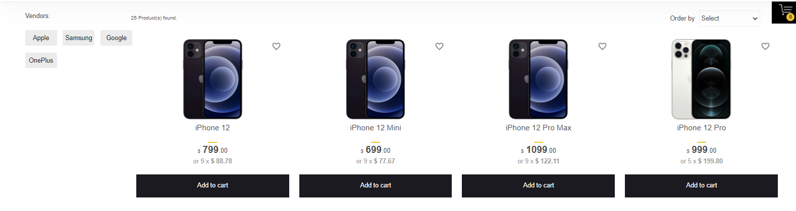

**Add to Cart sidebar**

Displays products added to the cart and provides button to proceed to Checkout Page and a button to close the cart sidebar.

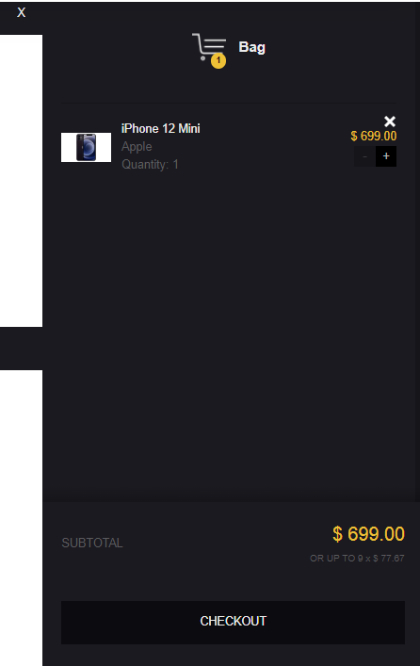

**The Checkout**

Once a product has been added to the cart, the customer can continue to the checkout to make their product purchase. The Checkout page can be accessed through “Add to cart” sidebar section. Customer checkout using BrowserStack is a simple process that can be completed in 4 steps.

1. Step 1: Checkout options The customer can log into or register their account (as explained above), or select guest checkout.
2. Step 2: Order summary will be displayed and verify order summary details
3. Step 3: Billing details Personal details including "First Name", "Last Name", "E-mail", “State/Province” and "Postal Code" are filled into a form.
4. Step 4: Confirm order In this last step, the customer will see an overview of their purchase; including the product description, quantity, and price (with tax & shipping).