LAB ASSIGNMENT -3
LINUX PROGRAMMING
17MIS1065
APARNA.R
DATE:25-12-2019

1)Write a shell script to search for a string in a file

grep -w “hello” b.txt (to check a word)
grep -c “hello” b.txt (to count the terms)

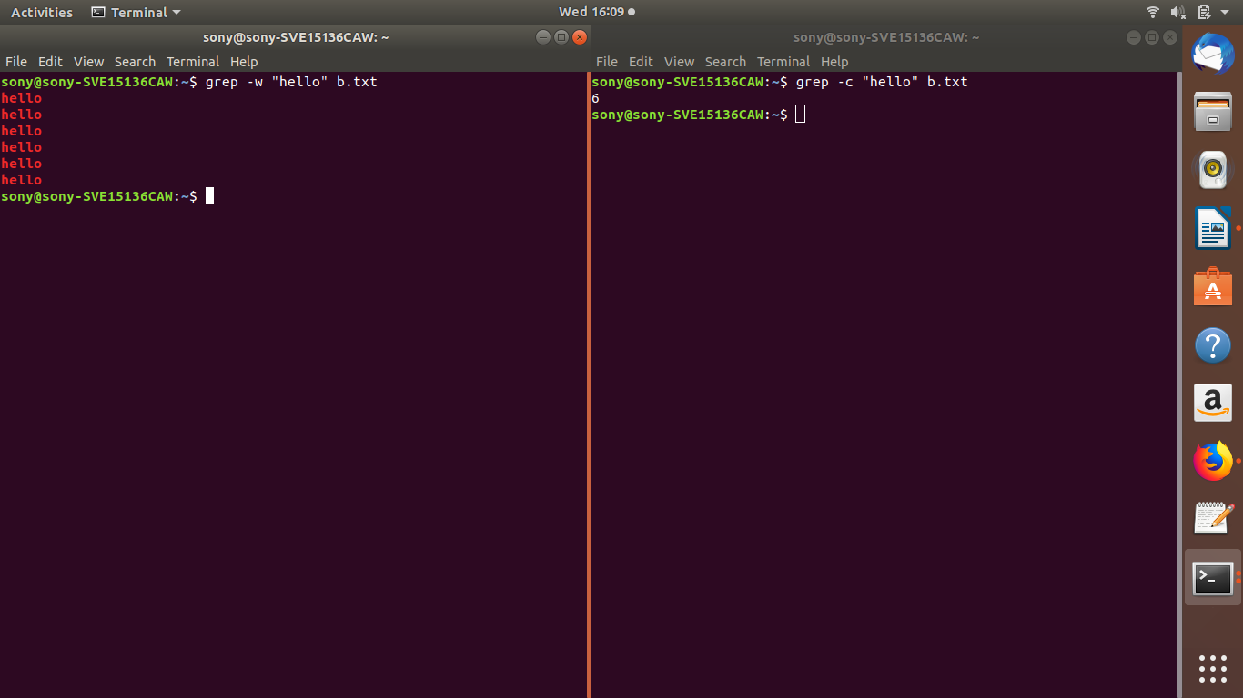

2)Use loops and find the string in a file.
file=”b.txt”
while read -r line
do
$Line=$line
if [[ $Line == hel* ]]
then
echo “$Line”
fi
done< “file”
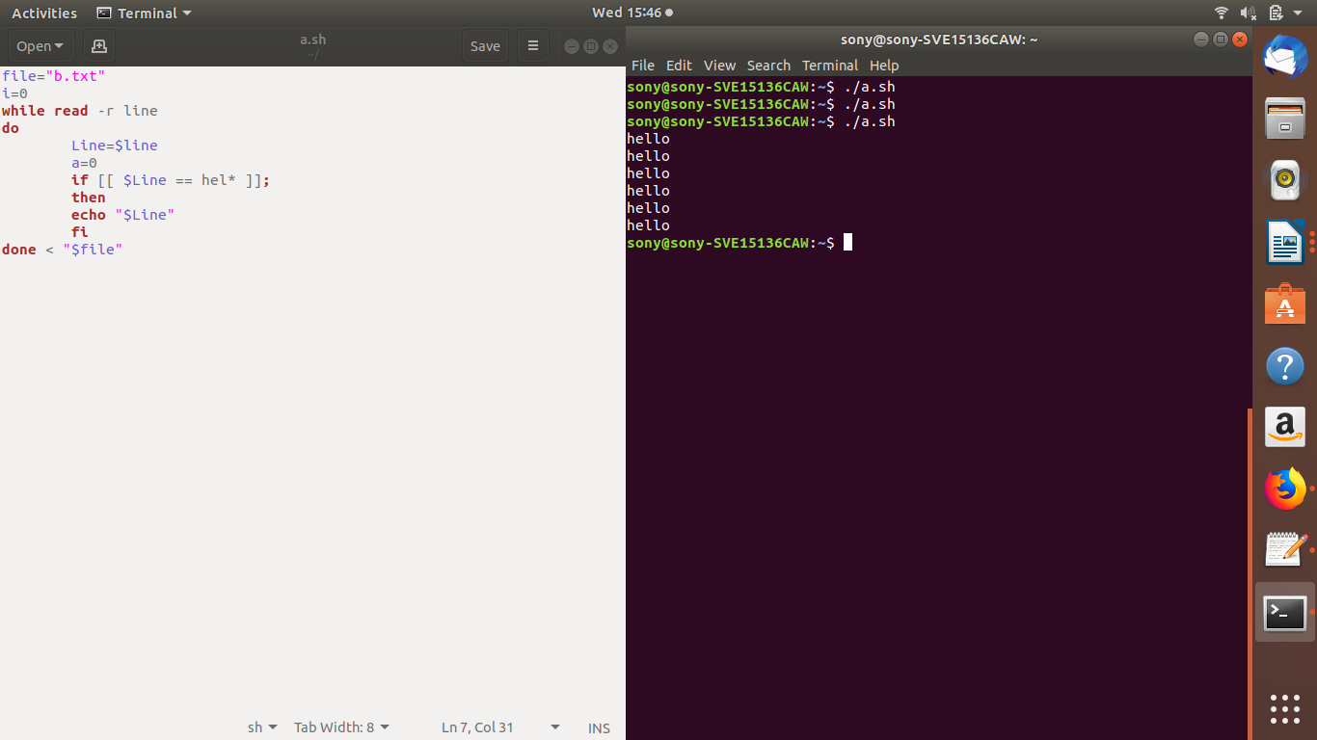

3)Write a script that will check log file everyhour to check for errors.
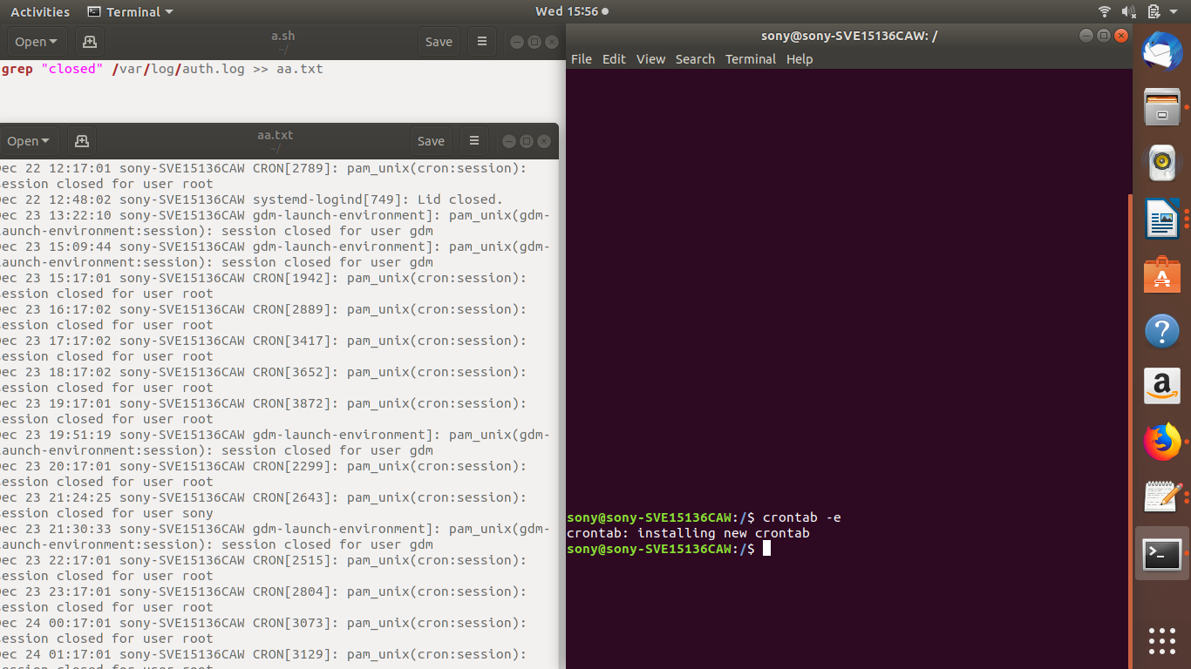

4)Write a shell script to perform the following
-measure the performance of process
-display every 5 minutes the CPU utilization and memory utilization and print into a file
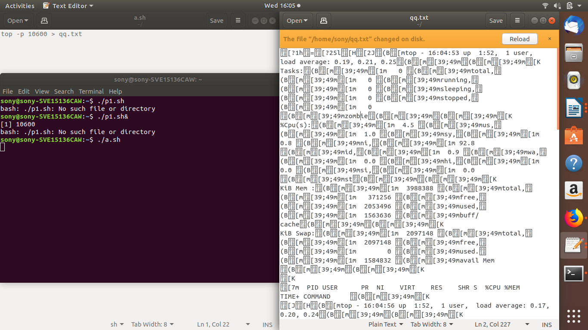

LAB2
LINUX PROGRAMMING
17mis1065
APARNA.R
12-12-2019


