## Q-1: ProblemStatement:

Create a registration form for XYZ University. The form should look as shown in the image below.

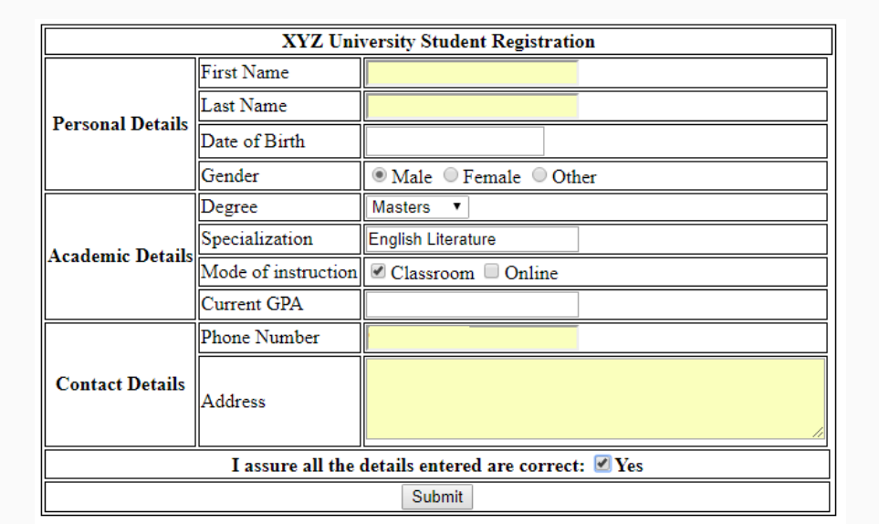

The validations for each field are described below:

* **First Name**: Required, max 10 characters
* **Last Name**: Required, max 10 characters
* **Date of birth**: Required
* **Gender**: Only one option must be selected
* **Degree**: Dropdown should contain "Bachelors", "Masters" and "Doctorate"
* **Specialization**: Required, max 40 characters
* **Current GPA**: Required, max value 5, increment in steps of 0.1
* **Phone Number**: Required
* **Address**: Required, max 4 rows of 40 characters each.

All required fields should be marked with a red asterisk (*)

## Q-2: ProblemStatement:

Create the below table for Destiny Tours & Travels price list.

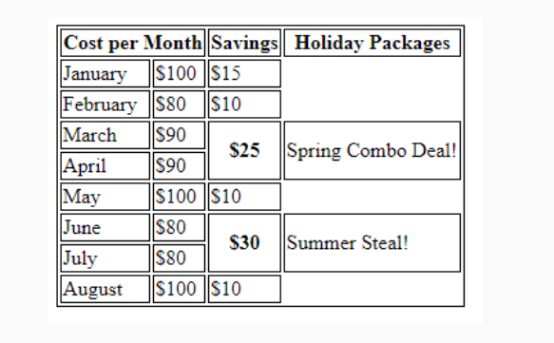

Q-3: 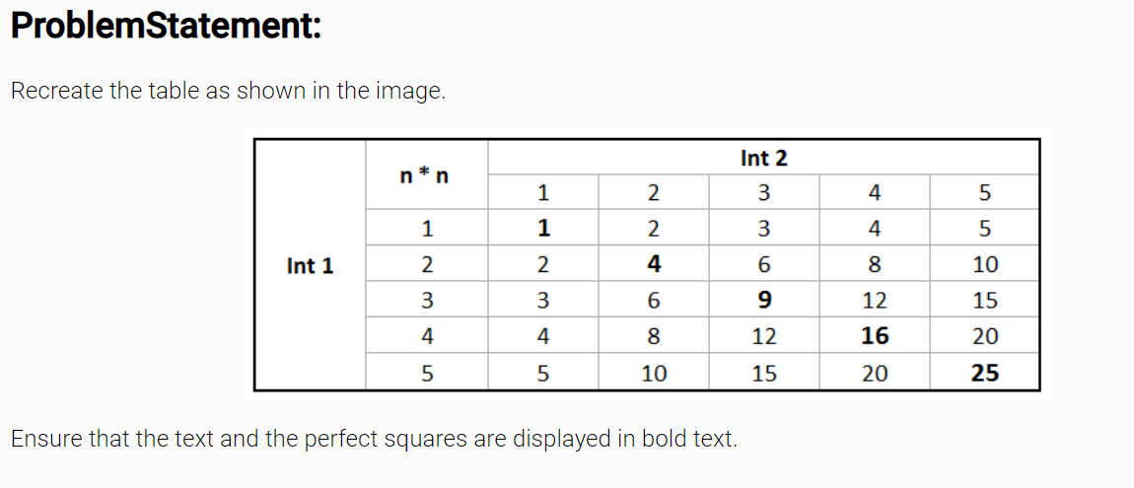

## Q-4: ProblemStatement:

Create a form for XYZ online pizza delivery service as shown in the image below.The validations for each field are given below:

* **First Name:**Required, max 20 characters
* **Phone Number**: Required
* **Size**: Required, only one option can be selected
* **Base**: Required, Dropdown should contain "Pan Pizza", "Cheese Crust" and "Chicken Stuffed Crust"
* **Additional details**: contains 2 rows of 30 cols each.

All required fields must be marked with a red asterisk (*)

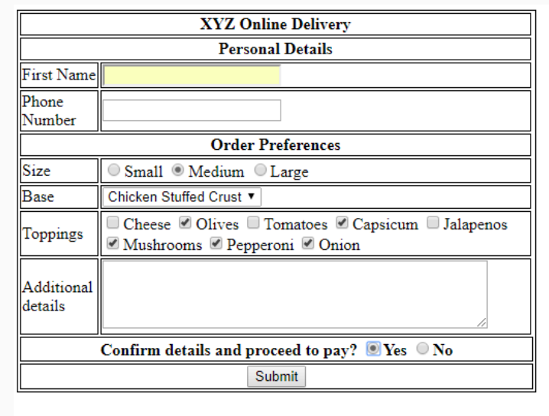

Q-5:PROBLEM STATEMENT – Create the below Form using HTML5 and CSS

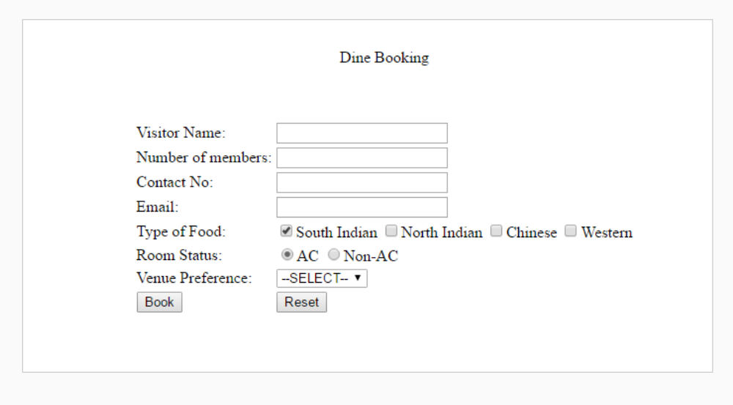

## Q-6: ProblemStatement:

– Create the below layout using Flexbox and Media Query. Depending upon the screen size defined you need to apply the media rules.

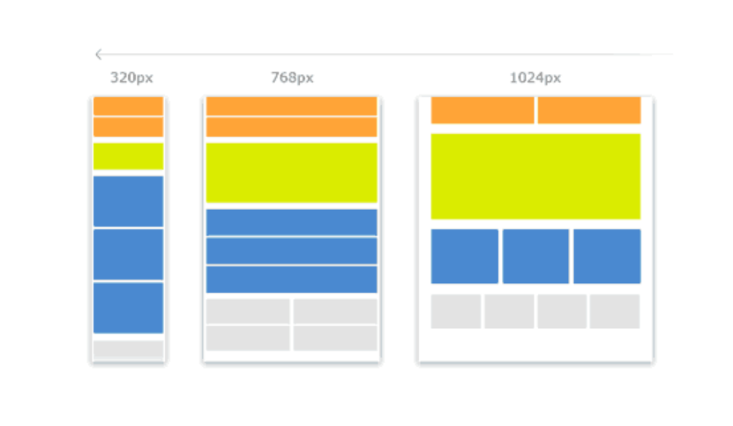

## Q-7: ProblemStatement:

Create the below page using HTML5 semantic element and CSS3 Flexbox.

Note: It should look similar to the page below.

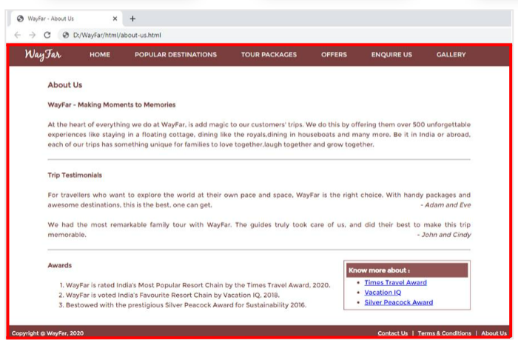

## Q-8: ProblemStatement:

Create the Contact Us page as shown below. Use HTML5,CSS3.

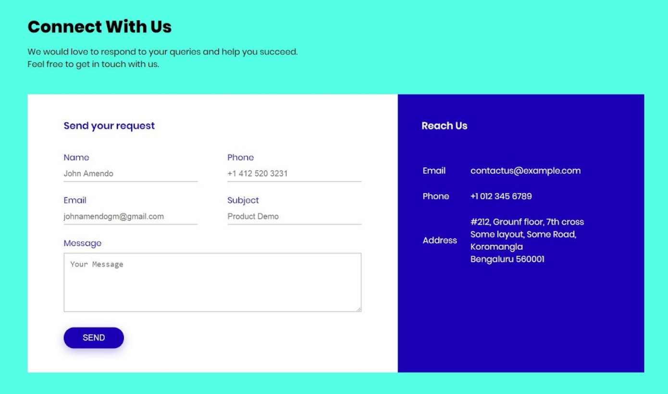

## Q-9: ProblemStatement: Create this page with these 3 cards using HTML5 and CSS3.



## Q-10: ProblemStatement: Create this page using HTML5 and CSS3 Flexbox.

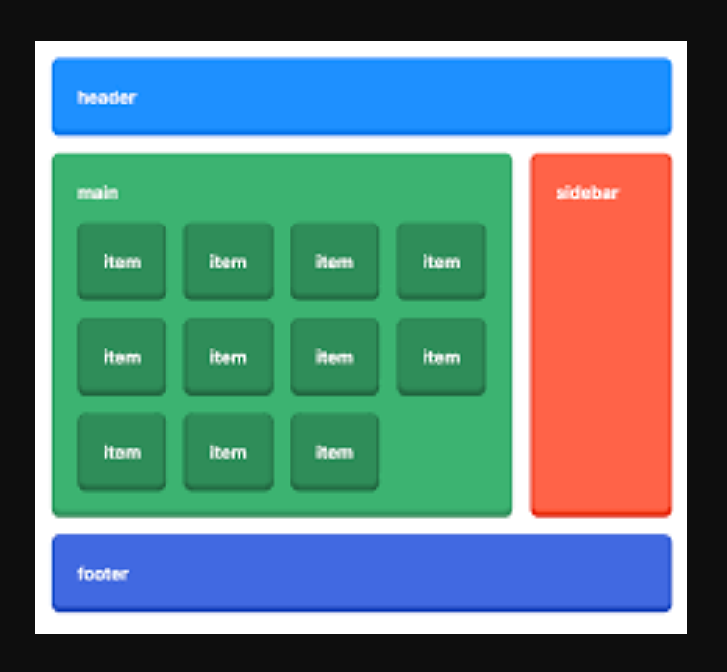

## Q-11: ProblemStatement:

**1. home.html**

This page renders the information about the company. It has a ‘Explore More’ button when clicked should take the user to services.html.

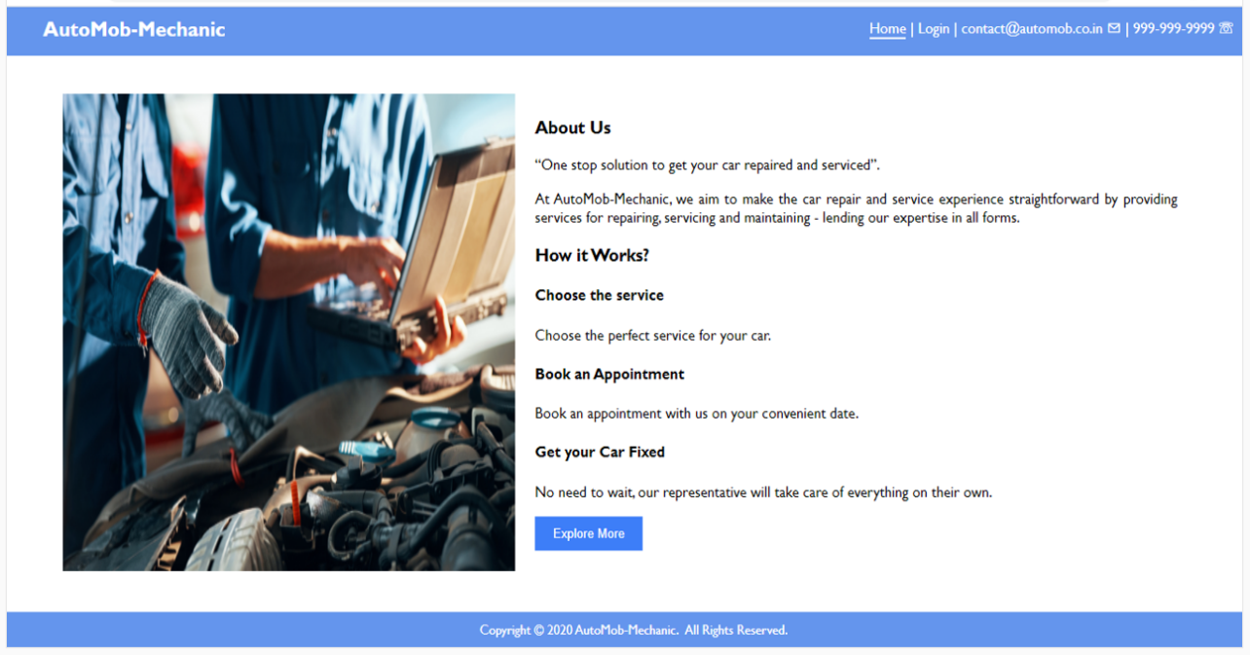

**Hint:** onclick event, location.assign()

2.Services.html : Here you have to display the content as it is. In bottom you have to use a timer to display **Offers ends in. To display those services use a javascript array to read the data.

Note: Use setInterval() in Javascript

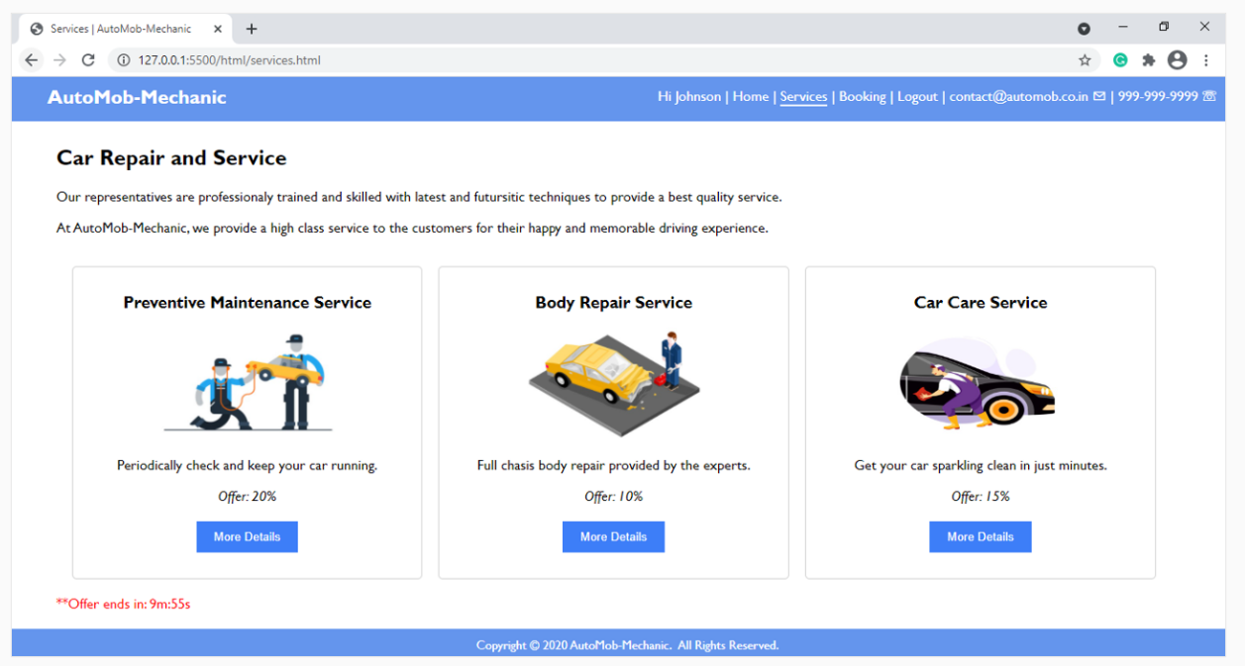

3. Reports.html – This page will render a table . Here you have to read the data from a javascript array.

