* **npx cypress open** for test runner

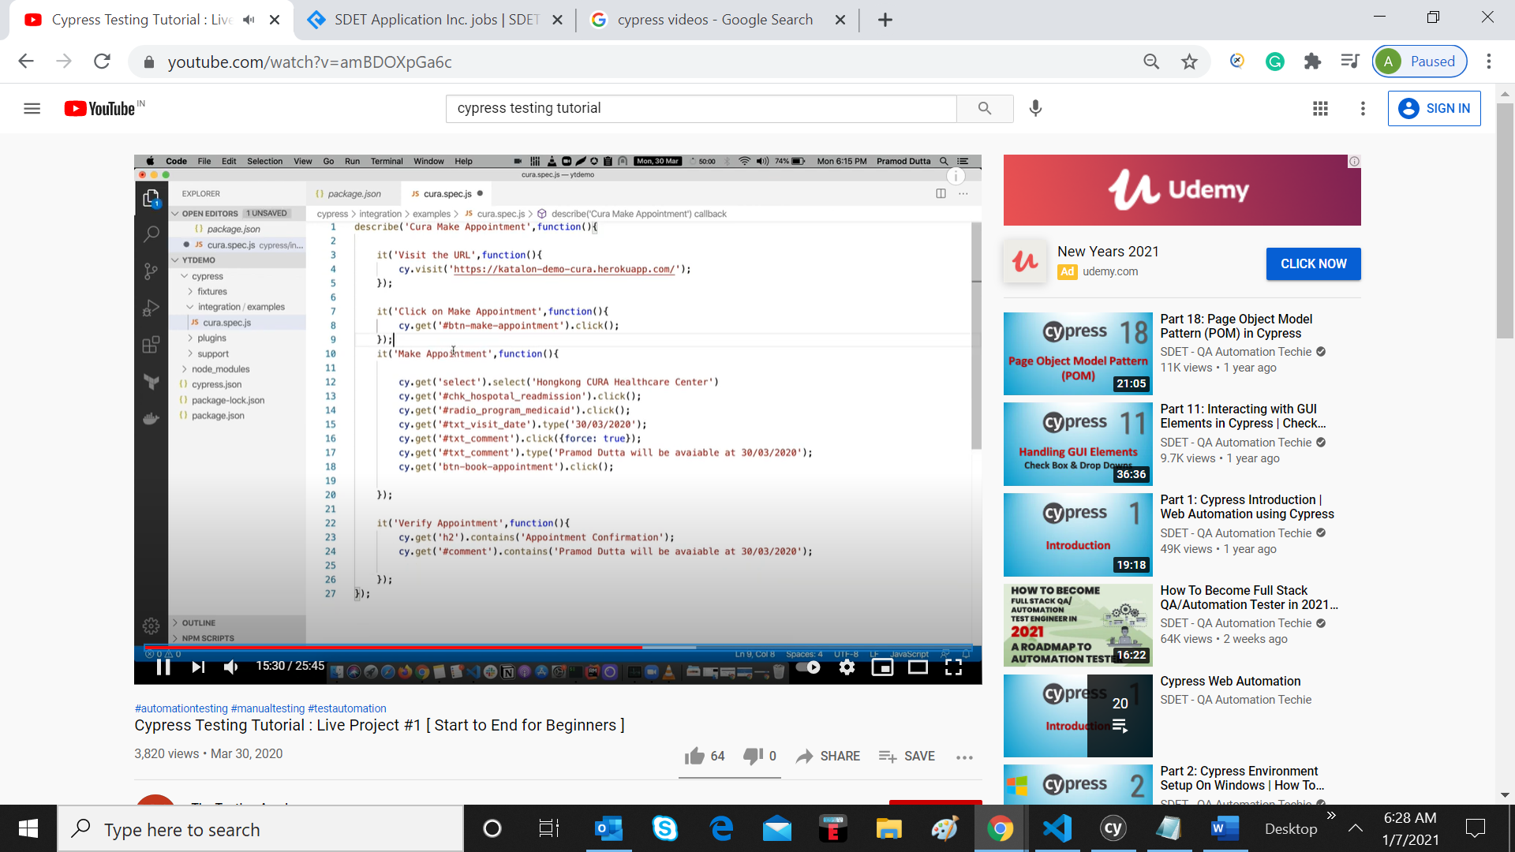

Run command



To see the report

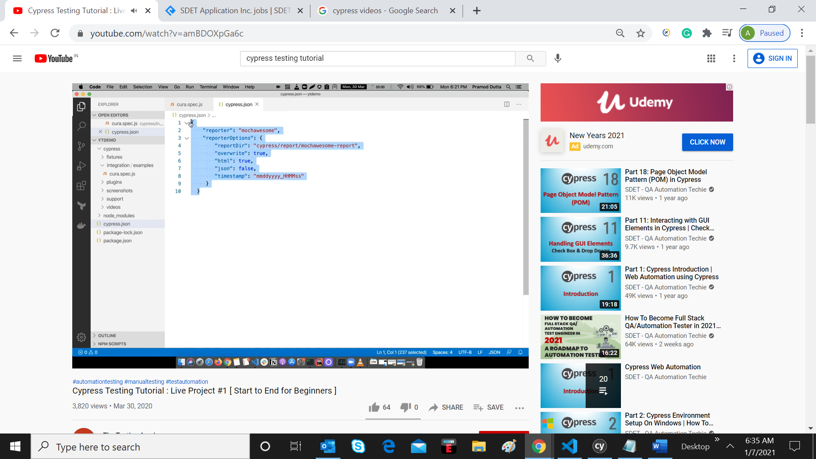

viewing jobs based on a filter, and clicking on a job to view details

cy.get(‘.products’).find(‘.product’).should(‘have.length’,4)

cy.get(‘.products’).find(‘.product’).eq(2).contains(‘Add to Cart’).click() ---------🡪 getting 2nd product from 4 products.

**************************************************************************************

Going to loop:

Cy.get(‘.products’).find(‘.product’).each($ele, index, $list) => {

Const textveg= $ele.find(‘h4.product-name’).text()

If((textVeg.includes(‘Cashewes’))

{

$ele.find(‘button’).click()

}

File upload..

1. Run this command at terminal, **npm install --save-dev cypress-file-upload**
2. Include below line into u r script

import 'cypress-file-upload';

const imagefile = ‘xxx.png’

cy.get(‘ ‘).attachFile(imagefile)