PROJECT REPORT
(22AIE202:OPERATING SYSTEMS)

TEAM:C-6

APARNA A-CB.SC.U4AIE24206
JENISHAA BHARATHI M-CB.SC.U4AIE24221
POLICE ARYAN-CB.SC.U4AIE24241
POOJA N-CB.SC.U4AIE24242

To-Do List Manager using System Calls
1.ABSTRACT
This project presents a To-Do List Manager that combines low-level system programming with a web-based interface. The core functionality is implemented in C using POSIX system calls such as open, read, write, lseek, and ftruncate, allowing direct manipulation of the tasks.txt file to add, view, mark, or delete tasks. The system ensures efficient OS-level file handling, demonstrating how basic file operations can be used to manage persistent data without relying on high-level abstractions. A Python Flask server acts as a bridge between the browser and the C program, receiving HTTP requests, executing the CLI commands via the subprocess module, and returning responses that update the user interface in real time. The front-end is built using HTML, CSS, and JavaScript, providing an intuitive and interactive environment for task management. This project illustrates the seamless integration of C programming, POSIX system calls, and modern web technologies, offering a practical example of how low-level programming concepts can be combined with web development to create functional and responsive applications on macOS/Linux platforms.

2.INTRODUCTION
In today’s fast-paced world, managing tasks efficiently is crucial for productivity. A To-Do List Manager helps users organize, track, and prioritize their daily activities. This project focuses on building a simple yet powerful task management system that combines low-level system programming with a web-based interface. Unlike traditional applications that rely on high-level file handling libraries, this project demonstrates direct interaction with the operating system using POSIX system calls in C—such as open, read, write, lseek, and ftruncate—to perform all operations on a persistent tasks.txt file.
The system allows users to add, view, mark as done, and delete tasks, with all updates handled through efficient OS-level file manipulations. To provide a user-friendly experience, the project uses Python Flask as a web server that acts as a bridge between the browser and the CLI program (todo_cli). Browser requests are received by Flask, which runs the CLI program using the subprocess module, retrieves the output, and updates the web-based UI in real time.
The front-end is designed with HTML, CSS, and JavaScript, providing an intuitive interface for interaction. This project not only reinforces understanding of C programming and POSIX system calls but also illustrates how low-level programming concepts can be integrated with modern web technologies to create functional, responsive, and interactive applications. It is compatible with macOS and Linux platforms, offering a practical example of bridging OS-level operations with web development.

3.DESCRIPTION OF METHODOLOGY

The development of the To-Do List Manager involves a combination of low-level system programming in C and web-based interface integration using Python Flask. The methodology focuses on how tasks are stored, managed, and displayed in a seamless and interactive manner. The process is divided into several key components:
- System-Level Task Management using C and POSIX System Calls:
  - The core task management functionality is implemented in C using POSIX system calls, providing a direct interaction with the operating system for file operations.
  - The program todo_cli handles all task-related operations on a file named tasks.txt.
  - Key system calls used include:
    - open() – to create or open the task file in appropriate modes.
    - read() – to read the contents of the file for viewing or processing tasks.
    - write() – to add new tasks or update existing tasks in the file.
    - lseek() – to navigate to specific positions in the file, enabling modification of specific tasks without rewriting the entire file.
    - ftruncate() – to remove completed tasks or resize the file when deleting tasks.
  - Tasks are stored line by line, and each operation (Add, View, Mark Done, Delete) is performed by reading the file, manipulating data in memory, and writing back the changes. This approach ensures persistent storage and real-time updates.
- Web Interface using Python Flask:
  - To make the task manager accessible via a browser, a Flask web server acts as an intermediary between the user interface and the CLI program.
  - Flask receives HTTP requests from the browser, such as adding a new task, viewing all tasks, marking a task as done, or deleting a task.
  - The server uses the subprocess module to execute the todo_cli program with the required commands and parameters.
  - The output from the CLI program is captured, processed, and sent back to the browser as a JSON response. This allows the UI to update dynamically without page reloads.
- Front-End Design with HTML, CSS, and JavaScript:
  - The front-end interface is designed to be simple, intuitive, and interactive.
  - HTML is used to structure the content, displaying the list of tasks, buttons for operations, and input fields for adding tasks.
  - CSS provides styling to enhance the visual appearance and user experience, including color-coding for completed tasks.
  - JavaScript handles asynchronous requests to the Flask server using AJAX/fetch API, allowing tasks to be added, updated, or deleted in real time without reloading the page.
- Integration of C Program and Web Interface:
  - The integration is achieved by combining the efficiency of low-level file handling with the flexibility of a web interface.
  - Flask translates browser actions into system-level commands, executes them using the CLI program, and reflects the changes instantly in the UI.
  - This architecture separates concerns: C handles file management, while Flask and JavaScript handle user interaction and display, ensuring modularity and maintainability.
- Testing and Platform Considerations:
  - The project is developed and tested on macOS and Linux platforms, where POSIX-compliant system calls are fully supported.
  - Various scenarios are tested, such as adding multiple tasks, marking them as done, deleting specific tasks, and viewing the updated list to ensure accuracy and robustness.
  - Error handling is incorporated in both the C program (e.g., handling file open errors) and the Flask server (e.g., invalid user input), providing a reliable and user-friendly experience.

4.SYSTEM ARCHTECTURE
The To-Do List Manager is designed using a three-layer architecture that integrates a web-based front-end,a Flask application layer, and a system-level C program. The front-end built with HTML, CSS, and JavaScript provides an interactive interface for adding, viewing, marking, and deleting tasks, while JavaScript handles asynchronous requests to the server. The Flask server acts as a bridge, receiving browser requests, executing the C CLI program (todo_cli) via the subprocess module, and returning results in JSON format. The C program manages the tasks.txt file using POSIX system calls (open, read, write, lseek, ftruncate), performing all task operations directly at the OS level. This layered architecture ensures efficient file handling, real-time UI updates, modularity, and seamless integration of low-level system programming with modern web technologies on macOS/Linux platforms.

5.RESULTS

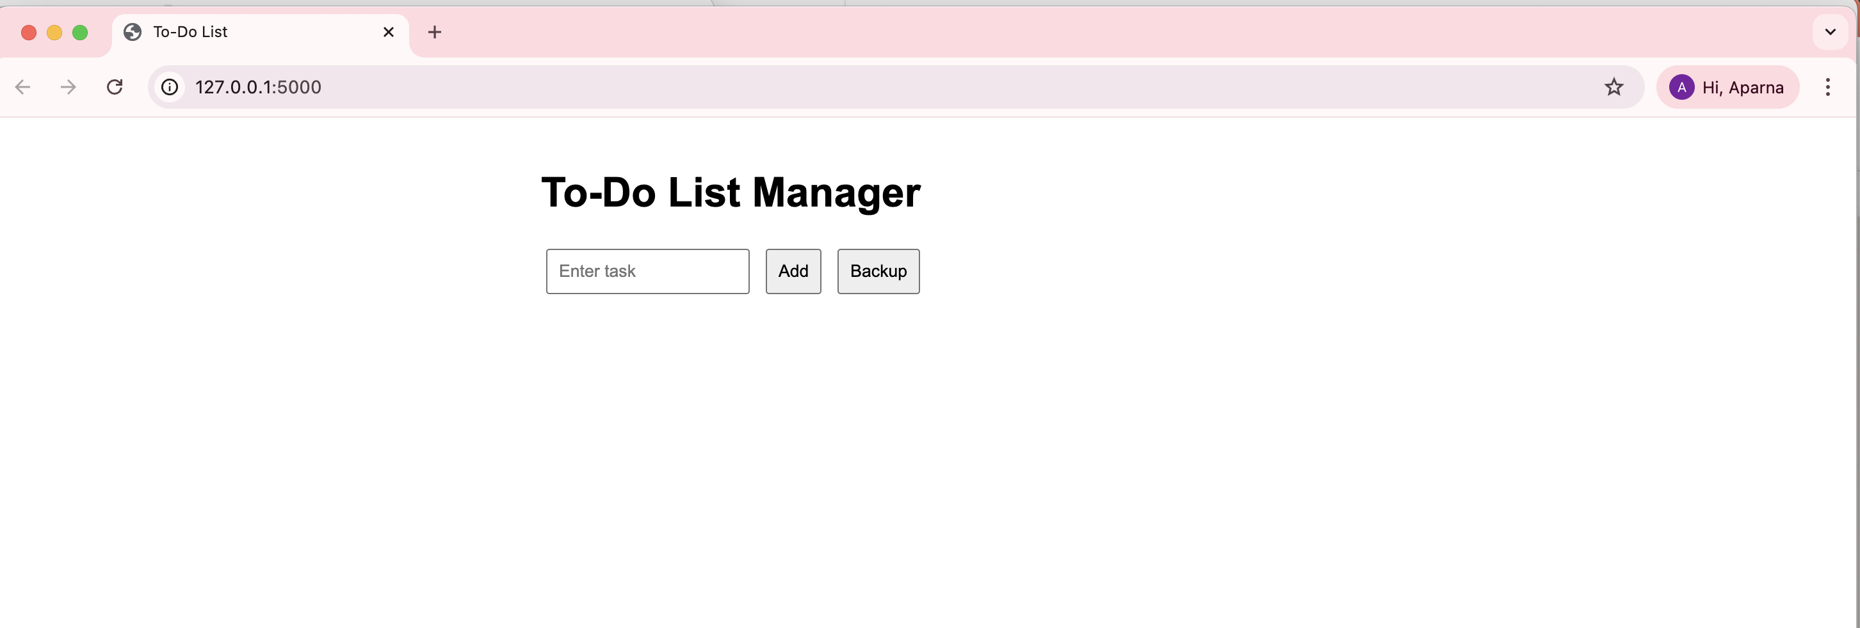
The web interface of the To-Do List Manager provides a simple, intuitive, and interactive user experience. Built using HTML, CSS, and JavaScript, it allows users to add, view, mark, and delete tasks directly from the browser. When a task is added, JavaScript sends an asynchronous request to the Flask server, which executes the todo_cli program via the subprocess module. The server returns the updated task list, and the UI is refreshed in real time without needing a page reload.
The webpage displays tasks clearly, with completed tasks visually marked, making it easy for users to track their progress. Buttons and input fields are provided for all operations, and error messages are displayed for invalid actions, enhancing usability. The integration of the front-end with the Flask server and C CLI program ensures that the webpage is not only interactive but also accurate and persistent, reflecting the true state of the tasks.txt file at all times. Overall, the webpage successfully demonstrates the real-time, responsive, and user-friendly nature of the To-Do List Manager.

6.CONCLUSION
The To-Do List Manager successfully demonstrates the integration of low-level system programming with a modern web-based interface. By using POSIX system calls in C, the project efficiently manages tasks in the tasks.txt file, ensuring persistent storage and accurate file handling. The Flask server bridges the gap between the browser and the C program, enabling real-time updates and a seamless user experience, while the front-end built with HTML, CSS, and JavaScript provides an intuitive and interactive interface.
This project highlights the practical application of combining operating system concepts, C programming, and web technologies to create a functional and responsive application. It reinforces understanding of system-level file operations, process management, and asynchronous web communication. Overall, the project achieves its goal of creating a reliable, user-friendly, and interactive To-Do List Manager, while demonstrating how low-level programming can be effectively integrated with modern web development.

