**Exercise No:** 1

**Date:** 14.10.2020

**Aim:**

To write a Python program to print the calendar of a given month and year.

**Program:**

import calendar

year = int(input())

month = int(input())

if(year>999 and year<10000 and month>0 and month <13):

print(calendar.month(year, month))

else:

print("Invalid Input")

**Link:**

[**http://103.53.53.18/mod/vpl/forms/edit.php?id=229&userid=1638**](http://103.53.53.18/mod/vpl/forms/edit.php?id=229&userid=1638)

**Output:**

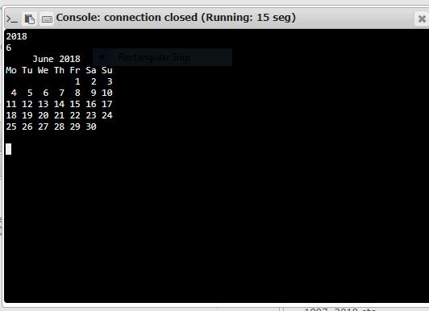

**Result:**

Using calendar import function, Calendar of the given year and month is obtained.