**Exercise No:** 2

**Date:** 14.10.2020

**Aim:**

To write a Python function **countX(lst, x)** to count the number x in a given list of numbers.

**Program:**

lst=[]

num=int(input())

def countX(lst,x):

count = 0

for i in lst:

if (i==x):

count+=1

print(count)

for j in range(0,num):

element =input()

lst.append(element)

x=input()

countX(lst,x)

**Link:**

[**http://103.53.53.18/mod/vpl/forms/edit.php?id=230&userid=1638**](http://103.53.53.18/mod/vpl/forms/edit.php?id=230&userid=1638)

**Output:**

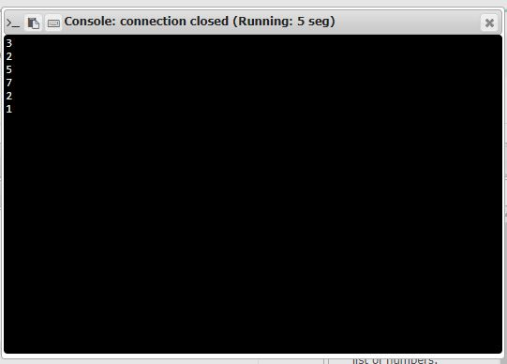

**Result:**

Thus a Python program using function **countX(lst, x)** to count the number x in a given list of numbers is obtained.