**Exercise No:** 3

**Date:** 14.10.2020

**Aim:**

To write a Python program to remove and print every second number from a list of numbers until the list becomes empty.

**Program:**

int_list=[]

num=int(input())

for i in range(0,num):

element = input()

int_list.append(element)

def removeThirdNumber(int_list):

pos = 2-1

x=0

len_list = (len(int_list))

while(len_list > 0):

x = (pos + x) % len_list

print(int_list.pop(x))

len_list-=1

removeThirdNumber(int_list)

**Link:**

[**http://103.53.53.18/mod/vpl/forms/edit.php?id=231&userid=1638**](http://103.53.53.18/mod/vpl/forms/edit.php?id=231&userid=1638)

**Output:**

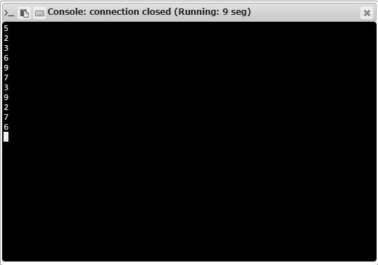

**Result:**

Thus a Python program to remove and print every second number from a list of numbers until the list becomes empty is obtained.