**Exercise No:** 5

**Date:** 14.10.2020

**Aim:**

To Write a Python function to print missing characters to make string pangram.

**Program:**

a=input()

a=set(a.strip())

a.remove(chr(32))

b="abcdefghijklmnopqrstuvwxyz"

b=set(b)

b=b.difference(a)

b=list(b)

b.sort()

print("".join(b))

**Link:**

[**http://103.53.53.18/mod/vpl/forms/edit.php?id=235&userid=1638**](http://103.53.53.18/mod/vpl/forms/edit.php?id=235&userid=1638)

**Output:**

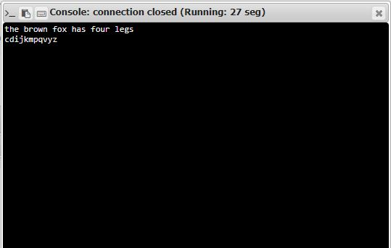

**Result:**

Thus a Python function to print missing characters to make string pangram is obtained.