

Landmark

Production Environment Architecture

& Pre-Requisites

IBM Planning Analytics 2.0.8



Creation Date 17th Feb, 2020

Version 1.1

**Document Revision History**

|  |  |  |  |  |
| --- | --- | --- | --- | --- |
| Version | Release Date | Author | Reviewed By | Comment |
| 1.1 | Feb 17, 2020 | Neel Raval, Jay Aparnathi | Jacky Patel |  |
| 1.2 | Feb 27, 2020 | Jacky Patel |  | Added External Database in the production architecture. |

**Customer Approvals**

|  |  |
| --- | --- |
| Name | Title |
| Shibu Gopi |  |
| Prashant Pawle |  |
|  |  |
|  |  |

Table of Content

1 Architecture and Planning: 3

1.1 Production Environment: 3

Production environment setup consists of 3 servers: 3

1.1.1 Hardware Sizing 4

1.1.2 Backup and Recovery: 4

1.1.3 PA Server Access Through WAN / LAN: 4

1.2 Non-Production Environment (Proposed – To be considered at later stage) 5

2 Application Data flow: 6

3 Pre requisites for installation: 7

2.3 IBM Planning Analytics Client (Power Users and Developer machines) 8

3.1 IBM Cognos Software: 9

3.2 Firewall ports to open: 10

**Architecture and Planning:**

Production Environment:

Production environment setup consists of 3 servers:

|  |  |  |
| --- | --- | --- |
| Server | Server Type | Components To Be Installed |
| A | 1 Virtual Server(VM) | PA Web & CA will be installed on this server. (Not to configure SSL) |
| B | 1 Physical Server | PA Admin, PA Application Server (Not to configure SSL) |
| C | 1 Virtual Server(VM) | Planning Analytics Workspace Server (Not to configure SSL) |

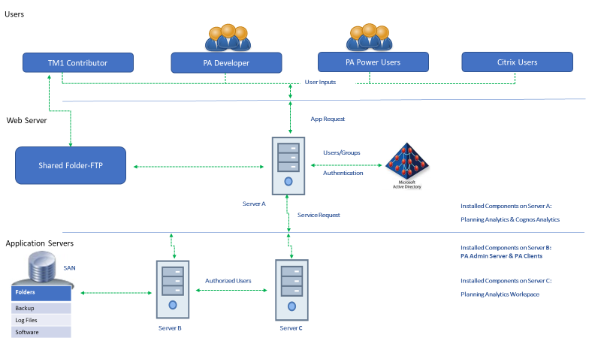



External SQL

Database

* + 1. Hardware Sizing

|  |  |  |  |  |  |  |
| --- | --- | --- | --- | --- | --- | --- |
|  | Production Environment | | | | | |
| Server | | Type | Server IP | Cores* | RAM* | HDD* |
| Server A | | TM1 Web, Gateway | ?? | 8 | 32 | C: 200 GB E: 500 GB |
| Server B | | TM1 Admin, Data | ?? | 32 | 128 | C: 200 GB E: 500 GB |
| Server C | | PAW | ?? | 8 | 32 | C: 200 GB E: 500 GB |

* + 1. Backup and Recovery:

PA is RAM-based system which provides superior performance to disk-based systems by reducing physical disk I/O operations. Since PA is RAM-based, a back-up strategy must take this into consideration. In order to back-up all PA data that is currently residing in RAM.

**Backup:** A regular Backup on tape can be scheduled for below applications/folders:

1. PA Configuration Backup
2. PA Application Backup

**Recovery:** In case of data or object loss, below steps can be followed for recovery:

1. Stop PA service
2. Copy the back up to server
3. Start the server.

NOTE*: Detailed process and screenshots will be provided in Production Installation and Configuration document.

* + 1. PA Server Access Through WAN / LAN:

PA will not be accessible outside of Landmark network. PA client has to be installed on Citrix machine when accessing through WAN and on User client machine while accessing through LAN. Moreover, there is no specific business requirement to access PA through Mobile.

NOTE*: Detailed process and screenshots for single client installation will be provided in Production Installation and Configuration document.

Non-Production Environment (Proposed – To be considered at later stage)

|  |  |  |
| --- | --- | --- |
| Server | Server Type | Components To Be Installed |
| A | Virtual Environment (VM) | All PA components and all CA components |
| B | Virtual Environment (VM) | Planning Analytics Workspace |

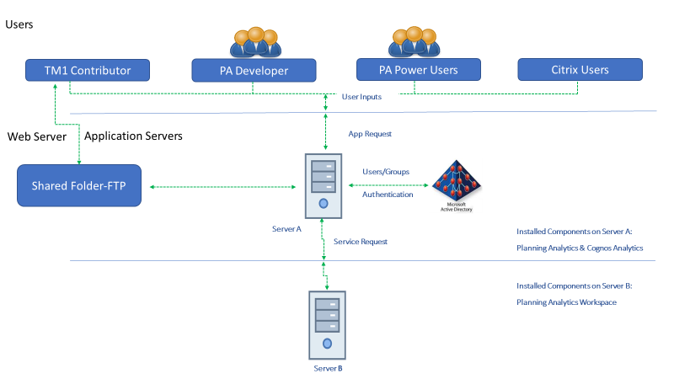

|  |  |  |  |  |  |  |
| --- | --- | --- | --- | --- | --- | --- |
|  | Development Environment (Proposed – To be considered at later stage) | | | | | |
| Server | | Type | Server IP | Cores* | RAM* | HDD* |
| Server A | | PAW |  | 8 | 32 | C: 200 GB E: 500 GB |
| Server B | | PA Admin, Data, CA, Gateway |  | 8 | 128 | C: 200 GB E: 500 GB |
|  | OR | | | | | |
| Server A | | All in One |  | 16 | 128 | C: 200 GB E: 500 GB |

**Application Data flow:**

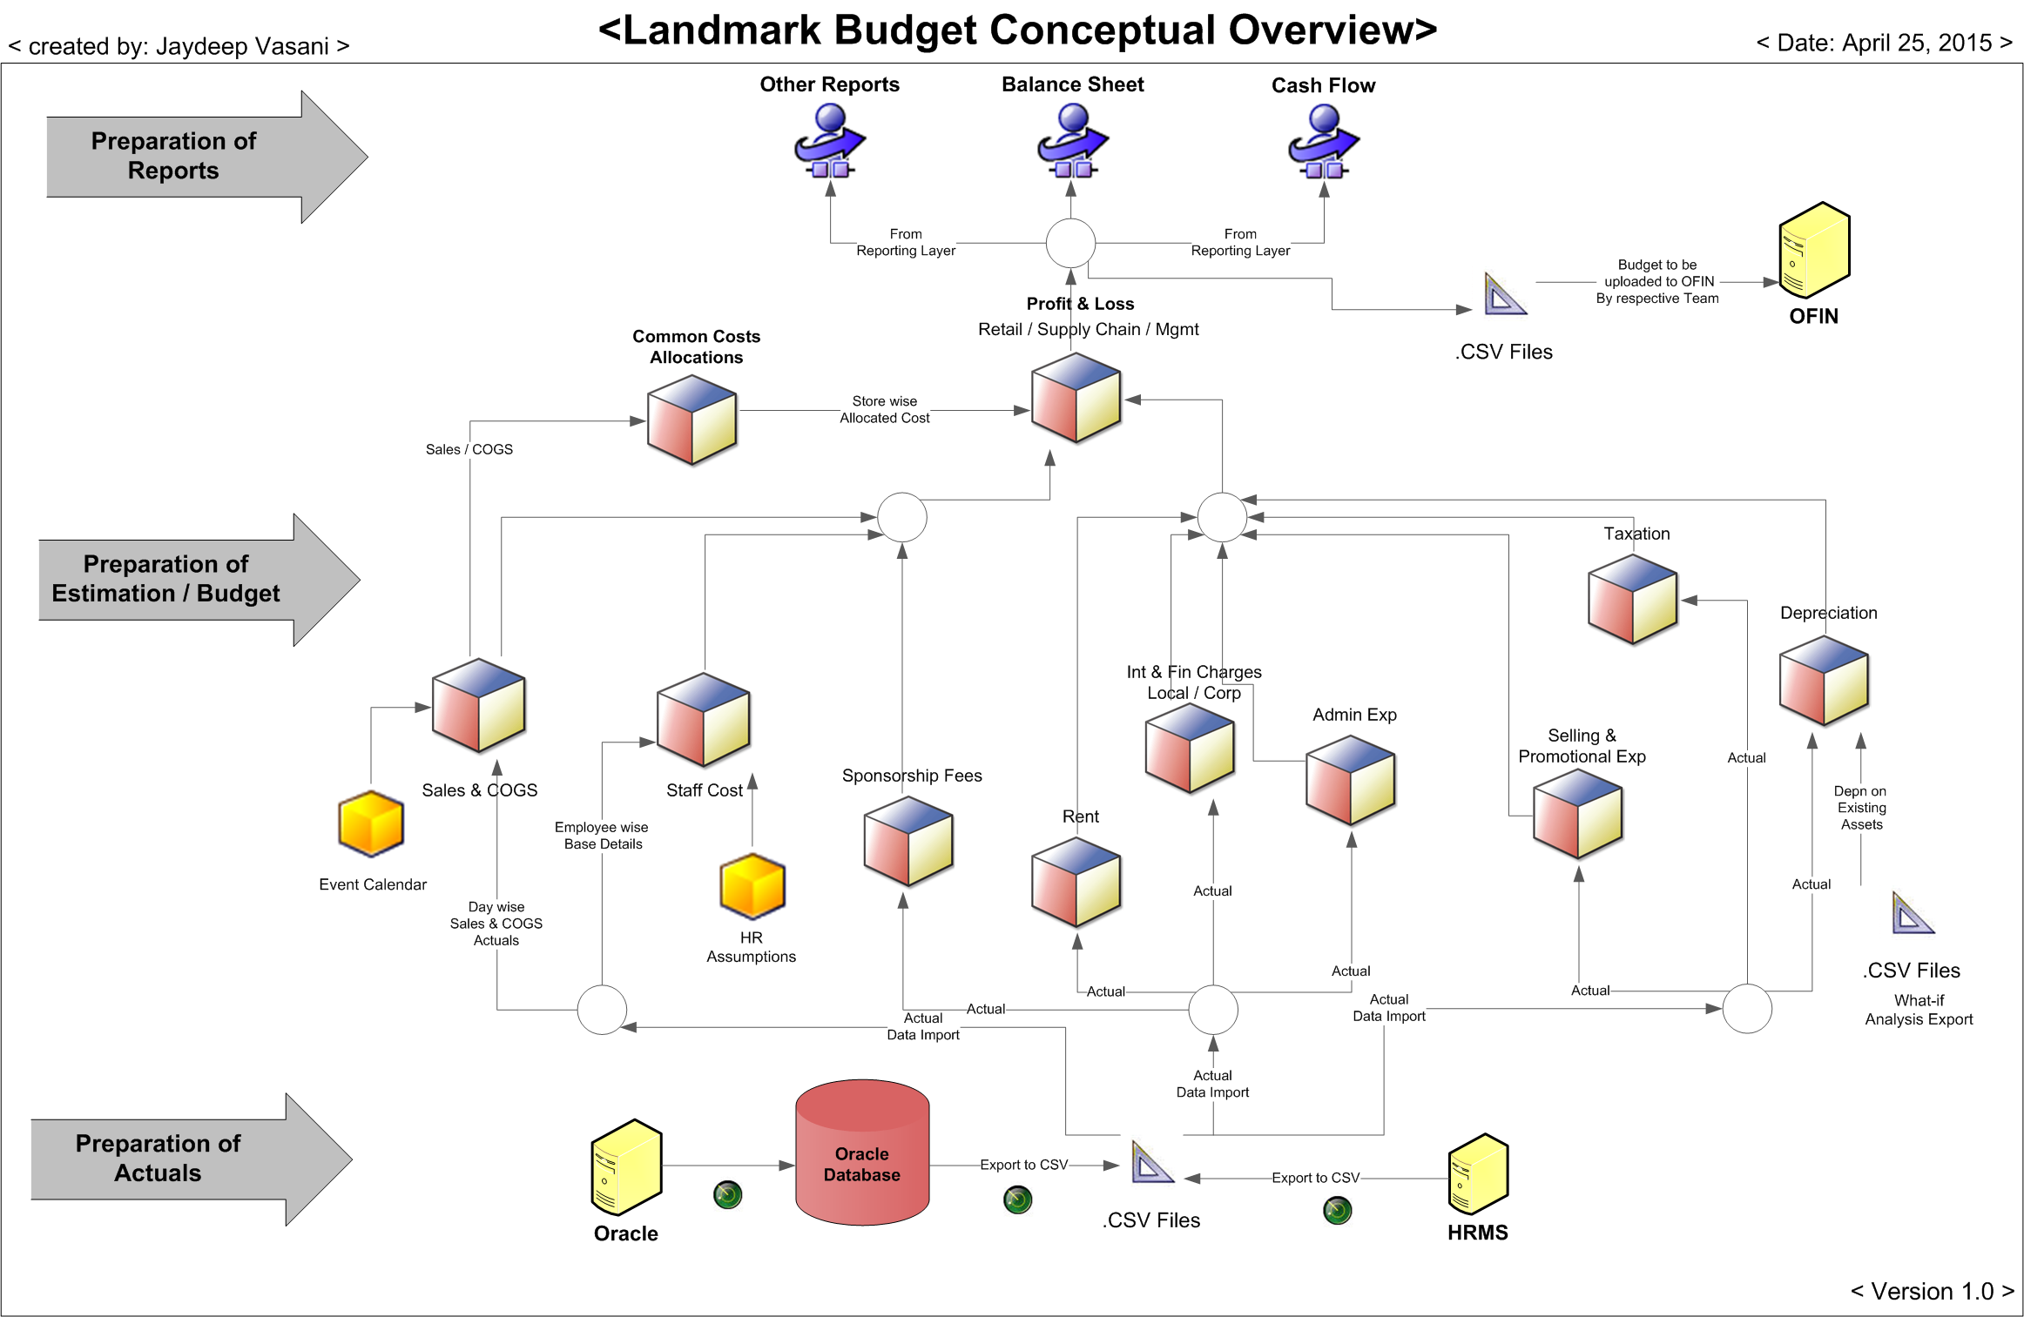

**Overview:**

* Development of the Budget Module would be done on the application server through PA Components like, Architect, Performance Modeler, Perspectives.
* Actual data required during the Budget / Estimation process will be provided through the extract from Oracle / HRMS in .csv format to the application server location (in the shared folder) from where, it will be fetched into PA Solution via Turbo Integrator process.
* Business users will access the Budget modules through PA web components based on the authentication / access provided & documented as per business requirements.
* Access is provided through Landmark’s active directory.
* Post budget process completion, system will provide budget data export to the application server location (in the shared folder) which would be further used for reporting purpose.

**Pre requisites for installation:**

Below are the pre requisites that needs to be take care of

|  |  |  |
| --- | --- | --- |
| **Sr. No** | **Description** | **Required (Dev & Prod)** |
| **1** | Server Operating System | Microsoft Windows Server 2016 Standard (Latest Patch and Service Packs) |
| **2** | Server Hardware (Core, RAM, HDD, Partition) | Mentioned Above. |
| **3** | LAN connection speed between Users and Server | Minimum 2 GBPS server and 100 MBPS users LAN connections |
| **4** | Authentication Source | Planning Analytics Native (Users & Groups) |
| **5** | Web browser | Microsoft Internet Explorer 11 / Mozilla latest / Chrome Latest |
| **6** | Server  machine prerequisites | Microsoft .NET Framework version 4 or higher |
| **7** | Installable Media | **IBM Planning Analytics, Planning Analytics Workspace & IBM Cognos Analytics** (See the attached below screenshot for detail component list)) |
| **8** | Firewall port to open | Details mentioned below. |
| **9** | Administrator Access User Account | Admin user account for installations and administration purpose during the installation, development and maintenance of the PA environment |
| **10** | VPN | 2 VPN access for all servers required prior to installation |
| **11** | Unzip Software | 7Zip to be installed on all servers |
| **12** | FQDN | All Server & Client Machine should be in same network domain. |
| **13** | File Sharing for Common folder for PA Upload Files | Windows Folder Sharing (on server or via FTP application) |
| **14** | Internet Connection | This is required to download the Docker images online to Install the Planning Analytics Workspace image.  (For only during installation & patch management purpose, not for permanent basis) |
| **15** | Database on SQL server | For Content Store of IBM Cognos Analytics   * Prod database name – CACMPRD   *Need an account which would connect the databases with fixed user name and password (User password must not change) |

**Note: - The Antivirus software must be install and configured post installation of PAW component in respective servers.** The Antivirus software that you use must fully support Windows Server 2016 and Docker.

## 2.3 IBM Planning Analytics Client (Power Users and Developer machines)

|  |  |  |
| --- | --- | --- |
| **Sr No** | **Description** | **Required** |
| **1** | Client Operating System | Microsoft Windows 10 (Latest Patch and Service Packs) |
| **2** | Client Hardware (Core, RAM, HDD, Partition) | 4 Core CPU, 8 GB RAM  Minimum (C:100GB, D: 100 GB)  *Need to confirm with Client IT team |
| **3** | LAN connection speed between Users and Server | Minimum 100 MBPS LAN connections |
| **5** | Supported Web browser | Microsoft Internet Explorer 11 / Mozilla latest / Chrome Latest |
| **6** | Planning Analytics For Excel | Microsoft Excel 2016 (with Office Tools & Features) with Latest patch |
| **7** | Server and Admin Client machine prerequisites | Microsoft .NET Framework version 4 or higher |
| **8** | Microsoft Chart Controls | Microsoft Chart Controls for .Net Framework 4 or higher |
| **9** | Microsoft Visual C++ | Microsoft Visual C++ 2010 Redistributable |
| **10** | Installable Media | **IBM Planning Analytics Excel Client** (See the attached below screenshot for detail component list)) |
| **11** | Firewall port to open | Details mentioned for client and developer machine |
| **12** | Administrator Access User Account | Admin user account for installations purpose |
| **13** | Unzip Software (Optional) | 7Zip to be installed on all servers |

IBM Cognos Software:

Below are the list of IBM Cognos PA and CA CAnaries which needs to be copied on all servers except metadata server:

|  |  |  |
| --- | --- | --- |
| **Category** | **CAnaries** | **Part Number/FC** |
|  |  |  |
| **CA** | IBM Cognos Analytics Installer 2.0.191205 Microsoft Windows Multilingual | CC4Q2ML |
| **CA** | IBM Cognos Analytics Server 11.1.5 Microsoft Windows Multilingual | CC54TML |
|  |  |  |
| **CA** | IBM Cognos for Microsoft Office 11.0 Microsoft Windows 32CAt Multilingual | CNPX0ML |
|  |  |  |
| **CA** | IBM Cognos for Microsoft Office 11.0 Microsoft Windows 64CAt Multilingual | CNPX1ML |
|  |  |  |
| **PA** | IBM Planning Analytics 2.0.8 Microsoft Windows Multilingual | CC2RSML |
|  |  |  |
| **PA** | IBM Planning Analytics Client 64-CAt 2.0.8 Microsoft Windows Multilingual | CC2RTML |
|  |  |  |
| **PAX** | IBM Planning Analytics for Microsoft Excel 32-CAt 2.0.48 Microsoft Windows Multilingual |  |
| **PAX** | IBM Planning Analytics for Microsoft Excel 64-CAt 2.0.48 Microsoft Windows Multilingual |  |
|  |  |  |
| **PAW** | IBM Planning Analytics Workspace - BA-PAWL-2.0.47(ipa_workspace_win_2.0.47) |  |

Note: - All the Fixed Packs should be with the Latest available release. Please download the FPs accordingly.

Firewall ports to open:

|  |  |
| --- | --- |
| **Port No and Usage** | **Source Machine – Target to All Servers** |
| 5895, 5898 – Rest API | Administrators and Developers |
| 8888 - Admin Tool | Administrators and Developers |
| 9510 - PA Web / Application | All users, administrators and developers |
| 7999 - PA Web / Application SSL* | All users, administrators and developers |
| 5498 - PA Architect 1 | All administrators and developers |
| 5495 - PA Architect 2 | All administrators and developers |
| **12301 to 12399** - PA server | All developers machines |
| 443, 8443 - IIS HTTPS – SSL* | All users, administrators and developers |
| 80, 8080 - IIS HTTP | All users, administrators and developers |
| 9012 - Planning Analytics Administration agent | All users, administrators and developers |
| 9300 - CA (IBM Cognos Connection) | All users, administrators and developers |
| 445 – FTP File Sharing from PA Server (optional) | All contributors users (to upload and download the .csv file from PA server) |
| **LDAP to Target PA server** |  |
| 389 –LDAP Server Optional (Active Directory) | Administrators |
| **Database Connectivity** | Database connection port opening with respect to chosen database & Local network configurations if any of the source to be connected (SQL / DB2)  **Content Store database for CA configuration**  (currently it is in Oracle on CA Server) |
| **Default Ports for the Database** | (Configured as per local IT policies) |
| For SQL DB Server | 1433 |
| DB2 | 5000 |
| Oracle Database | 1521 |