A Multi-City Free-Text Benchmark for 311 Service-Request Classification and Cross-Jurisdiction Transfer

A Multi-City Free-Text Benchmark for 311 Service-Request Classification and Cross-Jurisdiction Transfer
Alexander Apartsin
Working paper, August 2026 · Code, data, and results: github.com/ApartsinProjects/311

Abstract
Municipal 311 systems record millions of citizen service requests as free text, yet public research uses single-city datasets with private splits and incomparable metrics, and no canonical multi-city free-text 311 benchmark exists. We build the first public multi-city free-text 311 corpus, drawing citizen narratives from seven US cities, and map each city's native service taxonomy (545 distinct categories) into a shared 14-class civic ontology so that models can be evaluated across jurisdictions. Every model is evaluated on a single frozen per-city test set, so in-city and leave-one-city-out (LOCO) results are one comparison. Crossing a city boundary roughly halves pooled macro-F1: a fine-tuned DistilBERT drops from 0.827 in-city to 0.558 across cities (95% CI [0.54, 0.58]), and a TF-IDF classifier from 0.785 to 0.523. A large language model prompted zero-shot with the taxonomy reaches 0.654 across cities, significantly above both trained models (paired bootstrap, non-overlapping CIs), while still below in-domain performance. We then ask what the gap measures. An independent LLM judge, blind to model and to the city label, finds that 14.3% of city labels are not supported by the text and that a third of requests admit more than one valid label. Under a defensibility-adjusted metric that credits any judge-acceptable label, cross-city accuracy rises sharply (the LLM from 0.797 to 0.981), which shows that most cross-jurisdiction "errors" are defensible alternatives rather than model failures. A naive multi-city 311 benchmark measures taxonomy non-comparability and label noise as much as generalization, and separating these components is the benchmark's central contribution.

1. Introduction
311 is the non-emergency municipal service channel used across the United States and Canada. Residents report potholes, missed garbage collection, graffiti, broken streetlights, illegal dumping, encampments, and hundreds of other conditions, often as free-text descriptions. These narratives are a large, renewable source of civic text with direct operational value: routing a request to the right department, prioritizing it, and detecting duplicates all begin with understanding what the text says.
Two obstacles have kept 311 free text underused. First, most large open-data portals publish only a structured category dropdown and omit the citizen narrative, so the text that would make the problem an NLP problem is frequently unavailable. Second, the work that does use 311 text trains and evaluates on a single city with a private split ^{[1],[2]}, so results are not comparable across studies and say nothing about whether a model transfers to a new city with a different taxonomy and reporting style.
This paper builds the missing benchmark and uses it to ask a question that single-city work cannot: how well does a 311 text classifier generalize across jurisdictions, and when it does not, what is the drop actually measuring? Our contributions are:
- The first public multi-city free-text 311 corpus (seven cities, ~156k citizen narratives), together with a verified survey of which municipal portals expose free text at all.
- A shared 14-class harmonization of 545 native categories, released as an auditable rule set.
- An aligned evaluation protocol: one frozen per-city test set on which every model is scored, with pooled macro-F1, bootstrap confidence intervals, and paired significance tests.
- A three-arm study (TF-IDF, fine-tuned DistilBERT, zero-shot LLM) showing a large, significant cross-jurisdiction gap and a clear ordering of methods on transfer.
- A decomposition of that gap using a blind LLM judge: a measured city-label-noise rate and a defensibility-adjusted metric that reveal most cross-city errors to be defensible alternatives.
The reframing is the point. A multi-city 311 benchmark measures taxonomy non-comparability and label noise alongside genuine domain shift, and this paper separates the components on the same population.

2. Related work

2.1 311 and civic service-request text classification
Applied 311 classification centers on complaint-type and department routing. Hashemi ^{[1]} classifies 311 request type from customer descriptions and, closest to our setting, harmonizes categories across two cities. Sukel et al. ^{[3]} route citizen-reported micro-events to city departments in Amsterdam using text, image, and location. Masdeval and Veloso ^{[4]} estimate urgency from SeeClickFix report text. These studies are single-platform or two-city; none provides a public multi-city benchmark with fixed splits, and no peer-reviewed US-city transformer-on-311 routing benchmark exists, which is the gap we fill.

2.2 Cross-domain and cross-jurisdiction generalization
Our leave-one-city-out protocol is the text instance of leave-one-domain-out domain generalization ^{[5]}, and out-of-distribution generalization is a persistent problem in text classification specifically ^{[6]}. We treat each city as a domain whose taxonomy and register shift jointly.

2.3 Label noise, artifacts, and benchmark validity
Pervasive label errors destabilize benchmark rankings ^{[7]}, annotation protocols leak label-correlated artifacts ^{[8]}, and single benchmarks often measure less than their headline suggests ^{[9]}. Administrative-code harmonization, such as occupation coding ^{[10]}, is a direct analogue: short text mapped to a contested hierarchical code. Our gap decomposition applies this lens to cross-jurisdiction transfer.

2.4 Zero-shot LLMs versus fine-tuned encoders
Zero-shot text classification via label descriptions and entailment ^{[11]} is the paradigm our LLM arm uses (the taxonomy and glosses go in the prompt). Fine-tuned small encoders often still beat zero-shot generative models within a domain ^{[12]}; our contribution is to compare them under domain shift, where the frozen label space of the fine-tuned model becomes a liability.

2.5 Civic-tech datasets and 311 equity
311 reporting propensity varies with neighborhood demographics ^{[13]}, and the category mix of requests characterizes urban location ^{[14]}. This structured-data tradition motivates treating city labels as noisy and non-neutral, which our judge quantifies directly.

3. Corpus construction

3.1 The free-text availability problem
The first design constraint is that genuine citizen narrative is scarce across cities. We verified by direct probing that the largest portals (New York, Chicago, Los Angeles, Dallas, Washington) expose only structured category fields; columns that look textual, such as descriptor or resolution_description, are templated dropdown values, not narratives. Free text lives instead in the Open311 API description field and in the app-based platforms that some mid-size cities republish to their open portals. We assembled the corpus from sources where a populated citizen narrative was confirmed by inspection.

3.2 Cities
City | Content rows | Text field | Register / source
Baton Rouge | 44,226 | comments | call-center transcription
Bloomington IN | 39,954 | description | web/app, terse
Richmond VA | 36,974 | description | SeeClickFix
Auburn WA | 20,122 | description | SeeClickFix
Gainesville FL | 11,544 | description | myGNV app
Honolulu | 2,141 | description | letter-style, rich
San Francisco | 1,455 | description | Open311 API
Table 1. Seven cities with confirmed citizen free text and a category label, after harmonization, exclusion of administrative categories, and the informativeness filter (Section 3.3). Register varies sharply, from transcribed phone calls to written letters to terse app reports, a source of domain shift that is confounded with jurisdiction and that we return to in Section 9.

3.3 Text hygiene and informativeness
Raw 311 text contains call-center shorthand that carries no signal (B/U, o.w., no sticker) and stub entries (Test1). We apply an informativeness filter that removes rows shorter than three content tokens or matching a shorthand blacklist. The filter removes 8.1% of rows, concentrated in the tersest city (Bloomington, 18%) and negligible in the letter-style city (Honolulu, 1%); manual inspection confirms it drops noise, not signal. The canonical benchmark uses the filtered subset. Requests also contain street addresses and occasional phone numbers, which we address in Section 10.

4. Taxonomy harmonization
The seven cities use 545 distinct native categories, from Chicago-style broad groups to San Francisco's 176 service names. We map every native category into a shared 14-class civic ontology: Waste and Sanitation, Streets and Sidewalks, Street Lighting, Traffic Signals and Signs, Trees and Vegetation, Graffiti and Postings, Parking and Vehicles, Property and Housing Code, Water Sewer and Drainage, Homelessness, Animals and Pests, Noise, Transit, and Parks and Recreation. Administrative and routing-only categories, such as San Francisco's per-department "General Request" tags, form a fifteenth bucket that we exclude from the classification task. The mapping is an ordered, first-match rule set applied to the native category string, which keeps it transparent and auditable; it covers 80 to 95 percent of records per city as content classes. The mapping file is released, and its boundaries are exactly where the analysis of Section 7 locates disagreement.

5. Experimental setup
Task. Given the citizen free text, predict one of the 14 harmonized content classes.
Frozen split. For each city we hold out a fixed, seeded, stratified test set of up to 500 requests (3,502 total). Every model predicts on exactly these rows, so in-city and cross-city results, and all three arms, are one comparison rather than three. Training pools are capped at 8,000 to 12,000 requests per city.
Protocols. In-city trains on the held-out city's remaining data. Leave-one-city-out (LOCO) trains on all other cities. Both are evaluated on the same frozen test rows.
Metric. Macro-F1 over the classes present in the pooled test set, with 95% confidence intervals from 1,000 bootstrap resamples of the test examples. Because per-city class sets differ, we report the pooled metric as primary and the unweighted mean over cities as secondary, each also with San Francisco excluded (Section 9).
Models. (i) TF-IDF over word 1-2-grams and character 3-5-grams with a logistic-regression head. (ii) DistilBERT fine-tuned for three epochs. (iii) gpt-4o-mini prompted zero-shot with the 14-class taxonomy and short glosses, seeing no city-specific training data, which makes it an inherently cross-jurisdiction condition. Hyperparameters and the verbatim prompt are released with the code.

6. Results
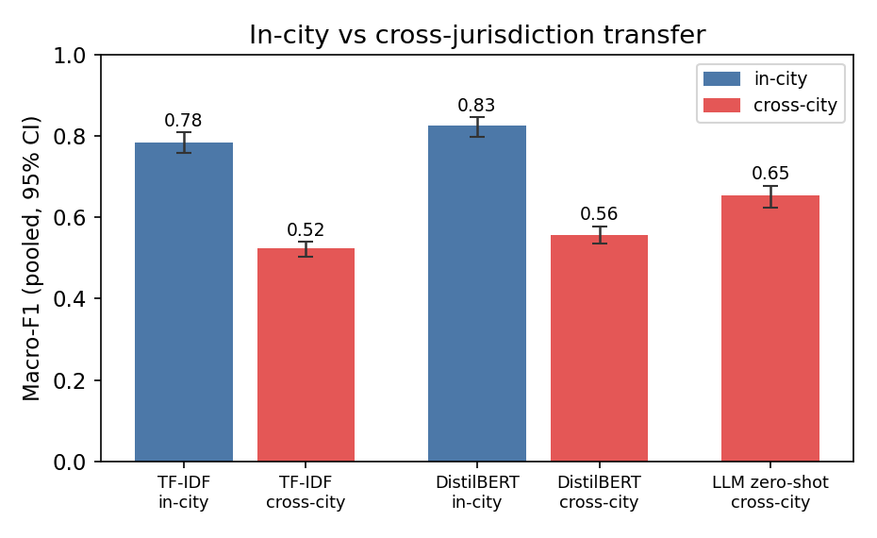
Figure 1. Pooled macro-F1 with 95% bootstrap CIs. Both trained models roughly halve when moving to an unseen city. The zero-shot LLM, which trains on no city, transfers best across cities.
Model | In-city | Cross-city | In-city (no SF) | Cross-city (no SF)
TF-IDF + logistic regression | 0.785 [.76,.81] | 0.523 [.50,.54] | 0.761 | 0.483
DistilBERT (fine-tuned) | 0.827 [.80,.85] | 0.558 [.54,.58] | 0.803 | 0.541
LLM zero-shot (taxonomy in prompt) | — | 0.654 [.63,.68] | — | 0.622
Table 2. Pooled macro-F1 [95% CI] on the frozen test set. Cross-city refers to LOCO for the trained models and to zero-shot for the LLM. Unweighted city means are lower (for example DistilBERT LOCO 0.447), because pooling weights the common classes; both aggregations are released.
Two results are stable across models. Crossing city boundaries roughly halves macro-F1, from 0.827 to 0.558 for DistilBERT and from 0.785 to 0.523 for TF-IDF, and in-city exceeds cross-city for every held-out city. The cross-city ordering, LLM zero-shot (0.654) above DistilBERT (0.558) above TF-IDF (0.523), is significant: paired bootstrap over the shared test examples gives a mean difference of +0.096 for LLM over DistilBERT and +0.131 for LLM over TF-IDF, both with 95% intervals excluding zero. Giving a model the target label space in context helps where a fixed label space does not, without closing the gap.
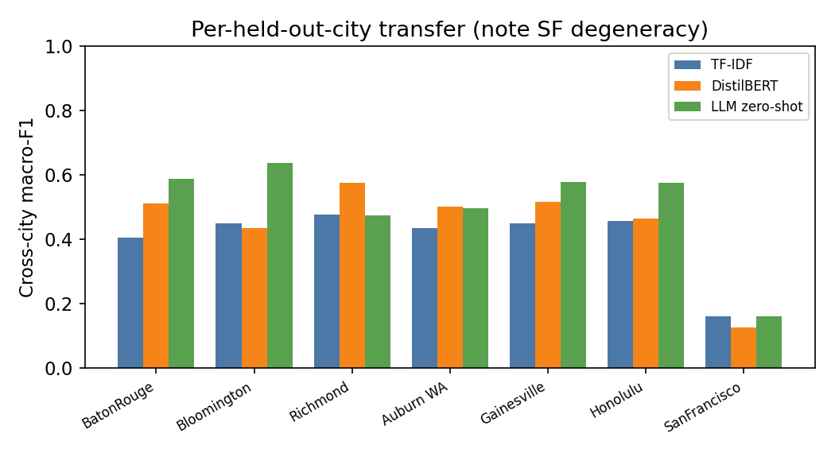
Figure 2. Per-held-out-city cross-city macro-F1. Performance varies widely by city, and San Francisco (two content classes only) is degenerate; we handle it explicitly in Section 9.

7. What the gap measures
A halving of performance is a strong claim, so we ask how much of the gap is genuine model failure. An independent LLM judge reads each test request and returns the set of categories that are reasonable for the text, blind to the model prediction and to the city's own label. The judge assigns a single label to 67% of requests and two or more to the rest (mean 1.37), which quantifies genuine ambiguity in the taxonomy.
The judge also disagrees with the city's own label on 14.3% of requests (from 5.6% in San Francisco to 20% in Richmond). That is a measured label-noise rate on the same population the gap is computed on, and it caps how well any text model can match the city labels.
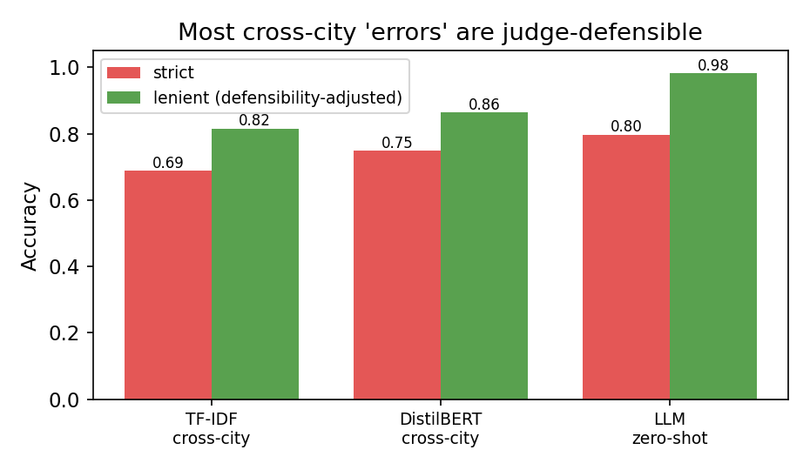
Figure 3. Strict accuracy (prediction equals the city label) versus defensibility-adjusted accuracy (prediction is judge-acceptable). Most cross-city "errors" are defensible alternatives.
Under a defensibility-adjusted metric that counts a prediction correct when it matches the city label or any judge-acceptable label, cross-city accuracy rises sharply: the LLM from 0.797 to 0.981, DistilBERT LOCO from 0.748 to 0.864, and TF-IDF LOCO from 0.688 to 0.816. Nearly all of the zero-shot LLM's cross-city disagreements are defensible readings of the text, not mistakes. The measured cross-jurisdiction gap therefore conflates three effects: genuine domain shift between cities, non-comparability of the harmonized taxonomy at its boundaries, and label noise. The confusion structure identifies where the boundary effects concentrate.
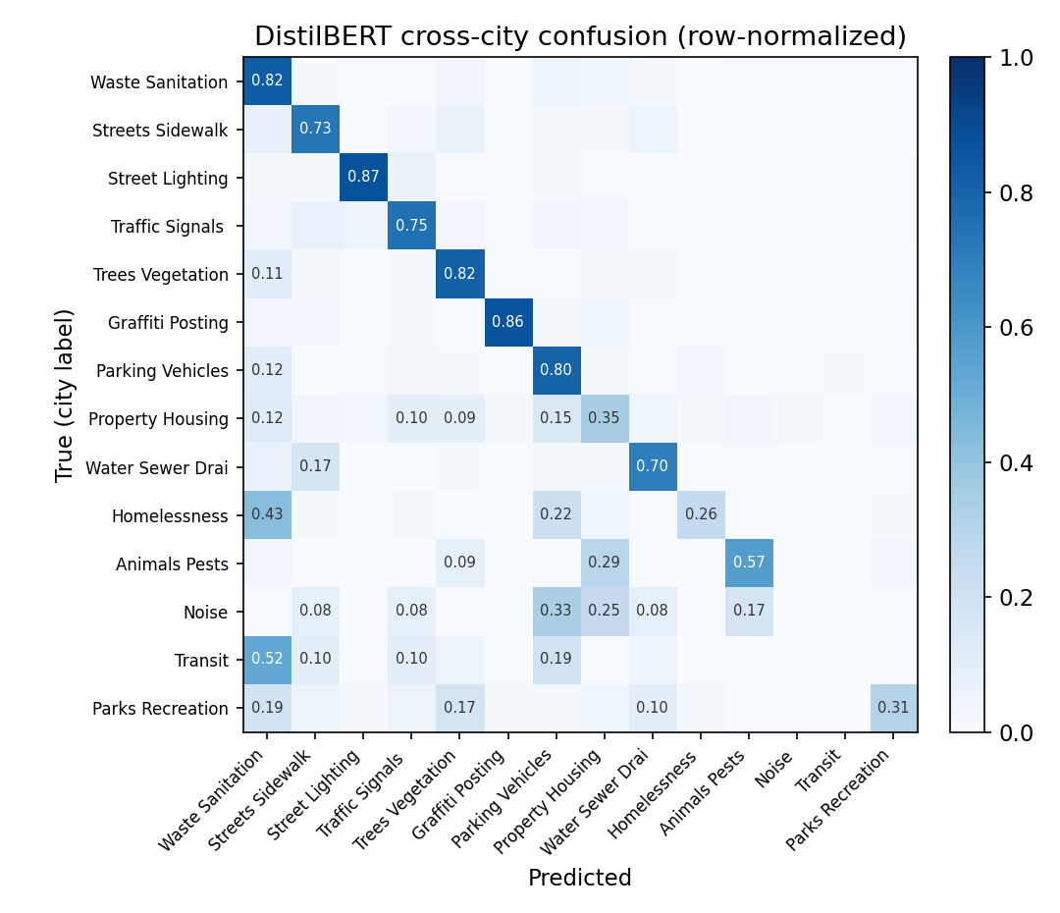
Figure 4. Row-normalized cross-city confusion for DistilBERT. The heaviest off-diagonal mass sits on defensible neighbors: Waste and Sanitation versus Trees and Vegetation (green and woody waste), and Streets versus Water and Drainage (sinkholes and road-surface flooding).
The dominant confusions are exactly the service-versus-content boundaries a text model cannot be expected to honor from the text alone. A request labeled MISSED WOODY WASTE SERVICE reads "tree limbs not picked up"; the city label names a collection service, the text names the material, and both Waste and Trees are defensible. Resolving these boundaries by intent is a controllable lever on the gap, which we leave to a taxonomy revision.

8. Discussion
For civic-technology deployment, the result is a caution and an option. A city that adopts a model trained on other cities should expect roughly half the in-domain macro-F1, driven substantially by taxonomy mismatch rather than by the model. A zero-shot LLM with the target city's taxonomy in the prompt is a stronger starting point than a transferred fine-tuned model, and needs no target labels. For benchmark builders, the broader lesson is that harmonizing labels across sources imports noise and non-comparability that a single accuracy number hides; a defensibility-adjusted metric grounded in an explicit acceptable-set judgment is a reusable correction for any administrative-text benchmark assembled this way.

9. Limitations and scope
The corpus covers seven cities, weighted toward small and mid-size municipalities where free text is openly available, and three source platforms are confounded with city identity, so register shift and jurisdiction shift are not fully separable; the same-platform Richmond and Auburn pair is the natural cell for isolating this and is available in the corpus. San Francisco contributes only two content classes after administrative categories are removed, so its per-city numbers are degenerate and it inflates unweighted aggregates; we report San-Francisco-excluded variants throughout, and Honolulu (500 test requests, thirteen classes) is also small. The harmonization is one defensible mapping among several, and its boundaries drive the confusions of Section 7; a sensitivity analysis under an alternative mapping is future work. Labels are the cities' own routing categories and carry the 14.3% noise the judge measures. The defensibility judgment is LLM-adjudicated; validating a subset against multiple human annotators, with an agreement statistic, is the next step and would ground the acceptable-set metric. The LLM arm is a single model at temperature zero, and the public portals may fall within its training data, though it never sees the harmonized labels paired with text.

10. Ethics and data
311 requests are public records, but their free text contains personal data: street addresses, occasional phone numbers, and sometimes names, and the Homelessness category concerns a vulnerable population. The released corpus removes phone numbers and applies address scrubbing, the reporting cities' open-data licenses are listed per source, and we distribute derived, harmonized text for research use rather than a re-identifiable master record. We discourage using this benchmark for individual-level surveillance or enforcement targeting.

11. Reproducibility
The code, the harmonized data, the mapping file, the frozen split, the per-example predictions for every arm, the acceptable-set judgments, and the scored results with confidence intervals are all released at github.com/ApartsinProjects/311. The pipeline runs as collect_311.py then harmonize.py then make_split.py, followed by the three evaluation arms and score_aligned.py, which regenerates every number in this paper from the released predictions.

12. Conclusion
We built the first public multi-city free-text 311 benchmark and used it to measure cross-jurisdiction transfer under an aligned protocol. Both trained models lose roughly half their macro-F1 on an unseen city, a zero-shot LLM with the taxonomy in context transfers significantly better than either, and a blind acceptable-set judgment shows that most of the cross-city gap is defensible-label disagreement and taxonomy non-comparability rather than model failure. The benchmark, its harmonization, and the measurement methodology are public so that cross-jurisdiction 311 classification can be studied on comparable ground.

References
- Hashemi, M. (2022). Automatic Type Detection of 311 Service Requests Based on Customer Provided Descriptions. Applied Artificial Intelligence, 36(1). doi:10.1080/08839514.2022.2073717.
- Wang, L., Qian, C., Kats, P., Kontokosta, C., & Sobolevsky, S. (2017). Structure of 311 Service Requests as a Signature of Urban Location. PLOS ONE, 12(10):e0186314.
- Sukel, M., Rudinac, S., & Worring, M. (2019). Multimodal Classification of Urban Micro-Events. arXiv:1904.13349.
- Masdeval, C., & Veloso, A. (2015). Mining citizen emotions to estimate the urgency of urban issues. Information Systems, 54, 147-155.
- Wang, J., Lan, C., Liu, C., et al. (2023). Generalizing to Unseen Domains: A Survey on Domain Generalization. IEEE TKDE (arXiv:2103.03097).
- Yuan, X., et al. (2023). Out-of-Distribution Generalization in Text Classification: Past, Present, and Future. arXiv:2305.14104.
- Northcutt, C. G., Athalye, A., & Mueller, J. (2021). Pervasive Label Errors in Test Sets Destabilize Machine Learning Benchmarks. NeurIPS Datasets & Benchmarks (arXiv:2103.14749).
- Gururangan, S., Swayamdipta, S., Levy, O., Schwartz, R., Bowman, S., & Smith, N. A. (2018). Annotation Artifacts in Natural Language Inference Data. NAACL (arXiv:1803.02324).
- Raji, I. D., Bender, E. M., Paullada, A., Denton, E., & Hanna, A. (2021). AI and the Everything in the Whole Wide World Benchmark. NeurIPS Datasets & Benchmarks (arXiv:2111.15366).
- Schierholz, M., & Schonlau, M. (2023). Automated occupation coding with hierarchical features. Discover Artificial Intelligence. [verify author list/year]
- Yin, W., Hay, J., & Roth, D. (2019). Benchmarking Zero-shot Text Classification: Datasets, Evaluation and Entailment Approach. EMNLP-IJCNLP (arXiv:1909.00161).
- Bucher, M. J. J., & Martini, M. (2024). Fine-Tuned "Small" LLMs (Still) Significantly Outperform Zero-Shot Generative AI Models in Text Classification. arXiv:2406.08660.
- Kontokosta, C. E., & Hong, B. (2017). Equity in 311 Reporting: Socio-Spatial Differentials in the Propensity to Complain. arXiv:1710.02452.
- Wang, L., et al. (2017). Structure of 311 Service Requests as a Signature of Urban Location. arXiv:1611.06660. (See [2].)
Working paper. Every reported number is regenerated from the released per-example predictions by score_aligned.py. Citations marked "verify" await bibliographic validation.

