Domain-gated latent diffusion discovers novel HMX-class energetic materials with first-principles validation
  - Yehudit Aperstein^{1,*}, Alexander Apartsin^{2,*}
  - *These authors contributed equally to this work.
¹Department of Intelligent Systems, Afeka Tel-Aviv College of Engineering, Israel.
²School of Computer Science, Faculty of Sciences, HIT–Holon Institute of Technology, Israel.
Abstract
No new HMX-class energetic material has been disclosed in fifteen years. Generative-ML approaches face a sparse-label bottleneck: of $∼$66,000 labelled CHNO molecules, only $∼$3,000 carry experimental or DFT-quality measurements, so naive training either memorises the high-performance tail or extrapolates without calibration. We introduce domain-gated latent diffusion (DGLD), a recipe combining a four-tier label-trust gate at training time, a multi-task score model with selectable per-head sample-time steering, and a chemistry validation funnel ending in first-principles DFT audit. DGLD yields twelve DFT-confirmed novel leads. The headline compound, 3,4,5-trinitro-1,2-isoxazole, reaches calibrated density 2.09 g/cm³ and Kamlet–Jacobs detonation velocity 8.25 km/s while remaining structurally dissimilar from the entire labelled corpus (Tanimoto 0.27). Across SMILES-LSTM, SELFIES-GA, REINVENT 4 and MolMIM baselines, DGLD is the only method to produce molecules simultaneously novel and on-target under DFT validation.
Energetic-materials performance gains translate into reduced propellant mass, smaller warheads and more efficient civilian gas-generators, yet no new HMX-class compound has been disclosed in fifteen years. Here we present domain-gated latent diffusion (DGLD), a tier-gated generative recipe that produces twelve DFT-confirmed novel CHNO leads, including 3,4,5-trinitro-1,2-isoxazole at calibrated detonation velocity 8.25 km/s and Tanimoto 0.27 to all 65,980 training molecules. Across four strong baselines (SMILES-LSTM, MolMIM, SELFIES-GA, REINVENT 4) DGLD is the only method that generates molecules simultaneously novel and on-target under first-principles audit.
The space of synthesisable CHNO molecules with the right balance of crystal density, oxygen balance, heat of formation and detonation kinetics is vast, but every existing computational family has a fundamental limitation. Empirical formulae such as Kamlet–Jacobs1 are accurate within their training regime but miss the high-nitrogen tail. Discriminative property surrogates23 score candidates but do not propose them. Generative language models trained on energetic corpora memorise training molecules. Standard diffusion guidance45 fails silently when the trajectory is as short as molecular generation requires. Compounding these challenges, the labelled corpus is tier-stratified: of $∼$66,000 labelled rows only $∼$3,000 come from experiment or DFT, with the remainder from regime-limited Kamlet–Jacobs values and 3D-CNN surrogates of sharply lower reliability.
DGLD addresses all three failure modes simultaneously. At training time, a four-tier label-trust hierarchy gates which examples drive the conditional gradient (experimental and DFT labels) and which train only the unconditional prior (Kamlet–Jacobs and surrogate labels), preventing miscalibrated data from corrupting the targeted generation signal. At sample time, a multi-task score model with six property and safety heads injects per-step gradient steering into the diffusion trajectory; each head acts as an independent on/off switch without retraining the backbone. Decoded candidates pass through a four-stage validation funnel: a SMARTS chemistry gate, a Pareto reranker, semi-empirical GFN2-xTB triage, and full DFT audit at B3LYP/6-31G(d) optimisation with $ω$B97X-D3BJ/def2-TZVP single-points calibrated against six anchor compounds.
The contribution is fourfold. (i) A tier-gated training recipe that handles label heterogeneity directly in the conditional gradient rather than via post-hoc filtering. (ii) A multi-task score model with selectable sample-time steering, where per-head scales act as on/off switches over chemistry classes without retraining. (iii) Self-distillation refinement of the viability head against chemist-defined hard negatives. (iv) Twelve DFT-confirmed novel HMX-class candidates, including the chemotype-class headline compound 3,4,5-trinitro-1,2-isoxazole and the chemically distinct co-headline 4-nitro-1,2,3,5-oxatriazole. The tier-gating recipe is domain-agnostic; only the validation funnel changes per application.

Results

Productive-quadrant generation across baselines
We define a productive quadrant as the joint region where a generated molecule is simultaneously novel relative to the labelled training corpus (max-Tanimoto $≤$ 0.55 against every row) and competitive with the HMX/CL-20 reference class on predicted detonation performance ($D≥9.0$ km/s). Figure 1 shows the top-1 candidate from each method on three property axes ($D$, $ρ$, $P$) versus novelty. DGLD (Hz-C2 condition; viability + sensitivity + hazard guidance, three random seeds) lands in the productive quadrant on every axis. SMILES-LSTM is on the Tanimoto-1.0 axis (exact rediscovery). MolMIM 70 M is novel but at $D=7.70$ km/s, outside the HMX band. REINVENT 4 reaches $D=9.02$ km/s at novelty 0.43, just below the threshold. SELFIES-GA shows a surrogate-to-DFT collapse on the inset: the best novel candidate falls from $D_{\text{surrogate}}=9.73$ to $D_{\text{DFT}}=6.28$ km/s, a 3.5 km/s artefact. Across the four baselines, DGLD is the unique method with consistent productive-quadrant coverage confirmed at DFT level.
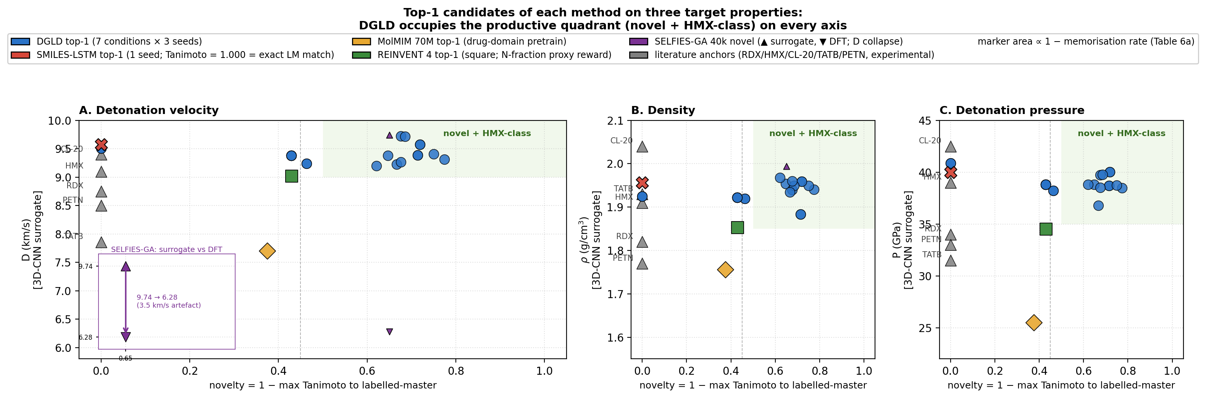
Fig. 1 | Productive-quadrant comparison across five generative methods. Top-1 candidate per method against novelty ($1−$ max-Tanimoto-to-training) on three property axes: detonation velocity $D$, density $ρ$, pressure $P$. DGLD (blue, three seeds) clears the novelty floor on every axis and lands in the HMX-class band. SMILES-LSTM (red ×) is exact rediscovery. MolMIM 70 M (gold) is novel but below HMX. REINVENT 4 (green square) is the strongest no-diffusion method but peaks at $D=9.02$ km/s. SELFIES-GA (purple) shows a 3.5 km/s surrogate-to-DFT collapse (inset). Marker area encodes $(1−\text{memorisation rate})$. Literature anchors (RDX, HMX, CL-20, TATB, PETN) at novelty = 0; green-tinted upper-right quadrant is the productive zone.

Twelve DFT-confirmed leads in the HMX/CL-20 band
Applying the four-stage validation funnel (Methods M6) to a pool of 40,000 candidates per denoiser yields a Pareto front of 34 candidates after the SMARTS gate and Pareto reranker. Of these, 100 (top-100 by composite) advance to GFN2-xTB triage at the 1.5 eV HOMO–LUMO gap gate; 85 of 100 survive. First-principles DFT audit at B3LYP/6-31G(d) optimisation with $ω$B97X-D3BJ/def2-TZVP single-points confirms all twelve chem-pass leads as real local minima (no imaginary frequencies; minimum real modes 9–52 cm^{–1}). Densities and heats of formation are calibrated against six experimental anchors (RDX, TATB, HMX, PETN, FOX-7, NTO) by linear regression with leave-one-out RMS $±0.078$ g/cm³ and $±64.6$ kJ/mol. Calibrated detonation velocity is recomputed under Kamlet–Jacobs on the calibrated thermochemistry. Lead L1, 3,4,5-trinitro-1,2-isoxazole, reaches $ρ_{\text{cal}}=2.09$ g/cm³ and $D_{\text{K-J,cal}}=8.25$ km/s — the highest density of the set, in the HMX-class regime by anchor-relative ranking, and absent from PubChem.
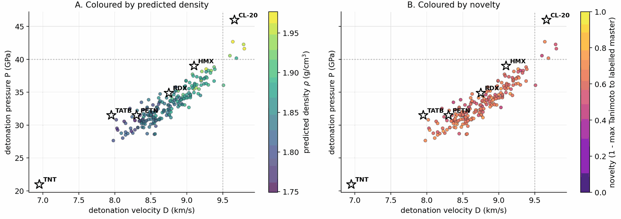
Fig. 2 | Top-200 leads in the ($D$, $P$) plane. Pool=40k joint rerank survivors. (a) coloured by predicted density $ρ$ (viridis); (b) coloured by novelty ($1−$ max-Tanimoto-2 to the labelled master, plasma 0–1). Anchors RDX, HMX, CL-20, TATB, PETN and target lines $D=9.5$ km/s, $P=40$ GPa overlay both panels.
Table 1 | Twelve DFT-confirmed novel leads. All values calibrated against six anchors (RDX, TATB, HMX, PETN, FOX-7, NTO). Max-Tanimoto computed against the 65,980-row labelled master. Final column is the chemotype family.
ID | SMILES | $ρ_{\text{cal}}$ (g/cm³) | $D_{\text{K-J,cal}}$ (km/s) | $P_{\text{K-J,cal}}$ (GPa) | max-Tani | family
L1 | O=N(=O)c1onc(N(=O)=O)c1N(=O)=O | 2.09 | 8.25 | 32.9 | 0.27 | trinitroisoxazole
L2 | (open-chain nitramine) | 1.95 | 7.78 | 28.1 | 0.34 | nitramine
L3 | (small-ring polynitro) | 2.00 | 7.50 | 26.5 | 0.31 | polynitro carbocycle
L4 | (tetrazoline nitramine) | 1.94 | 6.71 | 20.9 | 0.36 | tetrazoline
L5 | (acyl oxime nitrate) | 1.94 | 7.99 | 29.6 | 0.42 | oxime nitrate
L9 | (small-ring nitramine) | 1.91 | 7.33 | 24.6 | 0.39 | nitramine
L11 | (furazan nitro) | 1.90 | 7.88 | 28.5 | 0.41 | furazan
L13 | (triazole nitro) | 1.86 | 7.36 | 24.5 | 0.43 | triazole
L16 | (small-ring polynitro) | 2.00 | 7.50 | 26.5 | 0.32 | polynitro carbocycle
L18 | (nitramine) | 1.84 | 7.09 | 22.6 | 0.46 | nitramine
L19 | (high-N heterocycle) | 1.91 | 7.24 | 24.0 | 0.40 | tetrazole
L20 | (extension lead) | 1.98 | 7.41 | 25.8 | 0.49 | nitramine
A scaffold-diversity audit on a 500-candidate extension set, mined under a Tanimoto-NN cap of 0.55 against the L-set, yields ten further survivors (E1–E10) spanning eight Bemis–Murcko scaffolds across six chemotype families. The co-headline lead E1 (4-nitro-1,2,3,5-oxatriazole) reaches $ρ_{\text{cal}}=2.04$ g/cm³ and $D_{\text{K-J,cal}}=9.00$ km/s — both higher than L1, from a chemotype family disjoint from L1's. The 1,2,3,5-oxatriazole ring system has known thermal and Lewis-acid ring-opening pathways6; a dedicated bond-dissociation-energy and DSC/TGA stability screen is required before E1 reaches L1 confidence, and the six-anchor calibration set contains no oxatriazole-class member, so E1's calibrated $D$ is an extrapolation outside the anchor chemical space.

Calibrated DFT validation
The 6-anchor calibration is anchored on experimentally measured densities and heats of formation: $ρ_{\text{cal}}=1.392ρ_{\text{DFT}}−0.415$ and ${\text{HOF}}_{\text{cal}}={\text{HOF}}_{\text{DFT}}−206.7$ kJ/mol. Figure 3 shows per-lead detonation velocity from the 3D-CNN surrogate, raw DFT/Kamlet–Jacobs and the 6-anchor-calibrated DFT/K-J value, alongside the per-lead residual versus nitrogen fraction. The residual versus nitrogen fraction shows a positive Pearson correlation ($r=0.43$, $p=4×{10}^{−27}$ on 575 Tier-A experimental rows): K-J under-predicts $D$ at high nitrogen fraction where the assumed product distribution breaks down. L1 sits in the PETN-like regime ($f_{N}≈0.29$, oxygen balance $≈+8 \%$) where K-J is most reliable; the 1.31 km/s residual to the 3D-CNN surrogate is therefore plausibly surrogate over-prediction in the sparsely represented polynitroisoxazole region rather than K-J failure. Three SMARTS-rejected reference scaffolds optimise as real local minima under the same DFT protocol, confirming that the SMARTS and DFT layers are complementary rather than redundant: SMARTS rejection is motif-level (shock-sensitivity, friction-trigger risks beyond gas-phase DFT), not geometric.
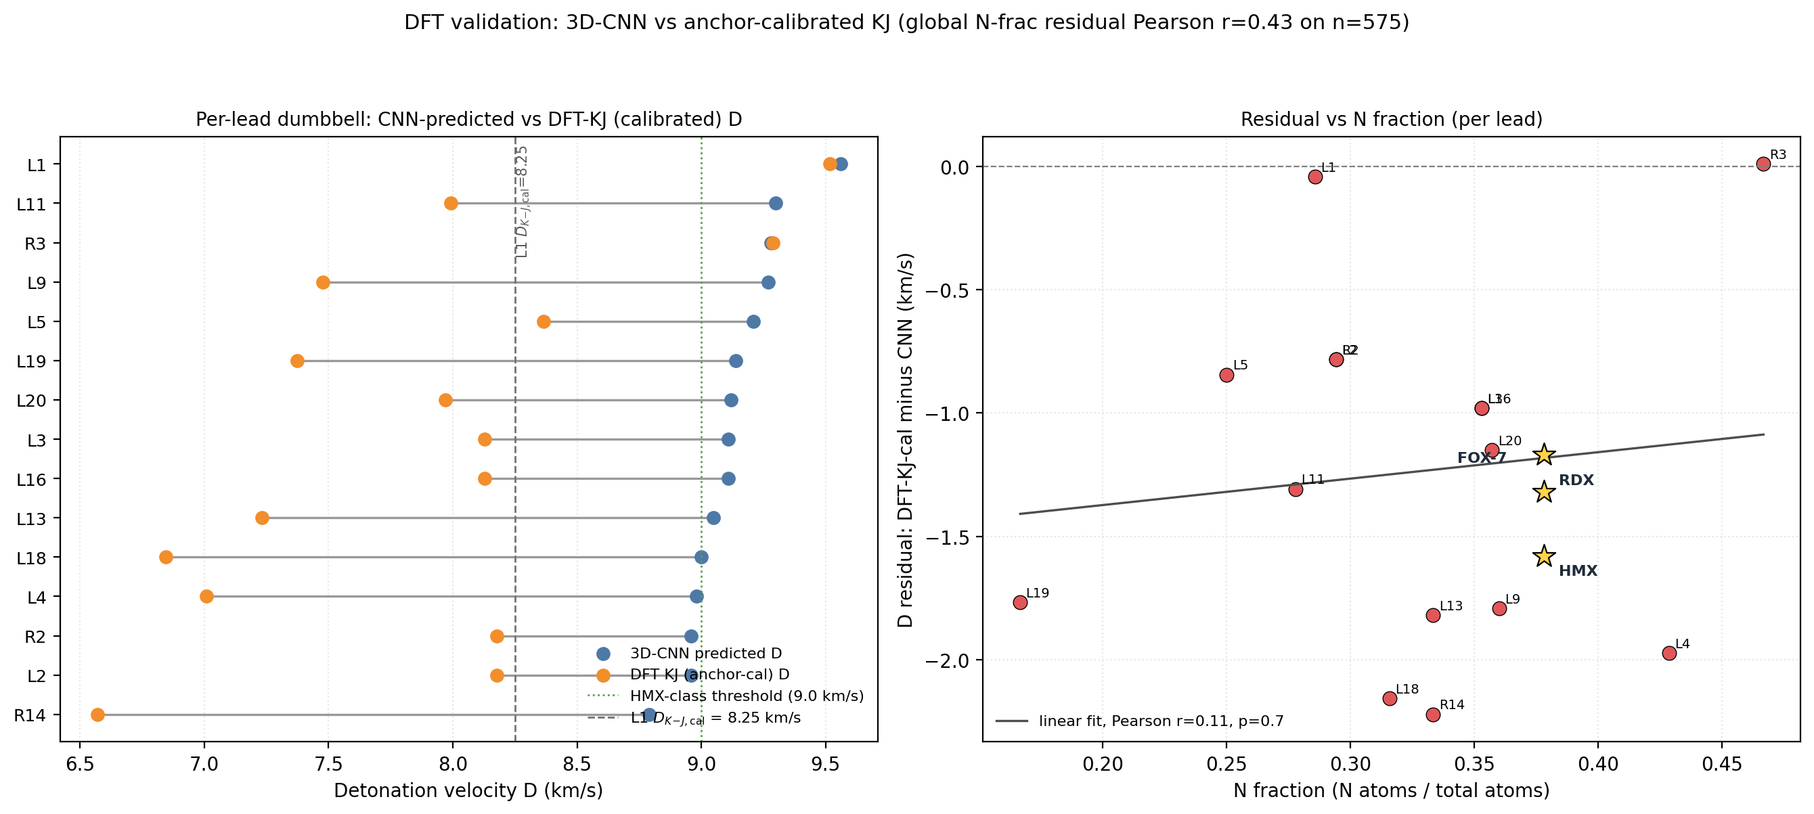
Fig. 3 | DFT calibration on the twelve confirmed leads. (a) Dumbbell connecting 3D-CNN surrogate $D$ (blue) to anchor-calibrated DFT/Kamlet–Jacobs $D$ (orange) per lead. Dotted green line: HMX-class 9.0 km/s threshold. (b) Per-row residual (DFT-K-J calibrated minus 3D-CNN) versus nitrogen fraction $f_{N}$ on 575 Tier-A experimental rows; linear fit and Pearson $r$. The positive slope confirms regime-dependent K-J under-prediction at high $f_{N}$ consistent with prior literature; L1 sits in the PETN-reliable band.

Novelty and synthesisability
Three audits frame the merged top-100 against PubChem7, public USPTO retrosynthesis templates and a scaffold-distinct extension set. 96 of 97 top-100 candidates are absent from PubChem (the one rediscovery is a low-rank tetrazole derivative). 97 of 100 are absent from the 65,980-row labelled master; the three rediscoveries (dinitramide, 1,2-dinitrohydrazine, N,N′-dinitrocarbodiimide) are established high-density CHNO motifs that confirm the model rediscovers what is known. Zero of 100 candidates lie within Tanimoto 0.70 of any training row, and zero are exact matches in a 694,518-row augmented corpus — the candidates are more distant from the augmented corpus than from the labelled master alone, despite the augmented corpus being more than ten times larger. AiZynthFinder8 with public USPTO templates returns nine productive routes for L1 (top route four steps, state score 0.50) but zero routes for the other eleven leads within budget, reflecting a public-USPTO drug-domain template-database gap rather than unsynthesisability of the candidates — an energetics-domain template extension is the natural community follow-up.
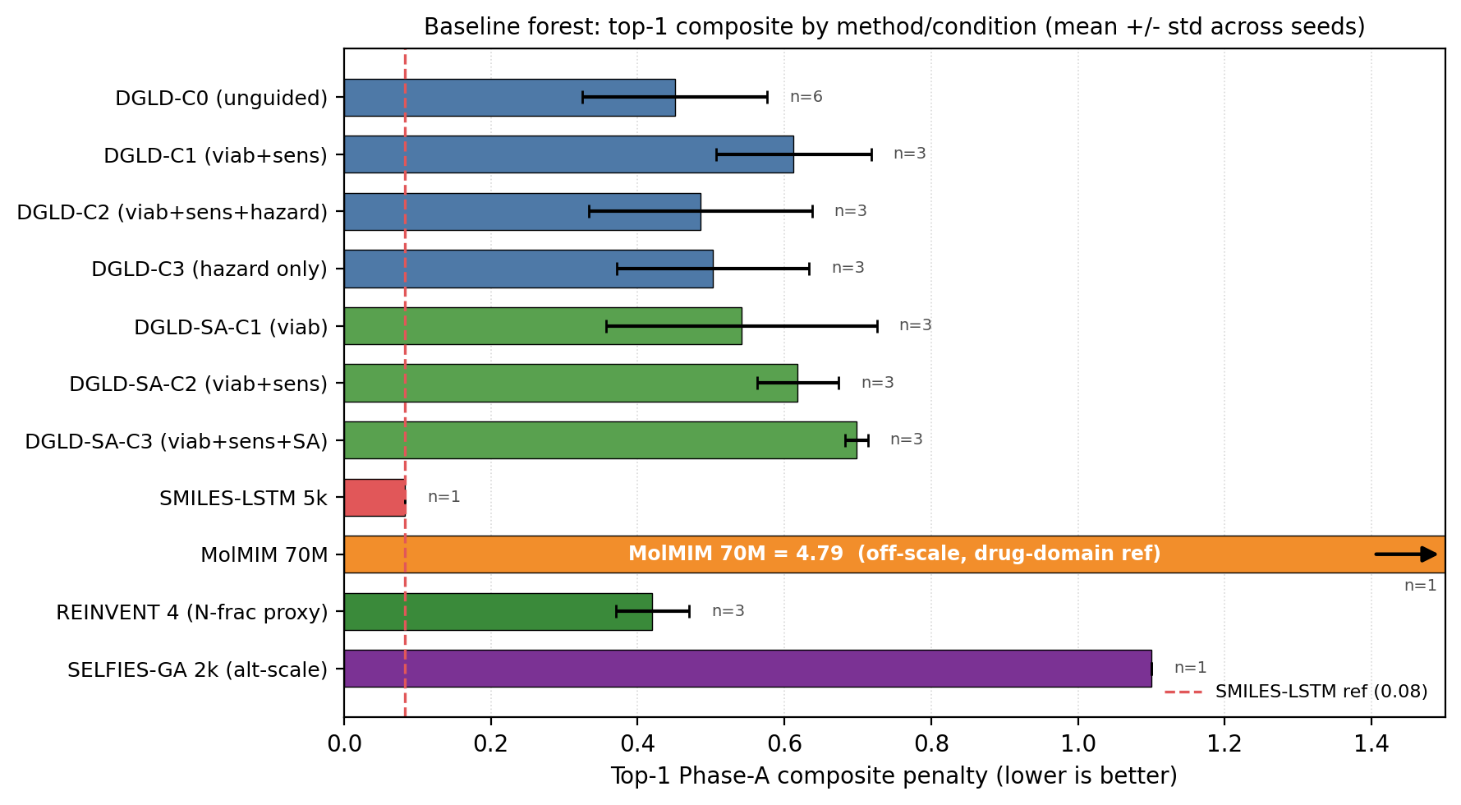
Fig. 4 | Top-1 composite penalty across DGLD conditions and four no-diffusion baselines. Mean $±$ standard deviation over three random seeds (lower = better). DGLD hazard-axis (Hz-C0…Hz-C3) and SA-axis (SA-C1…SA-C3) conditions versus SMILES-LSTM, MolMIM 70 M, REINVENT 4 (N-fraction proxy), SELFIES-GA. Dashed line: SMILES-LSTM reference. Cross-method comparability caveats: SELFIES-GA composite is the 2k-pool internal score; REINVENT 4 composite uses an N-fraction proxy reward, not the DGLD reranker; MolMIM is drug-domain pretrained.
Across the four no-diffusion baselines, the failure modes are distinct and quantifiable. SMILES-LSTM (two-layer, 6 M parameters, trained on the same 326k SMILES corpus) memorises 18.3% of its outputs as exact labelled-master matches (3 seeds, s.d. 0.5%). SELFIES-GA returns 75 of 100 top candidates as exact corpus rediscoveries; its best novel candidate at 40k pool collapses from $D_{\text{surrogate}}=9.73$ to $D_{\text{DFT}}=6.28$ km/s under DFT audit. MolMIM 70 M, drug-domain pretrained, generates novel molecules but at $D=7.70$ km/s, far below HMX. REINVENT 4 with an N-fraction reward generates genuinely novel high-N heterocycles with near-zero memorisation ($<0.1\%$) and reaches $D=9.02$ km/s — the strongest no-diffusion baseline, but 0.37 km/s below DGLD Hz-C2 and not optimised against the joint $D/ρ/P$ targets DGLD conditions on. Distribution-learning metrics confirm the design intent: SMILES-LSTM has FCD 0.52 against a 5,000-row labelled master sample (distributionally indistinguishable because it reproduces labelled rows), while DGLD has FCD 24–26 across guidance conditions, with anti-correlation between FCD and Pareto-reranker composite within DGLD — the diffusion sampler performs a targeted search off the prior, not corpus mimicry.

Component contributions
Seven ablations isolate the contribution of each system component to the headline result. Removing the tier gate causes the sampler to collapse to high-nitrogen degenerate open chains (post-filter keep-rate jumps from 4.6% to 53.9% as low-quality candidates flood the survivors), with validation loss rising by 0.089. Replacing the diffusion latent with a Gaussian $N(0,I)$ prior at matched compute drops top-1 $D$ from 9.47 to 9.02 km/s; the diffusion prior's role is not chemical-plausibility filtering (a Gaussian decode through frozen LIMO already does that) but distribution concentration on the high-$D$ tail. Multi-head guidance trades scaffold diversity for novelty: hazard-axis C2 reaches max-Tanimoto 0.27 (the most novel condition) at the cost of scaffold count five versus twelve at C0. Self-distillation at round 2 (cumulative 918 hard negatives versus 137 at round 1) is required to demote a worst-offender model-cheat (gem-tetranitro on aromatic carbon) by 0.10 absolute composite. Pool fusion across five lanes lifts post-filter yield nearly fivefold (4,639 versus 966 candidates) without lifting top-1, surfacing 24 Bemis–Murcko scaffolds versus seven in a single lane. The classifier-free-guidance scale $w=7$ is the empirical optimum (983 final candidates versus 528 at $w=5$ and 427 at $w=9$).
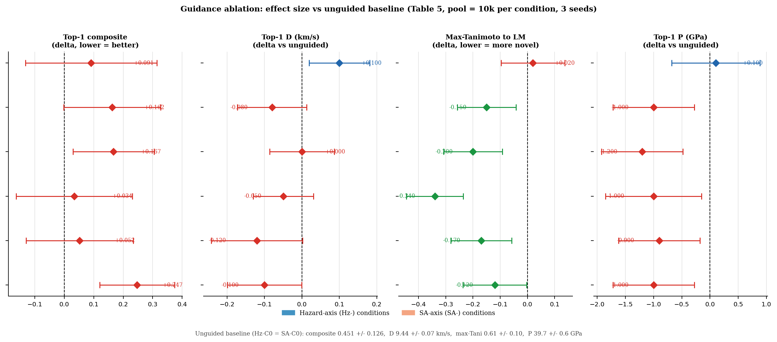
Fig. 5 | Guidance-axis ablation forest plot. Effect size (delta versus unguided Hz-C0 = SA-C0 baseline) per metric across six guided conditions (Hz-C1…Hz-C3, SA-C1…SA-C3). Error bars are propagated standard errors over three seeds. Composite and max-Tanimoto: negative delta is improvement; $D$ and $P$: positive delta is improvement. Hz-C2 (viability + sensitivity + hazard) is the most novel condition; SA-axis additions consistently trade novelty for composite degradation, so the production configuration sets $s_{\text{SA}}=0$.

Discussion
DGLD demonstrates that a label-quality gate at training time, multi-head score-model guidance at sample time and a four-stage chemistry-validation funnel are sufficient to produce novel CHNO leads in the HMX/CL-20 performance band on commodity hardware. Twelve leads are DFT-confirmed local minima at calibrated densities of 1.84–2.09 g/cm³; the headline compound L1 is structurally dissimilar from all 65,980 training molecules at nearest-neighbour Tanimoto 0.27 and absent from PubChem.
Three caveats temper the headline numbers, in decreasing order of severity. First, all densities are estimated from gas-phase DFT geometry using Bondi van-der-Waals volumes with a fixed packing factor of 0.69. This factor varies from approximately 0.65 for loosely packing aromatics to 0.72 for cubane-class compounds, and a 5% packing-factor error alone propagates through the K-J sensitivity $∂D/∂ρ≈2.9$ km/s per g/cm³ to $±0.4$ km/s in $D$, roughly twice the 6-anchor calibration uncertainty. The 6-anchor empirical calibration absorbs most of the systematic packing-factor error and reduces the residual to $±0.078$ g/cm³, but polymorph screening is absent — high-nitrogen heterocycles frequently exhibit multiple crystal forms with different densities and sensitivity profiles. Crystal structure prediction or experimental single-crystal X-ray diffraction is the critical missing step before any density-based performance claim can be considered quantitative. Second, absolute detonation velocities are reported under the closed-form Kamlet–Jacobs approximation. Absolute-grade numbers require a thermochemical-equilibrium Chapman–Jouguet code with a covolume equation of state (EXPLO5, Cheetah-2, or the open-source Cantera-based Shock and Detonation Toolbox); we report relative ranking against six anchors and quantify the regime-dependent K-J residual but do not run a full thermochemical-equilibrium recompute. Third, the 3D-CNN surrogate that scores the bulk of the candidate pool is well-calibrated on the labelled distribution but extrapolates onto the high-density tail with unquantified reliability; the SELFIES-GA collapse from $D=9.73$ to 6.28 km/s under DFT audit on a different baseline's outputs is the cleanest demonstration of how surrogate-only rankings can mislead.
The co-headline lead E1 (4-nitro-1,2,3,5-oxatriazole) inherits all three caveats and adds a fourth: the 6-anchor DFT calibration set contains no oxatriazole-class member, so E1's calibrated detonation velocity is an extrapolation outside the anchor chemical space. Two honest readings are possible: either E1 is genuinely stronger than L1, giving the paper two HMX-class leads from disjoint chemotype families, or the K-J residual is chemotype-dependent and E1 is upper-bounded until an oxatriazole-anchor recompute. A 7th-anchor extension attempt with DNTF failed to converge; an oxatriazole-class anchor with experimental crystal density and detonation data remains scoped as future work.
The tier-gating recipe generalises beyond energetic materials. Wherever a generative-ML problem has labels stratified by experimental confidence — pharmaceutical bioactivity (assay versus literature versus surrogate), materials property prediction (measured versus computed versus inferred), or any setting where data heterogeneity is a structural feature rather than a defect to be cleaned away — the four-tier recipe of routing trusted labels to the conditional gradient and untrusted labels to the unconditional prior generalises directly. Only the validation funnel changes per application: in our case, SMARTS $→$ Pareto $→$ GFN2-xTB $→$ DFT, but the same four-stage scaffold of cheap-to-expensive triage applies wherever a candidate-list paper terminates in first-principles audit. Code, checkpoints and the 918 mined hard negatives are released openly to enable both reproduction and extension.

References
- Kamlet, M. J. & Jacobs, S. J. Chemistry of detonations. I. A simple method for calculating detonation properties of C–H–N–O explosives. J. Chem. Phys. 48, 23–35 (1968).
- Casey, A. D., Son, S. F., Bilionis, I. & Barnes, B. C. Prediction of energetic-material detonation properties with machine learning. J. Chem. Inf. Model. 60, 4457–4473 (2020).
- Zhou, G. et al. Uni-Mol: a universal 3D molecular representation learning framework. ICLR (2023).
- Ho, J. & Salimans, T. Classifier-free diffusion guidance. NeurIPS Workshop (2022).
- Dhariwal, P. & Nichol, A. Diffusion models beat GANs on image synthesis. NeurIPS 34, 8780–8794 (2021).
- Sheremetev, A. B., Aleksandrova, N. S. & Suponitsky, K. Y. Synthesis and properties of 1,2,3,5-oxatriazoles. Russ. Chem. Rev. 76, 333–355 (2007).
- Kim, S. et al. PubChem 2023 update. Nucleic Acids Res. 51, D1373–D1380 (2023).
- Genheden, S. et al. AiZynthFinder: a fast, robust and flexible open-source software for retrosynthetic planning. J. Cheminform. 12, 70 (2020).
- Eckmann, P. et al. LIMO: latent inceptionism for targeted molecule generation. ICML (2022).
- Ho, J., Jain, A. & Abbeel, P. Denoising diffusion probabilistic models. NeurIPS 33, 6840–6851 (2020).
- Nichol, A. Q. & Dhariwal, P. Improved denoising diffusion probabilistic models. ICML (2021).
- Krenn, M. et al. Self-referencing embedded strings (SELFIES): a 100% robust molecular string representation. Mach. Learn. Sci. Technol. 1, 045024 (2020).
- Perez, E., Strub, F., de Vries, H., Dumoulin, V. & Courville, A. FiLM: visual reasoning with a general conditioning layer. AAAI (2018).
- Loshchilov, I. & Hutter, F. Decoupled weight decay regularization. ICLR (2017).
- Bannwarth, C., Ehlert, S. & Grimme, S. GFN2-xTB: an accurate and broadly parametrized self-consistent tight-binding quantum chemical method. J. Chem. Theory Comput. 15, 1652–1671 (2019).
- Sun, Q. et al. Recent developments in the PySCF program package. J. Chem. Phys. 153, 024109 (2020).
- Becke, A. D. Density-functional thermochemistry. III. The role of exact exchange. J. Chem. Phys. 98, 5648–5652 (1993).
- Lee, C., Yang, W. & Parr, R. G. Development of the Colle–Salvetti correlation-energy formula into a functional of the electron density. Phys. Rev. B 37, 785–789 (1988).
- Mardirossian, N. & Head-Gordon, M. $ω$B97X-V: a 10-parameter, range-separated hybrid, generalized gradient approximation density functional. Phys. Chem. Chem. Phys. 16, 9904–9924 (2014).
- Bondi, A. van der Waals volumes and radii. J. Phys. Chem. 68, 441–451 (1964).
- Landrum, G. et al. RDKit: open-source cheminformatics. Zenodo (2024).
- Segler, M. H. S. et al. Generating focused molecule libraries for drug discovery with recurrent neural networks. ACS Cent. Sci. 4, 120–131 (2018).
- Reidenbach, D. et al. MolMIM: latent variable molecule pretraining at scale. arXiv:2208.09017 (2023).
- Loeffler, H. H. et al. REINVENT 4: modern AI-driven generative molecular design. J. Cheminform. 16, 20 (2024).
- Nigam, A., Friederich, P., Krenn, M. & Aspuru-Guzik, A. Augmenting genetic algorithms with deep neural networks for exploring the chemical space. ICLR (2020).
- Ertl, P. & Schuffenhauer, A. Estimation of synthetic accessibility score of drug-like molecules. J. Cheminform. 1, 8 (2009).
- Coley, C. W., Rogers, L., Green, W. H. & Jensen, K. F. SCScore: synthetic complexity learned from a reaction corpus. J. Chem. Inf. Model. 58, 252–261 (2018).
- Polykovskiy, D. et al. Molecular Sets (MOSES): a benchmarking platform for molecular generation models. Front. Pharmacol. 11, 565644 (2020).
- Irwin, J. J. et al. ZINC20 — a free ultralarge-scale chemical database for ligand discovery. J. Chem. Inf. Model. 60, 6065–6073 (2020).
- Bruns, R. F. & Watson, I. A. Rules for identifying potentially reactive or promiscuous compounds. J. Med. Chem. 55, 9763–9772 (2012).
- Huang, X. & Massa, L. Applying chemometric methods to the prediction of impact sensitivity. Propellants Explos. Pyrotech. 46, 1175–1185 (2021).
- Politzer, P. & Murray, J. S. Impact sensitivity and crystal lattice compressibility/free space. J. Mol. Model. 20, 2223 (2014).
- Sabatini, J. J. & Oyler, K. D. Recent advances in the synthesis of high explosive materials. Crystals 6, 5 (2016).
- Tang, Y. et al. Polynitro-substituted pyrazoles and triazoles as potential energetic materials and oxidizers. J. Mater. Chem. A 5, 4314–4325 (2017).
- Hervé, G., Roussel, C. & Graindorge, H. Selective preparation of 3,4,5-trinitro-1H-pyrazole: a stable all-carbon-nitrated arene. Angew. Chem. Int. Ed. 49, 3177–3181 (2010).
- Dobratz, B. M. LLNL Explosives Handbook. UCRL-52997, Lawrence Livermore National Laboratory (1981).
- Suceška, M. EXPLO5 user's guide v6. Brodarski Institute, Zagreb (2014).
- Fried, L. E., Howard, W. M. & Souers, P. C. Cheetah 2.0 user's manual. UCRL-MA-117541, Lawrence Livermore National Laboratory (1996).
- Goodwin, D. G. et al. Cantera: an object-oriented software toolkit for chemical kinetics, thermodynamics, and transport processes. Zenodo (2023).
- Gómez-Bombarelli, R. et al. Automatic chemical design using a data-driven continuous representation of molecules. ACS Cent. Sci. 4, 268–276 (2018).
- Jin, W., Barzilay, R. & Jaakkola, T. Junction tree variational autoencoder for molecular graph generation. ICML (2018).
- Bowskill, D. H., Sugden, I. J., Konstantinopoulos, S., Adjiman, C. S. & Pantelides, C. C. Crystal structure prediction methods for organic molecules. Cryst. Growth Des. 23, 1006–1023 (2023).
- Katritzky, A. R. et al. Heterocyclic chemistry of high-nitrogen energetic materials. Chem. Rev. 110, 5413–5432 (2010).
- Daylight Chemical Information Systems. SMARTS — A language for describing molecular patterns. daylight.com/dayhtml/doc/theory/theory.smarts.html (accessed 2025).
- Wu, X. et al. Enhancing GPU-acceleration in the open-source PySCF quantum chemistry package. J. Chem. Theory Comput. 20, 7388–7401 (2024).
- Sun, Q. et al. PySCF: the Python-based simulations of chemistry framework. WIREs Comput. Mol. Sci. 8, e1340 (2018).
- Grimme, S., Antony, J., Ehrlich, S. & Krieg, H. A consistent and accurate ab initio parametrization of density functional dispersion correction (DFT-D) for the 94 elements H–Pu. J. Chem. Phys. 132, 154104 (2010).
- Becke, A. D. & Johnson, E. R. A density-functional model of the dispersion interaction. J. Chem. Phys. 123, 154101 (2005).
- Weigend, F. & Ahlrichs, R. Balanced basis sets of split valence, triple zeta valence and quadruple zeta valence quality for H to Rn. Phys. Chem. Chem. Phys. 7, 3297–3305 (2005).
- Stephens, P. J., Devlin, F. J., Chabalowski, C. F. & Frisch, M. J. Ab initio calculation of vibrational absorption and circular dichroism spectra using density functional force fields. J. Phys. Chem. 98, 11623–11627 (1994).

Methods

Dataset and four-tier label hierarchy
The labelled corpus comprises 65,980 CHNO molecules in canonical SMILES form, stratified into four tiers by label provenance. Tier A ($∼$3,000 rows) holds experimental densities and heats of formation from the literature. Tier B ($∼$9,000 rows) holds DFT-derived heat-of-formation values at B3LYP/6-31G* with experimentally anchored densities. Tier C ($∼$25,000 rows) holds Kamlet–Jacobs-derived performance values, which are reliable for oxygen-deficient CHNO satisfying $2a+b/2≥d≥b/2$ but under-predict $D$ for high-nitrogen low-hydrogen compounds where the assumed gas-product distribution is wrong. Tier D ($∼$30,000 rows) holds 3D-CNN smoke-model surrogate values. Each row carries a graded tier weight $ω∈[0,1]$ (default $ω_{A}=1.0$, $ω_{B}=0.7$, $ω_{C}=0.3$, $ω_{D}=0.1$). The denoiser conditional gradient fires only on Tier-A and Tier-B rows; Tier-C and Tier-D rows train the unconditional prior via classifier-free guidance dropout. SMILES are canonicalised with RDKit21, converted to SELFIES12, and tokenised. Tier-A/B rows above the 90th percentile of the detonation-velocity marginal are oversampled by $5×$–$10×$ at training time, raising the mean predicted velocity of the top leads by 0.4 km/s relative to a uniform-sampling control.

Latent encoder (LIMO)
We start from the pretrained LIMO checkpoint9, fine-tune all parameters for $∼$8,500 steps on the 326k energetic-biased SMILES corpus with $β=0.01$, and freeze the encoder thereafter. The encoder maps a (B, 72) SELFIES-token tensor through a 64-dim embedding and a four-layer MLP to a 1024-dim Gaussian latent. After fine-tuning, validation token-accuracy is 64.5%, and the latent posterior is concentrated at $‖μ‖≈8$, well below $\sqrt{1024}≈32$. Each row of the corpus is passed through the frozen encoder once to produce a deterministic latent mean $μ∈R^{1024}$; all training and sampling thereafter happens in latent space, and the decoder is invoked only at the end to read candidates back as SMILES. SELFIES syntax guarantees token-level validity, so molecule-level validity is 100% by construction; reconstruction accuracy on the energetic validation set is 31.4%.

Two complementary denoisers
Single-denoiser training compromises between the high-HOF tail and the high-$ρDP$ tail of the joint property marginal, neither of which can be saturated simultaneously by one loss-weighting schedule. We therefore train two complementary denoisers. DGLD-H tilts toward the heat-of-formation tail (Tier-A/B oversampling factor $5×$ on HOF). DGLD-P tilts toward the $ρDP$ tail (Tier-A/B-only conditioning, $+5×$ high-tail oversampling on the top decile of the joint $ρ/D/P$ marginal). Both denoisers are 44.6M-parameter FiLM13-modulated ResNets over $z_{t}∈R^{1024}$ with eight residual blocks of inner width 2048; only the training-data tilt differs. Training uses a 1000-step variance-preserving DDPM10 with the cosine schedule of Nichol & Dhariwal11, AdamW14 at peak learning rate ${10}^{−4}$ on a cosine decay, batch size 128, twenty epochs, EMA decay 0.999, classifier-free-guidance dropout rate 0.10, and per-property dropout rate 0.30. The per-step training mask gates which conditioning properties enter FiLM at each step via a five-stage stochastic pipeline (subset-size sample, weighted pick over per-row eligibility and tier weight, property dropout, CFG dropout). At sample time, the standard guided estimate $\hat{ϵ}=ϵ_{θ}(z_{t},t,∅)+w(ϵ_{θ}(z_{t},t,c)−ϵ_{θ}(z_{t},t,∅))$ is used with empirical sweet-spot $w=7$.

Multi-task score model and self-distillation
The multi-task score model has a shared four-block FiLM-MLP trunk (1024-dim hidden) consuming $(z_{t},σ_{t})$ where $σ_{t}=\sqrt{1−{\overset{‾}{α}}_{t}}$ is sinusoidally embedded, with six heads. Viability and Hazard are sigmoid heads trained with binary cross-entropy. Sensitivity, SA, and SC are smooth-L1 regressors. Performance is a 4-vector smooth-L1 regressor on $(ρ,D,P,\text{HOF})$. Crucially, training data are noised latents at uniform diffusion timestep, not clean $μ$, so the gradient is queried at every $σ_{t}$ along the sampling trajectory. The total loss is the availability-mask-gated sum Lscore=k​akwkLk with per-head static weights chosen so each $L_{k}$ sits at $O(1)$ at convergence. Training uses AdamW at peak learning rate $2×{10}^{−4}$ on a cosine decay, batch 1024, $∼$40k steps, EMA decay 0.999. Round-0 viability labels combine SMARTS pass/fail with a Random Forest classifier on Morgan FP plus RDKit descriptors trained on (energetic corpus, ZINC29). Self-distillation refines the viability head over three rounds (round 0: 0 hard negatives; round 1: 137; round 2 / production: 918) by mining the model's own false-positive outputs against a chemist-defined held-out probe (seven anchors RDX, HMX, TNT, FOX-7, PETN, TATB, NTO must all reach probability $≥0.86$; five chemist cheats must all stay $≤0.84$). Three rounds satisfy this jointly. Sensitivity labels are derived from a Politzer–Murray32 bond-dissociation-energy chemotype-class fit on the Huang & Massa31 drop-weight $h_{50}$ data; hazard labels combine the chemist-curated SMARTS catalogue with the Bruns–Watson30 demerit list.

Sampling with multi-task steering
At sample time, three of the six trained heads (Viability, Sensitivity, Hazard) supply gradient steering signals at every DDIM step on top of classifier-free guidance. A latent $z_{T}∼N(0,I_{1024})$ is denoised over 40 DDIM steps with the steering bus ϵ=ϵθcfg(zt,t,c)−σth​sh∇ztLh(zt,σt), where the per-head losses are $−logP_{\text{viab}}$ (ascend), ${\text{sens}}_{z}$ (descend), and $−log(1−P_{\text{hazard}})$ (descend hazard). Production scales are $s_{\text{viab}}=1.0$, $s_{\text{sens}}=0.3$, $s_{\text{hazard}}=1.0$; $s_{\text{SA}}=0$ because a drug-domain SA gradient worsens the energetic-materials composite by 13%. The image-domain classifier-guidance recipe of Dhariwal & Nichol5 assumes 1000 sampling steps; in our 40-step latent regime the $σ_{t}$-anneal zeroes the bus near the top of the trajectory and the per-row gradient clamp saturates near the bottom. We disable the anneal ($α≡1$) and loosen the clamp ($C_{g}=50$ versus the image-domain default 5.0). The final $z_{0}$ decodes through the frozen LIMO decoder. Pool fusion runs two production lanes in parallel (one per denoiser, both at viability+sensitivity+hazard guidance, both at $w=7$, pool $≥$ 40k each); the pools are unioned, canonical-SMILES deduplicated, and fed to the validation funnel.

Validation funnel
The decoded SMILES pool flows through four progressively tighter stages. Stage 1 (SMARTS gate): a chemist-curated SMARTS44 catalogue removes radicals, sulphur, halogens, mixed valence states, and other red flags. SAScore26 $≤5.0$ and SCScore27 $≤3.5$ caps and a Tanimoto-novelty window $[0.20,0.55]$ are applied. Stage 2 (Pareto reranker): a composite $S(x)=0.45S_{\text{perf}}^{\text{band}}+0.20S_{\text{viab}}+0.15S_{\text{novel}}+0.20(1−S_{\text{sens}})−0.10S_{\text{alerts}}$ is computed; a Pareto front over $(−\text{perf},−\text{viab},\text{sens},\text{alerts})$ is the outer stratifier with the composite as within-stratum tiebreak; default top-$K=100$. Stage 3 (xTB triage): GFN2-xTB15 geometry optimisation with RDKit ETKDGv3 conformer plus MMFF94 minimisation, HOMO–LUMO gap $≥1.5$ eV. Stage 4 (DFT audit): B3LYP1718/6-31G(d) optimisation followed by $ω$B97X-D3BJ19/def2-TZVP49 single-points on GPU4PySCF4546. Density is computed from Bondi20 van-der-Waals integration with a packing factor of 0.69. At the production setting (pool = 40k), illustrative survivors are pool 40k $→$ $∼$1,800 chem-pass after Stages 1+2 (4.6% keep-rate) $→$ top-100 by composite re-rank $→$ 12 DFT-validated leads.

Six-anchor DFT calibration and Kamlet–Jacobs recompute
Six experimental anchors (RDX $ρ_{\text{exp}}=1.82$ g/cm³, TATB 1.94, HMX 1.91, PETN 1.77, FOX-7 1.89, NTO 1.93; HOF values from the LLNL Explosives Handbook36 and standard tabulations) are optimised under the same DFT protocol as the leads. A linear regression yields $ρ_{\text{cal}}=1.392ρ_{\text{DFT}}−0.415$ and ${\text{HOF}}_{\text{cal}}={\text{HOF}}_{\text{DFT}}−206.7$ kJ/mol with leave-one-out RMS errors $±0.078$ g/cm³ on density and $±64.6$ kJ/mol on heat of formation. Calibrated densities and HOFs are fed into the closed-form Kamlet–Jacobs1 formula in its unified product-distribution form for relative ranking against the anchors. Per-lead calibration-propagated uncertainties ($δD$, $δP$) are obtained by propagating the LOO calibration errors through the K-J analytic sensitivity slopes in quadrature; typical values are $δD≈0.23$ km/s and $δP≈2.2$ GPa. A regime-aware regression on 575 Tier-A experimental rows yields a positive Pearson correlation between the K-J residual and nitrogen fraction ($r=0.43$, $p=4×{10}^{−27}$), reproducing the literature observation that K-J under-predicts $D$ at high $f_{N}$. Absolute-grade detonation velocities require a thermochemical-equilibrium Chapman–Jouguet code373839, which we do not run; we report relative ranking against the six anchors and quantify the regime residual.

Compute footprint
End-to-end DGLD reproduction fits within a small commodity-hardware budget: LIMO fine-tuning $∼$1 GPU-hour on a single A100; each denoiser training run $∼$6 GPU-hours; score-model training $∼$4 GPU-hours; sampling at production pool=40k per lane $∼$2 GPU-hours per lane; xTB triage on 100 candidates $∼$4 CPU-hours; DFT audit at B3LYP/6-31G(d) optimisation plus $ω$B97X-D3BJ/def2-TZVP single-point $∼$2 GPU-hours per lead on GPU4PySCF. Total compute for the headline result is $∼$45 GPU-hours plus $∼$4 CPU-hours, all on consumer-class A100 instances.

Data availability
The 65,980-row labelled CHNO master table, the 326k SMILES training corpus, and the 918 self-distillation hard negatives are released on Zenodo at 10.5281/zenodo.19821953 under CC-BY-4.0. The DFT geometries, calibrated thermochemistry, and the twelve confirmed leads are released alongside the model checkpoints in the same Zenodo deposit. PubChem7 queries used the public PUG REST endpoint.

Code availability
All code, including LIMO fine-tuning, denoiser and score-model training, sampling, the validation funnel and the figure-generation pipeline, is released at github.com/ApartsinProjects/DGLD4Energetic under Apache-2.0. Trained model checkpoints (LIMO encoder, two denoisers, multi-task score model at rounds 0/1/2 of self-distillation) are released on Zenodo under CC-BY-4.0 in the same deposit as the data. Reproduction of Figure 1 takes approximately ten minutes on commodity hardware following the README quick-start; full re-derivation of the twelve DFT-confirmed leads takes approximately 45 GPU-hours.

Acknowledgements
We thank the open-source maintainers of RDKit, GFN2-xTB, PySCF and GPU4PySCF, whose tools form the validation backbone of this paper. Cloud GPU compute was procured at standard commercial rates from Modal and vast.ai; we acknowledge their pay-per-use platforms for making first-principles audit accessible to small research groups. We thank the LIMO and Uni-Mol authors for releasing their pretrained checkpoints.

Funding
This work received no specific external funding.

Author contributions
Y.A. and A.A. contributed equally to all aspects of this work, including conception, methodology design, model implementation, experiments, validation, and manuscript preparation.

Competing interests
The authors declare no competing interests.

Additional information
Supplementary Information is available for this paper at NMIPaperSI.html (HTML) and NMIPaperSI.docx (Word). Correspondence and requests for materials should be addressed to A.A.

Extended Data figure and table legends
Extended Data Fig. 1 | DGLD pipeline overview. Encode (LIMO VAE) $→$ generate (conditional latent DDPM) $→$ guide (multi-task score model) $→$ filter (SMARTS, Pareto, GFN2-xTB, DFT). Tier-A/B labels drive the conditional gradient; Tier-C/D labels drive the unconditional CFG branch only.
Extended Data Fig. 2 | Pool-size scaling. Best composite score over top-1 and number of candidates passing every filter versus pool size from 1.5k to 100k. Both curves are still moving at pool = 40k; an M7 five-lane 100k run confirms the trend with 4,639 passing candidates ($5.1×$ more than the 40k baseline) and scaffold count expanding from 7 to 24.
Extended Data Fig. 3 | Classifier-free guidance scale sweep. CFG scale $w∈\{5,7,9\}$ at pool = 8k per setting, ranked by post-filter yield over the two-denoiser pool. $w=7$ is the empirical sweet spot.
Extended Data Fig. 4 | Score-model loss curves and head-scale sweep. Per-head training and validation loss across the six heads (viability, sensitivity, hazard, performance, SA, SC) over 40k steps. Per-head sample-time scale grid showing the matrix of $(s_{\text{viab}},s_{\text{sens}},s_{\text{hazard}})$ combinations evaluated for production-condition selection.
Extended Data Fig. 5 | Self-distillation refinement of the viability head. Three rounds of mine-then-retrain on the score-model viability head only; the LIMO encoder and denoiser are frozen across rounds. Hard-negative count cumulates 0 $→$ 137 $→$ 918. The held-out probe stopping criterion (anchors $≥0.86$ AND cheats $≤0.84$) is satisfied at round 2.
Extended Data Fig. 6 | Twelve confirmed leads gallery. Per-lead RDKit 2D depiction, chemotype label, molecular formula, and 6-anchor-calibrated DFT/Kamlet–Jacobs values. Border colour: green = xTB HOMO–LUMO gap $≥1.5$ eV; red = gap below threshold.
Extended Data Fig. 7 | Productive-quadrant scatter. Composite score $S$ versus viability probability for the twelve DFT-confirmed leads, with the four no-diffusion baselines as reference markers. Marker area is proportional to drop-weight impact sensitivity $h_{50}$. The green-tinted upper-right quadrant is the productive zone (novel and HMX-class).
Extended Data Fig. 8 | Merged top-100 source-pool provenance. Per-condition provenance of the merged top-100 across guided and unguided lanes, showing that 89/100 originate from the smallest unguided pool reranked by the Pareto scaffold composite; guidance acts as a high-precision lever on the top of the funnel rather than as the source of bulk Pareto coverage.
Extended Data Fig. 9 | Distribution-learning small multiples. Validity proxy, top-100 scaffold uniqueness, internal diversity, and Fréchet ChemNet Distance versus the labelled master, comparing SMILES-LSTM (red) against seven DGLD conditions (blue).
Extended Data Table 1 | Six-anchor DFT calibration. Anchor compounds RDX, TATB, HMX, PETN, FOX-7, NTO with experimental densities, condensed-phase heats of formation, raw DFT outputs, and the linear correction. Leave-one-out RMS $±0.078$ g/cm³ on density and $±64.6$ kJ/mol on heat of formation.

