School of Software Engineering: Intelligent Systems

Automating Structural Analytics Techniques for Event Forecasting using Large Language Models

A project report submitted toward the degree of
Master of Science in Intelligent Systems

Student name: Ben Remez
Supervisor: Dr Yehudit Aperstein
Advisor: Dr. Sasha Aperstein
Date: 26.8.25

Table of Contents
1. Introduction 3
2. Related Work 4
2.1. Introduction to Structural Analytics and Event Forecasting 4
2.2. ACH and Evidence-Based Decision-Making 4
2.3. Large Language Models (LLMs) in Decision Support and Forecasting 5
2.4. MIRAI Benchmark and Event Forecasting Tasks 7
2.5. Probabilistic Reasoning and Evidence-Based Forecasting 8
3. Novelty and Contributions of the Research 9
4. Technologies and Algorithms Used 9
4.1. LangChain 9
4.2. Weaviate 10
4.3. Maximal Marginal Relevance (MMR) 10
4.4. Reciprocal Rank Fusion (RRF) 11
5. Retrieval-Augmented Generation (RAG) 11
6. Dataset 12
7. Event Forecasting Benchmark 13
8. Methodology 14
9. Deep Analysis 17
9.1. Motivation 17
9.2. Approach 17
9.3. Impact on the Pipeline 18
10. Initial Experimentation 18
11. Experiments 21
11.1. First Experiment - Baseline Setup 22
11.1.1. Retrieval Methods 22
11.1.2. Findings 23
11.2. Second Experiment – Improved Indicators & Enhanced RAG 23
11.2.1. Balanced Indicator Generation 23
11.2.2. Enhanced RAG Retrieval Infrastructure 24
11.2.3. Findings 25
11.3. Third Experiment – Integrating Deep Analysis 26
11.3.1. Approach 26
11.3.2. Findings 26
11.4. Experiments Summary 27
12. Results 27
12.1. Initial Results (Baseline Experiment) 28
12.2. Results After Fine-Tuned Indicators 29
12.3. Results After Introducing Deep Analysis 31
13. Discussion 33
13.1. Interpretation of Findings 33
13.2. Trade-offs Between Manual and RAG Pipelines 33
13.3. Role of Deep Analysis 34
13.4. Scalability and Practical Implications 34
13.5. Limitations and Challenges 34
13.5.1. Abstract-Only Context 34
13.5.2. Resource Constraints 34
13.5.3. Outcome Grouping 34
13.5.4. RAG Limitations vs. Manual Quality 35
14. Conclusions 35
15. Future Work 36
15.1. Benchmark on Larger and Diverse Datasets 36
15.2. Refine RAG Retrieval 36
15.3. Explore Multi-Agent LLM Architectures 36
15.4. Full Article Analysis 36
15.5. Extend CAMEO Relations 36
15.6. Optimize Prompt Engineering 36
16. References 37
17. Appendix A – Deep Analysis Prompt 40
18. Appendix B – Entropy Analysis of Prediction Distributions 40
18.1. Methodology 40
18.2. Results 41
18.3. Interpretation 41
19. Appendix C – Threshold-Based Deep Analysis Exploration 41
19.1. Motivation 41
19.2. Methodology 41
19.3. Results 42
19.4. Interpretation 43

Introduction
Structural analytical techniques, such as Analysis of Competing Hypotheses (ACH), provide a systematic framework for evaluating complex problems by organizing information, identifying biases, and assessing multiple competing explanations. ACH, in particular, encourages analysts to consider alternative hypotheses, weigh evidence objectively, and avoid cognitive biases such as confirmation bias. By structuring the analysis around competing scenarios, ACH enhances transparency, reduces uncertainty, and improves decision-making. This technique is especially valuable in intelligence, business, and policy analysis, where accurate conclusions are critical. The benefits of ACH and similar structural techniques include fostering critical thinking, promoting collaboration, and delivering more robust, evidence-based outcomes. These methods enable analysts to navigate ambiguity and make informed judgments in dynamic environments.
This research aims to leverage large language models (LLMs) to analyze diverse information sources and enhance the accuracy of forecasting future outcomes. The forecasting task is structured as a multiple-choice question, where each answer choice represents an attribute of a future event. The study utilizes a dataset of recent news articles to achieve this, enabling the model to generate informed predictions based on the most up-to-date information available.
Using large language models (LLMs) in event forecasting offers several advantages. Firstly, LLMs mitigate the influence of human biases, ensuring that predictions are based solely on data-driven insights rather than subjective interpretations. Secondly, they can process and analyze vast amounts of information efficiently, comprehensively evaluating multiple sources. Lastly, LLMs leverage extensive common knowledge and factual information in their training data, enhancing their ability to generate well-informed and contextually relevant forecasts.

Related Work

Introduction to Structural Analytics and Event Forecasting
Structured analytical techniques provide a systematic framework for evaluating complex problems by organizing information, mitigating cognitive biases, and improving decision-making consistency. These techniques are instrumental in intelligence analysis, risk assessment, and forecasting, where uncertainty is high, and human judgment alone may introduce inconsistencies. One widely used structural method is the Analysis of Competing Hypotheses (ACH), which systematically evaluates multiple possible explanations or predictions by assessing how well available evidence supports or contradicts each hypothesis. ACH helps analysts minimize cognitive biases, such as confirmation bias, by requiring them to systematically consider disconfirming evidence.
However, it remains a manual, time-consuming process prone to human error and inconsistencies, especially when handling large-scale, unstructured data. Analysts often deviate from ACH’s steps, which increases bias and reduces reliability [9]. Cognitive bias [4] is a significant issue in the decision-making process. There are numerous cognitive factors that can influence human judgment in decision-making; therefore, a systematic framework can help mitigate cognitive bias and enable analysts to make more informed, evidence-based decisions. MacLean C.L. emphasizes the importance of bias mitigation and offers a framework to reduce it, supporting workplace investigators in developing evidence-based, consistent decision-making [24].

ACH and Evidence-Based Decision-Making
In the late 70ts, the CIA developed a methodology for reducing cognitive bias during the analysis of intelligence information. ACH helps to minimize a high-stakes decision into a series of smaller and, arguably, simpler decisions regarding individual pieces of information. However, the overall process is manual and, thus, time-consuming, still relying on human judgment. The method is also problematic when intelligent information is deceptive or unreliable. Therefore, more formal methodologies based on Bayesian networks [16] and other probabilistic models [28] have been introduced for the task. However, more formal methods require translating mostly unstructured language data (e.g., news or reports) into well-defined random variables. The framing of ill-posed data based on a large corpus of intelligence language and visual data poses a serious challenge for the application of formal probabilistic reasoning methods.
Intelligence analysts are required to assess evidence to test alternative accounts of a current or future situation. When performing such a cognitively complex task, analysts may resort to using simple strategies that can bias their thinking and lead to judgment errors. It is argued that analysts may be susceptible to “confirmation bias” [5]. Dhami M. K. et al. experimented to evaluate the difference between analysts who were trained to use ACH and those who were not in several categories.
In their experiment, they aimed to compare the accuracy between the groups and to measure the extent of within-individual consistency in the judgment processes of the ACH and untrained groups [13]. Their results suggest that most analysts trained (and instructed) to use ACH deviated from one or more of the steps prescribed by this technique, highlighting the value of an automated system to perform the steps for hypothesis evaluation systematically, avoiding missing steps and causing potential errors in the final decision-making. As people are more prone to such mistakes, an automated system with a well-defined pipeline will have substantially less probability of making mistakes of this kind.
A few online and downloadable software tools help automate the ACH process. These programs leave a visual trail of evidence, allowing the analyst to weigh the evidence. PARCH ACH 2.0 was developed by the Palo Alto Research Center (PARC) in collaboration with Richard J. Heuer, Jr. It is a standard ACH program that allows analysts to enter evidence and rate its credibility and relevance. Analysis of Competing Hypotheses (ACH) is an open-source implementation of ACH that can be accessed from the project’s website at https://competinghypotheses.org/. DECIDE is another existing computational implementation of ACH. It was developed by the analytic research firm SSS Research, Inc. DEDICE not only allows analysts to manipulate ACH, but it also provides multiple visualization products [1].
One of the primary challenges, particularly for inexperienced qualitative researchers, is managing and analyzing large volumes of qualitative data collected. The integration of quantitative techniques into qualitative research enhances analytical rigor, reduces bias, and improves decision-making across various fields. Patricia Martyn’s study [26] on C-Ratios and matrix analysis demonstrates how structuring qualitative data can systematically quantify relationships between themes, ensuring completeness and objectivity. This approach aligns with prior efforts in intelligence analysis (ACH frameworks), business strategy (risk matrices), and computational text analytics (NLP models), all of which aim to structure complex reasoning processes. By bridging the gap between qualitative depth and quantitative precision, these methods offer a scalable, bias-resistant approach to analyzing large volumes of data, making them essential for research, business intelligence, and policy-making.

Large Language Models (LLMs) in Decision Support and Forecasting
The merging capabilities of large language models have motivated a surge in interest in various applications. One of the most promising directions attempts to combine multiple LLM model states (also known as Agents) that are fed different prompts and information to achieve a common goal collaboratively [28]. Different conceptual and software frameworks have been proposed for establishing an ensemble of specialized agents (e.g., critic, analyzer, summarizer) while coping with various challenges (task termination, reliability, and evaluation).
Large Language Models (LLMs) possess advanced capabilities in processing and analyzing vast amounts of data by leveraging their scalability, contextual understanding, and adaptability. As outlined in Large Language Models: A Survey [22], LLMs excel in natural language comprehension, multilingual processing, reasoning, and tool utilization, enabling them to synthesize large datasets, extract key insights, and support complex analytical tasks. Their emergent abilities, such as in-context learning and self-improvement, allow them to handle dynamic and unstructured data efficiently, making them valuable for applications in intelligence analysis, research synthesis, and decision-making automation. In the rapidly evolving domain of artificial intelligence (AI), LLMs have emerged as copilot tools in various applications, notably in forecasting and anomaly detection. However, despite their growing prominence, a substantial knowledge gap exists regarding their comprehensive capabilities and limitations in these contexts. The work of large language models in forecasting can be broadly categorized into two types. One method involves applying large language models directly to time series predictions, focusing on converting time series data into input data suitable for the models, such as GPT, Llama, and others. The application of LLMs across various tasks, including forecasting, involves a spectrum of innovative approaches, each tailored to optimize performance and accuracy. These approaches include prompt-based, fine-tuning, zero-shot, one-shot, few-shot, and more, as referred to by Su, J. et al [32]. It is also noted that LLMs face some challenges in the realms of forecasting and anomaly detection. To perform high-quality forecasting using LLMs, an extensive historical dataset is necessary. The reliance of LLMs on extensive datasets not only necessitates the availability of vast amounts of data but also raises critical issues regarding the representativeness, quality, and bias inherent in the collected information. For accurate forecasting with LLMs, access to a comprehensive historical dataset is essential. These models depend heavily on large-scale data, making the availability of vast amounts of information a key requirement. However, this reliance also introduces significant challenges related to the representativeness, quality, and potential biases within the collected data, which can impact the reliability and fairness of the predictions. Hallucinations, instances where models generate false or misleading information, also pose a significant threat to the reliability of LLMs. These errors can erode trust in AI-driven forecasting, decision-making, and analysis, particularly in critical domains such as finance, healthcare, and intelligence. Addressing hallucinations through improved training methods, enhanced fact-checking mechanisms, and human oversight is essential to ensure the accuracy and credibility of LLM-generated insights.
Another development in the field of Artificial Intelligence (AI), Retrieval-Augmented Generation (RAG), is a method that enhances LLMs by retrieving external knowledge before generating responses, and can help make the decision-making process more reliable. There are several approaches when using RAG. Naive RAG, which follows a simple retrieve-read framework, Advanced RAG which op, which optimizes retrieval with indexing and metadata, and Modular RAG, which adds search, memory, and validation modules for adaptability [12]. These approaches enhance accuracy, transparency, and scalability, thereby reducing hallucinations and facilitating data-driven, structured decision-making in fields such as business, policy, and risk assessment.

MIRAI Benchmark and Event Forecasting Tasks
Evaluating large language models on event forecasting tasks is challenging, and extensive research has been conducted in this field. A proposed solution for this task is the MIRAI benchmark. MIRAI stands for Multi-Information Forecasting Agent Interface. MIRAI is a benchmarking framework designed to evaluate LLM-based forecasting in the context of international events. Developed to address the limitations of current forecasting models, MIRAI provides a structured, agentic environment where LLMs interact with relational databases and textual news sources through APIs, allowing them to autonomously collect, process autonomously, and reason over historical data. The benchmark utilizes a refined version of the GDELT event database and implements structured prediction tasks across various forecasting horizons. By evaluating models based on their ability to source critical information, execute code-based reasoning, and predict future events, MIRAI establishes a rigorous framework for assessing LLM reliability in structured decision-making and geopolitical forecasting [37]. The MIRAI benchmark framework utilizes the Conflict and Mediation Event Observations (CAMEO) ontology. CAMEO is a framework for coding event data, typically used for events that merit news coverage, and is generally applied to the study of political news and violence [6].
Several studies have explored event datasets for geopolitical forecasting, each offering unique solutions. Benjamin, D.M. et al. [2] integrate time-series data with human-machine hybrid models to enhance prediction accuracy and reduce forecasting errors. Kejriwal, M. [17] applies representation learning algorithms to the Global Terrorism Database (GTD) to predict event relationships and model the semantics of complex events. Mirtaheri, M., et al. [23] utilize the Integrated Crisis Early Warning System (ICEWS) dataset and employ both supervised and unsupervised machine learning techniques to enhance predictive accuracy for geopolitical interactions. Hossain, K. T. et al. [15] leverage sequential text datasets and introduce an attention-based LSTM model to detect early warning signals of geopolitical shifts, offering a structured approach to precursor identification. These studies collectively highlight the value of structured event datasets in advancing geopolitical forecasting through data-driven methodologies. However, evaluating model predictions for international event forecasting remains a significant challenge due to the complexity, evolving nature, and diverse sources of geopolitical data. Many models struggle to integrate structured knowledge graphs and unstructured textual data, leading to incomplete or biased predictions. Furthermore, the lack of historical grounding affects the interpretability and reliability of forecasts, especially for long-term geopolitical shifts. The dynamic nature of international relations, influenced by alliances, trade, and conflicts, further complicates forecasting, making it challenging for models to anticipate unexpected geopolitical developments [37] accurately.

Probabilistic Reasoning and Evidence-Based Forecasting
Mapping qualitative certainty to quantitative probabilities is essential for effective communication and decision-making across various disciplines. Two prominent approaches in this domain are the Intergovernmental Panel on Climate Change (IPCC) uncertainty framework and Bayesian statistical methods. The IPCC approach to uncertainty relies on a calibrated language system that translates expert judgments into confidence levels and likelihood metrics, providing a structured yet heuristic-based framework for assessing risks. Unlike decision-theoretic models, which use Bayesian inference and optimization techniques, the IPCC primarily employs scenario-driven risk assessments, often without explicit probability distributions. While effective for communicating uncertainty, this method has limitations in quantifying deep uncertainty and ambiguity. Integrating six decision-theoretic approaches, such as robust control and max-min utility frameworks, could enhance the IPCC’s methodology for structured decision-making across various domains beyond climate science [36]. Fairfield and Charman [11] propose a Bayesian approach to process tracing that systematically translates qualitative evidence into quantitative probabilities, thereby facilitating stronger causal inference. Their framework involves defining specific rival hypotheses, assigning prior probabilities based on background knowledge, and using logarithmic likelihood scales to evaluate new evidence. By applying Bayes' rule iteratively, researchers can refine their conclusions in a structured and transparent manner, reducing subjective biases in qualitative analysis. While effective, challenges remain in assigning numerical probabilities to complex qualitative data.
Managing multiple sources of uncertainty is a fundamental challenge in structured decision models, requiring methodologies that balance ambiguity, conflicting data, and unknown probabilities. The Evidential Reasoning Approach [10] addresses this by integrating qualitative and quantitative assessments through a belief structure, enabling a systematic aggregation of diverse evidence. The Dempster–Shafer Theory [8] extends Bayesian probability, allowing the combination of multiple evidence sources to derive degrees of belief, making it particularly effective for handling incomplete or conflicting information. Meanwhile, Robust Decision-Making (RDM) [29] evaluates strategies across a wide range of possible futures, ensuring resilience in the face of deep uncertainty. These approaches offer structured, adaptive frameworks that enhance the reliability and robustness of decision-making in complex and uncertain environments. Traditional probabilistic forecasting models, such as ARIMA and Gaussian Processes, have long been the standard for time-series prediction, relying on statistical assumptions and structured historical data. In contrast, LLM-based structured inference leverages vast datasets and deep learning architectures to capture complex patterns and dependencies. While some studies suggest that LLMs struggle to outperform traditional models in computational efficiency [33], others highlight their potential to zero-shot extrapolate time series and achieve competitive or superior results without task-specific training [13]. This indicates that while LLMs introduce new possibilities, they must be carefully evaluated against established models to justify their computational cost and effectiveness in structured decision-making.

Contributions of the Research
This research presents the first integration of Large Language Models (LLMs) with ACH-based structured reasoning for intelligence analysis. Unlike prior approaches that rely on manual processes or Bayesian networks, this study introduces an automated, scalable method for evaluating competing hypotheses using LLM-driven evidence extraction and probabilistic reasoning.
A key innovation is the multi-agent LLM system, which utilizes specialized agents to handle evidence retrieval, uncertainty estimation, and bias mitigation, thereby enhancing both accuracy and transparency. Additionally, this study bridges the gap between unstructured intelligence text and structured probabilistic inference, allowing ACH to be applied dynamically to real-world intelligence streams.
To ensure rigorous evaluation, this research adapts the MIRAI benchmark, providing the first standardized testing framework for LLM-based ACH systems in event forecasting.
The key contributions of this research include:
- Automating ACH for Scalable Intelligence Analysis: Reduces manual workload and cognitive biases while enabling real-time, data-driven reasoning.
- Multiagent LLM System for Structured Decision-Making: Introduces a specialized LLM-agent framework for evidence extraction, hypothesis ranking, and bias mitigation.
- Probabilistic Evidence Scoring: Maps qualitative intelligence data to structured probability assessments, improving reliability and transparency.
- Scalable Evaluation Benchmark: Adapts the MIRAI dataset as a proxy for ACH evaluation, addressing the lack of standardized intelligence benchmarks.

Technologies and Algorithms Used

LangChain
LangChain is a widely adopted open-source framework designed for orchestrating large language model (LLM) applications. It offers a modular and composable architecture that enables seamless chaining of LLMs, retrievers, prompt templates, and other utility components. Its structure facilitates rapid prototyping, provider-agnostic integration, and structured orchestration of complex AI workflows [19].
The advantages of LangChain:
LangChain’s primary strength lies in its flexibility and modularity. Its standardized interfaces allow for the easy integration of different LLMs, retrieval systems, and data sources without requiring significant refactoring. This adaptability accelerates the development of Retrieval-Augmented Generation (RAG) systems and supports efficient prompt chaining for complex multi-step tasks. Furthermore, its rich ecosystem of integrations enables developers to leverage a wide variety of embedding providers, vector databases, and APIs, making it a robust foundation for building scalable and maintainable AI pipelines [20].

Weaviate
Weaviate is a production-ready, open-source vector database optimized for high-dimensional vector searches. It enables efficient storage and retrieval of semantic embeddings, making it ideal for powering high-throughput RAG pipelines [34].
The advantages of Weaviate:
Weaviate is designed for performance and scalability, offering near real-time responses even when querying millions of high-dimensional vectors. Its support for hybrid search, combining vector similarity with keyword-based matching, enhances retrieval precision and relevance. Additionally, Weaviate provides mature SDKs, excellent documentation, and strong integration capabilities with popular LLMs and embedding models, enabling seamless adoption in advanced AI workflows. These qualities make it a natural fit for large-scale retrieval tasks, such as those in this project.

Maximal Marginal Relevance (MMR)
Maximal Marginal Relevance (MMR) is a retrieval algorithm that iteratively selects documents based on a trade-off between relevance to the query and redundancy with previously selected items, as described by Carbonell & Goldstein [3]. In this project, MMR was applied during document retrieval to ensure that the selected articles were not only highly relevant to the forecasting query but also provided non-redundant perspectives.
Formally, MMR iteratively selects documents that maximize the following objective:
MMR=argmaxDi ∈RSλ ∙SimDi, Q-1- λ∙ maxDj ∈SSimDi, Dj
Where:
- R = candidate documents
- S = already selected documents
- Sim(Di, Q) = similarity between documents Di and query Q
- SimDi, Dj = similarity between documents
- λ = balance factor between relevance and diversity
In this project, MMR was beneficial for reducing redundancy in the retrieved articles while maintaining a high coverage of diverse, relevant evidence for the LLM.

Reciprocal Rank Fusion (RRF)
Reciprocal Rank Fusion (RRF) is a rank aggregation method that combines multiple ranked lists, favouring documents that consistently rank highly across them, as proposed initially by Cormack et al. [7]. In our case, RRF was used to merge results from recent and historical article searches.
The RRF score for a document d Is computed as:
RRFd= r ∈ Rd1k+r
Where:
- Rd = set of ranks assigned to a document d across different retrieval runs
- r = rank position of the document in one retrieval list
- k = constant to reduce the influence of low-ranked documents
We combined results from two time windows:
- Recent documents: up to the target forecast date
- Historical documents: up to 30 days before the target date
To prioritize timeliness, we applied exponential time-decay weighting with α=0.015, giving higher importance to recent evidence. This approach improved retrieval quality and significantly contributed to the enhanced performance.

Retrieval-Augmented Generation (RAG)
Retrieval-Augmented Generation (RAG) is an emerging paradigm that enhances large language models (LLMs) by combining retrieval-based methods with generative reasoning. Instead of relying solely on the model’s pre-trained parameters, RAG dynamically retrieves relevant external knowledge. It integrates it into the generation process, enabling LLMs to provide more accurate, context-aware, and up-to-date responses [12].
In this project, RAG was implemented by combining LangChain for orchestrating the retrieval and reasoning pipeline and Weaviate as the semantic vector database to perform high-dimensional similarity searches. Relevant document embeddings were stored in Weaviate, enabling the pipeline to retrieve supporting evidence for each hypothesis and feed it into the LLM for improved hypothesis scoring and evaluation.
An essential enabler of RAG’s performance is the use of vector embeddings to represent document content in a high-dimensional semantic space. Weaviate’s vector search leverages embeddings derived from modern neural architectures to contextual and semantic similarity between documents. These concepts are rooted in foundational work on word representation learning by Mikolov et al. [21], which demonstrated that distributed representations in vector space allow semantically related words and concepts to cluster together. By extending this principle to document-level embeddings, RAG efficiently retrieves contextually relevant documents even from massive corpora.
In this project, RAG was implemented using LangChain and Weaviate to enable efficient retrieval of relevant article documents from a large corpus. LangChain orchestrated the retrieval workflow, while Weaviate provided semantic vector search capabilities to identify the most contextually relevant documents. These retrieved articles were then passed to the LLM, which evaluated each article’s context against the generated indicators and used this information to forecast the expected outcome for a given date between the two countries involved in the query. Leveraging these tools allowed the pipeline to ground its predictions in real, contextually relevant evidence, improving the accuracy, reliability, and scalability of the forecasting process.

Dataset
The experiments in this study were conducted using the MIRAI benchmark dataset, a publicly available and carefully curated resource designed to evaluate large language models (LLMs) and reasoning agents in the context of geopolitical event forecasting. The benchmark was introduced by Ye et al. [37] and builds upon the GDELT (Global Database of Events, Language, and Tone) dataset and the CAMEO (Conflict and Mediation Event Observations) ontology [6], both of which are widely used in computational political science and international relations research.
Each instance in the MIRAI benchmark consists of a structured forecasting query, defined by the following fields:
- A source and target country.
- A forecast date, which serves as the reference point for information retrieval.
- A ground truth event label encoded using a three-digit CAMEO code.
- Optionally, auxiliary context such as summaries and prompts provided to the model.
In total, the dataset includes 100 test queries, each mapped to one of 38 CAMEO relation types representing various forms of cooperation or conflict. These fine-grained relation types span a spectrum of verbal and material interactions, allowing nuanced evaluation of forecasting systems.
To enable both fine-grained and coarse-grained evaluations, the MIRAI benchmark defines additional relation groupings:
- Quad categories: Collapsing 38 relations into four classes — Verbal Cooperation, Material Cooperation, Verbal Conflict, and Material Conflict.
- Binary categories: Reducing the label space to two classes — Cooperation and Conflict.
In this project, we utilize the MIRAI test subset to evaluate our ACH-based system. For each query, relevant news documents are retrieved using a RAG-based pipeline from a local corpus constructed from real-world news data. This corpus is indexed using Weaviate, an open-source vector database that supports semantic search and hybrid retrieval. Alternatively, it can be manually searched utilizing a list of document IDs provided in the test files, which are specifically related to each query.
This experimental setup enables alignment with prior evaluations while offering flexibility for testing new architectures and reasoning strategies.

Event Forecasting Benchmark
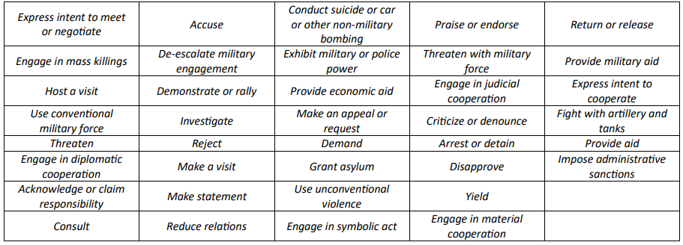
We utilize the recently published MIRAI benchmark [37], which is crafted to evaluate LLM agents for temporal forecasting in international events. Formally, we represent an event as 𝑒𝑡 = (𝑡, 𝑠, 𝑟, 𝑜), where 𝑡 is the timestamp, 𝑠, 𝑜 ∈ 𝐶 are respectively the subject and object countries from the country pool 𝐶, and 𝑟 ∈ 𝑅 denotes the relation type defined by the Conflict and Mediation Event Observations (CAMEO) ontology [6]. There are two hierarchical levels from the CAMEO ontology for detailed and comprehensive analysis of geopolitical dynamics. The first level includes 20 broad categories, represented by a two-digit code (e.g., “01: Public Statement” or “04: Consult”), which are subdivided into second-level categories identified by a three-digit code that corresponds to their parent category. For example, “03: Express intent to cooperate” is a first-level category with 10 different second-level relations, such as “036: Express intent to meet or negotiate”. Subsequently, the quadruple “(2023-11-03, AUS, 036, CHN)” denotes that on 3 November 2023, the Australian leader announced a planned visit to China. Figure 1 presents a sample of relationships extracted from MIRAI test data.
Figure 1: 38 Relations used in the test data
In the implementation of the MIRAI benchmark, the authors simplified the evaluation by reducing the granularity of the original 38 CAMEO event codes present in the test set. This was done to create more interpretable and robust evaluation categories. Specifically, the event codes were grouped into coarser relation categories under two schemes:
- Binary Classification – The 38 relations were collapsed into two broad categories:
- Mediation – Event codes ‘01’ – ‘08’
- Conflict – Event codes ‘09’ – ‘20’
- Quad Classification – The same 38 relations were mapped into four classes:
- Verbal Cooperation – Event codes ‘01’ – ‘04’
- Material Cooperation – Event codes ‘05’ – ‘08’
- Verbal Conflict – Event codes ‘09’ – ‘16’
- Material Conflict – Event codes ’17’ – ‘20’
These mappings formed the basis for evaluating system predictions and comparing them against ground truth labels using metrics such as precision, recall, F1 score, and KL divergence. The reduction in label complexity allows for clearer insight into the model’s capabilities across both broad and fine-grained relational understanding.

Methodology
The original ACH methods include the construction of the evidence matrix. The matrix is a key tool for systematically evaluating evidence against multiple hypotheses. It is structured with hypotheses listed across the top as columns and evidence listed down the side as rows, creating a grid that allows analysts to visually compare how each piece of evidence relates to each hypothesis [1]. Within the matrix, symbols such as "+" (support), "-" (contradict), or "0" (neutral) are used to indicate the relationship between evidence and hypotheses, ensuring a clear and organized assessment. This structured approach helps analysts identify diagnostic evidence—information that strongly supports one hypothesis while undermining others—and highlights inconsistencies or gaps in the analysis. By providing a transparent and logical framework, the ACH matrix reduces cognitive biases, fosters objectivity, and enables analysts to draw more accurate and well-supported conclusions.
Our approach adds a step where evidence is extracted from the relevant sources (new articles). Therefore, the analysis encompasses two types of uncertainties: uncertainty related to the presence of specified evidence (an early sign) in a specific news article and uncertainty related to the degree to which specific evidence impacts (supports or disproves) a given hypothesis. Our method addresses these uncertainties by querying LLM using a natural language representation of uncertainties.
To bring ACH fully into the LLM era, we reframe the analyst’s “evidence matrix” as two probabilistic mappings powered by a large language model (LLM). Instead of manually ticking “+” or “–” in a grid, we (1) use the LLM to identify latent “early‐sign” factors, (2) map how each factor drives each hypothesis, (3) retrieve real news manually or via RAG, (4) estimate whether each article actually mentions each factor, and (5) aggregate all signals via a Naïve-Bayes–style score. Concretely:

- Identify latent evidence signs
Prompt the LLM (e.g., GPT-4) to list the top K “early signs” that an analyst would watch to forecast the target relation. Example prompt:
“You are an expert geopolitical analyst assisting with strategic forecasting.
Given a set of possible future outcomes: ‘<list of outcomes>’, your task is to generate a set of early warning indicators that would help identify which outcome is most likely, with at least one indicator specifically designed to assess each outcome independently involving country: ‘<C1>’ and country: ‘<C2>’.
Instructions:
For each outcome, generate at least one unique, realistic, and observable indicator.
Each indicator should be designed to detect early signs or signals that support the specific outcome it is associated with.
Do not repeat indicators across outcomes.
Be concise but informative.
- Format your output as a list of indicators with each one tied to the outcome it assesses.”

- Score each factor’s impact on each hypothesis
For each (factor f, hypothesis h) pair, ask the LLM:
“Given that <factor f> occurs, how likely (‘highly likely’ / ‘likely’ / ‘possible’ / ‘unlikely’ / ‘highly unlikely’) is <hypothesis h>? Briefly justify”
The five qualitative results are then mapped into numeric probabilities:
"highly likely" → 0.9, "likely" → 0.66, "possible" → 0.33, "highly unlikely" → 0.1, "unlikely" → 0.0.
Example Prompt:
“You are an intelligence analyst specializing in international affairs. Your task is to predict a future event involving the country: Australia, and the country: China. There has been a recent development described as '<factor f>' that might indicate the future event described by '<hypothesis h>'. Assess the certainty of the future event based on the current development observed so far. Use the following qualitative descriptions of the certainty: 'highly likely', 'likely', 'possible', 'unlikely', or 'highly unlikely'. Provide a brief justification for your assessment.”
- Retrieve and rank relevant news (manually or using RAG)
In this section, we present two cases: manual retrieval of articles based on DocIds found in the relation_query.csv file, which is related to the relevant query in the test subset file, and RAG-based retrieval using “Weaviate” as a news-article corpus.
- Estimate factor presence in each article
For each retrieved article and each factor ‘f’, prompt the LLM:
“The article says <article abstract>. How certain (‘highly likely’/...) is it that <factor f> is actually present?”
As in step 2, we map the qualitative results into numeric probabilities in the same way.
Example Prompt:
“You are an open-source news analyst with expertise in international affairs. Your task is to predict a future event involving the country: Australia, and the country: China. You are examining a news item with the contents being: <article abstract>. Assess the certainty of the development described as <factor f> happening based on the facts reported in the news item. Use the following qualitative descriptions of the certainty: 'highly likely', 'likely', 'possible', 'unlikely', or 'highly unlikely'. Provide a brief justification for your assessment.
- Aggregate into hypothesis scores
In the final step, we compute a score for each hypothesis by aggregating evidence from all retrieved articles. This is done by first forming two matrices:
- The analysis matrix $A∈R^{nxm}$, where each entry $A_{ij}$ represents the estimated probability that the article $i$ contains indicator $j$, denoted as $\operatorname{Pr}\left(f_{i} \right| a_{i})$.
- The influence matrix $I ∈ R^{mxh}$, where each entry $I_{jh}$ represents the probability that the hypothesis $h$ is true given indicator $j$, denoted as $\operatorname{Pr}\left(h \right| f_{j})$.
These matrices are multiplied to obtain a prediction matrix. $P∈R^{nxh}$:
$$P=A⋅I$$
Each entry $P_{ih}$ reflects the contribution of the article $i$ to hypothesis $h$, aggregating over all factors.
To compute the final score of each hypothesis, we take the mean across all articles:
$$Score\left(h\right)= \frac{1}{n}\sum_{i=1}^{n}{P_{ih}}= \frac{1}{n}\sum_{i=1}^{n}{\sum_{j=1}^{m}{A_{ij}⋅I_{jh}}}$$
This results in a single score per hypothesis, reflecting how well the collected news evidence supports each potential outcome.
This matrix-based aggregation approach allows us to scale probabilistic ACH-style reasoning across large document sets. It retains the interpretability of manual ACH while enabling automation, reproducibility, and quantitative evaluation of complex geopolitical forecasts.
The diagram below illustrates the flow of forecasting for each query:
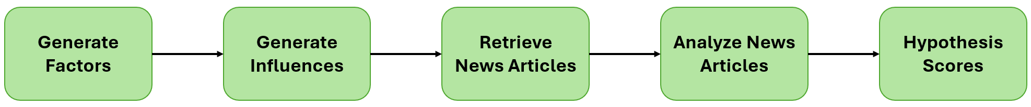
Figure 2: The forecasting flow per query

Deep Analysis

Motivation
During the experiments, we observed a recurring issue where the model struggled to distinguish between “Material” and “Verbal” categories when evaluating the context of the retrieved articles. For example, articles discussing diplomatic negotiations (verbal) were sometimes classified as material events, and vice versa. This ambiguity reduced the reliability of the pipeline’s forecasts, especially when articles contained mixed signals or lacked explicit descriptions of event types.
To address this limitation, we introduced a Deep Analysis step as an additional second-stage reasoning layer with the pipeline. The prompt of the Deep Analysis step can be found under Appendix A.

Approach
In the Deep Analysis step, the LLM receives the full context of each retrieved article, along with the names of the countries involved in the query, a base description of cooperation or conflict, depending on the top-ranked result, and base descriptions of verbal and material elements. The LLM is tasked with classifying each article for one of three categories: “Verbal”, “Material”, or “Uncertain” in cases where it fails to assess if the article is defined closer to “Verbal” or “Material”. The LLM is also required to specify the certainty level for “Verbal” or “Material” with certainty levels of either “High” or “Low” and a short explanation for the LLM’s choice.
After receiving the results from the LLM, we score each category, “Verbal” or “Material”, by adding a score of 1 for each category chosen with a certainty level of “High” and a score of 0.5 for each category selected with a certainty level of “Low”. We ignore articles categorized as “Uncertain”. After scoring each category, the category with the highest score is chosen as the final decision. In cases where scores are equal, we retain the original category that was initially ranked as the top decision in the original pipeline.
For example, the scores of the categories, computed according to the LLM’s response as shown in Figure 3, would be calculated as follows:
“Material” Score = 1 + 1 = 2
“Verbal” Score = 1 + 1 + 1 + 1 = 4
For this case, the chosen category shall be “Verbal”, and the final result will be Verbal Conflict/Cooperation (based on the top-ranked decision from the original pipeline).
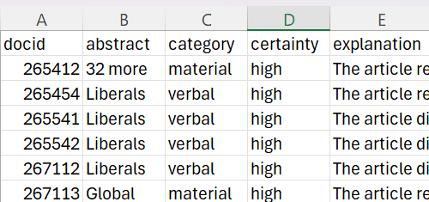
Figure 3: An example of a saved response file from the Deep Analysis step

Impact on the Pipeline
Introducing the Deep Analysis step significantly improved the reliability of the pipeline’s predictions by leveraging the full context of each retrieved article. Instead of solely relying on top-ranked decisions from the initial classification, the LLM now evaluates each article individually, assigns a certainty score for “Verbal” or “Material”, and aggregates these scores to determine the outcome. Articles labelled “Uncertain” are ignored, reducing noise from ambiguous data. This refinement resulted in more consistent and accurate categorizations, particularly in scenarios where the original pipeline struggled to distinguish between “Verbal” and “Material” categories.

Initial Experimentation
Forecasting Query: “2023-11-04, Israel, Accuse, Palestine”
The news articles (Only titles are shown)

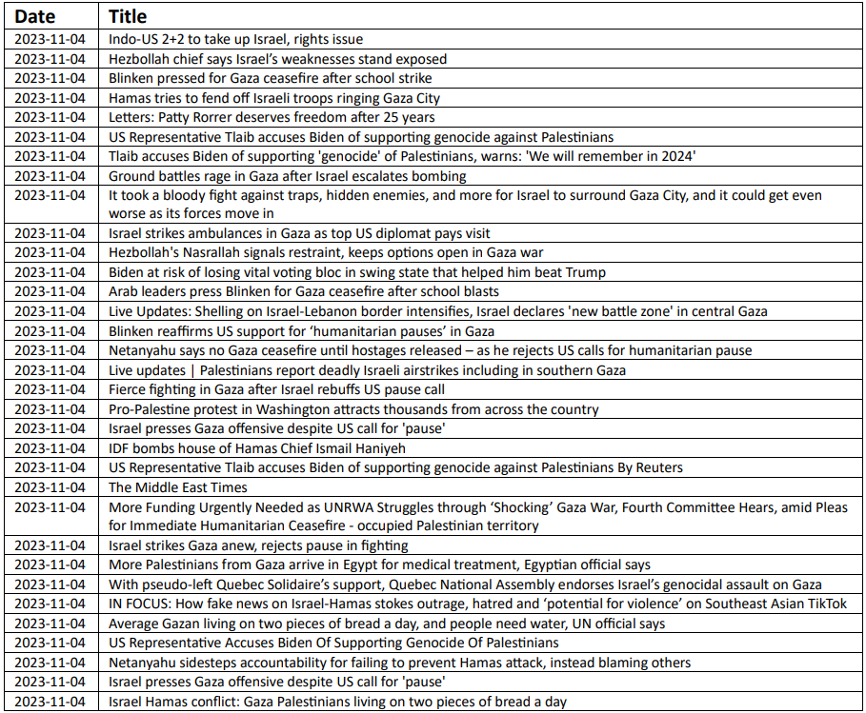
Underlying latent evidence space (only 10 are shown)
- Statements from Israeli officials regarding peace negotiations with Palestine
- Increased military presence or operations in Palestinian territories
- Reports of civilian casualties or mass killings in conflict zones
- International diplomatic efforts or visits aimed at mediating the Israel-Palestine conflict
- Public demonstrations or rallies in support of Palestinian rights
- Changes in U.S. or EU foreign policy towards Israel and Palestine
- Incidents of violence or terrorism attributed to militant groups in Palestine
- Economic aid packages or sanctions proposed by international bodies
- Official recognition or support for Palestinian statehood by other nations
- Joint initiatives or agreements between Israel and Palestine on humanitarian issues

Influence of the evidence on the outcomes (a sample)
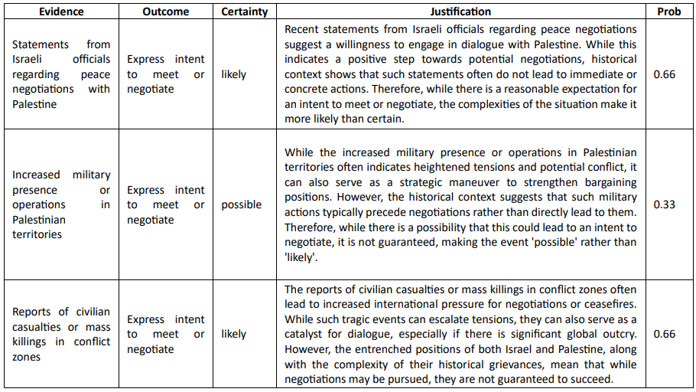
News Analysis (a sample)
Abstract | Evidence | Certainty | Justification | Prob
Indo-US 2+2 to take up Israel, rights issue The Israel-Hamas conflict, besides human rights and democracy, will be on the table at the forthcoming 2+2 meeting of the Foreign and Defence Ministers of the US and India on November 10. | Statements from Israeli officials regarding peace negotiations with Palestine | Possible | The news item indicates that the Israel-Hamas conflict and human rights issues will be discussed at the upcoming Indo-US 2+2 meeting. However, it does not provide direct evidence of ongoing peace negotiations between Israel and Palestine. While discussions at such high-level meetings could influence future negotiations, the actual statements from Israeli officials regarding peace negotiations are not confirmed in this report, making the likelihood of such statements occurring 'possible' but not certain. | 0.33
Indo-US 2+2 to take up Israel, rights issue The Israel-Hamas conflict, besides human rights and democracy, will be on the table at the forthcoming 2+2 meeting of the Foreign and Defence Ministers of the US  and India on November 10. | Increased military presence or operations in Palestinian territories | possible | The news item indicates that the Israel-Hamas conflict and human rights issues will be discussed at the upcoming Indo-US 2+2 meeting. While this suggests a focus on the situation in Israel and Palestine, it does not provide direct evidence of an imminent increase in military presence or operations in Palestinian territories. The discussions may lead to diplomatic actions or statements rather than immediate military changes, making the likelihood of increased military operations possible but not certain. | 0.33
Indo-US 2+2 to take up Israel, rights issue. The Israel-Hamas conflict, besides human rights and democracy, will be on the table at the forthcoming 2+2 meeting of the Foreign and Defence Ministers of the US and India on November 10. | Reports of civilian casualties or mass killings in conflict zones | likely | The news item indicates that the Israel-Hamas conflict, along  with human rights issues, will be discussed at an upcoming  international meeting. Given the ongoing nature of the conflict  and previous reports of civilian casualties, it is reasonable to  assess that there are likely ongoing reports of civilian casualties  or mass killings in the conflict zones. However, without specific  recent data or reports confirming these incidents, the certainty  is not at the highest level. | 0.66

Resulting Scores (correct relation is in red and has rank 4 out of 19)
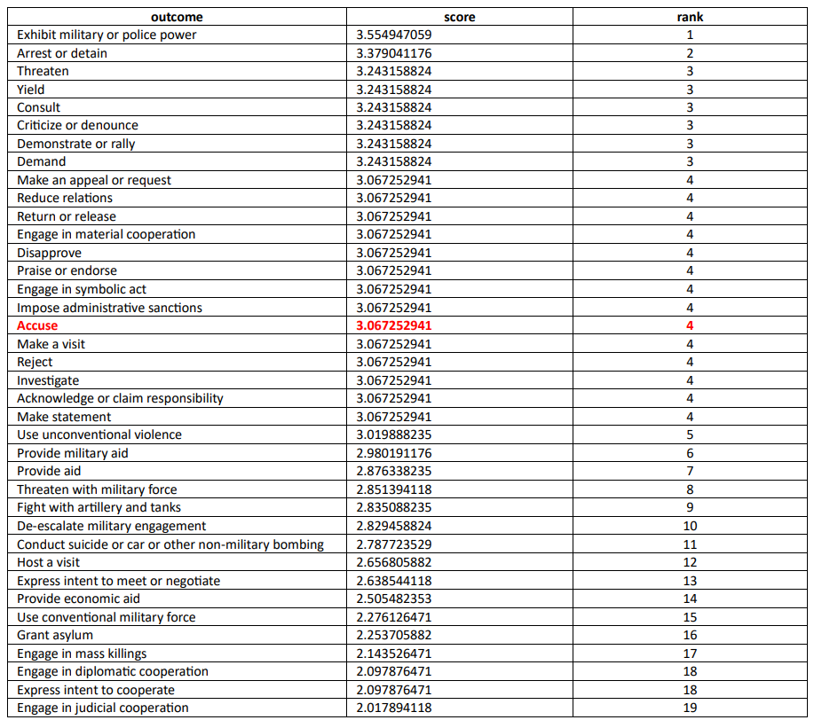

Experiments
To evaluate the performance of our proposed ACH-based inference framework, we conducted experiments using the MIRAI benchmark, introduced by Ye et al. [37], which is designed to assess LLM agents in the context of geopolitical event forecasting. Each MIRAI test query defines a structured prediction task, including a source and target country, a forecast date, and a ground truth event label encoded using the CAMEO schema [6].
Our experimental pipeline mirrors the high-level structure of the MIRAI evaluation framework. For each forecasting query, the system generates early indicators (factors) using an LLM, infers their influence on a predefined hypothesis space (CAMEO relations), retrieves relevant articles from a local news corpus using a retrieval-augmented generation (RAG) approach or manually using the document Ids (given in the test subset files), and computes final hypothesis scores using a matrix-based probabilistic aggregation method.
In our evaluation, we focused specifically on the first-level relation classification, which involves mapping the predicted and ground truth CAMEO codes to their corresponding two-digit top-level relation categories. This enables us to evaluate model performance at a coarser yet still meaningful semantic resolution, aligning with prior work.
To further align with the MIRAI framework, we replicated the benchmark’s “quad” and “binary” relation grouping schemes. However, at this stage, we have only conducted experiments on the quad classification setting, which reduces the 38 original CAMEO classes into four high-level categories: Verbal Cooperation, Material Cooperation, Verbal Conflict, and Material Conflict. This grouping enables us to evaluate the model’s capacity to capture the nature of inter-state interactions while reducing sparsity and class imbalance.
Performance was assessed using standard evaluation metrics: precision, recall, F1 score, and Kullback–Leibler (KL) divergence. These metrics were computed for both our RAG and manual document retrieval pipelines. The results are compared against the MIRAI benchmark’s reported performance, enabling a direct evaluation of the proposed method’s strengths and limitations.
This section presents the experimental design and execution process used to evaluate and refine our ACH-based forecasting pipeline. The experiments were designed iteratively, with each stage introducing targeted improvements based on insights from previous results. The evaluation compared two retrieval strategies — manual extraction and RAG-based retrieval — across three experiments.
These experiments were conducted using the MIRAI benchmark [37], which ensures a standardized evaluation framework and enables direct comparison with MIRAI’s reported results.

First Experiment - Baseline Setup
The first experiment aimed to establish a baseline performance benchmark for the pipeline.

Retrieval Methods
- Manual Extraction: Used manually provided Document IDs (docids) for each query, ensuring a fixed set of documents per event.
- RAG Retrieval (Basic Setup): Implemented directly via Weaviate interface without LangChain orchestration. Retrieval queries consisted only of the two country names (e.g., {C1} {C2}), and the system returned the top 10 most semantically similar documents based on vector similarity, without metadata filtering or advanced strategies.

Findings
While manual extraction provided consistent input, the RAG setup suffered from limited coverage and contextual relevance. The retrieved documents were often irrelevant or loosely related to the forecasting period, leading to unstable rankings and lower overall accuracy.
Compared to MIRAI’s reported metrics [37], our baseline results underperformed, highlighting the need for refinements in indicator generation and retrieval infrastructure.

Second Experiment – Improved Indicators & Enhanced RAG
Building on insights from the first experiment, the second experiment focused on improving both indicator generation and retrieval quality.

Balanced Indicator Generation
In the baseline experiment, the LLM-generated indicators showed a noticeable imbalance across outcome categories, with a bias toward different outcomes each time. This imbalance negatively impacted hypothesis scoring, as some categories were overrepresented while others lacked sufficient supporting evidence.
To address this, we refined the prompt used for indicator generation. The updated prompt explicitly instructed the LLM to generate a balanced set of indicators distributed evenly across the four high-level CAMEO categories (Verbal Cooperation, Material Cooperation, Verbal Conflict, Material Conflict).
Initial Prompt for Indicators Generation:
“You are an intelligence analyst with expertise in international affairs. Your task is to predict a future event involving country: <C1> and country: <C2>. You need to select your prediction from the following list of possible outcomes: '<list of outcomes>'. You monitor news articles for early signs and indicators of social or political developments that might lead to some future outcomes and decrease the likelihood of others. Identify the top ‘<k>’ significant indicators that you would pay attention to for making a prediction.”
Fine-Tuned Prompt for Indicators Generation:
“You are an expert geopolitical analyst assisting with strategic forecasting.
Given a set of possible future outcomes: ‘<list of outcomes>’, your task is to generate a set of early warning indicators that would help identify which outcome is most likely, with at least one indicator specifically designed to assess each outcome independently involving country: ‘<C1>’ and country: ‘<C2>’.
Instructions:
For each outcome, generate at least one unique, realistic, and observable indicator.
Each indicator should be designed to detect early signs or signals that support the specific outcome it is associated with.
Do not repeat indicators across outcomes.
Be concise but informative.
Format your output as a list of indicators with each one tied to the outcome it assesses.”

By enforcing balance in the prompt, the generated indicators became more representative and unbiased, which significantly improved classification accuracy in both manual and RAG-based pipelines during the second experiment.

Enhanced RAG Retrieval Infrastructure
In this experiment, LangChain was introduced to orchestrate the retrieval pipeline, making it modular and more adaptable. Several Key enhancements were applied:

Metadata-Aware Retrieval
Articles stored in Weaviate were enriched with a list of countries supported by the current article's metadata, including the date. This allowed queries to precisely filter documents relevant to specific countries involved and limit retrieval to articles around the forecasting period.

Recent vs. Old Documents
We divided retrieval into two distinct buckets:
- Recent Documents: Articles published on the target date (D).
- Old Documents: Articles published up to 30 days before the target date.
This structure reflected the assumption that the most recent month of news is the most relevant for predicting short-term geopolitical outcomes.

Exponential Time Decay Weighting
To prioritize newer documents without discarding potentially relevant historical context, we applied an exponential decay function:
weight= e-α ∙ days_from_t
where α=0.015.
This choice of α Ensured that documents from 30 days before retained approximately 63% of their weight (as shown in Figure 4), while articles older than a month were naturally deprioritized.
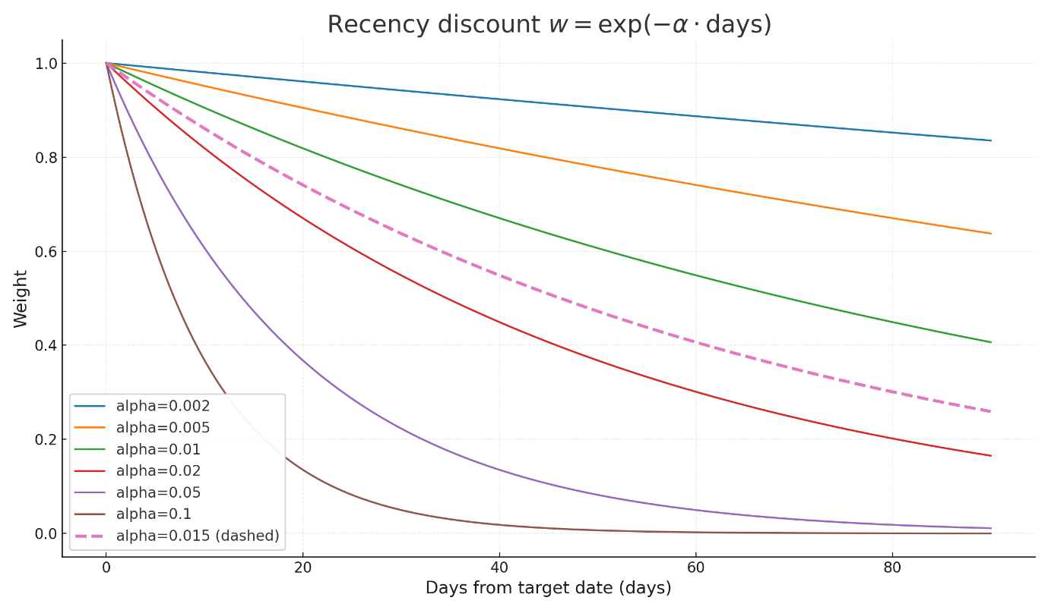
Figure 4: A graph representing different α Values to days from the target date. The dashed line shows the value for α=0.015.

MMR (Maximal Marginal Relevance)
MMR was applied to reduce redundancy by selecting documents that are both highly relevant to the query and diverse in content. This ensured the retrieved evidence set covered multiple perspectives rather than repeating similar information.

RRF (Reciprocal Rank Fusion)
RRF was used to merge multiple ranked lists – for example, combining results from recent and old document retrieval into a single ranking. By leveraging complementary rankings, RRF increased recall and improved evidence completeness.

Findings
The combination of balanced indicators, metadata-aware retrieval, advanced ranking strategies, and time-sensitive weighting significantly improved RAG retrieval quality. Articles were more contextually relevant, coverage was broader, and classification accuracy increased. In this experiment, RAG slightly outperformed manual extraction. This experiment significantly reduced the performance gap and laid the groundwork for further improvements.
These improvements enabled the enhanced RAG pipeline to approach and, in several metrics, exceed MIRAI’s baseline performance, showing significant gains in retrieval relevance and classification accuracy.

Third Experiment – Integrating Deep Analysis
The third experiment aimed to evaluate the impact of incorporating a Deep Analysis step into the pipeline to improve classification consistency and prediction quality. In earlier experiments, we observed that the LLM frequently struggled to differentiate between Verbal and Material categories, especially when articles contained ambiguous signals or lacked explicit descriptions of event types. To address this issue, we introduced Deep Analysis as a second-stage reasoning layer on top of the original ranked results.

Approach
In the Deep Analysis step, we focused on the ranked results generated by the original pipeline. For each query, we took the top-ranked articles. We provided the LLM with their full context, including the names of the involved countries, base descriptions of cooperation or conflict, and relevant text excerpts from the retrieved documents. The LLM was instructed to classify each article into one of three categories: Verbal, Material, or Uncertain when the information was insufficient for a confident decision.
For articles classified as "Verbal" or "Material," the LLM also provided a certainty level, either High or Low, along with a short explanation justifying its choice. To aggregate these outputs, we assigned 1 point for each "High" classification and 0.5 points for each "Low" classification, while ignoring any articles marked as "Uncertain." The cumulative scores for the Verbal and Material categories were then compared, and the category with the higher total score was selected as the final classification. In cases where the scores were tied, we preserved the original top-ranked result from the main pipeline.
This additional reasoning layer addressed ambiguities in the initial predictions, particularly when retrieved articles contained mixed signals or lacked explicit descriptions, leading to improved classification consistency and overall forecast accuracy.

Findings
The integration of the Deep Analysis step had a significant impact on improving classification consistency and overall predictive performance. By introducing a second reasoning layer, the pipeline improved its ability to resolve ambiguities between Verbal and Material event classifications, particularly in cases where articles contained mixed or weak contextual signals.
The improvement was most pronounced in the manual extraction pipeline, where access to highly relevant, curated documents allowed Deep Analysis to make more accurate and confident classifications. In this setting, we observed substantial gains in precision, recall, and F1 scores, alongside a notable reduction in KL divergence, indicating more stable and reliable forecasts.
For the RAG-based pipeline, the gains were more modest but still measurable. Since the retrieved articles via RAG occasionally included noisy or less relevant content, the second-stage reasoning helped reduce misclassifications. Still, its overall impact was limited compared to the manual extraction setup.
However, while manual extraction currently offers slightly higher accuracy due to the quality of curated documents, it comes at the cost of being complex and time-consuming. In contrast, RAG offers a scalable solution by automating the retrieval process, enabling rapid adaptation to new queries and datasets without requiring manual intervention. This makes RAG more suitable for real-world forecasting scenarios where efficiency and coverage are critical.
Deep Analysis further reduced misclassification errors, pushing both manual extraction and RAG pipelines beyond MIRAI’s reported benchmarks on precision and F1 score, while maintaining comparability in KL divergence and accuracy.

Experiments Summary
Across the three experiments, we gradually refined the pipeline to improve both retrieval quality and classification accuracy. In the first experiment, we established a baseline using predefined document IDs and a basic RAG setup, but performance was limited due to imbalanced indicators and restricted retrieval relevance. The second experiment introduced a fine-tuned indicator generation prompt alongside a significantly enhanced RAG infrastructure powered by LangChain and Weaviate, enriched with metadata filtering, MMR, RRF, and exponential time decay weighting. These improvements substantially boosted RAG performance, enabling it to outperform manual extraction when using the refined indicators slightly. In the third experiment, we integrated Deep Analysis, a second-stage reasoning layer designed to resolve ambiguities between Verbal and Material classifications. While manual extraction combined with Deep Analysis achieved the highest overall accuracy due to its reliance on highly relevant, curated documents, RAG with Deep Analysis also improved considerably and approached manual performance. Despite the slight accuracy advantage of manual extraction, its complexity and time-consuming nature make it less practical for large-scale forecasting. In contrast, the RAG-based pipeline offers a scalable and automated solution that can adapt efficiently to new queries and datasets, making it more suitable for real-world applications.

Results
To evaluate the effectiveness of our proposed pipeline for first-level relation classification, we compared our system’s performance with the MIRAI benchmark. As outlined earlier, our experiment focused on the quad setting of relation classification, grouping the original 38 CAMEO codes into four coarse-grained classes: verbal cooperation, material cooperation, verbal conflict, and material conflict.
We evaluated two variations of document retrieval for hypothesis formation:
- Manual Document Extraction: where relevant documents were manually selected based on known relevance.
- RAG-Based Retrieval: using Retrieval-Augmented Generation to retrieve relevant documents for hypothesis scoring automatically.

System performance was measured using precision, recall, F1 score, accuracy, and Kullback-Leibler (KL) divergence to assess the alignment of predicted distributions with ground truth. These metrics enable a direct and meaningful comparison with MIRAI’s results while ensuring alignment with the ground-truth distributions.

Initial Results (Baseline Experiment)
In the first experiment, we established a baseline by evaluating the pipeline using two retrieval strategies: manual document extraction and a basic RAG-based retrieval. For the manual approach, we relied on document IDs provided within the MIRAI dataset, ensuring that the selected articles were highly relevant to each forecasting query.
In contrast, the RAG-based retrieval employed a simple implementation through the Weaviate interface, without utilizing LangChain orchestration or advanced ranking strategies. Queries consisted solely of the two country names involved, and no temporal constraints or contextual filters were applied.
The results highlighted a slight gap between the two methods, with manual extraction being more consistent with the outcomes. As shown in the results in Table 1, manual extraction outperformed the basic RAG across all metrics due to its inherently higher-quality and more relevant documents, with a precision of 23.2%, recall of 38.8%, and an F1 score of 28.8% for manual extraction vs precision of 22.1%, recall of 37% and an F1 score of 27.5% for RAG.
Meanwhile, the RAG pipeline underperformed because the simplistic querying method failed to capture sufficient context, resulting in less accurate retrievals and weaker forecasting performance.
This baseline established a clear motivation for refining both the indicator generation process and the retrieval infrastructure in subsequent experiments.
When compared to MIRAI’s results, both manual extraction and early RAG retrieval underperformed substantially, motivating further iterations to close the performance gap.

Results After Fine-Tuned Indicators
The introduction of the fine-tuned indicator generation prompt marked a significant improvement over the initial experiment. In the baseline setup, both manual extraction and the early, basic RAG retrieval struggled with limited relevance and inconsistent coverage. By refining the indicator generation process, the system produced more balanced and contextually aligned signals, enabling more accurate classification of relationships between countries.
Compared to the initial experiment, the RAG retrieval pipeline showed the most significant gains. Early RAG, which relied solely on simple keyword-based country queries, delivered a precision of 22.1% and an F1 score of 27.5%. After introducing the improved infrastructure with metadata-driven retrieval, MMR re-ranking, RRF fusion, and time-decay weighting (α = 0.015 over a 30-day window), RAG Improved achieved a precision of 51.4% and an F1 score of 34.7%, nearly doubling performance in key metrics while also showing increased accuracy (45% vs. 53% after enhancements).
Similarly, manual extraction with fine-tuned indicators (Manual FT in Table 1) also benefited from the refined signals, improving to a precision of 50.4% and an F1 score of 33.3%. Overall, when comparing the two, ‘RAG Improved’ slightly outperformed ‘Manual FT’ across most metrics.
To better illustrate these improvements, Figures 5 and 6 compare the correct answer rank distributions between the initial experiment and the fine-tuned setup.
We can observe that the most significant change occurred in queries where the correct answer was initially ranked in 3rd place. We can see that the rank 2 bar for RAG did not change noticeably, indicating that most new correctly ranked queries were previously ranked in 3rd place and were moved to rank 1, showcasing the value of the enhanced retrieval pipeline. Meanwhile, we can observe that fine-tuning the indicators prompt also had a substantial effect on the queries ranked in rank 3 for the manual extraction as well. In this case, there is a noticeable change in rank two compared to the initial experiment, which indicates that the fine-tuned prompt has significantly improved the distributions. Yet, it still didn’t manage to reach higher accuracy levels than the ‘RAG Improved’ method. These results demonstrate that the refined indicators generation prompt and the enhanced RAG setup improved retrieval precision and the overall quality of top-ranked evidence, leading to more reliable hypothesis scoring without compromising scalability.
These results demonstrate a clear evolution: while manual extraction has historically provided more controlled, high-quality input, the upgraded RAG pipeline not only closes the gap but also surpasses manual performance in several aspects. Moreover, RAG offers a scalable and automated alternative to manual selection, which is inherently time-consuming and resource-intensive, making it a more practical solution for large-scale forecasting tasks.
Following these refinements, ‘RAG improved’ not only closed the gap but exceeded MIRAI’s reported precision and F1 score, while ‘Manual FT’ also achieved competitive performance.
In addition to the primary evaluation metrics, we also examined the entropy of the output distributions to assess the model's uncertainty in predictions. This analysis was performed on both the MIRAI benchmark results and our pipeline after incorporating the fine-tuned indicators and enhanced RAG retrieval. A detailed explanation and numerical results are provided in Appendix B.
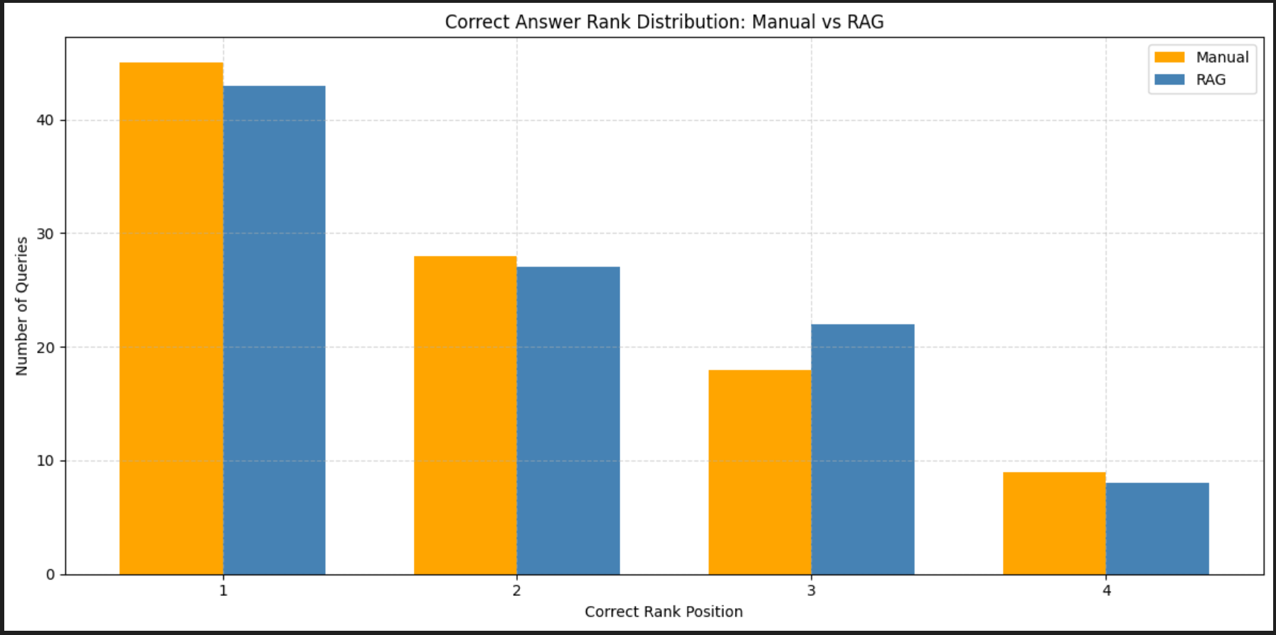
Figure 5: The rank position of the correct label as predicted by the system vs the number of queries for the initial (baseline) experiment.
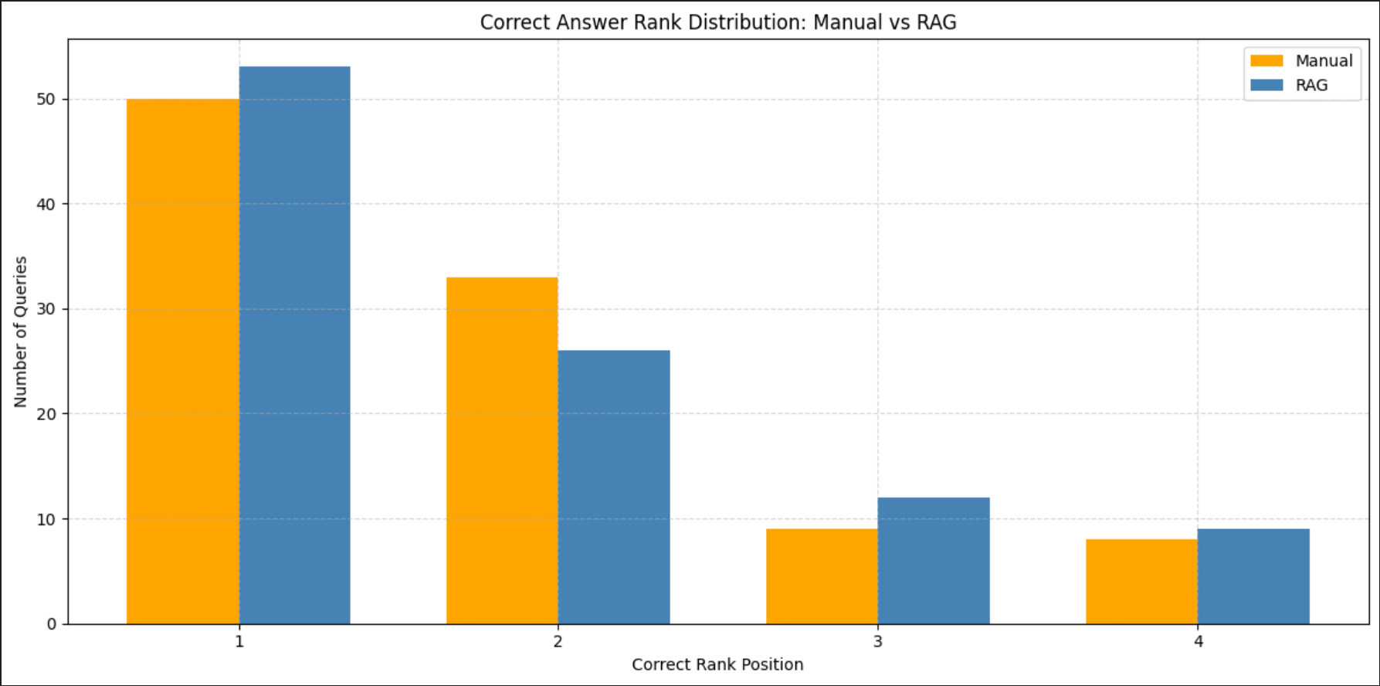
Figure 6: The rank position of the correct label as predicted by the system vs the number of queries for the second experiment (fine-tuned indicators, prompt, and enhanced RAG).

Results After Introducing Deep Analysis
The introduction of the Deep Analysis step further refined the pipeline’s performance by addressing a recurring limitation observed in previous experiments. Earlier, the LLM struggled to distinguish between “Verbal” and “Material” interaction when evaluating article context. This often led to misclassifications, particularly in ambiguous cases such as diplomatic negotiations being categorized as material events.
By incorporating a second-stage reasoning layer, Deep Analysis leveraged the full context of each retrieved article along with certainty-based scoring. For each top-ranked result, the LLM was tasked with assessing whether the article indicated Verbal or Material cooperation or conflict. Then we assigned scores based on the certainty of its predictions. This structured reasoning process enabled the pipeline to resolve conflicting signals across multiple articles and make more consistent, evidence-based decisions.
The impact of this step was especially significant for the manual extraction pipeline. With Deep Analysis, ‘Manual DA’ achieved a precision of 66.7%, a recall of 54.2%, an F1 score of 49.5%, and an accuracy score of 56%, outperforming all other configurations. In contrast, ‘RAG Improved DA’ also benefited from the enhanced reasoning layer but achieved slightly lower gains, reaching a precision of 50.4%, a recall of 51.1%, an F1 score of 50.5%, and an accuracy score of 54%.
While manual extraction with Deep Analysis currently leads in predictive accuracy, ‘RAG Improved DA’ closed much of the gap and remains the more scalable and automated solution. Manual document selection inherently provides higher-quality, domain-relevant context, but it is also time-consuming and resource-intensive. RAG, combined with Deep Analysis, delivers comparable performance without requiring manual curation, positioning it as a practical alternative for large-scale, real-world forecasting tasks.
With Deep Analysis, ‘Manual DA’ and ‘RAG Improved DA’ both surpassed MIRAI’s baseline scores across several key metrics, demonstrating that the proposed pipeline offers competitive or superior performance.
Additionally, we investigated whether a threshold could be identified for selectively applying the Deep Analysis step. Specifically, we examined the delta between the top two ranked hypotheses, assuming that smaller deltas (indicating higher ambiguity) would benefit most from further analysis. However, contrary to expectations, the results showed that lower deltas correlated with higher accuracy rather than lower, and thus no effective threshold could be established. Further details and supporting visualizations are provided in Appendix C.

Metric | RAG Improved DA | RAG Improved | RAG | Manual DA | Manual FT | Manual | MIRAI
Precision (↑) | 50.4% | 51.4% | 22.1% | 66.7% | 50.4% | 23.2% | 47.6%
Recall (↑) | 51.1% | 43.2% | 37% | 54.2% | 41.5% | 38.8% | 58.3%
F1 Score (↑) | 50.5% | 34.7% | 27.5% | 49.5% | 33.3% | 28.8% | 44.2%
KL Divergence (↓) | 0.014 | 5.209 | 10.643 | 0.312 | 0.88 | 10.546 | 5.9
Accuracy (↑) | 54% | 53% | 43% | 56% | 50% | 45% | 42%
Table 1: The final results for the table, showing the results for all methods.

Discussion

Interpretation of Findings
The experiments demonstrated that the refined RAG-based retrieval pipeline, combined with fine-tuned indicator generation, significantly improved performance compared to the initial baseline. While manual extraction maintained slightly higher document relevance, the improved RAG approach achieved comparable accuracy. It outperformed manual selection in several metrics (e.g., precision, recall, F1 score, and accuracy), while also enabling greater scalability.

Trade-offs Between Manual and RAG Pipelines
Manual extraction leverages human judgment to guarantee high-quality documents, but it introduces scalability and efficiency challenges, especially when working with large corpora. In contrast, RAG retrieval automates the process, reducing reliance on manual labor and enabling real-time adaptability. However, its effectiveness depends heavily on the quality of embeddings, prompt design, and filtering mechanisms.

Role of Deep Analysis
The introduction of the Deep Analysis layer significantly improved classification between verbal and material categories, especially for manually retrieved documents. While the RAG pipeline also benefited, manual extraction gained more from this step due to its higher baseline document quality. This highlights an opportunity to optimize RAG retrieval further to close the performance gap.

Scalability and Practical Implications
The improved RAG pipeline demonstrates strong potential for scalable, real-world deployment. By leveraging LangChain and Weaviate, the system can efficiently handle growing corpora and rapidly adapt to new data, enabling broader applicability in geopolitical forecasting and similar domains where fast retrieval and contextual reasoning are critical.

Limitations and Challenges
Despite the significant improvements achieved throughout this project, several limitations and challenges remain that should be considered when interpreting the results:

Abstract-Only Context
Currently, the pipeline utilizes only article abstracts instead of full texts due to the high computational and financial costs associated with embedding and processing complete documents. While abstracts often contain sufficient information, this limitation may cause the system to miss nuanced contextual signals that could improve classification accuracy.

Resource Constraints
Running experiments at scale, especially when testing the complete list of 38 potential CAMEO outcomes, remains highly resource-intensive. Due to the usage limits of the Azure Student OpenAI API, we focused our evaluations on a subset of queries. While sufficient for benchmarking purposes, broader-scale testing would provide a more robust assessment of the pipeline’s capabilities.

Outcome Grouping
Similar to the MIRAI benchmark, our experiments evaluate predictions using the quad-class grouping of CAMEO codes. While this reduces sparsity and facilitates comparisons, it also prevents evaluation at the second-level relation granularity. As a result, finer distinctions between related event types remain unexplored.

RAG Limitations vs. Manual Quality
Although the improved RAG-based retrieval pipeline outperformed manual extraction in several metrics, its effectiveness remains highly dependent on the quality of the embedding and Weaviate indexing. In specific scenarios, manual extraction of documents still produces higher-quality context, suggesting potential gains from hybrid approaches.

Conclusions
This project evaluated an ACH-based inference framework for geopolitical event forecasting, using the MIRAI benchmark [37] as the primary baseline for comparison. MIRAI provides a structured framework for evaluating LLM-based agents, offering ground truth data, task formulations, and reference results. Leveraging this benchmark allowed us to assess our pipeline’s performance meaningfully and ensure comparability with prior work.
By leveraging the MIRAI benchmark as the evaluation baseline, our approach demonstrated iterative improvements that gradually closed the performance gap and ultimately exceeded MIRAI’s reported results across several key metrics.
Over three iterative experiments, we refined both the indicator generation and retrieval processes, achieving a robust and scalable forecasting pipeline. Starting from MIRAI’s baseline, our initial results underperformed its benchmarks, but through iterative improvements, our system gradually closed the performance gap and even surpassed MIRAI on several key metrics. Specifically, incorporating balanced indicator prompts, upgrading RAG retrieval with MMR re-ranking, RRF fusion, and time-decay weighting, and introducing a Deep Analysis layer to better distinguish between verbal and material classifications all contributed to significant gains.
Although manual extraction often yielded more relevant and higher-quality documents, the enhanced RAG pipeline with Deep Analysis and the Manual Extraction with Deep Analysis ultimately achieved better overall performance across precision, F1 score, and accuracy, while maintaining full scalability. Compared to MIRAI’s reported performance, our final pipeline demonstrates competitive or superior results while also introducing design improvements that enhance adaptability to broader forecasting contexts.
Overall, this work demonstrates the value of combining retrieval-aware architectures with LLM-based reasoning and highlights the potential to outperform existing baselines, such as MIRAI, through iterative optimization of retrieval relevance and reasoning fidelity. By enhancing document coverage and automating key stages of the pipeline, we take a significant step toward achieving scalable and accurate geopolitical forecasting.

Future Work
Looking ahead, there are several directions in which this research can be extended to improve performance, scalability, and applicability further:

Benchmark on Larger and Diverse Datasets
Future evaluations should test the generalizability of the pipeline across multiple domains and larger datasets. While the MIRAI dataset provided a strong benchmark for geopolitical event forecasting, broader testing would better assess the system’s robustness and transferability to new contexts.

Refine RAG Retrieval
Improving the Retrieval-Augmented Generation (RAG) component remains a priority. Advanced query optimization strategies, improved similarity metrics, and adaptive retrieval thresholds can enhance recall while maintaining high precision. This could lead to a more comprehensive evidence base for the model’s reasoning.

Explore Multi-Agent LLM Architectures
Introducing a multi-agent setup, where specialized language models handle distinct subtasks (e.g., retrieval, reasoning, classification), could improve robustness and reduce errors. This modular design could enhance both interpretability and flexibility.

Full Article Analysis
Currently, the system relies on article abstracts due to cost and processing constraints. Extending the framework to handle full-text analysis would enable richer contextual understanding, improving forecast accuracy. This requires balancing computational costs with the added benefits of deeper content coverage.

Extend CAMEO Relations
Future experiments could leverage the full granularity of CAMEO’s 38 relation types rather than aggregating into four broad classes. Second-level relation forecasting would capture more nuanced distinctions in inter-state dynamics but would require careful handling of sparsity and class imbalance.

Optimize Prompt Engineering
Exploring reinforcement learning or human-in-the-loop prompt refinement strategies could improve indicator generation and classification accuracy. Optimized prompting would reduce uncertainty and enhance the quality of downstream decisions.

References
[1] Analysis of Competing Hypotheses, https://en.wikipedia.org/wiki/Analysis_of_competing_hypotheses
[2] Benjamin, D. M., Morstatter, F., Abbas, A. E., Abeliuk, A., Atanasov, P., Bennett, S., ... & Galstyan, A. (2023). Hybrid forecasting of geopolitical events. AI Magazine, 44(1), 112-128.
[3] Carbonell, J., & Goldstein, J. (1998, August). The use of MMR, diversity-based reranking for reordering documents and producing summaries in Proceedings of the 21st annual international ACM SIGIR conference on Research and development in information retrieval (pp. 335-336).
[4] Cognitive bias, https://en.wikipedia.org/wiki/Cognitive_bias
[5] Confirmation bias, https://en.wikipedia.org/wiki/Confirmation_bias
[6] Conflict and Mediation Event Observations, https://en.wikipedia.org/wiki/Conflict_and_Mediation_Event_Observations
[7] Cormack, G. V., Clarke, C. L., & Buettcher, S. (2009, July). Reciprocal rank fusion outperforms Condorcet and individual rank learning methods in Proceedings of the 32nd International ACM SIGIR Conference on Research and Development in Information Retrieval (pp. 758-759).
[8] Dempster-Shafer Theory, https://en.wikipedia.org/wiki/Dempster%E2%80%93Shafer_theory
[9] Dhami, M. K., Belton, I. K., & Mandel, D. R. (2019). The “analysis of competing hypotheses” in intelligence analysis. Applied Cognitive Psychology, 33(6), 1080-1090.
[10] Evidential Reasoning Approach, https://en.wikipedia.org/wiki/Evidential_reasoning_approach
[11] Fairfield, T., & Charman, A. E. (2017). Explicit Bayesian analysis for process tracing: Guidelines, opportunities, and caveats. Political Analysis, 25(3), 363-380.
[12] Gao, Y., Xiong, Y., Gao, X., Jia, K., Pan, J., Bi, Y., ... Y Wang, H. (2023). Retrieval-augmented generation for large language models: A survey. arXiv preprint arXiv:2312.10997, 2.
[13] Gruver, N., Finzi, M., Qiu, S., & Wilson, A. G. (2023). Large language models are zero-shot time series forecasters. Advances in Neural Information Processing Systems, 36, 19622-19635.
[14] Heuer, Richards J. Psychology of Intelligence Analysis. Center for the Study of Intelligence, 1999
[15] Hossain, K. T., Harutyunyan, H., Ning, Y., Kennedy, B., Ramakrishnan, N., & Galstyan, A. (2022). Identifying Geopolitical Event Precursors Using Attention-Based LSTMs. Frontiers in Artificial Intelligence, 5, 893875.
[16] Karvetski, C.W., Olson, K.C., Gantz, D.T. et al. Structuring and analysing competing hypotheses with Bayesian networks for intelligence analysis. EURO J Decis Process 1, 205–231 (2013)
[17] Kejriwal, M. (2021). Link Prediction between Structured Geopolitical Events: Models and Experiments. Frontiers in Big Data, 4, 779792. 15
[18] Kunkler, K. S., & Roy, T. (2023). Reducing the impact of cognitive bias in decision making: Practical actions for forensic science practitioners. Forensic Science International: Synergy, 7, 100341.
[19] LangChain, https://js.langchain.com/docs/concepts/why_langchain/
[20] LangChain and Its Role in Building Robust Rag Systems, https://blog.gopenai.com/langchain-and-its-role-in-building-robust-rag-systems-2808b7e5ddb9
[21] Mikolov, T., Chen, K., Corrado, G., & Dean, J. (2013). Efficient estimation of word representations in vector space. arXiv preprint arXiv:1301.3781.
[22] Minaee, S., Mikolov, T., Nikzad, N., Chenaghlu, M., Socher, R., Amatriain, X., & Gao, J. (2024). Large Language Models: A Survey. arXiv preprint arXiv:2402.06196
[23] Mirtaheri, M., Abu-El-Haija, S., & Hossain, T. (2019). Tensor-based method for temporal geopolitical event forecasting. In the ICML Workshop on Learning and Reasoning with Graph-Structured Data.
[24] Lidén, M., Thiblin, I., & Dror, I. E. (2023). The role of alternative hypotheses in reducing bias in forensic medical experts’ decision-making. Science & Justice, 63(5), 581-587.
[25] MacLean, C. L. (2022). Cognitive bias in workplace investigation: Problems, perspectives and proposed solutions. Applied Ergonomics, 105, 103860.
[26] Martyn, P. (2021). Using Quantitative Analytical Methods to Support Qualitative Data Analysis: Lessons Learnt During a PhD Study. Accounting, Finance & Governance Review, 27, 70-80.
[27] Meerveld, H. W., Lindelauf, R. H. A., Postma, E. O., & Postma, M. (2023). The Irresponsibility of Not Utilizing AI in the Military. Ethics and Information Technology, 25(1), 14.
[28] Multi-Agent LLM Applications | A Review of Current Research, Tools, and Challenges, https://newsletter.victordibia.com/p/multi-agent-llm-applications-a-review
[29] Robust Decision-Making, https://en.wikipedia.org/wiki/Robust_decision-making
[30] RootClaim, https://www.rootclaim.com/
[31] Roy, D., Srivastava, R., Jat, M., & Karaca, M. S. (2022). A complete overview of analytics techniques: descriptive, predictive, and prescriptive. Decision intelligence analytics and the implementation of strategic business management, 15-30.
[32] Su, J., Jiang, C., Jin, X., Qiao, Y., Xiao, T., Ma, H., Wei, R., Jing, Z., Xu, J., & Lin, J. (2024). Large language models for forecasting and anomaly detection: A systematic literature review. arXiv preprint arXiv:2402.10350.
[33] Tan, M., Merrill, M., Gupta, V., Althoff, T., & Hartvigsen, T. (2025). Are language models actually useful for time series forecasting? Advances in Neural Information Processing Systems, 37, 60162- 60191.
[34] Top 7 Best Vector Databases, DataCamp, https://www.datacamp.com/blog/the-top-5-vector-databases
[35] Whitesmith, Martha. Cognitive Bias in Intelligence Analysis: Testing the Analysis of Competing Hypotheses Method. Edinburgh University Press, 2020
[36] Xepapadeas, A. (2024). Uncertainty and climate change: The IPCC approach vs decision theory. Journal of Behavioural and Experimental Economics, 109, 102188.
[37] Ye, C., Hu, Z., Deng, Y., Huang, Z., Ma, M. D., Zhu, Y., & Wang, W. (2024). Mirai: Evaluating LLM agents for event forecasting. arXiv preprint arXiv:2407.01231.

Appendix A – Deep Analysis Prompt
“You are a geopolitical analyst. Your task is to assess international news articles and forecast the nature of future relations between two countries, based on the textual context.
We are analyzing the likely future relationship between {} and {}, using the news article provided below. It is already established that the relationship will be classified as ‘<Cooperation/Conflict >’, meaning: ‘<Cooperation/Conflict description>’.
Your task is to determine the type of this relationship based on the news article:
- Material ‘<Cooperation/Conflict >’ - typically involves: ‘<Material Cooperation/Conflict description>’
- Verbal ‘<Cooperation/Conflict >’ - typically involves: ‘<Verbal Cooperation/Conflict description>’
Please provide the following:
- Predicted relation type: verbal, material, or uncertain
- Certainty level: high or low (if verbal or material)
- Explanation: A concise justification based on evidence from the article
News Article:
‘<Article Context>’”

Appendix B – Entropy Analysis of Prediction Distributions
In addition to evaluating standard performance metrics such as precision, recall, F1 score, accuracy, and KL divergence, we also examined the entropy of the output distributions. Entropy provides a measure of the uncertainty associated with the model’s predictions. Lower entropy indicates that the model assigns higher confidence to its preferred classification, while higher entropy reflects greater uncertainty or a more uniform distribution of probabilities across categories.

Methodology
Entropy was computed using the Shannon entropy formula over the probability distribution of the four quad-class categories (Verbal Cooperation, Material Cooperation, Verbal Conflict, Material Conflict). For each query, the model produced probability scores for the four possible outcomes, and the entropy was calculated as:
Hp= -i=1npi∙ log(pi)
Where pi represents the predicted probability for the class i. The results presented here are the average entropy across all queries for each system.

Results
The average entropy values for the MIRAI benchmark and our pipelines are shown below:
System | Average Entropy
Manual FT | 0.1444
RAG Improved | 0.1421
MIRAI | 0.6745
Table B.1: The calculated average entropy per system.

Interpretation
The results demonstrate a substantial reduction in entropy for both our pipelines compared to the MIRAI benchmark. While MIRAI’s outputs exhibited an average entropy of 0.6745, indicating relatively high uncertainty in its predictions, our pipelines achieved much lower values: 0.1444 for Manual FT and 0.1421 for RAG Improved. This suggests that our approaches not only improved classification performance but also produced more confident predictions.
Notably, the RAG Improved pipeline yielded the lowest entropy, reflecting both the effectiveness of the refined indicator prompts and the enhanced retrieval infrastructure. These results reinforce the observation that our system consistently produces more decisive outputs than MIRAI, while maintaining scalability and competitive accuracy.

Appendix C – Threshold-Based Deep Analysis Exploration

Motivation
After implementing the Deep Analysis step, we sought to investigate whether its application could be optimized by introducing a threshold mechanism. The underlying hypothesis was that when the confidence gap between the top two ranked hypotheses was small, the system’s decision was more ambiguous. Thus, additional Deep Analysis might yield improved accuracy. Conversely, if the confidence gap was large, the top-ranked hypothesis could be accepted directly without the added computational overhead of Deep Analysis.

Methodology
To test this hypothesis, we calculated the delta between the scores of the top two-ranked hypotheses for each query. We then measured the accuracy of the system when applying Deep Analysis only to queries falling below different delta thresholds. This analysis was performed on queries where the correct answer appeared in either rank one or rank two, as these cases best capture ambiguity between competing hypotheses.
Two plots were generated:
- A raw accuracy vs. delta threshold curve (Figure 7), showing the direct relationship between delta values and accuracy.
- A smoothed version of the curve (figure 8), applying a quantile-based smoothing technique to highlight overall trends better and minimize noise.

Results
Contrary to our expectations, the results revealed that smaller deltas, which were assumed to reflect greater ambiguity, actually correlated with higher accuracy. This trend was consistent in both the raw and smoothed curves. As delta values increased, accuracy decreased, suggesting that the system was most reliable in cases of close competition between hypotheses.
Figures C.1 and C.2 illustrate these findings.
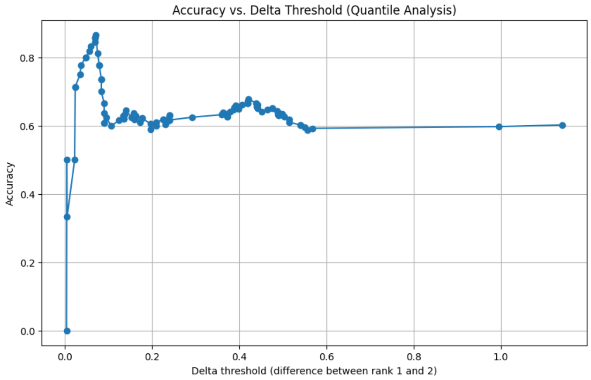
Figure C.1: Raw accuracy vs. delta threshold (per-query deltas)
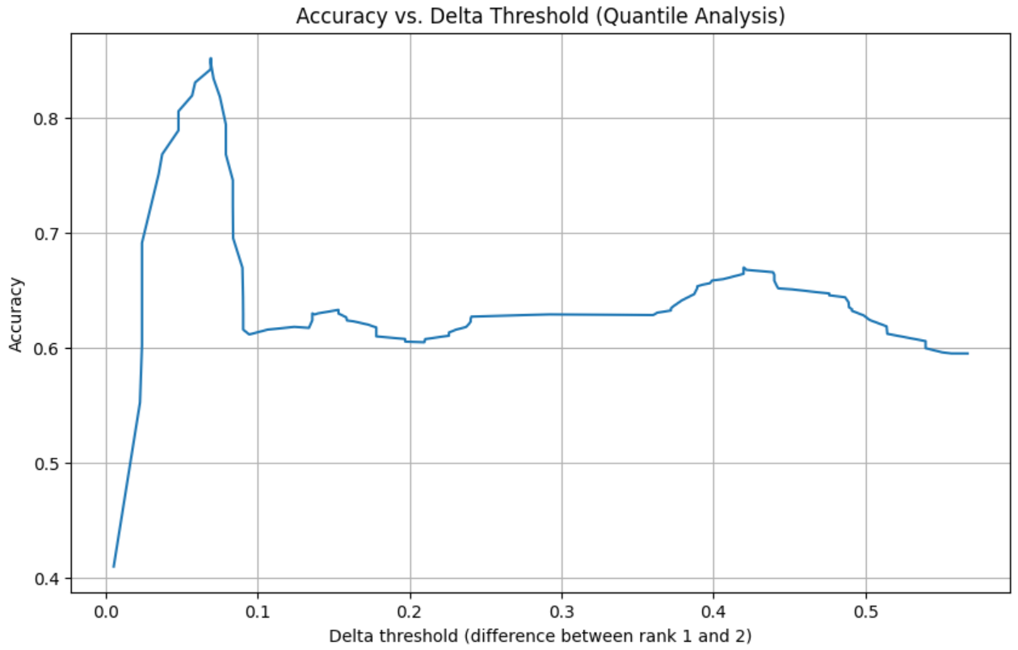
Figure C.2: Smoothed accuracy vs. delta threshold (quantile analysis).

Interpretation
The observed trend implies that introducing a simple thresholding mechanism to trigger Deep Analysis is not effective. Instead of improving decision quality in ambiguous cases, the analysis showed that the system already performed well when deltas were small. As deltas grew larger, the accuracy deteriorated, likely due to weaker overall evidence rather than decision ambiguity.
This finding highlights a potential limitation of threshold-based heuristics in pipeline orchestration. Future work may consider alternative strategies, such as dynamic confidence calibration or probabilistic uncertainty estimation, to more effectively determine when additional reasoning steps, like Deep Analysis, should be applied.

