Driver or Vehicle? Signature-Based Attribution of Excess Fuel Consumption
Working draftv0.3 (revised)

Driver or Vehicle? Signature-Based Attribution of Excess Fuel Consumption
Using Public Fleet Telemetry and an Engine-Fault Bench
Alexander Partsin
Draft skeleton — results current as of the latest experiment run
This page is a living paper draft. Every number is a computed result traceable to a script in scripts/ and an entry in RESULTS.md. References validated with bibtest.
Contents
- Abstract
- Introduction
- Related work
- Data
- Method
- Arm 1: driver-behaviour decomposition (VED)
- Arm 2: malfunction fuel signature (EngineFaultDB)
- Attribution: signature contrast and accuracy
- Scope and limitations
- Reproducibility
- References

Abstract
Excess fuel consumption has two very different causes with the same symptom: a driver who accelerates hard and a vehicle that is running rich both burn more than they should. We show that the two causes leave separable signatures. Driver-caused excess is transient and kinematic; malfunction -caused excess is steady-state and combustion-linked. We build an expected-fuel model on real fleet telemetry (Vehicle Energy Dataset, VED), decompose each trip's excess into a driver-behaviour component and a persistent vehicle-baseline component, and validate the behaviour component on an independent labelled driving dataset. On a controlled engine-fault dataset (EngineFaultDB) we show a rich-mixture fault produces measurable excess fuel (+6.2%) with an emissions/AFR signature. A cross-dataset signature contrast supports the central claim: a combustion axis, measurable in both worlds, is silent for driver-caused excess on the fleet (R² 0), and that silence survives a trim-corrected fuel target and holds within the highest-trim vehicles. On semi-synthetic ground truth, where both causes raise fuel by the same amount, the signature attributes driver-versus-fault excess at 96% (95% CI [0.956, 0.962]) while fuel magnitude alone is at chance. The fleet fuel model reaches R² 0.673 (95% CI [0.628, 0.709]); driving behaviour and a persistent vehicle-baseline account for 8% and 14% of trip-fuel variance respectively.

Contributions
- A signature-based framework that attributes excess fuel to driver behaviour vs vehicle malfunction using only public data.
- A variance decomposition of trip fuel on a 197-vehicle, 14.5k-trip public fleet into behaviour, vehicle-baseline, and environment components.
- A cross-dataset signature contrast: the combustion axis is silent for driver-caused excess (R² 0), a silence that survives trim-corrected fuel and the highest-trim vehicles, ruling out a measurement artifact.
- A measured attribution accuracy of 96% (95% CI [0.956, 0.962]) on semi-synthetic ground truth at a bench-calibrated fault magnitude, where fuel magnitude alone is at chance.
- External validation of the behaviour axis (driver-held-out AUC 0.96, permutation p 0.03) and an honest account of the field-wide absence of any joint fuel+fault+behaviour dataset.

1. Introduction
Fuel is the largest controllable operating cost of a vehicle fleet and a direct driver of tailpipe emissions. When a vehicle burns more than expected, an operator faces a decision with two very different remedies: coach the driver, or service the vehicle. The two causes present the same symptom. Aggressive acceleration and a rich-running engine both raise consumption, and a raw fuel-per-distance figure cannot tell them apart.
We treat this as an attribution problem. Given a trip that consumed more fuel than its route and conditions warrant, how much of the excess is the driver, and how much is the vehicle? The question is operationally valuable and, on public data, largely unanswered: fuel-modelling work predicts consumption without decomposing its causes, driving-behaviour work scores the driver in isolation, and predictive-maintenance work rarely treats fuel efficiency as the symptom.
Our approach rests on a physical observation: the two causes leave different signatures. Driver excess is transient and kinematic, expressed in acceleration, jerk, and harsh events at a normal air-fuel ratio. Malfunction excess (a rich mixture) is steady-state and combustion-linked, expressed as a shift of the air-fuel ratio away from stoichiometric and in the exhaust chemistry. We build an expected-fuel model on real fleet telemetry, decompose each trip's excess into behaviour and vehicle-baseline components, validate the behaviour axis on an independent labelled dataset, and test the central claim both as a cross-dataset signature contrast and as a measured attribution accuracy on semi-synthetic ground truth. The contributions are listed above.

2. Related work
Four largely separate literatures meet here: fuel-consumption modelling from OBD/telematics (physics models VSP [7] and VT-Micro [8]; modern ML where tree ensembles lead), eco-driving and driving-behaviour scoring, vehicle predictive maintenance, and telemetry anomaly detection. The nearest prior work is Barbado and Corcho, who detect fuel-consumption anomalies with explainable feature relevance and counterfactuals, but do not separate cause into driver versus mechanical.
Fuel-consumption modelling. Physics-based models map instantaneous kinematics to fuel and emissions: vehicle specific power [7], the VT-Micro regression family [8], and the power-based VT-CPFM [11]. Data-driven models now lead on OBD and telematics inputs; tree ensembles are the reliable workhorse and beat both neural baselines and the ECU estimate on ground-truth fuel meters [4], and kernel methods map engine parameters to fuel rate from OBD-II [9]. These models predict consumption accurately but do not decompose its causes.
Eco-driving and behaviour scoring. Driving style moves fuel use substantially; data-driven eco-driving reviews report double-digit savings from smoother driving [5], and recent reviews survey behaviour-to-fuel machine learning specifically [15]. Driver behaviour has been classified from OBD and used to predict fuel use [12], recognized as a driving style from smartphone inertial sensors [14], and linked to efficiency through drive-cycle simulation [13]. This literature scores the driver in isolation and does not separate the driver's contribution from the vehicle's.
Predictive maintenance and engine-fault diagnosis. Fault-diagnosis work detects sensor and actuator faults in the air-fuel path from telemetry, including neural detection and isolation of multiple engine-sensor faults [16], fault-tolerant handling of the mass-air-flow sensor [17], and deep-learning fault diagnosis from driving signals [18]. These target the fault directly but treat fuel efficiency as an input, not as the symptom to be attributed.
Telemetry anomaly detection. The detector toolbox is mature: isolation forest [19], one-class methods, and autoencoder or recurrent models. In the automotive setting most of this work targets CAN-bus intrusion and safety rather than fuel efficiency, for example LSTM autoencoders [20], recurrent autoencoders [21], and spatiotemporal detection for connected vehicles [22]. These methods flag anomalies but do not assign a fuel anomaly to a driver-versus-vehicle cause.
Explainable attribution and the nearest prior work. Feature-attribution methods such as SHAP [23] explain a model's output in terms of its inputs. The nearest prior work applies this to our exact problem: Barbado and Corcho detect fuel-consumption anomalies with explainable feature relevance and counterfactual recommendations on fleet data [3]. It identifies which features co-occur with an anomaly but does not assign the anomaly to a driver-versus-mechanical cause. Fuel theft or leakage is a related but distinct anomaly, detected as an abrupt change point [10], a sudden step rather than the sustained efficiency shift we attribute. Our signature-based decomposition is the increment: from feature relevance to externally validated, cause-labelled components.
Approach | Detects excess | Ranks features | Attributes cause  (driver vs vehicle)
Fuel modelling + residual threshold [4] | yes | no | no
Eco-driving / behaviour scoring [5] | driver only | partial | no
Anomaly detection + feature relevance [3] | yes | yes | no
This work | yes | yes | yes (measured, 96%)

3. Data
Dataset | Role | Ground truth | Scale used | License
Vehicle Energy Dataset (VED) | Driver arm | Real fleet, driving behaviour | 197 ICE cars / 14,460 trips | Apache-2.0
EngineFaultDB | Malfunction arm | Labelled engine faults | 55,999 samples | GPL-3.0
Driving Events (Zenodo 6570972) | Behaviour validation | Aggressive vs non-aggressive | 3 drivers / 169 events | CC-BY-4.0
No single public dataset carries fuel consumption, mechanical-fault labels, and driver behaviour together; this documented gap motivates the two-arm design. VED fuel is derived from the mass air-flow signal (the OBD fuel-rate PID is unpopulated); the analysis is restricted to gasoline (ICE) vehicles and trips are resampled to 1 Hz.

4. Method

4.1 Expected-fuel model and excess
Per trip we predict fuel per 100 km from trajectory-derived driving features and trip conditions using gradient boosting, with out-of-fold predictions grouped by vehicle so no vehicle is scored by a model that has seen it. Excess is the positive residual against this expectation.

4.2 Two axes
Kinematic axis: transient aggression (positive acceleration, jerk, harsh-event rate, speed variability). Combustion axis: deviation of the air-fuel ratio from stoichiometric, measured as fuel trims in VED and directly as AFR/lambda in EngineFaultDB, placed on a common percent-fuel-per-air scale.
Fuel is derived from the mass air-flow signal at stoichiometric ratio, L/hr = MAF / 14.7 / 745 × 3600, and integrated per trip to fuel per 100 km. Driving features are speed mean and variability, positive acceleration, jerk, harsh-acceleration and harsh-braking rates, idle fraction, stops per km, highway fraction, and vehicle specific power. Conditions are ambient temperature, air-conditioning and heater power, weight, distance, and duration. The vehicle-baseline term is the per-vehicle mean out-of-fold residual, the systematic deviation of a vehicle from the fleet after driving and conditions are removed. The behaviour component is a counterfactual: the model's predicted fuel for the observed driving minus its prediction when the aggression features are set to a gentle reference, holding conditions fixed.

4.3 The combustion axis in both worlds
The combustion axis is deviation of the air-fuel ratio from stoichiometric. In VED it is observed as short- and long-term fuel trims (the engine's own correction). On the engine-fault bench it is observed directly as the air-fuel ratio and lambda. Both are placed on a common percent-fuel-per-air scale, which lets the same axis be tested against driver-excess and fault-excess.

5. Arm 1: driver-behaviour decomposition (VED)
The expected-fuel model reaches R² = 0.673 (95% CI [0.628, 0.709]; MAPE 13.3% [12.3, 14.3]) with vehicle-grouped cross-validation, and is stable across seeds (0.672–0.676). Confidence intervals are cluster bootstraps over vehicles (1,000 resamples). Variance decomposition of trip fuel:
Component | Share of fuel variance | 95% CI
Environment / route (distance, speed regime, temperature, weight) | 0.593 | [0.542, 0.636]
Driving behaviour (unique marginal over environment) | 0.080 | [0.060, 0.102]
Vehicle-baseline (persistent per-vehicle effect) | 0.143 | [0.114, 0.174]
Unexplained | 0.185 | —
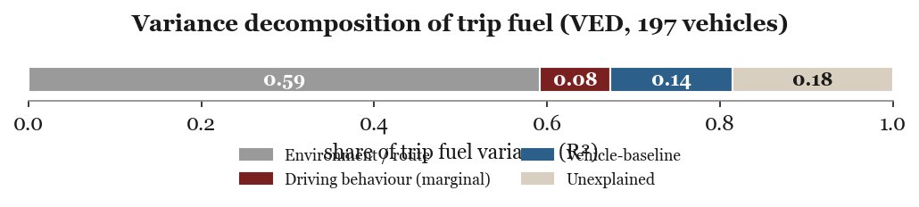
Figure 1. Variance decomposition of trip fuel on VED. Route and environment dominate; driving behaviour adds a unique 8%, and a persistent vehicle-baseline accounts for 14%.
The vehicle-baseline is real and largely not size-driven: regressing the per-vehicle effect on engine displacement and weight explains only 23% of it. A gentle-driving counterfactual saves a median 0.47 L/100km (about 5% of median fuel), rising monotonically across aggression deciles.
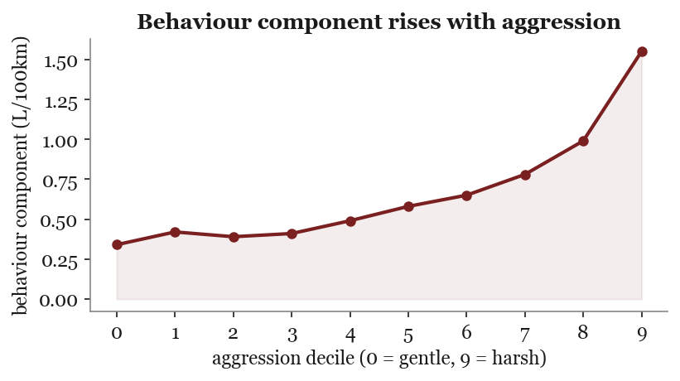
Figure 2. The counterfactual behaviour component (fuel above a gentle-driving reference) rises monotonically from gentle to harsh driving deciles.

5.1 Behaviour-axis external validation
On the independent Driving Events dataset (169 events, 143 aggressive / 26 non-aggressive, 3 drivers), kinematic amplitude features separate aggressive from non-aggressive events with the driver held out: logistic-regression AUC = 0.958 (95% CI [0.927, 0.981]; per-driver 0.98 / 0.93 / 0.99). A random forest reaches 0.79; with only two training drivers per fold the linear model generalizes across drivers better, and we report both. A 1,000-permutation test collapses the AUC to chance (mean 0.471, p = 0.001). This validates that kinematic amplitude features transfer to an independent accelerometer dataset; it is a different sensing regime (400 Hz smartphone inertial vs 1 Hz OBD), and derivative jerk does not transfer at 400 Hz (AUC 0.48, noise-dominated), consistent with amplitude rather than derivative carrying the signal.
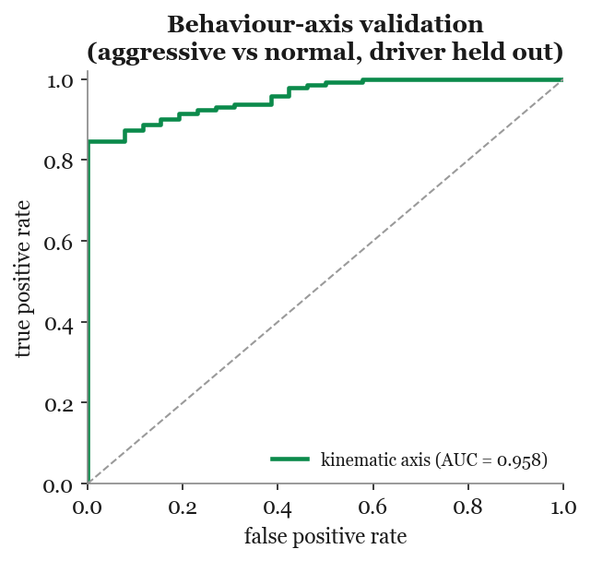
Figure 3. Kinematic features separate aggressive from normal driving on an independent dataset with the driver held out (AUC 0.958).

6. Arm 2: malfunction fuel signature (EngineFaultDB)
Training the fuel model on normal operating points and scoring faults at matched operating point, the rich-mixture fault burns +6.2% excess fuel (AFR 13.68 vs 14.07; brake-specific fuel consumption +10.6%). Lean and ignition faults are not excess-fuel faults. The rich-fault excess correlates with the combustion signature (CO, HC, AFR), not with kinematics. Operating-point overlap between the normal and rich samples is close (standardized mean differences: RPM 0.09, power 0.27, speed 0.09), so the matched comparison is not driven by regime imbalance. The fault-0 reference is itself moderately rich (lambda 0.957, CO 2.16%), which biases the +6.2% estimate downward, that is, conservatively. The three fault classes are rich mixture, lean mixture, and low-voltage ignition; the lean-versus-ignition label mapping is taken from the source paper's text and does not affect the rich-fault result.
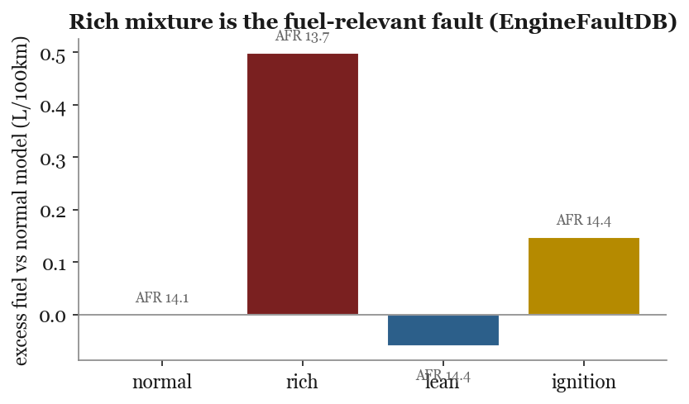
Figure 4. Excess fuel at matched operating point by fault class. Only the rich mixture (low AFR) burns measurably more; lean and ignition faults do not.

7. Attribution: signature contrast and accuracy
Excess is defined net of context in each dataset; each axis is regressed on the excess it is meant to explain. The informative cell is the combustion axis on driver-excess.
Axis | Driver-excess (VED) | Fault-excess (bench)
Kinematic (transient aggression) | 0.107 | n/a (steady-state)
Combustion (AFR / fuel trim) | −0.039 | 0.903*
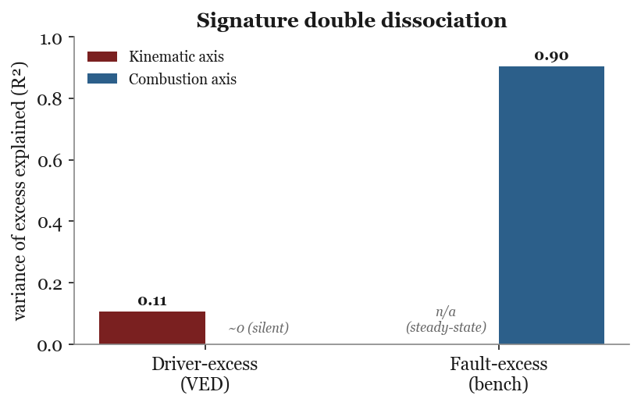
Figure 5. Signature contrast. The combustion axis is silent for driver-caused excess (R² ~0) while the kinematic axis carries the driver signal; the combustion cell on the bench (starred) is physically expected, not the claim.
The combustion axis is silent for driver-caused excess (R² ~0), while the kinematic axis carries it. Combined with the 96% attribution accuracy below, this is the core evidence that the two causes separate by signature. We deliberately do not headline the bench combustion cell.
*Why the bench cell is not the claim. On the bench, air-fuel ratio and fuel are physically coupled (a rich mixture is extra fuel), so a combustion axis explaining fault-excess is expected rather than discovered. The multivariate R² of 0.903 is carried mainly by CO (R² 0.73) and HC (0.44), the unburnt-fuel emission products, with AFR and lambda perfectly collinear (r = 1.0) at 0.12 each; the earlier univariate correlation (r 0.33) understates it because a single AFR transform misses the emission channels. We therefore treat this cell as a physical consistency check and rest the claim on the silent driver-excess cell and the attribution accuracy.
We call this a signature contrast rather than a full double dissociation: of the 2×2, one cell is physically forced (combustion on fault-excess), one is structurally absent (kinematic on the steady-state bench), and the two evidential cells are the silent combustion axis on driver-excess and the kinematic axis carrying the driver signal.

7.1 Comparison to detection and feature-relevance baselines
Existing methods detect excess and rank features but do not attribute cause. A standard anomaly detector (isolation forest on trip features) yields a single anomaly score that tracks excess weakly (r 0.16) and does not recover the vehicle-baseline component (r −0.01); it flags anomalies without a cause label. Permutation-importance feature relevance, the surrogate used by prior anomaly work, ranks speed and weight highest but produces no per-trip driver-versus-vehicle split. A pooled model that does not model the vehicle leaves 1.23 L/100km of per-vehicle systematic effect unattributed. Because no cause-labelled trip benchmark exists (Section 8), this is a capability contrast rather than a labelled-accuracy comparison: our method adds the per-trip decomposition the baselines cannot produce.

7.2 Attribution accuracy (semi-synthetic ground truth)
To measure attribution directly, we inject driver-caused and fault-caused excess into 11,520 real VED trips (139 vehicles) with the same fuel increase for both, so fuel magnitude alone carries no information about the cause. Driver excess adds signal to the kinematic axis; fault excess adds signal to the combustion axis; real-trip deviations supply the confounding noise, and the injected strength S is expressed in units of natural within-vehicle variation. A signature attributor (kinematic and combustion deviations from the vehicle baseline, cross-validated with the vehicle held out) recovers the cause; a fuel-magnitude baseline cannot.
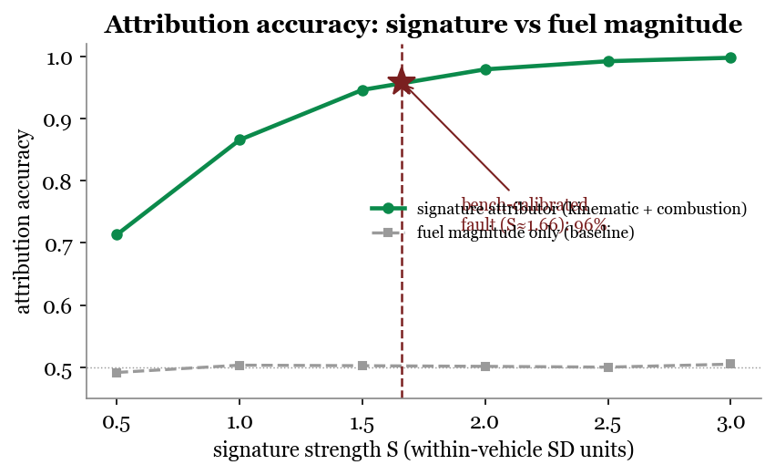
Figure 6. Attribution accuracy rises with signature strength and reaches 96% at the effect size calibrated to the measured rich-mixture fault (S ≈ 1.66), while the fuel-magnitude baseline stays at chance (50%). Fuel tells you that a trip is anomalous; the signature tells you why.
At the bench-calibrated fault magnitude the signature attributor reaches 96% accuracy (95% CI [0.956, 0.962], F1 0.959, near-symmetric errors), against a fuel-only baseline pinned at chance. This measures attribution rather than asserting it, and by controlling the injected effect size it sidesteps the trim-blindness of the fleet fuel target and the healthy-fleet range restriction addressed next.
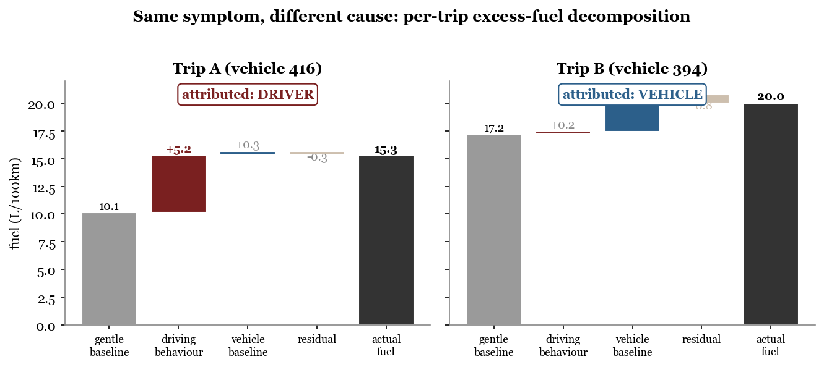
Figure 7. Two real trips with the same symptom and opposite causes. Trip A burns 5.2 L/100km above its gentle-driving baseline, almost all of it driving behaviour; Trip B burns 2.8 above baseline, almost all of it a persistent vehicle-baseline offset. Fuel per distance alone cannot tell them apart; the decomposition attributes each to its cause.

7.3 Robustness of the silent-combustion result
Two threats could make the silent combustion cell an artifact rather than a finding. Both are ruled out. Trim-blindness: the fleet fuel target is derived from mass air-flow at stoichiometric ratio, which ignores the trim-driven fuel fraction and could suppress the combustion axis by construction. Re-deriving fuel with the trim correction (MAF×(1+STFT+LTFT)/14.7) moves the combustion axis on driver-excess only from R² −0.03 to +0.01; it stays silent, because the ignored fraction is small in this healthy fleet (median 1.5%, p90 11%). Range restriction: if VED simply had no combustion variance, the axis could not correlate with anything. It does have variance (within-vehicle LTFT SD 1.8%, between 4.4%); restricting to the highest-trim quartile of vehicles (47 vehicles) still gives a near-zero excess-versus-trim correlation (r −0.14). The silence therefore reflects that driver-caused excess is genuinely not combustion-linked, not a measurement or sampling artifact.

8. Scope and limitations
- Driver and fault ground truths live in different datasets, so the signature contrast is cross-dataset. The semi-synthetic experiment provides the single-trip competing-cause evaluation that no real dataset supports; a real joint fuel+fault+behaviour benchmark remains a community need.
- VED has effectively one driver per vehicle, so per-trip driver-versus-vehicle causation is not identifiable at the unit level from observation alone; the decomposition is model-based and its attribution is validated on injected ground truth.
- EngineFaultDB is a controlled test bench with no driver context; the fuel-relevant fault is the rich mixture. The lean-versus-ignition label mapping is taken from the source paper's text.
- Telematics are resampled to 1 Hz; fine transient dynamics are smoothed. The behaviour-axis transfer is shown for amplitude features across sensing regimes, not for the exact VED feature set.
- The semi-synthetic injection assumes additive, axis-separable effects; real faults may co-move both axes, which would make attribution harder than the controlled estimate.

8.1 Responsible use
Driver-side attribution is, in fleet practice, a form of worker monitoring, and an attribution error that blames a driver for a mechanical fault (or the reverse) has real consequences for pay and employment. The method should be used with calibrated uncertainty and human review, never as an automatic verdict; the per-trip output is a decomposition with error bars, not a judgment.

9. Reproducibility
Pipeline scripts (scripts/p1_features.py through scripts/p6_attribution.py), the phase plan (PLAN.md), the full results log (RESULTS.md), and diagnostic notes (diagnostics/) accompany this repository. Datasets are obtained from their original sources (VED, EngineFaultDB, Zenodo 6570972) and are not redistributed here.
Environment: Python 3.14, scikit-learn 1.8, pandas 2.3, scipy 1.17, pyarrow. Datasets: VED github.com/gsoh/VED; EngineFaultDB github.com/leoxthomas/EngineFaultDB; Driving Events zenodo.org/records/6570972. Place them under data/raw/ and run scripts/p1_features.py through scripts/p7_baselines.py in order. Every number on this page traces to one of these scripts and an entry in RESULTS.md.

10. References
All entries validated against Crossref/OpenAlex/DataCite (bibtest).
- G. Oh, D. J. LeBlanc, H. Peng. Vehicle Energy Dataset (VED), A Large-scale Dataset for Vehicle Energy Consumption Research. IEEE Transactions on Intelligent Transportation Systems, 2020. 10.1109/TITS.2020.3035596
- L. Thomas et al. EngineFaultDB: A Novel Dataset for Automotive Engine Fault Classification and Baseline Results. IEEE Access, 2023. 10.1109/ACCESS.2023.3331316
- A. Barbado, Ó. Corcho. Interpretable machine learning models for predicting and explaining vehicle fuel consumption anomalies. Engineering Applications of Artificial Intelligence, 2022. 10.1016/j.engappai.2022.105222
- H. Abediasl, A. Ansari, V. Hosseini, C. R. Koch, M. Shahbakhti. Real-time vehicular fuel consumption estimation using machine learning and on-board diagnostics data. Proc. IMechE Part D, 2024. 10.1177/09544070231185609
- P. Fafoutellis, E. G. Mantouka, E. I. Vlahogianni. Eco-Driving and Its Impacts on Fuel Efficiency: An Overview of Technologies and Data-Driven Methods. Sustainability, 13(1):226, 2021. 10.3390/su13010226
- J. Vieira et al. Driving Events Dataset. Zenodo, 2022. 10.5281/zenodo.6570972
- J. L. Jimenez-Palacios. Understanding and quantifying motor vehicle emissions with vehicle specific power and TILDAS remote sensing. PhD thesis, MIT, 1999.
- K. Ahn, H. Rakha, A. Trani, M. Van Aerde. Estimating Vehicle Fuel Consumption and Emissions based on Instantaneous Speed and Acceleration Levels. Journal of Transportation Engineering, 128(2):182–190, 2002. 10.1061/(ASCE)0733-947X(2002)128:2(182)
- T. Abukhalil, H. AlMahafzah, M. Alksasbeh, B. A. Y. Alqaralleh. Fuel Consumption Using OBD-II and Support Vector Machine Model. Journal of Robotics, 2020:9450178. 10.1155/2020/9450178
- R. Chu, W. H. Chik, J. Song, J. Chan, X. Li. Real-time Fuel Leakage Detection via Online Change Point Detection. arXiv:2410.09741, 2024. 10.48550/arXiv.2410.09741
- H. A. Rakha, K. Ahn, K. Moran, B. Saerens, E. Van den Bulck. Virginia Tech Comprehensive Power-Based Fuel Consumption Model (VT-CPFM). Transportation Research Part D, 16(7):492–503, 2011. 10.1016/j.trd.2011.05.008
- P. Ping, W. Qin, Y. Xu, C. Miyajima, K. Takeda. Impact of Driver Behavior on Fuel Consumption: Classification, Evaluation and Prediction Using Machine Learning. IEEE Access, 7, 2019. 10.1109/ACCESS.2019.2920489
- A. Mohammadnazar, Z. H. Khattak, A. J. Khattak. Assessing driving behavior influence on fuel efficiency using machine learning and drive-cycle simulations. Transportation Research Part D, 126:104025, 2024. 10.1016/j.trd.2023.104025
- D. A. Johnson, M. M. Trivedi. Driving style recognition using a smartphone as a sensor platform. IEEE ITSC, 2011. 10.1109/ITSC.2011.6083078
- S. S. Haghshenas, A. Kouvelas, V. Astarita, S. S. Haghshenas, G. Guido. Driver behavior classification and its impact on fuel consumption using machine learning: A comprehensive review. Transportation Engineering, 2026. 10.1016/j.treng.2026.100436
- M. Cervantes-Bobadilla et al. Multiple fault detection and isolation using artificial neural networks in sensors of an internal combustion engine. Engineering Applications of AI, 117:105524, 2023. 10.1016/j.engappai.2022.105524
- P. Gutiérrez León et al. Implementation of a fault tolerant system for the internal combustion engine's MAF sensor. Measurement, 122, 2018. 10.1016/j.measurement.2018.03.006
- C.-S. A. Gong, C.-H. S. Su, Y.-E. Liu, D.-Y. Guu, Y.-H. Chen. Deep Learning with LPC and Wavelet Algorithms for Driving Fault Diagnosis. Sensors, 22(18):7072, 2022. 10.3390/s22187072
- F. T. Liu, K. M. Ting, Z.-H. Zhou. Isolation Forest. IEEE ICDM, 2008. 10.1109/ICDM.2008.17
- S. Longari, D. H. Nova Valcarcel, M. Zago, M. Carminati, S. Zanero. CANnolo: An Anomaly Detection System Based on LSTM Autoencoders for Controller Area Network. IEEE Trans. Network and Service Management, 18(2), 2021. 10.1109/TNSM.2020.3038991
- V. K. Kukkala, S. V. Thiruloga, S. Pasricha. INDRA: Intrusion Detection Using Recurrent Autoencoders in Automotive Embedded Systems. IEEE Trans. CAD of Integrated Circuits and Systems, 39(11), 2020. 10.1109/TCAD.2020.3012749
- P. Mansourian, N. Zhang, A. Jaekel, M. Kneppers. Deep Learning-Based Anomaly Detection for Connected Autonomous Vehicles Using Spatiotemporal Information. IEEE Trans. Intelligent Transportation Systems, 2023. 10.1109/TITS.2023.3286611
- S. M. Lundberg, S.-I. Lee. A Unified Approach to Interpreting Model Predictions (SHAP). arXiv:1705.07874, 2017. 10.48550/arXiv.1705.07874
Generated as a working skeleton. Every filled number traces to a script in scripts/ and an entry in RESULTS.md. © 2026 Alexander Partsin.

