Combustion and Flame

Full length article submissions must be submitted in double column format, and must not exceed 14 pages in length. Any submissions over the 14 page limit will not be considered. This corresponds to an equivalent word count of approximately 10000 words, in the specified two-column format.
Brief communications, Comments, Replies must not exceed 3 pages in length.

All text throughout is in Times New Roman font.
The title is 17pt bold, left aligned, with a line spacing (for multiple-line titles) of 20pt.
The authors’ names are 13pt, left aligned, with a line spacing (for cases where the names require more than one line) of 15pt.
The affiliations are 8pt italic, left aligned, with a line spacing of 10pt.
The abstract text is 9pt, justified, with a line spacing of 10pt, and runs the full-text width of 5.67 in (144 mm).
Keywords, separated by a semicolon (below the abstract) is 8pt, left-justified, with a line spacing of 10pt.
Start the main text using the two-column format. The width of each column is 2.67 in (67.7 mm), and the space between the two columns is 0.33 in (8.47 mm). Column specification details are set from Layout/Columns/More Columns… As stated in the Abstract, Times New Roman font is used throughout. Pagewise line numbers are included, to facilitate the review process.

The main text uses 9pt font with the line spacing set to exactly 10pt, and is justified. There are 61 lines per column, including headings and spaces, such that the total height of each column is 8.5 in (216 mm)

There is no extra space between paragraphs. The first line of each new paragraph is indented 0.15 in (3.8 mm).

Title line 1
Title line 2

Author 1 full name^{a,*}, Author 2 full name^{a,b}, Author 3 full name^{b}, . . .

ªAffiliation 1
^{b}Affiliation 2
Continue the list of affiliations as needed, with one per line
______________________________________________________________

Abstract
A concise and factual abstract is required with full-length articles. It should consist of one paragraph of 100-300 words. The abstract should state briefly the purpose of the research, the principal results and major conclusions. An abstract is often presented separately from the article, so it must be able to stand alone. For this reason, References should be avoided, but if essential, then cite the author(s) and year(s). Also, non-standard or uncommon abbreviations should be avoided, but if essential they must be defined at their first mention in the abstract itself.

Keywords: Keyword 1; Keyword 2; Keyword 3; Keyword 4; . . .
______________________________________________________________

*Corresponding author.

Novelty and significance statement
A "novelty and significance" paragraph is required for all manuscripts containing original contributions. The minimum length is 50 words and the maximum 150 words.
It should be noted that for a manuscript to be processed in Combustion and Flame, a case must be made that this work is novel and significant. The authors should refrain from outlining the objectives, what was done, and the conclusions.

- Introduction
Discuss background and pertinent literature, and state the objectives.

- Sections and subsections
Sections are numbered sequentially using Arabic numerals. Section headings are left-justified, using 10pt bold font, and are followed by a 10pt space.
Subsections are numbered sequentially within each section using Arabic numerals, as indicated below. Subsection headings are left-justified, using 10pt italic font, and are following by a 10pt space.

- Subsection heading
Here is subsection 2.1 text.

- Another subsection heading
If sub-subsections are used, the font and spacing for sub-subsection headings are the same as those for subsection headings, and the numbering is sequential within each subsection. For example, the first sub-subsection for the current subsection would be numbered 2.2.1, the second would be numbered 2.2.2, and so on.

- Figures, tables, and equations
Figures and tables are to be inserted at the location in which they are expected to appear in the paper. No separate list of figures and tables is to be provided within the initial submission.
Single-column figures (e.g., Fig. 1) should fit within the 2.67 in (67.7 mm) column width. Double-column figures (e.g., Fig. 2) should be sized for legibility, and the image must fit within the 5.67 in (144 mm) full text width. Figures are numbered sequentially using Arabic numerals. Figure captions are justified using 8pt font with 10pt spacing.
Single- and double-column tables are inserted similarly. The font size throughout a table is 8pt, with 10pt line spacing. Table 1 is an example of a single-column table, and Table 2 is an example of a double-column table
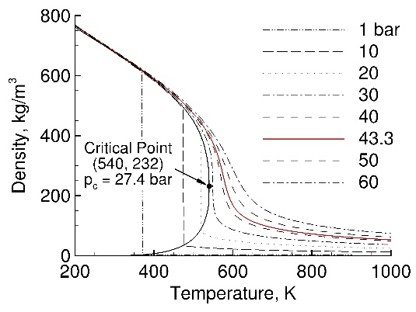
Fig. 1. Density versus temperature of n-heptane.

Equations are numbered sequentially in the order in which they appear. Recent Combustion and Flame papers can be consulted for appropriate equation formatting. Equation (1) is an example of a numbered equation. The Reynolds number, Re, is defined as:

Re ≡ UL/n , (1)

where U is a characteristic velocity, L is a characteristic length, and n is the fluid kinematic viscosity.

Table 1
Engine specifications and operating conditions.
Description (units) | Value
Bore (mm) | 86
Stroke (mm) | 86
Connecting rod (mm) | 159
Geometric compression ratio (-) | 8.9
Engine speed (r/min) | 1300
Intake manifold pressure (kPa) | 95
Global equivalence ratio (-) | 0.2

- Some example text
The text in this section is taken from [1]. It is included here so that the text will carry over across two more pages. There are no formatting instructions in this section.
Globally fuel-lean, stratified combustion in direct-injection spark-ignition (DISI) engines has the potential to reduce fuel consumption and carbon-dioxide emissions, compared to conventional stoichiometric homogeneous-charge engines. Issues include cycle-to-cycle variations (CCV) and criteria pollutant emissions, which require that the engine be calibrated to operate at conditions that are suboptimal for efficiency.
CCV have been studied extensively, using both experimental and computational approaches. In the case of homogeneous reactants, it has been shown that the early flame development largely determines the outcome of the combustion event. Most published CCV work has focused on the vicinity of spark plug at the time of ignition and the early flame development.
Spray-guided DISI (SG-DISI) engines operating in stratified mode offer additional complexities. The fuel is injected late, with appropriate timing and targeting to yield a flammable mixture at the spark plug at the time of ignition, and spark timing is limited to a narrow window after the end of injection. Exhaust-gas recirculation (EGR) may be used to control NOx, leading to even higher levels of CCV. It has been found that misfires in a SG-DISI engine correspond to cases where a flame kernel is initialized by the spark, but the kernel fails to fully develop into a propagating turbulent flame because it is advected away from the flammable mixture. This implies that the heat release associated with the main combustion event in a stratified SG-DISI engine is determined by the mixing and turbulence induced by the injection event. In-cylinder swirl has been shown to reduce variability as the engine speed is increased in a SG-DISI engine. Swirl generates a repeatable vortex near the spray centerline, which redistributes momentum, and thus reduces variability, but increases soot formation. Swirl and tumble also can lead to asymmetrical fuel distributions.

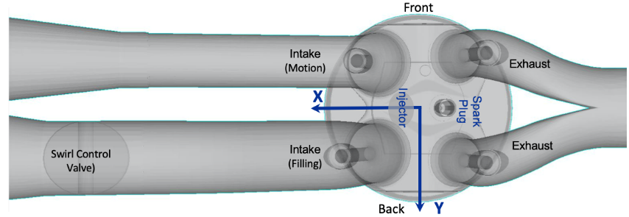

Fig. 2. Engine configuration (top view).

The engine is a four-valve, four-stroke-cycle, single-cylinder, optically accessible spark-ignition engine with direct in-cylinder fuel injection (Fig. 2). One intake port has a swirl-control valve that is used to modify the large-scale in-cylinder flow structure. Two of the eight spray plumes straddle the spark plug. The engine can be operated with early fuel injection, or in spray-guided stratified mode with late fuel injection.
Here a globally fuel-lean part-load stratified operating condition is considered, for which experimental results over 350 consecutive cycles are available. The fuel is an iso-octane/toluene blend; the toluene is included to enable equivalence-ratio measurements. Engine specifications and operating conditions are summarized in Table 1.

Table 2
Chemical mechanisms for multicomponent fuels.
First author | Fuels or molecules | # of species / # of reactions | Validation cases | Reference | Mechanism designation
O. Abianeh | TRF-Ethanol | 62 / 194 | LFS | [2] | A62
H. Wang | TRF-PAH | 109 / 543 | LFS, HCCI, DICI | [3] | W109
J.C.G. Andrae | TRF-Ethanol | 143 / 672 | LFS, HCCI | [4] | A143
J.C.G. Andrae | TRF-Ethanol | 1121 / 4961 | ST | [5] | A1121

Unnumbered sections
The CrediT authorship contirbution statement, Declaration of competing interest, Acknowledgements, Supplementary material (if included), and References section headings are not numbered. The font and spacing are the same as those for regular section headings.
The authors should consult the Guide for Authors of Combustion and Flame for Reference formatting that needs to be followed exactly. The font size in the References section is 8pt with 10pt line spacing. Note that titles are to be included for journal articles. If a paper is accepted for publication, links will be added in the final published paper to directly access each of the references, where available. It is not necessary to include such links in your submitted manuscript.

Nomenclature and appendices
The authors are encouraged to upload the Nomenclature section and Appendices as Supplementary Material to meet the 14-page manuscript length limitation. If a Nomenclature section is included, it should appear before the first numbered section heading under the unnumbered section heading “Nomenclature.”
If an Appendix is included, it should appear immediately before the References under the unnumbered section heading “Appendix.”
The formatting for these section headings should be the same as that used for the Declaration of competing interest, Acknowledgements, Supplementary Material, and References.

CrediT authorship contribution statement
Corresponding authors are encouraged to acknowledge co-author contributions using CRediT (Contributor Roles Taxonomy) roles.

Declaration of competing interest
This is a required section, in which authors are to disclose any competing interests relating to the work reported in the paper. See [6] for Elsevier’s policy. Authors will be required to complete a form related to competing interests at the time of manuscript submission. An appropriate statement in the case of no competing interests to report is given in the following paragraph.
The authors declare that they have no known competing financial interests or personal relationships that could have appeared to influence the work reported in this paper.

Acknowledgments
The authors should consult the Combustion and Flame Guide for Authors for content and formatting.

Supplementary material
If Supplementary Material is submitted along with the manuscript, that should be noted here. If the manuscript is accepted for publication, a DOI link to the online supplementary material will be included in the published paper.

References
- S.J. Kazmouz, D.C. Haworth, P. Lillo, V. Sick, Large-eddy simulations of a stratified-charge direct-injection spark-ignition engine: Comparison with experiment and analysis of cycle-to-cycle variations, Proc. Combust. Inst. 38 (2021) 5859-5857.
- O.S. Abianeh, Development of a new skeletal chemical kinetic mechanism for ethanol reference fuel, J. Eng. Gas Turb. Pow. 137 (2015) 061501.
- H. Wang, M. Yao, Z. Yue, M. Jia, R.D. Reitz, A reduced toluene reference fuel chemical kinetic mechanism for combustion and polycyclic-aromatic hydrocarbon predictions, Combust. Flame 162 (2015) 2390-2404.
- J.C.G. Andrae, R.A. Head, HCCI experiments with gasoline surrogate fuels modeled by a semidetailed chemical kinetic model, Combust. Flame 156 (2009), 842-851.
- J.C.G. Andrae, Development of a detailed kinetic model for gasoline surrogate fuels, Fuel 87 (2008) 2013-2022.
- Elsevier, FACTSHEET: Competing Interests, https://www.elsevier.com/__data/assets/pdf_file/0007/653884/Competing-Interests-factsheet-March-2019.pdf (2019; accessed July 2023).
- J. Han, CFD Modeling of Ignition and Soot Formation for Advanced Compression-Ignition Engines, Ph.D. Thesis, The Pennsylvania State University, University Park, PA, USA (2022).

