LLM-guided headline rewriting for clickability enhancement without clickbait
  - Yehudit Aperstein^{1,*}, Linoy Halifa¹, Sagiv Bar¹, Alexander Apartsin²
1 Intelligent Systems, Afeka Academic College of Engineering, Tel Aviv 69988, Israel
2 School of Computer Science, Faculty of Sciences, HIT-Holon Institute of Technology, Holon 58102, Israel
* Corresponding author: apersteiny@afeka.ac.il
Abstract
Optimizing news headlines for reader engagement is often conflated with clickbait, producing exaggerated or misleading phrasing that erodes editorial trust. We reframe clickbait not as a separate category but as the disproportionate amplification of otherwise legitimate engagement cues, and cast headline rewriting as a controllable generation problem in which chosen engagement attributes are strengthened under explicit faithfulness constraints. We steer a large language model at inference time with two lightweight guide models: a clickbait scorer providing negative guidance and an engagement-attribute model providing positive guidance, combined during decoding so engagement can be increased while clickbait is restrained. Both guides are trained on neutral news headlines and their synthetically amplified variants and transfer to entirely human-authored clickbait corpora. On held-out headlines, an ablation shows the two guides exert independent, opposite effects, and benchmarked against the decoding-time control methods DExperts and GeDi the dual guide adds an independent clickbait brake, a dedicated lever that lowers induced clickbait at a chosen engagement level and that single-axis methods lack. Independent automatic metrics and a three-annotator human study confirm higher faithfulness and lower induced clickbait than these baselines. The framework supports responsible headline optimization in journalism.
Keywords: Large Language Models; Controllable text generation; Clickbait mitigation; Inference-time control; FUDGE; Engagement optimization

1. Introduction
Digital news headlines function as the primary entry point to journalistic content and strongly influence readers' decisions about what to consume. In contemporary, algorithmically mediated information environments, headlines must attract attention within a narrow cognitive window while remaining faithful to the substance of the underlying article. This creates a structural tension between engagement and editorial integrity. In practice, this tension has encouraged the use of clickbait-like strategies, which can increase short-term attention but are often associated with reader frustration, unmet expectations, and long-term erosion of trust in news outlets[9].
Existing research has largely addressed this problem through clickbait detection, classification, and filtering, implicitly treating it as a discrete, undesirable stylistic category. Headlines are typically labeled as clickbait or non-clickbait, and models are trained to identify lexical, syntactic, or pragmatic markers correlated with exaggeration or deception[1,2,3]. While this work has produced useful datasets and benchmarks, it obscures an important distinction: many linguistic devices associated with clickbait, such as curiosity induction, emphasis framing, specificity manipulation, or interrogative constructions, are standard rhetorical tools in journalism. These mechanisms are not inherently misleading; they become problematic only when their use is amplified beyond editorially defensible bounds.
To make this distinction explicit, we define an engagement-attribute rubric that separates clickbait-oriented from clickability-oriented realizations of common headline mechanisms. The full comparison is presented in Table 1 (Section 3.1), where these mechanisms are operationalized for synthetic data generation and controllable guidance. This comparison motivates a shift from binary classification to a continuous, controllable view of engagement. We therefore adopt a generative rather than purely discriminative perspective and posit two core assumptions. First, clickbait and clickability differ in degree rather than kind: clickbait arises when otherwise legitimate engagement mechanisms are amplified beyond proportionate or editorially acceptable levels. Second, engagement can be decomposed into controllable linguistic attributes, allowing individual mechanisms (e.g., curiosity, specificity, or framing) to be selectively strengthened or attenuated while maintaining explicit constraints on semantic fidelity and overall emphasis. This rubric extends prior attribute-based clickbait attribution work[11] by explicitly pairing clickbait and clickability interpretations of each mechanism.
In this work, we introduce a controllable headline rewriting framework that operationalizes this view using Meta-Llama-3-8B-Instruct[19] as the base generator, guided at inference time by auxiliary models. The LLM is steered by two complementary signals: a BERT-based clickbait scoring model that provides negative guidance to penalize excessive stylistic amplification, and a BERT-based engagement-attribute model that provides positive guidance aligned with specified clickability objectives. By integrating these signals within a guided decoding paradigm, the framework enables fine-grained control over both the degree and type of engagement expressed in rewritten headlines, supporting responsible engagement enhancement without semantic distortion or disproportionate emphasis. This explicit control matters in practice: a generic instruction to make a headline “more engaging” offers no handle on how strongly to amplify or which rhetorical mechanism to use, whereas an editor typically needs to adapt both the strength of amplification and the specific engagement tactic to a particular audience, brand voice, or editorial policy. Our framework exposes these as continuous, selectable controls rather than a single fixed transformation.
The main contributions of this work are as follows:
- Headline rewriting is formulated as a controllable text generation task, in which clickbait is modeled as a graded consequence of disproportionate engagement-attribute activation rather than as a binary stylistic category.
- An interpretable space of engagement-driven rewriting directions is defined, enabling headline transformations to be represented along distinct linguistic dimensions that separate legitimate optimization from disproportionate clickbait-oriented variation.
- Dedicated positive and negative guidance models are trained to generate control signals for decoding, promoting target engagement attributes while suppressing excessive stylistic amplification.
- A dual-guidance inference-time rewriting framework is proposed, incorporating these learned signals into LLM-based headline generation.
- Guided decoding is shown, through external-corpus validation of the guides, a dual-guidance ablation, and a comparison against decoding-time baselines, to enable fine-grained control over engagement-related linguistic features while preserving semantic fidelity and fluency.
The rest of the paper is organized as follows. Section 2 reviews related work on clickbait detection and controllable text generation. Section 3 presents the proposed methodology, including the engagement-attribute rubric, synthetic dataset construction, auxiliary guide models, and FUDGE-based controlled decoding. Section 4 describes the experimental setting and reports the results of the clickbait scoring model, the engagement attribute model, and the controlled rewriting framework, together with external validation of the guides, a dual-guidance ablation, a comparison against decoding-time baselines, and a rater-based evaluation. Section 5 concludes the paper and outlines directions for future work.

2. Related Work

2.1 Clickbait Detection
Research on clickbait detection has progressed from feature-engineered classifiers to transformer-based and more interpretable frameworks. Early studies by Biyani et al.[1] and Chakraborty et al.[2] established that clickbait can be detected through lexical, stylistic, and structural cues, while Potthast et al.[3] standardized the task through the Webis Clickbait Corpus 2017 and the Clickbait Challenge, enabling both binary and graded modeling of clickbait strength.
The field has since expanded in both scope and methodology. As reviewed in ref.[4], clickbait research now spans not only detection algorithms, but also semantic manipulation, curiosity mechanisms, and credibility effects. Methodologically, recent work has shifted toward deep learning and pretrained language models. For example, ref.[5] reports strong performance with a RoBERTa-Large-based detector and complements classification with LIME and SHAP for interpretability, and ref.[6] extends the task to Urdu and highlights the value of sentence embeddings in low-resource settings.
Recent studies also explore more data-efficient and LLM-oriented paradigms. For instance, ref.[7] shows that strong results can be achieved from headline text alone, even with very limited labeled data, whereas ref.[8] finds that zero-shot and few-shot LLMs remain competitive and multilingual but still lag behind task-specific fine-tuned or prompt-tuned models. Together, these studies indicate that headline-level clickbait detection benefits from explicit supervision and task-adapted modeling rather than relying solely on general-purpose LLM inference.
At the same time, recent work suggests that clickbait should not be treated as a purely binary phenomenon. For example, ref.[9] shows that headlines can be too vague or too explicit, and ref.[10] demonstrates that explicit informativeness features improve both performance and interpretability. Finally, ref.[11] moves beyond binary detection toward attribution. Collectively, this line of work motivates treating clickbait as a graded, explainable, and attribute-driven phenomenon, which directly aligns with the present paper's controllable rewriting perspective.

2.2 Controllable Text Generation
In parallel with advances in detection, a growing body of work has explored controllable text generation, aiming to steer language model outputs toward desired attributes such as style, sentiment, topic, or level of sensationalism. Early approaches emphasized training-time control. Conditional language models explicitly incorporate control variables during training, enabling the generator to condition its output on metadata or attribute labels. A prominent example is CTRL[12], a large-scale transformer trained with control codes that specify domains, styles, or other high-level properties.
Another training-time paradigm relies on reinforcement learning, where generation policies are optimized using reward functions that encode target attributes. While effective, such approaches are often computationally expensive and tightly coupled to specific control objectives.
More recently, research has increasingly focused on inference-time control methods that operate on a fixed, pretrained language model, avoiding full retraining. These approaches augment the decoding process with auxiliary models or signals that bias token selection. Plug-and-Play Language Models[13] exemplify this strategy by combining a frozen generator with lightweight attribute classifiers. GeDi[14] adopts a probabilistic perspective, using smaller generative models as discriminators and applying Bayes' rule to reweight the token distribution of a larger generator. Similarly, DExperts[15] frames control as a product-of-experts problem, combining an "expert" model trained on desirable text with an "anti-expert" trained on undesirable text.
FUDGE[16] provides a particularly elegant formulation for decoding. It trains a discriminator to predict whether a partially generated sequence will satisfy a target attribute; during decoding, the base language model's next-token probabilities are multiplied by the discriminator's estimate, yielding a principled Bayesian factorization of P(text | attribute) at inference time. This allows attribute control without modifying or fine-tuning the underlying generator, making such lightweight, modular discriminators well suited to applications that require subtle control, such as generating curiosity-inducing yet non-clickbait headlines.

3. Method

3.1 Engagement Attribute Rubric
We first define a structured rubric of engagement attributes commonly found in news headlines, including information-gap control, emphasis intensity, emotional framing, salience allocation, referential clarity, structural emphasis, and interrogative framing (Table 1). For each attribute, the rubric specifies paired interpretations corresponding to clickability-oriented and clickbait-oriented usage. These paired interpretations should be understood not as different surface forms, but as different uses of the same underlying rhetorical mechanism. For example, information-gap control may appear either as calibrated partial disclosure that invites interest while preserving the core claim, or as withholding of essential facts that manufactures unresolved curiosity. Across the remaining attributes, the same principle applies: clickability reflects bounded, content-faithful use of engagement devices, whereas clickbait reflects disproportionate or misleading use. The overall flow of the approach is shown in Figure 1. This rubric provides an explicit operationalization of engagement as a set of controllable linguistic dimensions rather than an undifferentiated stylistic label, and serves as the foundation for both data generation and model supervision.
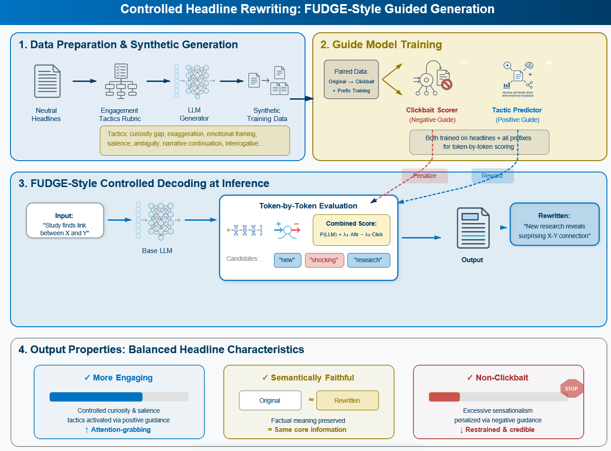
Figure 1. General flow of the proposed rubric-based and FUDGE-guided headline rewriting approach.
Table 1. Clickbait vs. clickability interpretations of common headline attributes.
Attribute | Clickbait interpretation | Clickability interpretation
Information gap control | Curiosity gap  Deliberate withholding of essential facts to compel a click by creating unresolved curiosity | Information gap calibration  Partial disclosure that invites interest while preserving the core factual claim
Emphasis intensity | Exaggeration  Overstating importance, impact, or certainty beyond what is supported by the article | Proportional emphasis scaling  Adjusting linguistic intensity to match the true significance of the event
Emotional framing | Emotional trigger  Manipulative activation of fear, outrage, or excitement disproportionate to the facts | Affective salience framing  Highlighting emotionally relevant aspects implied by the content without inflation
Salience allocation | Sensationalism  Focusing on dramatic or marginal aspects at the expense of informational balance | Salience-oriented framing  Foregrounding the most newsworthy element while maintaining contextual integrity
Structural emphasis | Lists or superlatives  Use of absolute rankings or hyperbolic enumeration to imply exceptionalism | Structured highlighting  Bounded use of ordering or comparison to organize key information
Referential clarity | Ambiguous references  Vague entities or pronouns that obscure meaning to provoke curiosity | Referential under-specification  Temporary abstraction that is resolved through reading without misleading
Reader addressing | Direct appeals  Imperative or coercive language explicitly urging the reader to click | Reader relevance cues  Implicit signaling of why the story matters to the reader
Narrative structure | Unfinished narratives  Artificial cliffhangers that omit essential outcomes | Narrative continuation cues  Indicating that further context follows while retaining essential information
Conceptual framing | Unexpected associations  Forced or misleading linkage between unrelated concepts | Cross-domain framing  Novel but factually grounded connections that increase interpretive interest
Interrogative form | Provocative questions  Questions implying false premises or exaggerated stakes | Interrogative framing  Questions used to frame inquiry or uncertainty without presupposition

3.2 Synthetic Dataset Generation with Controlled Clickbait Interpretation
Using the engagement rubric, we generate a synthetic corpus of clickbait headlines via attributed prompting of a large language model (GPT-4o-mini[21]), starting from a curated collection of real, neutral news headlines. These are the genuine Reuters news-agency headlines contained in the True.csv file of the ISOT Fake News Dataset[17,18], a public benchmark whose True.csv half holds real, verified news (and whose Fake.csv half, which we do not use, holds fabricated stories). Because these are real newswire headlines, we treat them as neutral, fact-oriented baseline formulations and assign each an all-zero engagement-attribute vector.
For every source headline, we generate a single clickbait variant by prompting the model to rewrite it using a controlled subset of engagement attributes. Specifically, the prompt allows the activation of up to three clickbait-oriented engagement mechanisms (e.g., curiosity, exaggeration, emotional triggers), which are explicitly specified at generation time. The generation is constrained to exaggerate only the selected dimensions while preserving the original headline's underlying factual content and core semantic meaning. As a result, each generated sample consists of a headline text, a binary clickbait label, and a sparse binary engagement-attribute vector indicating which attributes were exaggerated. Table 2 shows representative examples of this construction, in which a fixed prompt template, differing only in the activated tactic, yields controlled, interpretable stylistic amplification. The full generation prompt, batch size (15 headlines per API call), the up-to-three-tactic sampling rule, and the JSON self-repair retry policy are documented in Section 3.6 and released with the code repository.
Table 2. Examples of attribute-controlled clickbait generation via explicit tactics (synthetic corpus).
Neutral source headline | Attribute-control prompt (excerpt) | Generated headline
Supreme Court tosses Republican-drawn North Carolina voting districts | Rewrite using the Curiosity Gap tactic: withhold essential detail to create unresolved curiosity. Do not add new facts. | this surprising decision could change north carolina's voting landscape
Trump puts Goldman Sachs in spotlight, for better or worse | Rewrite using Exaggeration: overstate importance or impact beyond what the article supports. | trump's unprecedented move puts goldman sachs at risk
White House chief of staff not quitting, says job is not to control Trump | Rewrite using an Emotional Trigger: activate concern or alarm disproportionate to the reported facts. | concerns rise as white house chief of staff insists he won't control trump
House intelligence chief has seen no evidence to back Trump wiretap charge | Rewrite using Lists or Superlatives: imply exceptionalism through hyperbolic ranking or enumeration. | the top evidence that proves trump's wiretap claims are false

3.3 Clickbait Scoring Model
The clickbait scoring model is designed to operate on partial generations rather than on complete headlines alone, as it is used to guide the base language model during inference-time decoding. To address this requirement, each headline in the synthetic dataset is decomposed into all of its token-level prefixes. Given a headline represented as a token sequence w = (w₁, …, w_{T}), we construct training inputs from every prefix (w₁, …, w_{t}) for t = 1, …, T. Each prefix inherits the clickbait label of the full headline, allowing the model to learn how clickbait-related signals accumulate progressively as the headline unfolds. To distinguish complete headlines from prefixes, a terminal period token is appended to the full headline during training, while prefixes are left unmarked.
The scoring model is implemented by fine-tuning a BERT encoder[22] with a binary classification head. Because very short prefixes provide limited semantic evidence, we employ a length-aware weighted loss that down-weights shorter prefixes relative to longer prefixes and complete headlines, encouraging the model to focus on informative contexts while remaining robust to partial inputs. This yields a clickbait scorer that produces stable, prefix-consistent signals suitable for guiding controlled headline rewriting at inference time.

3.4 Engagement Attribute Model
In parallel with the clickbait scoring model, we train an engagement attribute model to predict the presence of specific engagement mechanisms defined in the rubric. Whereas the clickbait scorer provides a global assessment of disproportionate amplification, the engagement model captures fine-grained, attribute-specific signals corresponding to distinct rhetorical tactics. The model is implemented by fine-tuning a pretrained BERT encoder with a multi-label prediction head, where each attribute is modeled as an independent prediction dimension. As the model is used to guide generation incrementally, training is performed on both complete headlines and all token-level prefixes derived from them, with the same terminal-period convention and length-aware weighting used for the clickbait scorer.

3.5 FUDGE-Based Controlled Decoding
To enable fine-grained control over headline rewriting, we adopt a FUDGE-based (Future Discriminators for Generation) inference-time control framework, in which generation from a base large language model is steered by auxiliary scoring models operating on partial outputs. Let x denote the current generation prefix and y a candidate next token. At each decoding step, the base LLM proposes its top-k continuations, which are then re-weighted using guidance scores derived from the auxiliary models evaluated on the extended prefix x·y (see the combined objective in Section 3.5.3).

3.5.1 Negative Guidance via Clickbait Scoring
The clickbait scoring model provides a negative control signal intended to suppress disproportionate stylistic amplification. For each candidate continuation, the scorer outputs a scalar cb(x·y) ∈ [0, 1] representing the likelihood of clickbait. This score is incorporated as a penalty term with an associated weight β, reducing the probability of tokens that increase the predicted clickbait score. Intuitively, this signal acts as a soft constraint that discourages the generator from entering clickbait-prone regions of the engagement space without imposing hard rejection.

3.5.2 Positive Guidance via Engagement Attribute Signals
In parallel, the engagement attribute model provides positive control signals aligned with target clickability objectives. For each attribute k, the model produces a normalized score tac_{k}(x·y) ∈ [0, 1] indicating the strength of that engagement mechanism. Desired attributes are selected by a target mask m_{k} ∈ {0, 1}, and the overall positive guidance signal is the masked mean tac(x·y) = (Σ_{k} m_{k}·tac_{k}) / (Σ_{k} m_{k}) over the targeted attributes. This formulation allows explicit specification of which engagement mechanisms should be strengthened and which should be ignored.

3.5.3 Combined Guidance Objective
The final token selection score combines the base LLM log-probability with both guidance terms. We use the canonical FUDGE factorization in the log domain, which corresponds to the Bayesian product P(text)·P(attribute | text)·P(not-clickbait | text): for each candidate next token y with attribute score tac(·) and clickbait score cb(·) on the extended prefix,
score(y) = log p_{LLM}(y) + α · log tac(x·y) + β · log(1 − cb(x·y)).
By adjusting the guidance weights α (engagement) and β (clickbait suppression), the system can smoothly trade off engagement enhancement against editorial restraint. The log domain is used in place of the additive-probability heuristic score = p_{LLM} + α·tac − β·cb because it keeps the three factors on a common multiplicative footing and is numerically stable near the score extremes; the weight magnitudes are therefore re-tuned per objective (Section 4.8). Positive signals encourage the realization of selected clickability attributes, while negative signals continuously penalize excessive amplification, enabling responsible headline rewriting that enhances reader appeal while preserving semantic fidelity.

3.6 Implementation Details and Reproducibility
Base generator: Meta-Llama-3-8B-Instruct loaded in FP16. All reported experiments run on cloud GPUs (NVIDIA A10G / L40S) orchestrated with Modal; generation is fanned out across shards over disjoint item ranges. Decoding uses greedy rescoring over the top-k next-token candidates with k = 50. Under the log-domain objective of Section 3.5.3 the guidance weights are swept over α, β ∈ {0, 1, 2, 4} on a disjoint 40-item tuning subset, and the reported operating point is α = 4 (engagement) and β = 2 (clickbait suppression), selected on independent metrics only. A linear warm-up multiplies α by min(step/6, 1.0) during the first six tokens to avoid premature over-steering, and an EOS-length bonus discourages headlines shorter than six or longer than thirty-two whitespace tokens. For multilingual base generators, a language-consistency constraint restricts the top-k candidate set to the source script (candidates introducing characters outside the source headline's script range are masked) so that guidance operates within the target language.
Guide models: two BERT-base encoders, each fine-tuned for 2–3 epochs with early stopping on validation loss, AdamW at learning rate 2×10⁻⁵ with linear decay, mixed prefix-length mini-batches, and a length-aware weighted loss that down-weights very short prefixes (< 4 tokens). Synthetic data: the 12,600 neutral source headlines are the real Reuters headlines described in Section 3.2 (the genuine-news True.csv split of the ISOT dataset), yielding 12,599 validated clickbait variants after JSON-validity and duplicate filtering; GPT-4o-mini generates in batches of 15 at temperature 0.7, each call activating 1–3 tactics uniformly sampled from the ten-attribute rubric, with a GPT-based JSON self-repair retry (up to three attempts). The clickbait guide reaches AUROC 0.9998 and the ten-label engagement guide macro-F1 0.49 on the held-out synthetic test split (the full per-tactic and confusion-matrix evaluation is released in the deposit); the external-corpus and prefix-level validations of Sections 4.5–4.6 characterize their transfer to human-authored data. A separate DistilBERT[23] detector trained only on the human-authored Chakraborty corpus is used as the independent clickbait evaluator throughout Section 4. Complete prompt templates and all training/decoding hyperparameters are released with the deposit; approximate wall-clock cost is ≈ 1.2 s per rewritten headline on the A10G/L40S configuration.

3.7 Evaluation metrics and protocol
Because clickbait rewriting must balance several competing goals, we evaluate every method along independent axes, each with a metric chosen to be interpretable and, wherever possible, independent of the guide models themselves so that a result cannot be gamed by the model being scored.
- Semantic fidelity (BERTScore-F1). BERTScore[25] compares the rewrite and the source headline through their contextual BERT embeddings, matching each token to its closest counterpart and reporting an F1 score; higher means the rewrite still conveys what the original said. It is the primary guard against a more engaging rewrite that quietly changes the story, and it is the metric a reader would recognise as does this still mean the same thing.
- Logical faithfulness (NLI entailment). A natural-language-inference model (DeBERTa-v3[24]) asks whether the source headline entails the rewrite. Where BERTScore captures word-level overlap, NLI captures meaning: it flags rewrites that add an unsupported claim, drop a crucial qualifier, or reverse the sense, even when the wording still looks similar. We report the source-entails-rewrite direction because it is the one that detects invented content, which is exactly the failure a clickbait brake is meant to prevent.
- Fluency (perplexity). Perplexity is the exponentiated average next-word surprise of a held-out language model (distilGPT-2[26]) on the rewrite; lower means the text reads more naturally. It is important because a steering method can reach its attribute target by emitting awkward or ungrammatical text, and perplexity exposes that failure, which the fidelity and clickbait scores alone would miss.
- Induced clickbait (independent detector). Clickbait is scored by the DistilBERT detector trained only on human-authored Chakraborty headlines (Section 4.5), never by our own guide, so the number reflects human-judged clickbait rather than agreement with the model that did the steering. Lower is better.
- Tactic realisation (independent LLM judge). A separate LLM judge, shown only the target tactic and the rewrite, decides whether the intended engagement tactic is actually present (0–1). This measures whether control succeeded, independently of the engagement guide that performed the steering.
All method comparisons use item-matched significance testing (Wilcoxon signed-rank on the same source headlines) with 95% percentile-bootstrap confidence intervals, matched-pairs rank-biserial effect sizes, and Holm correction across each family of tests, so that a reported difference reflects a consistent per-item effect rather than aggregate noise. The tactic judge itself is not treated as ground truth: its confirmation rate for the intended tactic (≈ 0.50) agrees with the independent intended-vs-consensus recoverability from the rater study (F1 = 0.44, Section 4.10), indicating that both measurements track the same graded structure of fine-grained tactic recovery rather than idiosyncratic judge noise.

4. Experiments and Results

4.1 Dataset Overview
Figure 2 summarizes the composition of the synthetic dataset by engagement intensity. Neutral headlines, drawn directly from the curated source corpus, contain no activated engagement tactics, while clickbait variants are generated by activating one, two, or three tactics per headline. The dataset is approximately balanced across clickbait groups, enabling the scoring model to learn a graded notion of clickbait strength while preserving a clear distinction between neutral and increasingly amplified formulations.
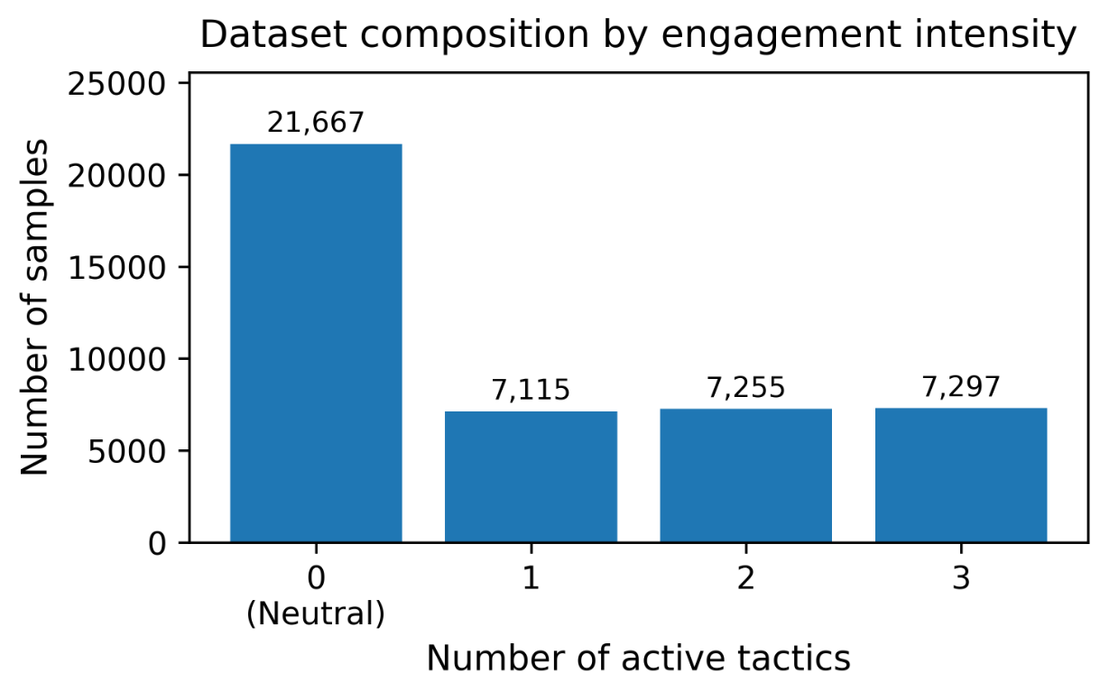
Figure 2. Dataset composition by engagement intensity. Neutral headlines contain 0 active tactics, whereas clickbait variants are generated with 1, 2, or 3 active tactics.

4.2 Clickbait Scoring Performance
For training and evaluation of the clickbait scoring model, the data are split at the source-headline level prior to synthetic generation to prevent leakage across prefixes. The curated set of real neutral headlines is first divided into 80% for training/validation and 20% for testing; synthetic clickbait variants and their prefixes are then generated separately within each split. On the held-out synthetic test set, the clickbait scorer achieved AUROC above 0.99, indicating near-perfect discrimination between neutral and clickbait headlines, which is expected given the controlled synthetic setup. Because near-perfect in-distribution scores can reflect generator artifacts rather than clickbait per se, Section 4.5 evaluates the same guide on entirely human-authored corpora.

4.3 Engagement Attribute Model Performance
For training and evaluation of the engagement attribute model, the dataset was split at the source-headline level into training (65%), validation (15%), and test (20%) sets to prevent leakage across prefixes. Figure 3 summarizes the behavior of the model through two complementary visualizations. Although the model is trained in a multi-label setting, we report per-tactic results on single-tactic examples for interpretability, isolating each mechanism to analyze tactic-specific recognition quality and structured confusions. The bar plot shows differences in how reliably various tactics are detected, with some attributes, such as Curiosity Gap and Exaggeration, more consistently recognizable, while others, such as Sensationalism and Provocative Questions, are more difficult; the model attains a macro-F1 of 0.49.
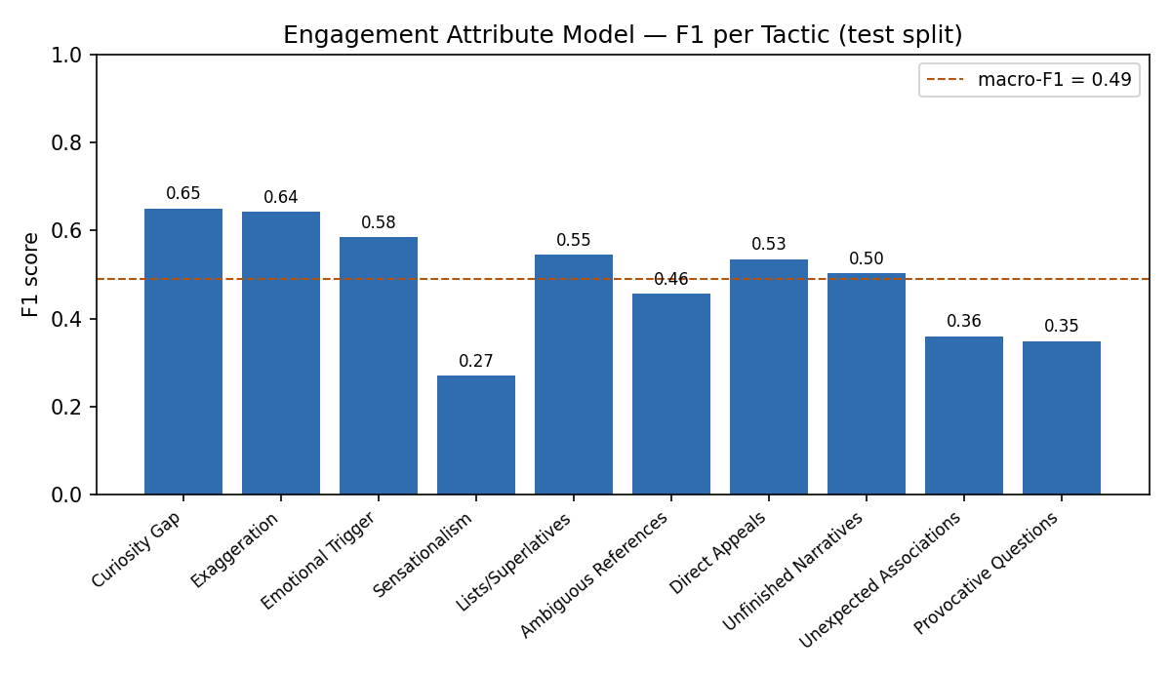
Figure 3. Per-tactic F1 of the engagement attribute model on single-tactic test examples (macro-F1 = 0.49).
The confusion matrix (Figure 4) provides a more detailed view of the model's predictions for single-attribute examples. A clear diagonal pattern indicates that the model often identifies the correct dominant tactic, while structured off-diagonal errors reveal confusion between semantically related attributes, such as Sensationalism with Exaggeration and Provocative Questions with Curiosity Gap. These results suggest that the model captures distinct engagement patterns while reflecting the natural overlap among persuasive strategies, providing informative and interpretable signals to guide controlled headline generation.
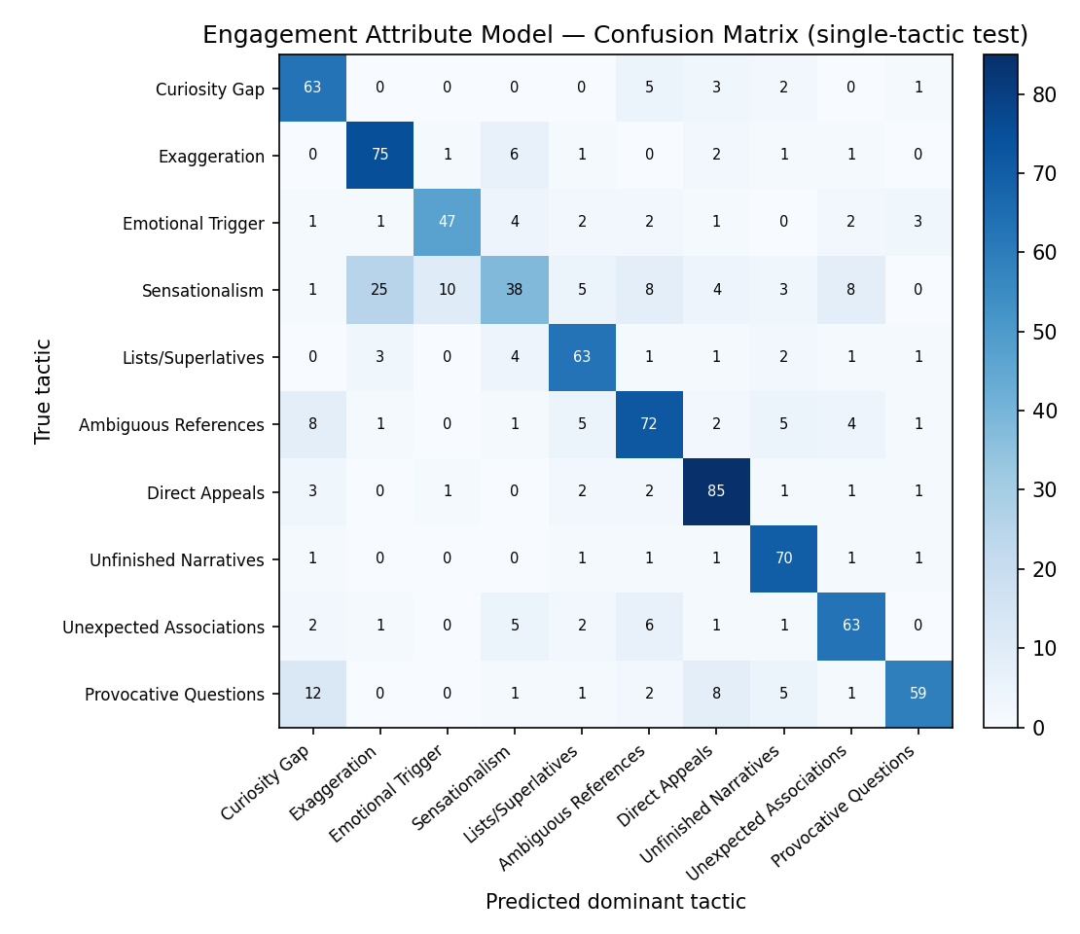
Figure 4. Confusion matrix of the engagement attribute model on single-tactic test examples; predicted dominant tactic vs. true tactic.

4.4 Controlled Rewriting Results
Table 3 presents qualitative examples of headline rewrites targeting different engagement attributes. The neutral headlines report events factually and descriptively. When rewritten with engagement guidance but no clickbait brake (α > 0, β = 0), the generated headlines increase engagement through stronger rhetorical strategies such as curiosity gaps, emotional triggers, and provocative questions. When the clickbait brake is applied (α > 0, β > 0), the headlines remain engaging and continue to reflect the intended tactic, but the phrasing becomes more restrained and informative. These examples illustrate that the framework can generate headlines that express specific engagement attributes while moderating excessive sensationalism through the clickbait control mechanism.
Table 3. Examples of headline rewrites targeting specific engagement attributes (held-out evaluation).
Target engagement attribute | Neutral headline | Rewriting (engagement guidance, no clickbait brake) | Rewriting (with clickbait brake)
Emotional Trigger + Sensationalism | 'Numerous' arrests made during Trump inauguration protests: police | Chaos unfolds as authorities crack down on defiant crowds during Trump's historic inauguration celebration". | Chaos erupts as peaceful protests turn violent, widespread arrests made on Inauguration Day".
Curiosity Gap + Provocative Questions | No. 2 Republican in U.S. House sees conference on tax bill soon | Will the Republican Party's Second-in-Command Deliver a Breakthrough on Tax Reform? A Conference is Imminent. | When Will House Republican Leaders Unify Behind Tax Reform Plan Next Week's Conference Holds the Key?
Emotional Trigger + Sensationalism | On the trail with Mike Pence: Putting out fires lit by Trump | Blazing a Critical Path: Pence's High-Stakes Mission to Douse the Flames of Controversy". | Blazing a Critical Path with Pence: Dousing Flames of Controversy Left by the President".
Curiosity Gap + Provocative Questions | U.S. lawmakers ask Trump to turn over any Comey tapes | What's Behind the President's Silence on the Comey Conversations? | Did Trump Record His Conversations with Comey - and Will He Share Them with Congress Now?".
Worked example: graded control on a single headline. Raising the engagement weight α escalates the framing ("Urgent Meeting" to "Major Move Imminent") while the independent clickbait probability (cb) stays near zero and BERTScore fidelity (bs) is maintained; the clickbait brake β keeps the strongest setting restrained.
Neutral sourceNo. 2 Republican in U.S. House sees conference on tax bill soon
α = 0, β = 0Tax Reform on the Brink: Top Republican Leader Hints at Urgent Meetingcb 0.00 · bs 0.24
α = 2, β = 0Tax Reform on the Brink: Top Republican Leader Hints at Imminent Conferencecb 0.00 · bs 0.29
α = 4, β = 0Tax Reform on the Horizon: Top GOP Leader Signals Major Move Imminent in the Housecb 0.00 · bs 0.33
α = 4, β = 2Tax Reform on the Horizon: Senior GOP Lawmaker Eyes Critical Conference This Weekcb 0.00 · bs 0.30
Table 4 shows the same behaviour across the full four-cell grid on three headlines: the engagement guide adds the targeted tactic, the clickbait brake pulls back the most sensational phrasing, and the dual setting balances the two.
Table 4. Controlled generation across the (α, β) grid: three source headlines each rewritten under the four ablation cells. The engagement guide (α) adds the targeted tactic, the clickbait brake (β) restrains sensational phrasing, and the dual setting balances the two.
Setting | Rewrite
Source: 'Numerous' arrests made during Trump inauguration protests: police
(0,0) no guidance | Chaos Erupts as Thousands Detained During Trump's Sworn-In Ceremony
(4,0) engage only | Chaos unfolds as authorities crack down on defiant crowds during Trump's historic inauguration celebration
(0,2) brake only | Chaos Erupts on Inauguration Day as Protesters Clash with Authorities
(4,2) dual | Chaos erupts as peaceful protests turn violent, widespread arrests made on Inauguration Day
Source: No. 2 Republican in U.S. House sees conference on tax bill soon
(0,0) no guidance | Will the Republican Party's Second-in-Command Deliver a Breakthrough on Tax Reform?
(4,0) engage only | Will the Republican Party's Second-in-Command Deliver a Breakthrough on Tax Reform? A Conference is Imminent
(0,2) brake only | When Will House Republican Leaders Unify Behind Tax Reform?
(4,2) dual | When Will House Republican Leaders Unify Behind Tax Reform Plan Next Week's Conference Holds the Key?
Source: U.S. lawmakers ask Trump to turn over any Comey tapes
(0,0) no guidance | Did Trump's Oval Office Secrets Just Get Exposed?
(4,0) engage only | Did the President's Silence Speak Louder Than Words on the FBI Chief's Fate?
(0,2) brake only | Did Trump Record His Conversations with Comey? Lawmakers Demand to Know
(4,2) dual | Did Trump Silence the Comey Truth: Lawmakers Demand Access to Secret Recordings

4.5 Guide-model validation on external, human-authored corpora
A scorer trained on GPT-4o-mini rewrites could in principle key on generator artefacts rather than clickbait, so we validate both guide models on two entirely human-authored corpora never seen in training: the Chakraborty et al.[2] corpus (32,000 balanced headlines) and the Webis Clickbait Corpus 2017[3] (2,459 graded headlines). We additionally train a fully independent DistilBERT clickbait detector on the human-authored Chakraborty data alone, and use that independent detector, never our own guide, for every clickbait number reported in the rewrite evaluation below. All figures carry 95% percentile-bootstrap confidence intervals (n = 1000).
Table 5. Prefix clickbait guide on external, human-authored corpora (95% bootstrap CI).
Corpus | n | AUROC | F1 | Graded Spearman
Chakraborty et al. (binary) | 32,000 | 0.955 (0.953–0.957) | 0.858 | n/a
Webis-17 (graded) | 2,459 | 0.740 (0.720–0.760) | 0.512 | 0.426 (p≈1×10⁻¹⁰⁹)
The guide generalizes strongly to clean human-authored clickbait (Chakraborty AUROC 0.955) and moderately, but significantly, to the noisier graded Webis corpus (AUROC 0.740; graded-strength Spearman 0.43). The engagement-attribute guide shows the same external validity: on Webis, all ten tactics score significantly higher on human clickbait than on non-clickbait headlines (Spearman r = 0.34–0.45, every p < 1×10⁻⁶⁰). The guides therefore transfer to entirely unseen, human-authored data.

4.6 Prefix-level behavior on real headlines
Because the guide operates on partial prefixes during decoding, not on complete headlines, we validate it in that regime on real data: each labeled Chakraborty / Webis headline is truncated to the training word-ratios (0.3 / 0.5 / 0.7 / 1.0) and the prefix score is compared to the parent headline's human label. AUROC rises monotonically as the prefix grows (Chakraborty 0.891 at 30% of the headline to 0.954 at full length; Webis 0.695 to 0.739), and the clickbait-vs-neutral score separation widens monotonically (Chakraborty +0.62 to +0.75). The guide therefore supplies a valid, monotone steering signal on real text from an early prefix.
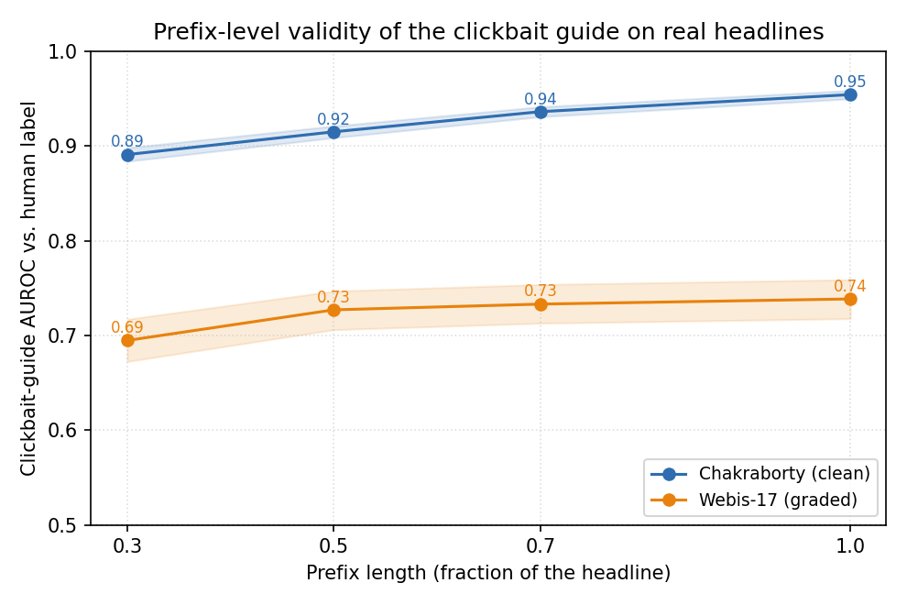
Figure 5. Prefix-level validity of the clickbait guide. AUROC of the guide's prefix score against the parent headline's human label as the prefix grows from 30% to 100% of the headline, on the Chakraborty and Webis corpora (shaded 95% CI). The guide provides a valid, monotonically strengthening signal from an early prefix.

4.7 Neutrality of the Reuters source pool
Our neutral source headlines are real Reuters news headlines, taken from the True.csv file of the ISOT Fake News Dataset, that is, the genuine-news half of a public fake-news benchmark. The whole framework only makes sense if these sources are themselves non-clickbait to begin with, so that any clickbait we later measure is introduced by rewriting rather than already present. To check this, we ran the independent clickbait detector over the entire pool of 20,825 unique Reuters headlines. Only 0.61% score above the 0.5 clickbait threshold (mean probability 0.007, median 0.0003), and manually inspecting the few high-scoring cases shows ordinary newswire formats such as "Factbox: …" or "What we know about …" rather than genuine clickbait. This confirms, rather than merely assumes, that the source pool is a clean neutral baseline.

4.8 Held-out rewrite evaluation and dual-guidance ablation
We evaluate rewrites on 300 held-out neutral headlines under the four-cell ablation of the dual-guidance design: (0,0) no guidance, (α,0) positive engagement guide only, (0,β) clickbait brake only, and (α,β) both. The operating point α = 4, β = 2 was selected on a disjoint 40-item tuning sweep using only independent metrics (an LLM judge and the external detector), never the guides' own scores. Fidelity is measured by BERTScore-F1 and DeBERTa-v3 NLI entailment; engagement-tactic realization by an independent LLM judge (0–1); clickbait by the independent detector; fluency by held-out distilGPT-2 perplexity. Every cell is n = 300 items × 3 tactic configurations.
Table 6. Four-cell dual-guidance ablation on 300 held-out headlines (n = 900 = 300 items × 3 tactic configurations). Clickbait and tactic realization use independent models; lower perplexity = more fluent. Parentheses give 95% percentile-bootstrap confidence intervals.
Cell | Tactic (judge) | Clickbait (ext.) | BERTScore | NLI | Perplexity (median) | Paired win vs (0,0)
(0,0) baseline | 0.476 (0.45–0.50) | 0.045 (0.04–0.06) | 0.282 (0.27–0.29) | 0.270 (0.25–0.29) | 211 (192–221) | n/a
(4,0) engage only | 0.509 (0.48–0.53) | 0.079 (0.07–0.09) | 0.280 (0.27–0.29) | 0.219 (0.21–0.23) | 175 (164–184) | 0.610 (p≈1×10⁻¹³)
(0,2) brake only | 0.446 (0.42–0.47) | 0.028 (0.02–0.04) | 0.279 (0.27–0.29) | 0.324 (0.31–0.34) | 275 (257–295) | 0.444
(4,2) dual | 0.500 (0.48–0.53) | 0.057 (0.05–0.07) | 0.251 (0.24–0.26) | 0.213 (0.20–0.23) | 241 (229–253) | 0.597 (p≈3×10⁻⁹)
The two guides have the designed, independent, opposite effects: the engagement guide (α) raises independent tactic realization from 0.48 to 0.51, while the clickbait brake (β) lowers the independent clickbait score from 0.079 back to 0.057 and improves entailment. Because the prompt already names the target tactic, the (0,0) cell is itself a capable rewriter, so these shifts are the contribution of the decoding-time guides on top of prompting. The engagement guide's absolute effect on tactic realization is modest (+0.03 judge-confirmed), as expected for a decoding-time signal that reweights an already-capable prompt; its value is delivering that shift while the brake keeps clickbait bounded. At the dual operating point the brake offsets most of the engagement-induced clickbait rise (0.079 back to 0.057), leaving the combined setting modestly above the no-guidance baseline (0.045); this is the intended trade of a small increase in clickbait for higher engagement, and the brake-only cell (0.028) confirms the brake lowers clickbait when engagement is not being pushed. NLI entailment is low in absolute terms across every cell (0.21 to 0.32, including the no-guidance baseline) because a headline rewrite substantially rephrases its source; we therefore read NLI comparatively across cells rather than as an absolute faithfulness threshold.
Figure 6 shows the same two effects across the full α×β tuning grid: independent tactic alignment rises with the engagement weight α (left panel), while independent clickbait falls as the brake β increases (right panel). The two controls therefore act along separate axes, and the reported operating point (α = 4, β = 2) sits where tactic alignment is high and clickbait is near its minimum.
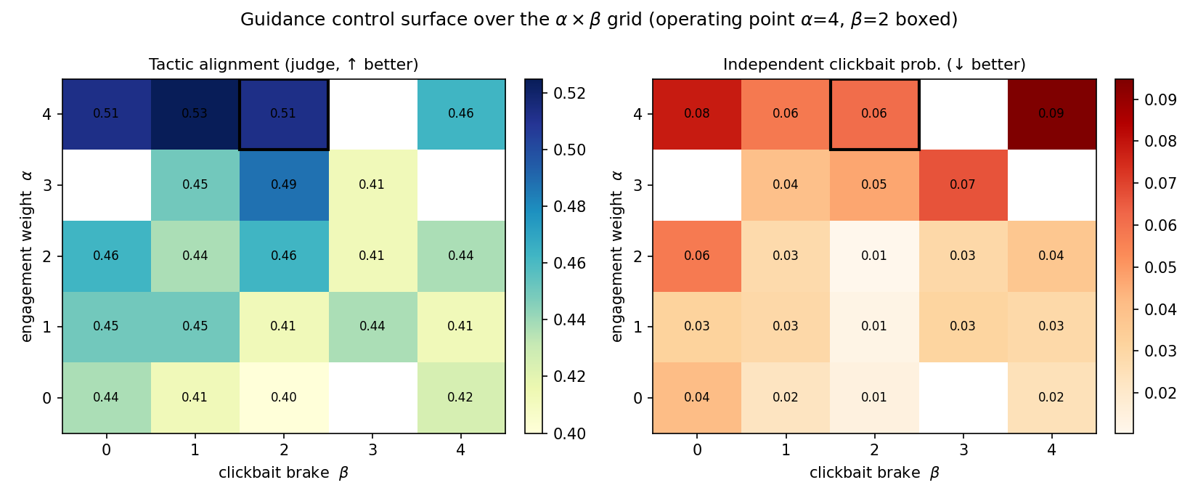
Figure 6. Guidance control surface over the α×β grid on the tuning sweep. Left: independent tactic alignment increases with the engagement weight α. Right: independent clickbait probability decreases with the clickbait brake β. The reported operating point (α = 4, β = 2) is boxed.

4.9 Comparison with decoding-time baselines
We compare FUDGE (α = 4, β = 2) against the two related decoding-time control methods DExperts and GeDi, each with its own Llama-3.2-1B expert/controller and strength sweep, on the same 300 items (item-matched Wilcoxon signed-rank, n = 900). The (0,0) ablation cell, which names the target tactic in the prompt but applies no decoding guidance, already supplies most of the tactic signal (0.476 tactic alignment); the decoding-time guides are then what lower induced clickbait and shape the fidelity trade-off on top of it.
Table 7. Cross-method comparison (n = 900 per row). FUDGE is shown at its dual operating point (4, 2); DExperts and GeDi are shown across their steering strength to expose the engagement–clickbait coupling: as the single-axis baselines steer harder to realize the tactic, induced clickbait rises steeply and fidelity falls, whereas the dual brake holds induced clickbait low. BERTScore = fidelity to source; clickbait = independent detector; perplexity (median) = fluency. Parentheses give 95% percentile-bootstrap confidence intervals. DExperts is decoded with a repetition penalty (1.3), a no-repeat-three-gram constraint, and a headline-length cap.
Method | Tactic (judge) | BERTScore | Clickbait (ext.) | Perplexity (median)
Prompt + tactic = FUDGE (0,0) | 0.476 (0.45–0.50) | 0.282 (0.27–0.29) | 0.045 (0.04–0.06) | 211 (192–221)
FUDGE dual (4,2) | 0.500 (0.48–0.53) | 0.251 (0.24–0.26) | 0.057 (0.05–0.07) | 241 (229–254)
DExperts (α = 0.5) | 0.520 | 0.263 (0.26–0.27) | 0.064 (0.05–0.08) | 191 (179–206)
DExperts (α = 2) | 0.465 | 0.102 (0.10–0.11) | 0.509 (0.48–0.54) | 515 (492–533)
DExperts (α = 4) | 0.500 | −0.002 (−0.01–0.00) | 0.733 (0.71–0.76) | 1270 (1223–1329)
GeDi (α = 5) | 0.465 | 0.224 (0.22–0.23) | 0.203 (0.18–0.23) | 165 (151–179)
GeDi (α = 30) | 0.500 | 0.055 (0.05–0.06) | 0.588 (0.56–0.61) | 1185 (1121–1263)
At matched independent tactic realization (≈ 0.50; the steered methods are statistically indistinguishable on this axis: FUDGE vs DExperts p = 0.44, vs GeDi p = 0.38), the methods differ in how they control the engagement-versus-clickbait trade-off. The single-axis baselines expose one steering strength that couples the two: as that strength increases, the external-detector clickbait probability rises steeply (DExperts 0.06, 0.13, 0.51, 0.73; GeDi up to 0.59) while BERTScore falls (DExperts 0.26 to 0.00; GeDi to 0.06), because they have no separate lever to lower clickbait once the engagement level is set. At low steering these baselines are competitive, reaching the tactic at low clickbait and high fidelity; what they lack is an independent clickbait control. The dual guide adds exactly that: the β brake holds the independent clickbait probability at 0.057 at the operating point and is adjusted separately from the engagement weight α (the α×β control surface, Figure 6). Figure 7 makes the contrast explicit: the dual-control line stays flat in induced clickbait across the steering range while the single-axis methods climb. This decoupling of engagement from clickbait is the dual-control contribution. DExperts is decoded with a repetition penalty (1.3), a no-repeat-three-gram constraint, and a headline-length cap matched to the base generator, which keep the product-of-experts baseline fluent under strong steering.
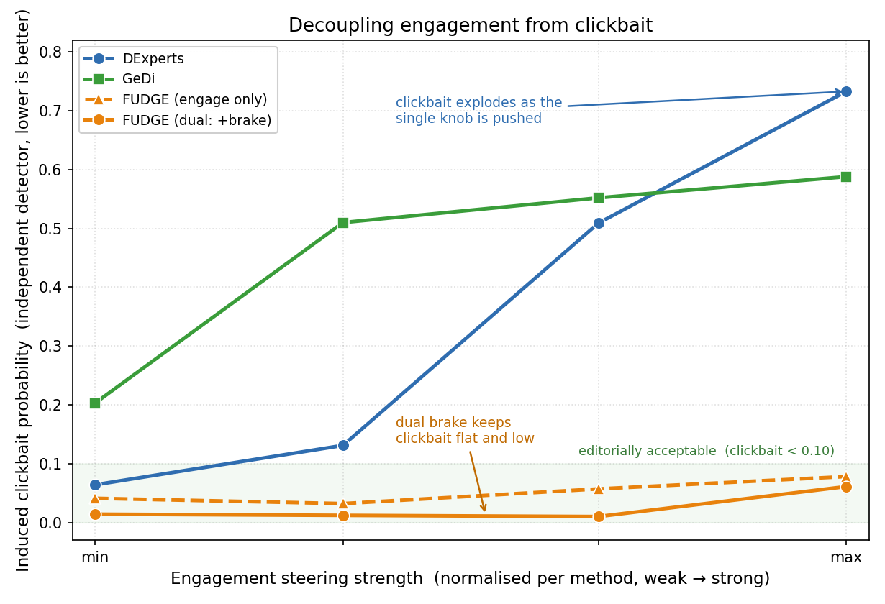
Figure 7. Independent control of clickbait. Induced clickbait (independent detector) as each method is steered from weak to strong engagement, with the steering strength normalised per method; shaded bands are 95% bootstrap confidence intervals. The single-axis baselines DExperts and GeDi expose one control that couples engagement and clickbait, so steering them harder drives induced clickbait up steeply (DExperts to 0.73, GeDi to 0.59). The dual guide adds an independent clickbait brake that holds induced clickbait low and flat across the range (below 0.06); the engage-only FUDGE curve (dashed) shows the multiplicative guidance is already low-clickbait and the brake lowers it further. This independent brake, which the single-axis methods lack, is the dual-control contribution.
Table 8. Qualitative cross-method comparison on two source headlines at comparable tactic realization (DExperts α = 2, GeDi ω = 10). The dual guide holds the independent clickbait probability near zero while staying faithful to the source; the single-axis baselines reach the same tactic only with markedly higher induced clickbait and lower fidelity. Independent detector for clickbait.
Source / method | Rewrite | BERTScore | Clickbait (ext.)
Source: White House says to have Supreme Court nominee in next couple of weeks
FUDGE (4,2) | Will the White House Deliver on Its Promise to Name a Supreme Court Nominee Within the Next Couple of Weeks?". | 0.43 | 0.01
DExperts (α = 2) | BOMshell SC Pick Up This Couple Freakily Soon!! | −0.16 | 1.00
GeDi (ω = 10) | What happens behind palace secrets ahead. | −0.07 | 0.02
Source: Trump and Obama set campaign rancor aside with White House meeting
FUDGE (4,2) | Unlikely Allies Unite: Emotional Tensions Melt Away as Trump and Obama Share Rare White House Encounter". | 0.34 | 0.07
DExperts (α = 2) | Histor ic Icons Come Unexpected Close to Breaking Down Last Summer. | −0.01 | 0.00
GeDi (ω = 10) | Unexpected unity unfolds amidst the fiery landscape. | 0.13 | 0.00

4.10 Rater-based evaluation
We complement the automatic metrics with a large annotation study using three independent human annotators applying a fixed rubric. Two studies are reported. (C1) Rubric validation over 150 headlines yields substantial inter-annotator agreement (mean Fleiss κ = 0.70) and a mean intended-vs-consensus tactic F1 of 0.44, consistent with the graded, fine-grained nature of the tactics and the attribute model's own recoverability. (C2) Rewrite-quality scoring over 1,500 rewrites across all methods yields good-to-excellent reliability (ICC(2,k) 0.82–0.94); annotator faithfulness ratings correlate with automatic BERTScore (Spearman ρ = 0.61, n = 1500), validating the automatic fidelity metric. The human ratings confirm the two designed effects with item-matched significance (Table 9, 1–5 scale): the clickbait brake lowers perceived clickbait (dual 2.03 versus no-guidance 2.61, p = 1×10⁻⁷) and the dual guidance is rated more faithful than the no-guidance baseline (3.58 versus 2.89, p = 1×10⁻⁷). Against the decoding-time baselines the dual guide is rated substantially more faithful (3.58 versus DExperts 2.54 and GeDi 2.27, both p < 1×10⁻¹³) and lower in perceived clickbait than DExperts (2.03 versus 3.32, p < 1×10⁻¹⁶). The complete rating data are released as a spreadsheet in the deposit.
Table 9. Human rater-based evaluation of rewrite quality (mean rating, 1–5; 95% bootstrap CI). Ratings from three independent annotators over 1,500 rewrites; higher clickbait = more clickbaity. The brake lowers perceived clickbait and the dual guidance is rated most faithful among the steered methods.
Method / cell | Engagement | Faithfulness | Clickbait
FUDGE dual (4,2) | 2.90 (2.81–2.98) | 3.58 (3.40–3.76) | 2.03 (1.91–2.17)
FUDGE engage only (4,0) | 3.51 (3.39–3.63) | 3.14 (2.93–3.33) | 2.64 (2.52–2.78)
FUDGE brake only (0,2) | 2.96 (2.86–3.05) | 3.44 (3.24–3.63) | 1.88 (1.75–2.02)
No guidance (0,0) | 3.46 (3.34–3.59) | 2.89 (2.71–3.07) | 2.61 (2.48–2.75)
DExperts | 3.21 (3.15–3.28) | 2.54 (2.45–2.64) | 3.32 (3.23–3.41)
GeDi | 3.24 (3.18–3.31) | 2.27 (2.20–2.34) | 2.80 (2.73–2.89)

4.11 Robustness and boundary analysis
We stress-test the framework on three constructions that probe the limits of the guides and quantify their effect on fidelity. First, provocative-question outputs of the form "…: But at what cost to X?" can occasionally slip past the negative guide because their surface lexicon is not exaggerated even though the implied premise is: the interrogative construction shifts manipulative content into the presupposition, which the prefix-level clickbait scorer is not explicitly trained to flag. Second, positive guidance targeting referential underspecification can, in rare cases, embellish the source with a novel noun phrase (for example "Secrets" or "A New Era") not present in the original headline; such outputs raise the attribute-realization score under our own engagement model but reduce semantic fidelity. Third, the clickbait scorer is trained on GPT-4o-mini generations and is therefore calibrated to that distribution; the external-benchmark evaluation of Section 4.5 quantifies its transfer to human-authored clickbait (AUROC 0.955 on clean and 0.740 on graded corpora). We quantified the second (embellishment) mode with a stricter LLM re-judge that separates a genuine new verifiable fact from rhetorical framing: at the dual operating point, a naive "adds any claim" judge flags 22% of rewrites, but 75% of those flags are rhetorical questions (a target tactic), and a refined new-fact judge, validated on faithful-paraphrase controls that score ≈ 0.02 and fact-injected controls that score 1.0, puts the genuine new-fact rate at 0.20, statistically indistinguishable from the 0.18 of the no-guidance baseline. The apparent fidelity cost is therefore dominated by the question form (which also depresses NLI entailment) rather than by fabricated content: restricted to non-question rewrites, the fidelity of the dual cell matches the baseline (NLI 0.29 vs 0.34).
Table 10 reports the calibration behind this analysis. On labelled controls the new-fact judge assigns a rate of 0.025 to faithful paraphrases and to faithful rhetorical questions, but 1.00 to fact-injected controls, separating genuine fabrication from rhetorical framing at AUROC ≈ 1.0. NLI entailment mirrors this (AUROC 0.997–1.00 for faithful vs unfaithful) but, unlike the fabrication judge, scores faithful questions low (0.20), confirming that the interrogative form depresses entailment without adding content.
Table 10. Calibration of the new-fact (fabrication) judge and of NLI entailment on labelled controls (n = 120). The judge separates injected facts from faithful rewrites at AUROC ≈ 1.0, and NLI separates faithful from unfaithful rewrites at AUROC 0.997–1.00. Faithful rhetorical questions add no new facts (0.025) yet score low on entailment (0.20), which is why the question form depresses NLI without introducing content.
Control type | New-fact rate (judge) | NLI entailment (mean)
Faithful paraphrase | 0.025 | 0.99
Faithful rhetorical question | 0.025 | 0.20
Fact-injected (positive control) | 1.00 | n/a

4.12 Cross-domain generalization
To test whether the framework generalizes beyond Reuters newswire, we apply the same guides, at the same operating point (α = 4, β = 2), to 150 human-authored, non-Reuters neutral headlines: the non-clickbait half of the Chakraborty corpus, spanning disasters, culture, and financial markets rather than political newswire. The two guides reproduce their designed, opposite effects on this different register (Table 11). The engagement guide raises tactic realization (guide-based, 0.10 → 0.16) and, with it, induced clickbait (0.05 → 0.10), while the clickbait brake lowers the independent clickbait score back from 0.097 to 0.061 and improves entailment, exactly as in-domain. Source fidelity is preserved (BERTScore 0.22–0.28, matching the in-domain 0.25–0.28) and induced clickbait stays in the same low regime (below 0.10 throughout). Perplexity is modestly higher than in-domain (266–368 vs 175–275), reflecting the greater lexical variety of this out-of-domain set, but the ordering across the four cells is unchanged. The dual-control mechanism is therefore not specific to the Reuters training domain.
Table 11. Cross-domain generalization: the same guides at the same operating point applied to 150 human-authored, non-Reuters neutral headlines (non-clickbait half of the Chakraborty corpus). Clickbait, BERTScore, NLI and perplexity are independent; the tactic column is the guide-based (circular) score, as the LLM judge was not run in this generality check. Parentheses give 95% bootstrap CIs (n = 450 per cell).
Cell | Tactic (guide*) | Clickbait (ext.) | BERTScore | NLI | Perplexity (median)
(0,0) baseline | 0.097 (0.08–0.12) | 0.049 (0.04–0.06) | 0.276 (0.26–0.29) | 0.278 (0.25–0.31) | 291 (267–329)
(4,0) engage only | 0.156 (0.14–0.18) | 0.097 (0.08–0.12) | 0.246 (0.23–0.26) | 0.231 (0.20–0.26) | 266 (240–295)
(0,2) brake only | 0.008 (0.00–0.01) | 0.027 (0.02–0.04) | 0.271 (0.26–0.29) | 0.304 (0.27–0.34) | 368 (336–407)
(4,2) dual | 0.074 (0.06–0.09) | 0.061 (0.05–0.08) | 0.220 (0.21–0.23) | 0.204 (0.18–0.23) | 319 (286–356)

4.13 Transfer to a second base generator
We test model-agnosticism by swapping the base generator to Qwen2.5-7B-Instruct[20], a different model family, keeping the guides and the operating point (α = 4, β = 2) unchanged and applying the language-consistency constraint of Section 3.6. Llama-3-8B remains the primary generator for comparability with the decoding-time baselines; this experiment shows that the same guides and operating point transfer to a different model family, and Qwen's higher BERTScore reflects its more conservative, closer-to-source rewriting. The dual control transfers cleanly to Qwen (Table 12): the engagement guide raises tactic realization (0.31 → 0.36); source fidelity and fluency are maintained and in fact exceed the Llama-3 configuration (BERTScore 0.43–0.47 versus 0.25–0.28; perplexity 133–163); induced clickbait stays low across all cells (below 0.06); and the clickbait brake holds the brake-only cell at or below the no-guidance baseline (0.033 versus 0.034). The two guides retain their designed, opposite effects on a second base-model family at the same operating point.
Table 12. Transfer to a second base generator (Qwen2.5-7B-Instruct), same guides and operating point, with the language-consistency constraint for multilingual generators. Independent metrics; the tactic column is the guide-based (circular) score. Parentheses give 95% bootstrap CIs (n = 450 per cell (786 for the α = 4, β = 0 cell)).
Cell | Tactic (guide*) | Clickbait (ext.) | BERTScore | NLI | Perplexity (median)
(0,0) baseline | 0.31 (0.28–0.33) | 0.034 (0.02–0.05) | 0.469 (0.46–0.48) | 0.315 (0.28–0.35) | 133 (116–148)
(4,0) engage only | 0.36 (0.34–0.38) | 0.058 (0.05–0.07) | 0.447 (0.44–0.46) | 0.237 (0.21–0.26) | 135 (121–145)
(0,2) brake only | 0.13 (0.11–0.15) | 0.033 (0.02–0.05) | 0.461 (0.45–0.48) | 0.358 (0.32–0.40) | 162 (144–178)
(4,2) dual | 0.20 (0.18–0.23) | 0.057 (0.04–0.08) | 0.432 (0.42–0.45) | 0.293 (0.26–0.33) | 163 (141–177)

5. Conclusion and Future Work
This work demonstrates that engagement-oriented headline rewriting can be explicitly controlled to avoid degenerating into clickbait. By introducing separate positive and negative control coefficients, the proposed approach disentangles engagement enhancement from manipulative amplification. The quantitative evaluation in Section 4 supports this: the clickbait brake measurably lowers both the independent detector score and human-rated clickbait (dual 2.03 versus 2.61 on a 1–5 scale, p = 1×10⁻⁷), independent annotators rate the dual guidance more faithful than the no-guidance baseline (3.58 versus 2.89, p = 1×10⁻⁷), and against the DExperts and GeDi decoding-time baselines the dual guide adds an independent clickbait brake, a lever that lowers induced clickbait separately from the engagement weight and that single-axis baselines lack, so that pushing their single control past the operating point raises induced clickbait steeply. The guide models themselves transfer to entirely human-authored clickbait (Chakraborty AUROC 0.955), the dual-control mechanism reproduces its designed effects on a different, non-Reuters news register (Section 4.12) and on a second base-model family (Qwen2.5-7B) with a language-consistency constraint for multilingual generators (Section 4.13), and a human rater evaluation reproduces the faithfulness ranking across methods.
The results support the central claim that clickbait is not an inevitable byproduct of engagement optimization; instead, it emerges when negative constraints are absent. Framing headline generation as a constrained optimization problem provides a practical, interpretable mechanism for navigating the trade-off between informativeness and appeal, with direct relevance to responsible media generation, recommender systems, and editorial AI tools.

5.1 Limitations and Scope
Several limitations frame the empirical scope of the current work. First, the synthetic corpus is built exclusively from the real Reuters political and world-news headlines described in Section 3.2 (the genuine-news half of the ISOT dataset); extending both guide models to tabloid, entertainment, and non-English registers remains open, although Section 4.12 shows that the trained guides already transfer at inference to a different, human-authored, non-Reuters English-news register with the same directional effects; the results in Section 4 should otherwise be read within this domain. Second, the neutrality of the Reuters source headlines is quantified rather than assumed: the independent detector flags only 0.61% of the source pool (Section 4.7). Third, the external evaluation on the Webis Clickbait Corpus 2017[3] and the Chakraborty et al.[2] corpus (Section 4.5) measures the synthetic-to-human distribution shift directly, with AUROC 0.955 on clean human clickbait and 0.740 on the noisier graded corpus. Fourth, the decoding-time guides operate as amplifiers on top of the prompt: they deliver their effect when the prompt names the target tactic (on the 40-item α–β tuning sweep, independent tactic realization +0.075, from 0.44 to 0.51, as α goes 0→4; on the 300-item held-out set the same contrast is +0.03, 0.48 to 0.51, Table 6), consistent with top-k rescoring reweighting tokens the base model already proposes; the framework is therefore designed and evaluated as prompt-plus-guidance. Fifth, all three decoding-time methods realize the target tactic to a comparable degree, and the single-axis baselines match the dual guide's fidelity at low steering; the dual guide's distinctive capability is the independent clickbait brake, which decouples engagement from clickbait so that induced clickbait stays low as engagement rises, while the single-axis baselines raise induced clickbait as they steer toward the same tactic (Section 4.9). All quantitative comparisons use item-matched significance testing with 95% bootstrap confidence intervals.
Several directions naturally extend this study. First, the control framework can be expanded from scalar coefficients to tactic-specific penalties, allowing fine-grained suppression of individual clickbait strategies such as urgency inflation, emotional manipulation, or curiosity gaps. Second, future work should evaluate the approach at scale using real-world engagement metrics and against editorial or platform-specific standards. Third, integrating the control mechanism into multi-step or reinforcement-based generation loops may further improve robustness under tactic composition. Finally, extending the framework beyond headlines to longer-form content such as summaries or social-media posts would test its generality for broader responsible text-generation settings.

Data Availability
The dataset, source code, the three-annotator human evaluation study, and the trained guide-model checkpoints (the two BERT guides and the independent DistilBERT detector) are archived on Zenodo at https://doi.org/10.5281/zenodo.21546641. The DExperts and GeDi baseline checkpoints derive from Llama-3.2-1B and are reproducible from the released scripts; the third-party evaluation corpora are referenced with retrieval instructions in the deposit.

Funding
This research received no specific grant from any funding agency in the public, commercial, or not-for-profit sectors.

References
1. Biyani, P., Tsioutsiouliklis, K. & Blackmer, J. "8 amazing secrets for getting more clicks": detecting clickbaits in news streams using article informality. In Proc. 30th AAAI Conf. on Artificial Intelligence 94–102 (AAAI Press, 2016).
2. Chakraborty, A., Paranjape, B., Kakarla, S. & Ganguly, N. Stop clickbait: detecting and preventing clickbaits in online news media. In Proc. IEEE/ACM Int. Conf. on Advances in Social Networks Analysis and Mining (ASONAM) 9–16 (IEEE, 2016).
3. Potthast, M., Gollub, T., Hagen, M. & Stein, B. The Clickbait Challenge 2017: towards a regression model for clickbait strength. Preprint at https://arxiv.org/abs/1812.10847 (2018).
4. Jácobo-Morales, D. & Marino-Jiménez, M. Clickbait: research, challenges and opportunities: a systematic literature review. Online J. Commun. Media Technol. 14, e202458 (2024).
5. Alarfaj, F. K., Muqadas, A., Khan, H. U. & Naz, A. Clickbait detection in news headlines using RoBERTa-Large language model and deep embeddings. Sci. Rep. 15 (2025).
6. Muqadas, A. et al. Deep learning and sentence embeddings for detection of clickbait news from online content. Sci. Rep. 15, 13251 (2025).
7. Wang, Y. et al. Clickbait detection via prompt-tuning with titles only. IEEE Trans. Emerg. Top. Comput. Intell. 9, 695–705 (2024).
8. Wang, H. et al. Clickbait detection via large language models. In Proc. Int. Conf. on Intelligent Computing 462–474 (Springer, 2025).
9. Aubin Le Quéré, M. & Matias, J. N. When curiosity gaps backfire: effects of headline concreteness on information selection decisions. Sci. Rep. 15, 994 (2025).
10. Michaluk, W., Urban, T., Kubita, M., Kuntur, S. & Wróblewska, A. Click it or leave it: detecting and spoiling clickbait with informativeness measures and large language models. Preprint at https://arxiv.org/abs/2602.18171 (2026).
11. Nofar, L., Portal, T., Elbaz, A., Apartsin, A. & Aperstein, Y. An interpretable benchmark for clickbait detection and tactic attribution. Preprint at https://arxiv.org/abs/2509.10937 (2025).
12. Keskar, N. S., McCann, B., Varshney, L. R., Xiong, C. & Socher, R. CTRL: a conditional transformer language model for controllable generation. Preprint at https://arxiv.org/abs/1909.05858 (2019).
13. Dathathri, S. et al. Plug and play language models: a simple approach to controlled text generation. Preprint at https://arxiv.org/abs/1912.02164 (2019).
14. Krause, B. et al. GeDi: generative discriminator guided sequence generation. In Findings of the Association for Computational Linguistics: EMNLP 2021 4929–4952 (ACL, 2021).
15. Liu, A. et al. DExperts: decoding-time controlled text generation with experts and anti-experts. In Proc. 59th Annual Meeting of the Association for Computational Linguistics (ACL) 6691–6706 (ACL, 2021).
16. Yang, K. & Klein, D. FUDGE: controlled text generation with future discriminators. In Proc. 2021 Conf. of the North American Chapter of the Association for Computational Linguistics (NAACL) 3511–3535 (ACL, 2021).
17. Ahmed, H., Traore, I. & Saad, S. Detecting opinion spams and fake news using text classification. Secur. Priv. 1, e9 (2018).
18. Ahmed, H., Traore, I. & Saad, S. Detection of online fake news using n-gram analysis and machine learning techniques. In Proc. Int. Conf. on Intelligent, Secure, and Dependable Systems in Distributed and Cloud Environments 127–138 (Springer, 2017).
19. Grattafiori, A. et al. The Llama 3 herd of models. Preprint at https://arxiv.org/abs/2407.21783 (2024).
20. Yang, A. et al. Qwen2.5 technical report. Preprint at https://arxiv.org/abs/2412.15115 (2024).
21. OpenAI. GPT-4o system card. Preprint at https://arxiv.org/abs/2410.21276 (2024).
22. Devlin, J., Chang, M.-W., Lee, K. & Toutanova, K. BERT: pre-training of deep bidirectional transformers for language understanding. In Proc. 2019 Conf. of the North American Chapter of the Association for Computational Linguistics: Human Language Technologies Vol. 1, 4171–4186 (ACL, 2019).
23. Sanh, V., Debut, L., Chaumond, J. & Wolf, T. DistilBERT, a distilled version of BERT: smaller, faster, cheaper and lighter. Preprint at https://arxiv.org/abs/1910.01108 (2019).
24. He, P., Gao, J. & Chen, W. DeBERTaV3: improving DeBERTa using ELECTRA-style pre-training with gradient-disentangled embedding sharing. Preprint at https://arxiv.org/abs/2111.09543 (2021).
25. Zhang, T., Kishore, V., Wu, F., Weinberger, K. Q. & Artzi, Y. BERTScore: evaluating text generation with BERT. In International Conference on Learning Representations (2020).
26. Radford, A. et al. Language models are unsupervised multitask learners. Technical report, OpenAI (2019).

