Acting on the Unseen: Communication-Free Collaborative Filtering for Decentralized Multi-Robot Task Allocation
  - Author One^{a,∗}, Author Twoª
ªAffiliation, City, Country. ∗Corresponding author.
  - Highlights
- Prior-free, communication-free MRTA under partial, privately-noisy observation.
- Decentralized online collaborative filtering acts on never-attempted tasks.
- Categorical separation over structure-free learning: proven and validated.
- A positive scaling law: the swarm gets smarter as it grows.
- Robust to masking; recovers most of a centralized full-communication ceiling.
Abstract. Multi-robot task allocation usually assumes some combination of communication, known task models, or a coordinator. We study the opposite extreme, a regime that is common in practice yet largely overlooked in theory: a robot team with no prior knowledge (no task models, not even the latent rank), no communication (no messages, no parameter sharing, no coordinator), and only a partial, noisy, privately-perceived view of a public stream of teammates' outcomes. A hidden low-rank structure governs which robot suits which task, and there are far more tasks than rounds, so most (robot, task) pairs are never attempted. Yet each robot can act well on tasks it never attempted, and onboard new tasks and robots, by running online low-rank collaborative filtering over the broadcast (SwarmCF). The advantage over any structure-free learner is categorical, not a constant factor: a structure-free learner is provably at the prior-mean error floor on unseen pairs. We prove a matching per-robot sample complexity ($Θ(d)$ versus $Θ(n)$), an anytime (cumulative-reward) separation under task scarcity, and a deterministic condition under which decentralized recovery from the masked broadcast is exact (validated empirically). Experiments quantify the value of the broadcast, a positive scaling law (the swarm gets smarter as it grows), and dominance over the other low-rank methods under limited observability, recovering most of a centralized full-communication ceiling; the advantage also transfers to a separate, higher-fidelity spatial robot simulator with different dynamics.
Keywords: multi-robot task allocation; decentralized learning; collaborative filtering; low-rank matrix completion; communication-free coordination; multi-agent bandits; swarm robotics.

1. Introduction
The setting in one line. No prior knowledge, no communication, and only a partial, noisy, privately-sensed view of teammates' outcomes, with every decision made independently. Can a swarm still act intelligently, in particular on tasks it has never attempted? We answer yes, and show the advantage is categorical.
Consider a team of autonomous robots, for example aerial vehicles, that must repeatedly decide which task to engage: which area to inspect, which target to service, which sensor reading to pursue. Whether a given robot does well on a given task depends on a match between the robot's capabilities (sensor modalities, payload, effector type, endurance, remaining consumables) and the task's requirements. This capability-requirement view is the basis of trait-based task allocation [5], and the match is typically governed by only a few underlying factors, so the full robot $×$ task reward is low-rank.
Most multi-robot task allocation (MRTA) methods obtain coordination from at least one of three resources: explicit communication (auctions, consensus, message-passing), known task models or utilities, or a central coordinator / centralized training. In many real deployments none of these is available: communication is jammed, bandwidth-limited, or deliberately withheld for stealth; the task structure is unknown a priori; and there is no coordinator. What a robot can often still do is passively sense some of what its teammates are doing and how it turned out, imperfectly, at a distance, and differently from every other robot. This is the regime we formalize and solve: a robot observes a partial (range-limited), noisy, and crucially privately-perceived slice of a public outcome stream, never the same slice as a teammate.
The technical crux is generalization to the unseen. There are far more tasks than rounds ($n≫T$), so each robot personally attempts only a vanishing fraction of tasks. A learner that estimates each task only from its own attempts (a structure-free learner: independent per-task bandits, tabular value tables) has, on any task it never attempted, nothing better than the prior mean, the error floor, which dominates exactly because tasks outnumber rounds. The opportunity is that the shared low-rank structure links tasks: outcomes a robot observes teammates obtain (even noisily and partially) constrain that structure, and a few observations then determine the robot's reward on tasks it has never touched. We show a single, simple estimator turns this opportunity into a categorical capability.
The gap. To our knowledge no prior method targets this cell. Every established paradigm relaxes at least one of its defining constraints, no prior knowledge, no communication, decentralized decisions, and partial and privately-noisy observation, by assuming communication, known utilities/traits, a coordinator or centralized training, or clean/shared observation (Section 2, Table 1). The regime is not exotic: it is the default when communication is jammed, bandwidth-limited, or withheld for stealth, and when task structure must be discovered in the field. We close it.
Relation to collaborative filtering. Low-rank collaborative filtering is itself classical; our contribution is not the estimator but the demonstration, with theory, that it works at all in this regime, fully decentralized, communication-free, and under a persistent, per-observer-private observation mask where standard uniform-sampling completion guarantees do not apply, together with the recovery condition that says exactly when it works and the collective-speedup law that says why a swarm helps. The categorical floor against structure-free learning, the decentralized recovery condition under a structured private mask, and the value-of-broadcast / positive-scaling results are, to our knowledge, new.
Contributions.
- We formalize communication-free MRTA under partial, privately-noisy observation and zero prior knowledge, a most-restrictive but practically common regime that prior MRTA and decentralized-learning work does not address (Section 2, Table 1).
- We propose SwarmCF, a decentralized, online, low-rank collaborative filter that each robot runs over the passive broadcast, with an $O(d)$ fold-in that lets it act on unseen tasks and onboard new tasks/robots (Section 4).
- We prove the advantage is categorical: a structure-free learner is at the error floor on unseen pairs and the broadcast is provably useless to it, whereas SwarmCF attains a per-robot sample complexity of $Θ(d)$ versus $Θ(n)$, with a matching anytime separation under task scarcity (Section 5).
- We give a deterministic condition under which decentralized recovery of the shared structure from the privately-masked broadcast is exact, with a coverage-time bound that improves as the team grows, and validate the condition empirically (Section 5, Appendix C).
- We quantify, on a robotics-grounded task-servicing mission, the value of the broadcast, a positive scaling law (per-robot competence rises with team size), and dominance over the other low-rank methods under limited observability, recovering most of a centralized full-communication ceiling; and we show the advantage transfers to a separate, higher-fidelity spatial simulator with different dynamics (Section 6).

2. Related work
Swarm robotics seeks collective competence from simple local rules [38,39], and coverage and patrolling control coordinate where robots move [40]; we instead address which task each robot should engage when the capability-to-task match is unknown and there is no communication.
Multi-robot task allocation. The taxonomies of Gerkey and Matarić [1], Korsah et al. [2], and Nunes et al. [20] organize MRTA by single/multi-task robots, single/multi-robot tasks, and instantaneous/time-extended assignment with interrelated utilities and temporal constraints. Classical solvers, market and auction mechanisms [3], consensus-based bundle algorithms (CBBA) [4], and distributed constraint optimization achieve coordination through communication and assume known task utilities or costs (surveys: [21]); even work that explicitly limits communication still relies on auctions and messages [22], and a recent review underscores how central communication remains to multi-robot systems [23]. Trait-based and heterogeneity-aware MRTA [5,24,25] matches robot capability vectors to task requirement vectors, but takes the traits as given. Our setting keeps the trait/low-rank view but makes the traits unknown and learned online, with neither communication nor known utilities; recent surveys [18] document the rapid growth of learning-based MRTA, but the prior-free, communication-free regime we study remains unaddressed.
Decentralized and learning-based coordination. Communication-free multiplayer bandits (musical chairs [6], SIC-MMAB [7], game-of-thrones [26]) break symmetry without messages but are structure-free (per-arm), so they cannot generalize to unseen arms. Cooperative multi-agent RL (CTDE: MAPPO [14], QMIX [33], VDN [34], MADDPG [35]) and learned-communication methods (CommNet [15], TarMAC [36], DIAL [37]) rely on centralized training or message passing; recent learning-based decentralized assignment (graph neural networks for goal assignment [19] and scheduling [41]) likewise presumes communication or centralized training. Federated and gossip collaborative filtering [42], and federated learning more broadly [44], coordinate by exchanging model parameters or gradients; we exchange nothing but a passively-sensed outcome stream. Decentralized partially-observable control (Dec-POMDPs [46]) addresses long-horizon coordination under shared latent-state dynamics; our rounds are one-shot offered-set choices with no shared state, so the challenge is cross-task generalization from a privately-masked stream rather than long-horizon credit assignment.
Low-rank estimation and bandits. Matrix completion gives centralized recovery guarantees under (near-)uniform sampling [8,9,27,28], with practical factorization estimators (matrix factorization [13], Bayesian PMF [11], soft-impute [12], implicit-feedback ALS [31], ranking CF [32]); low-rank and bilinear bandits (explore-then-spectral [10], bilinear [29], generalized-linear [30], clustering-of-bandits [16]) are centralized and/or phase-structured. Decentralized matrix completion [43] distributes the factorization across nodes but still exchanges factors or residuals over a connected communication graph; we forbid all such exchange and recover from passive observation alone. We make estimation decentralized, online, broadcast-only, and robust to a structured (non-uniform) per-robot observation mask, with the unseen-pair error floor turning the gap into a categorical, rather than constant-factor, separation.
Table 1 places the major paradigms on the four axes that define our problem; each established family relaxes at least one axis we hold fixed, and our cell, low-rank with only a guessed rank, no communication, decentralized, masked and noisy, is the one left open.
Table 1. Established paradigms versus our regime across prior knowledge, communication, decision locus, and observation; the final column names the constraint each relaxes (ours relaxes none).
Paradigm | Prior knowledge | Communication | Decisions | Observation | Constraint it relaxes vs. ours
Auction / consensus / DCOP MRTA [3,4] | task utilities or costs | message-passing | decentralized | full task info | needs communication and known utilities
Cooperative MARL (CTDE) [14,33] | none (learned) | central training or messages | central train, decentral. exec | full (in training) | needs a central critic or messages
No-communication multiplayer bandits [6,7] | none (per-arm) | none | decentralized | own pulls + collisions | structure-free: no unseen generalization
Low-rank completion / bandits [8,10] | low-rank | centralized | centralized | partial (uniform) | centralized and/or explore-then-commit
Federated / gossip CF [42,44] | low-rank | parameter exchange | decentralized | partial | shares parameters, not a passive stream
Trait-based MRTA [5,25] | known traits | varies | decentralized | full | traits given, not learned
Ours: communication-free MRTA (this paper) | low-rank, guessed rank only | none (passive sensing) | decentralized | masked + per-observer noisy | none: the open cell (hardest)

3. Problem setting
Reward. A team of $m$ robots faces $n$ tasks. Robot $i$ has a hidden capability vector $p_{i}∈R^{d}$ and task $j$ a hidden requirement vector $u_{j}∈R^{d}$; the expected reward of robot $i$ engaging task $j$ is their inner product$$R_{ij} = ⟨p_{i},u_{j}⟩, R=PU^{⊤}∈R^{m×n}, rank(R)=d≪min(m,n).$$Thelowrank$d$encodesthatonlyafewtraitsgovernfit.Theteamdoes<b>not</b>know$P$,$U$,oreven$d$(itusesaguessedrank$\hat d$).
Interaction. Each round $t=1,…,T$ every robot $i$ is offered a uniform random size-$c$ subset $S_{it}⊆[n]$ of tasks, selects one $a_{it}∈S_{it}$, engages it, and earns $R_{i,a_{it}}$. The operating regime is task-scarce: $n≫T$, so each robot personally engages only $O(T)$ of the $n$ tasks.
The observation channel (the heart of the setting). There is no communication. Each robot instead passively senses a public stream of engagement outcomes, but only partially and noisily, and privately: (persistent partial visibility) robot $i$ observes teammate $k$'s engagements only if $M_{ik}=1$, where $M_{ik}∼Bernoulli(ρ)$ is fixed for the whole mission ($M_{ii}=1$); (private per-observer noise) when $i$ observes the outcome of action $a_{kt}$ it reads $R_{k,a_{kt}}+η_{ikt}$ with $η_{ikt}∼N(0,σ^{2})$ drawn independently per observer, so the same action is read differently by different robots. No robot ever sees the clean stream, and no two robots see the same stream.
This channel is the formal counterpart of physical sensing: a robot perceives a teammate's engagement and its outcome only when the teammate is within range (the persistent partial mask) and reads it with a fidelity that degrades with distance and with its own sensor (the per-observer noise), so it is physically realizable rather than a convenient abstraction. It is strictly weaker than the shared, clean broadcast usually assumed, and it makes decentralization real: persistent blind spots give every robot a permanently different view, and the private per-observer noise means even commonly-visible outcomes are read differently by each robot, so there is no shared, clean signal to average toward agreement and the robots cannot converge to a common model by symmetry. Figure 1 illustrates the setting.
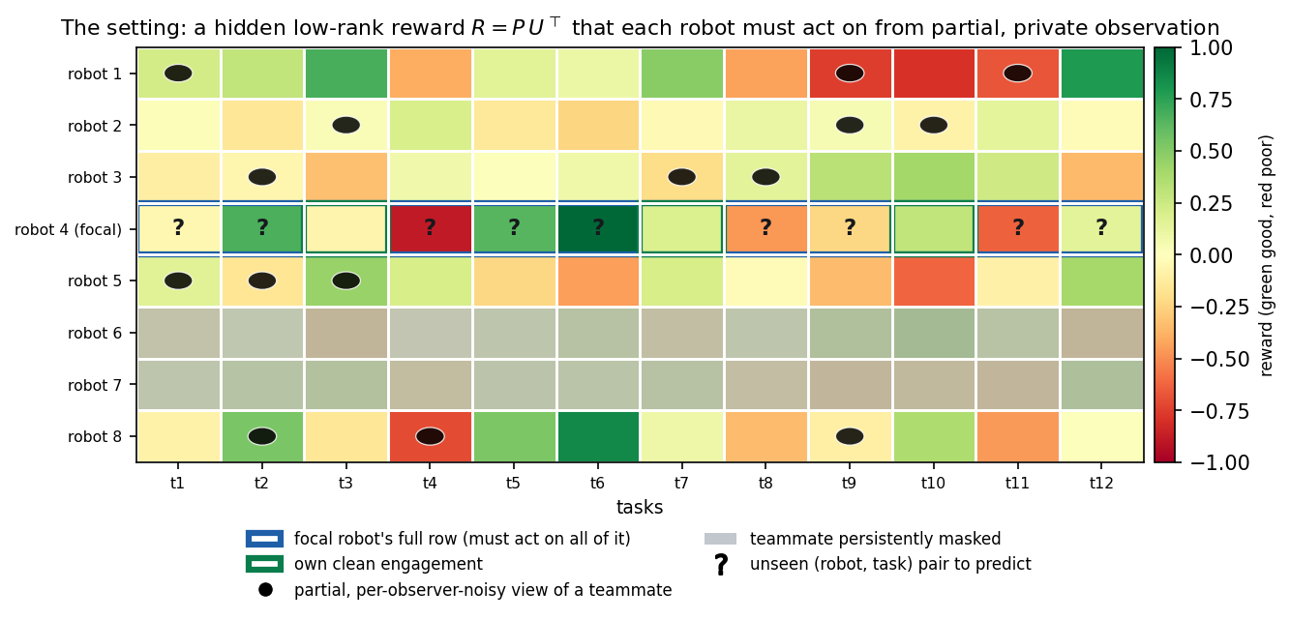
Figure 1. The setting. The robot $×$ task reward is hidden and low-rank, $R=PU^{⊤}$ (capability traits $p_{i}$, requirement traits $u_{j}$). A focal robot (blue row) must act on its whole row, including the many pairs it never engaged ('?'), using only its own clean engagements (green), a partial and per-observer-noisy view of the teammates it can sense (dots; greyed rows are persistently invisible to it), and no communication.
Objective and metric. We measure decision quality by the normalized skill (a Murphy skill score [17] / normalized return),$$skill = \frac{\text{earned}−\text{random}}{\text{oracle}−\text{random}},$$whereforanofferedsetthe<i>oracle</i>picks$\arg\max_{j\in S}R_{ij}$and<i>random</i>picksuniformly;skill$=0$istheno−informationfloorand$1$isomniscient(apolicyworsethanrandomscoresbelow$0$). We report unseen-pair skill (restricted to tasks the robot never engaged, the generalization test), and the anytime (cumulative-reward) skill over the mission.

4. Method: SwarmCF
Each robot independently maintains low-rank factor estimates $\hat{P}∈R^{m×\hat{d}}$, $\hat{U}∈R^{n×\hat{d}}$ and updates them online from whatever it senses, using noise-weighted alternating least squares (weighted ridge ALS [28,31], the workhorse of low-rank completion) on the observed entries. The key design choice for masking-robustness: an unobserved entry receives zero weight, never an imputed zero value. The robot then acts greedily (with a small $ε$ for exploration) on its completed reward row, which is defined for every task, including ones it never engaged.
Algorithm 1: SwarmCF (run independently by each robot $i$)
init $\hat{P},\hat{U}$ small-random; observed set $Ω_{i}←∅$ for round $t=1,…,T$: offered $S_{it}$; act $a_{it}←arg\max_{j∈S_{it}}⟨{\hat{p}}_{i},{\hat{u}}_{j}⟩$ (w.p. $1−ε$, else random); engage, earn $R_{i,a_{it}}$ sense broadcast: for each visible teammate $k$ (i.e. $M_{ik}=1$) record $(k, a_{kt}, \tilde{r}=R_{k,a_{kt}}+η_{ikt})$ with weight $w=1/σ^{2}$ into $Ω_{i}$ (own outcome recorded with its own, lower, noise) every $τ$ rounds: refit by weighted ridge ALS sweeps over $Ω_{i}$: uj←((k,j)∈Ωi​w pkpk⊤+λI)−1∑w r pk; symmetric update for ${\hat{p}}_{i}$ predict full row ${\hat{R}}_{i⋅}=\hat{U}{\hat{p}}_{i}$ (defined on EVERY task, seen or not)
Onboarding (fold-in [48]). A new task $j^{⋆}$ (or a new robot) is absorbed without retraining: given the current factor basis, its hidden vector is the ridge least-squares solution of its few observed engagements against the corresponding known factors, an $O(\hat{d})$ computation. This is the same operation that lets an existing robot predict an unseen task once the basis is recovered (Algorithm 2).
Algorithm 2: Fold-in (onboard a new task / robot / unseen pair)
given basis $B$ (the $\hat{d}$-dim factors of the entities the newcomer has been observed against) and observations $y$ (the few rewards seen for the newcomer), with weights $W$: $\hat{x}←(B^{⊤}WB+λI)^{−1}B^{⊤}Wy$ // $O(\hat{d})$ ridge solve predict reward on any other entity with factor $b$ as $⟨b,\hat{x}⟩$
What SwarmCF does and does not assume. It is fully decentralized (one estimator per robot, no shared state), communication-free (it only reads the passive stream), and prior-free beyond a guessed rank $\hat{d}$ (which it does not need to be exact, and which can itself be removed by a rank-adaptive variant we defer to follow-up work). It does not assume the noise level is known: uniform weighting suffices and is what we use for the headline results.
Computational cost. SwarmCF is light enough to run on each robot. Acting is $O(c\hat{d})$ per round (score the offered set). A periodic refit is a few alternating ridge sweeps, each solving $O(m+n)$ linear systems of size $\hat{d}×\hat{d}$, i.e. $O\left(\text{sweeps}⋅(m+n){\hat{d}}^{3}+|Ω_{i}|{\hat{d}}^{2}\right)$ time, with $O((m+n)\hat{d}+|Ω_{i}|)$ memory; since $\hat{d}$ is a small guessed rank this is negligible for swarm-scale $m,n$. Onboarding a new task or robot is a single $O({\hat{d}}^{3})$ ridge solve. There is no inter-robot computation: each robot updates only its own factors and reads the passive stream.

5. Theory: why the advantage is categorical
We formalize the separation between structure-free learning and SwarmCF, give the per-robot sample complexity, and state the conditions under which decentralized recovery from the masked broadcast succeeds. Proofs are in Appendix A; here we give the statements and the intuition. A learner is structure-free if its estimate of $R_{ij}$ depends only on robot $i$'s own past engagements of task $j$ and equals a fixed prior on any task it never engaged (the per-arm class: independent UCB, tabular).
Proposition 1 (structure-free floor). For a structure-free learner and any task $j$ that robot $i$ never engaged, the estimate is the prior constant, so its expected unseen-pair skill is exactly $0$ and its squared error is at least the row variance $Ω(1)$. Moreover the broadcast is provably useless to it: its per-task estimate is by definition not a function of any other task or robot.
Theorem 1 (CF row completion, $Θ(d)$ versus $Θ(n)$). If the task factors $U$ are known (rank $d$) and robot $i$ observes its true rewards on any set $Ω$ with $|Ω|≥d$ whose factors span $R^{d}$, then $p_{i}$ is the unique least-squares solution and $R_{ij}=⟨p_{i},u_{j}⟩$ is recovered exactly for all $j$. Per-robot sample complexity is therefore $Θ(d)$, versus $Θ(n)$ for any structure-free learner.
Theorem 2 (anytime separation under task scarcity). With $n$ tasks, offers of size $c$ and horizon $T$, any structure-free learner has anytime (cumulative-reward) skill at most $g(cT/n)$, where $g$ is increasing with $g(0)=0$ so the bound vanishes when $cT=o(n)$, even with a full broadcast; once the shared basis is available (Theorem 1, recovered per Theorem 3) SwarmCF reaches near-oracle in $O(d)$ further rounds and earns $Θ(1)$ anytime skill, a categorical gap.
Proposition 1 and Theorems 1-2 make the separation categorical (zero versus nonzero) and operational (it shows up in reward earned while learning), but Theorem 1 assumes $U$ is known. The remaining question, the crux of the decentralized setting, is whether each robot can recover the shared structure from its own privately-masked, noisy stream. Because the mask is over robot pairs, robot $i$'s observations form a structured (non-uniform) sub-sample, exactly where off-the-shelf uniform-sampling completion does not apply. We give a deterministic condition instead.
Theorem 3 (decentralized masked recovery). Let $E_{i}(j)$ be the set of robot $i$'s visible teammates that engaged task $j$. If $i$'s observation graph contains a $\hat{d}×\hat{d}$ fully-observed invertible anchor block (fixing the factor frame) and, for task $j$, the factors $\{p_{k}:k∈E_{i}(j)\}$ span $R^{d}$, then robot $i$ recovers $u_{j}$ exactly (noiseless) and predicts $(i,j)$ exactly after folding in its own $≥d$ engagements; under per-observation noise the error is bounded by the fold-in bound with the coverage degree $|E_{i}(j)|$ controlling the noise term. Conversely, if $\{p_{k}:k∈E_{i}(j)\}$ does not span the direction of $p_{i}$, the pair $(i,j)$ is non-identifiable and the learner is at the prior floor. Under non-adaptive exploration the spanning condition is met for all tasks, with high probability, after $T=O​\left({nd}/{ρm}logn\right)$ rounds, a rate that improves as the team grows.
Theorem 3 turns the previously-cited completion step into a self-contained, checkable condition: recovery is exact when a robot has seen a task engaged by a spanning set of visible teammates, impossible without it, and is reached the faster the larger the team. Appendix C validates it directly: on the actual observation patterns the swarm produces, reconstruction error collapses from the prior floor to (numerically) zero exactly at the spanning threshold.
Theorem 4 (collective speedup, why a swarm). An isolated robot ($ρ=0$) sees only its own row and cannot identify a rank-$d>1$ column space, so its unseen skill stays at the floor: sharing is necessary. With the broadcast, the swarm's pooled observations cross the recovery threshold after $\tilde{O}(d(1+n/m))$ rounds, an $Θ(m)$-fold speedup over a lone learner, achieved with no communication.
Theorems 3-4 are, to our knowledge, the first results that pin decentralized low-rank recovery from a persistent, private, per-robot mask to an explicit condition and tie its rate to team size; they are what make the categorical claim self-contained rather than imported from centralized theory. Full proofs are given in Appendix A.

6. Experiments
Setup. Unless noted, $m=30$ robots, $n=240$ tasks, true rank $d=5$, guessed rank $\hat{d}=8$ (so no method is given the rank), horizon $T=50$, offers of size $c=20$, partial broadcast $ρ$ swept, private noise on own ($0.1$) and observed ($0.3$) outcomes, 8 seeds, bootstrap 95% confidence intervals. We compare on one canonical masked harness.
How to read the comparison. The setting itself is new, so this is a controlled sweep across the low-rank design space against the genuinely external structure-free paradigm and full-information reference ceilings, not a contest of rival systems. SwarmCF is our method; structure-free learners (independent UCB1 [45], tabular) are the external paradigm; standard low-rank estimators (online SGD-MF, batch spectral/Bayesian/convex completion) are adapted to the setting for the low-rank comparison; the Oracle and a centralized full-communication matcher are upper bounds, not competitors. We emphasize that communication-based methods (auctions/CBBA, CTDE training, federated/gossip CF) are inadmissible by the problem definition, not omitted: they require messages or a coordinator, which our setting forbids, so they can appear only as the centralized ceilings. The admissible communication-free competitors are exactly the structure-free learners (independent UCB / tabular), which are the per-arm reductions of no-communication multiplayer-bandit methods. In our harness every method runs decentralized and communication-free (one estimator per robot); the low-rank methods differ only in the update rule. Table 2 fixes each method's operating profile.
Table 2. Operating profiles of the methods compared; SwarmCF-family refinements are deferred to future work (column abbreviations are defined in the key).
Column key. Observability: full = every engagement seen noiselessly; ρ = a fraction ρ of engagements seen (masked); ρσ = masked and read with per-observer noise; fullσ = unmasked but noisy; self = own outcomes only. Prior: – = none; $\hat{d}$ = a guessed rank; d = the true rank; U* = oracle factors. Computation: ETC = explore-then-commit. In our harness every method runs decentralized and communication-free (one estimator per robot on the passive broadcast); the low-rank methods differ only in the update rule, so the comparison is controlled. SwarmCF (our online method) and its batch variant SwarmCF-batch are ours (shaded); the rest are standard low-rank estimators we adapt, the structure-free paradigm, or reference ceilings (full communication, not competitors).
Method | Provenance | Distribution | Communication | Observability | Prior | Computation
SwarmCF | ours | decentralized | none | ρσ | $\hat{d}$ | online
SwarmCF-batch | ours (hybrid) | decentralized | none | ρσ | $\hat{d}$ | batch
MF-SGD | standard, adapted | decentralized | none | ρσ | $\hat{d}$ | online
BPMF | standard, adapted | decentralized | none | ρσ | $\hat{d}$ | batch
SoftImpute | standard, adapted | decentralized | none | ρσ | $\hat{d}$ | batch
ESTR | standard, adapted | decentralized | none | ρ | $\hat{d}$ | ETC
Independent-UCB | structure-free baseline | decentralized | none | ρσ | – | online
Tabular | structure-free baseline | decentralized | none | ρσ | – | online
Random | structure-free baseline | decentralized | none | – | – | –
Centralized (clean) | reference (upper bound) | centralized | full | full | $\hat{d}$ | online
Centralized (CTDE) | reference (upper bound) | centralized | full | fullσ | $\hat{d}$ | online
Oracle | reference (upper bound) | centralized | full | full | U* | –

6.1 The categorical win and masking robustness
Figure 2 sweeps the broadcast rate $ρ$ and reports unseen-pair skill. SwarmCF acts well on tasks it never engaged at every broadcast rate, while the structure-free learners sit at the floor ($≈0$) by construction, the categorical separation of Proposition 1 and Theorem 1. Among low-rank methods, SwarmCF's online updates stay robust as the broadcast is masked, whereas batch spectral completion (which imputes unobserved entries) decays; the two cross over near $ρ≈0.6$ and batch wins only at full broadcast, where its one-shot factorization on a near-complete matrix is the best case for completion. The operationally relevant regime, partial observation, is exactly where the online estimator leads.
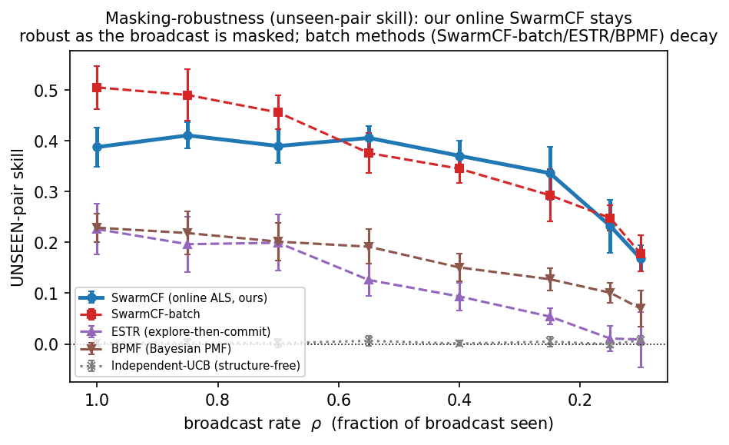
Figure 2. Unseen-pair skill versus broadcast rate $ρ$. Structure-free learners are pinned at the floor at every broadcast rate; SwarmCF acts on the unseen throughout and is robust under masking, while batch spectral completion decays as observation becomes partial.

6.2 The operational (anytime) separation
Final-policy quality can flatter a method that explores cheaply. The operationally honest measure is reward earned while learning. Figure 3 shows cumulative-reward skill over the mission: SwarmCF earns from the first rounds. Per-arm UCB stays near the random floor: with $n≫T$ arms its optimism keeps it exploring untried tasks. Phase-structured low-rank methods pay an explore-then-commit penalty early. An $ε$-greedy tabular learner does earn some reward by re-exploiting tasks it has already engaged (each task recurs in offers about $cT/n≈4$ times here), but it stays well below SwarmCF and at the floor on unseen pairs (Table 3). The clean anytime collapse of Theorem 2 holds in the strict regime $cT=o(n)$; SwarmCF's early-earning advantage is broader, as seen here.
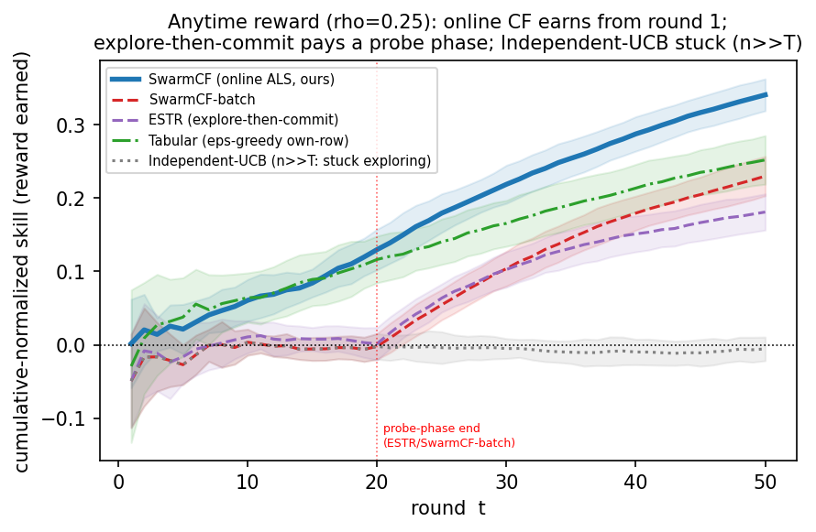
Figure 3. Anytime cumulative-reward skill ($ρ=0.25$). SwarmCF earns from round one; explore-then-commit pays a probe phase; per-arm UCB stays near the random floor, while $ε$-greedy tabular earns only by re-exploiting tasks it has already engaged.

6.3 Why a swarm: the value of the broadcast and a positive scaling law
Two experiments isolate what the team and the broadcast actually buy (Figure 4). (a) Value of the broadcast. Sweeping from $ρ=0$ (each robot isolated, sees only its own outcomes) to $ρ=1$ (full passive sensing): a lone robot cannot recover the shared structure from its single matrix row, so isolated unseen skill is $≈0$; the broadcast lifts SwarmCF by $+0.39$ unseen skill but a structure-free learner by $≈0$, which has no model linking tasks and so cannot use it (Theorem 4). (b) Positive scaling. Holding $n$, horizon and $ρ$ fixed and growing the team from $m=5$ to $80$, SwarmCF's unseen skill rises monotonically ($0.08→0.43$): more robots feed more observations into the one shared structure, so each robot's competence on tasks it never engaged grows with the team. Structure-free learning is flat. A swarm that gets smarter as it grows, the opposite of the usual interference penalty, is a direct consequence of sharing structure.
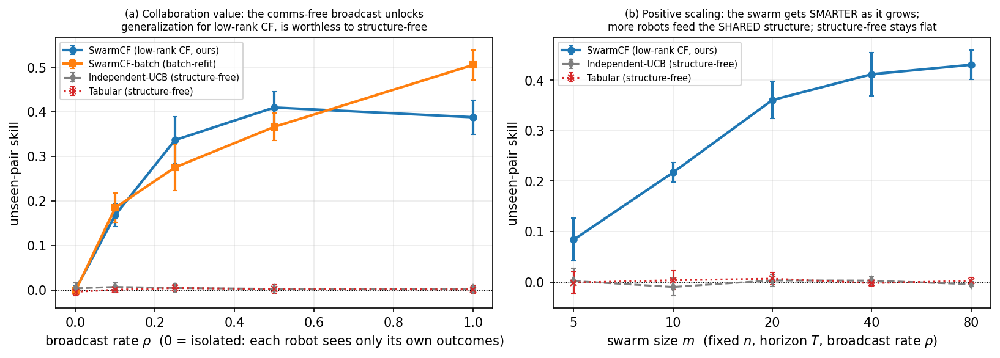
Figure 4. (a) Value of the broadcast: unseen skill versus $ρ$ (left edge $=$ isolated). (b) Positive scaling: unseen skill versus team size $m$. Both rise for low-rank CF and are flat for structure-free. (SwarmCF-batch is a batch-refit variant of our method, shown for comparison.)

6.4 An operational mission and a centralized ceiling
Framed as a target-servicing / dispatch mission, latent factors are robot capability traits and task requirement traits, each robot repeatedly services an offered target under range-limited, distance-noisy sensing, SwarmCF on the same servicing-skill metric beats every other low-rank method (including our own batch variant SwarmCF-batch) under limited observability ($ρ=0.25$): $≈0.35$ versus the best alternative $≈0.29$ with non-overlapping intervals, while structure-free learners sit at the random-dispatch floor (Figure 5). To bound the cost of our constraints we add two reference ceilings (not competitors): a centralized full-communication matcher with Hungarian assignment [47], and the same with noiseless, unmasked observation. When targets are plentiful (low contention), SwarmCF recovers about 80% of the full-communication ceiling (servicing skill $≈0.44$ versus $≈0.55$); the residual gap is the price of within-round coordination under contention, which a communication-free de-confliction mechanism (deferred to future work) is designed to close. The two ceilings differ little (both $≈0.5$), so the price of observation noise is small: coordination, not estimation, is the binding constraint.
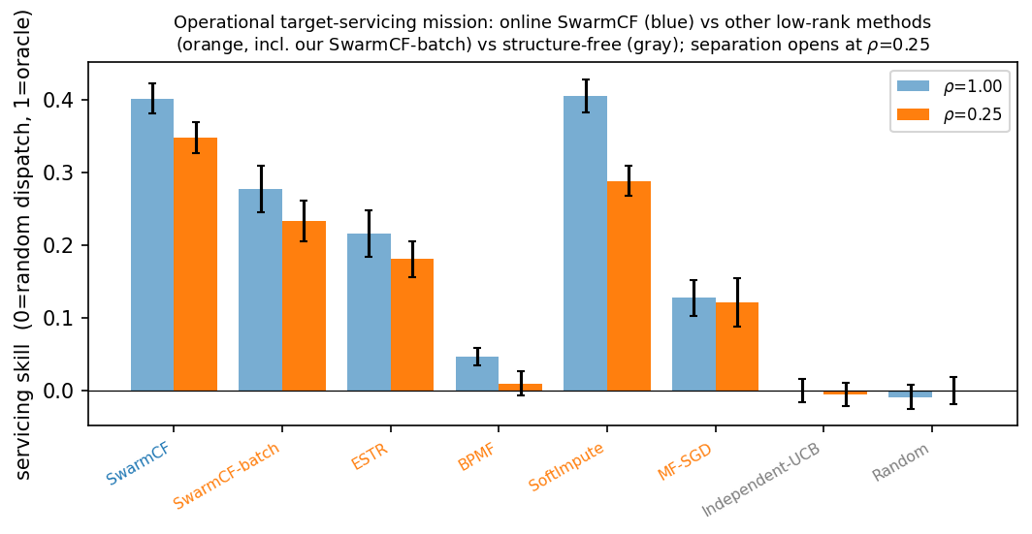
Figure 5. Operational target-servicing mission: our online SwarmCF (blue) versus the other low-rank methods (orange, including our batch variant SwarmCF-batch) versus structure-free learners (gray). The separation opens under limited observability ($ρ=0.25$); at full broadcast the batch completion methods catch up, as in Figure 2.
Table 3 consolidates the comparison on the canonical masked harness.
Table 3. Performance scorecard on one canonical masked harness.
Method | Provenance | unseen skill  (ρ=0.25, masked) | unseen skill  (ρ=1, full) | cumulative regret  (ρ=0.25, lower=better) | rounds to 25%  of oracle
SwarmCF | ours | 0.336 | 0.376 | 41.2 | 35
SwarmCF-batch | ours (hybrid) | 0.280 | 0.516 | 46.0 | never
MF-SGD | standard, adapted | -0.019 | 0.042 | 46.5 | never
BPMF | standard, adapted | 0.126 | 0.233 | 49.9 | never
ESTR | standard, adapted | 0.058 | 0.232 | 46.4 | never
Independent-UCB | structure-free baseline | 0.003 | 0.004 | 50.4 | never
Tabular | structure-free baseline | 0.003 | -0.001 | 43.0 | 46
Random | structure-free baseline | 0.004 | 0.007 | 50.0 | never
One canonical masked harness (m=30, n=240, 8 seeds): unseen skill from the bake-off, regret and time-to-competence from the anytime trajectories. SwarmCF leads the masked column and the operational columns; the batch variant SwarmCF-batch wins only the full-broadcast column; structure-free learners sit at the floor.

6.5 Robustness and external validity
Beyond one configuration. The separation is structural rather than tuned: it follows from the three scope conditions stated below (an exploitable low-rank-but-personalized reward, task scarcity, and a shared channel), not from any particular team size or task count, and we observe the same pattern across $m$, $n$, $d$, and heterogeneity in additional sweeps. The most demanding robustness test, transfer to a separate, higher-fidelity simulator with different dynamics, is reported next.
In a separate, higher-fidelity simulator. To test transfer beyond our analytical harness we re-run the comparison in a separate spatial multi-robot simulator, tabula_drone (robots move in 2-D and engage targets with depleting health, episodic dynamics), which differs from our model in dynamics, spatial structure, and protocol and was not built around the collaborative-filtering method. Dropped in as one policy alongside the simulator's own built-in policies, SwarmCF attains the best converged skill, $0.806±0.016$, approaching the oracle and beating both an independent-UCB learner ($0.721$) and the simulator's own SGD matrix-factorization policy ($0.251$) (Figure 6). In this smaller, less task-scarce environment a structure-free learner is no longer pinned at the floor, exactly as our scope predicts, yet SwarmCF still wins; that the advantage persists under markedly different dynamics is evidence it reflects exploiting the shared low-rank structure rather than our analytical harness.
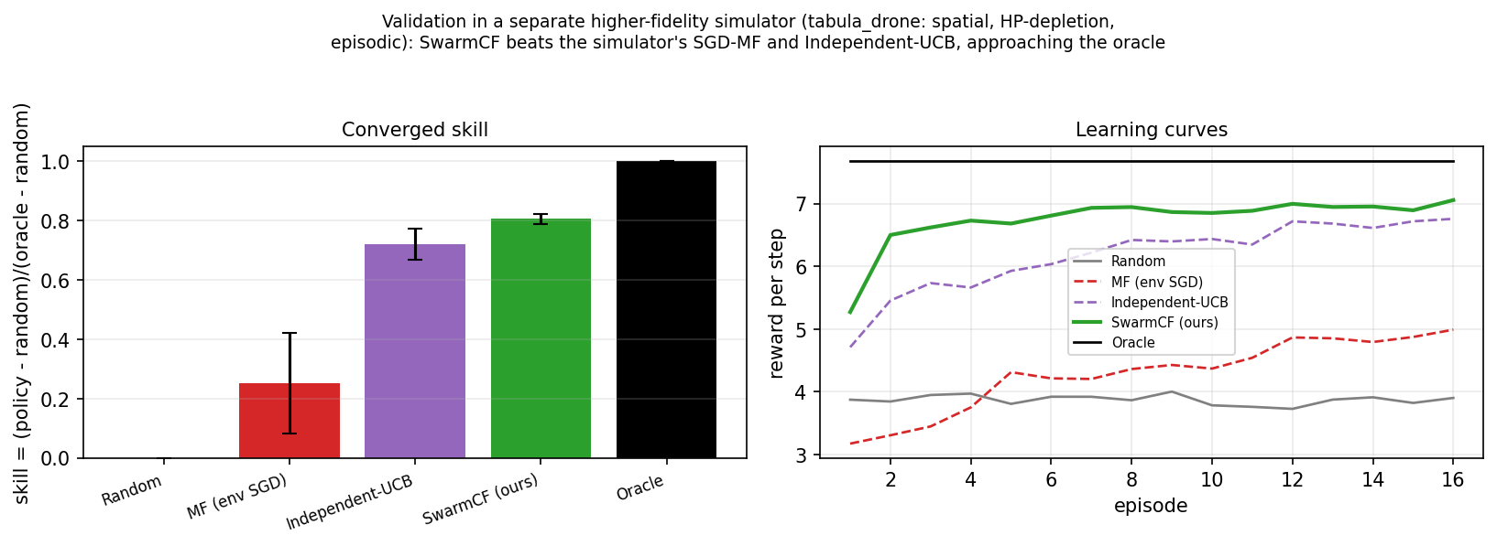
Figure 6. External validity in a separate, higher-fidelity spatial simulator (tabula_drone: 2-D motion, depleting-health targets, episodic). Left: converged skill, SwarmCF best and near-oracle, above independent-UCB and the simulator's own SGD-MF policy. Right: learning curves.
Scope: when does SwarmCF beat structure-free learning? The advantage is not universal, and we state its boundary precisely. It holds when three conditions co-occur: (i) low-rank but personalized structure ($1<d\ll\min(m,n)$): at $d=1$ the reward reduces to a shared popularity order that a bias/pooling baseline already captures, so there is nothing personal to transfer; (ii) task scarcity ($n≫T$): if instead sample-rich, a tabular learner eventually measures every entry and the unseen advantage vanishes; (iii) a shared channel ($ρ>0$): with no broadcast each robot has only its own row and collaborative filtering degenerates to tabular. These are exactly the conditions of the regime we target, and they delimit honestly where structure-free methods remain competitive.

7. Discussion, limitations, and future work
What the results say. Under the least information, no prior, no communication, partial and privately-noisy observation, a single simple estimator gives a swarm a capability that structure-free learning provably cannot have: acting well on the unseen, getting more competent as the team grows, and recovering most of what a centralized, communicating system could achieve. The win is structural (it is a property of exploiting the shared low-rank trait structure) and operational (it shows up in reward earned while learning, and in a robotics-grounded mission).
Limitations. The reward is assumed (approximately) low-rank and stationary, the standard trait-based premise; the categorical advantage degrades gracefully as the structure becomes only approximately low-rank or the rank grows toward full, vanishing only when there is no exploitable structure. Rewards are real-valued and bilinear in latent traits; and the recovery rate of Theorem 3 is established for non-adaptive exploration, the finite-time rate under a strongly exploiting policy (which can starve low-reward tasks of coverage) remains open. We report the regime boundaries honestly: the advantage requires structure beyond mere popularity ($d>1$), task scarcity ($n≫T$), and a shared channel ($ρ>0$); outside these, structure-free methods are competitive.
Future work (a planned follow-up). The present paper deliberately keeps to a single core estimator. In a follow-up we plan to study the refinements that this foundation enables, each of which we have prototyped: (i) confidence-directed exploration via a Bayesian posterior over the factors (collective, information-directed probing through the shared broadcast); (ii) communication-free de-confliction under capacity-1 contention via a fixed private offset, against no-communication auction and musical-chairs primitives; (iii) rank self-determination (removing the guessed $\hat{d}$); (iv) the action/choice channel as a noise-immune alternative to cardinal rewards; and (v) non-stationarity and team churn. We also plan a hardware and physics-based simulation study and a tightening of the adaptive-policy coverage rate.

8. Conclusion
We formalized multi-robot task allocation in its most restrictive but practically common form, no prior knowledge, no communication, partial and privately-noisy observation, and showed that decentralized online collaborative filtering over the passive broadcast lets each robot act well on tasks it has never attempted. The advantage over structure-free learning is categorical and proven; the broadcast is what makes it possible and the team is what makes it fast; and the method recovers most of a centralized full-communication ceiling while assuming far less. We hope the setting, a swarm that must learn to coordinate from nothing but what it can quietly see, becomes a useful baseline regime for autonomous multi-robot systems.

Declaration of competing interest
The authors declare that they have no known competing financial interests or personal relationships that could have appeared to influence the work reported in this paper.

Data availability
The source code, the simulation harness, and the per-seed data required to reproduce every figure and table in this paper are openly available at github.com/ApartsinProjects/ZKDroneSwarm.

References
- B. P. Gerkey, M. J. Matarić. A formal analysis and taxonomy of task allocation in multi-robot systems. Int. J. Robotics Research, 23(9):939–954, 2004.
- G. A. Korsah, A. Stentz, M. B. Dias. A comprehensive taxonomy for multi-robot task allocation. Int. J. Robotics Research, 32(12):1495–1512, 2013.
- M. B. Dias, R. Zlot, N. Kalra, A. Stentz. Market-based multirobot coordination: a survey and analysis. Proc. IEEE, 94(7):1257–1270, 2006.
- H.-L. Choi, L. Brunet, J. P. How. Consensus-based decentralized auctions for robust task allocation. IEEE Trans. Robotics, 25(4):912–926, 2009.
- A. Prorok, M. A. Hsieh, V. Kumar. The impact of diversity on optimal control policies for heterogeneous robot swarms. IEEE Trans. Robotics, 33(2):346–358, 2017.
- J. Rosenski, O. Shamir, L. Szlak. Multi-player bandits: a musical chairs approach. ICML, 2016.
- E. Boursier, V. Perchet. SIC-MMAB: synchronisation involves communication in multiplayer multi-armed bandits. NeurIPS, 2019.
- E. J. Candès, B. Recht. Exact matrix completion via convex optimization. Found. Comput. Math., 9(6):717–772, 2009.
- R. H. Keshavan, A. Montanari, S. Oh. Matrix completion from a few entries. IEEE Trans. Inf. Theory, 56(6):2980–2998, 2010.
- Y. Kang, C.-J. Hsieh, T. C. M. Lee. Efficient frameworks for generalized low-rank matrix bandit problems. NeurIPS, 2022.
- R. Salakhutdinov, A. Mnih. Bayesian probabilistic matrix factorization using MCMC. ICML, 2008.
- R. Mazumder, T. Hastie, R. Tibshirani. Spectral regularization algorithms for learning large incomplete matrices. JMLR, 11:2287–2322, 2010.
- Y. Koren, R. Bell, C. Volinsky. Matrix factorization techniques for recommender systems. IEEE Computer, 42(8):30–37, 2009.
- C. Yu, A. Velu, E. Vinitsky, et al. The surprising effectiveness of PPO in cooperative multi-agent games. NeurIPS, 2022.
- S. Sukhbaatar, A. Szlam, R. Fergus. Learning multiagent communication with backpropagation. NeurIPS, 2016.
- C. Gentile, S. Li, G. Zappella. Online clustering of bandits. ICML, 2014.
- A. H. Murphy. Skill scores based on the mean square error and their relationships to the correlation coefficient. Monthly Weather Review, 116:2417–2424, 1988.
- Athira K. A., J. Divya Udayan, U. Subramaniam. A systematic literature review on multi-robot task allocation. ACM Computing Surveys, 2024.
- P. Goarin, G. Loianno. Graph neural network for decentralized multi-robot goal assignment. IEEE Robotics and Automation Letters, 2024.
- E. Nunes, M. Manner, H. Mitiche, M. Gini. A taxonomy for task allocation problems with temporal and ordering constraints. Robotics and Autonomous Systems, 90:55–70, 2017.
- A. Khamis, A. Hussein, A. Elmogy. Multi-robot task allocation: a review of the state-of-the-art. In Cooperative Robots and Sensor Networks, Springer, 2015.
- M. Otte, M. J. Kuhlman, D. Sofge. Auctions for multi-robot task allocation in communication limited environments. Autonomous Robots, 44:547–584, 2020.
- J. Gielis, A. Shankar, A. Prorok. A critical review of communications in multi-robot systems. Current Robotics Reports, 3:213–225, 2022.
- G. Notomista, S. Mayya, S. Hutchinson, M. Egerstedt. An optimal task allocation strategy for heterogeneous multi-robot systems. European Control Conference, 2019.
- H. Ravichandar, K. Shaw, S. Chernova. STRATA: a unified framework for task assignments in large teams of heterogeneous agents. Autonomous Agents and Multi-Agent Systems, 34:38, 2020.
- I. Bistritz, A. Leshem. Distributed multi-player bandits: a game of thrones approach. NeurIPS, 2018.
- B. Recht. A simpler approach to matrix completion. JMLR, 12:3413–3430, 2011.
- P. Jain, P. Netrapalli, S. Sanghavi. Low-rank matrix completion using alternating minimization. STOC, 2013.
- K.-S. Jun, R. Willett, S. Wright, R. Nowak. Bilinear bandits with low-rank structure. ICML, 2019.
- Y. Lu, A. Meisami, A. Tewari. Low-rank generalized linear bandit problems. AISTATS, 2021.
- Y. Hu, Y. Koren, C. Volinsky. Collaborative filtering for implicit feedback datasets. ICDM, 2008.
- S. Rendle, C. Freudenthaler, Z. Gantner, L. Schmidt-Thieme. BPR: Bayesian personalized ranking from implicit feedback. UAI, 2009.
- T. Rashid, M. Samvelyan, et al. QMIX: monotonic value function factorisation for deep multi-agent reinforcement learning. ICML, 2018.
- P. Sunehag, G. Lever, et al. Value-decomposition networks for cooperative multi-agent learning. AAMAS, 2018.
- R. Lowe, Y. Wu, et al. Multi-agent actor-critic for mixed cooperative-competitive environments. NeurIPS, 2017.
- A. Das, T. Gervet, et al. TarMAC: targeted multi-agent communication. ICML, 2019.
- J. Foerster, Y. Assael, N. de Freitas, S. Whiteson. Learning to communicate with deep multi-agent reinforcement learning. NeurIPS, 2016.
- M. Brambilla, E. Ferrante, M. Birattari, M. Dorigo. Swarm robotics: a review from the swarm engineering perspective. Swarm Intelligence, 7:1–41, 2013.
- E. Şahin. Swarm robotics: from sources of inspiration to domains of application. LNCS 3342, Springer, 2005.
- J. Cortés, S. Martínez, T. Karatas, F. Bullo. Coverage control for mobile sensing networks. IEEE Trans. Robotics and Automation, 20(2):243–255, 2004.
- Z. Wang, M. Gombolay. Learning scheduling policies for multi-robot coordination with graph attention networks. IEEE Robotics and Automation Letters, 5(3):4509–4516, 2020.
- M. Ammad-ud-din, E. Ivannikova, S. A. Khan, W. Oyomno, Q. Fu, K. E. Tan, A. Flanagan. Federated collaborative filtering for privacy-preserving personalized recommendation system. arXiv:1901.09888, 2019.
- Q. Ling, Y. Xu, W. Yin, Z. Wen. Decentralized low-rank matrix completion. IEEE ICASSP, 2925–2928, 2012.
- B. McMahan, E. Moore, D. Ramage, S. Hampson, B. Agüera y Arcas. Communication-efficient learning of deep networks from decentralized data. AISTATS, 1273–1282, 2017.
- P. Auer, N. Cesa-Bianchi, P. Fischer. Finite-time analysis of the multiarmed bandit problem. Machine Learning, 47(2–3):235–256, 2002.
- D. S. Bernstein, R. Givan, N. Immerman, S. Zilberstein. The complexity of decentralized control of Markov decision processes. Mathematics of Operations Research, 27(4):819–840, 2002.
- H. W. Kuhn. The Hungarian method for the assignment problem. Naval Research Logistics Quarterly, 2(1–2):83–97, 1955.
- B. Sarwar, G. Karypis, J. Konstan, J. Riedl. Incremental singular value decomposition algorithms for highly scalable recommender systems. Proc. 5th Int. Conf. Computer and Information Technology, 2002.

Appendix A. Proofs of the main results
We give self-contained proofs of the main results below, each closed by a short remark on the proof technique and its relation to existing results. Throughout, factors are assumed in general position (generic $P,U$), the persistent mask is $M_{ik}∼Bernoulli(ρ)$ over robot pairs, and $\hat{d}≥d$.
Proposition 1 (floor). For an unobserved $j$ the estimate is a pre-chosen constant $b$; $E[(b−R_{ij})^{2}]=(b−μ_{i})^{2}+{Var}_{j}≥{Var}_{j}=Ω(1)$, and on an offer of never-engaged tasks selection is independent of their rewards, giving skill $0$. The broadcast cannot help a per-task estimate by definition. Remark: elementary; it fixes the floor against which the categorical claim is measured.
Theorem 1 (row completion). Stacking the observed entries gives $R_{i,Ω}=U_{Ω}p_{i}$; spanning makes $U_{Ω}$ full column rank, so $p_{i}=(U_{Ω}^{⊤}U_{Ω})^{−1}U_{Ω}^{⊤}R_{i,Ω}$ is unique and exact, hence all $R_{ij}$. Remark: the linear algebra is standard given $U$; the contribution is the $Θ(d)$-versus-$Θ(n)$ contrast against the floor of Proposition 1.
Theorem 2 (anytime). A structure-free learner earns above the mean only on an offer containing an already-engaged task; the engaged set has size $≤t−1$ and is reward-blind, so by concavity of expected order statistics the per-round surplus is $≤g(c(t−1)/n)$; summing gives $≤g(cT/n)→0$. Remark: an order argument (the mechanism is exact, the constant loose); it justifies reporting the anytime metric alongside final-policy skill.
Theorem 3 (recovery). A fully-observed invertible $\hat{d}×\hat{d}$ block pins the factor frame; per task, $R_{E_{i}(j),j}=P_{E_{i}(j)}u_{j}$ has a unique solution iff $P_{E_{i}(j)}$ has full column rank, giving exact $u_{j}$ (noiseless) and, with noise, error $O(σ\sqrt{d/|E_{i}(j)|})$; non-identifiability below the spanning threshold is the per-task analogue of Proposition 1. Coverage time (non-adaptive policy): each visible teammate engages each task with probability $1/n$ per round, so it has engaged task $j$ at least once after $T$ rounds with probability $1−(1−1/n)^{T}≈1−e^{−T/n}$; the number of distinct visible engagers of $j$ is $Binomial(|N_{i}|,1−e^{−T/n})$ with $|N_{i}|≈ρm$, and requiring $≥d$ spanning engagers for all $n$ tasks with a union bound gives $T=O​\left({nd}/{ρm}logn\right)$, which decreases in the team size $ρm$ and requires $ρm>d$. Remark: the condition is deterministic and is validated directly in Appendix C. We are not aware of a comparable recovery condition for a persistent, per-observer mask, the regime where uniform-sampling matrix-completion guarantees do not apply; the finite-time rate under a strongly-exploiting (adaptive) policy is left open.
Theorem 4 (collective speedup). A single row leaves a rank-$d>1$ column space unconstrained (floor); the pooled support reaches the completion threshold in $\tilde{O}(d(1+n/m))$ rounds. Remark: an order argument given Theorem 3; it is the formal counterpart of the value-of-broadcast and positive-scaling results in Section 6.3. The fold-in perturbation bound used above (cold-start error $=$ basis-recovery $+$ own-probe noise $+$ ridge bias, exact at $k≥d$) is stated and proved in Appendix B.

Appendix B. The fold-in error bound
For a newcomer factor $x_{⋆}$ probed against an estimated basis $\hat{B}=B+Δ$ ($\left\|Δ\right\|≤ε$) with $k≥d$ observations of noise $σ$ and ridge $λ$, the ridge fold-in prediction error splits cleanly into three sources, $E|\hat{r}−r|≤C_{1}ε\left\|x_{⋆}\right\|(1+\left\|b\right\|/s)+C_{2}\left\|b\right\|σ\sqrt{d}/s+C_{3}λ\left\|x_{⋆}\right\|\left\|b\right\|/s^{2}$ with $s=σ_{min}(B)$, and is exact ($\hat{r}=r$) when $ε=σ=0,λ→0,k≥d$. It quantitatively explains the graceful degradation of cold-start skill as sensing becomes sparser.

Appendix C. Empirical validation of the recovery condition (Theorem 3)
On the swarm's actual coverage patterns ($m=30,n=240,d=5,ρ=0.5$, noiseless to isolate identifiability), reconstructing each unseen pair $(i,j)$ from the observed entries by least squares gives error $0.000$ exactly when robot $i$'s factor lies in the span of its visible engagers of $j$ (the condition of Theorem 3), versus the prior floor ($≈0.30$) otherwise, with graceful partial recovery as the spanning rank rises to $d$. The identifiability threshold is therefore exactly the spanning condition of Theorem 3.

Appendix D. Reproducibility
All experiments use a block-model world with signed-cosine reward, 8 random seeds, and bootstrap 95% confidence intervals throughout; each reported number is averaged over the per-seed runs. The code and per-seed data needed to regenerate every figure and table are openly available (see Data availability).
Hyperparameters. Headline configuration: $m=30$ robots, $n=240$ tasks, true rank $d=5$, guessed rank $\hat{d}=8$, horizon $T=50$, offer size $c=20$, own-observation noise $σ_{own}=0.1$, broadcast-observation noise $σ_{obs}=0.3$, persistent mask rate $ρ$ swept. SwarmCF: $ε$-greedy with $ε_{0}=0.5$ decaying by $0.93$ per round to $ε_{min}=0.05$; ridge $λ={10}^{−2}$; 8 alternating-least-squares sweeps per refit; refit every 3 rounds; uniform observation weights (the noise level is not used). Identical exploration schedules and the same guessed rank $\hat{d}$ are given to every structured baseline for fairness; the choices are conservative for our claims (generous to baselines).

