Working draft (v5). Text highlighted in green is changed in this editor conditional-acceptance round; red marks the reviewer round and yellow marks earlier changes.

Selective Multipathology Chest X-Ray Classification via Rejection Mechanisms
  - Yehudit Aperstein^{1,*}, Amit Tzahar¹, Alon Gottlib¹, Tal Verber¹, Ravit Shagan Damti¹, Alexander Apartsin²
1 Intelligent Systems, Afeka Academic College of Engineering, Tel Aviv 69988, Israel
2 School of Computer Science, Faculty of Sciences, HIT-Holon Institute of Technology, Holon 58102, Israel
* Corresponding Author: apersteiny@afeka.ac.il
Abstract
Overconfidence in deep learning models poses a significant risk in high-stakes medical imaging tasks, particularly in multi-label classification of chest X-rays, where multiple co-occurring pathologies must be detected simultaneously. This study introduces an uncertainty-aware framework for chest X-ray diagnosis based on a DenseNet-121 backbone, enhanced with an entropy-based selective prediction mechanism that abstains, on a per-pathology basis, from predictions whose binary entropy exceeds a calibrated threshold, deferring those findings to clinical experts. A quantile-based calibration procedure tunes rejection thresholds using either global or class-specific strategies. On NIH ChestX-ray14, MIMIC-CXR, and PadChest, selective prediction is evaluated with risk-coverage analysis and balanced accuracy under non-parametric bootstrap confidence intervals. At a calibrated operating point, abstention improves balanced accuracy for all four target pathologies on NIH ChestX-ray14, with gains of 0.07 to 0.09 at a coverage of 0.70, a relative reduction in balanced error of 25 to 36% (95% confidence intervals excluding zero). Every target pathology is also supported on MIMIC-CXR and PadChest, on an independently trained model evaluated cross-dataset on a source excluded from its training, and under leave-one-dataset-out domain shift in both transfer directions. These results support the integration of selective prediction into AI-assisted diagnostic workflows, providing a practical step toward safer, uncertainty-aware deployment of deep learning in clinical settings.
Keywords: Chest X-ray classification; Rejection mechanism; Multi-label diagnosis; Selective prediction; Uncertainty estimation; Risk-coverage analysis; Balanced accuracy; Domain shift

1. Introduction
Automating medical diagnosis with deep learning has shown great potential, particularly in medical imaging domains such as chest X-ray analysis. Convolutional neural networks, including architectures like DenseNet-121, have demonstrated strong performance in detecting a range of thoracic pathologies [1],[2]. However, successfully integrating such models into clinical workflows requires more than high classification accuracy. It demands robust mechanisms for managing uncertainty and ensuring patient safety. This need spans diagnostic imaging broadly, including but not limited to oncologic applications; the present study addresses it for four common non-oncologic thoracic findings, described next.
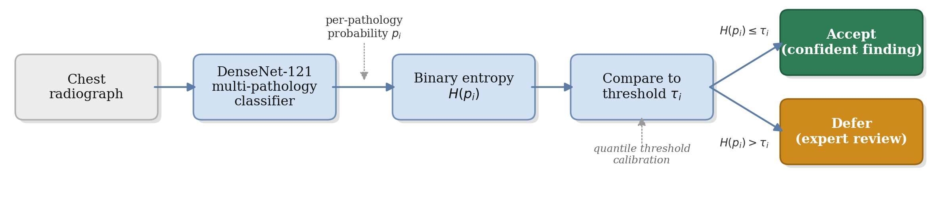
Figure 1: Overview of the proposed selective chest X-ray classification framework. The multi-pathology classification model (a DenseNet-121 backbone) produces per-pathology probabilities; a confidence-estimation stage computes the binary entropy H(pi) of each, and quantile-based threshold calibration yields a per-class threshold τi. The decision module compares each pathology's entropy against its threshold, accepting confident findings (H(pi) ≤ τi) as a partial-pathology classification and deferring uncertain findings (H(pi) > τi) for expert review. Each pathology is accepted or deferred independently, so acceptance is a partial-label output rather than a global clearance of the image.
One of the most critical risks in this domain is the occurrence of false negatives, where existing pathologies go undetected. Such failures can delay treatment and lead to serious consequences for patient outcomes. The problem is compounded by the nature of medical imaging, where visual data alone may not be sufficient for a definitive diagnosis. Identifying a condition may require image-based interpretation, contextual clinical information, laboratory results, or expert judgment. These challenges are amplified in multi-label classification settings, where multiple overlapping or subtle findings must be simultaneously considered.
In high-stakes medical imaging, a model that always produces a prediction, even when uncertain, can pose significant risks. Rejection mechanisms provide a safeguard by allowing the model to abstain on ambiguous cases, deferring them to expert review. This capability is especially critical in multi-pathology chest X-ray classification, where subtle or overlapping findings can lead to overconfident errors. Integrating rejection directly into the diagnostic workflow therefore enhances reliability and patient safety beyond what conventional classifiers can provide.
To address these concerns, we propose a chest X-ray classification framework built on a DenseNet-121 backbone and augmented with an entropy-based rejection mechanism that measures per-pathology uncertainty using binary entropy and abstains, independently for each pathology, when that uncertainty exceeds a calibrated threshold. Each pathology prediction is accepted or deferred on its own; acceptance yields a partial-label output and is not a global clearance of the image. This allows the model to selectively defer uncertain findings to human experts, reducing the risk of overconfident misclassifications.
Crucially, we implement a calibration procedure using a held-out portion of the training data to tune rejection thresholds. We explore two strategies: shared thresholds, which apply uniformly across all pathology classes, and class-specific thresholds, which are independently optimized per class to account for differences in prevalence and model confidence. This calibration-driven approach enables flexible and interpretable control over the trade-off between diagnostic performance and rejection coverage.
This study makes the following contributions to AI-assisted medical imaging: (1) an uncertainty-aware framework that integrates a DenseNet-121 backbone with a per-pathology entropy-based rejection mechanism for multi-pathology diagnosis; (2) a quantile-based calibration procedure that supports both global and class-specific thresholds, enabling fine-grained control over the trade-off between diagnostic performance and rejection coverage; (3) an evaluation based on risk-coverage analysis and balanced accuracy with bootstrap confidence intervals, together with a formal leave-one-dataset-out assessment of selective behaviour under domain shift across NIH ChestX-ray14, MIMIC-CXR, and the geographically independent PadChest cohort; and (4) the finding that pretrained chest X-ray backbones apply an operating-point normalization that deforms the per-pathology probability axis, so that predictive entropy must be computed on the raw model probability for the selective signal to transfer consistently across pathologies and datasets. Unlike SelectiveNet [3], which jointly trains a dedicated selection head end-to-end with the classifier to optimize a single global accuracy-coverage trade-off, the present framework applies a post-hoc, per-pathology entropy threshold to a frozen, already-trained multi-label backbone [4], with each pathology's threshold calibrated independently via quantile calibration. The novel contribution is therefore this per-pathology rejection-and-calibration layer and its multi-label, multi-dataset evaluation, not the underlying classifier, which is adopted unchanged from prior work [4].
The remainder of this paper is organized as follows. Section 2 reviews related work on deep learning for chest X-ray diagnosis and selective classification. Section 3 describes the proposed methodology, including dataset construction, model design, and the rejection mechanism. Section 4 presents experimental results. Section 5 discusses the findings and their implications, and Section 6 concludes.

2. Prior work
Recent advances in deep learning have significantly improved automated chest X-ray interpretation, particularly in multi-label pathology classification. Deploying such models in clinical settings requires more than high predictive accuracy: it also demands robustness to uncertainty, transparency in decision-making, and mechanisms for risk-aware abstention. This section reviews three areas central to our work: deep learning for chest X-ray diagnosis, rejection mechanisms in machine learning, and selective prediction and uncertainty modeling in medical imaging.

2.1 Deep learning in medical imaging and chest X-ray diagnosis
Deep convolutional neural networks have become the method of choice for medical image analysis. Large public datasets and deep CNNs enable expert-level disease classification in chest radiography. Wang et al. [5] introduced the ChestX-ray8 dataset (approximately 112,000 frontal radiographs, 14 labels) and demonstrated multi-label classification and localization of common thoracic diseases. Rajpurkar et al. [6] trained a 121-layer DenseNet (CheXNet) on ChestX-ray14 and reported radiologist-level pneumonia detection. The CheXpert dataset [7] includes 224,316 chest radiographs with uncertainty labels and has been used to show that CNN models can reach radiologist-level performance on several pathologies. Lakhani and Sundaram [8] classified tuberculosis with an AUC near 0.99; Majkowska et al. [9] matched radiologist performance on five findings; and Park et al. [10] applied a self-evolving vision transformer with knowledge distillation. Cohen et al. [4] study balanced batch sampling across multiple chest X-ray datasets to improve out-of-distribution generalization for Cardiomegaly, Consolidation, Edema, and Effusion, using a DenseNet-121 with a leave-one-dataset-out strategy across ChestX-ray8 [5], CheXpert [7], MIMIC-CXR [11], and PadChest [12] [13]; we adopt the corresponding TorchXRayVision backbone [4] and augment it with a rejection mechanism. Cross-domain generalization in this setting is known to be fragile: Zech et al. [14] show that models can exploit hospital-specific confounders and degrade across acquisition sites, and Cohen et al. [13] attribute much of the cross-dataset gap to label shift rather than to a shift in the images themselves. Ovadia et al. [15] further show that predictive uncertainty degrades under dataset shift, motivating an explicit out-of-distribution evaluation of selective behaviour.

2.2 Rejection mechanisms in machine learning
The behavior of predictive models under uncertainty has been widely studied, with stability recognized as a key factor in the reliability of estimators. Prior work in statistical signal processing [16] and machine learning [17] shows that increased uncertainty leads to greater sensitivity to small perturbations, often indicating operation near a decision boundary. Such instability motivates analyzing perturbation responses as a diagnostic tool [18] and is frequently leveraged in active learning [19],[20], where uncertain samples are prioritized for annotation. Selective classification, the reject option, allows a model to abstain on uncertain inputs to reduce errors. Chow [21] formalized the error-reject trade-off, and Cortes et al. [22] developed frameworks for learning with a reject option. For deep networks, Geifman and El-Yaniv [23] introduced a risk-coverage framework that thresholds the maximal softmax response to guarantee a user-specified error rate, and proposed SelectiveNet [3], which optimizes the accuracy-coverage trade-off during training. Lakshminarayanan et al. [24] showed that deep ensembles provide high-quality uncertainty estimates. Fisch et al. [25] train a selector for calibrated selective classification; Cattelan and Silva [26] propose a logit normalization that improves confidence-based rejection; and Rabanser et al. [27] reject inputs whose predictions flip during training. The risk-coverage curve and its area introduced in this line of work [23] provide the threshold-free evaluation we adopt in Section 4.
Beyond entropy thresholding, the broader uncertainty-estimation literature includes Monte Carlo Dropout [28], Bayesian neural networks [29], deep ensembles [24], temperature-scaled confidence calibration [30], evidential deep learning [31], and conformal prediction [32], each estimating or calibrating predictive uncertainty by a different mechanism (stochastic multi-pass inference, explicit posterior modelling, model-committee disagreement, post-hoc rescaling, direct evidence parameterization, and distribution-free coverage guarantees, respectively). We adopt single-pass entropy thresholding on a frozen backbone in preference to these alternatives because it requires no retraining, no additional forward passes at inference, and no committee of models, making it the lowest-overhead selective mechanism to deploy on top of an already-validated multi-label classifier; Section 4.1 compares it empirically against a deep-ensemble disagreement signal and simpler confidence-based alternatives on the same evaluation split.

2.3 Rejection methods in medical imaging and chest X-ray classification
Uncertainty-aware models can improve diagnostic safety by flagging ambiguous cases. Kompa et al. [33] emphasize that machine learning systems in healthcare should be able to say "I do not know" for high-uncertainty cases, and survey abstention methods. Faghani et al. [34] outline emerging trends in uncertainty quantification for medical imaging, noting that an uncertainty measure allows experts to re-evaluate doubtful cases. In chest radiography specifically, Whata et al. [35] developed a Bayesian CNN that quantifies predictive uncertainty for multi-class classification, and Das et al. [36] proposed a semi-supervised lesion-detection framework using confidence-guided pseudo-labelling. These works illustrate that rejection and uncertainty modelling are actively integrated into medical imaging pipelines to enhance decision support.

3. Methodology
Our framework for multi-label chest X-ray classification with selective prediction is illustrated in Figure 1. It integrates a deep convolutional neural network for pathology classification with a rejection mechanism that enables the model to abstain from uncertain predictions. The subsections below detail the dataset and partitioning strategies, the baseline model, the rejection mechanism, and the threshold calibration procedure.

3.1 Dataset
The classification task is formulated as multi-label, wherein each image can simultaneously exhibit one or more of four conditions: Cardiomegaly, Effusion, Edema, and Consolidation. In contrast to single-label classification, this setup accounts for the co-occurrence of multiple pathologies within a single image. To improve generalizability and account for variability in imaging protocols and patient populations, the dataset aggregates samples from multiple publicly available sources. Each image is labeled at the image level, and the labels are not mutually exclusive. The model produces a confidence score for each pathology, which is subsequently used by the rejection mechanism. Table 1 summarizes the class distribution of the final evaluation cohort (37,397 frontal images) used for all reported analyses, and Figure 2 shows representative frontal radiographs for the target conditions. These four conditions were selected because they are the pathologies common to the label sets of all three source datasets (NIH ChestX-ray14, MIMIC-CXR, and PadChest) with sufficient positive prevalence for stable per-class threshold calibration (Table 1), which is what enables the cross-dataset and leave-one-dataset-out comparisons central to this study; pathologies present in only one or two sources could not support the same cross-source evaluation.
Table 1: Class distribution of the final evaluation cohort used for the selective-prediction analyses, across the three sources (NIH ChestX-ray14, MIMIC-CXR, and PadChest; N = 37,397 frontal images), reported as positive-label counts. This cohort is the harmonized, patient-level-split set on which all reported results are computed. The data is imbalanced, with Effusion and Cardiomegaly more prevalent than the rarer Edema and Consolidation, and a subset of images carry multiple positive labels.
Category | Positive count | Percentage (%)
Cardiomegaly | 3447 | 9.2
Effusion | 4396 | 11.8
Edema | 1407 | 3.8
Consolidation | 1125 | 3.0
Multi-Pathology | 1885 | 5.0
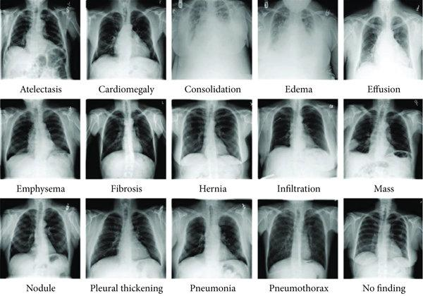
Figure 2: Representative frontal chest radiographs spanning the range of thoracic findings in the source datasets. The four conditions studied in this work, Cardiomegaly, Effusion, Edema, and Consolidation, are a subset of these findings; the selective mechanism makes an independent accept-or-defer decision for each of the four.

3.2 Data partition for validation and rejection tuning
The dataset aggregates chest X-ray images from MIMIC-CXR [44] (obtained from the MIMIC-CXR-JPG release, version 2.1.0 [43], distributed through PhysioNet [45]), NIH ChestX-ray14, and PadChest. Each source uses slightly different imaging protocols, labelling criteria, and patient populations, introducing domain variability. We employ two partitioning strategies. In intra-source splitting, each dataset is split independently into 80% for training and 20% for validation, with all partitions performed at the patient level so that images from the same patient are assigned exclusively to one subset, preventing leakage and reflecting deployment to previously unseen individuals. In inter-source splitting, one or two complete source datasets are used for training while another source is held out entirely for evaluation, creating an out-of-distribution test scenario. The intra-source approach supports stable tuning under controlled conditions, while the inter-source setup tests robustness to domain shift.

3.3 Baseline model
DenseNet-121 [37] is a convolutional neural network characterized by dense connectivity, wherein each layer receives the feature maps of all preceding layers within a dense block. This design enhances information flow, alleviates the vanishing-gradient problem, and promotes feature reuse. The architecture consists of an initial convolution and pooling layer followed by four dense blocks separated by three transition layers, each dense block following a BN, ReLU, Conv(3x3) pattern, with a growth rate that governs the progressive expansion of feature dimensionality.
The baseline employs a standard DenseNet-121 backbone pre-trained on large-scale chest X-ray datasets, including CheXpert and NIH ChestX-ray14 [6],[7]. We employ a fine-tuning strategy with multi-domain balanced sampling, constructing each mini-batch to include an equal number of samples from each domain to encourage domain-invariant features [4]. The model performs multi-label classification by outputting a probability for each target pathology. Training uses the AdamW optimizer ($β_{1}=0.9$, $β_{2}=0.999$, learning rate ${10}^{−4}$, batch size 64) for up to 30 epochs, with a ReduceLROnPlateau schedule (factor 0.2, patience 4) and square-root inverse-frequency class weighting within a weighted binary cross-entropy loss to mitigate class imbalance while maintaining calibrated probability estimates. Input images are converted to single-channel grayscale, center-cropped, resized to 224x224, and intensity-normalized to the [-1024, 1024] range expected by the backbone. Calibration and evaluation splits are patient-level, and the random seed is fixed (1337) throughout; code and frozen per-image predictions are released for full reproducibility. The primary evaluation uses the released TorchXRayVision DenseNet-121 [4], whose published checkpoint was trained on a pooled corpus that includes NIH ChestX-ray14, MIMIC-CXR, CheXpert, and PadChest; consequently MIMIC-CXR and PadChest are in-distribution for this backbone, and the replication results in Section 4.1 establish that the selective benefit holds across sources rather than constituting an out-of-distribution test. The out-of-distribution claims (Section 4.3) instead rest on single-source leave-one-dataset-out models and on the independently trained weighted-BCE DenseNet-121, which follows the procedure above and is evaluated on a source it never trained on. For the primary evaluation the released weights are used and the rejection mechanism is applied post hoc to frozen predictions; the training hyperparameters above describe the independently trained weighted-BCE replication model, not the released backbone.
Model training was performed on a single NVIDIA RTX 4090 (24 GB); inference, selective-prediction scoring, and the Grad-CAM analysis were run locally on a single NVIDIA RTX 2060 (6 GB). The independently trained weighted-BCE DenseNet-121 (6.96 M parameters) was trained for up to 15 epochs at batch size 64 on 16,000 NIH ChestX-ray14 frontal images (13,534 training / 2,466 validation, patient-level split), with early stopping at epoch 9 (best model at epoch 3); training and validation completed in under four minutes of wall-clock (about 24 s per epoch), reaching a best validation macro-AUC of 0.85. At inference, scoring 2,500 frontal images on the RTX 2060 takes approximately 150 to 165 s (of order 60 ms per image, including image decoding and preprocessing); the rejection mechanism itself operates on precomputed per-pathology probabilities and therefore adds negligible overhead beyond the backbone forward pass. The software environment is PyTorch 2.4 (CUDA 12.4) with TorchXRayVision 1.3.4.

3.4 Rejection mechanism
Rejection is defined independently for each pathology. For the predicted probability $p_{i}$ of pathology $i$, the binary entropy is
$$H(p_{i})=−\left[ p_{i}\log_{2}p_{i}+(1−p_{i})\log_{2}(1−p_{i}) \right],$$
which is maximal at the decision boundary and minimal as $p_{i}→0$ or $p_{i}→1$. A pathology prediction is rejected when its entropy exceeds a calibrated threshold $τ_{i}$,
$$\text{reject class }i⇔H(p_{i})>τ_{i}.$$
The accept-defer boundary is therefore $H(p_{i})=τ_{i}$, where $τ_{i}$ is the calibrated entropy threshold for pathology $i$. This rejection threshold is distinct from the probability threshold used to convert $p_{i}$ into a binary label; the latter sets the decision boundary, while $τ_{i}$ sets how much uncertainty around that boundary is tolerated before a finding is deferred.
Selective prediction is applied independently for each pathology: a finding is deferred when the model cannot generate a sufficiently reliable prediction for that condition. Acceptance corresponds to a partial-label output and is not a global clearance of the image, since other findings for the same image may remain uncertain. Rejection rates are therefore computed and reported per pathology, aligning with a clinical decision-support workflow in which uncertain findings are deferred for expert review while confident predictions remain available. In practice this means a single image's report can carry a mixed accept/defer status across its four pathology fields (for example, Cardiomegaly accepted while Edema is deferred on the same image); the intended output is therefore a per-finding confidence flag alongside each pathology prediction, analogous to a structured radiology report annotated at the level of individual findings rather than a single accept/reject decision for the whole study. Empirically these per-finding decisions are correlated rather than independent: at the 0.70-coverage operating point on NIH ChestX-ray14, most images (40%) have no finding deferred and only 5% have all four deferred, while any two findings are co-deferred at 1.4 to 1.9 times the rate expected under independence (strongest for Consolidation with Effusion). Deferrals therefore concentrate on a minority of intrinsically harder images rather than spreading uniformly across the cohort, so the per-image review burden is lower than the 30% per-pathology rate alone would suggest.
An equivalent view of this rule is interval-based: a class is treated as confident when a calibrated interval around its probability lies entirely on one side of the decision boundary. On a deterministic backbone this interval rule is a monotone function of the distance of the probability from the boundary, so it induces the same selective ordering as entropy thresholding; we therefore adopt the single entropy-based rule. Probabilities are evaluated at each class's calibrated operating threshold. Thresholds are selected globally or per class on a held-out calibration subset.
Predictive entropy is computed on the backbone's raw per-pathology probability (the sigmoid output), with the operating-point normalization that the pretrained checkpoints apply by default disabled. That normalization rescales each pathology's output around a fixed training-source operating threshold, deforming the probability axis differently per pathology and per source, which distorts the entropy ranking used for deferral; the raw probability provides a consistent uncertainty axis across pathologies and datasets.

3.5 Threshold calibration
We adopt a quantile-based calibration strategy to determine effective thresholds. Calibration is performed on a dedicated subset disjoint from both the training and evaluation data, minimizing optimistic bias from information leakage. Entropy thresholds are estimated from the distribution of entropy values computed over correctly classified calibration samples, identifying confidence regions historically associated with reliable predictions. For each pathology, we explore a range of candidate percentiles (from 0.70 to 0.99) and compute either a class-specific or a global threshold corresponding to the selected quantile. A threshold-sensitivity analysis (Figure 7) reports the selective metric and rejection rate across calibration percentiles from 0.70 to 0.99, so that the operating point is an interpretable, tunable design choice rather than a fixed property of the model. Although results are reported at fixed thresholds for consistency, the mechanism outputs a continuous confidence score, allowing thresholds to be tuned post hoc to a clinical risk tolerance. The calibration subset is drawn at the patient level, disjoint from both training and evaluation, following the same patient-level partitioning described in Section 3.2. To quantify threshold stability beyond the percentile sweep of Figure 7, calibration was repeated across ten independent random patient-level splits at a fixed operating point. The per-pathology entropy threshold is stable across splits (standard deviation at most 0.019 on NIH ChestX-ray14 and about 0.001 on MIMIC-CXR), and the balanced-accuracy gain at a coverage of 0.70 stays positive across all ten splits for Effusion, Edema, and Consolidation. Cardiomegaly is the most split-sensitive pathology (mean gain +0.07, with one split of ten marginally negative), consistent with its greater view dependence discussed in Section 5. In deployment, a practitioner selects the calibration percentile to match available radiologist capacity: Figure 7 reports the induced rejection rate and retained performance at each percentile, so a lower percentile can be chosen where expert-review capacity is scarce and a higher percentile where the cost of a missed finding is high.

4. Results
Calibration and evaluation use disjoint patient-level splits. Results are reported on 11,212 NIH ChestX-ray14 frontal images, 8,185 MIMIC-CXR frontal images, and 18,000 PadChest frontal images. The backbone attains per-pathology discrimination in the range of AUC 0.77 to 0.94 across the three evaluation sources. We characterize selective behaviour with two complementary, threshold-aware measures: balanced accuracy at a calibrated operating point, and the risk-coverage curve. Both are reported with 1000-sample non-parametric bootstrap confidence intervals; these intervals are robust to patient-level clustering of the resampling, which shifts every interval bound by at most 0.002 and changes no support decision. Balanced accuracy is used as the primary endpoint because the four target pathologies are prevalence-imbalanced (Table 1: 3.0-11.8% positive), so plain accuracy would be dominated by the majority (negative) class and could mask class-specific rejection benefit. The per-pathology 95% confidence intervals reported throughout (Tables 2 and 3) are not corrected for multiple comparisons. Each pathology is treated as an independent, pre-registered hypothesis defined by the study design, namely the same four conditions evaluated identically across datasets and transfer directions, rather than as one of many post hoc comparisons. We report the intervals as computed rather than family-wise adjusted, so that readers can apply their own correction if a more conservative reading is preferred.

4.1 Selective prediction improves balanced accuracy
The results below on MIMIC-CXR and PadChest are obtained with the primary backbone, for which these two sources are in-distribution (Section 3.3); the corresponding out-of-distribution evaluation, using single-source leave-one-dataset-out models, is reported separately in Section 4.3.
Predictive entropy is informative about correctness: incorrect predictions concentrate at high entropy and correct predictions at low entropy (Figure 3), the signal that selective deferral exploits.
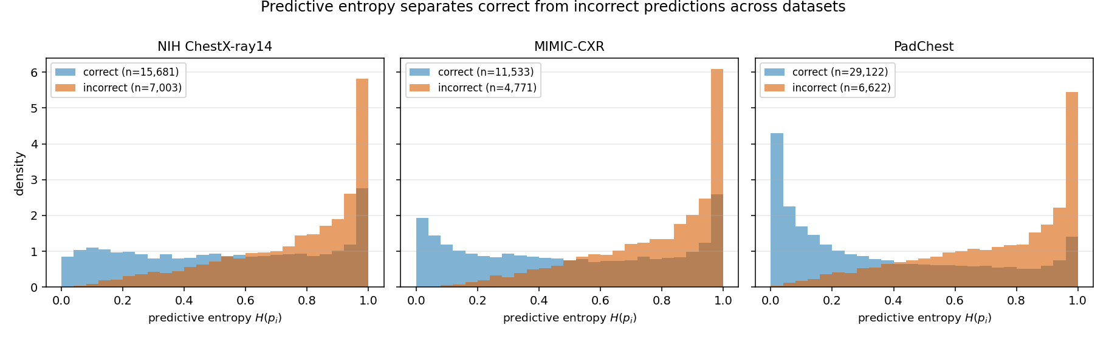
Figure 3: Distribution of predictive entropy for correct versus incorrect predictions, pooled over the four target pathologies, on NIH ChestX-ray14, MIMIC-CXR, and PadChest. On every dataset, correct predictions concentrate at low entropy and incorrect predictions at high entropy, which is what makes uncertainty-based deferral effective.
At a calibrated operating point, deferring the most uncertain predictions improves balanced accuracy for every target pathology. Table 2 reports the balanced accuracy at full coverage and at a coverage of 0.70 (a rejection rate of 0.30) on NIH ChestX-ray14, with bootstrap confidence intervals on the change. All four improvements are supported (95% confidence intervals excluding zero), and the effect replicates on MIMIC-CXR and on an independently trained model; Figure 4 traces the balanced accuracy across coverage for each pathology.
Table 2: Selective balanced accuracy at a calibrated operating point (NIH ChestX-ray14, rejection rate 0.30). All four gains have 95% bootstrap confidence intervals excluding zero. The final column reports the balanced-error reduction: the relative decrease in balanced error (one minus balanced accuracy) from full to 0.70 coverage.
Pathology | Balanced accuracy (full coverage) | Balanced accuracy at 0.70 coverage | Change (95% CI) | Balanced-error reduction
Cardiomegaly | 0.757 | 0.844 | +0.087 [0.058, 0.115] | 36%
Effusion | 0.780 | 0.855 | +0.075 [0.064, 0.087] | 34%
Edema | 0.754 | 0.839 | +0.085 [0.052, 0.123] | 35%
Consolidation | 0.730 | 0.797 | +0.067 [0.049, 0.086] | 25%
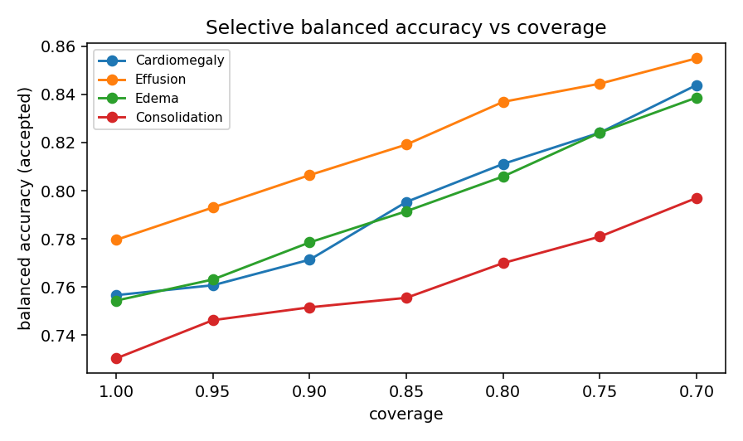
Figure 4: Selective balanced accuracy as a function of coverage for each pathology. Balanced accuracy increases as the most uncertain predictions are deferred.
On MIMIC-CXR (8,185 frontal images), the same calibrated-threshold analysis yields supported balanced-accuracy gains for all four pathologies (Cardiomegaly +0.071 [0.059, 0.086], Effusion +0.086 [0.073, 0.097], Edema +0.072 [0.058, 0.087], Consolidation +0.034 [0.014, 0.054]; 95% confidence intervals excluding zero), and an independently trained weighted-BCE DenseNet-121 (Section 3.3; validation macro-AUC 0.85) reproduces the improvement on all four pathologies both on the held-out NIH test set (Cardiomegaly +0.074 [0.049, 0.098], Effusion +0.062 [0.052, 0.073], Edema +0.060 [0.022, 0.101], Consolidation +0.044 [0.012, 0.073]) and cross-dataset on MIMIC-CXR, a source it never trained on (Cardiomegaly +0.055 [0.042, 0.066], Effusion +0.087 [0.075, 0.098], Edema +0.073 [0.057, 0.090], Consolidation +0.067 [0.036, 0.100]); all gains have 95% confidence intervals excluding zero, confirming the effect is specific to neither the backbone nor the dataset. On PadChest, where the backbone attains strong discrimination (Cardiomegaly AUC 0.91, Effusion 0.94, Consolidation 0.87), deferral improves balanced accuracy for all four pathologies (Cardiomegaly +0.080 [0.070, 0.091], Effusion +0.056 [0.043, 0.070], Edema +0.075 [0.058, 0.096], Consolidation +0.076 [0.051, 0.108]; 95% confidence intervals excluding zero), confirming the benefit on a third source; the corresponding out-of-distribution test, in which a single-source model is applied to PadChest, is reported in Section 4.3.
A non-parametric bootstrap confirms these gains are not resampling artefacts: across 1,000 resamples the balanced accuracy with rejection exceeds the baseline for every pathology on all three evaluation sets (Figure 5).
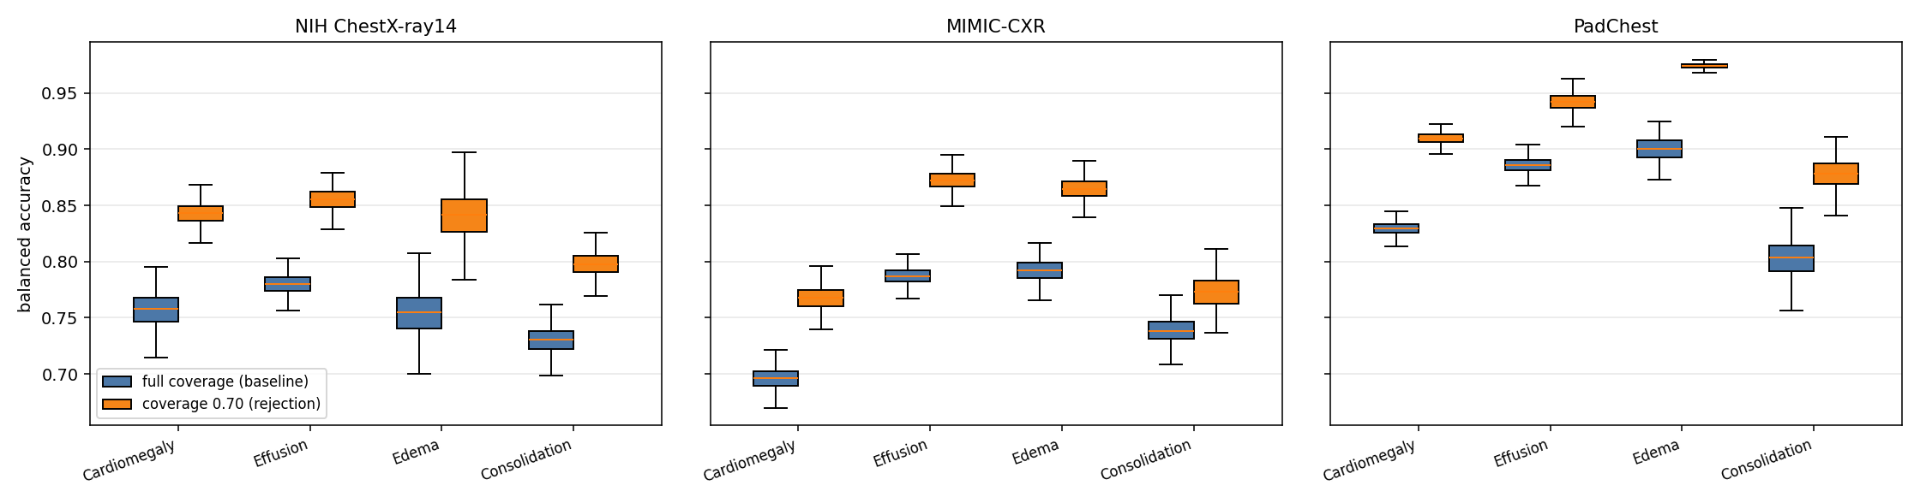
Figure 5: Bootstrap validation of the balanced-accuracy change before and after rejection. Boxplots show the distribution of balanced accuracy over 1,000 bootstrap resamples at full coverage (baseline, blue) and at a coverage of 0.70 (with rejection, orange), per pathology, on the NIH ChestX-ray14, MIMIC-CXR, and PadChest evaluation sets. The with-rejection distribution exceeds the baseline for every pathology on all three datasets.
To confirm that these gains come from the uncertainty signal rather than from evaluating on a smaller retained set, entropy-based deferral is compared against a random-rejection control and against alternative confidence scores on the same NIH evaluation split. At a coverage of 0.70, random rejection leaves balanced accuracy essentially unchanged (within 0.001 of zero for all four pathologies), whereas entropy-based deferral recovers the gains of Table 2. Margin and maximum-probability rejection are rank-identical to entropy on a deterministic backbone and induce the same selective ordering, so entropy is reported as their representative. A deep-ensemble disagreement signal computed across the five public TorchXRayVision checkpoints does not exceed single-pass entropy at this operating point, so the single forward-pass rule is retained. On the full evaluation split, three further post-hoc estimators were each compared against single-pass entropy on the same images: Monte Carlo Dropout [28] (dropout retrofitted on the penultimate features, which the backbone otherwise lacks), Monte Carlo BatchNorm [38], and test-time augmentation [39]. None meaningfully exceeds it: Monte Carlo Dropout equals it, test-time augmentation matches it within noise at eight-fold the inference cost, and Monte Carlo BatchNorm is lower on all four pathologies (Supplementary Table S1). Temperature scaling [30], Platt scaling [40], and isotonic regression [41] are monotone rescalings of the score, so they preserve the entropy ordering and leave the selective gain unchanged, though temperature scaling does improve calibration (the expected calibration error falls, for example, from 0.15 to 0.09 for Cardiomegaly). A paired bootstrap further supports the advantage over the random control: the per-resample entropy-minus-random difference at a coverage of 0.70 has a 95% confidence interval excluding zero for all four pathologies. The proposed single forward-pass entropy rule is thus the least expensive of the estimators considered, requiring no retraining, repeated passes, or ensemble, yet it is matched or preferred throughout; the cheapest uncertainty signal is also the most practical to deploy.

4.2 Risk-coverage analysis
Figure 6 presents the risk-coverage curve for each pathology, summarized by the area under the curve. As coverage decreases, the model retains its more confident predictions, and the curves quantify the accuracy-coverage trade-off that a deployment can select according to a target risk tolerance.
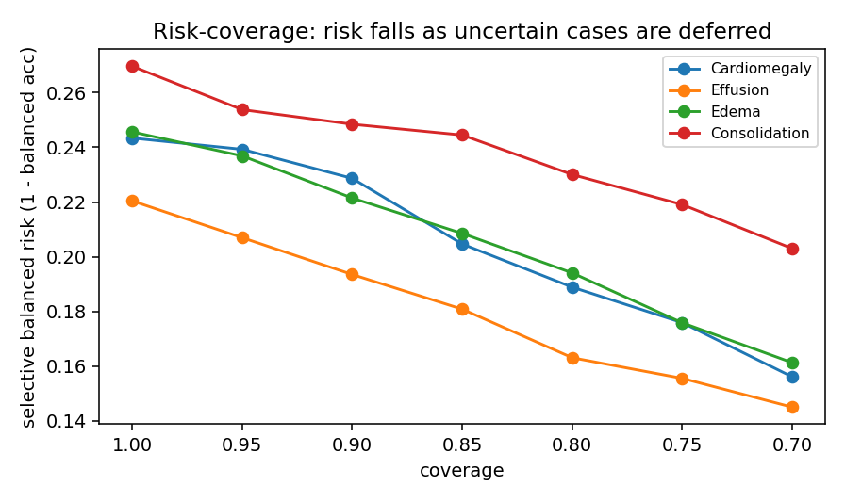
Figure 6: Risk-coverage curves per pathology. The retained-prediction performance is traced against coverage as the entropy threshold varies. Area under the risk-coverage curve over the plotted coverage range (AURC; lower is better): Cardiomegaly 0.206, Effusion 0.180, Edema 0.207, Consolidation 0.239.

4.3 Out-of-distribution evaluation
To assess behaviour under domain shift, we evaluate a single-source model on an unseen source in a leave-one-dataset-out protocol. The discrimination of a model trained on NIH ChestX-ray14 decreases when it is applied to MIMIC-CXR (per-pathology AUC falls from 0.864 to 0.687 for Cardiomegaly, 0.818 to 0.793 for Effusion, 0.867 to 0.763 for Edema, and 0.793 to 0.694 for Consolidation), quantifying the domain-shift penalty that the inter-source setting is designed to expose and against which selective prediction provides a safeguard by deferring uncertain cases.
Domain shift lowers discrimination, but the selective mechanism remains effective on the shifted distribution: deferring the most uncertain predictions improves retained balanced accuracy on the unseen source. Table 3 reports this across all three leave-one-dataset-out transfer directions: the NIH-trained model evaluated on MIMIC-CXR, the reverse direction (a MIMIC-trained model evaluated on NIH ChestX-ray14), and the NIH-trained model applied to PadChest, a geographically independent Spanish cohort never seen during training. In every direction, deferral improves retained balanced accuracy for all four pathologies, with a relative reduction in balanced error of 7 to 53% and 95% bootstrap confidence intervals excluding zero throughout. Selective prediction therefore provides a safeguard precisely where it is most needed, on out-of-distribution inputs.
Table 3: Selective balanced accuracy under domain shift across all three leave-one-dataset-out transfer directions, at full coverage and at a coverage of 0.70. Every one of the twelve gains has a 95% bootstrap confidence interval excluding zero. Balanced-error reduction is the relative decrease in balanced error (one minus balanced accuracy) on the shifted source.
Pathology | Balanced accuracy (full → 0.70 coverage) | Balanced-error reduction | Change (95% CI)
NIH → MIMIC
Cardiomegaly | 0.632 → 0.676 | 12% | +0.044 [0.033, 0.058]
Effusion | 0.716 → 0.787 | 25% | +0.071 [0.059, 0.081]
Edema | 0.673 → 0.695 | 7% | +0.022 [0.010, 0.035]
Consolidation | 0.619 → 0.668 | 13% | +0.049 [0.022, 0.076]
MIMIC → NIH
Cardiomegaly | 0.604 → 0.702 | 25% | +0.098 [0.004, 0.204]
Effusion | 0.705 → 0.785 | 27% | +0.080 [0.050, 0.109]
Edema | 0.740 → 0.878 | 53% | +0.138 [0.055, 0.225]
Consolidation | 0.647 → 0.711 | 18% | +0.064 [0.014, 0.109]
NIH → PadChest
Cardiomegaly | 0.761 → 0.839 | 33% | +0.078 [0.065, 0.090]
Effusion | 0.833 → 0.907 | 44% | +0.074 [0.058, 0.088]
Edema | 0.793 → 0.838 | 22% | +0.045 [0.025, 0.067]
Consolidation | 0.704 → 0.763 | 20% | +0.059 [0.007, 0.107]

4.4 Threshold sensitivity
Figure 7 traces the rejection rate and retained performance across calibration percentiles. Selective performance varies smoothly with the calibration percentile, so the accuracy-coverage trade-off is a controllable design parameter that can be set to a clinical risk tolerance. At a fixed calibration percentile the induced rejection rate is similar across pathologies (0.37 to 0.43 at the 0.70 percentile), reflecting the consistent raw-probability uncertainty axis on which entropy is computed.
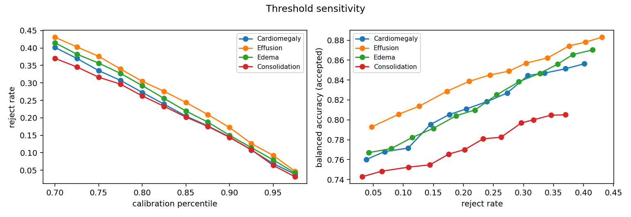
Figure 7: Threshold sensitivity. Rejection rate and retained performance as a function of the calibration percentile.

4.5 Decision-region behaviour and interpretability
The decision regions of accepted and deferred predictions can be examined spatially with class-activation mapping (Figure 8): for confident accepted predictions the activation concentrates over the relevant lung fields, whereas borderline deferred predictions show diffuse, spatially spread activation. This contrast holds for all four target pathologies and is consistent with the uncertainty-driven abstention used throughout this work. This visualization is presented as an illustrative, qualitative view of decision-region behaviour rather than a mechanistic validation of the rejection rule itself; the entropy-based rejection decision is computed directly from the predicted probability (Section 3.4), and Grad-CAM is not part of that decision pathway.
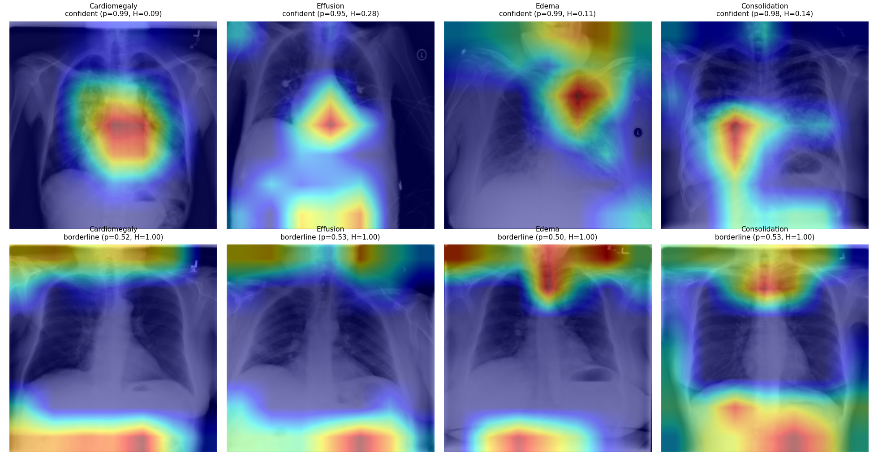
Figure 8: Representative Grad-CAM overlays for the four target pathologies (columns), each with a confident accepted prediction (top) and a borderline deferred prediction (bottom). Accepted predictions show activation concentrated over the relevant lung fields, whereas deferred predictions show diffuse, spatially spread activation.

5. Discussion
The results show that selective prediction provides meaningful control over the trade-off between predictive confidence and coverage. At a calibrated operating point, deferring the most uncertain per-pathology predictions improves balanced accuracy for all four conditions on NIH ChestX-ray14 and MIMIC-CXR, on an independently trained model (including when applied cross-dataset), and under leave-one-dataset-out domain shift in both transfer directions, with every target pathology supported on all three datasets; the risk-coverage curves give a complete, threshold-aware view of the accuracy-coverage trade-off. The improvement is most pronounced for conditions where the model is less certain, consistent with rejection concentrating on ambiguous and low-prevalence findings such as Edema. Across pathologies and views, deferral concentrates on the same kinds of cases: low-prevalence, harder-to-discriminate findings such as Edema (Section 4.1), and, for Cardiomegaly specifically, anteroposterior and portable acquisitions where the cardiothoracic-ratio cue is geometrically less reliable (below); a common thread is that the mechanism defers where the underlying visual cue is intrinsically weaker, rather than uniformly across all cases.
A leave-one-dataset-out evaluation quantifies the domain-shift penalty and shows that deferring uncertain cases improves retained balanced accuracy on the unseen source in both transfer directions, so selective prediction is most valuable precisely on the out-of-distribution inputs that most threaten reliability. This improvement in retained balanced accuracy under shift reflects the selective mechanism successfully filtering out the least reliable predictions on the shifted distribution; it does not imply that the underlying classifier's discrimination is itself robust to domain shift, which Section 4.3 shows is not the case (AUC falls substantially, e.g., from 0.864 to 0.687 for Cardiomegaly under NIH→MIMIC shift). The two observations are complementary rather than contradictory: an unreliable classifier can still be safely deployed with selective prediction, provided the uncertainty signal continues to track correctness under the shift, as it does here.
The operating point used throughout defers 30% of per-pathology predictions to recover balanced-accuracy gains of 0.07 to 0.09 on NIH ChestX-ray14 (a relative reduction in balanced error of 25 to 36%); because the rejection rate is a tunable, per-pathology quantile (Figure 7), a deployment can trade radiologist workload against retained accuracy to match its capacity, deferring fewer cases where expert review is scarce and more where the cost of an error is high. A random-rejection control that defers the same fraction yields no such gain (Section 4.1), so the benefit reflects the uncertainty ranking rather than the reduced caseload. This 30% figure is a per-pathology deferral rate, not a fraction of studies requiring full re-read: because rejection is evaluated independently per finding (Section 3.4), a deferred Cardiomegaly prediction does not imply the whole image needs review, only that one finding does. The rate is also broadly consistent with precedent in the selective-classification and clinical-AI-triage literature: SelectiveNet [3] itself reports and tunes coverage across 0.70-0.90 (10-30% rejection) as its standard operating range, and deployed AI stroke-triage systems have reported flagged-case (extra-review) rates in the range of roughly 10-48% depending on the system, which is comparable to or higher than the rate used here. We are not aware of a chest-X-ray-specific study that validates a 30% per-pathology deferral rate against measured radiologist workflow capacity, and we flag this as an open question rather than a settled one; a workload study of the kind described in Section 5.1 would be needed to establish it directly for this setting.
These findings extend the selective-classification framework, which formalizes the error-reject trade-off [21] and the risk-coverage view [23], to the multi-label medical-imaging setting, and they isolate a point specific to it: at a calibrated per-pathology operating point the reject option raises balanced accuracy even where it cannot raise a rank-based measure such as AUC, because abstention removes the near-boundary cases on which ranking depends. Whereas deep ensembles derive uncertainty from multiple forward passes [24], the single-pass entropy rule attains comparable selective behaviour here (Section 4.1), and the gains persist under the dataset shift known to degrade uncertainty estimates [15] and cross-site generalization [14]. Together these findings support uncertainty-aware selective prediction as a route to safer, more trustworthy AI-assisted diagnosis.
The cross-source behaviour is consistent with the documented fragility of chest X-ray models across acquisition sites, where networks exploit hospital- and protocol-specific confounders [14], and with label-definition shift between sources rather than a shift in the images themselves [13]. The datasets differ in scanner and protocol, patient population (PadChest is a Spanish outpatient cohort, MIMIC-CXR an intensive-care population), and in projection mix. For Cardiomegaly this projection mix is decisive: the cardiothoracic ratio that defines cardiomegaly is geometrically magnified on anteroposterior and portable acquisitions (the heart lies farther from the detector), so a model trained on a predominantly posteroanterior cohort over-calls cardiomegaly on anteroposterior-heavy sources. Stratifying by view makes this explicit: within the posteroanterior stratum the NIH-trained model transfers to PadChest with AUC 0.88 and deferral still improves balanced accuracy (+0.10 at a coverage of 0.70), whereas on the anteroposterior and portable subset discrimination falls to AUC 0.66. This is a geometric property of acquisition, not a pixel artifact that intensity normalization or contrast windowing can remove; selective prediction is the appropriate response, abstaining on the projections where the cue is unreliable.

5.1 Limitations
The validated regime has five boundary conditions. First, the evaluation covers four thoracic findings on frontal views; additional findings and lateral views remain for future work. Second, the primary backbone is trained on a corpus that includes the MIMIC-CXR and PadChest evaluation sources (Section 3.3), so the cross-source generalization claims rest on the single-source leave-one-dataset-out models and the independently trained weighted-BCE model rather than on the primary backbone alone. Third, results are reported for the DenseNet-121 family; transfer to other backbones is established only through the independently trained model. Fourth, the labels are the public datasets' image-level annotations, which carry known noise, and the abstention benefit is measured against these labels rather than a prospective radiologist-adjudicated reference; a reader study quantifying the clinical value of the deferred-case workflow is a natural next step. Finally, subgroup fairness of the selective mechanism, that is, whether deferral rates and retained accuracy are equitable across patient subgroups [42], is not assessed here and is left for future work.
Two further boundary conditions warrant explicit statement. Because the reference labels themselves carry known annotation noise, label errors near the decision boundary could inflate the apparent rejection benefit reported here. A mislabeled case is simultaneously more likely to sit at high predictive entropy and more likely to be scored as an error before rejection, so some fraction of the measured balanced-accuracy gain may reflect the mechanism filtering out label noise rather than genuine model uncertainty. The direction of the reported effect is not affected by this caveat, but its magnitude should be read with this in mind. Second, although the headline thresholds are reported from a single calibration split, a ten-split robustness check (Section 3.5) confirms that both the entropy thresholds and the 0.70-coverage gains are stable across independent calibration draws, so the reported operating point is not an artefact of one split; Cardiomegaly remains the most split-sensitive pathology and its per-split gain, while positive on average, is the least consistent of the four. On the clinical-integration side, a deferred case in this framework is intended to enter a radiologist's worklist as a flagged, per-finding item for either a second read or a priority read, analogous to how flagged studies are already triaged in existing double-reading and AI-triage workflows; validating that this specific integration improves outcomes, rather than assuming it, requires the prospective reader study noted above.

6. Conclusions and future directions
We presented a framework for multi-label chest X-ray diagnosis that integrates a DenseNet-121 backbone with a per-pathology entropy-based rejection mechanism and a quantile-based calibration of global or class-specific thresholds. Evaluated with risk-coverage analysis and balanced accuracy under bootstrap confidence intervals, and with a formal leave-one-dataset-out assessment, selective prediction improves the reliability of accepted predictions and provides interpretable control over the accuracy-coverage trade-off. The validated regime and its boundary conditions are detailed in Section 5.1. Future work will incorporate complementary clinical information, extend the approach to additional disease classes, and explore Bayesian and ensemble uncertainty estimators. Code and frozen per-image predictions are released to support reproduction. Looking further ahead, the imaging-only signal used here is one input among several that could inform a more complete uncertainty-aware diagnostic pipeline; extending selective prediction to jointly consider non-imaging clinical information, and eventually multimodal data such as genomic or transcriptomic features, is a natural direction as such data becomes available alongside chest radiographs.

Data Availability
This study analysed existing third-party chest-radiograph datasets and generated no new patient data. Each dataset is available from its provider under that provider's access terms. MIMIC-CXR-JPG (version 2.1.0) is distributed by PhysioNet under credentialed access (https://doi.org/10.13026/jsn5-t979): to download it, a researcher must become a credentialed PhysioNet user, complete the required human-subjects research (CITI "Data or Specimens Only Research") training, and sign the PhysioNet Credentialed Health Data Use Agreement (DUA). The authors completed this training and signed the Data Use Agreement, and used the data solely in accordance with its terms. Because the DUA prohibits redistribution, the authors cannot host the MIMIC-CXR images directly; however, any credentialed researcher can obtain the identical version 2.1.0 from PhysioNet, and, to enable verification and reproduction without re-accessing the raw images, the exact frozen per-image model predictions used for every table and figure are released with the code (see Code Availability). NIH ChestX-ray14 is publicly available without restriction from the NIH Clinical Center (https://nihcc.app.box.com/v/ChestXray-NIHCC). PadChest is available from BIMCV (https://bimcv.cipf.es/bimcv-projects/padchest/) on acceptance of its data-use terms. CheXpert (used only in the released backbone's pretraining corpus, not scored in this study) is available from the Stanford Machine Learning Group (https://stanfordmlgroup.github.io/competitions/chexpert/) under its research-use agreement.

Code Availability
Code, configuration files, and frozen per-image predictions used to reproduce every table and figure in this paper are available at github.com/ApartsinProjects/cxr-selective-rejection-code. A citable, versioned snapshot of this repository is permanently archived in the Zenodo repository under the DOI https://doi.org/10.5281/zenodo.XXXXXXX (to be replaced with the assigned DOI on deposit).

Abbreviations
AP: anteroposterior; AUC: area under the receiver operating characteristic curve; AURC: area under the risk-coverage curve; BCE: binary cross-entropy; BN: batch normalization; CI: confidence interval; CNN: convolutional neural network; ECE: expected calibration error; Grad-CAM: gradient-weighted class activation mapping; LODO: leave-one-dataset-out; MC Dropout: Monte Carlo Dropout; PA: posteroanterior; ReLU: rectified linear unit.

Funding
This research received no specific grant from any funding agency in the public, commercial, or not-for-profit sectors.

Supplementary Material
Supplementary Table S1: Comparison of post-hoc uncertainty estimators against single-pass predictive entropy on NIH ChestX-ray14, reported as the selective balanced-accuracy gain at a coverage of 0.70 (rejection rate 0.30) per pathology. Margin, maximum-probability, and temperature-scaled confidence are rank-identical or rank-preserving transformations of the entropy score, so their selective gains equal the entropy gains of Table 2. Monte Carlo Dropout, Monte Carlo BatchNorm, and test-time augmentation are evaluated on the full primary evaluation split (5,688 images) against the identical raw single-pass entropy baseline, which reproduces Table 2 (+0.088 / +0.075 / +0.088 / +0.069), so their gains are directly comparable to it. Deep-ensemble disagreement requires all five public checkpoints and is reported on the matched per-model subset (1,244 images), with the single-pass entropy gain on that subset shown in parentheses. No estimator exceeds single-pass predictive entropy: the closest alternative matches it within noise at several times the inference cost.
Method | Selective gain at 0.70 coverage (Cardiomegaly / Effusion / Edema / Consolidation) | Evaluation set (n) | Exceeds entropy?
Single-pass entropy (proposed) | +0.087 / +0.075 / +0.085 / +0.067 (Table 2) | primary (5,671) | reference
Margin rejection | rank-identical to entropy (same gains as Table 2) | primary (5,671) | no
Maximum-probability rejection | rank-identical to entropy (same gains as Table 2) | primary (5,671) | no
Temperature-scaled confidence | rank-preserving (same gains as Table 2); expected calibration error improves, e.g. 0.149 → 0.086 for Cardiomegaly | primary (5,671) | no
Deep-ensemble disagreement | −0.019 / +0.034 / −0.050 / −0.033 (entropy on same subset: +0.028 / −0.006 / +0.052 / +0.069) | per-model (1,244) | no (1/4)
Monte Carlo Dropout | +0.083 / +0.077 / +0.088 / +0.071 | primary (5,688) | no (mean +0.080, equal to entropy)
Monte Carlo BatchNorm | +0.006 / +0.051 / +0.035 / +0.048 | primary (5,688) | no (below entropy on all four)
Test-time augmentation | +0.098 / +0.077 / +0.086 / +0.064 (entropy of the mean over eight augmentations; augmentation-variance deferral is far weaker, −0.22 to +0.00) | primary (5,688) | no (matches within noise, +0.001 on the mean, at eight-fold cost)

References
1. Sufian, M. A., Hamzi, W., Sharifi, T., Zaman, S., Alsadder, L., Lee, E., Hakim, A., & Hamzi, B. (2024). AI-driven thoracic X-ray diagnostics: Transformative transfer learning for clinical validation in pulmonary radiography. Journal of Personalized Medicine, 14(8), 856. https://doi.org/10.3390/jpm14080856
2. Arulananth, T. S., Prakash, S. W., Ayyasamy, R. K., Kavitha, V. P., Kuppusamy, P. G., & Chinnasamy, P. (2024). Classification of paediatric pneumonia using modified DenseNet-121 deep-learning model. IEEE Access, 12, 35716-35727. https://doi.org/10.1109/ACCESS.2024.3371151
3. Geifman, Y., & El-Yaniv, R. (2019). SelectiveNet: A deep neural network with an integrated reject option. In Proceedings of the 36th International Conference on Machine Learning (ICML 2019) (Proceedings of Machine Learning Research, Vol. 97, pp. 2151-2159). PMLR. https://proceedings.mlr.press/v97/geifman19a.html
4. Cohen, J. P., Viviano, J. D., Bertin, P., Morrison, P., Torabian, P., Guarrera, M., Lungren, M. P., Chaudhari, A., Brooks, R., Hashir, M., & Bertrand, H. (2021). TorchXRayVision: A library of chest X-ray datasets and models. arXiv. https://arxiv.org/abs/2111.00595
5. Wang, X., Peng, Y., Lu, L., Lu, Z., Bagheri, M., & Summers, R. M. (2017). ChestX-ray8: Hospital-scale chest X-ray database and benchmarks on weakly-supervised classification and localization of common thorax diseases. In Proceedings of the IEEE Conference on Computer Vision and Pattern Recognition (CVPR) (pp. 2097-2106). IEEE. https://doi.org/10.1109/CVPR.2017.369
6. Rajpurkar, P., Irvin, J., Zhu, K., Yang, B., Mehta, H., Duan, T., Ding, D., Bagul, A., Langlotz, C., Shpanskaya, K., Lungren, M. P., & Ng, A. Y. (2017). CheXNet: Radiologist-level pneumonia detection on chest X-rays with deep learning. arXiv. https://arxiv.org/abs/1711.05225
7. Irvin, J., Rajpurkar, P., Ko, M., Yu, Y., Ciurea-Ilcus, S., Chute, C., Marklund, H., Haghgoo, B., Ball, R., Shpanskaya, K., Seekins, J., Mong, D. A., Halabi, S. S., Sandberg, J. K., Jones, R., Larson, D. B., Langlotz, C. P., Patel, B. N., Lungren, M. P., & Ng, A. Y. (2019). CheXpert: A large chest radiograph dataset with uncertainty labels and expert comparison. Proceedings of the AAAI Conference on Artificial Intelligence, 33(1), 590-597. https://doi.org/10.1609/aaai.v33i01.3301590
8. Lakhani, P., & Sundaram, B. (2017). Deep learning at chest radiography: Automated classification of pulmonary tuberculosis by using convolutional neural networks. Radiology, 284(2), 574-582. https://doi.org/10.1148/radiol.2017162326
9. Majkowska, A., Mittal, S., Steiner, D. F., Reicher, J. J., McKinney, S. M., Duggan, G. E., Eswaran, K., Chen, P.-H. C., Liu, Y., Kalidindi, S. R., Ding, A., Corrado, G. S., Tse, D., & Shetty, S. (2020). Chest radiograph interpretation with deep learning models: Assessment with radiologist-adjudicated reference standards and population-adjusted evaluation. Radiology, 294(2), 421-431. https://doi.org/10.1148/radiol.2019191293
10. Park, S., Kim, G., Oh, Y., Seo, J. B., Lee, S. M., Kim, J. H., Moon, S., Lim, J.-K., Park, C. M., & Ye, J. C. (2022). Self-evolving vision transformer for chest X-ray diagnosis through knowledge distillation. Nature Communications, 13, 3848. https://doi.org/10.1038/s41467-022-31514-x
11. Johnson, A. E. W., Pollard, T. J., Greenbaum, N. R., Lungren, M. P., Deng, C.-Y., Peng, Y., Lu, Z., Mark, R. G., Berkowitz, S. J., & Horng, S. (2019). MIMIC-CXR-JPG, a large publicly available database of labeled chest radiographs. arXiv. https://arxiv.org/abs/1901.07042
12. Bustos, A., Pertusa, A., Salinas, J.-M., & de la Iglesia-Vayá, M. (2020). PadChest: A large chest X-ray image dataset with multi-label annotated reports. Medical Image Analysis, 66, Article 101797. https://doi.org/10.1016/j.media.2020.101797
13. Cohen, J. P., Hashir, M., Brooks, R., & Bertrand, H. (2020). On the limits of cross-domain generalization in automated X-ray prediction. In Proceedings of the Third Conference on Medical Imaging with Deep Learning (MIDL 2020) (Proceedings of Machine Learning Research, Vol. 121, pp. 136-155). PMLR. https://proceedings.mlr.press/v121/cohen20a.html
14. Zech, J. R., Badgeley, M. A., Liu, M., Costa, A. B., Titano, J. J., & Oermann, E. K. (2018). Variable generalization performance of a deep learning model to detect pneumonia in chest radiographs: A cross-sectional study. PLOS Medicine, 15(11), Article e1002683. https://doi.org/10.1371/journal.pmed.1002683
15. Ovadia, Y., Fertig, E., Ren, J., Nado, Z., Sculley, D., Nowozin, S., Dillon, J. V., Lakshminarayanan, B., & Snoek, J. (2019). Can you trust your model's uncertainty? Evaluating predictive uncertainty under dataset shift. In Advances in Neural Information Processing Systems (Vol. 32, pp. 13991-14002). Curran Associates.
16. Apartsin, A., Cooper, L. N., & Intrator, N. (2012). Semi-coherent time of arrival estimation using regression. The Journal of the Acoustical Society of America, 132(2), 832-837. https://doi.org/10.1121/1.4730885
17. Goodfellow, I. J., Shlens, J., & Szegedy, C. (2015). Explaining and harnessing adversarial examples. In 3rd International Conference on Learning Representations (ICLR 2015). https://arxiv.org/abs/1412.6572
18. Lee, J., & AlRegib, G. (2020). Gradients as a measure of uncertainty in neural networks. In 2020 IEEE International Conference on Image Processing (ICIP) (pp. 2416-2420). IEEE. https://doi.org/10.1109/ICIP40778.2020.9190679
19. Rokach, L., Aperstein, Y., & Akselrod-Ballin, A. (2025). Deep active learning framework for chest-abdominal CT scans segmentation. Expert Systems with Applications, 263, Article 125522. https://doi.org/10.1016/j.eswa.2024.125522
20. Levy, D., Assayag, B., Gaspar, L., Shimshoni, I., & Specktor-Fadida, B. (2026). From cold start to active learning: Embedding-based scan selection for medical image segmentation. arXiv. https://arxiv.org/abs/2601.18532
21. Chow, C. K. (1970). On optimum recognition error and reject tradeoff. IEEE Transactions on Information Theory, 16(1), 41-46. https://doi.org/10.1109/TIT.1970.1054406
22. Cortes, C., DeSalvo, G., & Mohri, M. (2016). Learning with rejection. In Algorithmic Learning Theory (ALT 2016) (Lecture Notes in Computer Science, Vol. 9925, pp. 67-82). Springer. https://doi.org/10.1007/978-3-319-46379-7_5
23. Geifman, Y., & El-Yaniv, R. (2017). Selective classification for deep neural networks. In Advances in Neural Information Processing Systems 30 (NeurIPS 2017) (pp. 4878-4887). Curran Associates. https://proceedings.neurips.cc/paper/2017/hash/4a8423d5e91fda00bb7e46540e2b0cf1-Abstract.html
24. Lakshminarayanan, B., Pritzel, A., & Blundell, C. (2017). Simple and scalable predictive uncertainty estimation using deep ensembles. In Advances in Neural Information Processing Systems 30 (NeurIPS 2017) (pp. 6402-6413). Curran Associates. https://proceedings.neurips.cc/paper/2017/hash/9ef2ed4b7fd2c810847ffa5fa85bce38-Abstract.html
25. Fisch, A., Jaakkola, T. S., & Barzilay, R. (2022). Calibrated selective classification. Transactions on Machine Learning Research. https://openreview.net/forum?id=zFhNBs8GaV
26. Cattelan, L. F. P., & Silva, D. (2024). How to fix a broken confidence estimator: Evaluating post-hoc methods for selective classification with deep neural networks. In Proceedings of the 40th Conference on Uncertainty in Artificial Intelligence (UAI 2024) (Proceedings of Machine Learning Research, Vol. 244, pp. 547-584). PMLR. https://proceedings.mlr.press/v244/cattelan24a.html
27. Rabanser, S., Thudi, A., Hamidieh, K., Dziedzic, A., Bahceci, I., Bin Sediq, A., Sokun, H., & Papernot, N. (2022). Selective prediction via training dynamics. arXiv. https://arxiv.org/abs/2205.13532
28. Gal, Y., & Ghahramani, Z. (2016). Dropout as a Bayesian approximation: Representing model uncertainty in deep learning. In Proceedings of the 33rd International Conference on Machine Learning (ICML 2016) (Proceedings of Machine Learning Research, Vol. 48, pp. 1050-1059). PMLR. https://proceedings.mlr.press/v48/gal16.html
29. Blundell, C., Cornebise, J., Kavukcuoglu, K., & Wierstra, D. (2015). Weight uncertainty in neural networks. In Proceedings of the 32nd International Conference on Machine Learning (ICML 2015) (Proceedings of Machine Learning Research, Vol. 37, pp. 1613-1622). PMLR. https://proceedings.mlr.press/v37/blundell15.html
30. Guo, C., Pleiss, G., Sun, Y., & Weinberger, K. Q. (2017). On calibration of modern neural networks. In Proceedings of the 34th International Conference on Machine Learning (ICML 2017) (Proceedings of Machine Learning Research, Vol. 70, pp. 1321-1330). PMLR. https://proceedings.mlr.press/v70/guo17a.html
31. Sensoy, M., Kaplan, L., & Kandemir, M. (2018). Evidential deep learning to quantify classification uncertainty. In Advances in Neural Information Processing Systems 31 (NeurIPS 2018) (pp. 3179-3189). Curran Associates. https://arxiv.org/abs/1806.01768
32. Angelopoulos, A. N., & Bates, S. (2023). Conformal prediction: A gentle introduction. Foundations and Trends in Machine Learning, 16(4), 494-591. https://doi.org/10.1561/2200000101
33. Kompa, B., Snoek, J., & Beam, A. L. (2021). Second opinion needed: Communicating uncertainty in medical machine learning. npj Digital Medicine, 4(1), Article 4. https://doi.org/10.1038/s41746-020-00367-3
34. Faghani, S., Moassefi, M., Rouzrokh, P., Khosravi, B., Baffour, F. I., Ringler, M. D., & Erickson, B. J. (2023). Quantifying uncertainty in deep learning of radiologic images. Radiology, 308(2), Article e222217. https://doi.org/10.1148/radiol.222217
35. Whata, A., Dibeco, K., Madzima, K., & Obagbuwa, I. (2024). Uncertainty quantification in multi-class image classification using chest X-ray images of COVID-19 and pneumonia. Frontiers in Artificial Intelligence, 7, Article 1410841. https://doi.org/10.3389/frai.2024.1410841
36. Das, A., Gorade, V., Kumar, K., Chakraborty, S., Mahapatra, D., & Roy, S. (2024). Confidence-guided semi-supervised learning for generalized lesion localization in X-ray images. In Medical Image Computing and Computer-Assisted Intervention (MICCAI 2024) (Lecture Notes in Computer Science, Vol. 15001, pp. 242-252). Springer. https://doi.org/10.1007/978-3-031-72378-0_23
37. Huang, G., Liu, Z., Van Der Maaten, L., & Weinberger, K. Q. (2017). Densely connected convolutional networks. In Proceedings of the IEEE Conference on Computer Vision and Pattern Recognition (CVPR) (pp. 4700-4708). IEEE. https://doi.org/10.1109/CVPR.2017.243
38. Teye, M., Azizpour, H., & Smith, K. (2018). Bayesian uncertainty estimation for batch normalized deep networks. In Proceedings of the 35th International Conference on Machine Learning (ICML 2018) (Proceedings of Machine Learning Research, Vol. 80, pp. 4907-4916). PMLR. https://proceedings.mlr.press/v80/teye18a.html
39. Wang, G., Li, W., Aertsen, M., Deprest, J., Ourselin, S., & Vercauteren, T. (2019). Aleatoric uncertainty estimation with test-time augmentation for medical image segmentation with convolutional neural networks. Neurocomputing, 338, 34-45. https://doi.org/10.1016/j.neucom.2019.01.103
40. Platt, J. C. (1999). Probabilistic outputs for support vector machines and comparisons to regularized likelihood methods. In A. J. Smola, P. Bartlett, B. Schölkopf, & D. Schuurmans (Eds.), Advances in Large Margin Classifiers (pp. 61-74). MIT Press. ISBN 978-0-262-19448-8.
41. Zadrozny, B., & Elkan, C. (2002). Transforming classifier scores into accurate multiclass probability estimates. In Proceedings of the 8th ACM SIGKDD International Conference on Knowledge Discovery and Data Mining (KDD 2002) (pp. 694-699). ACM. https://doi.org/10.1145/775047.775151
42. Seyyed-Kalantari, L., Liu, G., McDermott, M., Chen, I. Y., & Ghassemi, M. (2021). CheXclusion: Fairness gaps in deep chest X-ray classifiers. In Pacific Symposium on Biocomputing 2021 (pp. 232-243). World Scientific. https://doi.org/10.1142/9789811232701_0022
43. Johnson, A., Lungren, M., Peng, Y., Lu, Z., Mark, R., Berkowitz, S., & Horng, S. (2024). MIMIC-CXR-JPG — chest radiographs with structured labels (version 2.1.0) [Data set]. PhysioNet. RRID:SCR_007345. https://doi.org/10.13026/jsn5-t979
44. Johnson, A. E. W., Pollard, T. J., Berkowitz, S. J., Greenbaum, N. R., Lungren, M. P., Deng, C.-Y., Mark, R. G., & Horng, S. (2019). MIMIC-CXR, a de-identified publicly available database of chest radiographs with free-text reports. Scientific Data, 6, 317. https://doi.org/10.1038/s41597-019-0322-0
45. Goldberger, A. L., Amaral, L. A. N., Glass, L., Hausdorff, J. M., Ivanov, P. Ch., Mark, R. G., Mietus, J. E., Moody, G. B., Peng, C.-K., & Stanley, H. E. (2000). PhysioBank, PhysioToolkit, and PhysioNet: Components of a new research resource for complex physiologic signals. Circulation, 101(23), e215-e220. https://doi.org/10.1161/01.CIR.101.23.e215

