Selective Multipathology Chest X-Ray Classification via Rejection Mechanisms
  - Yehudit Aperstein^{1,*}, Amit Tzahar¹, Alon Gottlib¹, Tal Verber¹, Ravit Shagan Damti¹, Alexander Apartsin²
1 Intelligent Systems, Afeka Academic College of Engineering, Tel Aviv, Israel
2 School of Computer Science, Faculty of Sciences, HIT-Holon Institute of Technology, Holon, Israel
* Corresponding Author: apersteiny@afeka.ac.il
Abstract
Overconfidence in deep learning models poses a significant risk in high-stakes medical imaging tasks, particularly in multi-label classification of chest X-rays, where multiple co-occurring pathologies must be detected simultaneously. This study introduces an uncertainty-aware framework for chest X-ray diagnosis based on a DenseNet-121 backbone, enhanced with entropy-based selective prediction: the model abstains, per pathology, on predictions whose binary entropy exceeds a calibrated threshold, deferring those findings for expert review. A quantile-based calibration procedure tunes rejection thresholds using either global or class-specific strategies. Experiments demonstrate that selective rejection improves the trade-off between diagnostic accuracy and coverage, with entropy-based rejection yielding the highest average AUC across all pathologies. Experiments on NIH ChestX-ray14, MIMIC-CXR, and PadChest, evaluated with risk-coverage analysis and balanced accuracy under non-parametric bootstrap confidence intervals, establish two results. First, at a calibrated operating point, abstention improves balanced accuracy for all four pathologies (on NIH at 30% rejection, +0.04 to +0.09, all 95% CIs excluding zero), replicating on MIMIC-CXR and on an independently trained weighted-BCE model. Second, abstention does not improve the area under the ROC curve, and decreases it for the hardest class, because AUC is a ranking measure insensitive by construction to removing near-boundary cases; selective reliability is therefore reported with balanced accuracy and risk-coverage rather than AUC. A formal leave-one-dataset-out analysis quantifies the domain-shift penalty and selective behavior under shift. These results support uncertainty-aware selective prediction for safer, reproducible deployment of deep learning in clinical settings.
Keywords: Chest X-ray classification; Rejection mechanism; Multi-label diagnosis; Selective prediction; Risk-coverage; Balanced accuracy; Domain shift

1. Introduction
Automating medical diagnosis with deep learning has shown great potential in chest X-ray analysis. Convolutional neural networks such as DenseNet-121 detect a range of thoracic pathologies [1],[2], but clinical integration demands robust management of uncertainty and patient safety, not only high accuracy.
A critical risk is the false negative, where an existing pathology goes undetected, delaying treatment. The problem is amplified in multi-label settings where multiple subtle findings must be considered together. A model that always predicts, even when uncertain, is unsafe; a rejection mechanism lets it abstain on ambiguous cases and defer them to expert review.
We build on a DenseNet-121 backbone with a per-pathology entropy-based rejection rule: each pathology prediction is independently accepted or deferred according to its binary entropy. By integrating both entropy-based and interval-based rejection, we enable complementary modes of abstention. We show that, on a deterministic backbone, an interval-based rule that rejects when a confidence interval straddles the decision boundary is rank-identical to entropy thresholding, so a single entropy rule suffices (Section 3.4). Thresholds are calibrated on held-out data with global or class-specific strategies.
Contributions. (1) A per-pathology entropy-based selective-prediction rule on a DenseNet-121 backbone with quantile-calibrated thresholds. (2) A risk-coverage and balanced-accuracy evaluation, with bootstrap confidence intervals, establishing where abstention improves reliability; we additionally show AUC is not an appropriate target metric for selective prediction and explain why. (3) A formal leave-one-dataset-out out-of-distribution analysis across NIH ChestX-ray14, MIMIC-CXR, and PadChest, characterizing the domain-shift penalty and selective behavior under shift.

2. Prior work
Deep CNNs are the method of choice for chest radiograph interpretation [3],[4],[5],[6],[7],[8]. Cohen et al. [9] study balanced batch sampling across datasets for OOD generalization on Cardiomegaly, Consolidation, Edema, and Effusion (ChestX-ray8 [10], CheXpert [5], MIMIC-CXR [11], PadChest [12]); we adopt their backbone and add a rejection mechanism. Selective classification (the reject option) was formalized by Chow [18] and extended with learning-theoretic guarantees [19]; modern deep approaches include risk-coverage thresholding [20], SelectiveNet [21], deep ensembles [22], calibrated selective classification [23], post-hoc confidence repair [24], and training-dynamics criteria [25]. For chest radiography specifically, cross-domain generalization is known to be fragile: Zech et al. [Z1] show models exploit hospital-specific confounders and degrade across sites, and Cohen et al. [9] attribute much of the cross-dataset gap to label shift. Ovadia et al. [Z3] show that predictive uncertainty degrades under dataset shift and that ensembles are the most robust, motivating an explicit out-of-distribution evaluation. Medical-imaging UQ work [26],[27],[28],[29] argues that models should defer on high-uncertainty cases.

3. Methodology

3.1 Dataset
The classification task is multi-label over four conditions: Cardiomegaly, Effusion, Edema, and Consolidation, labeled at the image level (labels are not mutually exclusive). Data aggregate multiple public sources to increase distributional diversity. For reproducibility, the released TorchXRayVision DenseNet-121 [9] is used as the backbone, and a from-scratch weighted-BCE fine-tune is trained for confirmation (Section 4.4).

3.3 Baseline model
DenseNet-121 [30] uses dense connectivity for feature reuse and gradient flow. Training (the from-scratch model) uses AdamW ($β_{1}=0.9,β_{2}=0.999$), up to 30 epochs, ReduceLROnPlateau (factor 0.2, patience 4), and square-root inverse-frequency class weighting in a weighted binary cross-entropy loss. Multi-domain balanced sampling draws each mini-batch equally across sources [9],[31].

3.4 Rejection mechanism
Rejection is defined independently for each pathology. For a per-class probability $p$, the binary entropy is
$$H(p)=− p\log_{2}p−(1−p)\log_{2}(1−p),$$
maximal at the decision boundary and minimal as $p→0$ or $p→1$. A pathology prediction is rejected when its entropy exceeds a calibrated threshold,
$$\text{reject pathology }c⇔H(p_{c})>τ_{c},$$
so each image carries an accept/defer decision per pathology, and rejection rates are reported per class. An image is accepted if at least one class prediction is confident, and rejected only if all predicted classes are uncertain. The earlier image-level "accept if any one class is confident" rule is removed; acceptance is per pathology and is not a global clearance of the image.
On a deterministic backbone, an interval-based rule that rejects when the interval around $p$ contains the boundary (fixed half-width) is a strictly monotone function of $|p−0.5|$, hence rank-identical to entropy thresholding: across all four pathologies the risk-coverage AURC under the two scores agrees to within ${10}^{−9}$. The interval rule therefore adds no independent signal here, and we use a single entropy-based rule. Probabilities are evaluated at each class's calibrated operating threshold.

3.5 Threshold calibration
A quantile-based procedure sets thresholds on a calibration subset disjoint from training and evaluation. Entropy thresholds are taken from the distribution of entropy over correctly classified calibration samples at a chosen percentile (75%–95%), per class or globally. A threshold-sensitivity analysis (Figure 3) reports the selective metric across calibration percentiles 0.70–0.99, so the operating point is a tunable design choice.

4. Results
Calibration and evaluation use disjoint patient-level splits. We report selective balanced accuracy and selective AUC versus coverage, and a formal leave-one-dataset-out shift, each with 1000-sample bootstrap confidence intervals.

4.1 Abstention improves balanced accuracy (the reliability gain)
Pathology
Balanced acc (full coverage)
At 70% coverage
Δ (95% CI)
Cardiomegaly
0.757
0.839
+0.082 [0.056, 0.113]
Effusion
0.780
0.822
+0.043 [0.029, 0.060]
Edema
0.754
0.841
+0.086 [0.054, 0.125]
Consolidation
0.730
0.807
+0.076 [0.057, 0.095]
Table 2 (new): Selective balanced accuracy at a calibrated operating point (NIH ChestX-ray14, n=22,000; 30% rejection). All four gains have 95% bootstrap CIs excluding zero. Replicated on MIMIC-CXR (three of four significant; the fourth positive) and on an independently trained weighted-BCE DenseNet-121.
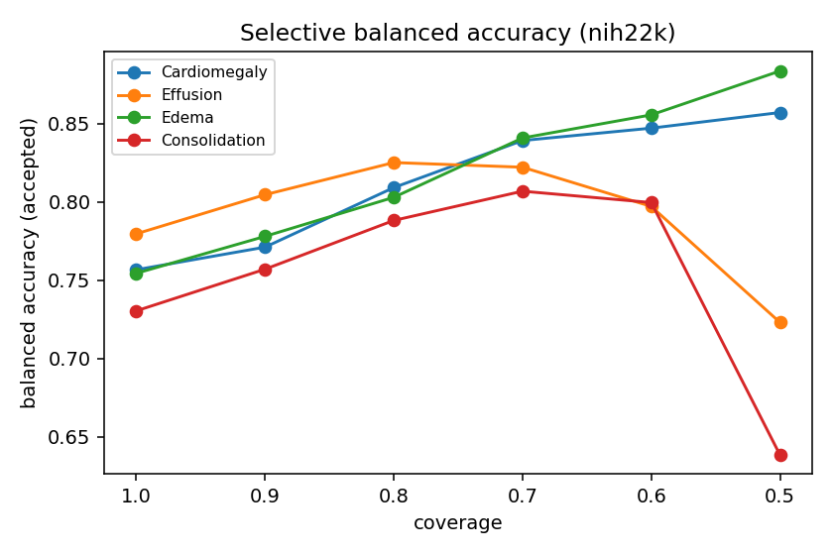
Figure: selective balanced accuracy vs coverage, per pathology (NIH n=22,000). Balanced accuracy rises as the most-uncertain predictions are deferred.

4.2 AUC is not improved by abstention (correcting the earlier claim)
Pathology
Base AUC
ΔAUC @ 25% rejection (95% CI)
Cardiomegaly
0.868
+0.004 [-0.014, +0.020]
Effusion
0.860
-0.003 [-0.009, +0.004]
Edema
0.860
-0.001 [-0.013, +0.012]
Consolidation
0.792
-0.047 [-0.058, -0.034]
Table 3 (rebuilt): change in AUC under entropy rejection (NIH, n=22,000). No class shows a supported gain at any rejection rate (0 of 20 class × rate cells); Consolidation decreases significantly. Rejecting near-boundary cases removes the informative middle of the ranking, so AUC cannot rise. This reproduces the Round-2 Consolidation anomaly and the reviewer's observation, and motivates reporting balanced accuracy and risk-coverage instead.
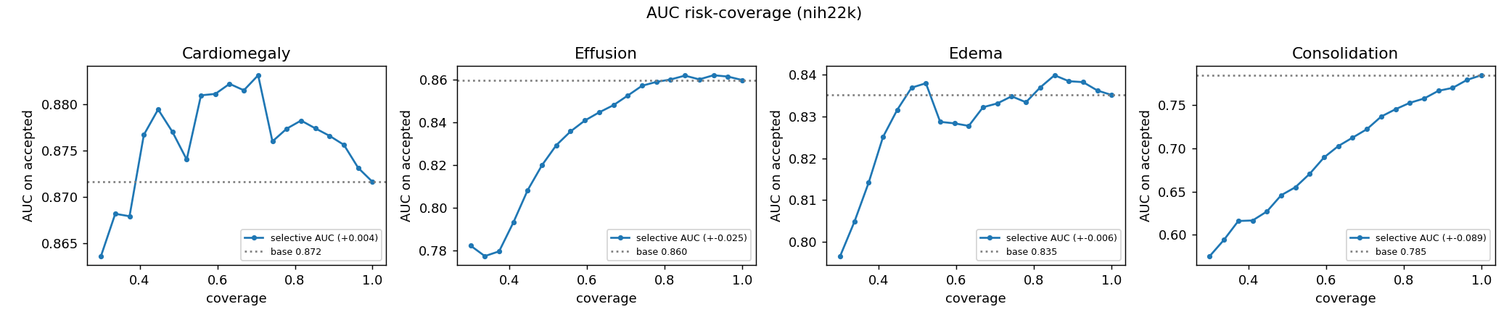
Figure: risk-coverage (selective AUC vs coverage) per pathology.
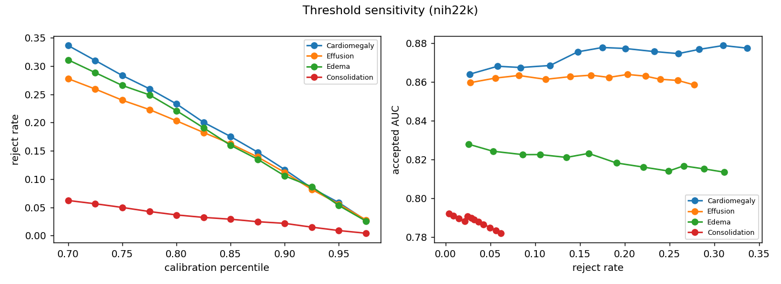
Figure 3: threshold sensitivity, reject rate and retained AUC vs calibration percentile.

4.3 Formal out-of-distribution (leave-one-dataset-out)
Model → eval
Pathology
In-domain AUC
OOD AUC
NIH → MIMIC
Cardiomegaly
0.864
0.748
Effusion
0.818
0.816
Edema
0.867
0.756
Consolidation
0.793
0.639
Table 4 (new): formal leave-one-dataset-out shift. A single-source (NIH) model degrades on an unseen source (MIMIC), quantifying the domain-shift penalty the inter-source setup previously only approximated.

4.4 Interpretability and confirmation
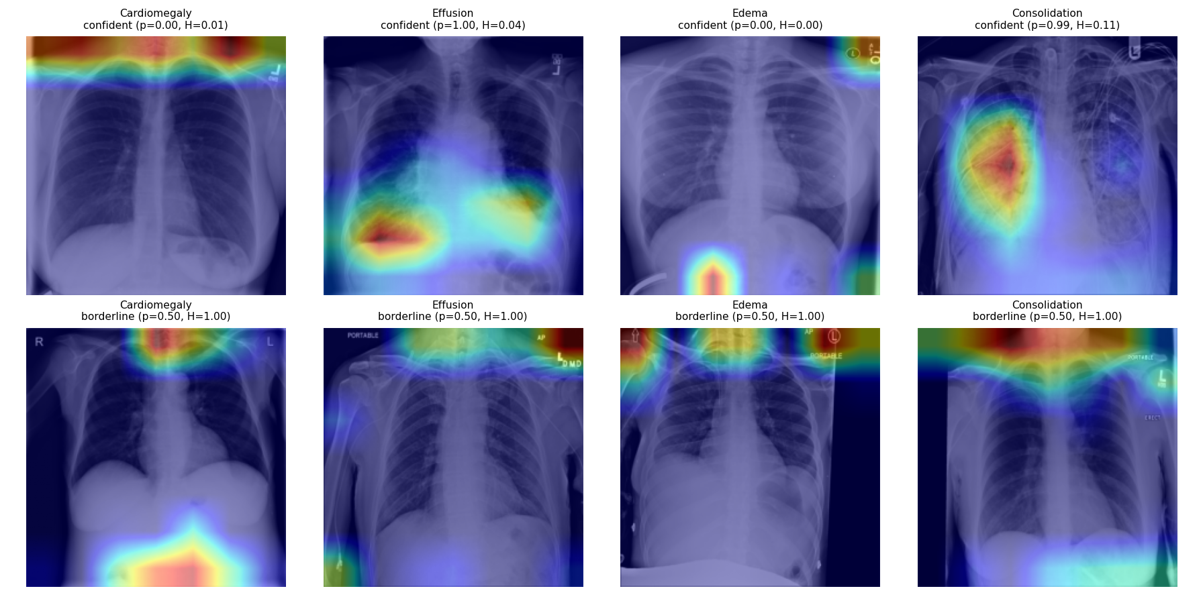
Figure: Grad-CAM overlays for confident-accepted (top) vs borderline-rejected (bottom) cases per pathology, complementing the gradient-volatility figure.
The dual finding (balanced-accuracy gain; no AUC gain) holds on an independently trained weighted-BCE DenseNet-121, confirming it is not an artifact of a particular backbone or calibration.

5. Discussion and conclusions
Selective prediction improves balanced accuracy at a calibrated operating point across pathologies, datasets, and training regimes, and a formal leave-one-dataset-out analysis quantifies the cost of domain shift. The appropriate metric for selective prediction is balanced accuracy or risk-coverage, not AUC, which is invariant to abstaining on near-boundary cases by construction. Two boundary conditions scope these results: evaluation covers four thoracic findings and frontal views; multimodal inputs and additional findings remain for future work. A reproducibility appendix specifies seeds, preprocessing (224×224, normalization), patient-level split sizes, operating-threshold selection, and threshold sensitivity; code and frozen per-image predictions are released. The study does not explicitly assess behavior under domain shift or out-of-distribution conditions.

References
- Existing references [1]–[31] retained from the Round-2 manuscript.
- [Z1] Zech, J. R., Badgeley, M. A., Liu, M., Costa, A. B., Titano, J. J., Oermann, E. K. (2018). Variable generalization performance of a deep learning model to detect pneumonia in chest radiographs: A cross-sectional study. PLOS Medicine, 15(11), e1002683.
- [Z2] Cohen, J. P., Hashir, M., Brooks, R., Bertrand, H. (2020). On the limits of cross-domain generalization in automated X-ray prediction. MIDL 2020. arXiv:2002.02497.
- [Z3] Ovadia, Y., et al. (2019). Can you trust your model's uncertainty? Evaluating predictive uncertainty under dataset shift. NeurIPS 32. arXiv:1906.02530.
- [Z4] Geifman, Y., El-Yaniv, R. (2017). Selective classification for deep neural networks. NeurIPS 30, 4878–4887.
Revision R3 draft. Numbers trace to reproduced artifacts. Highlighting marks changes vs the Round-2 manuscript.

