2.5.1 Title, researchers and institution
קול קורא 34/2026 · משרד האנרגיה והתשתיות · יחידת המדען הראשי · מסלול אקדמיה

JouleFlex: A Model-Based Decision and Control Framework for Maximizing Useful AI Work under Dynamic Power Limits
JouleFlex: מודלים ובקרה חכמה למקסום תפוקת AI תחת מגבלות הספק משתנות
Principal Investigator (מנהל הפרויקט): Alexander Apartsin, Senior Lecturer, Department of Computer Science · Institution: Holon Institute of Technology (HIT)

2.5.2 Abstract / תקציר

English (299/300 words)
In July 2026 Israel's Electricity Authority froze new data-center grid connections for 140 days. The queue had reached about 27,000 MW, three times Israel's average demand [2]. One way forward, proposed in the Authority's June 2026 hearing [19], is flexible connection: the system operator may reduce the center's power at peak. Most of that power goes to GPUs, the chips that run AI. Today a data center adjusts by capping their power or switching some off.
The PI's study [1] shows that both are wasteful. Switching GPUs off loses their work. Capping too hard makes jobs run so long that the GPU's fixed baseline power costs more energy. Capping too little spends much more energy for little extra speed. Energy per task is therefore U-shaped. At its bottom, the Joule Point, each unit of energy does the most AI work. Measured on 20 AI models and four GPU types, it lies well below full power and cuts energy per task by 29 to 31 percent. A fleet simulation did the same work with 18 to 45 percent less energy. Capped GPUs draw less power, so more fit behind the same connection: up to about 50 percent more AI work per megawatt of GPU power. Servers and cooling draw power that capping does not cut, so the project measures the real gain at the building's meter.
Knowing this optimum turns flexibility from forced cutbacks into a design choice. This project builds the tools. Control keeps each GPU near its Joule Point and lowers power when the grid asks. Pricing rewards efficient use of flexible power. Planning sets how many GPUs to install behind a connection. Connection scenarios show, by region, how much of the queue flexible connections could serve. This gives a measured third option between full-power connection and refusal.

עברית (292/300 מילים)
ביולי 2026 פרסמה רשות החשמל הוראת שעה להתליית הליכי הבחינה של בקשות חדשות ותלויות לחיבור חוות שרתים לרשת החשמל למשך 140 יום, לאחר שצבר הבקשות הגיע לכ-27,000 מגה-וואט, פי שלושה מהביקוש הממוצע לחשמל בישראל [2]. דרך אחת להתקדם היא ניהול גמיש של צריכת החשמל, כפי שמוצע בשימוע של רשות החשמל מיוני 2026 [19]: מנהל המערכת יוכל לצמצם חלק מצריכת החשמל של חוות השרתים בשעות עומס. רוב הצריכה הזו היא של מעבדי GPU, השבבים שמריצים בינה מלאכותית, וכיום חוות שרתים מסתגלת על ידי הגבלת ההספק שלהם או כיבוי חלק מהם.
מחקר החוקר הראשי [1] מראה ששתי הדרכים בזבזניות. כיבוי מעבדים מוותר על העבודה שלהם. הגבלה חזקה מדי מאריכה את זמן הריצה, וצריכת הבסיס הקבועה של המעבד מצטברת. הגבלה חלשה מדי מוציאה הרבה יותר אנרגיה תמורת מעט מאוד מהירות נוספת. לכן האנרגיה למשימה יוצרת עקומה בצורת U. בתחתיתה נמצאת ה-Joule Point, הנקודה שבה כל יחידת אנרגיה מבצעת את מרב עבודת ה-AI. במדידות על 20 מודלים של AI וארבעה סוגי GPU היא נמצאה הרבה מתחת להספק המלא, והפחיתה את האנרגיה למשימה ב-29 עד 31 אחוז. סימולציית צי ביצעה עבודה זהה ב-18 עד 45 אחוז פחות אנרגיה. מעבדים מוגבלים צורכים פחות הספק, ולכן יותר מהם נכנסים מאחורי אותו חיבור: עד כ-50 אחוז יותר עבודת AI לכל מגה-וואט של הספק המעבדים. שרתים וקירור צורכים חשמל שהגבלת ההספק אינה מורידה, ולכן הפרויקט מודד את הרווח האמיתי במונה של המבנה.
הכרת הנקודה המיטבית הופכת את הגמישות מקיצוץ כפוי לבחירה תכנונית. פרויקט זה בונה את הכלים לכך: בקרה שמחזיקה כל מעבד קרוב ל-Joule Point ומורידה את ההספק כשמנהל המערכת מבקש, תמחור שמתגמל שימוש יעיל בהספק גמיש, תכנון של מספר המעבדים שכדאי להתקין מאחורי חיבור נתון, ותרחישים שמראים כמה מצבר הבקשות ניתן לאשר עם ניהול גמיש של הצריכה, לפי אזור. כך נוצרת אפשרות שלישית ומדודה בין חיבור במלוא ההספק לבין סירוב.

2.5.3 Glossary
Term | Meaning
Power cap | A software limit on a GPU's power draw. It is set with one command and takes effect in about 0.2 seconds. It is the control setting of this project.
TDP | A GPU's full rated power. Running at TDP is today's default.
Joule Point (JP) | The power cap at which energy per task is lowest for a given card. Measured at 43–46% of TDP on large GPUs.
Operating point | The pair (GPU, power cap) a job runs at.
Power limit | A limit on a facility's total power draw. It can change over time, set by a budget, a price or carbon signal, or a grid instruction.
Digital twin / simulator | A simulator that replays the measured power-versus-speed curves of a fleet. It tests any control policy or power limit.
ELF | The PI's released dataset and measurement software: dense power-cap sweeps of 20 AI models on 4 GPUs, about 5,500 measured rows.
SLO | Service level objective: the deadline or latency a job must meet.
Firm / flexible capacity | Firm: grid connection capacity guaranteed at all times. Flexible: capacity given on condition that the facility reduces power when instructed.
Firm-plus-flexible connection | A grid connection that combines a guaranteed (firm) part with a flexible part that can be reduced on instruction.
Energy-worst point | The operating point with the highest energy per task: full power (TDP).
Card / board | Card: one GPU. Board power is the GPU's own draw, from its built-in meter. It excludes the host server, cooling and building losses.
Server input (BMC) | The power entering the server, read by its management controller (BMC). This is what the grid measures, before cooling and building losses.
Cap binds | The power cap really limits the GPU (the GPU is busy enough to reach it).
LLM | Large language model: the AI model class behind chat and text services.
FTE | Full-time-equivalent: one full-time researcher's work.
Bounding result | A documented limit on where the law or the JP holds. It is itself a deliverable.

2.5.4 Objectives of the program

2.5.4.1 The objective
The problem. In July 2026 the Electricity Authority stopped accepting new data-center connection requests for 140 days. The queue had reached about 27,000 MW, three times Israel's average demand [2]. AI data centers are the fastest-growing load in that queue. Most of their power goes to GPUs, the chips that run AI.
GPU power control. Today a data center adjusts its AI load by capping GPU power or by switching GPUs off. A GPU's power draw is a software setting. One command sets a cap. Within about 0.2 s the GPU uses less power and runs a little slower. Capping lets a facility fit its load to the power it has, and fit more GPUs behind one connection. Switching off loses work. Capping without measurement also wastes work.
The Joule Point. There is a best cap. The PI's study [1] measured 20 AI models on 4 GPUs. It found a simple rule, the power-response law: when the cap is lowered, the GPU's output drops more slowly than its power. Energy per task therefore falls to a minimum, the Joule Point (JP), and rises again below it. Airlines face the same trade-off. Flying faster burns much more fuel, but flying too slowly keeps the engines running longer. Planes therefore cruise at the speed that uses the least fuel per kilometer. The Joule Point is the GPU's cruising speed. Measured at the GPU board, the JP lies well below rated power (TDP). It is nearly the same for every job on a given card. At the JP a GPU uses 29–31 percent less energy per task and takes about 1.2 times longer. Run at the JP, a fixed connection delivers up to about 50 percent more AI work per connected megawatt. This is the measured A100 curve at the chip, to be confirmed at the facility meter. Running at maximum, today's default, is the energy-worst point. It is also the point the grid is sized for.
The objective is to research, validate and develop models and methods for controlling, pricing, planning and allocating power in AI data centers. These are data centers whose power supply is limited and changes over time. With these methods, a data center can be connected on condition of flexibility. It runs its GPUs near the Joule Point and lowers their power further when the grid asks. Each connected megawatt then does more useful AI work. This is a third option between full-power connection and refusal.
Deliverables. Within 24 months the project delivers JouleFlex, an open software toolkit built on the JP (minimum-success path in 2.5.7.1). Its core is a control engine (C1). It predicts the best power cap for each job and each GPU, and decides which GPU runs which job. It keeps the facility within its power limit while jobs meet their deadlines. Around it, the toolkit sets prices that reward efficient use of flexible power (C2). Today's per-hour billing instead pushes renters to full power. The toolkit designs the fleet (C3): for an expected workload and power limit, it picks which GPUs to buy, and how many. It weighs each GPU's cost against the revenue it earns at its estimated Joule Point. The toolkit also shows, region by region, how much of the queue could be connected if part of each connection were flexible (C4). A simulator built from the measurements tests all four. C3 and C4 are studies on public data, not deployed systems. Everything is released openly (2.5.6.1).

2.5.4.2 The research question
The central question is whether an AI data center can act as a flexible electrical load. Such a load runs efficiently, follows a power limit that changes over time, and still finishes its work on time. Four research questions follow. Each answers one knowledge gap (2.5.5.3), is worked on in the work packages named with it (2.5.5.5), and produces one deliverable (2.5.4.1).
- Control (C1). Can the Joule Point be predicted for any job and GPU? Can a controller keep a whole facility near it under a changing power limit while meeting deadlines? (WP1–WP3)
- Pricing (C2). Which prices reward a data center for using flexible power efficiently instead of running at full power? (WP5)
- Planning (C3). For an expected workload and a limited, changing power supply, which GPUs give the best return, and how many? The return counts hardware cost, energy cost and revenue. (WP2–WP3)
- Allocation (C4). How much power can a facility give back to the grid? How much of the connection queue could flexible connections serve, region by region? (WP4–WP5)

2.5.5 The proposed research

2.5.5.1 Scientific and technological background
The Israeli challenge is specific and pressing. Data centers, with AI the main growth driver, approach 945 TWh of electricity demand by 2030 [3]. On Israel's island grid, the 27,000 MW queue [2] makes connected megawatts, not energy, the real national limit. Yet how much AI work a connected megawatt delivers depends on the energy each task uses. Today's operating decisions count watts, not joules.
The discovery. The PI's study [1] (the ELF dataset) measured how energy per task depends on the power cap. Board power follows a simple measured law in the computing rate θ,
P(θ) = P₀ + a·θ^{β}, median R² = 0.99,
a fixed floor P₀ plus a term that grows faster than the rate. Energy per task, E = P/θ, is therefore U-shaped in the cap. Its minimum, the JP, lies at 43 to 46 percent of rated power on the large GPUs. These are GPU board numbers. The grid measures power further up the chain. After the board comes the server input, which adds the host's own power. Then comes the facility, which adds cooling and building losses (PUE). WP1 measures the board-to-server step. WP4 extends it to the facility megawatt the grid sees.

2.5.5.2 Review of existing knowledge
Four research lines meet here. Energy-proportional computing [4] identified the power a server draws even when idle as the main waste. Our floor P₀ measures this idle draw for GPUs. Speed-scaling theory proved that energy is minimized at a speed below maximum [5,6,7]. ELF gives the measured form for GPU inference (running a trained AI model to answer requests). GPU energy systems: Zeus [8] and the ML.ENERGY benchmarks [9,10] search for the best GPU setting for each job while it runs. Because the JP is nearly the same for every job on a given card, one measurement replaces that search. Production context: cluster studies [11] and public traces [12] show how jobs arrive. Energy-aware GPU schedulers [13,14] leave GPU power at its default. Method reviews [15] support our fixed measurement protocol. Recent work caps inference servers at one fixed power [20]. Other work finds capping does little during decode [23]. Decode is the step where a language model writes its answer word by word. It is limited by memory, not computation. A third line runs AI data centers as grid assets that follow a facility power target [21].

2.5.5.3 Knowledge gaps
- Control (C1): the optimum is mapped only in the lab. The Joule Point is established for single jobs at fixed settings on three GPUs (A100, A10G, L4) [1]. Whether it holds on newer hardware, on production AI software and on shared GPUs is unknown. No model yet predicts the best cap for a new job or GPU without a full measurement sweep. And no controller yet chooses job placement and power caps together under one changing power limit. The 18 to 45 percent fleet saving used a fixed placement, with caps chosen afterward.
- Pricing (C2): the incentive points the wrong way. Under per-hour billing, full power is the renter's cheapest option. A per-joule surcharge is too small to change that, because energy is a small part of the hourly rent [1]. Which prices do work is open.
- Planning (C3): fleets are sized for full power. Data centers choose GPUs as if each ran at full power and power were unlimited. No method yet picks the GPU mix that earns the most under a power limit, using each card's own optimum.
- Allocation (C4): flexibility is unmeasured. All published numbers are GPU-board numbers. The grid measures the whole facility, where server and power-supply losses add to the fixed power floor and move the optimum. How much power an AI facility can give back, how fast, for how long and at what cost has never been measured. The Authority's open hearing on the large-load connection track [19] does not yet have these numbers.

2.5.5.4 Description of the proposed research
JouleFlex builds one measured foundation and four tools on it. WP1 and WP2 measure and predict the best cap for each job and card. WP3 controls job placement and power in real time, tested in a digital twin (a simulator replaying the measurements). WP4 and WP5 connect to the grid: the flexibility a facility can offer, and the rules that reward it.

2.5.5.5 Methods (work packages)
WP | Objective | Approach and output
WP1 | Foundation for C1–C4. Repeat the energy-versus-power measurements on current GPUs, production software and whole servers. | WP1 repeats the study's cap sweep on current GPUs (H100/L40S class) and on production serving engines. A cap sweep measures how much power and energy a GPU uses at each cap. The serving engines are vLLM [16] and TensorRT-LLM, the software that runs AI models for users. Power is read at three points: the GPU board (NVML, the GPU's built-in meter) and the host CPU (RAPL, the CPU's meter). The third is the server input, or wall (BMC, the server's management controller). Meter error matters little. The JP is where a line from the origin touches the power curve P(θ) (dE/dθ = 0). A meter that reads a few percent high or low leaves it unchanged. Only a fixed offset moves it, and WP1 states this limit for absolute megawatt figures. Output: the ELF-2 open dataset (board and server-input).
WP2 | Control (C1). Predict the best cap for a new card or a new job without a full measurement sweep. | A job model predicts a job's best cap from the job's features. A transfer model scales a measured card's curve to a new card after one short test. It is validated by predicting each measured card from the others. Both report error bars and a range of validity. A short proof gives an upper limit on the loss from using one cap per card. Output: the characterization kit (models and one-test protocol).
WP3 | Control and planning (C1, C3). Decide, in real time, which job runs on which card and at what cap, to do the most useful work within a changing power limit. Then use the simulator to design the fleet. For an expected workload and power limit, compare each GPU option's cost with the revenue it earns at its estimated JP. | The controller makes both choices together, because moving a job changes the power left for the others. It is tested in a digital twin that replays the measured curves, against baselines with known exact answers. When power is tight, the controller delays low-priority work and reports the cost. For a fixed placement, the best cap per card is already solved exactly [1]. That exact solution is the floor the joint approximate method (heuristic) must beat. Output: the open control engine and digital twin.
WP4 | Allocation (C4). Measure how much power a controlled facility can give up, how fast and for how long, in the form a grid contract needs. | WP4 defines three contract terms. First, a committed power limit. Second, a flexibility offer. It states how many MW the facility sheds (gives up) at the connection point, and how fast (seconds). It also states for how long (hours, through the evening peak), the notice needed, and how many times per season. Finally, it states how fast the facility recovers, the work lost and its cost. Third, a record of delivery that can be checked. WP4 demonstrates them on a rented metered server, so no operator site is needed. It also demonstrates them at fleet scale in the twin, under an Israeli firm-plus-flexible scenario. Output: the flexibility products and the Israel demonstration.
WP5 | Pricing and allocation (C2, C4). Test, in the simulator, which pricing and connection rules reward efficient operation, and release everything openly. | An incentive model shows why per-hour billing rewards the energy-worst point and which changes fix it. A simulation puts a value, in shekels per megawatt, on the flexible-connection option. It uses public figures: the TAOZ tariff, the Noga marginal price, and the Authority's capacity payment and curtailment right [19]. Curtailment means an ordered power reduction. The project's energy-systems advisor (2.5.8) reviews the economics. Each rule is tested in the WP3 twin. Output: the policy report and the open release of the dataset, control engine, twin, and interfaces.

2.5.5.6 Novelty and originality
- AI load as a grid resource, grounded in the measured optimum. Grid-following controllers [21] cut a facility to whatever power target the grid sets. JouleFlex instead runs each card at its measured best cap. It turns the resulting flexibility into a contract: MW shed, ramp (speed of change), hold duration and recovery, measured and checked.
- Energy first, power as the means. Published inference capping saves energy at one chosen cap [20] and can fail for memory-bound decode [23]. JouleFlex sets each card and job to its computed energy minimum where the cap binds. Every recommendation also states its capital cost: the extra cards needed to cover the 1.2 times longer runtime.
- An open dataset with no equivalent. WattGPU [22] and ML.ENERGY [9,10] report inference power at one setting, and open power-cap sweeps cover training or HPC. No sweep dense enough to locate the inference energy minimum existed before ELF.
- Job placement and capping solved together, to the measured optimum. Placing jobs and setting every cap at the energy minimum is one joint problem. Grid-following controllers [21] do not address it. The JouleFlex engine is a first solution on measured curves.

2.5.5.7 Fit to the Ministry's R&D goals
Submitted under topic 16.2 (AI and energy for data centers) of the Ministry's 2026 R&D policy [17], call 34/2026 [18]. The core deliverable answers 16.2, and the methods also serve three 2026 priorities (8, 16.1, 6.3). Clause by clause (Chapter 1 numbering):
Clause | How the project addresses it
16.2 · טכנולוגיות תכנון וניהול הספקת אנרגיה לחוות שרתים | The core deliverable: the control engine manages a farm's power in real time. It keeps each card at its best setting and the whole fleet under its committed power limit. The simulator shows how many cards fit behind a connection and how much power can be shed.
8 · התייעלות באנרגיה וביזור מערכות אנרגיה (2026 priority) | Energy efficiency of a new industrial load class (8.1, 8.3): 29–31 percent less energy per task at the card [1], and 18–45 percent per served job at the fleet (simulation). Both come from software on installed hardware.
16.1 · שימוש בבינה מלאכותית ככלי עזר לפיתוח ומחקר בכל הנושאים לעיל (סעיפים 1-15) (2026 priority) | Machine learning as a tool: the WP2 job model predicts each job's best cap from its features. The scaling rule predicts a new card's curve from one short test. The WP3 controller decides job placement and caps together, using the learned curves.
6.2 / 6.3 · ניהול אנרגיה מקומי וניהול ביקושים · בקרה וניהול רשת בחדירת מתחדשות גבוהה (6.3: 2026 priority) | Demand management: a cap takes effect in about 0.2 s on one card, and the demonstration aims at a 60-second ramp for a whole facility. The project supplies the ramp, hold-time and notice numbers that the Authority's hearing [19] needs to define a curtailment product for AI load.
15.1 / 15.3 · כלי מדיניות לייעול השימוש באנרגיה · מתודולוגיה וכלי עזר בקבלת החלטות | Policy tools for efficient energy use (15.1): WP5 tests billing and connection rules in the twin and shows which reward the energy-optimal point. Decision support (15.3): the report for regulators measures how much of the queue firm-plus-flexible connections could serve.

2.5.5.8 Preliminary results
The preliminary results are the applicant's study The Joule Point [1] and its ELF dataset. The dataset holds about 5,500 measurements over 20 models and four GPUs (A100, A10G, L4 swept finely, T4 coarsely). Main numbers: at the JP (43 to 46 percent of TDP), energy per task drops 29 to 31 percent while jobs run 1.2 times longer. In a fleet simulation on the measured curves, energy per served job drops 18 to 45 percent, with deadlines met as well or better. A cap takes effect in about 0.2 s (191 ms measured). Supporting results: the law fits with median R² = 0.99 per fixed-setting sweep (pooled per-card fits 0.88 to 0.92, Fig. A1). One fixed cap per card serves all twenty workloads, losing under one percent on average. Under strict deadlines, capping still saved 28 percent of energy while keeping 95 percent of the work's value. Under per-hour billing, the renter's cheapest choice is the most wasteful one. ELF and the code behind these numbers are openly released, so every figure is reproducible. WP1–WP3 extend them.

2.5.6 Application: expected benefit and impact

2.5.6.1 What the project delivers, concretely
The project delivers JouleFlex, the toolkit of 2.5.4.1, as concrete pieces others can use. For control (C1): the control engine, with the ELF-2 dataset and the cap-prediction models it runs on. For pricing (C2): pricing rules and the incentive model behind them. For planning (C3): a fleet-design tool built on the simulator. It weighs each GPU option's cost against its expected revenue for a given workload and power limit. For allocation (C4): connection scenarios by region. The pricing and allocation results also appear in a policy report. Appendix Table A1 lists each piece and who uses it. Everything is released openly on delivery, crediting the Ministry's R&D program under call 34/2026 [18].

2.5.6.2 Benefit and impact
Scientific contribution. The project turns a measured property of GPUs, the Joule Point, into a numerical basis for treating AI computing as a flexible electrical load. It establishes how far the optimum holds across hardware, software and whole servers. It also measures how much of a facility's power can be reduced, how quickly and for how long, while useful work is preserved. Today AI load is treated as fixed. These measurements, released as the open ELF-2 dataset, give the first evidence on how flexible it can be.
Impact on the grid. The recent freeze on data-center connections [2] shows that grid connection is becoming a constraint on AI computing in Israel. Near its Joule Point a GPU does nearly the same work at much lower power, so the same connection can host more computing. The gain is up to about 50 percent more work per megawatt at the GPU. The facility-level figure is measured in WP1 and WP4. The same reduction can be applied on request at peak times. This is the kind of evidence that the flexible-connection rules under discussion [19] depend on. Those rules expect reduced supply for 100 to 200 hours a year, down to 60 percent of a connection. A GPU at its Joule Point already draws about 40 percent less than its normal uncapped power. Regional scenario analysis (C4) then estimates how much of the connection queue such connections could serve. All savings and reductions quoted are relative to a GPU's normal uncapped draw.
Impact on data centers. Operators gain lower energy per unit of work on existing hardware, through software alone. The gains are 29 to 31 percent per task, and 18 to 45 percent per served job in simulation (C1). Fleet-design methods (C3) show, before money is spent, which GPUs give the best return under a power limit. Pricing models (C2) show how customers can be rewarded for efficient use of flexible power.
Training and human capital. The project and its open data will support several student projects at HIT, in computer science and other departments. These projects teach students how computing and energy are linked. They prepare students for careers in AI, data centers and the energy sector.

2.5.7 Work plan

2.5.7.1 Stages, deliverables, duration and success metrics
Months | Stage | Deliverable | Success metric
M1–M6 | WP1: extend the existing measurement software. Run H100/L40S and vLLM sweeps. Measure board and server-input power. | D1: ELF-2 v1 and the M4 regulator memo | Law fit R² ≥ 0.95 per sweep (median 0.99 [1]). JP located per platform at board and server-input power, or its absence documented as a bounding result. M4 memo: the measured power reduction at the Joule Point, from the existing ELF curves (board level).
M5–M8 | WP1: shared GPUs, LLM phases, fine-tuning. Sweeps where the constant should break. | MS1: validity map (where the law holds) and M8 brief (Hebrew) | Server-input (BMC) wall tier validated. Validity range documented. The JP shift (in percentage points of TDP) at which the per-card constant breaks is set in advance.
M7–M12 | WP2: job model, transfer model, and one-test characterization protocol | MS2: models result | The job model places the cap within 5 percentage points of TDP where the constant breaks. The scaling rule places it within 5 points, validated by predicting each measured card from the others. Protocol cost ≤ 8 hours and ≤ ₪1,500 per card model.
M9–M16 | WP3: twin, and joint controller under fixed, price, carbon and curtailment power limits | MS3: controller result | Energy per served job and on-time rate versus uncapped, single-cap and cap-only baselines. Target set in advance: at least 10 percent below cap-only at the same on-time rate (a gain over an already-capped fleet). No power overruns beyond WP1's meter noise in committed periods. Short violations in under 1 percent of intervals.
M14–M21 | WP4–WP5: flexibility products, BMC-metered demonstration, incentive model, connection value on published Israeli data, and Israel scenario | MS4: flexibility demonstration and policy report | Power that can be shed, in MW of facility load at the connection point, and as a fraction of the measured uncapped draw. Full-power-to-JP tier: about 40 percent (exact fraction fixed by the M4 memo). JP-and-below tier: a floor of at least 15 percent of the committed JP power limit, set in advance. It is reached within the ramp deadline at limited SLO loss. Measured on a BMC-metered server and projected to fleet scale in the twin. Ramp within 60 seconds, hold time in hours through the evening peak, notice time, and recovery within 5 minutes. These match the curtailment right in the hearing [19]. Delivery-record compliance and service cost. C3 check: a twin-recommended fleet beats a same-cost uncapped design by a work margin stated in advance. The condition under which each billing structure rewards efficient operation, confirmed in the twin. Option value per MW and break-even curtailment frequency, with sensitivity to every price input. C4 check: a scenario analysis on at least 3 transmission regions (grid areas) from public queue data. It states how much of each region's queue is served at each flexibility level.
M21–M24 | WP5: release, documentation, validation, publication | D2: open release. D3: final report | Public code repositories that reproduce every result. Metered validation. Final scientific and policy reports.
The M4 preliminary memo, the M8 technical brief and the M21 policy draft are named deliverables. They are written in Hebrew for the Ministry, the Authority and Noga [19]. A result that shows where the method stops working also counts as a deliverable. Minimum-success path: H100/L40S validation, one serving engine, BMC wall measurement, the job and transfer models, the joint controller, and one Israeli flexibility scenario. B200-class cards, a second engine, fine-tuning and shared GPUs are extensions as access allows.

2.5.7.2 Budget by stage
Stage | Share | Amount (₪) | Principal costs
M1–M8 (WP1, WP2 begins) | 30% | 148,314 | Postdoctoral researcher. GPU rentals for cap sweeps.
M9–M16 (WP2 ends, WP3, WP4 begins) | 33% | 163,145 | Postdoctoral researcher. Card-model rentals for transfer validation. Twin and controller work.
M17–M21 (WP4 ends, WP5) | 25% | 123,595 | Postdoctoral researcher. BMC-metered rentals. Flexibility campaign.
M22–M24 (WP5: release and validation) | 12% | 59,326 | Postdoctoral researcher. Metered validation runs. Documentation, publication and sharing of results.
Total |  | 494,380 | Full breakdown in the מפרט תקציבי

2.5.7.3 Risks and mitigation
Risk | Impact | Mitigation
Production serving software (requests grouped as they arrive, shifting phases) weakens the per-card constant | One fixed cap per card is no longer near-best for LLMs | Measured first (WP1, M1). The job model predicts the best cap where the constant breaks.
Power-cap control or server-input (BMC) readout unavailable on some rented platforms | Measurement campaign narrowed | AWS EC2 gives direct GPU access and full control. Where the lowest allowed cap is above the JP, limiting the clock speed reaches it instead (L4 [1]). Named bare-metal vendors with BMC metering have given dated quotes (GPU Mart and similar). Backup: a metered power strip at the wall.
Postdoc hiring is delayed, or the single hire is lost mid-project | Scope narrows to the minimum path | The PI runs the WP1 bench himself on his own software. The minimum path needs one FTE. An M.Sc. student, funded from the unspent stipend, covers the gap. WP5 proceeds on public data.

2.5.8 The applicant
Project manager and principal investigator: Alexander Apartsin, Senior Lecturer, Computer Science, HIT. Single PI, responsible for all five work packages, about one day per week (20 percent) over 24 months, no grant salary (§2.6).
Fit of expertise to the proposed work. The PI produced the measured foundation this project extends. Study [1] delivered the ELF dataset, the power-response law and the Joule Point. Its software, models and simulator are working code that WP1–WP3 extend directly. His engineering record is capacity-and-cost work of this kind: system-sizing at Amdocs (about $10M in savings) and cost-aware AI systems in industry. He has led industrial R&D teams (Head of AI, Motorola Solutions Israel Innovation Center, and Head of Data Science, Questar). As group leader, he delivered the technical milestones of an Israel-U.S. BIRD grant and an Israel Innovation Authority Magneton grant. Earlier work also addressed efficiency in computing: energy-efficient remote sensing [24] and efficient deep-network inference (CalexNet [25]).
Advisor. Prof. Moshe Tshuva (Afeka College of Engineering) is a senior energy-systems engineer with two decades in energy management and efficiency. He advises the project, unpaid, on the energy-systems and regulatory basis of the flexibility and valuation work.
Research personnel. One postdoctoral researcher at 90% position, both years, extends the ELF software, models and simulator under the PI's direct supervision. The hire is reported within a month of signature (‎2.5). Profile: GPU systems, energy instrumentation, ML systems, optimization or control. The backup plan for a hiring delay is in 2.5.7.3. WP4 and WP5 run under the PI's direction, guided by the advisor, for sharing with the Authority and Noga during the hearing [19].
Resources. The project owns no hardware: measurement and the WP4 demo run on rented AWS and BMC-metered servers at list prices. HIT provides lab space, computing and administration.

2.5.9 Funding
No other, complementary, or parallel student funding is taken or sought (‎1.5.2, §2.10).

2.5.10 Bibliography
- Apartsin, A. and Aperstein, Y. (2026). The Joule Point: an Energy-Optimal Operating Point for AI Inference. arXiv preprint, September 2026. arXiv: 2609.27926 (CC BY 4.0), with the released ELF dataset.
- JNS (22 July 2026). Israel halts new data-center grid requests for 140 days amid surge in demand. Press report on the Electricity Authority's temporary order: pending applications of approximately 27,000 MW, about three times Israel's average power demand (about 9,000 MW). https://www.jns.org/news/israel-news/israel-halts-new-data-center-grid-requests-for-140-days-amid-surge-in-demand (the Authority's order is published on gov.il).
- International Energy Agency (2025). Energy and AI: Energy Demand from AI. https://www.iea.org/reports/energy-and-ai/energy-demand-from-ai
- Barroso, L. A. and Hölzle, U. (2007). The Case for Energy-Proportional Computing. IEEE Computer 40(12), pp. 33–37.
- Yao, F., Demers, A., and Shenker, S. (1995). A Scheduling Model for Reduced CPU Energy. Proceedings of FOCS 1995, pp. 374–382.
- Miyoshi, A., Lefurgy, C., Van Hensbergen, E., Rajamony, R., and Rajkumar, R. (2002). Critical Power Slope: Understanding the Runtime Effects of Frequency Scaling. Proceedings of ICS 2002, pp. 35–44.
- Gandhi, A., Harchol-Balter, M., Das, R., and Lefurgy, C. (2009). Optimal Power Allocation in Server Farms. Proceedings of ACM SIGMETRICS 2009, pp. 157–168.
- You, J., Chung, J.-W., and Chowdhury, M. (2022). Zeus: Understanding and Optimizing GPU Energy Consumption of DNN Training. arXiv:2208.06102. https://arxiv.org/abs/2208.06102
- Chung, J.-W., Ma, J. J., Wu, R., et al. (2025). The ML.ENERGY Benchmark: Toward Automated Inference Energy Measurement and Optimization. arXiv:2505.06371. https://arxiv.org/abs/2505.06371
- Chung, J.-W., Wu, R., Ma, J. J., et al. (2026). Where Do the Joules Go? Diagnosing Inference Energy Consumption. arXiv:2601.22076. https://arxiv.org/abs/2601.22076
- Hu, Q., Sun, P., Yan, S., Wen, Y., et al. (2021). Characterization and Prediction of Deep Learning Workloads in Large-Scale GPU Datacenters. arXiv:2109.01313. https://arxiv.org/abs/2109.01313
- Alibaba Group (2020). cluster-trace-gpu-v2020: production GPU cluster traces from Alibaba PAI. https://github.com/alibaba/clusterdata
- Lipe, E., Karia, N., Espenshade, C., Stein, C., Tantawi, A., and Tardieu, O. (2026). Energy Efficient Scheduling of AI/ML Workloads on Multi-Instance GPUs with Dynamic Repartitioning. arXiv:2606.25082. https://arxiv.org/abs/2606.25082
- Lu, T. and Reda, S. (2026). Agentic CPU-GPU Scheduling for Heterogeneous AI Workloads. arXiv:2607.22242. https://arxiv.org/abs/2607.22242
- Rodriguez, C., Degioanni, L., Kameni, L., Vidal, R., et al. (2024). Evaluating the Energy Consumption of Machine Learning: Systematic Literature Review and Experiments. arXiv:2408.15128. https://arxiv.org/abs/2408.15128
- Kwon, W., Li, Z., Zhuang, S., et al. (2023). Efficient Memory Management for Large Language Model Serving with PagedAttention. Proceedings of SOSP 2023. arXiv:2309.06180. https://arxiv.org/abs/2309.06180
- Ministry of Energy and Infrastructure (2026). R&D Support Policy for 2026 (in Hebrew). Chapter 1 clauses 6, 8, 15, 16; Chapter 2 priority list.
- Ministry of Energy and Infrastructure (2026). Call for Proposals 34/2026 for Research Funding in Energy and Earth and Marine Sciences (in Hebrew).
- Calcalist (June 2026). Report on the Electricity Authority's public hearing: a dedicated connection track for transmission-grid consumers of 50 MVA and above, including a system-operator right to curtail consumption at peak and payments for holding connection capacity. Under public consultation; cited as regulatory direction, not settled regulation. https://www.calcalist.co.il/calcalistech/article/rylkyxemgx (in Hebrew; the hearing documents are published on gov.il).
- Ma, Y., Srinivasan, S., and Wang, X. (2025). Power Capping of GPU Servers for Machine Learning Inference Optimization. Proceedings of ICPP 2025 (54th International Conference on Parallel Processing). DOI: 10.1145/3754598.3754670.
- Colangelo, P., Coskun, A. K., Megrue, J., et al. (2025). AI data centres as grid-interactive assets. Nature Energy. DOI: 10.1038/s41560-025-01927-1; field demonstration in Phoenix, AZ, arXiv:2507.00909.
- Fadel Argerich, M., Fürst, J., and Patiño-Martínez, M. (2026). WattGPU: Predicting Inference Power and Latency on Unseen GPUs and LLMs. arXiv:2607.02391. https://arxiv.org/abs/2607.02391
- Ma, B., Afzal, A., Eitzinger, J., and Wellein, G. (2026). The Illusion of Power Capping in LLM Decode: A Phase-Aware Energy Characterisation. arXiv:2605.11999. https://arxiv.org/abs/2605.11999
- Apartsin, A., Cooper, L. N., and Intrator, N. (2014). Energy-Efficient Time-of-Flight Estimation in the Presence of Outliers. IEEE Journal of Selected Topics in Applied Earth Observations and Remote Sensing 7(4). DOI: 10.1109/JSTARS.2013.2295324.
- Aperstein, Y. and Apartsin, A. (2026). CalexNet: Soft Cascade-Aligned Training and Calibration for Lightweight Early-Exit Branches. Electronics 15. DOI: 10.3390/electronics15102149.

Appendix A: Figures (within the 5-page allowance of ‎2.2)
JouleFlex · קול קורא 34/2026 · Appendix to the research proposal, permitted under ‎2.2 (graphs, tables and diagrams, up to 5 A4 pages, outside the 10-page limit). All figures are measured results from the applicant's study [1].
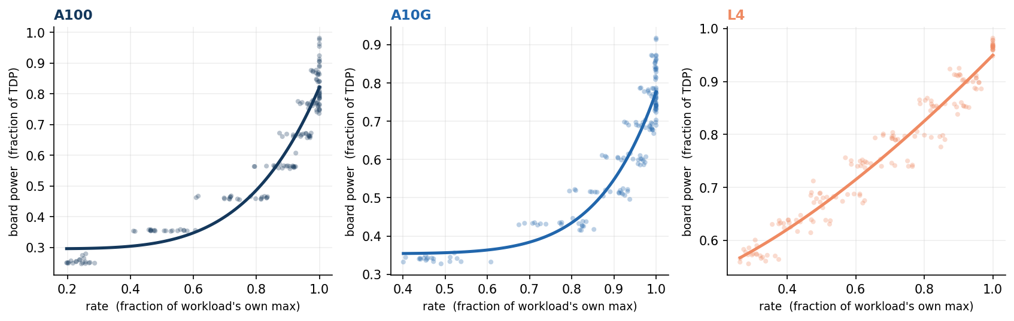
Figure A1. The response law is a card property. One panel per GPU (A100, A10G, L4); each dot is a measured operating point for one of the 20 workloads in the loaded regime, rate normalized to the workload's own maximum and power to the card's TDP. All workloads follow a single fitted law per card, P(θ) = P₀ + a·θ^{β} (pooled per-card R² of 0.88 to 0.92; per-sweep fits higher, median 0.99), showing the exponent travels with the card rather than the model. This is the empirical basis for the one-time per-card characterization that WP2 turns into a transfer model.
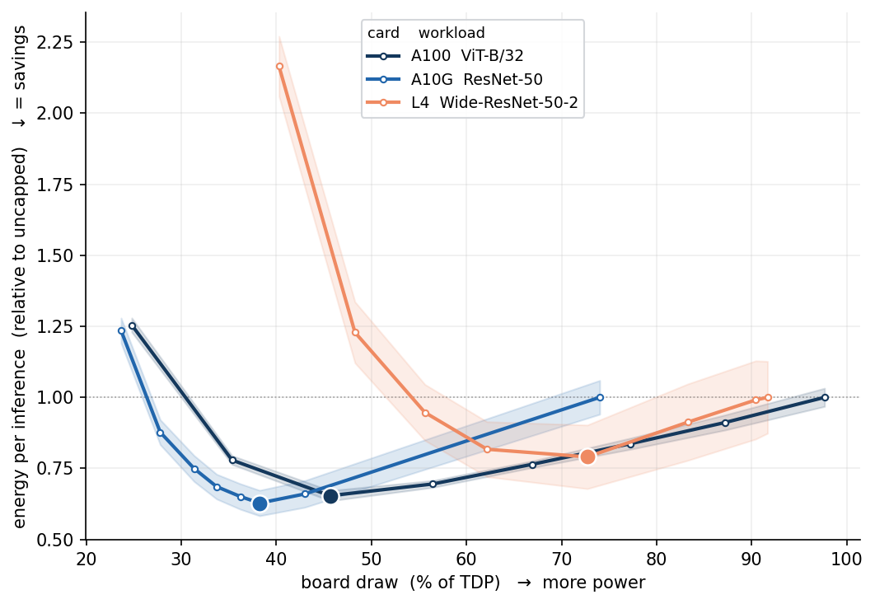
Figure A2. Every card has an energy U-shape. Energy per inference, normalized to each card's own uncapped value, against board draw as a fraction of TDP; the dot marks the JP, the shaded band one standard deviation over repetitions. On the large GPUs the minimum sits at 43–46 percent of TDP and capping to it cuts energy per inference by 29–31 percent; on the L4 the interior minimum lies below the power cap's reachable floor and is exposed by the graphics clock instead, mapping which actuator applies to which card class.
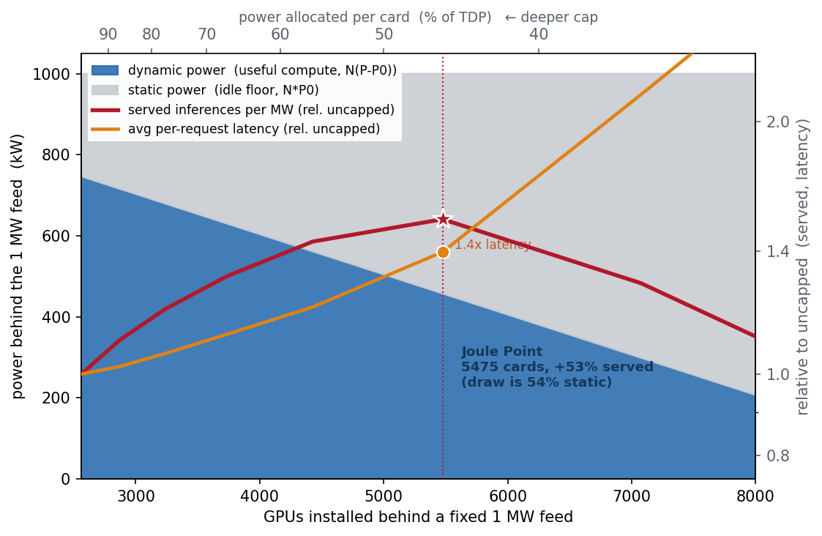
Figure A3. When power, not capital, binds, the JP is the interior optimum. Behind a fixed 1 MW feed (A100, ViT-B/32 at batch 64), installing more GPUs forces each to a deeper cap, shifting the megawatt from useful dynamic compute (blue) to the static idle floor (grey). Served inferences per megawatt (red) peak at the JP, near 5,500 installed cards, about 50 percent above the uncapped configuration. This is the capacity lever the Israel demonstration (WP4) operationalizes: under a rationed connection, efficiency becomes throughput. The same measured curves, allocated exactly across a fleet, dominate uncapped operation at every power budget from 100 down to 40 percent of total TDP; the preliminary measured-curve fleet simulation result appears in section 2.5.5.8.

Table A1. The five artifacts: what each is, who uses it
The project delivers five named artifacts, each with a defined user and use:
Artifact | What it is | Who uses it, for what
ELF-2 | An open dataset: power, throughput and latency at every operating point, board to wall, on current GPUs and production serving software | Researchers and vendors, as ground truth; every other deliverable is built and validated on it
The characterization kit | Software plus protocol: a one-test procedure and the two fitted models placing the JP of a job or of a new, unmeasured card within the validated hardware domain, in hours | A GPU engineer or operator qualifying a new card model or a new serving stack before deployment, at known cost
The control engine | An open-source control engine that assigns jobs and sets caps to keep a fleet inside its envelope, evaluated in the twin and demonstrated on a metered rented server before any deployment | An AI data-center manager, to cut energy per job and honor a committed envelope; its report doubles as the compliance record
The digital twin | A simulator replaying the measured curves of a described fleet and job mix, evaluating any policy or envelope scenario exactly before hardware is touched | An operator testing policies before deployment; a planner or regulator asking what a proposed facility could deliver and shed under a given connection
The grid interface and policy report | A blueprint: open formats for the envelope commitment, the flexibility offer and the delivery record, plus a regulator-facing report quantifying firm-plus-flexible connections against the national queue | The Electricity Authority and Noga, as the technical basis for offering conditional connections and auditing compliance
Table A1. The chain of use is direct: ELF-2 calibrates the models, the models feed the controller, the twin proves the controller before deployment, and the grid interface turns the controlled facility into something the regulator can contract with.

