Preprint

Segment Where the Interaction Persists
What public advertising logs reveal about plan-based impression allocation: a pre-committable segmentation rule, a bias-audited replay protocol, and a regime map for when planning pays.
Alexander Apartsin · August 2026

Abstract
Under fixed campaign quotas, impression allocation can exploit exactly one statistical object: campaign-by-segment interaction in click-through rate that persists across planning windows. Main effects are neutralized, campaign effects by the quotas and segment effects by supply. We give a pre-committable rule for choosing the segmentation an allocator should use: measure the persistence of double-centered interaction residuals across adjacent planning windows, segment only on the axes that persist, and set granularity in proportion to per-cell data density. On 26.6M impressions of the Taobao display-advertising log the rule, computed from planning-window data alone and without reference to replay outcomes, selects the configuration whose replay results then match the full ablation ordering: activity tiers pay, demographics and time do not, and finer granularity pays only while cells stay dense. On Avazu the rule ranks axes consistently, and the re-planning timescale it implies is confirmed at the boundary where a daily plan fails. A pre-registered application to a third log (Outbrain), with the configuration frozen before replay, transfers the rule’s persistence ranking but also shows its scope: persistence identifies exploitable axes, yet the realized lift is governed by contention, and an uncontended market yields little to allocate whatever the segmentation.
Evaluation uses a replay protocol hardened against the traps we document: single-model replay inflates lift through a winner’s curse, and our dual-model scoring, exact uniform-null control, support and fatigue audits, user-clustered inference (headline z = 4.55), and a propensity-weighted outcome bracket delimit what public logs can and cannot show. The protocol yields a regime map. At exact feasibility, plan-informed policies beat greedy serving by 3.5–4.7% expected clicks and information-matched, feasibility-aware dual-price pacing nearly matches them. under over-subscription (quotas at 110–150% of supply) adaptive dual-price pacing collapses below greedy, but a fixed dual policy pinned at the LP’s optimal prices stays positive and tracks the re-solved plan, isolating online scalar adaptation, not per-campaign pricing, as the failure; the periodically re-solved plan dominates every regime (+2.2 to +4.4% over greedy, z ≥ 3.4). The full ordering reproduces on a second, independent dataset (Outbrain, 87M impressions), where the adaptive collapse deepens to −44% while re-solving stays positive. The model-scored gains resist fatigue and support audits; grounding them in realized outcomes, however, is inconclusive on the small logging-matched subset, an inherent limit of public-log evaluation.

1Introduction
A mobile advertising platform must answer one question millions of times a day: a subscriber has just opened a page; which campaign should fill this impression? The obvious answer, show whichever ad this subscriber is most likely to click, is wrong. Campaigns carry contracted impression quotas, subscribers arrive in an unpredictable order, and every impression given to one campaign is an impression denied to all others. Serving each impression greedily fills popular campaigns with the first subscribers who arrive, not those who respond best, and leaves the remaining campaigns with a poorly matched audience.
On the open web this failure is blunted by coarseness: broad audiences are interchangeable audiences, so the opportunity cost of a greedy choice is small. Operator-run mobile advertising inverts that condition: verified profiles and gateway-complete response attribution support far finer segmentation, and fine segmentation is precisely what advertisers pay an operator for, not “males 18–49” but urban music buyers on sports content on weekend afternoons. That deployment setting motivated this study; Section 8 describes the serving design built for it.
Precision is what turns serving into an allocation problem. Narrow, high-value targets are scarce, and campaigns defined this precisely overlap: the subscribers one advertiser most wants are the subscribers other advertisers most want, in the same hours, on the same content. Contention over specific sub-audiences stops being an edge case and becomes the normal operating condition. Every impression then carries a real opportunity cost, and greedy serving, harmless when audiences are interchangeable, systematically hands the scarcest inventory to whichever campaign arrives first. The same richness that creates the problem also makes it solvable: with complete attribution, the click probability of every (campaign, segment) pair is a measured quantity, so the cost of any assignment against any alternative can be computed rather than guessed. An operator that targets precisely and attributes completely does not merely benefit from global optimization; it forfeits the value of its own data without it. Precision here is a property of demand: advertisers buy narrow targets, and narrow targets contend. Which segmentation the allocator itself should use is a separate, empirical question, and Section 5 shows its answer is governed by which interactions persist, not by maximal fineness.
This paper treats ad serving as that global allocation problem and makes three contributions, each validated on public advertising logs. First, a pre-committable segmentation rule: measure the persistence of campaign-by-segment interaction residuals across adjacent planning windows, segment only on the axes that persist, and scale granularity to per-cell data density. Second, a replay evaluation protocol for allocation policies, hardened against the winner’s curse and selection artifacts that we show inflate naive replay. Third, a regime map locating where planning pays: plan-informed policies lead at exact feasibility and dominate outright under over-subscription, where dual-price adaptation collapses. Section 2 quantifies the cost of greedy serving on a minimal instance and Section 3 states the allocation program. Section 4 develops the replay protocol, Section 5 the persistence rule, and Section 6 the regime map. Section 7 calibrates the harness on a synthetic market with known ground truth, Section 8 presents the reference serving architecture that motivated the study, and Section 9 situates the work in the online-allocation and offline-evaluation literature.

2The allocation problem: a worked example
Consider the smallest interesting instance. Two campaigns run at the same time: a soft drink and a sports car. Each has bought exactly two impressions. Four subscribers will each generate one ad opportunity. From past behavior we can estimate every subscriber’s probability of clicking each campaign:
Subscriber | P(click | drink) | P(click | car)
u₁ | 0.10 | 0.80
u₂ | 0.30 | 0.50
u₃ | 0.20 | 0.60
u₄ | 0.40 | 0.70
A greedy server shows every subscriber their personally best ad. All four prefer the car, so the car campaign’s quota is consumed by whoever happens to arrive first, say u₁ and u₂. The drink campaign is then forced onto the remaining two:
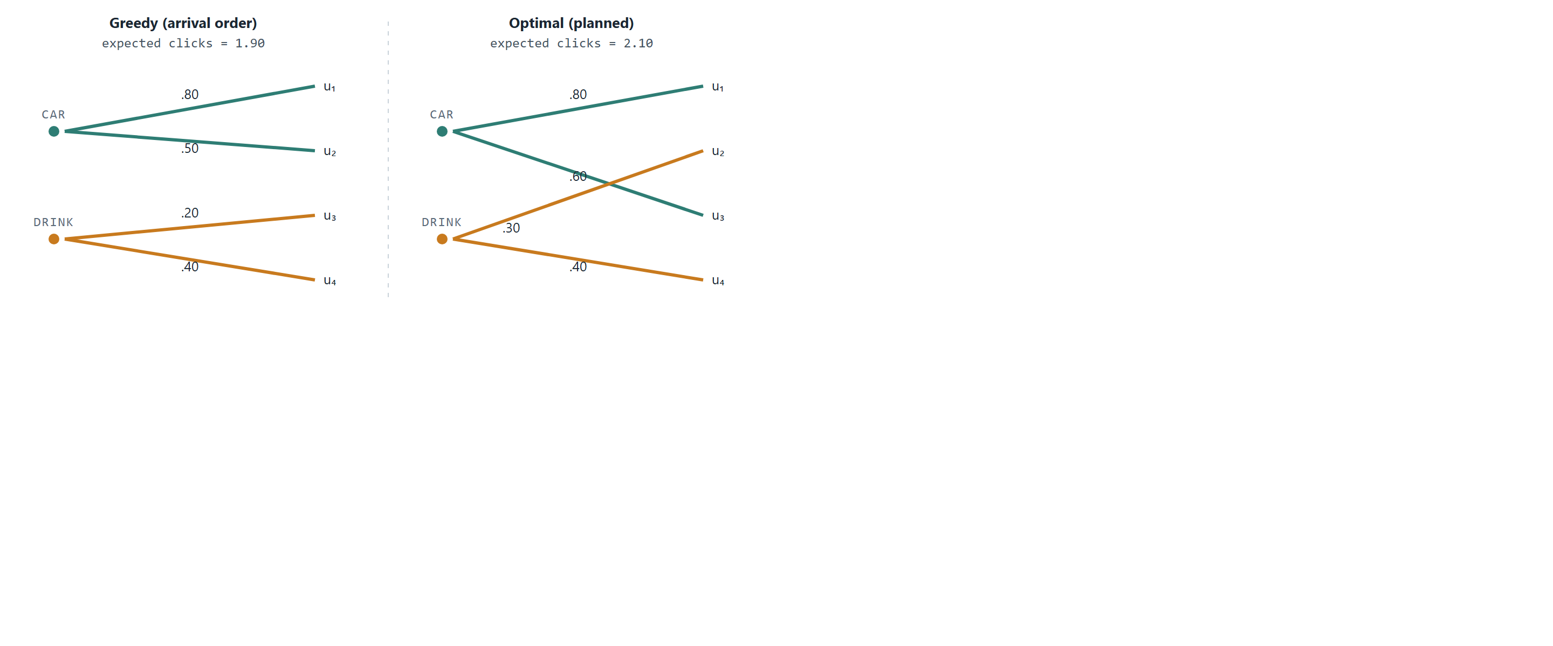
Figure 1. Two campaigns, four subscribers, two impressions per campaign. Greedy serving fills the car campaign with the first arrivals (u₁, u₂) for 0.80 + 0.50 + 0.20 + 0.40 = 1.90 expected clicks. The optimal assignment gives the car campaign u₁ and u₃ and the drink campaign u₂ and u₄, for 0.80 + 0.60 + 0.30 + 0.40 = 2.10, an 11% lift from re-pairing the same impressions. The greedy value depends on arrival order; averaged over all orders it is 1.80, so the drawn order is a conservative case.
Nothing about the subscribers or the campaigns changed between the two panels. The only difference is that the right-hand assignment was chosen jointly: the car campaign gives up u₂ (a 0.50 click chance), whose 0.30 with the drink remains a strong pairing, and takes u₃ (0.60) instead. Each individual swap looks locally worse for someone; the total is strictly better.
The gap grows with scale. With hundreds of campaigns, millions of subscribers, targeting constraints, frequency caps, and time-of-day windows, greedy serving does not just lose a few percent: it systematically starves narrow-audience campaigns, over-exposes indifferent subscribers, and leaves contracted quotas unfilled at the end of the flight. Optimal allocation is not a refinement of ad serving; it is the difference between selling inventory and wasting it.
The core insight: click probability is a property of a pair (audience, campaign), not of a campaign alone. Revenue is maximized by choosing the pairing globally, subject to each campaign’s quota, and this choice can be made ahead of time because audience behavior is statistically predictable even though individual events are not.

3Formulation
Formally, the planning stage solves a transportation-style optimization. Audience supply is described by segments: s ranges over (cluster, context slot) pairs, where a cluster is a group of behaviorally similar subscribers and a context slot is a recurring situation (a time window crossed with a content category). Let H_{s} be the predicted number of impressions segment s will generate during the planning horizon, and p_{c,s} the estimated probability that an impression from segment s produces a click on campaign c. Each campaign pays r_{c} per impression and q_{c} per click, and has bought Q_{c} impressions. The plan chooses x_{c,s}, the number of impressions of campaign c allocated to segment s:
maximize Σc,s xc,s · ( rc + qc · pc,s )
subject to Σc xc,s ≤ Hs (segment supply)
Σs xc,s ≤ Qc (campaign quota)
xc,s = 0 where targeting excludes (c, s)
xc,s ≥ 0
Figure 1 is this program with two campaigns, four single-subscriber segments, H_{s} = 1 and Q_{c} = 2. At production scale the same structure holds; the segments are just coarser and the counts larger. Because both objective and constraints are linear, the plan is solvable with off-the-shelf LP solvers (we use the dual simplex of [1]) even for large instances, and, critically, it is solved offline. The online server never optimizes; it executes a pre-computed plan and corrects for drift.
Three practical notes. First, the objective prices impressions and clicks separately, so campaigns that pay mostly per impression and campaigns that pay mostly per click compete in one currency, expected revenue; when supply suffices, quotas bind at the optimum (every unit of x earns at least r_{c} > 0), and the impression-price term becomes a constant, making the allocation choice a pure expected-clicks problem; Section 6 studies the over-subscribed regime where this simplification fails. Second, the quota appears as an upper bound: when targeting and supply cannot fill a quota, the program returns the revenue-maximal under-delivery rather than infeasibility, and the shortfall is the input to make-good scheduling, which we treat as outside the model. Third, the quota constraint is what makes greedy serving inadequate: without it, serving every impression to its highest-value campaign would be optimal, and no planning stage would be needed.

4Replay evaluation protocol
A synthetic market controls everything (Section 7); real logs control nothing, which is the point. The experiments of Sections 4–6 replay the public Taobao display-advertising dataset [2, 3]: 26.6 million impressions over 8 days in May 2017, roughly 1.1 million users with declared demographics, and explicit campaign identifiers, the closest public analog to an operator's data. The market is reconstructed from the log itself: campaigns are the top 100 by planning-window volume, each campaign’s quota is the number of impressions it actually received in the serving window, and policies re-pair the identical impression stream, so the counterfactual is the same inventory, re-allocated.
Replay evaluation has a trap. If the table of click probabilities that the planner optimizes also scores the outcome, both the plan and the bound harvest the table’s estimation noise: in our first run the measured lift was +8.9% while the mean assignment value exceeded the best campaign’s true click rate, an impossibility. The design that survives this is dual-model scoring: policies plan and serve using only planning-window estimates, while all values, including the hindsight bound, are scored under an independent table fitted on the serving window. A uniform-probability control run then yields exactly 0.0% lift with every policy at exactly 100% of the bound, confirming the harness measures pairing quality and nothing else. Evaluation is walk-forward: for each of five serving days, the plan is fitted on all prior days and scored on that day alone. The adaptive baseline is fully specified: a dual-price pacing policy that serves the quota-remaining campaign maximizing p̂_{cs} − μ_{c}, updating μ_{c} ← μ_{c} + η(served_{c}/Q_{c} − t/T) after each impression with η set to half the global click rate; it consults no plan. Reported errors are the scoring table’s closed-form binomial variance propagated through each comparison’s assignment difference; the across-fold spread of the five per-fold lifts independently reproduces the same standard error, and the all-folds-positive sign pattern supports the parametric statement distribution-free. The uniform control defends the harness; a further check defends the scorer itself: standardizing the scoring table along the strongest observable within-cell covariate the segmentation does not use (each user’s own training-window click propensity) shifts the headline lifts by at most +0.3pp, upward, so observable within-cell selection in the logged exposures does not account for the measured gains. Support is also measured directly: only 6% of the planned policy’s assignment mass (and 5% of the re-paired mass) lands in cells with fewer than 100 logged serving-window impressions, and scoring those thin cells with a pooled campaign-level fallback moves the headline from +3.46% to +2.99%; the counterfactual does not rest on extrapolated cells. (Forcing the fallback on all cells below 1,000 impressions, 78% of the mass, collapses the lift toward zero, as it must: a campaign-constant scorer deletes the interaction dimension, and under fixed quotas every assignment then scores equally, the same argument as the uniform control.) The replay isolates the architecture’s allocation core, plan against serving policy at segment granularity: every campaign is eligible on every segment, and the per-subscriber serving components of Section 8.2 (soft-membership blending, frequency caps, threshold pacing) operate below this granularity and are not exercised by these experiments.

5The persistence rule
Allocation under fixed quotas can exploit exactly one thing: campaign-by-segment interaction in click probability that persists from the planning window to the serving window. Campaign main effects persist strongly (week-over-week correlation 0.81) but fixed quotas neutralize them; segment main effects are fixed by supply. Measuring the persistence of double-centered interaction residuals per candidate axis therefore predicts, from planning-window data alone, which segmentations can pay. The estimator is explicit. For a candidate axis, take two adjacent planning windows (here 8-day and 2-day slices of the training period) and, in each, form the empirical click rate of every (campaign, group) cell with at least 300 impressions in one window and 150 in the other. Double-center each window’s cell rates by subtracting the impression-weighted campaign mean and the impression-weighted group mean and adding back the grand mean, leaving the pure interaction residual. The axis’s persistence is the Pearson correlation of these residuals across the two windows over the shared cells; empty or below-threshold cells are dropped, not imputed. An axis is retained when its persistence exceeds its estimation-noise floor (the correlation a pair of independent binomial draws at the same cell counts would produce, near zero at these volumes). The measured persistences:
Segmentation axis | Interaction persistence (r) | Interaction size beyond noise
Activity tier (usage volume) | 0.48–0.54 | ~1pp on a 5.5pp base
Gender × age | 0.28 | ~0.5pp
Hour × position slot | 0.08 | ~0
The persistence table fixes the evaluation configuration before any replay is scored: the activity axis persists most strongly, and its measured persistence improves from four tiers to eight (r = 0.48 to 0.54), so the pre-committed configuration for the 100-campaign market is eight activity tiers. Both headline comparisons are reported for that single configuration; the remaining rows are the ablation that tests the rule.
Segments | Count | Planned vs greedy | z | Planned vs adaptive pacing | z
Activity, 8 tiers (pre-committed) | 8 | +3.46% ± 0.69pp | +5.0 | +0.92% ± 0.47pp | +2.0
Activity, 4 tiers | 4 | +2.51% ± 0.50pp | +5.0 | +1.15% ± 0.31pp | +3.7
Tier × demographics | 168 | +1.93% ± 0.91pp | +2.1 | +0.40% | +0.6
Demographics only | 48 | −0.20% ± 0.61pp | −0.3 | +0.46% | +1.1
Per-fold lifts for the pre-committed configuration, so signs are visible rather than summarized: against greedy +5.2, +4.2, +2.6, +3.2, +2.2 (five of five positive; one-sided sign-test p = 0.03 independent of the parametric error model); against adaptive pacing +2.2, +1.7, +1.9, −0.5, −0.9 (three of five positive, consistent with its z = 2.0).
Three conclusions. First, the architecture’s claim holds on real inventory under the model-scored replay protocol: on the pre-committed configuration the plan beats greedy serving by 3.5% expected clicks (positive in every fold) and beats an adaptive dual-price pacing policy in the family of online allocation methods [5], the strong online baseline, by 0.9% (z = 2.0; the four-tier ablation row separates from pacing at z = 3.7), while serving from precomputed tables. Second, persistence, not granularity, carries the value: eight segments on the persistent axis beat 168 finer ones, because finer cells add estimation noise and re-pairing churn faster than they add exploitable signal; and the right granularity scales with per-cell data density (in a 500-campaign market, four tiers beat eight). The density component is not free of tension: eight tiers give the larger edge over greedy, yet four tiers separate more decisively from the adaptive baseline, so the depth that maximizes the gap depends on which competitor one measures against; we pre-commit to the greedy-referenced choice and report both. Third, the persistence measurement itself is the deployable design rule: before segmenting, correlate double-centered interaction residuals across adjacent planning windows, and segment only on axes that persist. The rule generalizes: on a second public log (Avazu, 40.4M mobile impressions [4]), the same measurement ranks page category as the most persistent axis (r = 0.88) and, in both datasets, time-of-day as the least, confirming that time belongs to the pacing loop, not to segmentation. Avazu’s own replay is where the rule earns its boundary: a plan fitted on a full prior window and served for a whole day is negative on three of five days, because Avazu’s ad portfolio and delivery mix turn over within a day. The persistence measurement implies a re-planning timescale, and re-planning at that timescale (every 50,000 impressions) turns the same market positive on all five days (+6.5%, +8.3%, +1.7%, +2.7%, +0.5% over greedy), confirming the mechanism and the stability condition Section 11 states. With that rule applied, the replayed policies capture 85–91% of the hindsight bound; the residual is the estimation noise and week-over-week drift that the pacing loop of Section 8.2 exists to absorb.
The granularity-density frontier. Varying tier count against market size traces the frontier directly. In the top-100 market, 8 tiers deliver +3.46% over greedy (z = 5.0) while 16 tiers deliver +0.32% (z = 0.4). In the top-500 market, 4 tiers deliver +1.55% (z = 4.8), 8 tiers +0.94% (z = 2.2), and 16 tiers −0.43% (z = −0.9). Optimal granularity shrinks monotonically as per-cell density falls, so the rule is: persistence picks the axis, density picks the depth.

6The regime map
Over-subscription is the regime that motivates planning, and the market reconstruction supports stressing it directly. Quotas set to each campaign’s realized delivery make the market exactly feasible; scaling all quotas above deliverable supply forces genuine contention, and policies choose which campaigns under-deliver. Five policies replay each regime on the pre-committed configuration: the static plan; a periodically re-solved plan (the same LP re-solved on remaining quotas and prorated remaining supply every 20,000 impressions); a plain dual-price pacing policy; and a tuned dual-price policy (step size tuned by simulated serving on the last planning day), started either cold or warm from the plan LP’s quota shadow prices. Lift versus greedy, combined over the five walk-forward folds, with z in parentheses:
Quota scale | Static plan | Re-solved plan | Dual, fixed optimal prices | Dual, adaptive (warm) | Dual, adaptive (plain)
1.0 | +3.46% (5.0) | +4.40% (6.7) | +4.63% (7.2) | +4.55% (7.7) | +3.43% (6.2)
1.1 | +2.16% (3.1) | +3.49% (5.2) | +2.41% (3.8) | +0.09% (0.2) | −1.36% (−2.3)
1.25 | +1.56% (2.2) | +3.39% (5.2) | +3.04% (4.8) | +0.47% (0.8) | −4.19% (−6.7)
1.5 | +0.28% (0.4) | +2.22% (3.4) | +1.48% (2.4) | −0.97% (−1.5) | −8.33% (−12.1)
The dual-price baselines are given every advantage: their step size is tuned on held-out planning-window traffic, the warm variant is initialized from the plan LP’s own quota shadow prices, and, so the comparison is not rigged by an unreachable target, each paces toward a feasible delivery trajectory (the proportionally deliverable quota for the plan-free variants, the LP’s planned delivery for the warm variant) rather than the raw over-subscribed quota. The re-solved plan is held to the same information as the plan: it re-solves on the planning-window forecast prorated to remaining supply, never on realized serving-window arrivals. A fifth policy separates the price from its adaptation: the fixed optimal-dual policy serves the quota-remaining campaign maximizing p̂_{cs} − μ*_{c} using the exact optimal quota shadow prices μ* of the over-subscribed plan LP, with randomized tie-breaking and no online update. It is a per-campaign-price policy that never adapts.
At exact feasibility, all five strong policies cluster at the top; most of the value is the forecast itself, which each consumes. Under contention the policies split cleanly, and the split identifies the mechanism. The adaptive dual-price variants fall below greedy, steeply so as quotas tighten (the plain variant reaches −8.3% at 150% over-subscription, and warm-starting only delays the collapse). Yet the fixed optimal-dual policy, the same per-campaign-price form with its prices frozen at the LP optimum, stays positive at every contention level (+2.4%, +3.0%, +1.5%, z ≥ 2.4) and tracks the re-solved plan within about a percentage point. So it is not per-campaign pricing that fails under contention; a static price vector can carry the allocation, as linear-programming duality predicts. What fails is learning that vector online by scalar pacing: as quotas tighten the pacing update chases a moving delivery target and drifts off the optimal prices, and the fixed policy beats the best adaptive one by +2.3 to +2.6% (z ≥ 4.2). The periodically re-solved plan, which recomputes the prices rather than adapting them, dominates every regime, its edge over the static plan growing from +0.9% (z = 2.8) to +1.9% (z = 5.2).
The deployment rule sharpens accordingly: the LP’s prices are what matter, so recompute them on the pacing cadence (re-solve, or refresh the fixed dual vector); do not learn them online by scalar pacing adaptation, which is the standard budget-pacing controller and the one policy class that fails under contention here.
The regime map reproduces on a second, independent dataset. We repeat the whole protocol on the Outbrain content-recommendation log (87M joined impressions, a slate-click structure unlike Taobao’s display, with the segmentation axis fixed in advance to the most persistent one measured on the planning window, page platform at r = 0.95). At native quotas the Outbrain market is barely contended, per-segment supply dwarfs the quotas, so every policy sits within a percentage point of greedy, exactly the low-contention corner of the map. Under the same over-subscription stress, the same ordering returns and sharpens: the re-solved plan is the only policy positive at every level (+0.3 to +0.6%), the static plan and the fixed optimal-dual degrade gently, and adaptive dual-price pacing collapses far more steeply than on Taobao, to −19%, −34%, and −44% at 1.5×, 2×, and 3× quotas. That adaptation, not per-campaign pricing, is the failure, and that re-solving the plan is the robust choice, holds across two datasets from different domains.
Three robustness checks anchor the table. The headline planned-versus-greedy comparison survives a user-clustered bootstrap (z = +4.55) and an across-fold t-test (t(4) = +5.50); the planned-versus-plain-dual cell at feasibility is fragile (z = 1.9, t = 1.3), and the ordering across regimes, not that single cell, is the claim. Re-pairing the impression stream changes per-user exposure composition; re-scoring under a first-exposure table (each user’s first impression of each campaign only, which removes repeat-exposure composition) moves the headline from +3.46% to +3.88%, so exposure fatigue does not manufacture the result. The regime map is a single-market result: the over-subscription sweep is run on the Taobao top-100 reconstruction, while Avazu contributes only the stability boundary. The z-values in the table above the headline row come from the parametric binomial model; the conclusions that rest on them (the re-solved plan’s dominance at every scale, the dual collapse) hold with the same sign and comparable magnitude under the user-clustered bootstrap where we recomputed them. The remaining, and inherent, limitation is that these are model-scored expected clicks: an outcome-grounded estimate is possible only on the 2–2.4% of impressions where a policy’s choice coincides with the logged action, a subset both tiny and selected toward the logging policy. On it, a self-normalized inverse-propensity estimate with an estimated segment-level logging propensity puts planned within ±1pp of greedy at t(4) = −0.5, that is, inconclusive; the matched-subset calibration shows the model scorer understates realized CTR slightly and symmetrically for both policies (about 6.8% realized versus 6.5% modeled), so it is not inflating the gap. Public logs cannot close this gap; only an interventional deployment can.

7Simulation as calibration
Before real logs, a fully synthetic market calibrates the harness where ground truth is known. The four-subscriber example of Section 2 proves the mechanism exists; a Monte-Carlo simulation quantifies it at realistic scale. Each replication generates a synthetic market: 60 segments with lognormal traffic (about 200,000 impression opportunities), 25 campaigns whose quotas sell 80% of expected inventory, per-impression prices drawn uniformly on [$0.05, $0.30] and per-click prices on [$0.50, $3.00], and click probabilities from a campaign-audience affinity model (each campaign genuinely fits some audiences better than others, with rates spanning 0.1%–8%). Each campaign is eligible, by targeting, on roughly 60% of segments.
Two policies then serve the identical event stream under identical quotas, prices, probabilities, and targeting. The greedy policy is the conventional per-event rule: serve the eligible, quota-remaining campaign with the highest immediate expected revenue. The planned policy solves the linear program of Section 3 offline on the traffic forecast, then serves each event by drawing down the planned allocation, falling back to greedy where the plan is locally exhausted. The plan never sees the realized traffic; events are drawn randomly around the forecast, so the planned policy faces genuine forecast error. A third quantity, the hindsight bound, is the offline optimum computed on the traffic that actually occurred; no online policy can exceed it.
Measure (20 replications) | Mean | Range
Revenue lift, planned over greedy | +6.5% | +4.1% to +8.8%
Expected-click lift, planned over greedy | +33.0% | +22.9% to +40.6%
Planned revenue as share of hindsight bound | 93.8% | ≥ 91.7%
Greedy revenue as share of hindsight bound | 88.1% | ≥ 85.4%
Quota fill, both policies | 100% | all replications
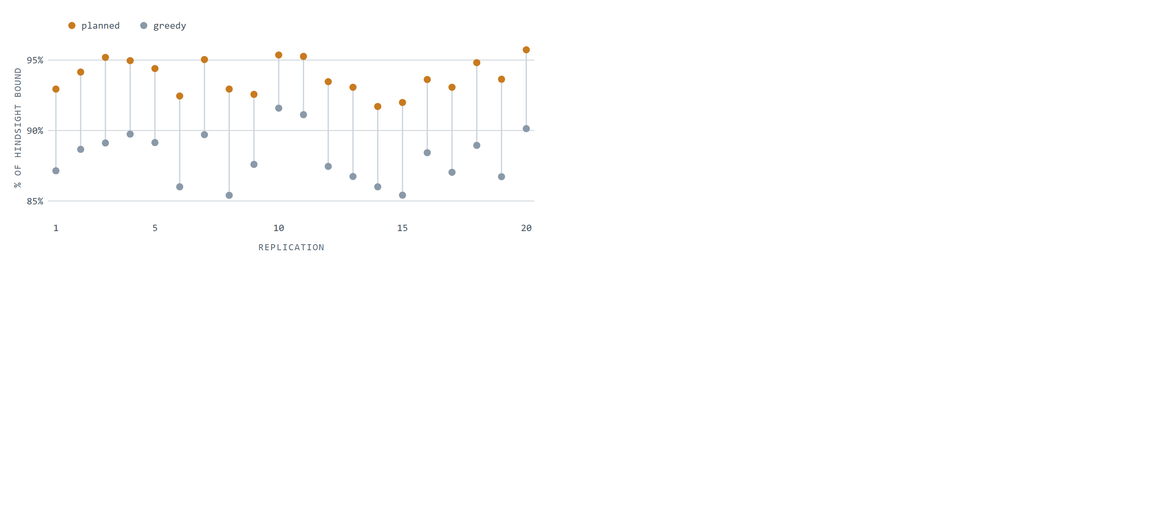
Figure 5. Revenue captured by each policy as a share of the hindsight offline optimum, per replication. Planned allocation dominates greedy serving in all 20 replications; the two distributions do not overlap (planned minimum 91.7%, greedy maximum 91.6%).
Both policies fill every quota, so the entire gap is pairing quality: the same impressions, sold to the same campaigns, assigned to different audiences. This also explains why the click lift (33%) exceeds the revenue lift (6.5%): per-impression fees are earned identically by both policies once quotas fill, so planning’s advantage is concentrated wholly in the click-priced component of revenue. In markets weighted further toward performance pricing, the revenue gap widens toward the click gap.
The simulation carries its own controls. Both policies are verified against the hindsight bound in every replication. On control instances where all campaigns share identical click probabilities, so pairing cannot matter, the measured lift is 0.000%, confirming that the gap measures allocation quality and not an artifact of the harness. And the planned policy’s 93.8% of a bound computed with perfect hindsight shows that forecast noise costs the plan only a few points, the residual that Section 8.2’s pacing mechanism and the refinement loop exist to absorb.

8A reference serving architecture
This section describes the deployment design that motivated the study: an operator-grade two-stage architecture that compiles the allocation plan into constant-time lookup serving. It is a design sketch: the experiments of Sections 4–6 validate the allocation core (plan versus serving policy at segment granularity), not the per-subscriber machinery described here.
The design targets the operator’s data position. A web ad network observes a browser: a resettable, unverified cookie, activity on the sites it instruments, and demographics inferred by guesswork. A network operator observes a customer: a verified identity anchored in a billing account, declared attributes, financial signals, and, because all browsing crosses the gateway, complete response attribution joined under one stable identifier.
Dimension | Web ad network | Network operator
Identity | Cookie or device fingerprint; resettable, unverified | Subscriber account; stable, verified, one per person
Demographics | Inferred from behavior | Declared at subscription: age, gender, address
Financial signal | None or modeled | Plan, spend level, content purchase history
Location | Coarse, via IP | Network-observed, continuous
Browsing coverage | Sites the network instruments | All traffic through the gateway
Exposure control | Per-site frequency caps | Global caps across all inventory, per subscriber
The vantage point carries obligations that shape the design. Subscriber data is usable for advertising only within a consent and data-protection framework: profiling requires a lawful basis and per-subscriber opt-out under regimes such as the GDPR and ePrivacy rules, and gateway-observed browsing is subject to purpose limitation. The architecture is built for data minimization under those constraints: raw attributes and browsing records are confined to the offline stage, the serving path receives only anonymous cluster distances and campaign eligibility lists, and every online decision reads aggregate tables rather than individual histories. Segment coarseness is itself a privacy parameter: the segments that carry allocation value in Section 5 are a handful of aggregate behavior tiers, not individual dossiers. Not every subscriber has a profile at all: prepaid subscribers may be anonymous, which is why the clustering machinery supports membership computed from response behavior alone (Section 8.1.3).

8.1 The offline stage: learning the inputs to the plan
The allocation program needs two inputs that do not exist in raw data: predicted traffic per segment (H_{s}) and click probabilities per campaign-segment pair (p_{c,s}). The offline analytics stage builds both from event history, under three modeling assumptions, each holding with high probability rather than certainty:
- The distribution of (context, profile) pairs observed in the past will recur in the future.
- Subscribers who responded similarly under similar conditions will continue to respond similarly.
- Subscribers who respond similarly share something observable in their profiles or histories.
Assumption 1 justifies forecasting traffic from history; assumptions 2 and 3 justify pooling sparse per-subscriber click data into clusters that have enough volume to estimate probabilities reliably.

8.1.1 Response records
The atomic unit of evidence is an ad response record: who saw what, in what context, and whether they clicked.
Time of day | Day of week | Content category | Campaign | Click
11:23 | Monday | News | C1 (active) | 0
14:15 | Monday | Sport | C2 (active) | 1
18:14 | Sunday | Sport | C4 (past) | 1
Records are grouped per subscriber and joined with the profile (age, gender, location, income band, purchase indicators) where one is available. Past campaigns matter as much as active ones: a subscriber’s reaction to a finished campaign is evidence about how they will react to similar future ones.

8.1.2 Proximity and clustering
Subscribers are clustered by a weighted distance that mixes profile similarity with response-pattern similarity: response to the same campaigns (active and past) and to similar campaigns. Each attribute contributes its own distance component:
Attribute | Distance component
Age | Absolute difference
Gender | Fixed penalty if different
Campaign affinity | By campaign category; fixed penalty if different
Day of week | Absolute difference, circular
Location (x, y) | Straight-line distance
Membership is deliberately soft. A subscriber is not filed into one cluster; they carry a pre-computed distance to each nearby cluster. A 35-year-old married streaming subscriber in a large city may sit at distance 0.8 from the “metropolitan professionals” cluster and 0.1 from “music lovers”; a 22-year-old gaming subscriber in the same city sits close to “gamers” and “music lovers” instead. These distances become interpolation weights at serving time (Section 8.2), so predictions blend the behavior of every cluster the subscriber resembles.

8.1.3 Cluster representation and click estimation
Each cluster is summarized by two compact structures. Its context slots describe when and where the cluster generates traffic, with predicted hit counts; this is the supply side H_{s}. Its click statistics record impressions and clicks per campaign per context slot, the raw material for p_{c,s}:
Context slot | Time of day | Day of week | Category | Predicted hits
CS1 | 10:00–12:00 | Mon–Tue | News, Sport | 3,000
CS2 | 11:00–17:00 | Sun | Sport | 4,000
Campaign | Context slot | Impressions | Clicks
C1 | CS1 | 1,000 | 3
C1 | CS2 | 2,000 | 2
C2 | CS1 | 1,000 | 7
For a brand-new campaign with no history of its own, probabilities are borrowed from the most similar past or active campaigns in the same category, the same pooling idea applied across campaigns instead of across subscribers. Where the profile itself is missing (anonymous or prepaid subscribers), distance to clusters is computed from response history alone, and the subscriber inherits the response statistics of the cluster they behave like. The design degrades gracefully as data thins out: per-subscriber evidence backs off to cluster evidence, and per-campaign evidence backs off to category evidence.

8.1.4 Compiling the plan into lookup tables
Solving the allocation program yields planned impression counts per (campaign, cluster, context slot). Everything the online server needs is then flattened into three lookup structures, so that no clustering, no distance computation, and no optimization happens on the serving path:
Structure | Keyed by | Contents
Model table | cluster × campaign | Targeted time slots and content categories as bit masks; planned impressions; expected clicks
Match table | subscriber | Campaigns this subscriber is eligible for under targeting rules
Cluster table | subscriber | Distance to each nearby cluster (the soft-membership weights)
Time and content targeting are encoded as fixed-width bit masks, 168 weekly hour-slots and up to 256 content categories, so an eligibility test at serving time is a bitwise AND rather than a rule evaluation. A model table row reads, in full: “cluster L1, campaign C1, time mask 0100…, content mask 1111…, 10,000 planned impressions, 450 expected clicks.” That one row carries targeting, allocation, and the performance baseline the online stage will pace against.

8.2 The online stage: executing the plan in real time
At serving time an impression event arrives carrying a subscriber identifier and a context (time, day, content category of the page being viewed). The decision engine must return a single campaign within the latency budget of a page load. It consults the three model structures plus two live state tables: a status table mirroring the model table but accumulating actual impressions and clicks, and a response table holding each subscriber’s recent exposure records.
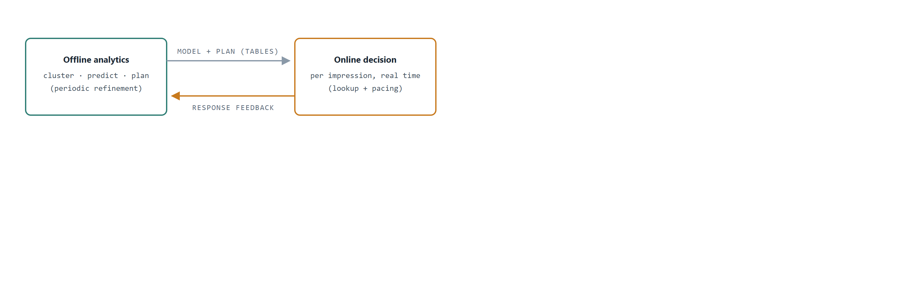
Figure 2. The closed loop. Offline analytics compiles the model and allocation plan into lookup tables; the online engine executes them per impression and streams response records back, which the next analytics cycle uses to refine clusters, probabilities, and the plan.

8.2.1 The seven-step decision
- Find eligible campaignsmatch table Look up the campaigns this subscriber may be shown under targeting rules.
- Apply exposure policyresponse table Drop campaigns that would violate frequency rules for this subscriber, a minimum interval between exposures, a maximum number of exposures per day.
- Fetch cluster distancescluster table Retrieve the subscriber’s pre-computed distances to nearby clusters.
- Predict click probability per candidatemodel table Blend cluster-level click rates with the soft-membership weights (Section 8.2.2).
- Compute pacing per candidatestatus table Compare actual delivery against plan, prorated to this point in the flight (Section 8.2.3).
- Decide If any campaign is critically underserved, serve it. Otherwise drop overserved campaigns and serve the candidate with the greatest expected revenue.
- Update statestatus + response tables Increment the served campaign’s actual counters and append the exposure record, which later feeds back to analytics.
Every step is a keyed lookup, a bit-mask test, or arithmetic over a handful of rows. The expensive work (clustering, probability estimation, optimization) was all paid for offline.
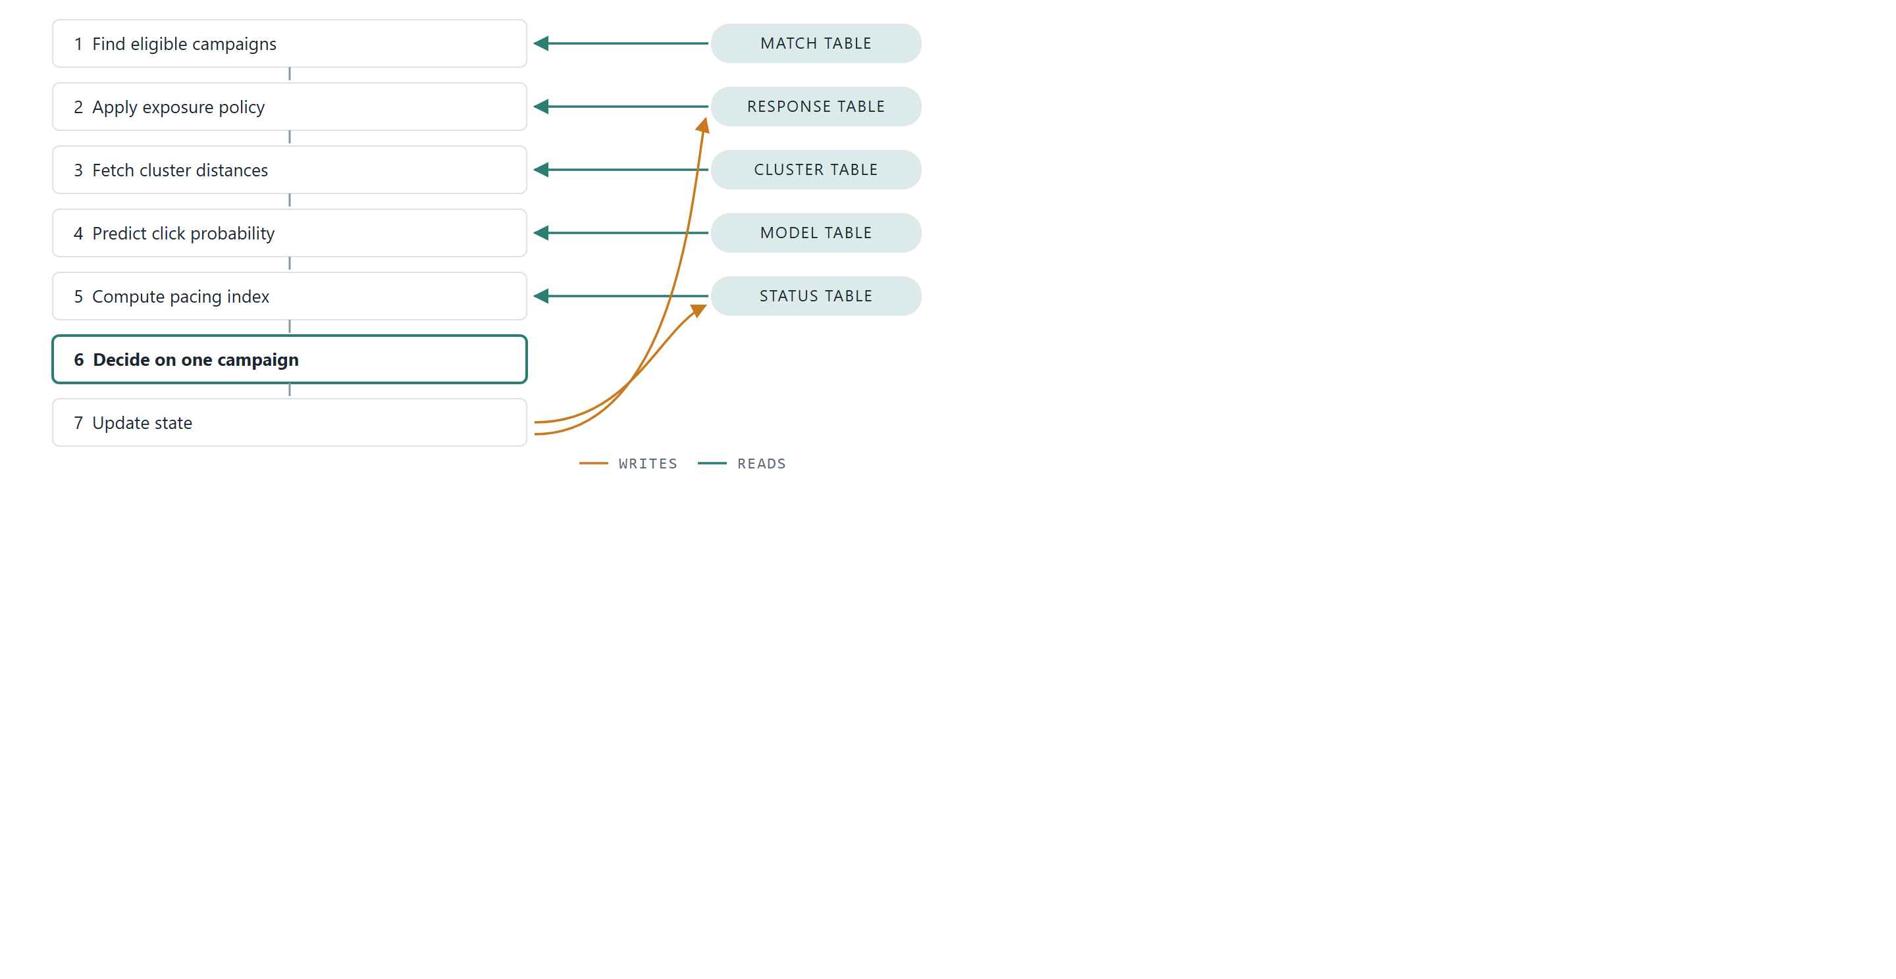
Figure 3. The seven-step decision path and its data dependencies. Steps 1–5 each read one pre-computed or live table; step 6 is pure arithmetic over the candidates; step 7 writes the served impression back into the status and response tables, which is also the record that feeds the next offline refinement cycle.

8.2.2 Click prediction by soft membership
Suppose the event context is Monday, 14:00, Sport and the subscriber sits at weight 0.2 to cluster L1 and 0.8 to cluster L2 (weights derived from the stored distances). The model table gives campaign C1’s historical rates in the matching context: 40 clicks per 8,000 impressions in L1 and 60 per 10,000 in L2. The prediction is the weighted blend:
p(click | C1) = 0.2 · (40 / 8,000) + 0.8 · (60 / 10,000) = 0.0058
Because the subscriber borrows from every cluster they resemble, the estimate is stable even for subscribers with thin personal histories, and it is computed from two table rows and four multiplications.

8.2.3 Pacing: planned versus actual
The plan is a trajectory, not just a total. If a campaign is one third of the way through its flight in a given cluster, it should have received roughly one third of its planned impressions there. The engine aggregates this across the clusters where the campaign runs:
Cluster | Flight elapsed | Planned by now | Actual
L1 | 33% | 8,000 × 0.33 = 2,640 | 2,000
L2 | 50% | 10,000 × 0.50 = 5,000 | 5,100
Total |  | 7,640 | 7,100
performance index = actual / planned-by-now = 7,100 / 7,640 ≈ 93%
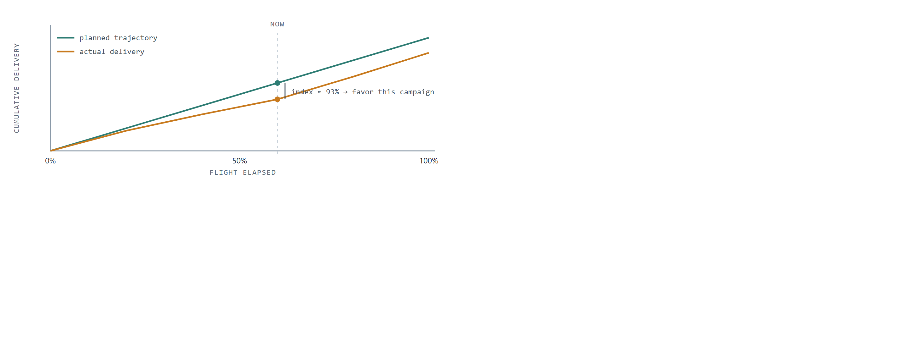
Figure 4. Pacing as trajectory tracking. The plan implies a cumulative delivery path; actual delivery drifts below it, the performance index measures the gap at the current moment, and the decision rule favors the lagging campaign on suitable impressions until the curves reconverge.
An index near 100% means the campaign is on plan. Far below a threshold (say 50%), the campaign is critically underserved and jumps the queue (step 6); far above another (say 120%), it is overserved and stands aside. Between the thresholds, campaigns compete on the same per-impression value the plan optimizes, expected revenue = impression price + click price × P(click):
Campaign | Impression price | Click price | Perf. index | P(click) | Expected revenue
C1 | $0.10 | $1.00 | 55% | 0.01 | $0.110
C2 | $0.10 | $0.80 | 91% | 0.03 | $0.124
C3 | $0.10 | $1.50 | 96% | 0.02 | $0.130
C4 | $0.10 | $1.00 | 128% | 0.07 | $0.170
C4 carries the greatest expected revenue but sits at 128% of plan, past the overserved threshold, so it is dropped; C1 at 55% is behind plan but above the critical threshold, so it earns no override. Among the remaining candidates the engine serves C3, the greatest expected revenue for this impression. The pacing mechanism is what lets a static offline plan survive contact with real, noisy traffic: the plan sets the destination, and the index steers thousands of small per-impression corrections toward it. Deviations that pacing cannot absorb (a traffic forecast that proves wrong, a campaign that outperforms its category prior) are exactly what the feedback loop carries back into the next planning cycle.

9Related work
Online matching and allocation. The theoretical core of ad allocation is online bipartite matching, from the optimal 1 − 1/e algorithm of Karp, Vazirani, and Vazirani [6] through its budgeted AdWords generalization [7]. Under stochastic arrivals, the random-permutation model admits near-optimal algorithms that learn dual prices from an initial sample [8], and primal-dual training on forecast samples extends to display allocation [9] and general online linear programming [10]. This line of work supplies the adaptive dual-price policy we use as the strong online baseline; our contribution is orthogonal: an empirical account, on public logs, of when a compiled offline plan beats such adaptive methods and what segmentation makes the plan's advantage real.
Guaranteed display allocation. Closest in spirit are systems that precompute compact allocation plans for guaranteed-delivery display advertising: optimal online assignment with forecasts [11] and the SHALE algorithm [12] both compute offline parameters that a lightweight online server executes, as our architecture does. Those works optimize the plan's representation and solve time; we address the two questions they leave open in deployment: which audience segmentation gives the plan exploitable, durable structure (the persistence rule of Section 5), and how to measure a plan's realized value against strong baselines without an online experiment. Budget-pacing controllers [13, 14] are the production embodiment of the adaptive alternative and correspond to the pacing loop our serving stage carries in Section 8.2. Relative to this line, our contributions are a pre-committable, falsifiable segmentation test and a public-log evaluation protocol; the architecture itself is a deployment sketch.
Click prediction and offline evaluation. Industrial click-through-rate modeling ranges from large-scale logistic regression [15] and field-aware factorization machines [16] to attention architectures over user behavior [17, 3]. Our click model is deliberately simpler, hierarchical empirical rates with soft cluster membership, because the architecture consumes any calibrated estimator and the allocation question is about the pairing structure, not the estimator frontier. For evaluation, replay methods [18], counterfactual reasoning in computational advertising [19], and offline A/B testing [20] establish the off-policy toolbox; the dual-model scoring of Section 4 applies the same discipline to allocation policies specifically, where we show single-model replay inflates lift through the plan’s own estimation noise.

10Discussion
The optimization lives where time is cheap. Global allocation over all campaigns and segments is a large linear program, and it is solved where minutes are available, not milliseconds. The serving path touches five small tables and does arithmetic. This is the classic plan/execute split, applied so that the online system inherits the quality of the offline optimum at lookup cost.
Pooling defeats sparsity. No individual generates enough clicks to estimate their own response rates. Clusters do. Soft membership then re-personalizes the pooled estimates, blending each subscriber’s several behavioral neighborhoods instead of forcing a single label. The same back-off logic handles new campaigns (borrow from similar campaigns) and profile-less subscribers (cluster by response history alone), so one mechanism covers three cold-start problems.
The plan is a baseline, not a cage. Real traffic never matches the forecast. By carrying planned counts into the serving state and steering with a performance index, the system tolerates forecast error gracefully: small deviations are corrected impression by impression, and persistent ones are evidence, fed back into the next modeling cycle rather than silently accumulated.
Every representation is serving-shaped. Bit masks make targeting tests branchless; pre-computed distances make personalization a weighted sum; per-(cluster, campaign) rows make pacing a two-row query. The offline stage does not merely produce a model; it compiles one, in the same sense a compiler turns a program into a form the machine executes directly.

11Scope and assumptions
The architecture optimizes expected revenue for a known campaign portfolio over a planning horizon; it does not address auction-based pricing, real-time bidding against external demand, or creative selection within a campaign. Its guarantees rest on the stability assumptions of Section 8.1: allocation quality degrades in proportion to how far future traffic and response distributions drift from the modeled ones between refinement cycles, which sets the practical requirement for how frequently the offline stage must re-run. Exposure policy enforcement is per-subscriber and rule-based; richer fatigue models would slot into step 2 without changing the surrounding machinery. Finally, window-fitted planning presumes a campaign portfolio stable over the planning horizon, which is the operator’s contracted-campaign setting; in marketplaces where the ad portfolio and its delivery mix turn over within a day, the re-planning interval must shrink to the churn timescale for the plan to retain value.

References
- Q. Huangfu and J. A. J. Hall. Parallelizing the dual revised simplex method. Mathematical Programming Computation, 10(1):119–142, 2018.
- Alibaba Tianchi. Ad Display/Click Data on Taobao.com. Dataset 56, tianchi.aliyun.com/dataset/56, accessed August 2026.
- Y. Feng, F. Lv, W. Shen, M. Wang, F. Sun, Y. Zhu, and K. Yang. Deep Session Interest Network for Click-Through Rate Prediction. In Proceedings of IJCAI, pages 2301–2307, 2019.
- Avazu. Click-Through Rate Prediction. Kaggle competition, kaggle.com/c/avazu-ctr-prediction, 2014, accessed August 2026.
- A. Mehta. Online Matching and Ad Allocation. Foundations and Trends in Theoretical Computer Science, 8(4):265–368, 2013.
- R. M. Karp, U. V. Vazirani, and V. V. Vazirani. An optimal algorithm for on-line bipartite matching. In Proceedings of the 22nd ACM Symposium on Theory of Computing (STOC), pages 352–358, 1990.
- A. Mehta, A. Saberi, U. V. Vazirani, and V. V. Vazirani. AdWords and generalized online matching. Journal of the ACM, 54(5), Article 22, 2007.
- N. R. Devanur and T. P. Hayes. The adwords problem: online keyword matching with budgeted bidders under random permutations. In Proceedings of the 10th ACM Conference on Electronic Commerce (EC), pages 71–78, 2009.
- J. Feldman, M. Henzinger, N. Korula, V. S. Mirrokni, and C. Stein. Online stochastic packing applied to display ad allocation. In Proceedings of the 18th European Symposium on Algorithms (ESA), pages 182–194, 2010.
- S. Agrawal, Z. Wang, and Y. Ye. A dynamic near-optimal algorithm for online linear programming. Operations Research, 62(4):876–890, 2014.
- E. Vee, S. Vassilvitskii, and J. Shanmugasundaram. Optimal online assignment with forecasts. In Proceedings of the 11th ACM Conference on Electronic Commerce (EC), pages 109–118, 2010.
- V. Bharadwaj, P. Chen, W. Ma, C. Nagarajan, J. A. Tomlin, S. Vassilvitskii, E. Vee, and J. Yang. SHALE: an efficient algorithm for allocation of guaranteed display advertising. In Proceedings of the 18th ACM SIGKDD Conference (KDD), pages 1195–1203, 2012.
- D. Agarwal, S. Ghosh, K. Wei, and S. You. Budget pacing for targeted online advertisements at LinkedIn. In Proceedings of the 20th ACM SIGKDD Conference (KDD), pages 1613–1619, 2014.
- J. Xu, K.-c. Lee, W. Li, H. Qi, and Q. Lu. Smart pacing for effective online ad campaign optimization. In Proceedings of the 21st ACM SIGKDD Conference (KDD), pages 2217–2226, 2015.
- H. B. McMahan, G. Holt, D. Sculley, et al. Ad click prediction: a view from the trenches. In Proceedings of the 19th ACM SIGKDD Conference (KDD), pages 1222–1230, 2013.
- Y.-C. Juan, Y. Zhuang, W.-S. Chin, and C.-J. Lin. Field-aware factorization machines for CTR prediction. In Proceedings of the 10th ACM Conference on Recommender Systems (RecSys), pages 43–50, 2016.
- G. Zhou, X. Zhu, C. Song, Y. Fan, H. Zhu, X. Ma, Y. Yan, J. Jin, H. Li, and K. Gai. Deep Interest Network for click-through rate prediction. In Proceedings of the 24th ACM SIGKDD Conference (KDD), pages 1059–1068, 2018.
- L. Li, W. Chu, J. Langford, and X. Wang. Unbiased offline evaluation of contextual-bandit-based news article recommendation algorithms. In Proceedings of the 4th ACM WSDM Conference, pages 297–306, 2011.
- L. Bottou, J. Peters, J. Quiñonero Candela, D. X. Charles, M. Chickering, E. Portugaly, D. Ray, P. Y. Simard, and E. Snelson. Counterfactual reasoning and learning systems: the example of computational advertising. Journal of Machine Learning Research, 14(1):3207–3260, 2013.
- A. Gilotte, C. Calauzènes, T. Nedelec, A. Abraham, and S. Dollé. Offline A/B testing for recommender systems. In Proceedings of the 11th ACM WSDM Conference, pages 198–206, 2018.
Preprint, August 2026. Code and replay harness: github.com/ApartsinProjects/optimal-impression-allocation.

