Digital Logic Design
  - 6-BIT RANDOM NUMBER GENERATOR
M. Ibrahim Kiani | M. Abdullah Ali | Mudassir Asghar

DS A

Introduction

Members:
This project was assigned to a group of 3 people.
- Muhammad Abdullah Ali (23i-2523)
- Muhammad Ibrahim Kiani (23i-2536)
- Mudassir Asghar (23i-2577)
It consists of using digital logic components to generate a random 6-bit number. After that, the goal is to display that number on a double 7-segment display. In the decimal number system, this number lies from 0-63.

Significance:
In the real world, computer generated random numbers are only pseudorandom and patterns can usually be found within these numbers.
Physical component based random numbers, however, can be more random or harder to predict, by introducing noise into the circuit, or how we implemented it, using a module to vary the frequency of the 555 IC. Effectively changing the fixed pattern that the random number generation previously followed. The circuit can be used for encryption, games, statistics etc.

Implementation

Functionality:
The project consists of a button that, when pressed, produces a random 6-bit number and displays them in both binary form, and decimal form through BCD conversion in the form of two 7-segment displays. Each time the button is toggled, a new random number will be generated and displayed.

Logic:
A 555-Astable IC will pulse rapidly in microseconds to increase an up-counter (555 IC has varying frequency output according to sine wave, generated by another module). When the button is pressed, the circuit will be incrementing process will stop.
The number in binary will be displayed but in order to display it in decimal, we first convert the binary number to BCD form. After getting 2 groups of 4-bits in BCD, we connect them both to a 7-segment display to display the number in decimal.
To achieve this, the project was divided into different modules, each of which performing its function separately, and then connected to achieve the desired effect of random number generation.

Modules

List of components:
- Sine Wave Generator
- 555 Astable IC
- 6-Bit UP Counter
- 6-Bit Binary to BCD Converter
- 2-Digit BCD to 7-Segment Display

Sine Wave Generator:
The sine wave generator uses a relaxation oscillator, operational amplifiers and passive components to generate a sine wave, which is then fed to a transistor. The transistor is connected in parallel to R₂, this varies the effective resistance of R₂ depending on the current value of the sine wave AC signal.

Astable IC:
A 555 IC is used to generate a continuous square wave to provide a consistently changing pulse generation mechanism.
Using the two resistors and capacitor, the pulse frequency is 35 kHz (averages at this number, varies around it according to previously generated sine wave) which allows extremely fast pulsing which helps in generation of a new random number, even if the time between two button pressed is very small.

Up-Counter:
6 JK Flip Flops are connected in series to create a sequential circuit that counts up to 63 and then resets back to 0 upon reaching it.

Binary to BCD Converter:
A truth table was made comprising of all 63 combinations of binary and how it maps to BCD representation. After this, K-Maps were used to simplify the boolean expressions to generate 8 Boolean expressions.
The boolean expressions are divided into two groups; 4 bits to represent the units digit and 4 for the tens digit. Each of these two digits (tens and ones) were then connected to a BCD to 7-segment decoder IC (4511).
The outputs of the 4511 IC were then passed onto two 7-segment display units.

BCD to 7-Segment Display:
Each of the outputs of the aforementioned 4511 IC is connected to a separate 7-segment display.
The output representing the units digit is positioned to the left whereas the one representing the tens digit is positioned to the right.

Hardware

Sine Wave Generator:
- 3x LM741 Op-Amps
- 2x 1N4732A Zener Diodes
- 1x 1nF Capacitor
- 1x 2N2222 Transistor + 1x PN2907A Transistor
- 3x 100k Ohm, 5.1k Ohm, 3.15k Ohm, 1.8k Ohm, 2.7k Ohm, 5k Ohm and 10k Ohm resistors
- 6x Silicon Diodes
- 2x 15V Cells

555 Astable IC:
- 1x 555 IC
- 1k, 10k, and 20k Ohm resistors
- 1x 1nF Capacitor
- 1x 2N2222 Transistor

6 Bit UP Counter:
- 3x Dual JK Flip Flops (74LS76)
- 1x Quad AND IC (74LS08N)

6 Bit Binary to BCD Convertor:
- 13x Quad AND IC (74LS08N)
- 6x Quad OR IC (74LS32)
- 3x Triple 3-Input AND IC (74LS11)
- 9x Dual 4-input AND IC (74LS21)

BCD to 7-segment Display:
- 8x 10k Ohm Resistors
- 2x BCD to 7-Segment Decoder (4511)
- 2x 7-Segment Cathode Display

Software

Truth tables and Karnaugh Maps:
- http://www.32x8.com/var6.html
- https://www.boolean-algebra.com
Websites were used for generation of Binary to BCD conversion circuit. Truth table was provided and it generated the 8 expressions for the tens and unit’s binary.
For the 6 Bit UP Counter, the theory course slides were used for its implementation using a sequential circuit.

Proteus design

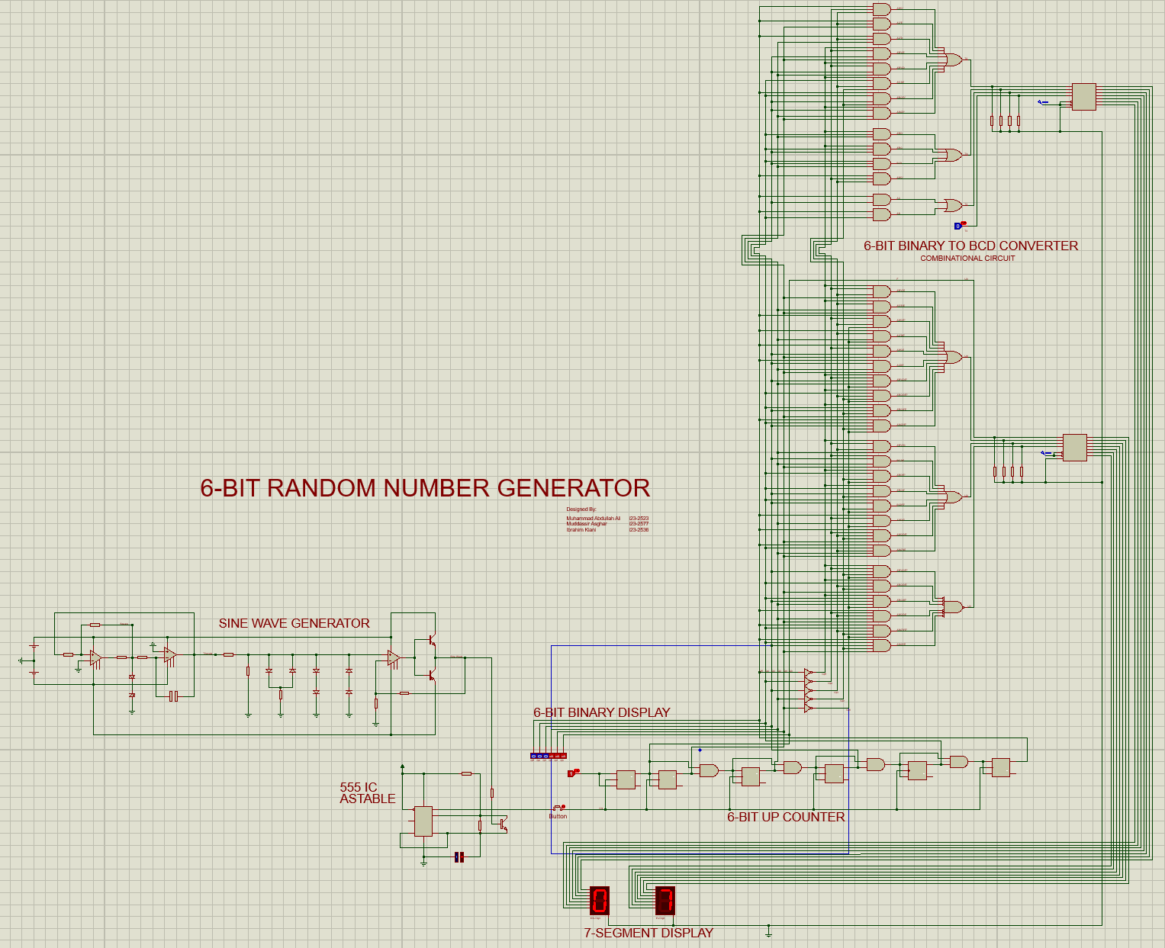

Binary to BCD Converter:

T3: 0

T2: AC + AB
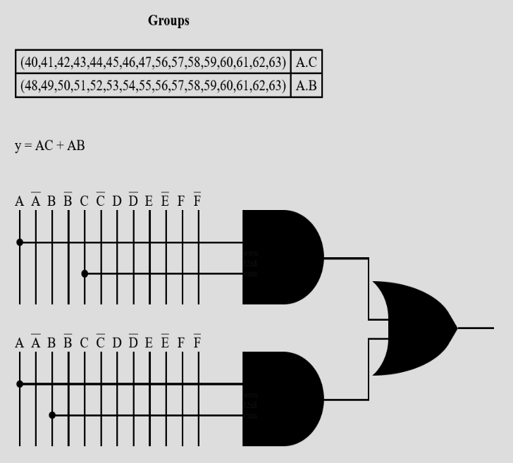

T1: A'BD + A'BC + BCD + AB'C'
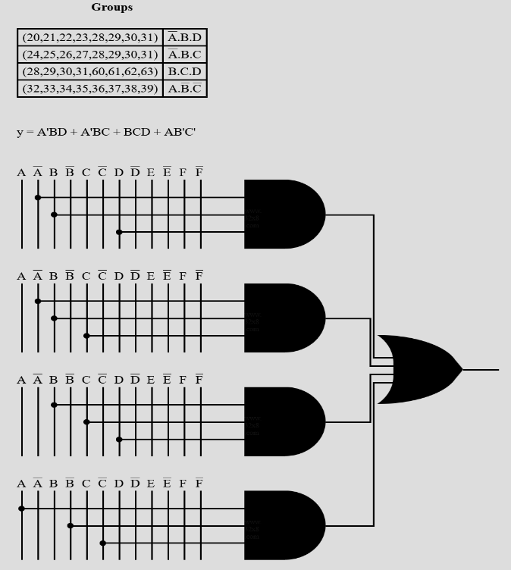

T0 = AB'C' + AC'E + AC'D + A'B'CE + A'B'CD + A'CDE + A'BC'D' + ABCD'
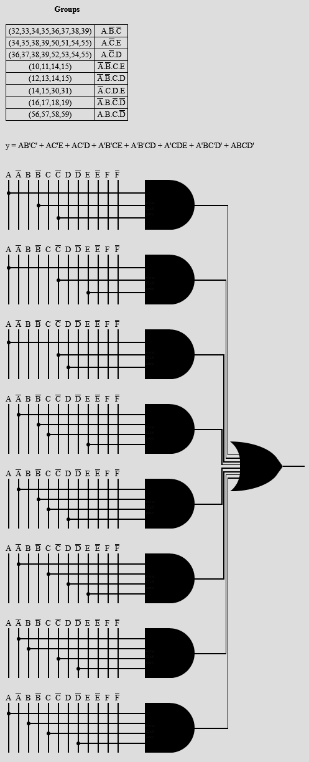
U3 = A'B'CD'E' + A'BC'D'E + A'BCDE' + AB'C'DE + ABC'D'E' + ABCD'E
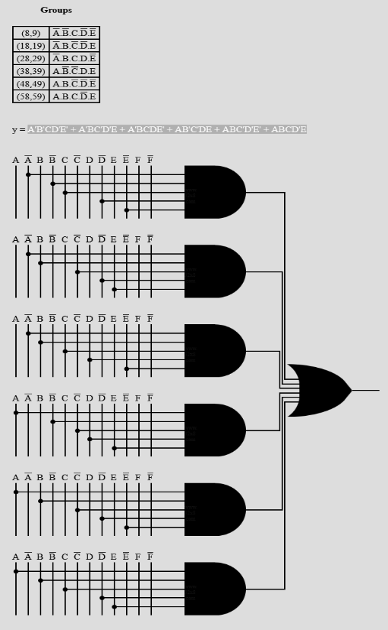

U1 = A'B'C'E + A'C'DE + AB'C'E' + AC'DE' + AB'CE + ACDE + A'B'CDE' + A'BC'D'E' + A'BCD'E + ABCD'E'
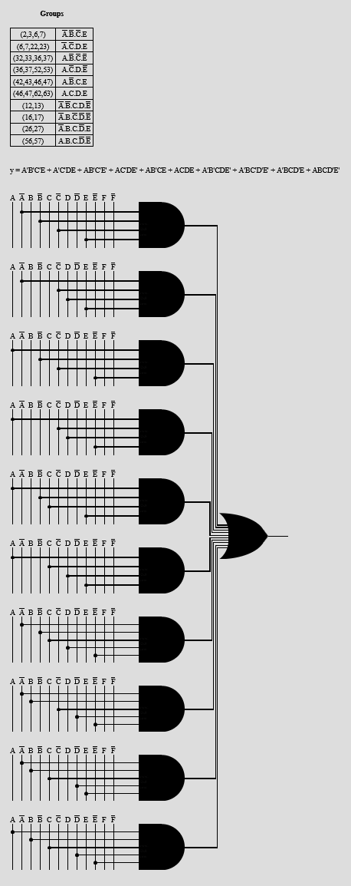

U0: F

