**DAILY ONLINE ACTIVITIES SUMMARY**

|  |  |  |  |  |  |  |  |  |  |
| --- | --- | --- | --- | --- | --- | --- | --- | --- | --- |
| **Date:** | **16-06-2020** | | | | | **Name:** | | **Apeksha Rane** | |
| **Sem & Sec** | **6th  Sem ‘A’ Sec** | | | | | **USN:** | | **4AL17CS010** | |
| **Online Test Summary** | | | | | | | | | |
| **Subject** | | **C programming Quiz and**  **python workshop quiz** | | | | | | | |
| **Max. Marks** | | **PAP=20**  **C quiz=8** | | **Score** | | | | **PAP=8**  **Quiz=was not evaluated.** | |
| **Pre-Placement Training Summary** | | | | | | | | | |
| **Course** | **Workshop of C programming and Python workshop.** | | | | | | | | |
| **Faculty** | | | **Merlyn mam.**  **Dr.Badhusha sir** | | | | **Duration** | | **4 hours** |
| **Coding Challenges** | | | | | | | | | |
| **Problem Statement:1.Python workshop workout examples and Exercises .** | | | | | | | | | |
| **Status: done** | | | | | | | | | |
| **Uploaded the report in Github** | | | | | **yes** | | | | |
| **If yes Repository name** | | | | | Daily Report =<https://github.com/Apeksha12appu/19-5-2020-online-coding-activity>  Python workshop= <https://github.com/Apeksha12appu/python-using-DA-and-ML> | | | | |
| **Uploaded the report in slack** | | | | | **yes** | | | | |

**Class and Quiz Snapshots:**

**C programming:**

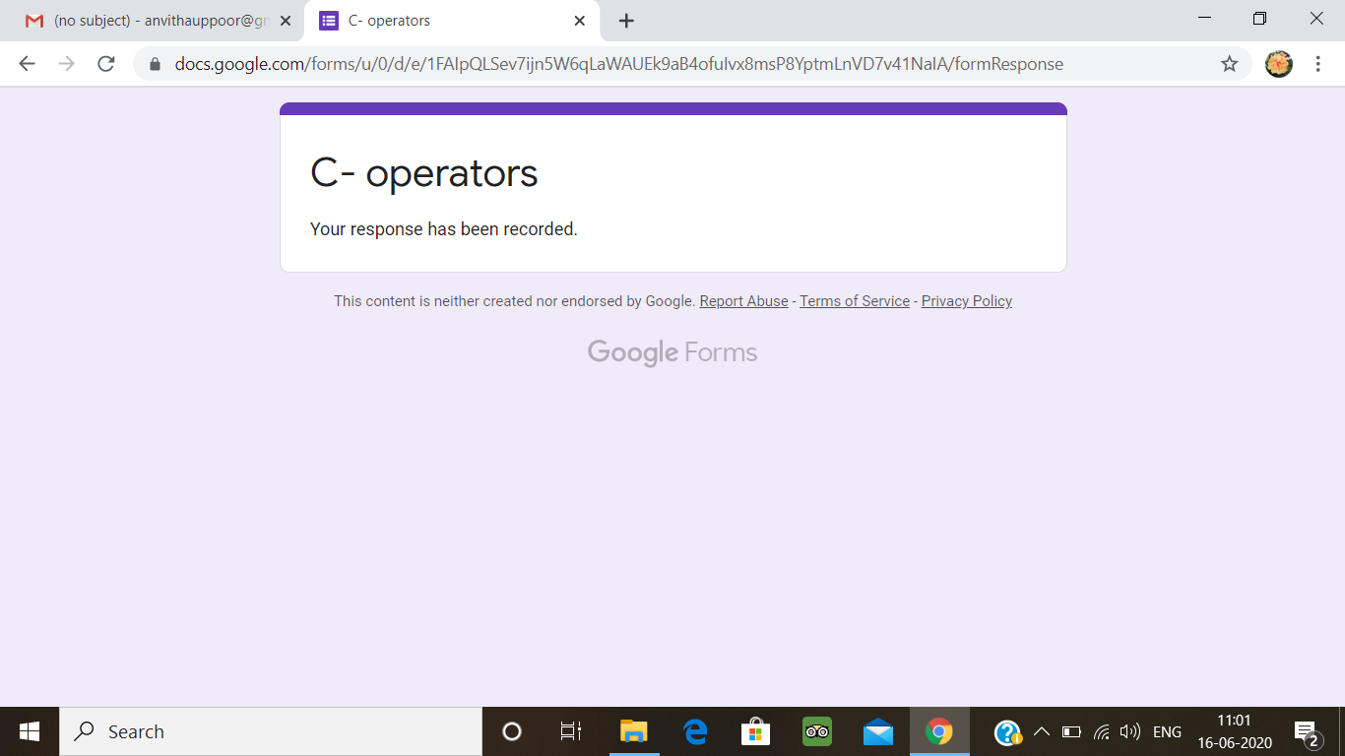

**Python workshop :**

