**DAILY ONLINE ACTIVITIES SUMMARY**

|  |  |  |  |  |  |  |  |  |  |
| --- | --- | --- | --- | --- | --- | --- | --- | --- | --- |
| **Date:** | **30-06-2020** | | | | **Name:** | | | **Apeksha Rane** | |
| **Sem & Sec** | **6th  Sem ‘A’ Sec** | | | | **USN:** | | | **4AL17CS010** | |
| **Online Test Summary** | | | | | | | | | |
| **Subject** | | **JAVA.** | | | | | | | |
| **Max. Marks** | | **JAVA Quiz=20** | | | | | **Score** | **JAVA Quiz=10** | |
| **Pre-Placement Training Summary** | | | | | | | | | |
| **Course** | **Workshop of JAVA.** | | | | | | | | |
| **Faculty** | | | **Sharan Sir.** | | | **Duration** | | | **2 hours** |
| **Coding Challenges** | | | | | | | | | |
| **Problem Statement:** 1. Write a Java Program to determine whether one string is a rotation of another.  2. Write a C Program to generate first n Ugly Numbers. | | | | | | | | | |
| **Status: done** | | | | | | | | | |
| **Uploaded the report in Github** | | | | **Yes** | | | | | |
| **If yes Repository name** | | | | Daily Report =<https://github.com/Apeksha12appu/19-5-2020-online-coding-activity> | | | | | |
| **Uploaded the report in slack** | | | | **Yes** | | | | | |

**Class and Quiz Snapshots:**

**JAVA:**

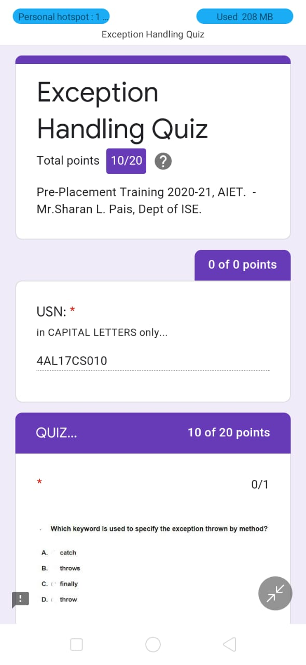

**Coding Challenge:**

1. Write a Java Program to determine whether one string is a rotation of another.

Description:  
In this program, we need to check whether a string is a rotation of another string or not.

String 1: abcde  
String 2: deabc  
String 1 + String 1: abcdeabcde

Consider the above example, suppose we need to check whether string 2 is a rotation of string 1. To find this, we concatenate string 1 with string 1. Then, try to find the string 2 in concatenated string. If string 2 is present in concatenated string then, string 2 is rotation of string 1. String 2 deabc is found on the index 3 in concatenated string. So, deabc is rotation of abcde.

ALGORITHM  
STEP 1: START  
STEP 2: DEFINE String str1 = "abcde", str2 = "deabc"  
STEP 3: IF length of str1 not equals to str2 then PRINT "No"  
else go to STEP 4  
STEP 4: CONCATENATE str1 with str1.  
STEP 5: IF str2 present in str1 then PRINT "Yes" else PRINT "No".  
STEP 6: END

public class RotationString {

public static boolean checkRotation(String st1, String st2) {

if (st1.length() != st2.length()) {

return false;

}

String st3 = st1 + st1;

if (st3.contains(st2))

return true;

else

return false;

}

public static void main(String[] args) {

String str1 = "avajava";

String str2 = "javaava";

System.out.println("Checking if a string is rotation of another");

if (checkRotation(str1, str2)) {

System.out.println("Yes " + str2 + " is rotation of " + str1);

} else {

System.out.println("No " + str2 + " is not rotation of " + str1);

}

}

}

**Output:**

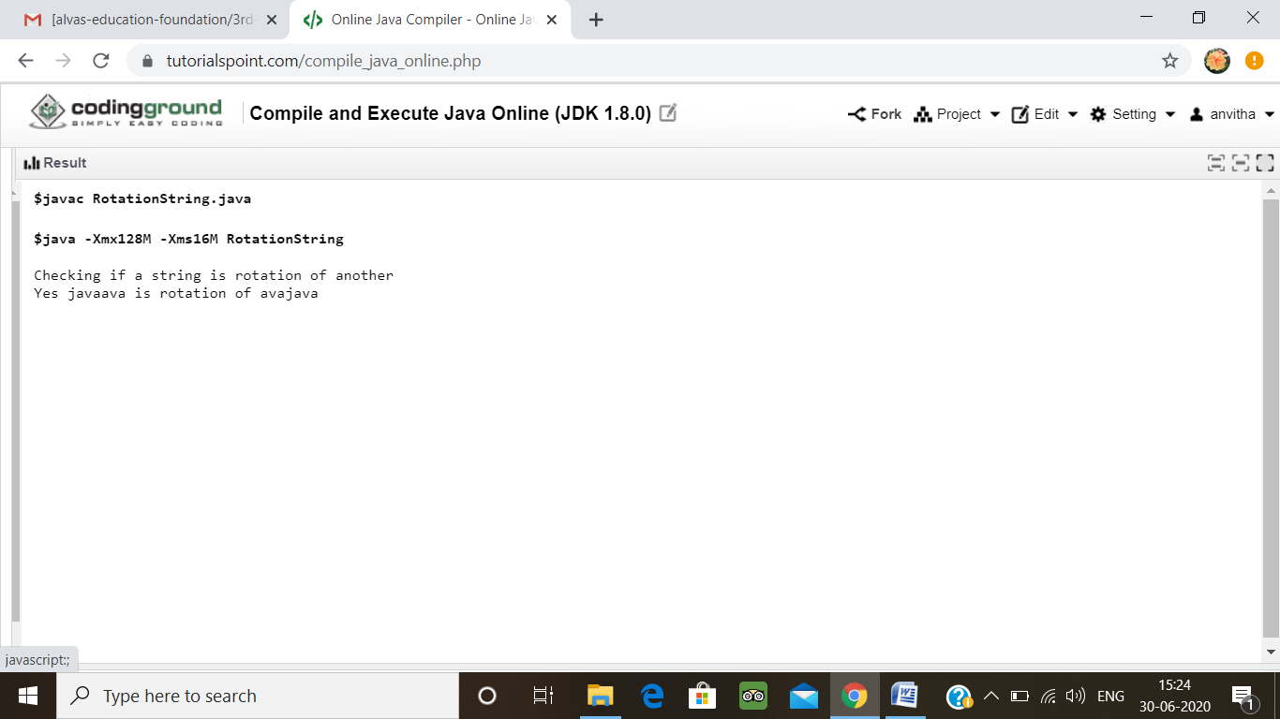

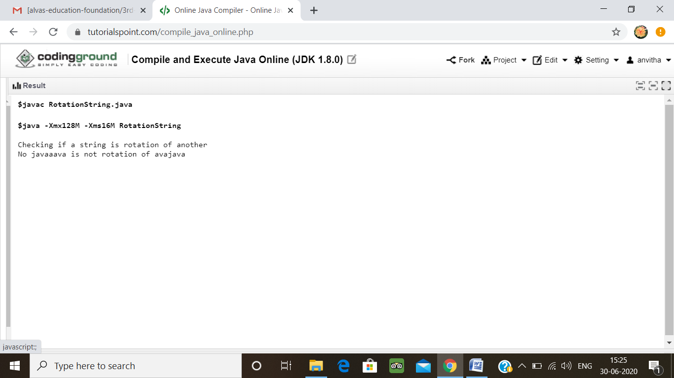

2. Write a C Program to generate first n Ugly Numbers Write a C Program to generate first n Ugly Numbers

Ugly numbers are those number whose prime factors are 2, 3 or 5. From 1 to 15, there are 11 ugly numbers 1, 2, 3, 4, 5, 6, 8, 9, 10, 12, 15. The numbers 7, 11, 13 are not ugly because they are prime. The number 14 is not ugly because in its prime factor the 7 will come.

# include<stdio.h>

# include<stdlib.h>

int maxDivide(int a, int b)

{

while (a%b == 0)

a = a/b;

return a;

}

int isUgly(int no)

{

no = maxDivide(no, 2);

no = maxDivide(no, 3);

no = maxDivide(no, 5);

return (no == 1)? 1 : 0;

}

int getNthUglyNo(int n)

{

int i = 1;

int count = 1;

while (n > count)

{

i++;

if (isUgly(i))

count++;

}

return i;

}

int main()

{

unsigned no = getNthUglyNo(15);

printf("15th ugly no. is %d ", no);

getchar();

return 0;

}

**Output:**

