Assignment-04
NLTK (Natural Language Toolkit) is a Python library that provides tools to:
- Process text
- Analyze language structure
- Perform machine learning with text
- Work with datasets like WordNet
Important Features of NLTK

Tokenization : Breaking text into words or sentences
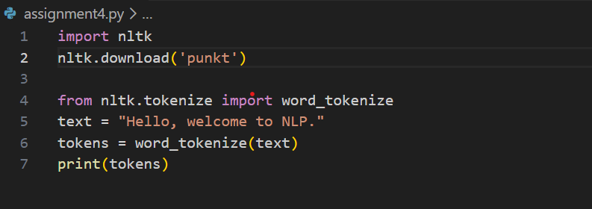

Stopword Removal : Removing common words like "is", "the", "and".

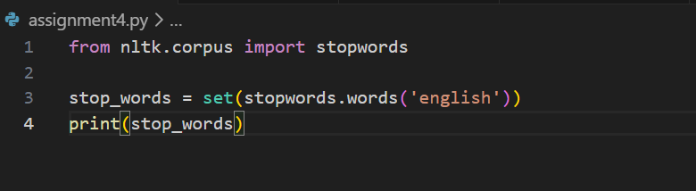

Stemming
Reducing words to root form.
Example:
- playing → play
- running → run

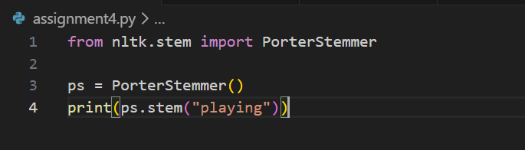

Lemmatization
Converts word to meaningful base form.
Example:
- better → good
- running → run

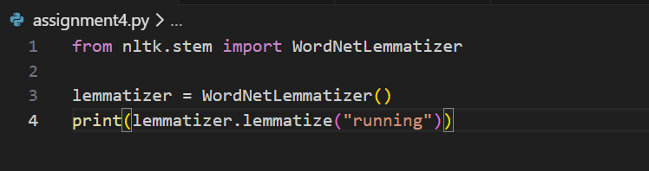

Part of Speech (POS) Tagging
Identifies grammar role (noun, verb, etc.)

