## IMPORTING LIBARIRES

import pandas as pd

import numpy as np

import matplotlib.pyplot as plt

from sklearn.model_selection import train_test_split

from sklearn.linear_model import LinearRegression

from sklearn.metrics import confusion_matrix,accuracy_score

from sklearn.ensemble import RandomForestRegressor

## REDAING DATASET

df=pd.read_csv('Financial Distress.csv.zip')

df

## OUTPUT

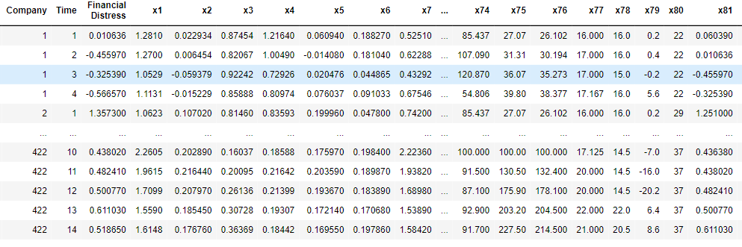

## TO CHECK FIRST FIVE COLUMNS

df.head()

## output

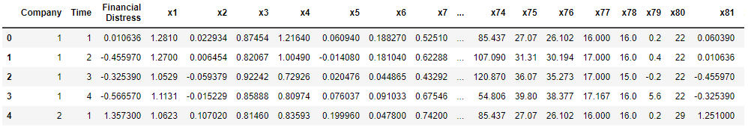

df.shape

## output



## CHECKING MISSING VALUE

df.isnull().sum()

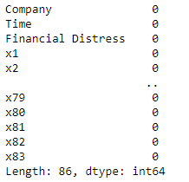

df.isnull().any()

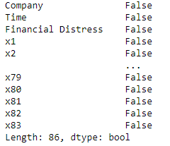

## INFORMATION ABOUT DATASET

df.info()

## output:

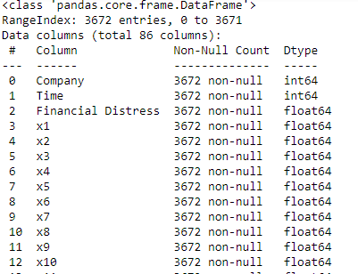

df.describe()

## output:

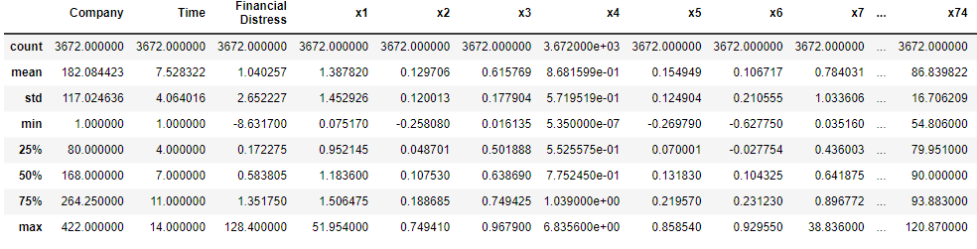

print('lenghth of dataset:',len(df))



## SPLITTING THEDATASET

x=df.drop('x74',axis=1)

x

## output:

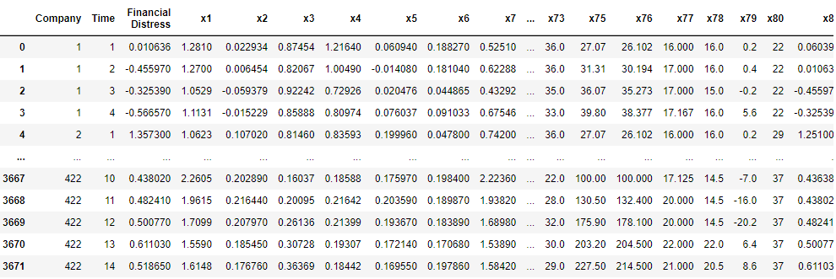

y=df['x74']

y

## output:

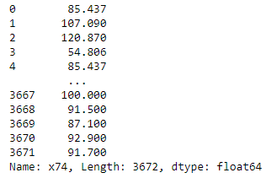

from sklearn.model_selection import train_test_split

x_train,x_test,y_train,y_test=train_test_split(x,y,random_state=0)

print(x_train.shape)

print(x_test.shape)

print(y_train.shape)

print(y_test.shape)

## output:

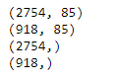

from sklearn.linear_model import LinearRegression

regressor=LinearRegression()

regressor.fit(x_train,y_train)

## output:

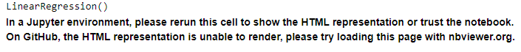

print(regressor.coef_)

## output:

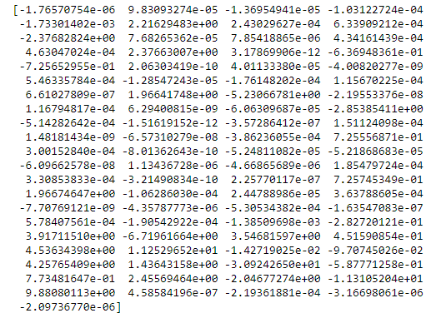

print(regressor.intercept_)

## output:

-46.268254777815955

predicted=regressor.predict(x_test)

predicted

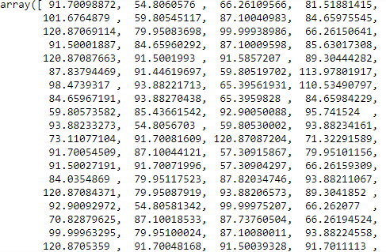

print(x_test)

## output:

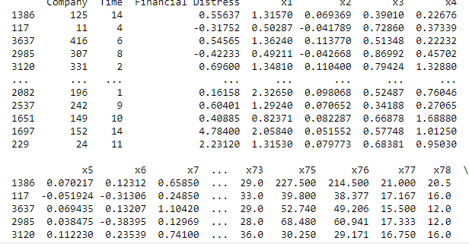

predicted.shape

## output:

(918,)

dframe=pd.DataFrame(y_test,predicted)

dframe

## output:

| **x74** |
| --- |
| **91.700989** | NaN |
| **54.806058** | NaN |
| **66.261096** | NaN |
| **81.518814** | NaN |
| **101.676488** | NaN |
| **...** | ... |
| **78.786461** | NaN |
| **93.882140** | NaN |
| **100.000214** | NaN |
| **91.700595** | NaN |
| **91.500303** | NaN |
|  |  |
|  |  |

dfr=pd.DataFrame({'Actual Price':y_test,'Predicted Price':predicted})

dfr

## output:

|  | **Actual Price** | **Predicted Price** |
| --- | --- | --- |
| **1386** | 91.700 | 91.700989 |
| **117** | 54.806 | 54.806058 |
| **3637** | 66.262 | 66.261096 |
| **2985** | 81.521 | 81.518814 |
| **3120** | 101.670 | 101.676488 |
| **...** | ... | ... |
| **2082** | 78.786 | 78.786461 |
| **2537** | 93.883 | 93.882140 |
| **1651** | 100.000 | 100.000214 |
| **1697** | 91.700 | 91.700595 |
| **229** | 91.500 | 91.500303 |

dfr.head(60)

## output:

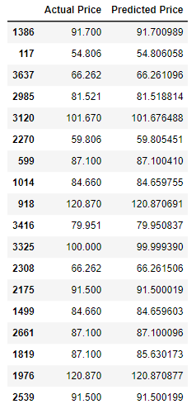

from sklearn.metrics import confusion_matrix,accuracy_scorein_accuracy

train_accuracy=regressor.score(x_train,y_train)

print('train_accuracy',train_accuracy)

test_accuracy=regressor.score(x_test,y_test)

print('test_accuracy:',test_accuracy)

## output:



import math

from sklearn import metrics

print('Mean Absolute Error:',metrics.mean_absolute_error(y_test,predicted))

print('Mean Squared Error:',metrics.mean_squared_error(y_test,predicted))

print('Root Mean Squared Error:',math.sqrt(metrics.mean_squared_error(y_test,predicted)))

## output:



graph=dfr.head(20)

graph

## output:

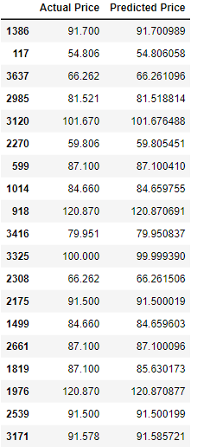

graph.plot(kind='bar')

plt.title('BarGraph')

plt.xlabel('Actual&prediceted price')

plt.ylabel('frequency')

plt.show()

## output:

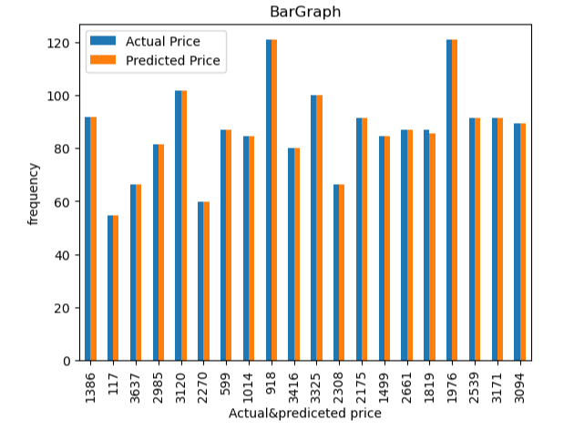

from sklearn.metrics import confusion_matrix,accuracy_scorein_accuracy

x_train,x_test,y_train,y_test=train_test_split(x,y,test_size=0.90,random_state=100)

print(x_train.shape)

print(x_test.shape)

print(y_train.shape)

print(y_test.shape)

## output:

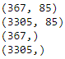

from sklearn.ensemble import RandomForestRegressor

regressor = RandomForestRegressor(n_estimators=100,random_state=0)

regressor.fit(x_train,y_train)

## output:



predicted=regressor.predict(x_test)

predicted

## output:



from sklearn.metrics import confusion_matrix,accuracy_score

train_accuracy=regressor.score(x_train,y_train)

print('train_accuracy:',train_accuracy)

R_test_accuracy=regressor.score(x_test,y_test)

print('test_accuracy:',R_test_accuracy)

## output:



import matplotlib.pyplot as plt

linear_regression_accuracy =0.9999999825628604

random_forest_accuracy =0.992675587067571

accuracy_scores = [linear_regression_accuracy, random_forest_accuracy]

model_names = ['Linear Regression', 'Random Forest Regression']

plt.bar(model_names, accuracy_scores)

plt.xlabel('Regression Models')

plt.ylabel('Test Accuracy')

plt.title('Comparison of Test Accuracy: Linear Regression vs Random Forest Regression')

plt.show()

## output:

