BEST PRACTICE

RESTFULL API

Muhammad Arif Rahman - FSDO003ONL004 – Dokumentasi Sesi 10

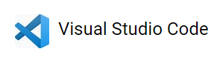

1. Aplikasi persiapan
   1. Browser
   2. DBeaver
   3. VS Code
   4. SQLyog
   5. Postman

Absen sesi10

<https://docs.google.com/forms/u/0/d/e/1FAIpQLSca9QDX4Ufwr7lqvRxVqIg4nQYUQpjA9_fzoRY6nok7-FnM8Q/formResponse>

codeshare.io/csharpbatch3

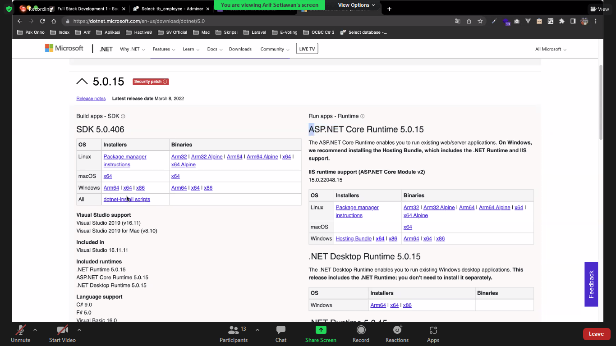

Gunakan terminal di VS Code

dotnet new webapi -n “TodoApp” -lang “C#” -au none

# tutorial 10

todo app with jwt

----

dotnet ef migrations add "Initial Migration"

dotnet ef database update

dotnet add package Microsoft.AspNetCore.Authentication.JwtBearer --version 5.0.11

dotnet add package Microsoft.AspNetCore.Identity.EntityFrameworkCore --version 5.0.11

dotnet add package Microsoft.AspNetCore.Identity.UI --version 5.0.11

https://www.browserling.com/tools/random-string

yglsfwoijugqfcstmizvdthddahqxsbm

dotnet ef migrations add "Addig authentication to our Api"

dotnet ef database update

cara buat

-----------------------------------------------------------------------------------------------------

dotnet new webapi -n "TodoApp" -lang "C#" -au none

https://localhost:5001/api/todo/testrun

https://localhost:5001/WeatherForecast

dotnet ef migrations add "Initial Migration"

# install terlebih dahulu

-----------------------------------------------------------------

Sebelum mengikuti instalasi di atas sebelumnya terlebih dahulu instalasi dibawah ini.

dotnet tool install --global dotnet-ef

dotnet add package NuGet.CommandLine.XPlat --version 5.11.0

dotnet add package Microsoft.EntityFrameworkCore.Tools --version 5.0.11

dotnet add package Microsoft.EntityFrameworkCore.Sqlite --version 5.0.11

dotnet add package Microsoft.EntityFrameworkCore.Design --version 5.0.11

database

--

dotnet ef database drop

version

--

dotnet restore

dotnet --version

run dotnet

---

dotnet run watch

cek certificate

---

dotnet dev-certs https --trust

migrasi

---

dotnet ef migrations rermove

dotnet ef migrations add "Initial Migrations"

dotnet ef migrations add InitialCreate

dotnet ef migrations add InitialCreate --output-dir Migrations

dotnet ef migrations add InitialCreate --context BlogContext --output-dir Migrations/SqlServerMigrations

dotnet ef migrations add InitialCreate --context SqliteBlogContext --output-dir Migrations/SqliteMigrations

dotnet tool update --global dotnet-ef --version 3.1.0

dotnet tool update --global dotnet-ef --version 5.0.2

dotnet tool uninstall --global dotnet-ef

-------------------------------------------------------------

My solution was to install the tool dotnet-ef from microsoft

https://www.nuget.org/packages/dotnet-ef.

It uses the same commands but no warnings.

The change is to use dotnet-ef instead of dotnet ef.

And if you already have dotnet-ef installed then use dotnet tool

update --global dotnet-ef --version n.n.n (n.n.n your version to update to)

-------------------------------------------------------------

https://www.nuget.org/packages/Microsoft.EntityFrameworkCore.Tools

Entity Framework Core Tools for the NuGet Package Manager Console in Visual Studio.

Enables these commonly used commands:

Add-Migration

Drop-Database

Get-DbContext

Get-Migration

Remove-Migration

Scaffold-DbContext

Script-Migration

Update-Database

https://www.nuget.org/packages/NuGet.CommandLine.XPlat/

NuGet executable wrapper for the dotnet CLI nuget functionality.

https://www.nuget.org/packages/Microsoft.EntityFrameworkCore.Sqlite/

SQLite database provider for Entity Framework Core.

https://docs.microsoft.com/en-gb/aspnet/core/data/ef-mvc/intro?view=aspnetcore-5.0

https://stackoverflow.com/questions/41011700/how-to-generate-controller-using-dotnetcore-command-line

-------------------------------------------------------------

Table Items

-----

Id Integer

Title Text

Description Text

Done Integer

CREATE TABLE "Items" ( "Id" INTEGER NOT NULL CONSTRAINT "PK_Items" PRIMARY KEY AUTOINCREMENT, "Title" TEXT NULL, "Description" TEXT NULL, "Done" INTEGER NOT NULL )

CREATE TABLE "__EFMigrationsHistory" ( "MigrationId" TEXT NOT NULL CONSTRAINT "PK___EFMigrationsHistory" PRIMARY KEY, "ProductVersion" TEXT NOT NULL )

TodoApp.cproj­­­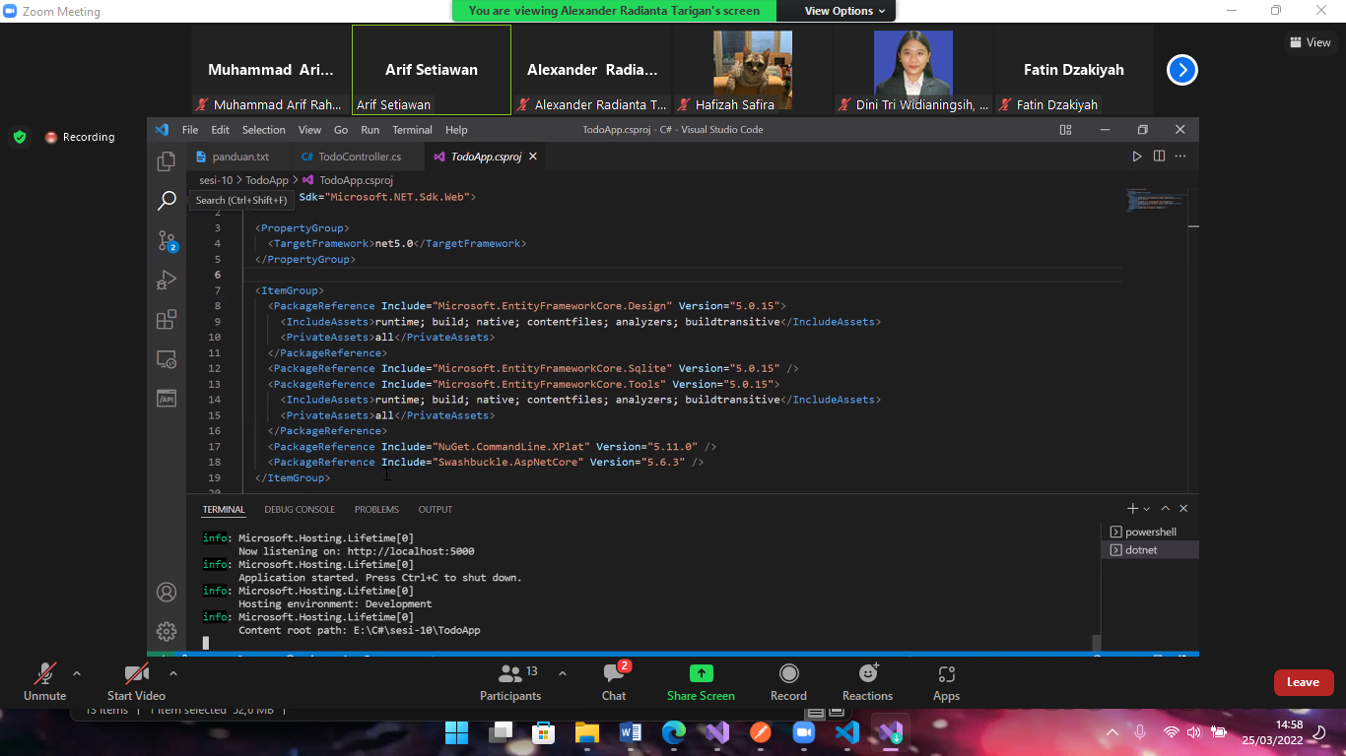

Tugas ikutin gwt lalu tinggal buat db php my admin

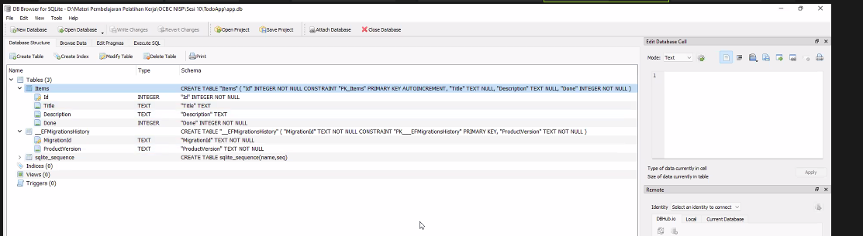

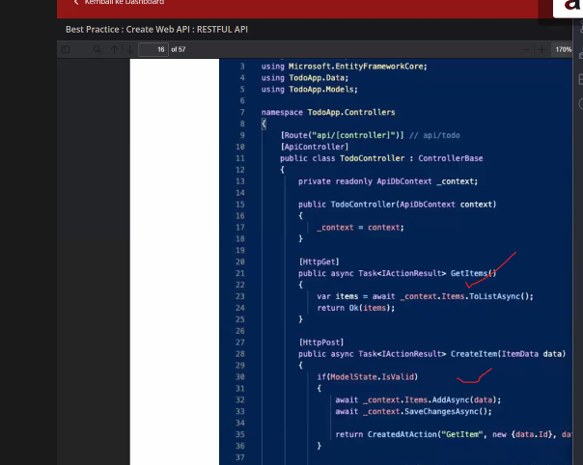

Dotnet build untuk running dan untuk stop “ctrl + c”

Catatan

Jika eror pada TodoApp di line 3 maka jadikan command seperti dibawah ini

// using Microsoft.EntityFrameworkCore;

Untuk mengakses link yang ada gunakan swagger

