TESTING API SWAGGER

+ POSTMAN

Muhammad Arif Rahman - FSDO003ONL004 – Dokumentasi Sesi 12



1. Aplikasi persiapan
   1. Visual Code
   2. Browser
   3. Xampp
   4. Docker
   5. VS Code
   6. SQLyog
   7. Postman

<https://docs.google.com/forms/u/0/d/e/1FAIpQLSca9QDX4Ufwr7lqvRxVqIg4nQYUQpjA9_fzoRY6nok7-FnM8Q/formResponse?pli=1>

using System;using System.Collections.Generic;using System.Linq;using System.Threading.Tasks;using Microsoft.EntityFrameworkCore;using MySql.EntityFrameworkCore;namespace UnitTest_Mock.Models{ public partial class AppDbContext : DbContext { public AppDbContext(DbContextOptions<AppDbContext> options) : base(options) { } public DbSet<Employee> Employees { get; set; } }}

sqlserver

"connection" : "server=localhost; database=UnitTest; Trusted_Connection=true"

using System;

using System.Collections.Generic;

using System.Linq;

using System.Threading.Tasks;

using Microsoft.EntityFrameworkCore;

namespace UnitTest_Mock.Models

{

public partial class AppDbContext : DbContext

{

public AppDbContext(DbContextOptions<AppDbContext> options) : base(options)

{

}

public DbSet<Employee> Employees { get; set; }

}

}

checklist

---

3 Basic Graphs

5 Additional Graphs

Auto-Stop Listener

BM.Sense Uploader

BlazeMeter Step-by-step Debugger

Cassandra Support

Command-Line Graph Plotting Tool

Composite Timeline Graph

Console Status Logger

Custom JMeter Functions

Custom SOAP Sampler

Custom Thread Groups

DBMon Sample Collector

Directory Listing Config

Klik Kanan Pada Web Services

> Add > Listener > View Results Tree

> Add > Listener > View Results in Table

> Add > Listener > jp@gc - Response Times Over Time

> Add > Listener > jp@gc - Transactions per Second

> Add > Listener > Aggregate Report

> Add > Listener > Summary Report

Command to generate HTML Report:

1) To create report at the end of the test run:

jmeter -n -t [test JMX file] -f -l [test log file] -e -o [Path to output folder]

eg:

jmeter -n -t D:\jmeterProject\recording_demo\recording_demo.jmx -f -l D:\jmeterProject\recording_demo\output\csvReports\result4.csv -e -o D:\jmeterProject\recording_demo\output\HTMLReport\HTMLReport2

2) To create report after test run from the result file:

jmeter -g [log file] -o [Path to output folder]

eg:

jmeter -g D:\jmeterProject\recording_demo\output\csvReports\result3.csv -o D:\jmeterProject\recording_demo\output\HTMLReport\HTMLReport1

run to export csv

./jmeter.sh -n -t /Users/arif/_Arif/Hactive8/Full\ Stack\ OCBC\ \(C\#\)\ Batch\ 2/Belajar/Sesi\ 12/Web\ Services.jmx -f -l /Users/arif/_Arif/Hactive8/Full\ Stack\ OCBC\ \(C\#\)\ Batch\ 2/Belajar/Sesi\ 12/Web.csv

run to export html

./jmeter.sh -n -t /Users/arif/_Arif/Hactive8/Full\ Stack\ OCBC\ \(C\#\)\ Batch\ 2/Belajar/Sesi\ 12/Web\ Services.jmx -f -l /Users/arif/_Arif/Hactive8/Full\ Stack\ OCBC\ \(C\#\)\ Batch\ 2/Belajar/Sesi\ 12/Web.csv -e -o /Users/arif/_Arif/Hactive8/Full\ Stack\ OCBC\ \(C\#\)\ Batch\ 2/Belajar/Sesi\ 12/JMeterTest

export to html

./jmeter.sh -g /Users/arif/_Arif/Hactive8/Full\ Stack\ OCBC\ \(C\#\)\ Batch\ 2/Belajar/Sesi\ 12/Web.csv -o /Users/arif/_Arif/Hactive8/Full\ Stack\ OCBC\ \(C\#\)\ Batch\ 2/Belajar/Sesi\ 12/JMeterTest2

referensi

---

https://stackoverflow.com/questions/54211645/unable-to-generate-html-report

<https://www.youtube.com/watch?v=L7Ou6ju6x9c>

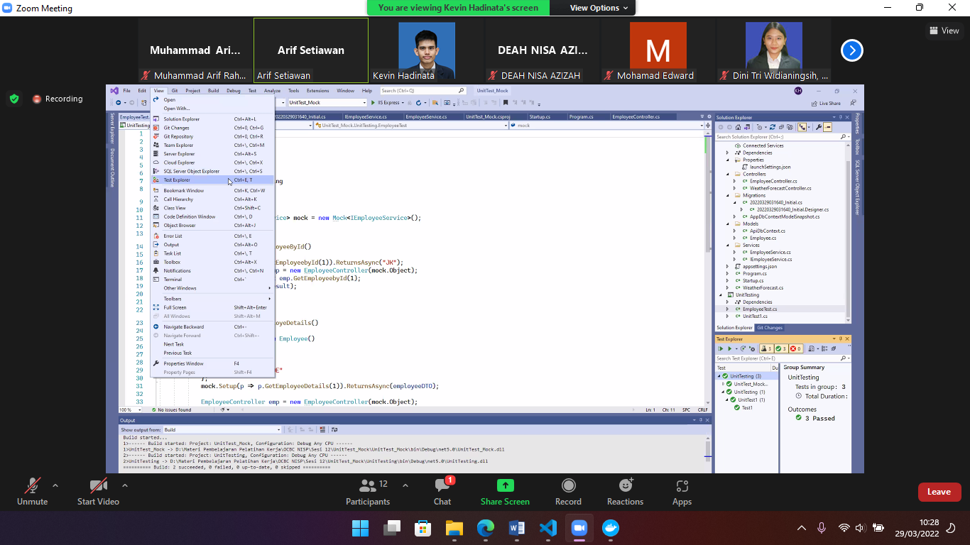

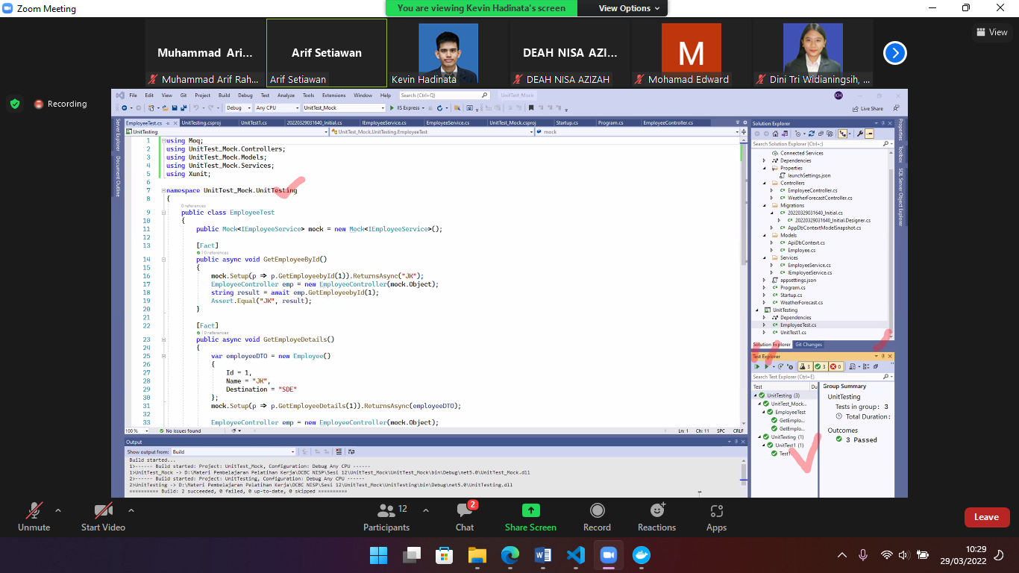

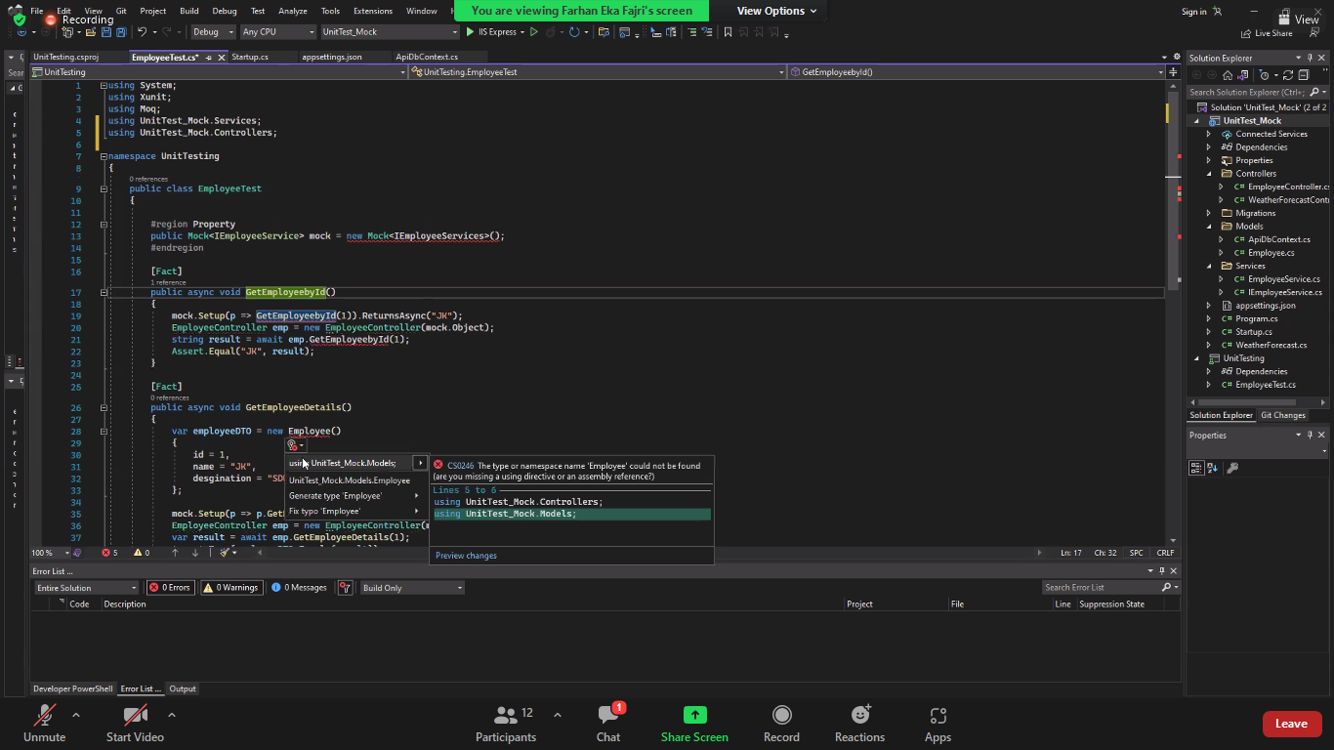

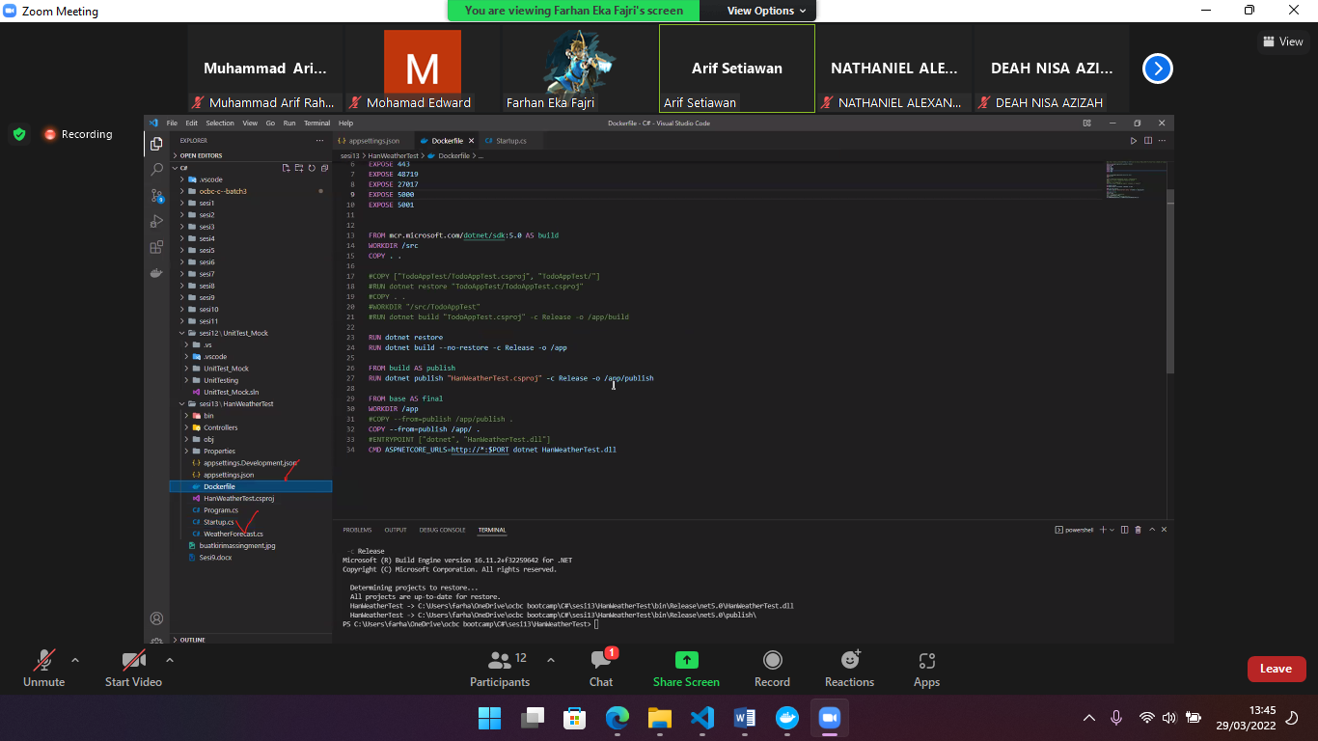

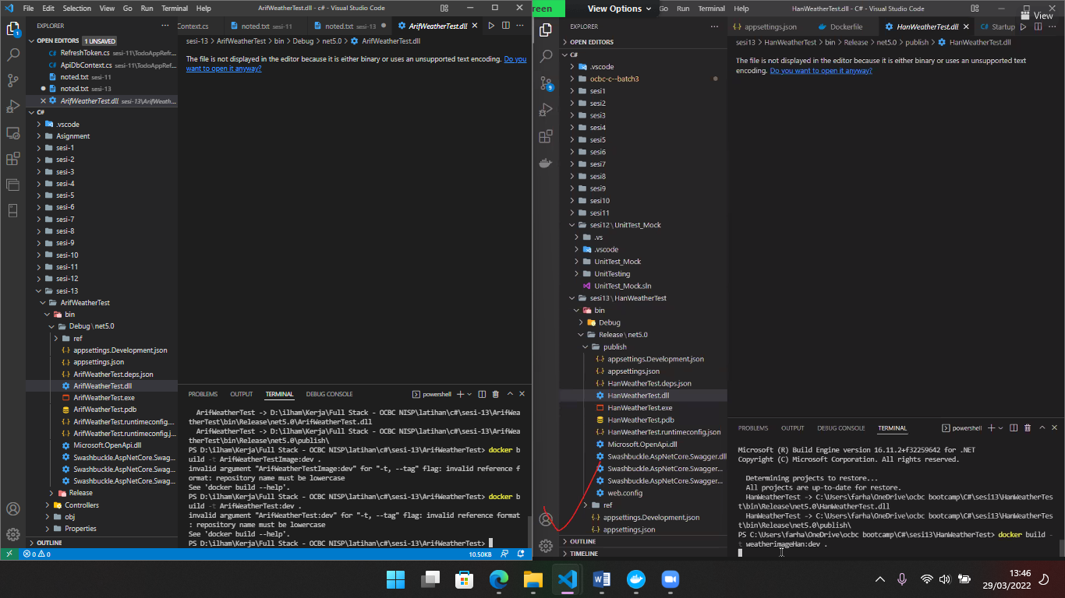

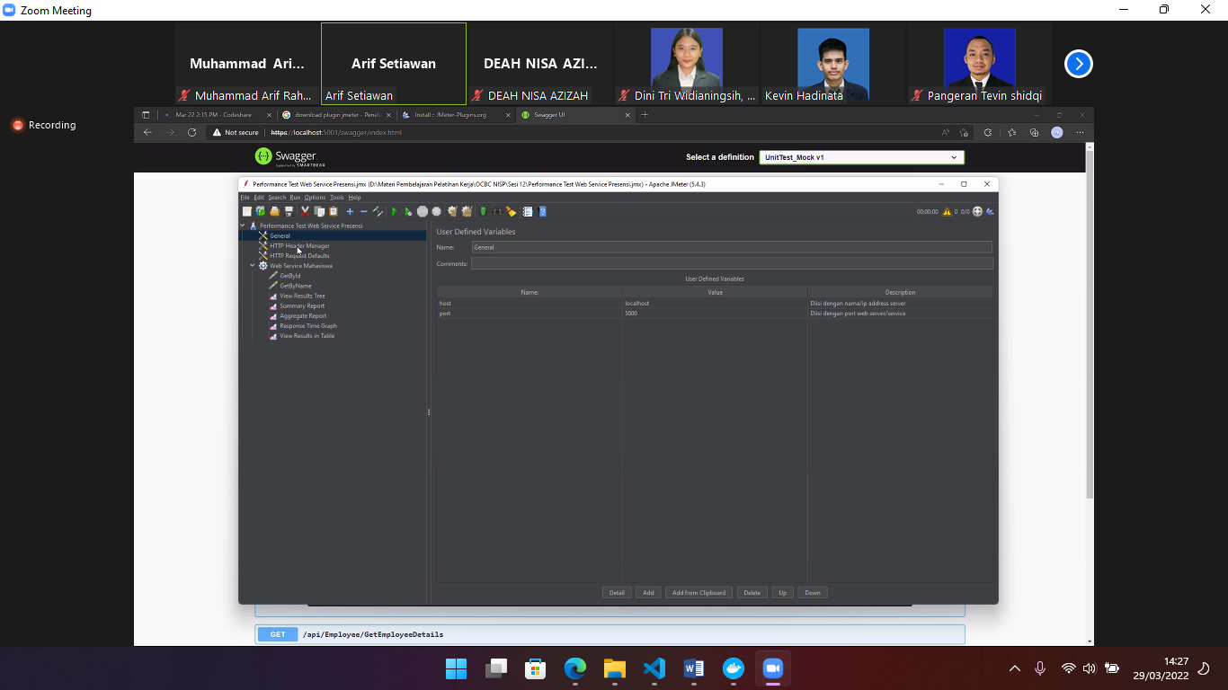

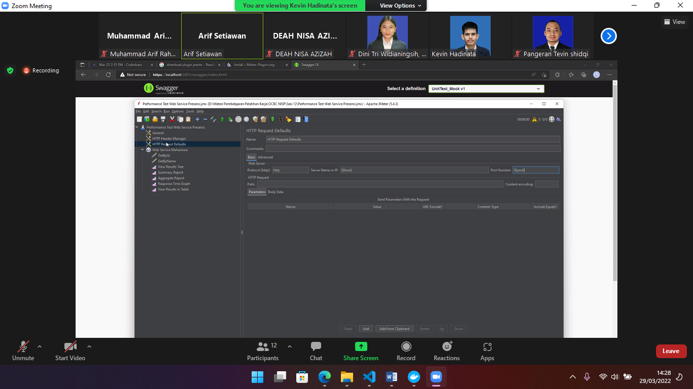

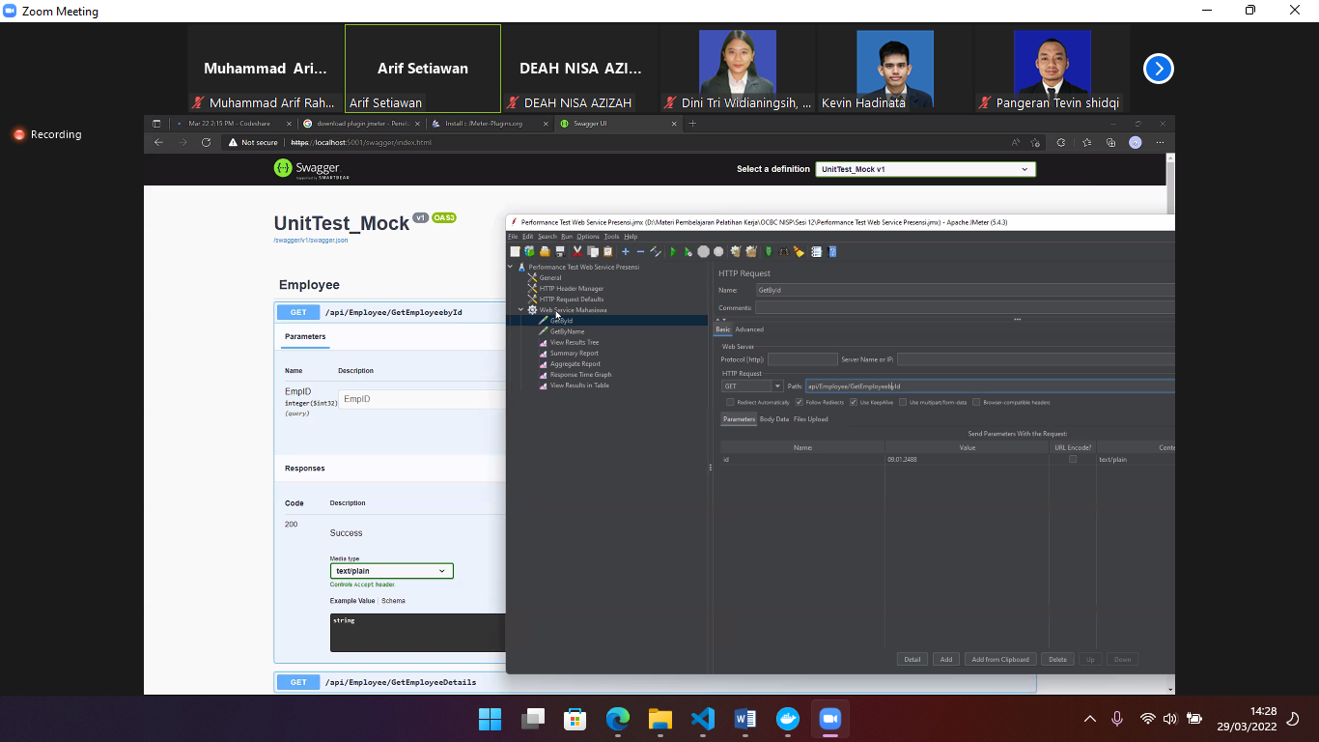

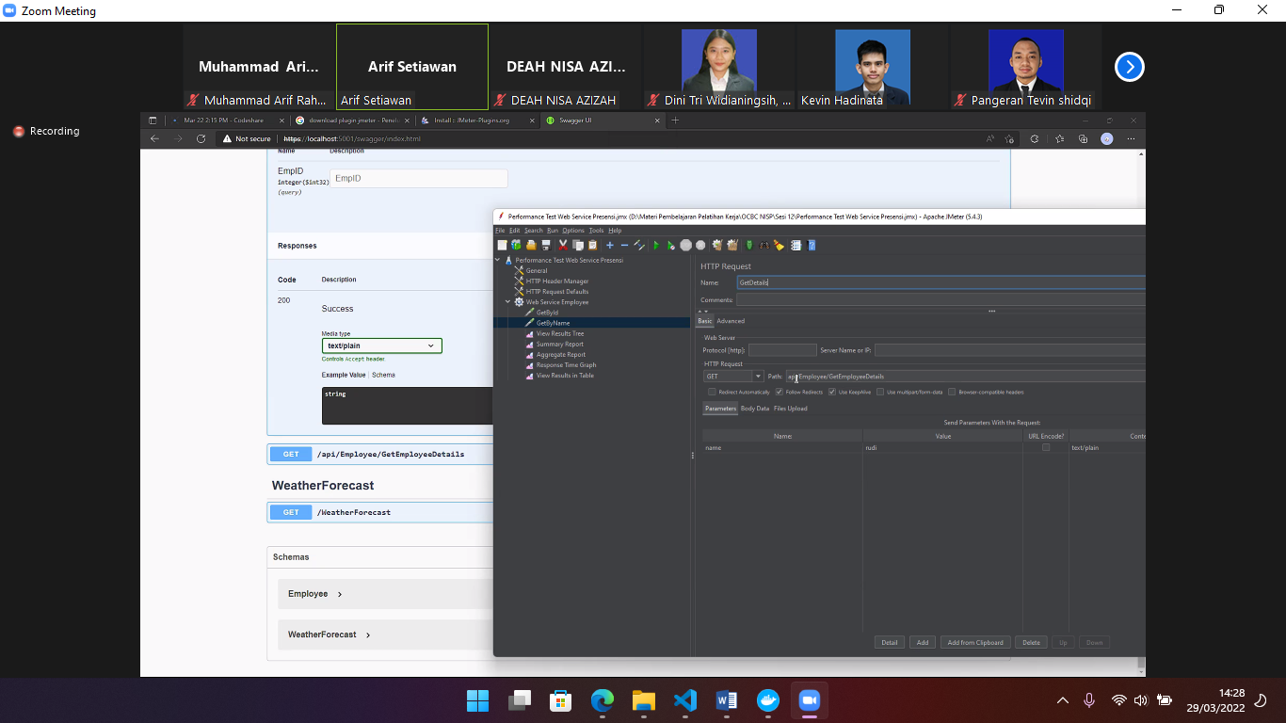

Jms

