Problem Statement: There can be multiple customers, who can place multiple orders on the site. Now a sales person can handle these orders will distribute into multiple sales persons (One order will be assigned to one salesperson only. So a sales person can have multiple orders of multiple customers
- Create Database
CREATE DATABASE mydb;
Syntax: create database “database_name”;
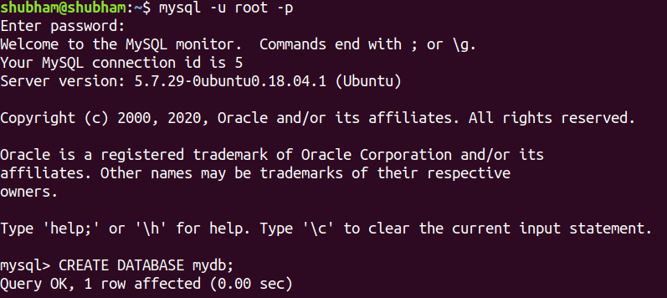
- Design Schema
desc CUSTOMER;
Syntax: desc “table_name”;
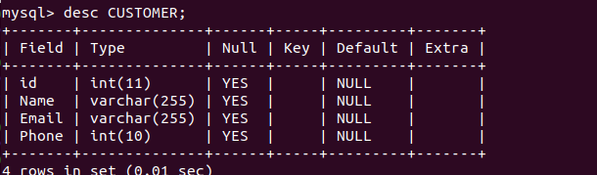

- Create tables
CREATE TABLE CUSTOMER(id int, Name varchar(255), Email varchar(255), Phone int(10), primary key(id));
Syntax: create table “table_name”(“column_name” “column_type” )
- Insert sample data
Insert into customer values(01, ‘Akash Gupta’, ‘akash.gupta@gmail.com’, 9944556677);
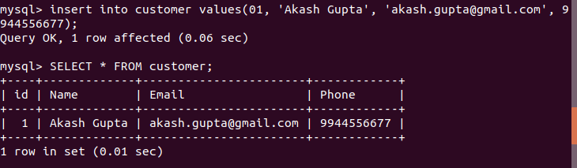
- Find the sales person have multiple orders.
select salesman.s_name, count(orders.o_id) from salesman left join orders on salesman.s_id = orders.s_id group by salesman.s_id having count(orders.o_id) > 1;
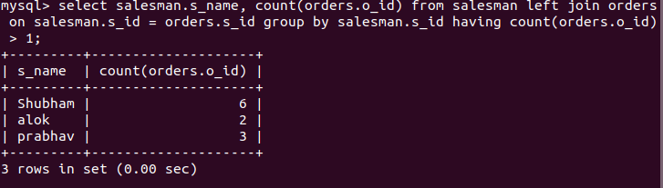

- Find the all sales person details along with order details
select * from salesman left join orders on salesman.s_id = orders.s_id;
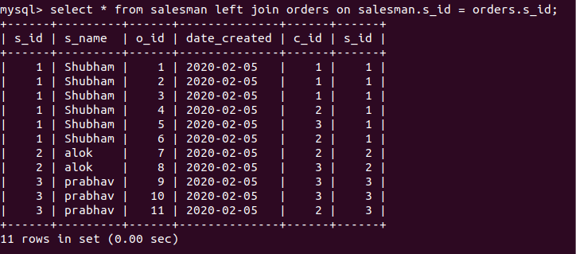
- Create index
create index abc on customer(Name);
- How to show index on a table
Show index from customer;
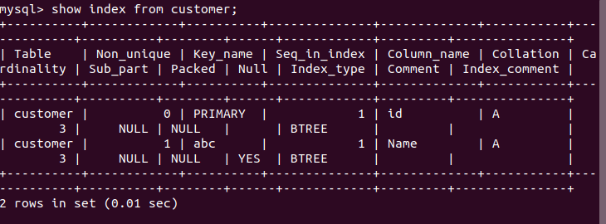

- Find the order number, sale person name, along with the customer to whom that order belongs to
select orders.o_id , salesman.s_name , customer.Name from orders left join salesman on salesman.s_id = orders.s_id left join customer on customer.id = orders.c_id;
