go get -v github.com/qor/qor
go get -v github.com/qor/admin
go get -v github.com/qor/qor-example
这三个命令会安装qor所有的依赖到gopath，qor-example也会被安装到对应的gopath下F:\go_path\src\github.com\qor\qor-example
在当下目录F:\go_path\src\github.com\qor\qor-example\config找到database.example.yml文件，修改数据库配置，需要添加password
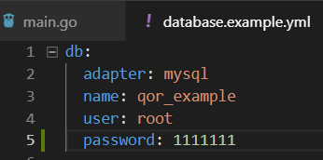
go run main.go
访问http://localhost:7000/admin就可以看到效果了
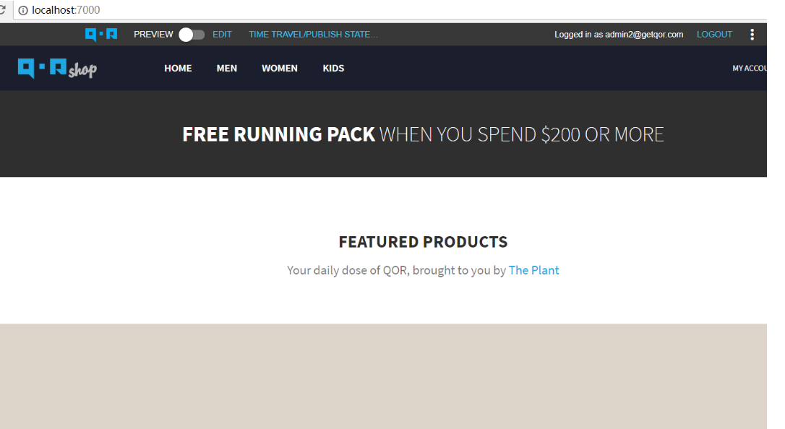
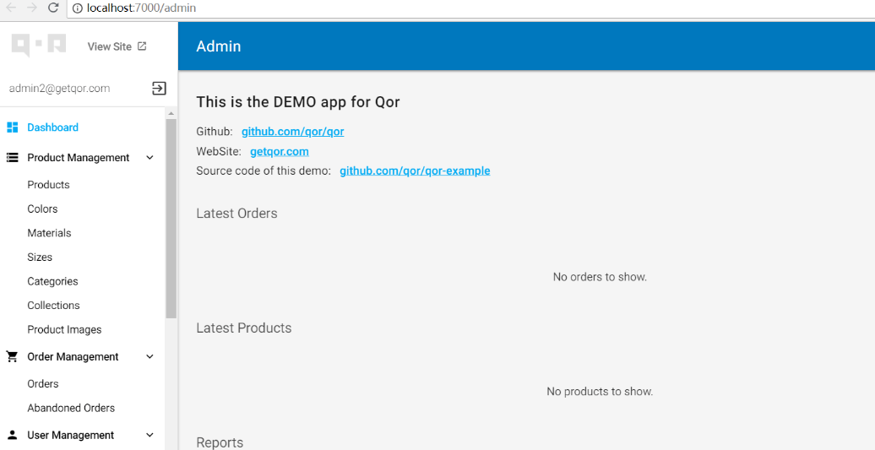
Qor-admin 我是在F:\go_path\src\qor下创建了个main.go，使用的是mysql
package main

import (
"fmt"
"net/http"
// "github.com/qor/qor"
"github.com/qor/admin"
"github.com/jinzhu/gorm"
_ "github.com/jinzhu/gorm/dialects/mysql"
)

// Define a GORM-backend model
type User struct {
gorm.Model
Name string
}

// Define another GORM-backend model
type Product struct {
gorm.Model
Name string
Description string
}

func main() {
// Set up the database
mysql_url := "root:111111@/qor?charset=utf8&parseTime=True&loc=Local"
DB, _ := gorm.Open("mysql", mysql_url)
DB.AutoMigrate(&User{}, &Product{})

// Initalize
Admin := admin.New(&admin.AdminConfig{DB: DB})

// Create resources from GORM-backend model
Admin.AddResource(&User{})
Admin.AddResource(&Product{})

// Initalize an HTTP request multiplexer
mux := http.NewServeMux()

// Mount admin to the mux
Admin.MountTo("/admin", mux)

fmt.Println("Listening on: 8000")
http.ListenAndServe(":8000", mux)
}
因为已经有了qor-example的环境go run main.go 之后，就直接生成环境了
最终运行得到
