System Architecture

Application Programmer Interface (API)
Architecture
Simple Object Access Protocol (SOAP)  XML-based, strict, favoured in exterprises  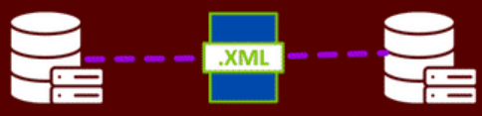 | Representational State Transfer (REST)  Building scalable APIs using standard HTTP methods   | GraphQL  Query language for APIs, allowing client to request specific data  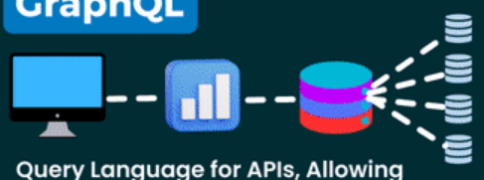 | gRPC  High performance framework for remote procedure calls, using HTTP/2  
WebSocket  Bidirectional, real time communication protocol  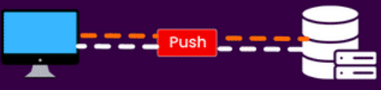 | Webhook  Event-driven, server-side mechanism that sends HTTP callbacks  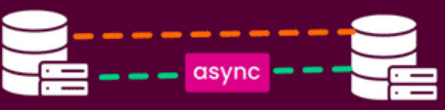 | Message Queuing Telemetry Transport (MQTT)  Lightweight messaging protocol for constrained devices  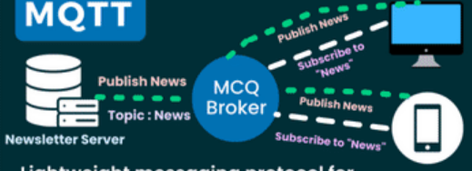 | Advanced Message Queuing Protocol (AMQP)  Open messaging protocol for reliable communication  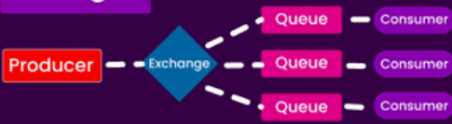
Types of API Method
GET  Retrieves data from a specified resource | HEAD  Similar to GET but retrieves headers only | POST  Submits data to be processed to a resource | OPTIONS  Describes communication options for the resource
PUT  Updates a specified resource completely | CONNECT  Establish a tunnel to the server | DELETE  Deletes the specified resource | TRACE  Echoes back the received request
PATCH
Partially updates a resource
API Status Codes
200 OK  Request successful; content delivered | 201 Created  New resource successfully created | 204 No Content  Success, but no content returned | 301 Moved Permanently  Resource permanently moved elsewhere
307 Temprorary Redirect  Temporary redirection to another URL | 400 Bad Request  Invalid request; client error | 401 Unauthorised  Authenticated credentials not provided | 403 Forbidden  Server refuses action; authorisation failed
404 Not Found  Requested resources not available | 405 Method Not Allowed  HTTP method is not permitted | 409 Conflict  Request conflicts with resource state | 500 Internal Server Error  Generic server-side error
502 Bad Gateway  Invalid response from another server | 503 Service Unavailable  Server unavailable, commonly overloaded | 504 Gateway Timeout  Upstream server timed out
API Security
Use HTTPS | Use OAuth2 | Use WebAuthn | Use Leveled API Keys
Authorization to view only | Rate Limiting | API Versioning  GET/v1/users/0x123 | Allowlist
OWASP API Security Risks | User API Gateway | Error Handling | Input Validation

Load Balancing Technique
Round Robin  Weighted and unweighted  Distributes incoming requests sequentialy across all servces in the list | Lease connections  Weighted and unweighted  Directs traffic to the servce with the fewest active connections | Least response time  Routes incoming requests to the server with the lowest response time | Least bandwidth  Directs traffic to the server that's currently handling the least amount of data
Least packets  Sends incoming requests to the server that has received the fewest nuber of packets | IP Hash  Determines the server to handle a request by hashing the IP address of the client | Sticky sessions  Useful for applications that store session information locally on the server | Layer 7 load balancing  Distributes incoming traffic across multiple targets based on content types, URL or header
Geographical load balancing  Routes requests based on the geographic location of the client | DNS load balancing  Uses the DNS to direct users to the best server based on various strategies | Transport layer protocol load balancing  Distributes incoming traffic based on transport layer protocols | Adaptive load balancing with AI  Uses AI to analyse current traffic in real-time and adjust routing decisions

Docker's Component
Docker Daemon  A background service responsible for managing Docker objects | Dockerfile  A script-like file that defines the steps to create a Docker image | Volumes  Allows data to persist outside of containers and to be shared between constainer instances | Docker Engine  Responsible for running and managing containers. Consists of the daemon a REST API, and a CLI
Container  An instance of an image. it is a lightweight and standalone executable package that includes everything needed to run an application |  | Images  A read-only template for creating containers. Contains application code, libraries, and dependencies

Open Systems Interconnection (OSI) Layers
7. Application (data) | End user layer | HTTP, FTP, IRC, SSH, DNS
6. Presentation (data) | Syntax layer | SSL, SSH, IMAP, FTP, MPEG, JPEG
5. Session (data) | Sync & send to port | API's, Sockets, WinSock
4. Transport (segments) | End-to-end connections | TCP, UDP
3. Network (packets) | Packets | IP, ICMP, IPSec, IGMP
2. Data Link (frames) | Frames | Ethernet, PPP, Switch, Bridge
1. Physical (bits) | Physical structure | Coax, Fiber, Wireless, Hubs, Repeaters

Database

Free tools
[This type of content is unavailable for download at the moment.] | [This type of content is unavailable for download at the moment.] | [This type of content is unavailable for download at the moment.] | [This type of content is unavailable for download at the moment.]

Structured Query Language (SQL)
Alias | As
Window Functions | OVER() | ROW_NUMBER() | RANK()
Window Functions | DENSE_RANK() | NTILE() | LAG()
Window Functions | LEAD()
Functions | AVG() | SUM() | COUNT()
Functions | MIN() | MAX()
Where | <, >, <>, <=, >=, = | AND, OR, NOT | BETWEEN
Where | LIKE | IN | ANY
Where | ALL | EXISTS
Group By | GROUP BY COLUMN | HAVING
Order By | ORDER BY ASC | ORDER BY DESC
Join | INNER JOIN | FULL JOIN | LEFT JOIN
Join | RGHT JOIN | OUTER JOIN
Data Manipulation Language (DML) | INSERT  - Data to Table | Update  - Field | Field  - Delete
Data Manipulation Language (DML) | Select  - Column(s)  - All Table(*)
Data Control Language (DCL) | GRANT | REVOKE
Transaction Control Language (TCL) | COMMIT | ROLLBACK | SAVEPOINT
Data Definition Language (DDL) | VIEW  - Database  - Table  - View | DROP  - Database  - Table | TRUNCATE  - Table
Data Definition Language (DDL) | ALTER  - Table  - Modify  - Data type  - Default  - Remove  - Column  - Constraints  - Add  - Column  - Constraints  - Unique  - NOT NULL  - Primary Key  - Foreign Key  - Check  - Default

Types of Databases
Blockchain Database  - Ensures data integrity and security  - Supports decentralised applications  - Ideal for transactional data recording  Examples:  - BigchainDB  - Chainbase | SQL Database  - Structured data storage and retrieval  - Supports ACID properties for transactions  - Uses relational data model  Examples:  - MySQL  - Microsoft SQL Server | Columnar Database  - Optimised for reading/writing columns of data  - Efficient in analytical and OLAP systems  - Compresses data for faster access  Examples:  - Amazon Redshift  - Apache Cassandra | NewSQL Database  - Combines SQL reliability with NoSQL scalability  - Supports ACID transactions at scale  - Offers real-time analytics  Examples:  - Google Spanner  - CockroachDB
In-Memory Database  - Stores data in RAM for speed  - Offers ultra-fast data processing  - Suitable for real-time analytics  - Volatiles or persistent storage options  Examples:  - SAP HANA  - MemSQL | Spatial Database  - Stores and queries spatial data types  - Supports location-based services and GIS  - Enables spatial indexing and querying  - Used in mapping and navigation  Examples:  - PostGIS  - Oracle Spatial | Vector Database  - Optimised for vector data storage  - Supports AI and machine learning models  - Enables fast similarity search  - Used in image and voice recognition  Examples:  - Milvus  - Pinecone | Graph Database  - Stores data in nodes and edges  - Optimised for complex relational queries  - Supports network and social graph analyses  - Ideal for recommendation systems  Examples:  - Neo4j  - Microsoft Azure Cosmos DB
Time-Series Database  - Supports metrics and event tracking  - Ideal for IoT and monitoring applications  - Efficient in data aggregation over time  Examples:  - InfluxDB  - TimescaleDB | Key-Value Database  - Stores data as key-value pairs  - Fast access via key lookup  - Suitable for caching and session storage  Examples:  - Redis  - Amazon DynamoDB | Document Database  - Stores data in document-like structures  - Schema-less, flexible data model  - Ideal for content management systems  - Supports JSON, XML  Examples:  - MongoDB  - Couchbase | Object-Oriented Database  - Stores data as objects  - Supports complex data types  - Aligns with object-oriented programming  - Used in Engineering  Examples:  - db4o  - ObjectDB

Vector Database Workflow
Embedding Phase Convert raw data into numerical vectors that capture semantic meaning
Text / image / code ingestion | Chunking large documents | Embedding model selection | Vector generation | Metadata attachment
Indexing Phase Store and organize vectors for fast similarity search
Vector storage | Index creation | Distance metric selection | Metadata indexing | Index optimization
Search Phase Find relevant vectors based on query similarity
Query embedding | Similarity computation | Approximate Nearest Neighbor (ANN) search | Candidate vector retrieval | Latency optimization
Ranking Phase Refine results to improve relevance and accuracy
Re-ranking algorithms | Metadata filtering | Score normalization | Context relevance checks | Noise reduction
Retrieval Phase Return the most relevant data to downstream systems
Top-K result selection | Context packaging | Source attribution | Data handoff to LLM / application | Response-ready context delivery

Development
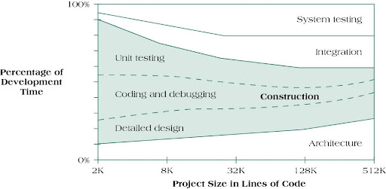

Software Development Lifecycle (SDLC)


Agile Development with DevOps
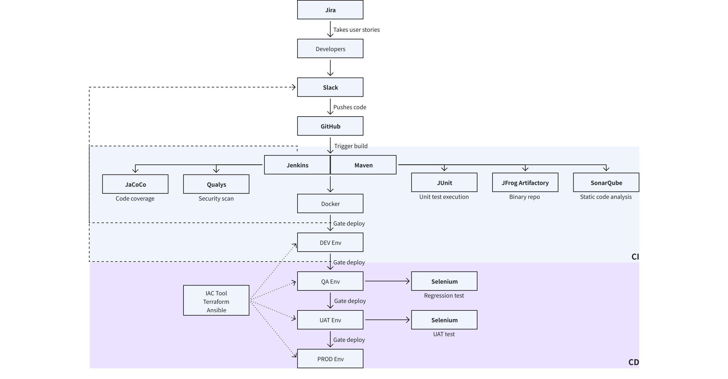

Testings
Smoke testing | Input data → application |  | Simply validate if the APIs are working
Functional testing | Functional specification → input data → application → compare results to expected results |  | Test against functional requirements
Integration testing | Test plan → input data → application → compare results to expected results |  | Test several API calls
Regression testing | Functional specifications → input data → compare old & new app results |  | Changes won't break the existing behaviours of APIs
Load testing | Test script → JMeter → test engine → application |  | Test for application's capacity by simulating loads
Stress testing | High loads → JMeter → test engine → application |  | Delibrately create high loads to see if APIs function normally
Security testing | Security test specification → application |  | Test against all possible external threats
UI testing | UI → application |  | Test interactions between the UI and the APIs
Fuzz testing | Unexpected data → application |  | Identify vulnerabilities by sending unexpected data into the APIs

Cloud Software
Linux (Terminal Bash Scripting)
Ubuntu | Red Hat | Debian | Fedora
Networking (HTTP/S, FTP, SSL, TLS, SSH)
NGINX | pfsense | Wireshark | Nagios
Cloud Services
AWS | Azure | Google Cloud | Oracle
Security (Encryption, Authentication)
Prisma | Open Policy Agent | Kube-Hunter | Kube-bench
Containers and Orchestration (Service Mesh)
Istio | Docker | Consul | Linkerd
Kubernetes | Podman
Infrastructure as Code
Configuration Management | Ansible | Puppet | Chef
Infrastructure Provisioning | Terraform | Cloud formation | Crossplane
Observability
Monitoring | Splunk | Grafana | Prometheus
Logging | Papertrail | Elastic Search | LogStash
CI/CD
Github | Bitbucket | GitLab | Flux
Argo | Jenkins | Azure Devops | Spinnaker

