AI

Common Terms
Turing Test  Where a human evaluator engages in natural language conversation with a machine and a human | Neural Networks  Machine learning models that mimic the brain, learning to recognise patterns and make predictions via artificial neuron connections | DeepMind  Was acquired by Google in 2014 for $500 million | Natural Language Processing  Teaches computers to understand and use human language using techniques like machine learning
Lovelace Test  A test made to detect AI through examining its ability to create art | Artificial Intelligence  Machines thinking and learning like humans, solving problems without explicit programming | Machine Learning  Computer learning patterns from data, making decisions and predictions without explicit programming | Deep Learning  Computers using interconnected networks to solve complex problems like recognising speech or images
Supervised Learning  Teaching computers with labeled examples to predict outcomes in new situations | Unsupervised Learning  Computer finding patterns without labeled examples, exploring data for insights | Reinforcement Learning  Machines learning by trial and error, getting rewards for correct actions | Natural Language Processing  Computers understanding, interpreting, and generating human language
Internet of Things  Devices connected to the internet, sharing and exchanging data for smart applications | Cloud Computing  Storing, managing, and processing data on remote servers rather than local computers | Data Mining  Extracting valuable patterns and information from large datasets | Big Data  Handling and analysing massive volumes of diverse and complex data
Computer Vision  Machines interpreting visual information, like recognising objects in images | Chatbot  A computer program engaging in conversation, often used for customer support | Bias in AI  Unintentional unfairness in machine decision-making due to biased data or algorithms | Algorithm  Step-by-step instructions or rules for solving problems and making decisions
Robotics  Combining AI with physical machines for tasks like automation and assembly | Algorithmic Fairness  Ensuring AI systems make unbaised and fair decisions for all individuals | Data Mining  Extracting valuable patterns and information for large dataset | Big Data  Handling and analysing massive volumes of diverse and complex data
Transfer Learning  Applying knowledge gained in one task to improve performance in another | Edge Computing  Processing data near the source of generation, reducing the need for centralised servers | Edge AI  Implementing AI algorithms on local devices instead of relying on centralised servers | AI Ethics  Considerations and guidelines for ensuring resposible and ethical AI development and use
Explainable AI  Makng AI decision-making understandable and transparent to users and developers | Generative Adversarial Networks  AI models creating new, realistic data by pitting two networks against each other | Biomimicry  Imitation of the models, systems and elements of nature for the purpose of solving complex human problems | Psychometrics  The science of measuring mental capacities and processes
Cost function  How good the trained data | Skip-Thought Vectors  Distributed sentence encoder | Text-guided Attention Model  Understand an image and generate natural language of descriptions | Ubiquitous Computing  Computing to be made to appear anytime and anywhere
Data wrangling (munging)
Transforming and mapping raw data to relational data
Autoregressive Sequence Models (ASM) | Language Modeling Techniques | Transformer Architectures | Tokenization and vocabulary encoding
Deep Learning and Neural Networks | Probability and Statistics | Recurrent Neural Networks | Sequence-to-Sequence Models
Training and Fine-Tuning Strategies | Sequence Prediction Models
Retrieval-Augmented Generation (RAG) | Natural Language Processing (NLP) | Machine Learning Algorithms | Generative Pre-trained Transformers
Knowledge Bases and Databases | Text Embeddings and Vectorization | Semantic Search Techniques | Deep Learning Frameworks
Document Ranking and Selection | Informational Retrieval | Named Entity Recognition (NER)
Multi-Model AI | Data Fusion and Integration | Human-Computer Interaction | Neural Network Architectures
Sensor Data Processing and Integration | Machine Perception and Sensory Processing | Representation Learning | Cross-Modal Informational Retrieval
Featrure Extraction and Normalization | Supervised and Unsupervised Learning | Multimodel Dialogue Systems
Cognitive Architecture | AI and ML | Computational Modeling | Symbolic Reasoning and Logic
Neural Computation and Networks | Memory Storage and Retrieval | Perception and Sensory Processing | Decision Making and Problem Solving
Emotion and Motivation Modeling | Human Cognitive Processes and Models

Definition
Artificial Intelligence | Cognitive computing | AI Ethics | Speech recognition
Knowledge representation | Planning and scheduling | Natural language processing | Computer vision
Expert systems | Robotics | Automated reasoning | Fuzzy logic
Machine Learning | Feature engineering | Emsemble learning | Support vector machines
Decision trees | Dimensionality reduction | Unsupervised learning | Semi-supervised learning
Reinforcement learning | Classification | Regression | Clustering
Neural Networks | Drop out | Generative adversarial networks (GAN) | Long short-term memory (LSTM)
Convolutional neural network (CNNs) | Perceptrons | Multi-layer perceptron (MLP) | Backpropagation
Activation functions | Recurrent neural networks (RNN) | Self-organising maps (SOMs)
Deep Learning | Capsule network | Deep reinforcement learning | Deep convolutional neural networks (CNNs)
Deep neural networks (DNNs) | Transfer learning | Generative adversarial networks (GANs) | Deep belief networks (DBNs)
Attention mechanisms
Generative AI | Language modeling | Transfer learning | Transformer architecture
Self-attention mechanism | Natural language understanding | Text generation | Summarisation
Dialogue systems

Roadmap
- AI Culture  - Interdisciplinary impact  - Ethical considerations  - Societal influence | - Core Principls  - Machine learning  - Neural networks  - Probabilistic models | - Math Foundations  - Linear algebra  - Calculus  - Statistics | - Programming skills  - Python coding  - AI libraries  - Framework proficiency
- Data management  - Data preprocessing  - Big data  - Data storage | - Learning algorithms  - Supervised learning  - Unsupervised learning  - Reinforcement learning | - Deep learnings  - CNNs  - RNNs  - GANs | - NLP  - Text processing  - Language models  - Text analysis
- Computer vision  - Image processing  - Object detection  - Vision models | - Robotics  - Sensor integration  - Navigation algorithms  - Human-interaction | - Cloud AI  - Cloud services  - Model deployment  - Workflow automation | - Ethical AI  - Bias fairness  - Transparency  - Regulation compliance
- Project Management  - Agile methodology  - Team collaboration  - Lifecycle management | - Continuous Learning  - Research updates  - Community engagement  - Ongoing education | - AI Applications  - Healthcare AI  - Financial modelling  - Autonomous systems

Argument
Fast-thinking dog argument | Anthropocentric argument | The limits of intelligence argument | The computational complexity argument

Risks

Risk Types
Risk Type | Code | Risk Name | Description
Model Risks | HAL | Hallucination | AI generates false or misleading answers.
Model Risks | BIA | Bias | AI produces unfair or one-sided outputs.
Model Risks | DRF | Data Drift | Input data changes over time.
Model Risks | MD | Model Drift | Model performance slowly degrades.
Model Risks | OVF | Overfitting | Model memorizes instead of generalizing.
Model Risks | UND | Underfitting | Model fails to learn useful patterns.
Model Risks | ERR | Error Propagation | Small errors spread across workflows.
Model Risks | UNC | Uncertainty | AI gives confident but unsure outputs.
Model Risks | PII | Personal Data Exposure | Sensitive user data gets revealed.
Data Risks | SRC | Source Risk | Unverified sources reduce answer trust.
Data Risks | MIS | Mislabeling | Wrong labels damage model learning.
Data Risks | DUP | Duplicate Data | Repeated data reduces model reliability.
Data Risks | SYN | Synthetic Data Risk | Fake data creates weak model behavior.
Data Risks | CON | Consent Risk | Data used without proper permission.
Data Risks | DAT | Data Leakage | Training data leaks into responses.
Data Risks | DQL | Data Quality Loss | Poor data creates unreliable outputs.
Security Risks | JBR | Jailbreak Risk | Users bypass AI safety limits.
Security Risks | PJI | Prompt Injection | Malicious prompts manipulate AI behavior.
Security Risks | ADV | Adversarial Attack | Inputs are designed to fool models.
Security Risks | EXT | Data Exfiltration | AI leaks confidential information.
Security Risks | API | API Abuse | Attackers misuse connected AI services.
Security Risks | TOK | Token Theft | Credentials or keys get exposed.
Security Risks | ACC | Access Risk | Wrong users access restricted systems.
Security Risks | SUP | Supply Chain Risk | Third-party tools introduce vulnerabilities.
Security Risks | REG | Regulatory Risk | AI violates legal requirements.
Security Risks | AUD | Audit Gap | Decisions lack proper records.
Governance & Compliance | GOV | Governance Failure | AI lacks proper oversight.
Governance & Compliance | DOC | Documentation Gap | Model usage is poorly recorded.
Governance & Compliance | CMP | Compliance Risk | AI breaks industry standards.
Governance & Compliance | OWN | Ownership Gap | No clear person owns AI outcomes.
Governance & Compliance | POL | Policy Failure | Internal AI rules are unclear.
Governance & Compliance | EXP | Explainability Gap | AI decisions are hard to understand.
Operational Risks | SCL | Scaling Risk | System fails under higher demand.
Operational Risks | CST | Cost Overrun | AI usage becomes too expensive.
Operational Risks | LAT | Latency Risk | AI responses become too slow.
Operational Risks | MON | Monitoring Gap | AI issues go unnoticed.
Operational Risks | ROB | Reliability Risk | AI behaves inconsistently in production.
Operational Risks | DEP | Deployment Risk | Poor rollout creates failures.
Operational Risks | INT | Integration Risk | AI breaks existing workflows.
Operational Risks | ROL | Rollback Gap | Teams cannot safely reverse failures.
Operational Risks | REP | Reputation Risk | AI mistakes damage brand trust.
Operational Risks | CUS | Customer Trust Loss | Users stop trusting AI outputs.
Human & Ethical Risks | FAI | Fairness Risk | AI treats groups unequally.
Human & Ethical Risks | TRU | Trust Gap | People avoid using AI systems.
Human & Ethical Risks | JOB | Job Displacement Fear | Teams fear AI replacing roles.
Human & Ethical Risks | HITL | Human-in-the-Loop Gap | Critical decisions lack review.
Human & Ethical Risks | STR | Strategy Risk | AI adoption lacks clear direction.
Human & Ethical Risks | HYP | AI Hype Risk | Expectations exceed real capability.
Human & Ethical Risks | MIS | Misuse Risk | AI gets used for wrong purposes.
Human & Ethical Risks | ROI | ROI Failure | AI investment brings weak returns.
Human & Ethical Risks | REV | Revenue Risk | AI failures impact business results.
Human & Ethical Risks | VEN | Vendor Lock-In | Business depends too much on one provider.
Monitoring & Control | KILL | Kill Switch Gap | AI cannot be stopped quickly.
Monitoring & Control | FBK | Feedback Gap | User feedback never improves the system.
Monitoring & Control | EVAL | Evaluation Failure | Testing misses real-world issues.
Monitoring & Control | RED | Red Teaming Gap | Risks are not stress-tested.
Monitoring & Control | VAL | Validation Gap | Outputs are not properly checked.
Monitoring & Control | MET | Metric Blindness | Teams track the wrong AI metrics.
Monitoring & Control | ALR | Alert Failure | Critical issues trigger no alerts.
Monitoring & Control | LOG | Logging Gap | AI actions are not traceable.
Monitoring & Control | CHAIN | Multi-Agent Failure | One agent’s error affects others.
Agentic AI Risks | AUT | Automation Bias | Humans trust AI too quickly.
Agentic AI Risks | MAN | Manipulation Risk | AI influences users unfairly.
Agentic AI Risks | ETH | Ethical Risk | AI creates harmful social outcomes.
Agentic AI Risks | SAF | Safety Risk | AI causes real-world harm.
Agentic AI Risks | AGT | Agent Autonomy Risk | Agents act beyond intended limits.
Agentic AI Risks | TLS | Tool Misuse | Agents use tools incorrectly.
Agentic AI Risks | MEM | Memory Risk | Agents store sensitive context.
Agentic AI Risks | LOOP | Loop Failure | Agents repeat actions endlessly.
Agentic AI Risks | GOAL | Goal Misalignment | Agent pursues the wrong objective.
Agentic AI Risks | ACT | Unauthorized Action | Agent performs restricted operations.
Agentic AI Risks | DEL | Delegation Risk | Agents pass tasks without control.

Risk Classification
UNACCEPTABLE RISK — BANNED OUTRIGHT  - Social scoring by governments  - Manipulative AI exploiting vulnerabilities  - Real-time biometric surveillance (public spaces)  - Predictive policing based on profiling | HIGH RISK — STRICT COMPLIANCE REQUIRED BY AUG 2, 2026  Examples:  - Credit scoring  - Fraud detection  - Algo trading  - HR screening  - Clinical decision support  - Critical infrastructure  - Educational assessment  Requires:  - Conformity assessment  - Technical documentation (Annex IV)  - Human oversight (Art.14)  - Audit logging  - Risk management system (Art.9) | LIMITED RISK — TRANSPARENCY OBLIGATIONS ONLY  - Chatbots  - AI-generated content  - Emotion recognition tools  Requirements:  - Must disclose AI involvement to users  - No conformity assessment needed | MINIMAL RISK — NO OBLIGATIONS  - Spam filters  - AI in video games  - Productivity assistants  - Standard recommendation engines
Penalties | Up to €35M or 7% global revenue (prohibited practices) | €15M or 3% (high-risk violations) | €7.5M or 1% (misleading authorities)

Risk Framework
EU AI ACT  Binding Law  Aug 2, 2026 Deadline  Requirements:  - Risk classify every AI system  - Conformity assessment (high-risk)  - Technical docs — Annex IV  - Human oversight mechanism  - Incident reporting to regulator  - Post-market monitoring  - AI literacy for staff  Who: Any org serving EU users  Extraterritorial scope | NIST AI RMF  De Facto US Standard  4 Core Functions  Functions:  - GOVERN — ownership + accountability  - MAP — context + risk identification  - MEASURE — bias + accuracy + drift  - MANAGE — mitigate + respond + improve  Additional notes:  - GenAI Profile covers LLMs + agents  - No penalties BUT gates fed contracts  - Required for enterprise procurement  Who: US federal + enterprise supply chain  Voluntary — but practically mandatory | ISO/IEC 42001  Certifiable Standard  AI Management System  Requirements:  - Clause 4: Org context + stakeholders  - Clause 5: Leadership + AI policy  - Clause 6: Risk + impact assessment  - Clause 7: Resources + competence  - Clause 9: Performance evaluation  - Third-party certification available  - Bridges EU AI Act + NIST RMF  Who: Any org seeking certification  Procurement + audit differentiator | SINGAPORE MGAF  World’s First Agentic AI Framework  Requirements:  Jan 22, 2026 — launched  - Agent authority boundaries defined  - Autonomy classification required  - Decision audit trails mandatory  - Cascading failure protocols  - Only framework built for agents  - Adopt now — others will follow  Who: Any org deploying AI agents  Global best practice standard

7-Step Risk Assessement
01 - Inventory  Every model, agent and tool across the org. | 02 - Classify  Apply EU AI Act risk tiers to each system. | 03 - Impact Assess  FRIA for high-risk. Bias test. Data lineage review. | 04 - Assign Owner  Named human. Accountable for every output.
05 - Document  Model card. Risk register. Annex IV technical docs. | 06 - Monitor Live  Drift detection. Audit logs. Real-time guardrails. | 07 - Review  Quarterly. Continuous. Not once.

Risk Framework Selection
Framework | Legal Force & Deadline | When You Need It | Start If…
EU AI Act | Binding Law. Aug 2, 2026 | Any EU exposure or EU users | You have high-risk AI in scope
NIST AI RMF | Voluntary. Now - gates procurement | US federal contracts or enterprise sales | Customers ask “what’s your framework?”
ISO 42001 | Voluntary - Certifiable. 12–18 months to certify | Want audit-ready certification signal | Board wants proof, not just policy
SG MGAF | Voluntary. Before agent goes live | Deploying AI agents or agentic workflows | Agents execute multi-step actions

Governance

Governance Framework
Items | Risk Area | Business Impact | Governance Control
Data Governance | Poor data quality, unclear ownership, or uncontrolled data usage. | Inaccurate AI outputs, privacy violations, and weak decision-making. | Define data ownership, classification, lineage, and approval workflows.
Model Validation | Models are deployed without proper testing, evaluation, or approval. | Unreliable predictions, operational errors, and reduced stakeholder trust. | Use validation benchmarks, performance thresholds, and independent review.
Bias & Fairness | AI systems produce unfair, discriminatory, or unbalanced outcomes. | Reputational damage, legal exposure, and customer trust erosion. | Run bias testing, fairness audits, and representative dataset reviews.
Human Oversight | AI decisions are automated without meaningful human review. | Incorrect actions, accountability gaps, and high-risk business decisions. | Add human-in-the-loop approval, escalation paths, and override controls.
Regulatory Compliance | AI systems fail to meet legal, industry, or regional requirements. | Regulatory penalties, audit failures, and blocked enterprise adoption. | Map AI use cases to policies, regulations, and compliance checklists.
Security Controls | AI systems are exposed to prompt attacks, data leakage, or misuse. | Unauthorized access, sensitive data exposure, and system manipulation. | Apply access controls, input validation, encryption, and security testing.
Vendor Risk | Third-party AI tools, APIs, or models introduce hidden risks. | Dependency failures, compliance gaps, and supply chain exposure. | Conduct vendor assessments, contract reviews, and continuous monitoring.
Audit Logging | AI actions, prompts, outputs, and decisions are not properly recorded. | Poor traceability, weak accountability, and failed investigations. | Maintain detailed logs for model activity, user actions, and decisions.
Model Monitoring | Model performance changes over time due to drift or new conditions. | Degraded accuracy, inconsistent results, and business process failures. | Track performance, drift, anomalies, and trigger retraining workflows.
Incident Response | AI failures, misuse, or security events are not handled quickly. | Extended disruption, legal exposure, and enterprise trust loss. | Create AI incident playbooks, escalation teams, and recovery procedures.

Forecasting & Scenario
Trend-impact analysis (TIA) | Cross-impact analysis (CIA) | The intuitive logics school | The probabilistic modified trends (PMT) school
La Prospective, a.k.a. the French school
Scenario Mapping Techniques
Scenario Network Mapping (SNM)  - 30 to 50 scenarios  - Qualitative  - Complex cases with large numbers of scenarios  - Time consuming and requires 15-20 experts | Cognitive Maps  - 8 to 24 scenarios  - Qualitative  - Useful in multiple organisation contexts, rapid workshop development  - Weak scenario development, lack of rigor in method | Fuzzy Cognitive Map (FCM)  - 8 to 18 scenarios  - Quantitative and qualitative  - Flexible method, quantitative and qualitative elements, aggregates cognitive maps  - Limited quantative value, limited judgemental value | Judgemental Distillation Mapping (JDM)  - 6 to 30 scenarios  - Quantitative and qualitative  - Complex cases that require probabilistic forecasts  - Resource intensive and requires diversity of expert

Analytics Methodology
Aggregate analysis  Describe population, segment or compare segments - descriptive analysis, profiling, campaign analysis, winner-loser analysis | Correlation analysis  Relationship between prospect - pre and post, test control, drivers, dashboard | Trends analysis  Over time and period - trends of sales, revenues, breaks in trends and segments | Sizing/Estimation  Near accurate guesstimate in absence of historical data - limited data or dependent on external data
Correlations and drivers  Determine what metrics and factors could have any influence on the metric is that being sized | Assumptions  What do we know about the various factors that make up the equation | Computation  Involves doing the math to get to the estimates for each segment | Triangulation/orthogonal method  Approach same estimates with different drivers, matching
Predictive Analytics/Time series  Current and historical data - conversion, customer engagement, forecasting | Segmentation  Grouping through customisation - targeting and customisation | Customer life cycle  Determine its stage and how to move them up - purchase to use, sales funnel | Predictive analytics  Builds on insights from business analytics that can evaluate hundreds of metrics that can identify the most important parameters to drive business but it is time and resource intensive
Mean
Average value (x̄ = Σx / n) Trimmed mean take away the n front and back (x̄ = (Σ(n-p) + 1(x)(i)) / (n – 2p)) Weighted mean adds multiplier into the mean (x̄(w) = Σ(i=1)w(i)x(i) / Σ(i)w(i))

Framework
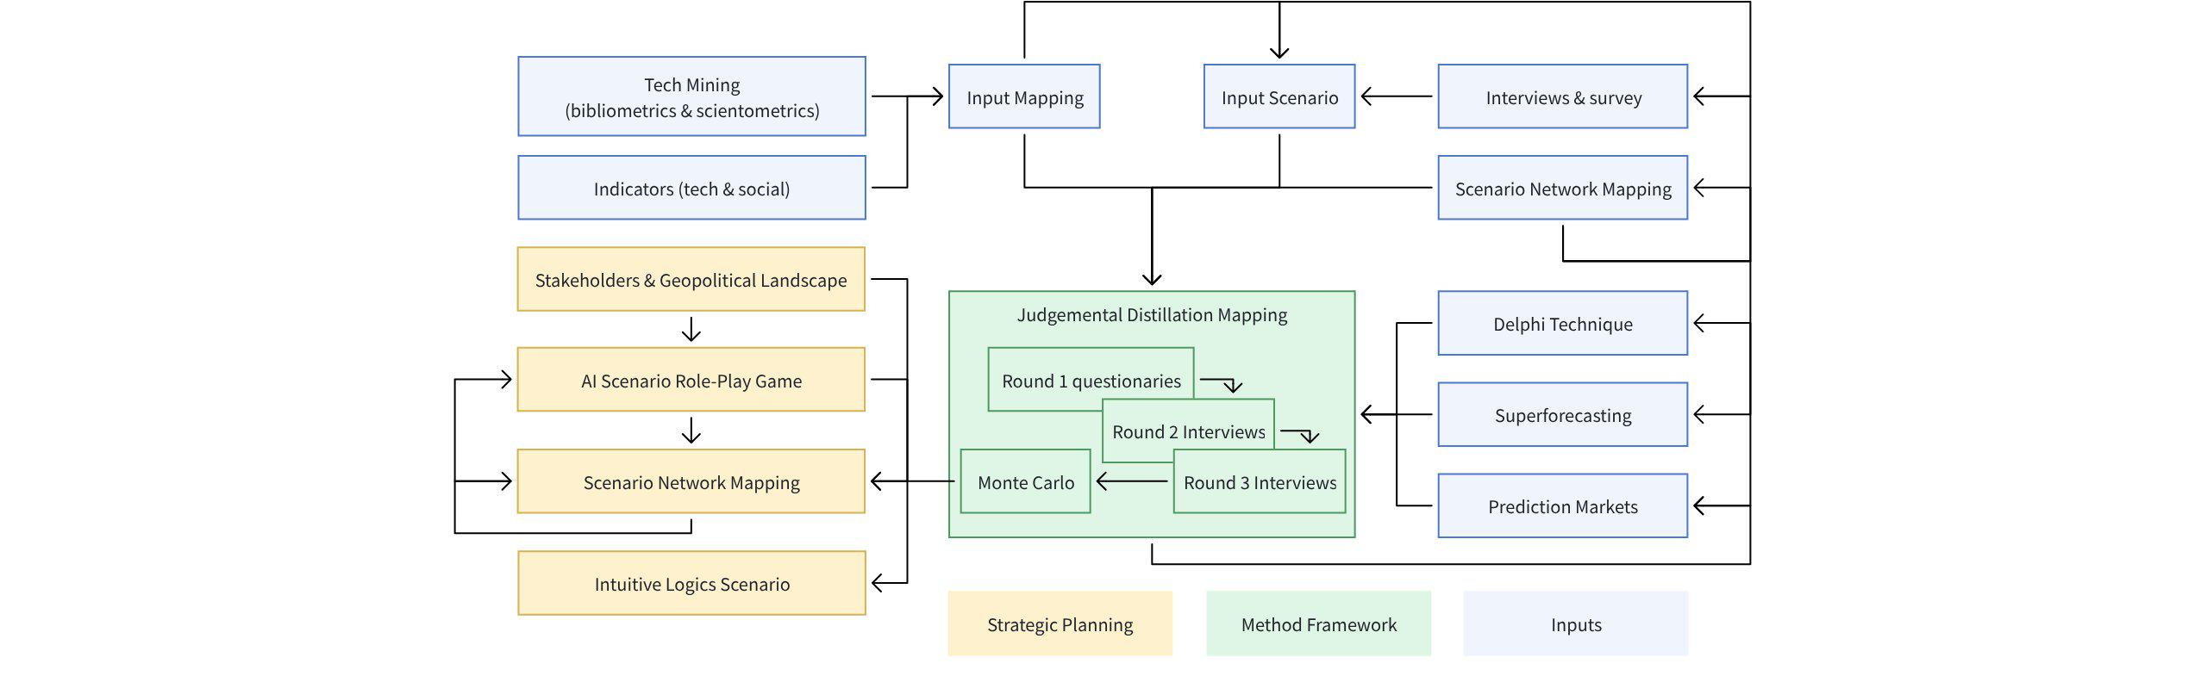

Data

Types
Structured data | Organised | Formally defined | Easy to access and query
Lower availability | Efficient to analyse | Unstructured data | Scattered and dispersed
Free-form | Hard to access and query | Higher availability | Additional preprocessing is needed
Attitudinal data | How the customer feels about something | Behavioural data | Sales transaction
Demographic data | Personal information | Data-driven data | No prior knowledge
Broad use of data-mining tools | Suited for large-scale data | Open scope | Needs verification of results
Uncovers patterns and associations | User-driven data | In-depth domain knowledge | Specific design for analysis and testing
Can work on smaller datasets | Limited scope | Easier adoption of analysis results | May miss hidden patterns and associations
Labelled data | A group of samples that have been tagged with one or more labels

Classification
Bayesian classification  Predict class membership probabilities such as the probability that a given tuple Naïve Bayes Network – probability based on evidence Bayesian nonparametric model – allowing the data to determine the complexity of the model | Logit  Function that maps the probability of belonging to a class with range from ±∞ Odds – ratio of success (1) to not success (0) Log odds – response in the transformed model that mapped back to a probability Techniques: generalized linear models | Accuracy  The percent of cases classified correctly Confusion matrix – record counts vs their actual classification status Sensitivity – the percent of 1s correctly classified Specificity – the percent of 0x correctly classified Precision – the percent of predicted 1s that are 1s Receiver Operating Characteristic (ROC) curve – a plot of sensitivity versus specificity Area Underneath Curve (AUC) Lift – how effective the model is at different probability cutoff Percent Correct Classification (PCC) – measure overall accuracy
Undersample  Use fewer of the prevalent class records in the classification model Oversample – use more of the rare class records in the classification model Up weight or down weight – attach incorrect weight or prevalent class in the model Data generation – each new bootstrapped record is slightly different from its source K – number of neighbour considered in the nearest neighbour calculation K-Nearest Neighbour (KNN) – hunt similar features and plot a circumference around it Euclidean distance – the "ordinary" straight-line distance between two points in Euclidean space Manhattan distance – between real vectors using the sum of their absolute difference (∑(i=1) |x(i) - y(i)|) Hamming distance – categorical variable (D(H) = ∑(i=1) (x(i) - y(i))) |  | Conditional probability  Probability of observing some event P(X(i)|Y(i)) Posterior probability – an outcome after the predictor information has been incorporated | Covariance  One variable varies in concert with another Discriminant function – maximizes the separation of the classes Discriminant weights – the scores to estimate the probabilities belonging to another class Techniques: Linear Discriminant Analysis (LDA), Covariance Matrix, Fisher’s Linear Discriminant
Support Vector Machine (SVM)
Binary classifier Kernel Method - a class of algorithms for pattern analysis, member for SVM

Preparation
Big data characteristics
Volume  Exacerbates of scale to process | Velocity  Real time streaming data | Variety  Many, many types of data | Veracity  Doubts about the data accuracy
OSEMN
- Obtaining data | - Scrubbing data | - Exploring data | - Modelling data
- Interpreting data | To succeed in machine learning: accessing & managing data, skill sets, disparate technologies
3-legged stool | Domain expert | Data expert | Predictive modelling expert
Steps
- Define data sources | - Cross Industry Standard Process | - Data Mining  CRISP-DM | - Data exploration
- Prepare data | - Data aggregation, preprocessing & warehousing | - Sampling data | - Formulate hypothesis
- Design experiment | - Machine learning | - Clustering | - Aomaly detection  one-class classifier
- Association-rule mining  Do you want fries with that? Frequent itemset & Apriori algorithm | - Building deployable models | - Prediction  Propensity model & regression | - Decision making
- Collect data | - Inference / conclusions | - Evaluating your model | - Updating your model
Processes
- Learning rates (MLPs) | - Momentum (MLPs) | - Number of iterations/epochs | - number of hidden layers and number of neurons in each hidden layers
- Stopping criteria | - Weight updates | - Quick propagation | - Resilient propagation (Rprop)
- Second-order methods

Smoothing
Reduction of noises that is causing the fluctuations | Methods to reduce  - Random Walk  - Moving Average  - Exponential Smoothing

Processing
Insertion sort  Simple sorting algorithm | Orthogonalization  Linear algebra, finding a set of orthogonal vectors that span a subspace | Binary search  Search algorithm that finds the position of a target value within a sorted array | Dickey-fuller test  Check financial data that is always changing
Simpson’s Paradox  Reverse trend when variables combined | Anova  Analysis of variance, difference of means, f-statistic | Text Recommendation Algorithm | Singular Value Decomposition (SVD)
Latent Dirichlet Allocation (LDA) | Gains and Lift Chart | Taylor Neural Network | Fourier Transform
Discrete Fourier Transform (DFT) | Discrete Wavelet Transformation (DWT) | Singular Value Decomposition (SVD) | Locally Linear Embedding (LLE)
ISOMap | t-SNE | Multidimensional Scaling (MDS)

Data Pipeline
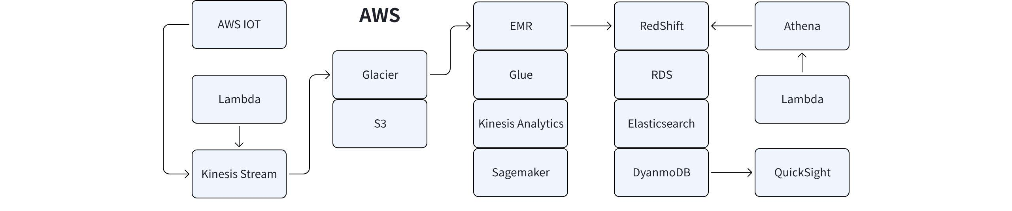
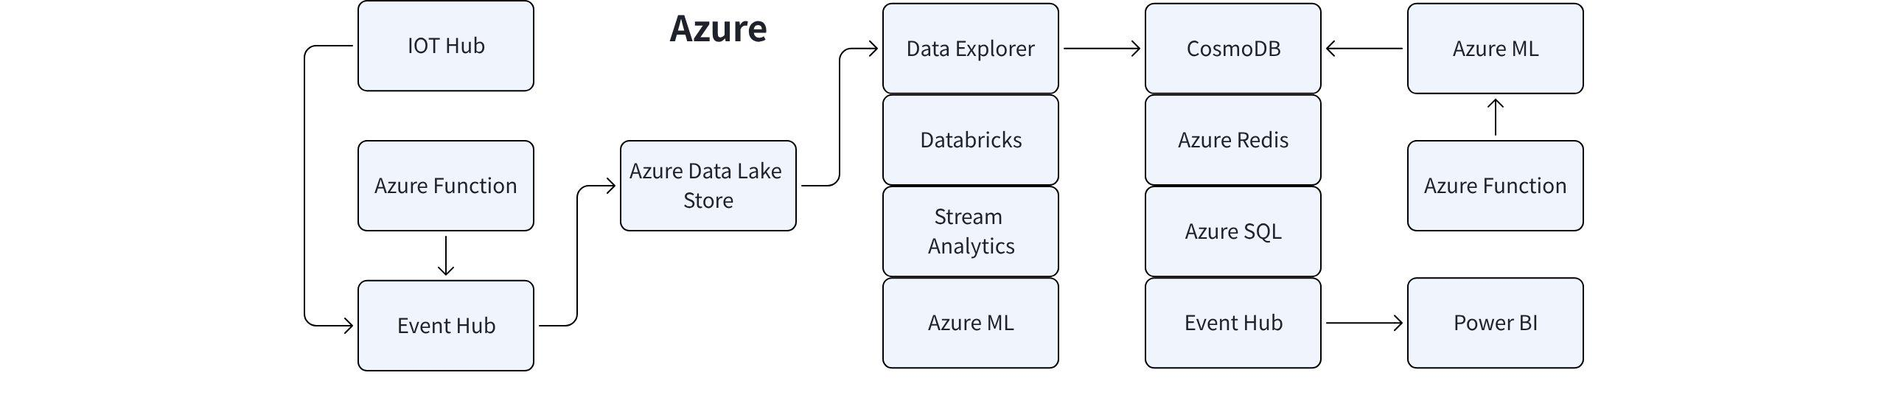
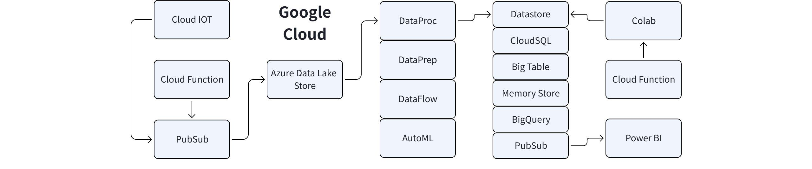

Mathematics

Regression
Response  The variable we are trying to predict | Independent variable  The variable to predict the response | Record  The vector of predictor and outcome values for a specific individual | Intercept  The predicted value when x = 0
Regression coefficient  The slope of the regression line | Fitted values  The estimates ŷ(i) obtained from the regression line | Residuals  The difference between the observed and fitted values | Least squares  Fit a regression by minimizing the sum of squared residuals
Maximum likelihood  A method of estimating the parameters of a statistical model, given observations | Root mean squared error  The square root of the average squared error of the regression | Residual standard error  Same as root mean squared error but with freedom | R-squared  Proportion of variance explained by the model from 0 to 1
Weighted regression  Regression with records of having different weights | Cross-validation  Set aside 1/k → train remaining data → apply score model to 1/k holdout → restore first 1/k data and set aside next 1/k → repeat training until each record is used → average or combine the model assessment metrics
Dummy variables  Binary 0-1 variables derived by recording factor data | Reference coding  Factor to use as references and another factor to compare that level | One hot encoder  All factors levels are retained | Deviation coding  Compares each level against the overall mean
Correlated variables  Difficult to interpret individual coefficients | Multicollinearity  Near perfect correlation rendering unstable to compute | Collinearity  1 predictor variable in a multiple regression model can be linearly predicted | Main effects  Predictor and outcome variable are independent
Interactions  Interdependent relationship between 2 or more predictors | Bayesian Linear Regression  Regression model with prior distribution is assumed | Standardized residuals  Residuals divided by the standard error | Outliers  Records that are distant from the rest of the data
Influential value  Value that make a big difference in the regression equation | Leverage  Degree of influence that a single record has | Non-normal residuals  It can invalidate some technical requirements | Heteroskedasticity  Some outcome range experience residuals with higher variance
Partial residual plots  Diagnostic plot to show between outcome variable and a single predictor | Polynomial regression  Adds polynomial terms to a regression | Spline regression  Fitting a smooth curve with a series of polynomial segments | Knots  Values that separate spline segments
Generalized additive models  Spline models with automated selection of knots | Lasso-based linear regression  Performs both variable selection and regularization to enhance the prediction accuracy | Monotonic regression  Fitting a free-form line to a sequence of observations under the following constraints | Adaptive regression  Locally estimated scatterplot smoothing (LoESS), proportional hazard regression, quantile regression, robust regression
Numerical Optimisation
Broyden-Fletcher-Goldfarb-Shanno (BFGS)  Solving unconstrained nonlinear optimization problems | Baseline Model  A simple initial model used to compare the performance of more complex models. | Low-Rank Matrix Factorization  Decomposes a matrix into lower-dimensional matrices to approximate the original while capturing its underlying patterns. | Alternating Least Square  Alternates between fixing one matrix and solving for the other to minimize the reconstruction error in matrix factorization.
Contrastive Divergence  An approximation method used to train energy-based models like Restricted Boltzmann Machines by estimating the gradient of the log-likelihood. | Restricted Boltzmann Machine  A generative neural network that learns a probability distribution over its input using a layer of visible and hidden units with no intra-layer connections. | Multi-armed bandit algorithm  Explicit optimization and more rapid decision | Karush–Kuhn–Tucker (KKT)  First derivative tests for a solution in nonlinear programming to be optimal, provided that some regularity conditions are satisfied

Metaheuristic Optimisation
Ant Colony Optimization (ACO)  Inspired by the foraging behavior of ants, ACO uses pheromone trails and heuristic information to guide the search for optimal paths or solutions. | Artificial Bee Colony (ABC)  ABC mimics the foraging behavior of honeybees and their communication through waggle dances to find optimal solutions. | Bee Algorithm (BA)  BA imitates the foraging behavior of honeybees, where employed bees explore and exploit solutions, and scout bees search for new areas of the search space. | Cuckoo Search (CS)gt  Based on the brood parasitic behavior of cuckoo birds, CS imitates the laying and discovery of eggs to search for optimal solutions.
Cultural Algorithm (CA)  CA combines a population-based approach with a knowledge sharing mechanism. It incorporates a belief space that represents cultural knowledge and guides the evolution of solutions. | Differential Evolution (DE)  DE utilizes the differential operator to combine and mutate candidate solutions, promoting exploration and exploitation of the search space. | Estimation of Distribution Algorithm (EDA)  EDA utilizes probabilistic models to estimate the distribution of promising solutions in a population. It uses these models to generate new candidate solutions for further optimization. | Firefly Algorithm (FA)  Inspired by the flashing behavior of fireflies, FA uses the attractiveness of fireflies to guide the search for optimal solutions.
Genetic Algorithm (GA)  Inspired by the process of natural evolution, GA uses the concepts of selection, crossover, and mutation to search for optimal solutions. | Genetic Programming (GP)  GP applies the principles of natural selection and genetic operations to evolve programs or mathematical expressions to solve problems. | Gravitational Search Algorithm (GSA)  Inspired by the law of gravity, GSA simulates the interaction of masses governed by the law of gravity. It utilizes the concept of attraction and repulsion to optimize solutions within a population. | Harmony Memory Consideration (HMCR)  HMCR maintains a memory of past solutions and combines them based on memory considerations to generate new candidate solutions.
Harmony Memory Upgrade (HMU)  HMU improves upon the Harmony Search algorithm by incorporating a memory consideration operator for better solution generation. | Harmony Search Algorithm (HS).  Inspired by musical improvisation, HS searches for optimal solutions by iteratively creating new "harmonies" based on memory and pitch adjustment rules within a population. | Imperialist Competitive Algorithm (ICA).  ICA models competition and cooperation between empires and colonies. It evolves a population of imperialists and colonies to find optimal solutions. | Particle Swarm Optimization (PSO).  Based on the collective behavior of a swarm of particles, PSO optimizes solutions by iteratively updating particle positions and velocities.
Shuffled Frog Leaping Algorithm (SFLA).  SFLA is inspired by the hierarchical behavior of frogs. It employs a population of virtual frogs that undergo local search, individual learning, social learning, and shuffling to explore and improve solutions. | Simulated Annealing (SA).  Inspired by the annealing process in metallurgy, SA simulates the cooling and solidification of a material to search for optimal solutions. | Tabu Search (TS).  TS maintains a short-term memory of past moves and uses a tabu list to avoid revisiting recently explored solutions, enabling exploration of new regions in the search space. | Variable Neighborhood Search (VNS).  VNS systematically explores different neighborhoods around solutions to escape local optima and find better solutions.

Distribution
Standard distribution | Normal (Gaussian) distribution | Uniform distribution | Bernoulli Beta Binomial
Bivariate Normal | Binomial | G-and-H | Burr Bimodal
Heavy Tailed | Continuous Probability | Categorical | Yule-Simon
Lévy Cauchy | Degenerate | Cumulative Frequency | Cumulative Geometric
Beta Dirichlet | Extreme Value | Discrete Probability | Empirical Gompertz
Reciprocal | Generalized Error | Wishart | Uniform
T Factorial | Hypergeometric | Folded / Half Normal | Wallenius Fat Tail
F J Shaped | Inverse Normal | Inverse Gaussian | Von Mises
U-Shaped | Fisk | Laplace | Kumaraswamy
Multivariate | Normal Lindley | Lognormal | Kent
Long Tail | Marginal | Mixture | Multimodal
Multinomial | Rician | Nakagami | Negative Binomial
Open Ended | Pareto | Zeta | Pearson
Unimodal | Relative | Power Law | Rayleigh
Poisson  Frequency distribution of the number of events in sampled unit | Tukey Lambda  The rate per unit of time or space at which events occur | Exponential  Frequency distribution of the time or distance between events | Weibull  Generalized version of the exponential which rate can shift
Frequency | Skewed | Triangular | Stable
Symmetric | Truncated | Trapezoidal | Generalized Error
Sample statistic  Metric calculated drawn from a larger population | Data distribution  Frequency distribution of individual values in a data set | Sampling distribution  Frequency distribution of sample statistic | Central limit theorem  Tendency of sampling distribution takes on a normal shape
Standard error  The variability of a sample statistic over many samples (SE = s/√n) | Boxplot  Quick way to visualize data | Frequency table  Tally of count of numeric data that fall into a set of intervals | Histogram  Frequency table with x and y axis
Density plot  Smoothed version of histogram | Confidence level  The percentage of confidence interval to contain the statistic interest | Interval endpoints  Top and bottom confidence interval | Error  Difference between a data point and a predicted or average value
Standardize  Subtract the mean and divide by the standard deviation | Z-score  Result of standardizing an individual data point | Standard normal  Mean = 0 and standard deviation = 1 | QQ-Plot
Trial  An event with a discrete outcome | Success  The out of interest for a trial | Binomial  Having 2 outcomes, measure error at 95% confidence level | Binomial trial  A trial with 2 outcomes
Binomial distribution  Distribution of number of successes in x trials | Skewness  Measurement of asymmetry of a distribution | Kurtosis  The sharpness of the peak of a frequency-distribution curve | Tail  Long narrow portion of a frequency distribution
Skew  One tail of a distribution is longer than the other | Anscombe's Quartet  Datasets appeared identical yet very different when graphed | Fix positive skew  Log transform log(x), multiplicative inverse 1/x, square root sqrt(x) | Fix negative skew  Square x(n), inv log -log10(1+abs(x))

Statistic
Treatment  Something to which a subject is exposed | Treatment group  A group of subjects exposed to a specific treatment | Control group  A group of subjects exposed to no or standard treatment | Randomization  Randomly assigning subjects to treatments
Subjects  Items that are exposed to treatments | Test statistic  Matric used to measure the effect of the treatment | Hypothesis testing  Confirmatory data analysis | Null hypothesis  Chance is to blame
Alternative hypothesis  Counterpoint to null as on what you hope to prove | The one-way test  Count chance results only in 1 direction | The two-way test  Count chance results in 2 directions | Permutation test  Combining 2 or more samples together and random reallocating observation
With or without replacement  An item is returned to the sample before the next draw | P-value  Probability of obtaining results as unusual or extreme | Alpha  Probability threshold of unusualness | Type 1 error  Mistakenly concluding an effect is real when it is due to chance
Type 2 error  Mistakenly concluding an effect is due to chance when it is real | False discovery rate  Across multiple tests making type 1 error | Adjustment of the p-value  Doing multiple tests on the same data | Underfitting  Lack of essential variables
Overfitting  Fitting the noise | MCAR  Missing completely at random | MAR  Missing at random | MNAR  Missing not at random
T-test  To determine whether there is a significant difference between the means of two groups | Test statistic  Metric for the difference or effect of interest | T-statistic*  Standardized version of the test statistic | T-distribution  A reference distribution to which the observed t-statistic can be compared
Q-statistic  A test statistic output by either the Box-Pierce test or, in a modified version which provides better small sample properties | Pairwise comparison  Hypothesis test between 2 groups among multiple groups | Omnibus test  Single hypothesis test of the overall variance among multiple group means | Decomposition of variance  Separation of components and contributing to an individual value
F-statistic  Measure the extent among group means to a chance model | The sum of squares (SS)  Deviation from some average value (Σ(i=1) (y(i) - ȳ)(2)) | Chi-square statistic  Measure of some observed data departs from expectation (χ= Σ ΣR(2)) | Pearson residual  Raw residual divided by the square root of the variance function
Pearson correlation coefficient  Measure of the linear correlation between two variables X and Y | Expectation or expected  How we expect the data to turn out under some assumption | Effect size  You hope to detect in a statistical test | Power  The probability of detecting a given effect size with a given sample size
Significance level  Level at which the test will be conducted | R-squared  A statistical measure of how close the data is to the fitted regression line | Mean error (ME)  Average of all the errors in a set | Mean absolute error (MAE)  Difference between two continuous variables
Root-mean-square error (RMSE)  Differences between values predicted by a model or an estimator and the values observed | Theil's U / Entropy coefficient  Measure of nominal association | Bayes's theorem  Probability of an event, based on prior knowledge of conditions that might be related to the event

Correlation
Spurious (not related), Crosstab (cross tabulation), Scatterplot | Correlation coefficient  Metric that measure from -1 to +1 | Correlation matrix  A table of value that correlates diagonally | Scatterplot  Plot with x and y axis
Pearson correlation coefficient (r)  Linear correlation between two variables X and Y | Contingency tables  Tally of counts between 2 or more categorical variables | Hexagonal binning  2 numeric variables with the records to binned into hexagon | Contour plots  Density of 2 numeric variables like a topographical map
Violin plots  Like a boxplot but showing the density estimate | Time series characteristic  Hurst exponent, autocorrelation coefficient | Time series  A series of data points indexed (or listed or graphed) in time order

Detection
Edge detection  - Canny  - Deriche  - Differential  - Sobel  - Prewitt  - Roberts Cross | Corner detection  - Harris Operator  - Shi and Tomasi  - Level Curve Curvature | Scale space  - Scale-Space Axioms  - Axiomatic Theory of Receptive Fields | Blob detection  - Laplacian of Gaussian (LoG)  - Determinant of Hessian (DoH)  - PCBR
Hessian Feature Strength Measures | Maximally Stable Extremal Regions | Difference of Gaussians (DoG) | Ridge detection Hough transform
Generalized Hough Transform | Structure tensor | Generalized Structure Tensor | Affine invariant feature detection
Affine Shape Adaptation | Harris Affine | Hessian Affine | Feature description
Scale-Invariant Feature Transform (SIFT) | Speeded Up Robust Features (SURF) | Gradient Location and Orientation Histogram (GLOH) | GIST Histogram of Oriented Gradients (HOG)
Local Binary Pattern (LBP) | Implementation Details | Pyramids

Machine Learning
Epoch  One forward and backward pass | Batch size  Training examples on how many epoch | Iteration  Number of epoch based on batch size. E.g. 1000 training exercise, batch size of 500 need 2 iterations to complete | Multi-Task Learning (MTL)  Subfield of ML, multiple learning tasks are solved at the same time with the need for explicit learning
Pre-training  Use the weights saved from the previous network to initiate the new training | Supervised learning  Task driven; split, apply, combine. Learning rules to create rules with data and answers or converting frequencies to probabilities E.g. classification and regression | Unsupervised learning  Data driven e.g. clustering, dimensionality reduction, recommendation | Generative Adversarial Networks (GAN)  NN contesting with each other in a zero-sum game. Requires lesser data and fewer parameters. Can be used for high resolution image processing, text-to-image synthesis, train with less data and provides prediction on missing data
Transfer learning  Storing knowledge gained while solving one problem and applying it to a different one | Reinforcement learning  Algorithm learns to react to an environment such as reward maximisation | Deep learning  Uses very complex neural networks to recognise patterns and solve harder problems (like rezecognising faces in photos) | K-means clustering  Divide data into different groups
Expectation Maximization (EM)  Computes probabilities based on one or more probability distributions | Gaussian mixture  Probabilistic model that assumes all the data points | Cluster  Group of records that are similar | Cluster means  The vector of variable means for the records in a cluster
Hierarchical clustering  More flexible than k-means with more non-numerical variables | Agglomerative algorithm  Until 1 cluster is left (d(x,y) = √(x(1)-y(1))(2) + (x(2)-y(2))(2) + … + (x(p)-y(p))(2)) | Divisive clustering  Different from agglomerative, top down, start from big and subdivide to small | Dendrogram  Visual records and hierarchy or clusters to which they belong
Distance  Measure of how close one record to another | Dissimilarity  How close one cluster to another | Principal component  A linear combination of the predictor variables | Loadings  The weights that transform the predictors into the components
Scree Plot  Showing the relative importance of the components | Model-based clustering  Similar records and not necessarily close to one another | Multivariate normal distribution  Generalization of the 1D normal distribution to higher dimensions | Bayesian Information Criteria (BIC) and Akaike information criterion (AIC)
Markov Model  A stochastic model used to model randomly change system (sequence data model) | Hidden Markov Model  Markov model with unobserved states | Markov Chain Monte Carlo  For sampling from a probability distribution | Kalman Filter / Linear Quadratic Equation (LQE)  Accurate estimates of unknown variables
Scaling  Squashing or expanding data | Scaling  Magnitude scaling, sigmoid, min-max normalization, z-score, rank scoring | Normalization  Subtracting the mean and dividing by the standard deviation | Gower’s distance  Bringing all variables to a 0-1 range
Sample  Subset from a larger dataset | Population  Large dataset or idea of a data set | N(n)  The size of the population | Random sampling  Drawing elements into a sample at random
Stratified sampling  Divide the population into strata | Simple random sample  Sampling the population without stratify | Sample bias  A sample that misrepresent the population | Bias  Systematic error
Data snooping  Extensive hunting through data in search of something interesting | Vast search effect  Bias or no reproducibility resulting from repeated data modeling | Bootstrap sample  A sample taken with replacement from an observed data set | Resampling  Taking repeated samples from observed data
Recursive partitioning  Repeatedly dividing and subdividing the data until it is homogeneous | Split value  Predictor value that divides the record | Node  The graphical or rule representation of a split value | Leaf  The if-then else rules
Loss  The number of misclassifications at a stage in the splitting process | Impurity  Mix of classes found in a sub partition of the data | Measurement  Gini (Gini(E) = 1−∑(j=1 )p(j)) and entropy (H(E) = −∑(j=1)p(j )log p(j)) | Pruning  Progressively cutting its branches to reduce overfitting
Ensemble  Forming a prediction by using a collection of models (split and boost accuracy) | Bagging  A general technique to form a collection of models by bootstrapping the data | Random forest  A type of bagged estimate based on decision tree models | Variable importance  Measure of the importance of a predictor variable in the performance of the model
Flocking algorithm  Self-propelled entities and collective animal behavior | Boosting  Giving more weight to the records with large residuals for each successive round | Adaboost  Reweighting the data based on the residuals | Gradient boosting  Minimizing a cost function
Stochastic gradient boosting  Resampling of records and columns in each round | Regularization  To avoid overfitting by adding penalty term (and dropout) | Hyperparameters  Parameters to be set before fitting the algorithm | XGBoost  Public software for Stochastic gradient boosting

Methods
Logistic Regression  Decides which group something belongs to by looking at its features (like sorting fruits into apples or oranges). | Support Vector Machine  Finds the best boundary that separates groups of data points. | K-Nearest Neighbours  Looks at the closest data points to guess what group a new point should belong to. | Decision Tree  Makes decisions by asking a series of yes/no questions (like 20 questions game).
Clustering Algorithm  Groups similar things together without being told what the groups should be. | Naive Bayes  Uses probability to make predictions, like guessing the likelihood of rain based on clouds. | Principal Component Analysis  Simplifies data by focusing on the most important parts. | Linear Regression  Like drawing a straight line through points on a group to predict wher the next point will be.
Gradient Boosting Machines  Improves decision-making step-by-step to make a final good guess. | Random Forest  Combines many decision trees to make a more accurate guess.

Time Complexity
n: data size, p: features, T trees, I: iterations, m: components, h: hidden units, k: clusters
ML Alorithms |  | Training Time | Inference Time
Linear Regression | 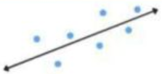 | 0(np² + p³) | 0(p)
Logistic Regression |  | 0(np) | 0(p)
Naive Bayes | 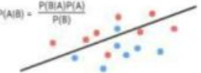 | 0(np) | 0(p)
Decision Tree | 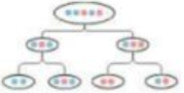 | 0(n log n p) avg | 0(T)
Random Forest | 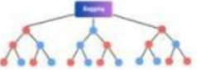 | 0(n log n p T) | 0(T depth)
Gradient Boosted Trees |  | 0(T·nlog n) | 0(T·log n)
Principal Component | 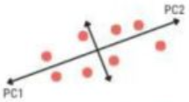 | 0(np² + p³) | 0(pm)
K-Nearest Neighbour | 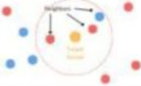 | 0(1) | 0(np)
K-Means | 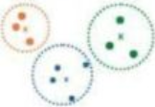 | 0(I·K·n·p) | 0(k·p)
Dense Neural Network | 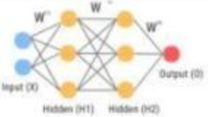 | 0(I·n·p·h) | 0(p·h)

Process
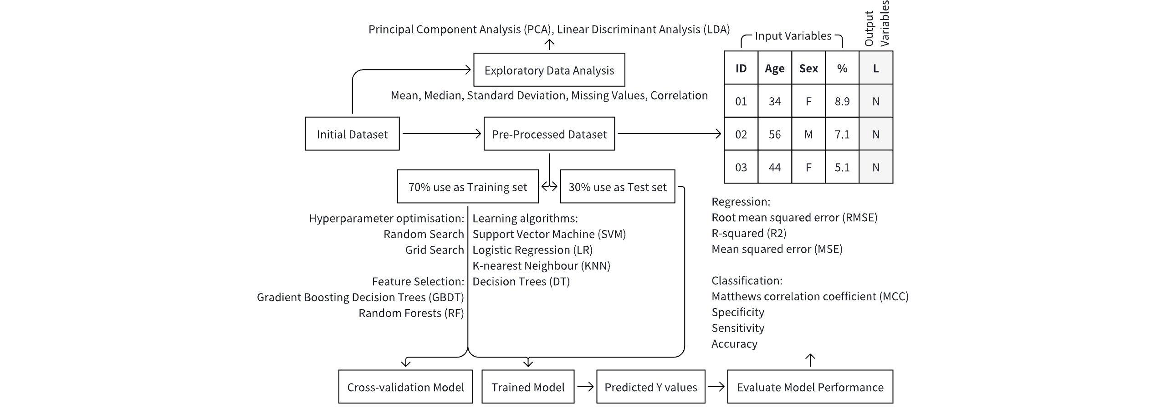

Deep Learning
Machine learning  Handle the prediction on our behalf. | Job Report 2020  World Economic Forum's estimates by 2025 85 million jobs may be displaced | Usage  Human judgement ► rules-based system ► machine learning | Deep learning  A type of algorithm that's adaptable to varying complexities of data and rules
Driving forces  Algorithm, data & computational power | Roadmap  Linear regression ► Non-linear regression ► Binary classification ►Multi-class classification | Neural network (neurons, layers, archictecture)  Predict (weighted sum, activation) ► Measure (cost, metrics) ► Feedback (gradients, backpropagation) ► Adjust (weights, biases) ►
Foundation
Neuron  The smallest unit and the building block of a neural network | Inputs  Positive or negative, no limit to inputs | Weighted sum  Multiplies the input by its corresponding weight | Weights and biases  Parameters of neural network
Activation  Second computation performed by the neuron | Linear activation  For the neural network to express itself | Data  Structured, semi-structured, unstructured | Dataset  Composed of data points, single observation collected
Features  2 pieces of information, describe the properties of a data point  E.g. Distance & Rating | Target  The prediction goal that the neural network is going to make  E.g. Price (of hotel vs. distance) | Training  To get a model from the dataset.  E.g. 0.8, 2.7 ► 147  1.5, 3.6 ► 136 | Testing  A portion of the dataset is used to test the trained model
Linear regression
Error value  The performance of the difference between the predicted and actual | Loss function  The network adjust the parameters to reach its goal | Mean squared error (MSE)  8 error values ► squared error ► averaged to MSE | Minimise loss  The smaller the MSE, the better the network is doing
Weight vs. loss  Adjustment to the parameters will affect the loss | Loss curve  Corresponding MSEs against weight will get a U-shaped curve | Minimum point  Where all the curves reaches its minimum | Gradient  The derivative of an output with respect to its input.
Steepness  Steep curve = large gradient = further from optimal value | Minimum gradient  Gradient = 0, succeed in finding the ideal weight | Magnitude  Informs the neuron how far its prediction is from the actual | Direction  The either side of the curve, negative or positive
Gradient descent  Network goes through multiple training cycles to iminimum point | Weight gradient  Derivative of the loss function with respect to the weight | Learning rate  Value multiplied by the gradient before weight adjustment | Bias  To adjust the position of the function, shifting it up or down
Bias gradient  The derivative of the loss function with respect to the bias | Epoch  Completes one round of training | Performance measure  Cost = internal  Metric = external | Monitoring  MSE continues to improve and converge after many epochs
Non-linear regression
Neural network  Non-linear is more complex will need neuron building blocksj | Architectures  Consist of layers which each layer has its own neurons | Data flow  Neuron receives inputs from preceding and send to next layer | Layer  Consists of input, output and in between is hidden layer.
Input layer  The number input is equivalent to the number of features | Hidden layer  Guided transforms of information into useful forms | Output layer  The final point in the network with prediction model | Backpropagation  Flows back to all neurons so each weight receives its gradient
Error contribution  Larger the input have a greater influence on the output value | Negative gradient  The network will need to increase its weight instead | Linear activation  Returns exactly the same value of the input it receives | Linearity  If all neurons are using linear activation, output is the same
Linear plane  To view it in a 3D aspect, the data points are linear actually | Rectified Linear Unit (ReLU)  Neuron can choose to activate only when the input is positive
Binary classification
Classification  Predicting group in 1 and 0  E.g. Is is a car or a tree | Use cases  Natural language processing (NLP)  Computer vision | Sigmoid  Squeeze the input into value between 0 and 1 | Discretise  Force the output to be either 0 or 1
Probability  After sigmoid, the possible outcome will only be 0 or 1 | Convex loss  A desirable property of a single minimum point | Non-convex loss  More than 1 location and unable to find the global minimum | Accuracy  Total correct ÷ total predictions
True negative (TN)  Both the actual and predicted value are 0 | Fale positive (FP)  Actual value 0 but the predict value is 1 | False negative (FN)  Actual value is 1 but the predicted value is 0 | True positive (TP)  Both the actual and predicted values are 1
Confusion matrix  Measure performance in a balanced way (TN, FP, FN, TP) | Precision and recall  Remove true negatives and give attention to other 3 | F1 score  To provide a balanced emphasis on precision and recall
Multi-class classification
Multi-class  More than 2 possible classes | Softmax activation  Performs exponentiation and normalisation | Exponent  Transform into positive number and amplifies large inputs | Normalise  Each input is divided by the sum of all inputs
Hyperparameters  Cannot be learned by the neural network and have to be provided | Size  Larger neural network is capable of handling more complexity | Batch size  Splitting of large data points into mini batchs | Full batch gradient descent  Parameter adjustments only after an epoch is completed
Stochastic gradient descent  Model may perform updates at every data point | Mini batch gradient descent  In between full batch and stochastic gradient descent | Overfitting  In training, model is too attuned and performs poorly on new data | K-fold cross validation  Cycle through training data where every data point is covered
Bigger picture
Feedforward neural networks  Information flows through the layers in a forward direction | Convolutional neural networks  Using filters to group neurons, typically for image data | Image classification  To predict the class of an image | Object detection  Classification to detect object and regression to detect position
Semantic segmentation  Classification at pixel level with finer definition | Recurrent neural network  Data types with a sequence element, e.g. time-series data | Test classification  Capture the essence of each word to form meaningful context | Machine translation  To translate between different languages
Text generation  To predict the next word | Generative adversarial networks  Create new data points follow the same distribution | Generator  Generate new examples that are distinct from the original | Discriminator  Compete with the generator to determine if the data are real

Large Language Model LLM
LangGraph | A graph-driven framework for building stateful, multi-agent LLM workflows. | - Set app goal | - Build graph nodes
- Add LangChain parts | - Set node states | - Link state steps | - Launch & monitor
- Fix edge cases | - Test full graph | - Run parallel flows | - Add memory support
CrewAI | A coordination framework where role-based LLM agents collaborate to achieve shared tasks. | - Set project goal | - Define agent roles
- Pick base LLMs | - Add agent tools | - Set memory use | - Deliver output
- Refine results | - Trigger execution | - Split into subtasks | - Plan tasks
AutoGen | A multi-agent system that enables AI agents to work together through conversations. | - Set task goal | - Create agents
- Assign roles | - Attach LLMs | - Enable agent chat | - Run till complete
- Improve replies | - Add human feedback | - Simulate live chats | - Plan task steps
LangChain | A developer-focused toolkit to create LLM-powered apps with chains, tools, and memory. | - Pick LLM provider | - Make prompt templates
- Build chain modules | - Add useful tools | - Link external data | - Keep updated
- Deploy app | - Refine logic | - Test prompt results | - Set up memory

LLM Types
GPT (General Pretrained Transformer)  - Tokenization of Input  - Model Architecture Processes Tokens  - Pretrained Knowledge Applied  - Contextual Text Prediction  - Output | MoE (Mixture of Experts)  - Tokenization of Input  - Gating Network  - Expert 1 | Expert 2 | … | Expert n  - Select Experts  - Combine Outputs  - Output | LRM (Large Reasoning Models)  - Tokenization of Input  - Decompose Problem  - Internal CoT Reasoning  - Answer 1 | Answer 2  - Self-Reflection & Verification  - Output | VLM (Vision Language Models)  - Divide the input  - Visual/Image → Image Encoder  - Text → Text Encoder  - Multimodal fusion  - Build Text Conclusion  - Output
SLM (Small Language Models)  - Tokenization of Input  - Embed tokens (plus positional information)  - Compact Transformer Process  - Sample next tokens  - Output | LAM (Large Action Models)  - Parse Goal and Context  - Task Breakdown  - Task 1 | Task 2 | Task 3  - Use Tools  - Compile Output  - Verify & Adapt  - Output | HRM (Hierarchical Reasoning Model)  - Encode Problem State  - High-Level Planning (Slow) | Low-Level Computation (Faster)  - H updates G using L’s result and resets L  - Hierarchical Convergence  - Decode Output  - Output | LCM (Large Concept Model)  - SONAR Embedding  - PreNet Normalize & Map  - Diffusion refinement  - One Tower | Two Tower  - PostNet Map Back  - Concept Decoding  - Output

Artificial Neural Network ANN
Feedforward Neural Network (FNN)  - Also known as Artificial Neural Network (ANN)  - Perceptron is a single layer neural network (binary)  - Also known as Multilayer Perceptron (MLP)  - Global basis functions (sigmoid)  - Require non-linear regression, i.e. using an optimization algorithm to minimize error and that down the regression  - Non-linear regression = have a little variation  - Better at approximating sparse data  - More accurate for non-uniform point distribution, again mainly because cross-validation works better for uniformly dense sets  - When using ensembles, typically 4500 neural networks must be computed individually (including the ensembles and hidden nodes options) could take days  - Σ(j) W(j)X(j)+B W = weight X = node B = bias k = period l = layer j = neuron |  | Radial Basis Function (RBF)  - Localised basis functions (e.g. Gaussian)  - Using linear regression (if the spread (S) and number of basis functions (m) is fixed)  - Cross-validation in the outer loop of the regression to determine m and S. Cross-validation means that we minimise the PRESS error over m and S to theoretically get the best predictor  - In uniformly dense sets it may be better since, theoretically, cross-validation should provide a more accurate response surface  - A single design point (i.e. a converged solution), using the default SRSM (sequential) approach with linear basis functions (the default approach) is still the best and cheapest  - E.g. a power grid fails, it will find the most effective route to patch back  - Φ(x,c) = Φ(‖x-c ‖)  - Anything that satisfy the above formula is RBF x is the node, c is the center  - Φ is Phi, the golden number, 1.618 (‖x-c ‖) is the norm of the vector  - Φ(r) = e(-( εr)2)  - This is the Gaussian model r = ‖x-x(i) ‖ (i the previous node) e is Euler number, 2.718 ε is Epsilon, the definition of limit
Modular Neural Network
- Multiple neural network
Kohonen Self-Organizing Map Neural Network (SOM)  - Finding the outline of an image and will map to the nearest vector  - Does not handle categorical variables well, computationally expensive & potentially inconsistent solutions  - Each node’s weight is initialised  - A vector is chosen randomly from the training dataset  - The winning node that are most like the input vector become the Best Matching Unit (BMU)  - BMU’s neighbour is calculated and decrease overtime  - BMU and its neighbour become more like the sample vector and learn less as it farther  - Repeat step 2 for N iterations  - W(v)(s+1) = W(v)(s) + θ(u,v,s) · α(s) · (D(t) - W(v)(s))  - W(v) is the current weight vector of node v  - s is the current iteration  - u is the index of the best matching unit (BMU) in the map  - v is the index of the node in the map  - t is the index of the target input data vector in the input data set D  - θ(u,v,s) is a restraint due to distance from BMU, usually called the neighbourhood function  - α(s) is a learning restraint due to iteration progress  - D(t) is a target input data vector |  | Recurrent Neural Network (RNN)  - Common associated with Long Short-Term Memory (LSTM) (h(t )= tanh(C(t)) · o(t))  - Elman and Jordan (y(t) = σ(h)(W(y)h(t) + b(y))  - Gate Recurrent Unit (GRU) (h(t) = (1−z(t)) · h(t−1) + z(t) · ħ(t))  - Continuous-time (CTRNN) - neuron of the incoming spike train, postsynaptic node  - Ideal for time base data processing  - Also used for speech and translation  - Include the brute force approach – predict and train child network using all possible neural network
Convolutional Neural Network
- Max pooling (sample-based discretization process; down-sampling) One of max pooling property is that it is non-convexity
- Average pooling (instead of the highest probable nodes, it averages the nodes)
- Also known as AlexNet
- Common image dataset can be found at Canadian Institute For Advanced Research (CIFAR)
- An improvement version is called the Capsule Neural Network
- Pretrained image datasets: VGG, ResNet50, Inception (GoogLeNet), Xception, Residual Network
Energy based Neural Network  - Traditional model using electrical pulse  - Using model paradigm, generative model  - Undirected, e.g. Restricted Boltzmann Machine (RBM)  - Gating – max entropy to obtain energy-based models for binary gate |  | Autoencoder  - Learn efficient data coding in an unsupervised manner  - Compress data from the input layer into a short code, and then uncompress that code into something that closely matches the original data  - E.g. learning how to ignore noise  - z = σ(Wx + b)

Quantitative Neural Network
Neural network does not make any forecast and instead they predict the price data and uncover opportunities | Example  Using MLP with OHLCV tuple for MACD, Ichimoku Cloud, RSI and volatility)  Objective is to skip sideways movement  [(‘Total Return’, ‘1.66%’), (‘Sharpe Ratio’, ‘16.27’), (‘Max Drawdown’, ‘2.28%’),  (‘Drawdown Duration’, ‘204’)]  Signals: 9 Orders: 9 Fills: 9  [(‘Total Return’, ‘3.07%’), (‘Sharpe Ratio’, ‘27.99’), (‘Max Drawdown’, ‘1.91%’),  (‘Drawdown Duration’, ‘102’)]  Signals: 7 Orders: 7 Fills: 7
Potential adjustments | Forecast something different (e.g. volatility) | Use multimodal learning on different data source | Mixed of different classical

Human Brain Comparison
Dendrites (input)  - Model Evaluation – good fit between model and data Confidence Interval – how reliable a statistical estimate is Confusion Matrix – context of clustering Gain and Life Chart – ratio of result with and without the predictive model Kolmogorov-Smirnov Chart – compare distributions under nonparametric Gini Coefficient – classification problems Cross Validation – how the model will perform in the future Predictive Power – concept of entropy or Gini index  - Single-variable selection techniques Chi-square test CHAID stump using Chi-square test Association Rules Confidence, 1 antecedent ANOVA Kolmogorov-Smirnov (K-S) distance, two sample tests Linear regression forward selection (1 step) Principal component analysis |  | Axon (output)  - Activations functions  - Sigmoid function – 0 to 1 | σ(z) = 1 / (1+e(-z))  - Threshold (Step) function – 0 or 1 | y = 0, x<n; 1, x≥n  - Rectified Linear Unit (ReLU) function – correct non-linear input | R(z) = max(0, z)  - Leaky ReLU – fix ReLU problem with 0.01 allowance | max(0.1x,x)  - Hyperbolic tangent (tanh) function – -1 to 1 | tanh(z) = 1-tanh(2)(z)  - Exponential Linear Unit (ELU)  - Deeply-supervised Net (DSB) – under CNN  - Network-in-Network (NiN) – micro network  - Maxout – maximum of multiple possible outputs  - Highway network – regulate info flow  - Expected Signal Propagation (ESP) - technique in Bayesian machine learning
Cell nucleus (nodes) x Synapse (weight)
- Transfer function
- Only have AND, NAND, OR, XOR, NOR, NOT
- Layers
- Softmax
Predictive  - Sample, Explore, Modify, Model, Access (SEMMA) | Human brain structure  - Processing Neuron Nervous System  - Implicit Memory Procedural (muscle memory) Priming (external correlation) Classical conditioning (internal correlation)  - Explicit Memory Semantic (knowledge and facts) Episodic (Life’s events)  - Stages Sensory (all the senses) Working (short term and temporary) Long term (storage) | General intelligence  - g factor (psychometric: cognitive abilities & human intelligence)  - Neuromorphic processor  - Turing test and Lovelace test  - 4(th) quadrant of math (highest point between abstraction and application) | Hyper intelligent  - Could be achieved with quantum processor (qubit)  - Computer be so smart it will have thought we are just like cockroaches

9 types of intelligence
Intrapersonal | Spatial | Naturalist | Musical
Logical-mathematical | Existential | Interpersonal | Bodily-kinesthetic
Linguistic

Generative AI
LLM (Large Language Model)  AI Systems  Advanced AI systems trained on vast text datasets to understand and generate human-like text, foundational for modern AI and content generation. | Transformers  Transformer Architecture  Revolutionary neural network architecture using self-attention mechanisms to process sequential data for language understanding and generation. | Prompt Engineering  AI Instruction Design  Strategic formulation of inputs to AI models to achieve desired outputs by combining instructions, context, and constraints for optimal results. | Fine-tuning  Model Specialization  Process of adapting pre-trained AI models to specific tasks by training on specialized datasets, enhancing targeted performance.
Embeddings  Vector Representations  Numerical representations of text or images in high-dimensional space for semantic search and efficient AI processing. | RAG (Retrieval Augmented Generation)  Retrieval Technique  Technique combining knowledge retrieval with text generation for accurate, factual responses by accessing external information during generation. | Tokens  Text Units  Fundamental units of text processing, such as words or characters, determining model capacity and processing limitations. | Hallucination  AI Fabrication  Phenomenon where AI generates plausible but factually incorrect information, posing challenges for reliable outputs.
Zero-shot  Zero-shot Learning  AI capability to perform tasks without specific training examples, using general knowledge to understand instructions. | Chain-of-Thought  Reasoning Process  Prompting technique encouraging AI models to break tasks into step-by-step processes for accuracy and explainability. | Context Window  Input Capacity  Maximum amount of text an AI model can process in a single interaction, affecting coherence and reference information. | Temperature  Randomness Parameter  Control parameter that affects AI's randomness and creativity, balancing deterministic and creative variations.

Agentic AI
- Ops & Governance Layer
Deployment Pipelines | Cost Optimization (CO) | No-Code / Low-Code Builders | Observability Tools
Governance & Policy Engines | Data Privacy Enforcement | Resource Management (Quota, Budget) | Agent Registries & Discovery
Logging & Auditing | Trust Frameworks
- Application Layer
Personal Assistant | Creation Tools (Image/Video/Code) | Entertainment (Games, Music, Storytelling) | E-Commerce Agents (Recommendations, Buying Agents)
Research Agents | Scheduling / Automation Bots | Learning Agents | Collaborative Writing / Document Agents
Platform Agents (Slack, Discord, Notion) | Security & Watchdog Agents
- Memory & Personalization Layer
Working Memory (WM) | Long-Term Memory (LM) | Identity Module (ID) | Preference Engine (PRF)
Personal Profiles | Conversation History | Behavior Modeling | Emotional Context Storage
Goal History Tracker | Tool Usage History
- Cognition & Reasoning Layer
Planning (PL) | Decision Making (DM) | Self-Improvement (SI) | Error Handling (EH)
Reasoning Engine (R) | Reactivity & Adaptation | Goal Management (G) | Guardrails & Ethics Engine
Feedback Loop (GF) | Multi-Step Task Handling
- Tooling & Enrichment Layer
Retrieval-Augmented Generation (RAG) | Vector DBs (Chroma, FAISS) | External Tool Use | Browsing Modules
Function Calling (OpenAI Tools, LangChain Tools) | Environment Interfaces | Code Execution Sandbox | Calculator / Python REPL
Knowledge Bases | Plugin Integration Layer
- Protocol Layer
A2A (Agent-to-Agent Protocol) | MCP (Model Context Protocol) | ACP (Agent Capability Protocol) | ANP (Agent Negotiation Protocol)
AGORA | AGP (Agent Gateway Protocol) | TAP (Tool Abstraction Protocol) | OAP (Open Agent Protocol)
FCP (Function Call Protocol)
- Agent Internet Layer
Autonomous Agents | Multi-Agent Systems | Communication Protocols | Agent Memory (Short/Long-Term)
Embedding Stores (Pinecone, Weaviate) | Agent Mesh Networks | Agent Identity & State | Execution Environments
Tool Use Modules | Agent Actions API
- Infrastructure Layer
APIs (REST, GraphQL) | HTTP / WebSockets | GPU / TPU / Cloud | Data Centers
Data Lakes / Warehouses | Orchestration Engines (Airflow, Prefect) | Load Balancers | CDN (Content Delivery Networks)
Storage (S3, GCS) | Monitoring Tools (Prometheus, Grafana)

Organisation
- Value & Portfolio The bets the business makes, and how it proves they paid
Agentic business model | Use-case portfolio | ROI / value thresholds | Zero-marginal-cost economics | Outcome ownership
- Operating Model & Workflows How work is redesigned around human + agent teams
Agentic workflow redesign | Human + agent teams | Agent factory | Decision rights | Flatter structure
- People, Roles & Culture Humans move above the loop, not out of it
Reskilling at scale | Humans above the loop | Judgment & apprenticeship | Leadership role-modelling | Continuous reinvention
- Agent Platform & Orchestration The shared platform the enterprise runs every agent on
Agent registry | Orchestrator + task agents | Agent-to-agent (A2A) | Model Context Protocol (MCP) | Agentic mesh
- Data, Knowledge & Ontology The company's knowledge, encoded so agents can use it
Governed data access | Ontology & semantic layer | Knowledge graphs | Long-running memory | Real-time streaming
- Trust, Governance & Control Who answers for what agents do on the company's behalf
Agent identity & access | Runtime guardrails | Observability & tracing | Policy enforcement | Accountability & audit

History of AI
1943  McCullock & Pitts publish a paper titled "A Logical Calculus of Ideas Immanent in Nervous Activity", proposing the ground work neural networks | 1950  Turing publishes "Computing Machinery and Intelligence", proposing the Turing Test as a way to measure a machine's ability | 1951  Marvin Minsky and Dean Edmonds build SNAR, the first neural network computer | 1956  The Dartmouth Conference (organised by McCarthy, Minsky, Rochester, and Shannon) is held, marking the birth of AI as a field of study
1957  Rosenblatt develops the Perceptron: the first artificial neural network capable of learning | 1965  Weizenbaum develops ELIZA: a natural language processing program that simulates conversation | 1967  Newell and Simon develop the General Problem Solver (GPS), one of the first AI programs to demostrate human-like problem-solving | 1974  The first AI winter begins, marked by a decline in funding and interest in AI research due to unrealistic expectations and limited progress
1980  Expert systems gain popularity, with companies using them for financial forecasting and medical diagnoses | 1986  Hinton, Rumelhard, and William publish "Learning Representations by Back-Propagating Errors", allowing much deeper neural networks to be trained | 1997  IBM's Deep Blue defeats chess world champion Kasparov, marking the first time a computer beats a world champion in a complex game | 2002  iRobot introduces Roomba, the first mass-producted domestc robot vaccum cleaner with an AI-powered navigation system
2011  IBM's Watson defeats two former Jeopardy! champions | 2012  AI startup DeepMind develops a deep neural network that can recognise cats in YouTube videos | 2014  Facebook creates DeepFace, a facial recognition system that can recognise faces with near-human accuracy | 2015  AlphaGo, developed by DeepMind, defeats world champion Lee Sedol in the game of Go
2017  Google's AlphaZero defeats the world's best chess and shogi engine in a series of matches | 2020  OpenAI releases GPT-3, marking a significant breakthrough in natural language processing | 2021  DeepMind's AlphaFold2 solves the protein-folding problem, paving the way for new drug discoveries and medical breakthroughs | 2022  Google tires engineer Blake Lemonie over his claims that Google's Language Model for Dialogue Applications (LaMDA) was sentient
2023
Artists file a class-action lawsuit against Stability AI, DeviantArt, and Mid-journey for their use of Stable Diffusion to remix the copyrighted works of millions of artists

Energy Usage
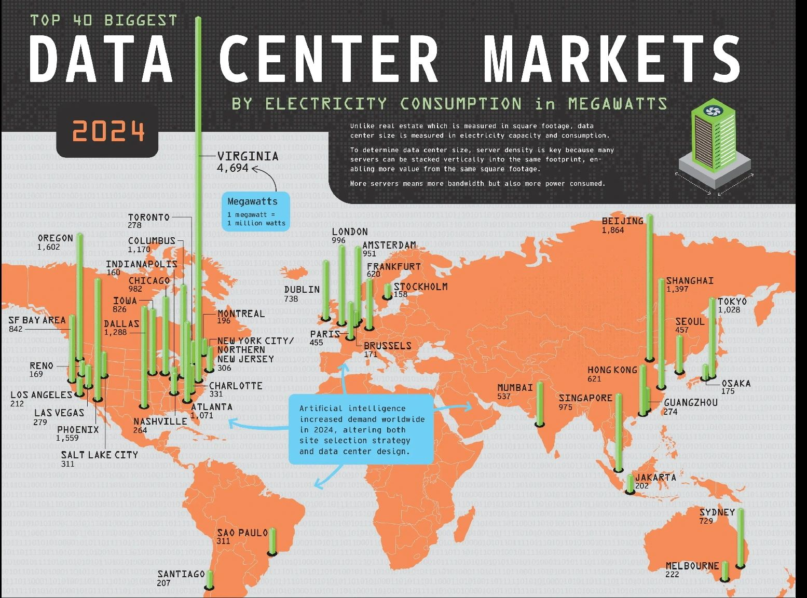

AI Career
Data Engineer  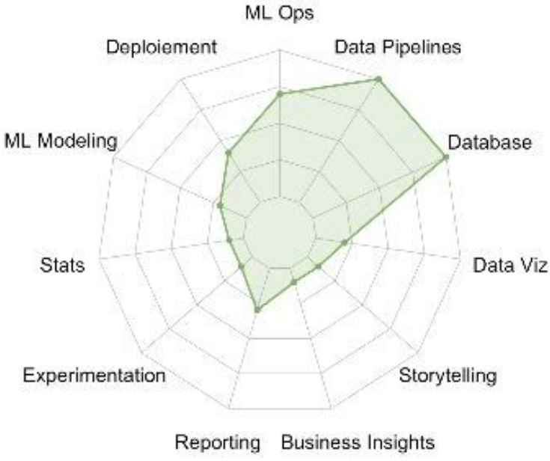 | ML Engineer  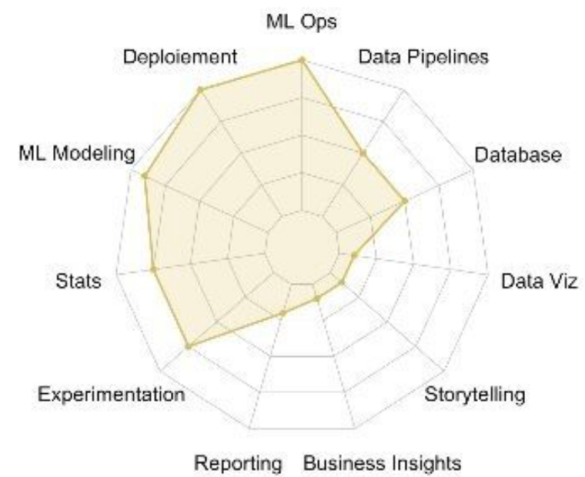 | Data Scientist  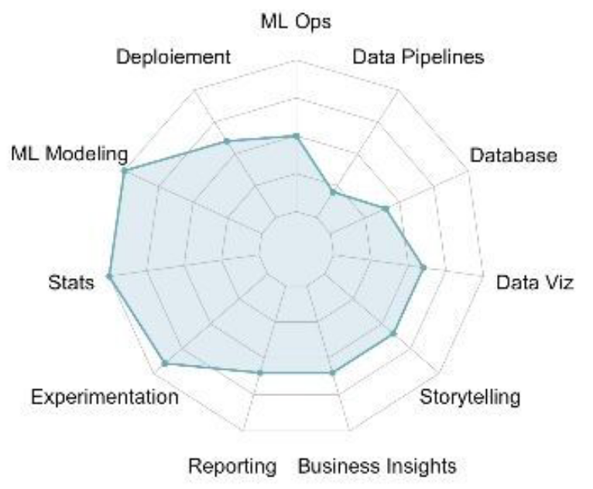 | Data Analyst  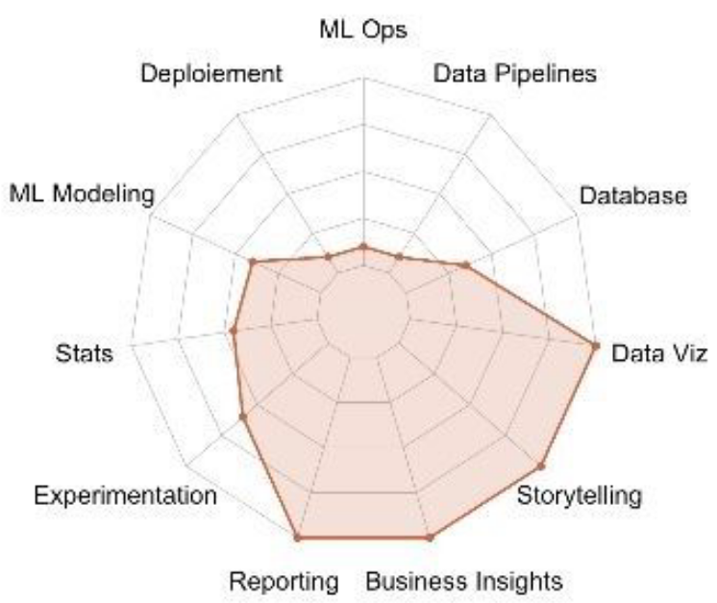
AI Engineer Roadmap
Intro to AI  What is AI, impact, future trends, applications | Mathematics  Statistics, probability, linear algebra calculus | Programming  Python, R, Java | Big data  Hadoop, Spark, Cassandra, MongoDB
Data science  Acquisition, preparation, data analysis, data manipulation | Machine learning  Scikit learn | supervised learning | linsupervised learning | reinforcement learning | Deep learning  TensorFlow, Keras, Neural Networks, CNN, RNN, GAN, LSTMS | Business intelligence  Tableau, Quilkview, PowerBI

