Big_Experiment_Analyses

Hamza

1 June 2019

# Boxplot

Comparing between sexes and treatment groups over time. The treatment groups continue to gain more weight, and as expected, females are always heavier (in both groups) 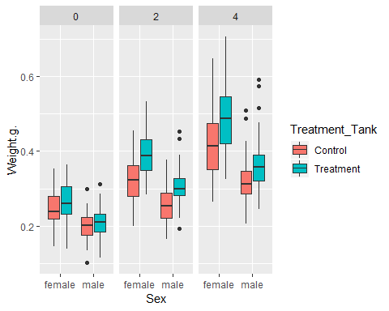

# Individual growth

I thought it would be intersting to see the indvidual growth trajectories. I suspect the zebrafish hierachy is coming into play. Some fish in the control group are still getting obese quick because they’re dominating; while some fish in the treatment group aren’t gaining weight as fast because they’re subdued. 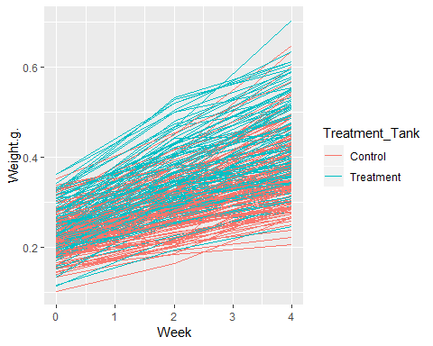

# Summary

Summary

|  |  |  |  |  |  |  |  |
| --- | --- | --- | --- | --- | --- | --- | --- |
| Week | Tank | Treatment_Tank | N | Weight.g. | sd | se | ci |
| 0 | HA_C1 | Control | 23 | 0.2213913 | 0.0468030 | 0.0097591 | 0.0202391 |
| 0 | HA_C2 | Control | 24 | 0.2255833 | 0.0493646 | 0.0100765 | 0.0208448 |
| 0 | HA_C3 | Control | 24 | 0.2363333 | 0.0486046 | 0.0099214 | 0.0205239 |
| 0 | HA_C4 | Control | 24 | 0.2240833 | 0.0487406 | 0.0099491 | 0.0205813 |
| 0 | HA_C5 | Control | 24 | 0.2115417 | 0.0510703 | 0.0104247 | 0.0215651 |
| 0 | HA_T1 | Treatment | 24 | 0.2489583 | 0.0484736 | 0.0098946 | 0.0204686 |

# Line plot (body weight)

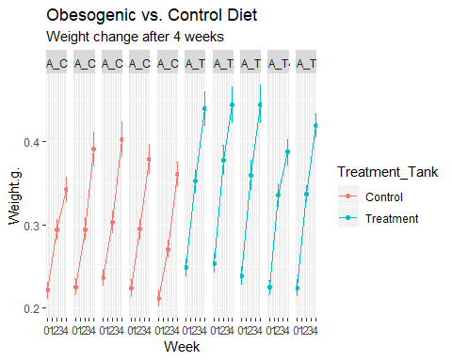

# Mixed Model

Weight g

Predictors

Estimates

CI

p

(Intercept)

0.25

0.24 – 0.26

<0.001

Treatment_TankTreatment

0.04

0.03 – 0.05

<0.001

Week

0.04

0.04 – 0.04

<0.001

Sexmale

-0.08

-0.09 – -0.06

<0.001

Random Effects

σ2

0.00

τ00 Fish_ID

0.00

ICC Fish_ID

0.58

Observations

719

Marginal R2 / Conditional R2

0.647 / 0.852

The results indicate the treatment is working, and as expected, females are significantly heavier. It’s interesting that the control group is still gaining weight. I assume this will even out soon enough while the treatment group continues to gain weight. Every week we are seeing significant changes in weight.

# Body Length Analysis

# Summary (Body Length)

Summary_Length_Tank

|  |  |  |  |  |  |  |
| --- | --- | --- | --- | --- | --- | --- |
| Week | Tank | N | Fish_Length_cm | sd | se | ci |
| 0 | HA_C1 | 23 | 2.351261 | 0.4558341 | 0.0950480 | 0.1971175 |
| 0 | HA_C2 | 24 | 2.772833 | 0.2282346 | 0.0465882 | 0.0963750 |
| 0 | HA_C3 | 24 | 2.564667 | 0.1531781 | 0.0312674 | 0.0646814 |
| 0 | HA_C4 | 24 | 2.476792 | 0.1581037 | 0.0322728 | 0.0667613 |
| 0 | HA_C5 | 24 | 2.243167 | 0.2726161 | 0.0556475 | 0.1151157 |
| 0 | HA_T1 | 24 | 2.653167 | 0.1847915 | 0.0377204 | 0.0780306 |
| 0 | HA_T2 | 24 | 2.660958 | 0.1769440 | 0.0361185 | 0.0747169 |
| 0 | HA_T3 | 24 | 2.531333 | 0.1816168 | 0.0370724 | 0.0766901 |
| 0 | HA_T4 | 24 | 2.483458 | 0.1776119 | 0.0362549 | 0.0749989 |
| 0 | HA_T5 | 24 | 2.566667 | 0.1881758 | 0.0384112 | 0.0794597 |
| 2 | HA_C1 | 24 | 2.807250 | 0.1989910 | 0.0406189 | 0.0840265 |
| 2 | HA_C2 | 24 | 2.856583 | 0.1827685 | 0.0373075 | 0.0771764 |
| 2 | HA_C3 | 24 | 2.698542 | 0.1767312 | 0.0360751 | 0.0746270 |
| 2 | HA_C4 | 24 | 2.816167 | 0.1598822 | 0.0326358 | 0.0675123 |
| 2 | HA_C5 | 24 | 2.745167 | 0.1693886 | 0.0345763 | 0.0715265 |
| 2 | HA_T1 | 24 | 2.936333 | 0.1476876 | 0.0301466 | 0.0623630 |
| 2 | HA_T2 | 24 | 3.058917 | 0.1527285 | 0.0311756 | 0.0644916 |
| 2 | HA_T3 | 24 | 2.990000 | 0.1893573 | 0.0386524 | 0.0799586 |
| 2 | HA_T4 | 24 | 2.933667 | 0.1877141 | 0.0383170 | 0.0792647 |
| 2 | HA_T5 | 24 | 2.931167 | 0.1319762 | 0.0269395 | 0.0557287 |
| 4 | HA_C1 | 24 | 3.014875 | 0.1766087 | 0.0360501 | 0.0745753 |
| 4 | HA_C2 | 24 | 3.132958 | 0.1890683 | 0.0385934 | 0.0798365 |
| 4 | HA_C3 | 24 | 3.101667 | 0.2030193 | 0.0414411 | 0.0857275 |
| 4 | HA_C4 | 24 | 3.047000 | 0.1651076 | 0.0337024 | 0.0697188 |
| 4 | HA_C5 | 24 | 2.978875 | 0.1696206 | 0.0346237 | 0.0716245 |
| 4 | HA_T1 | 24 | 3.287917 | 0.2239561 | 0.0457149 | 0.0945684 |
| 4 | HA_T2 | 24 | 3.281958 | 0.1949449 | 0.0397930 | 0.0823180 |
| 4 | HA_T3 | 24 | 3.230083 | 0.1583562 | 0.0323243 | 0.0668680 |
| 4 | HA_T4 | 24 | 3.189750 | 0.1844624 | 0.0376532 | 0.0778916 |
| 4 | HA_T5 | 24 | 3.210167 | 0.1331170 | 0.0271724 | 0.0562104 |

Summary_Length_Treatment

|  |  |  |  |  |  |  |
| --- | --- | --- | --- | --- | --- | --- |
| Week | Treatment_Tank | N | Fish_Length_cm | sd | se | ci |
| 0 | Control | 119 | 2.482840 | 0.3261228 | 0.0298956 | 0.0592015 |
| 0 | Treatment | 120 | 2.579117 | 0.1917333 | 0.0175028 | 0.0346572 |
| 2 | Control | 120 | 2.784742 | 0.1838187 | 0.0167803 | 0.0332266 |
| 2 | Treatment | 120 | 2.970017 | 0.1682418 | 0.0153583 | 0.0304110 |
| 4 | Control | 120 | 3.055075 | 0.1868280 | 0.0170550 | 0.0337706 |
| 4 | Treatment | 120 | 3.239975 | 0.1827955 | 0.0166869 | 0.0330417 |

Summary_Length_All

|  |  |  |  |  |  |  |  |
| --- | --- | --- | --- | --- | --- | --- | --- |
| Week | Treatment_Tank | Tank | N | Fish_Length_cm | sd | se | ci |
| 0 | Control | HA_C1 | 23 | 2.351261 | 0.4558341 | 0.0950480 | 0.1971175 |
| 0 | Control | HA_C2 | 24 | 2.772833 | 0.2282346 | 0.0465882 | 0.0963750 |
| 0 | Control | HA_C3 | 24 | 2.564667 | 0.1531781 | 0.0312674 | 0.0646814 |
| 0 | Control | HA_C4 | 24 | 2.476792 | 0.1581037 | 0.0322728 | 0.0667613 |
| 0 | Control | HA_C5 | 24 | 2.243167 | 0.2726161 | 0.0556475 | 0.1151157 |
| 0 | Treatment | HA_T1 | 24 | 2.653167 | 0.1847915 | 0.0377204 | 0.0780306 |
| 0 | Treatment | HA_T2 | 24 | 2.660958 | 0.1769440 | 0.0361185 | 0.0747169 |
| 0 | Treatment | HA_T3 | 24 | 2.531333 | 0.1816168 | 0.0370724 | 0.0766901 |
| 0 | Treatment | HA_T4 | 24 | 2.483458 | 0.1776119 | 0.0362549 | 0.0749989 |
| 0 | Treatment | HA_T5 | 24 | 2.566667 | 0.1881758 | 0.0384112 | 0.0794597 |
| 2 | Control | HA_C1 | 24 | 2.807250 | 0.1989910 | 0.0406189 | 0.0840265 |
| 2 | Control | HA_C2 | 24 | 2.856583 | 0.1827685 | 0.0373075 | 0.0771764 |
| 2 | Control | HA_C3 | 24 | 2.698542 | 0.1767312 | 0.0360751 | 0.0746270 |
| 2 | Control | HA_C4 | 24 | 2.816167 | 0.1598822 | 0.0326358 | 0.0675123 |
| 2 | Control | HA_C5 | 24 | 2.745167 | 0.1693886 | 0.0345763 | 0.0715265 |
| 2 | Treatment | HA_T1 | 24 | 2.936333 | 0.1476876 | 0.0301466 | 0.0623630 |
| 2 | Treatment | HA_T2 | 24 | 3.058917 | 0.1527285 | 0.0311756 | 0.0644916 |
| 2 | Treatment | HA_T3 | 24 | 2.990000 | 0.1893573 | 0.0386524 | 0.0799586 |
| 2 | Treatment | HA_T4 | 24 | 2.933667 | 0.1877141 | 0.0383170 | 0.0792647 |
| 2 | Treatment | HA_T5 | 24 | 2.931167 | 0.1319762 | 0.0269395 | 0.0557287 |
| 4 | Control | HA_C1 | 24 | 3.014875 | 0.1766087 | 0.0360501 | 0.0745753 |
| 4 | Control | HA_C2 | 24 | 3.132958 | 0.1890683 | 0.0385934 | 0.0798365 |
| 4 | Control | HA_C3 | 24 | 3.101667 | 0.2030193 | 0.0414411 | 0.0857275 |
| 4 | Control | HA_C4 | 24 | 3.047000 | 0.1651076 | 0.0337024 | 0.0697188 |
| 4 | Control | HA_C5 | 24 | 2.978875 | 0.1696206 | 0.0346237 | 0.0716245 |
| 4 | Treatment | HA_T1 | 24 | 3.287917 | 0.2239561 | 0.0457149 | 0.0945684 |
| 4 | Treatment | HA_T2 | 24 | 3.281958 | 0.1949449 | 0.0397930 | 0.0823180 |
| 4 | Treatment | HA_T3 | 24 | 3.230083 | 0.1583562 | 0.0323243 | 0.0668680 |
| 4 | Treatment | HA_T4 | 24 | 3.189750 | 0.1844624 | 0.0376532 | 0.0778916 |
| 4 | Treatment | HA_T5 | 24 | 3.210167 | 0.1331170 | 0.0271724 | 0.0562104 |

# Line plot (body weight) for tanks

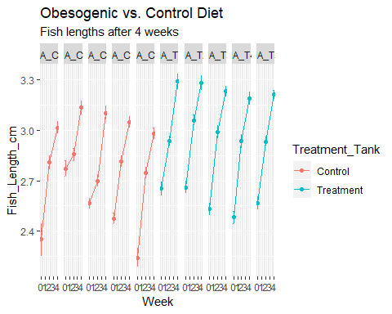 # Line plot for treatments

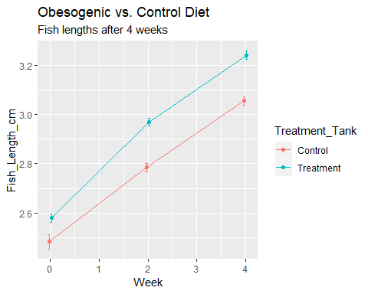 #Summary (BMI)

Summary_BMI_Treatment

|  |  |  |  |  |  |  |
| --- | --- | --- | --- | --- | --- | --- |
| Week | Treatment_Tank | N | BMI | sd | se | ci |
| 0 | Control | 119 | 0.0380688 | 0.0160183 | 0.0014684 | 0.0029078 |
| 0 | Treatment | 120 | 0.0354360 | 0.0047426 | 0.0004329 | 0.0008573 |
| 2 | Control | 120 | 0.0373389 | 0.0054464 | 0.0004972 | 0.0009845 |
| 2 | Treatment | 120 | 0.0398095 | 0.0064680 | 0.0005904 | 0.0011691 |
| 4 | Control | 120 | 0.0398095 | 0.0068197 | 0.0006226 | 0.0012327 |
| 4 | Treatment | 120 | 0.0403734 | 0.0067656 | 0.0006176 | 0.0012229 |

Summary_BMI_All

|  |  |  |  |  |  |  |  |
| --- | --- | --- | --- | --- | --- | --- | --- |
| Week | Treatment_Tank | Tank | N | BMI | sd | se | ci |
| 0 | Control | HA_C1 | 23 | 0.0474952 | 0.0319982 | 0.0066721 | 0.0138371 |
| 0 | Control | HA_C2 | 24 | 0.0292116 | 0.0045021 | 0.0009190 | 0.0019011 |
| 0 | Control | HA_C3 | 24 | 0.0356906 | 0.0049865 | 0.0010179 | 0.0021056 |
| 0 | Control | HA_C4 | 24 | 0.0361910 | 0.0050728 | 0.0010355 | 0.0021420 |
| 0 | Control | HA_C5 | 24 | 0.0421485 | 0.0082766 | 0.0016895 | 0.0034949 |
| 0 | Treatment | HA_T1 | 24 | 0.0351727 | 0.0048882 | 0.0009978 | 0.0020641 |
| # Line | plot (BMI) |  |  |  |  |  |  |

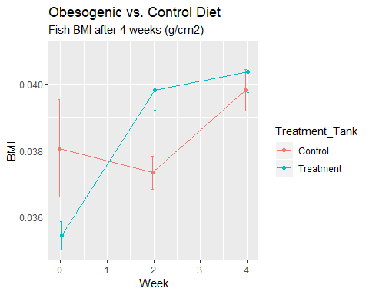 #line plot for BMI (tanks) 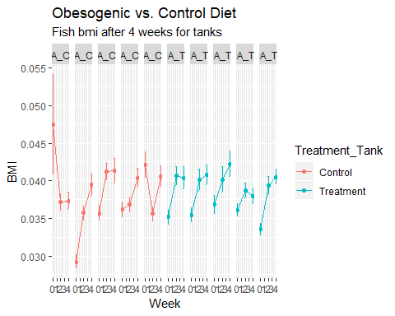 #Scatterplot of Weight and BMI

Scatterplot <- ggplot(Data, aes(x=Weight.g., y=BMI, shape = Treatment_Tank, color = Treatment_Tank)) +   
 geom_point()+  
 geom_smooth(method=lm, se=FALSE, fullrange=TRUE)  
Scatterplot

