Cleaned Results

Hamza

30 September 2019

## Meta-analysis

### Calculating effect sizes

Here, we calculated our effect sizes (log response ratio lnRR) for our complete data set (all traits).

#Import data  
ALL_TRAITS <- read_excel("C:\\Users\\hamanw\\Dropbox\\Meta Analysis Project\\Extraction\\Transgenerational Meta-Analysis\\R\\data\\ALL_TRAITS.xlsx")

## readxl works best with a newer version of the tibble package.  
## You currently have tibble v1.4.2.  
## Falling back to column name repair from tibble <= v1.4.2.  
## Message displays once per session.

MG_ALL <- read_excel("C:\\Users\\hamanw\\Dropbox\\Meta Analysis Project\\Extraction\\Transgenerational Meta-Analysis\\R\\data\\MG_ALL.xlsx")  
  
OF_ALL <- read_excel("C:\\Users\\hamanw\\Dropbox\\Meta Analysis Project\\Extraction\\Transgenerational Meta-Analysis\\R\\data\\OF_ALL.xlsx")  
  
Overall_effect_size <- read_excel("C:\\Users\\hamanw\\Dropbox\\Meta Analysis Project\\Extraction\\Transgenerational Meta-Analysis\\R\\data\\Overall effect size.xlsx")  
  
Overall_MG_OF <- read_excel("C:\\Users\\hamanw\\Dropbox\\Meta Analysis Project\\Extraction\\Transgenerational Meta-Analysis\\R\\data\\Overall_MG_OF.xlsx")  
  
Overall_effects_not_split <- read_excel("C:\\Users\\hamanw\\Dropbox\\Meta Analysis Project\\Extraction\\Transgenerational Meta-Analysis\\R\\data\\Overall_effects_not_split.xlsx")  
  
Table_results_overall <- read_excel("C:\\Users\\hamanw\\Dropbox\\Meta Analysis Project\\Extraction\\Transgenerational Meta-Analysis\\R\\data\\Table results.xlsx")

## Meta-analysis

### Calculating effect sizes

Here, we calculated our effect sizes (log response ratio lnRR) for our complete data set (all traits). 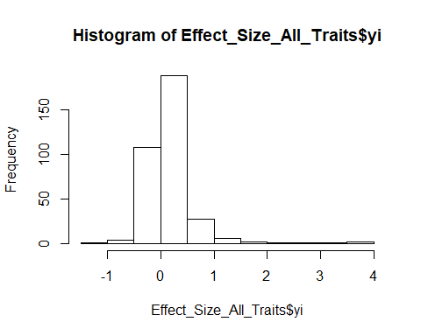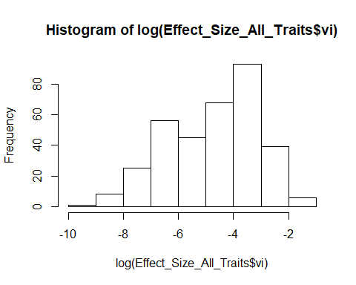

### Deciding random effects

We used AIC values to decide which random effects to use. Combining “Trait”, “Paper_ID” and “Cohort_ID” yielded the lowest AIC values.

meta1null <- rma.mv(yi, vi, data=Effect_Size_All_Traits, method = 'ML')   
  
metastudy <- rma.mv(yi, vi,random = ~1|Cohort_ID, data=Effect_Size_All_Traits, method = 'ML')   
anova(meta1null, metastudy)

## df AIC BIC AICc logLik LRT pval  
## Full 2 1378.6372 1386.3010 1378.6727 -687.3186   
## Reduced 1 6089.5148 6093.3467 6089.5266 -3043.7574 4712.8776 <.0001  
## QE  
## Full 7077.4171  
## Reduced 7077.4171

meta0study <- rma.mv(yi, vi,random = list(~1|Paper_ID, ~1|Cohort_ID), data=Effect_Size_All_Traits, method = 'ML')   
anova(meta1null, meta0study)

## df AIC BIC AICc logLik LRT pval  
## Full 3 1313.1434 1324.6390 1313.2146 -653.5717   
## Reduced 1 6089.5148 6093.3467 6089.5266 -3043.7574 4780.3714 <.0001  
## QE  
## Full 7077.4171  
## Reduced 7077.4171

meta1study <- rma.mv(yi, vi,random = ~1|Trait, data=Effect_Size_All_Traits, method = 'ML')   
anova(meta1null, meta1study)

## df AIC BIC AICc logLik LRT pval  
## Full 2 5178.5253 5186.1891 5178.5608 -2587.2627   
## Reduced 1 6089.5148 6093.3467 6089.5266 -3043.7574 912.9895 <.0001  
## QE  
## Full 7077.4171  
## Reduced 7077.4171

metastudy_best <- rma.mv(yi, vi,random = list(~1|Paper_ID,~1|Cohort_ID,~1|Trait), data=Effect_Size_All_Traits, method = 'ML')   
anova(meta0study, metastudy_best)

## df AIC BIC AICc logLik LRT pval  
## Full 4 888.5884 903.9160 888.7075 -440.2942   
## Reduced 3 1313.1434 1324.6390 1313.2146 -653.5717 426.5549 <.0001  
## QE  
## Full 7077.4171  
## Reduced 7077.4171

#### Running meta-analysis (overall, and then overall split by exposure type)

#ALL OF and MG  
  
All_Traits_Analysis_0mods <- rma.mv(yi, vi, random = list(~1|Trait, ~1|Paper_ID,~1|Cohort_ID), data=Effect_Size_All_Traits, method = 'REML')  
  
summary(All_Traits_Analysis_0mods)

##   
## Multivariate Meta-Analysis Model (k = 341; method: REML)  
##   
## logLik Deviance AIC BIC AICc   
## -438.8728 877.7457 885.7457 901.0615 885.8651   
##   
## Variance Components:   
##   
## estim sqrt nlvls fixed factor  
## sigma^2.1 0.0251 0.1584 6 no Trait  
## sigma^2.2 0.0974 0.3121 25 no Paper_ID  
## sigma^2.3 0.0040 0.0629 74 no Cohort_ID  
##   
## Test for Heterogeneity:   
## Q(df = 340) = 7077.4171, p-val < .0001  
##   
## Model Results:  
##   
## estimate se zval pval ci.lb ci.ub   
## 0.2066 0.0909 2.2744 0.0229 0.0286 0.3847 *  
##   
## ---  
## Signif. codes: 0 '***' 0.001 '**' 0.01 '*' 0.05 '.' 0.1 ' ' 1

# Modelling all traits with no mods MG (lnRR)  
All_Traits_Analysis_0mods_MG <- rma.mv(yi, vi, random = list(~1|Trait, ~1|Paper_ID,~1|Cohort_ID), data=MG_ALL, method = 'REML')  
  
summary(All_Traits_Analysis_0mods_MG)

##   
## Multivariate Meta-Analysis Model (k = 118; method: REML)  
##   
## logLik Deviance AIC BIC AICc   
## -365.9658 731.9316 739.9316 750.9803 740.2887   
##   
## Variance Components:   
##   
## estim sqrt nlvls fixed factor  
## sigma^2.1 0.1115 0.3339 6 no Trait  
## sigma^2.2 0.1539 0.3923 13 no Paper_ID  
## sigma^2.3 0.0040 0.0635 24 no Cohort_ID  
##   
## Test for Heterogeneity:   
## Q(df = 117) = 5726.1223, p-val < .0001  
##   
## Model Results:  
##   
## estimate se zval pval ci.lb ci.ub   
## 0.4002 0.1765 2.2679 0.0233 0.0543 0.7460 *  
##   
## ---  
## Signif. codes: 0 '***' 0.001 '**' 0.01 '*' 0.05 '.' 0.1 ' ' 1

#Heterogeneity I2 (adapt for all models)  
W <- diag(1/MG_ALL$vi)  
X <- model.matrix(All_Traits_Analysis_0mods_MG)  
P <- W - W %*% X %*% solve(t(X) %*% W %*% X) %*% t(X) %*% W  
I2_MG <- 100 * sum(All_Traits_Analysis_0mods_MG$sigma2) / (sum(All_Traits_Analysis_0mods_MG$sigma2) + (All_Traits_Analysis_0mods_MG$k-All_Traits_Analysis_0mods_MG$p)/sum(diag(P)))  
I2_MG

## [1] 99.20734

# Modelling all traits with no mods OF (lnRR)  
All_Traits_Analysis_0mods_OF <- rma.mv(yi, vi, random = list(~1|Trait, ~1|Paper_ID,~1|Cohort_ID), data=OF_ALL, method = 'REML')  
  
summary(All_Traits_Analysis_0mods_OF)

##   
## Multivariate Meta-Analysis Model (k = 223; method: REML)  
##   
## logLik Deviance AIC BIC AICc   
## 124.5815 -249.1630 -241.1630 -227.5523 -240.9787   
##   
## Variance Components:   
##   
## estim sqrt nlvls fixed factor  
## sigma^2.1 0.0022 0.0469 6 no Trait  
## sigma^2.2 0.0018 0.0425 16 no Paper_ID  
## sigma^2.3 0.0009 0.0294 52 no Cohort_ID  
##   
## Test for Heterogeneity:   
## Q(df = 222) = 552.2364, p-val < .0001  
##   
## Model Results:  
##   
## estimate se zval pval ci.lb ci.ub   
## 0.0711 0.0249 2.8552 0.0043 0.0223 0.1200 **  
##   
## ---  
## Signif. codes: 0 '***' 0.001 '**' 0.01 '*' 0.05 '.' 0.1 ' ' 1

W <- diag(1/OF_ALL$vi)  
X <- model.matrix(All_Traits_Analysis_0mods_OF)  
P <- W - W %*% X %*% solve(t(X) %*% W %*% X) %*% t(X) %*% W  
I2_OF <- 100 * sum(All_Traits_Analysis_0mods_OF$sigma2) / (sum(All_Traits_Analysis_0mods_OF$sigma2) + (All_Traits_Analysis_0mods_OF$k-All_Traits_Analysis_0mods_OF$p)/sum(diag(P)))  
I2_OF

## [1] 64.41059

#Dataframe was created using results from above meta-analysis models  
  
#Plotting overall  
  
plot_lnRR_overall <- ggplot(Overall_effect_size, aes(x=ID, y=Effect_Size_lnRR, colour=Experiment_Type)) +   
 geom_errorbar(aes(ymin=ci.lb, ymax=ci.ub), width = 0, position = position_dodge(0.3)) +  
 geom_point(aes(x = ID, y = Effect_Size_lnRR), position = position_dodge(0.3))+  
 geom_hline(yintercept = 0, lty = "dotted") +  
 labs(title ="Difference between treatment and control in means, overall", x = "ID", y = "lnRR") +  
 coord_flip()  
   
plot_lnRR_overall

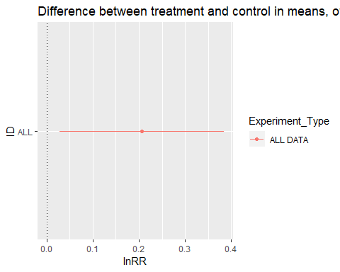

#Plotting overall when split by multigenerational and one off exposure  
  
plot_lnRR_overall_exposure <- ggplot(Overall_MG_OF, aes(x=ID, y=Effect_Size_lnRR, colour=Experiment_Type)) +   
 geom_errorbar(aes(ymin=ci.lb, ymax=ci.ub), width = 0, position = position_dodge(0.3)) +  
 geom_point(aes(x = ID, y = Effect_Size_lnRR), position = position_dodge(0.3))+  
 geom_hline(yintercept = 0, lty = "dotted") +  
 labs(title ="Difference between treatment and control in means, overall", x = "ID", y = "lnRR") +  
 coord_flip()  
   
plot_lnRR_overall_exposure

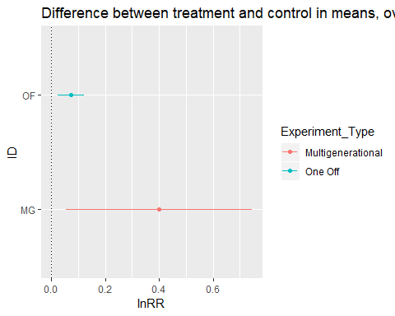

#### Running meta-analysis (Overall with moderators, and then overall split by exposure type with moderators)

#Adding moderators  
All_Data_Analysis_f0 <- rma.mv(yi, vi, mods = ~F0_Parent_Exposed, random = list(~1|Trait, ~1|Paper_ID,~1|Cohort_ID), data=Effect_Size_All_Traits, method = 'REML')  
  
summary(All_Data_Analysis_f0)

##   
## Multivariate Meta-Analysis Model (k = 341; method: REML)  
##   
## logLik Deviance AIC BIC AICc   
## -437.7151 875.4301 887.4301 910.3684 887.6839   
##   
## Variance Components:   
##   
## estim sqrt nlvls fixed factor  
## sigma^2.1 0.0251 0.1584 6 no Trait  
## sigma^2.2 0.0975 0.3122 25 no Paper_ID  
## sigma^2.3 0.0038 0.0614 74 no Cohort_ID  
##   
## Test for Residual Heterogeneity:   
## QE(df = 338) = 7056.6821, p-val < .0001  
##   
## Test of Moderators (coefficient(s) 2:3):   
## QM(df = 2) = 4.3577, p-val = 0.1132  
##   
## Model Results:  
##   
## estimate se zval pval ci.lb  
## intrcpt 0.2721 0.1149 2.3677 0.0179 0.0468  
## F0_Parent_ExposedFemale -0.0556 0.0761 -0.7301 0.4653 -0.2048  
## F0_Parent_ExposedMale -0.1271 0.0637 -1.9963 0.0459 -0.2519  
## ci.ub   
## intrcpt 0.4973 *  
## F0_Parent_ExposedFemale 0.0936   
## F0_Parent_ExposedMale -0.0023 *  
##   
## ---  
## Signif. codes: 0 '***' 0.001 '**' 0.01 '*' 0.05 '.' 0.1 ' ' 1

All_Data_Analysis_rodents <- rma.mv(yi, vi, mods = ~Rodent_type, random = list(~1|Trait, ~1|Paper_ID,~1|Cohort_ID), data=Effect_Size_All_Traits, method = 'REML')  
  
summary(All_Data_Analysis_rodents)

##   
## Multivariate Meta-Analysis Model (k = 341; method: REML)  
##   
## logLik Deviance AIC BIC AICc   
## -437.7635 875.5269 885.5269 904.6569 885.7071   
##   
## Variance Components:   
##   
## estim sqrt nlvls fixed factor  
## sigma^2.1 0.0251 0.1584 6 no Trait  
## sigma^2.2 0.1015 0.3186 25 no Paper_ID  
## sigma^2.3 0.0040 0.0629 74 no Cohort_ID  
##   
## Test for Residual Heterogeneity:   
## QE(df = 339) = 6776.4521, p-val < .0001  
##   
## Test of Moderators (coefficient(s) 2):   
## QM(df = 1) = 0.0927, p-val = 0.7608  
##   
## Model Results:  
##   
## estimate se zval pval ci.lb ci.ub   
## intrcpt 0.2214 0.1038 2.1332 0.0329 0.0180 0.4248 *  
## Rodent_typeRat -0.0411 0.1350 -0.3045 0.7608 -0.3058 0.2235   
##   
## ---  
## Signif. codes: 0 '***' 0.001 '**' 0.01 '*' 0.05 '.' 0.1 ' ' 1

All_Data_Analysis_sex <- rma.mv(yi, vi, mods = ~Sex, random = list(~1|Trait, ~1|Paper_ID,~1|Cohort_ID), data=Effect_Size_All_Traits, method = 'REML')  
  
summary(All_Data_Analysis_sex)

##   
## Multivariate Meta-Analysis Model (k = 341; method: REML)  
##   
## logLik Deviance AIC BIC AICc   
## -437.0467 874.0934 886.0934 909.0316 886.3471   
##   
## Variance Components:   
##   
## estim sqrt nlvls fixed factor  
## sigma^2.1 0.0248 0.1575 6 no Trait  
## sigma^2.2 0.1418 0.3765 25 no Paper_ID  
## sigma^2.3 0.0041 0.0638 74 no Cohort_ID  
##   
## Test for Residual Heterogeneity:   
## QE(df = 338) = 6794.7529, p-val < .0001  
##   
## Test of Moderators (coefficient(s) 2:3):   
## QM(df = 2) = 6.1576, p-val = 0.0460  
##   
## Model Results:  
##   
## estimate se zval pval ci.lb ci.ub   
## intrcpt 0.4871 0.1596 3.0521 0.0023 0.1743 0.7998 **  
## SexFemale -0.3419 0.1471 -2.3237 0.0201 -0.6303 -0.0535 *  
## SexMale -0.3250 0.1477 -2.2001 0.0278 -0.6144 -0.0355 *  
##   
## ---  
## Signif. codes: 0 '***' 0.001 '**' 0.01 '*' 0.05 '.' 0.1 ' ' 1

#Plotting these results from data frame   
  
plot_lnRR_overall_mods <- ggplot(Overall_effects_not_split, aes(x=ID, y=Effect_Size_lnRR, colour=Experiment_Type)) +   
 geom_errorbar(aes(ymin=ci.lb, ymax=ci.ub), width = 0, position = position_dodge(0.3)) +  
 geom_point(aes(x = ID, y = Effect_Size_lnRR), position = position_dodge(0.3))+  
 geom_hline(yintercept = 0, lty = "dotted") +  
 labs(title ="Difference between treatment and control in means, overall", x = "ID", y = "lnRR") +  
 coord_flip()  
   
plot_lnRR_overall_mods

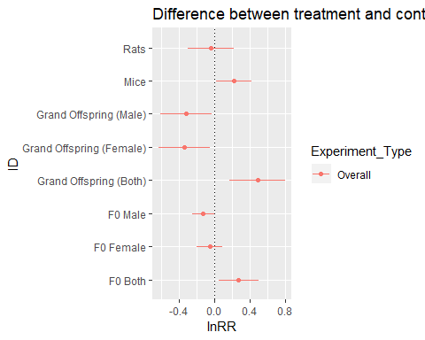 #### Split by exposure type and with moderators

#Adding moderators  
All_Traits_Analysis_0mods_MG_f0 <- rma.mv(yi, vi, mods = ~F0_Parent_Exposed, random = list(~1|Trait, ~1|Paper_ID,~1|Cohort_ID), data=MG_ALL, method = 'REML')  
  
summary(All_Traits_Analysis_0mods_MG_f0)

##   
## Multivariate Meta-Analysis Model (k = 118; method: REML)  
##   
## logLik Deviance AIC BIC AICc   
## -364.5615 729.1230 739.1230 752.8909 739.6684   
##   
## Variance Components:   
##   
## estim sqrt nlvls fixed factor  
## sigma^2.1 0.1114 0.3338 6 no Trait  
## sigma^2.2 0.1677 0.4095 13 no Paper_ID  
## sigma^2.3 0.0040 0.0634 24 no Cohort_ID  
##   
## Test for Residual Heterogeneity:   
## QE(df = 116) = 5697.9389, p-val < .0001  
##   
## Test of Moderators (coefficient(s) 2):   
## QM(df = 1) = 0.1306, p-val = 0.7178  
##   
## Model Results:  
##   
## estimate se zval pval ci.lb ci.ub  
## intrcpt 0.4173 0.1864 2.2393 0.0251 0.0521 0.7826  
## F0_Parent_ExposedMale -0.1148 0.3178 -0.3614 0.7178 -0.7377 0.5080  
##   
## intrcpt *  
## F0_Parent_ExposedMale   
##   
## ---  
## Signif. codes: 0 '***' 0.001 '**' 0.01 '*' 0.05 '.' 0.1 ' ' 1

All_Traits_Analysis_0mods_OF_f0 <- rma.mv(yi, vi, mods = ~F0_Parent_Exposed, random = list(~1|Trait, ~1|Paper_ID,~1|Cohort_ID), data=OF_ALL, method = 'REML')  
  
summary(All_Traits_Analysis_0mods_OF_f0)

##   
## Multivariate Meta-Analysis Model (k = 223; method: REML)  
##   
## logLik Deviance AIC BIC AICc   
## 127.3955 -254.7910 -242.7910 -222.4292 -242.3966   
##   
## Variance Components:   
##   
## estim sqrt nlvls fixed factor  
## sigma^2.1 0.0022 0.0473 6 no Trait  
## sigma^2.2 0.0020 0.0444 16 no Paper_ID  
## sigma^2.3 0.0006 0.0245 52 no Cohort_ID  
##   
## Test for Residual Heterogeneity:   
## QE(df = 220) = 529.0430, p-val < .0001  
##   
## Test of Moderators (coefficient(s) 2:3):   
## QM(df = 2) = 11.2287, p-val = 0.0036  
##   
## Model Results:  
##   
## estimate se zval pval ci.lb  
## intrcpt 0.1873 0.0481 3.8926 <.0001 0.0930  
## F0_Parent_ExposedFemale -0.1126 0.0439 -2.5632 0.0104 -0.1987  
## F0_Parent_ExposedMale -0.1382 0.0414 -3.3412 0.0008 -0.2192  
## ci.ub   
## intrcpt 0.2816 ***  
## F0_Parent_ExposedFemale -0.0265 *  
## F0_Parent_ExposedMale -0.0571 ***  
##   
## ---  
## Signif. codes: 0 '***' 0.001 '**' 0.01 '*' 0.05 '.' 0.1 ' ' 1

All_Traits_Analysis_0mods_MG_rodent <- rma.mv(yi, vi, mods = ~Rodent_type, random = list(~1|Trait, ~1|Paper_ID,~1|Cohort_ID), data=MG_ALL, method = 'REML')  
  
summary(All_Traits_Analysis_0mods_MG_rodent)

##   
## Multivariate Meta-Analysis Model (k = 118; method: REML)  
##   
## logLik Deviance AIC BIC AICc   
## -364.6998 729.3996 739.3996 753.1675 739.9450   
##   
## Variance Components:   
##   
## estim sqrt nlvls fixed factor  
## sigma^2.1 0.1114 0.3338 6 no Trait  
## sigma^2.2 0.1647 0.4058 13 no Paper_ID  
## sigma^2.3 0.0040 0.0635 24 no Cohort_ID  
##   
## Test for Residual Heterogeneity:   
## QE(df = 116) = 5704.1480, p-val < .0001  
##   
## Test of Moderators (coefficient(s) 2):   
## QM(df = 1) = 0.2348, p-val = 0.6280  
##   
## Model Results:  
##   
## estimate se zval pval ci.lb ci.ub   
## intrcpt 0.4442 0.2013 2.2062 0.0274 0.0496 0.8388 *  
## Rodent_typeRat -0.1141 0.2355 -0.4846 0.6280 -0.5756 0.3474   
##   
## ---  
## Signif. codes: 0 '***' 0.001 '**' 0.01 '*' 0.05 '.' 0.1 ' ' 1

All_Traits_Analysis_0mods_OF_rodent <- rma.mv(yi, vi, mods = ~Rodent_type, random = list(~1|Trait, ~1|Paper_ID,~1|Cohort_ID), data=OF_ALL, method = 'REML')  
  
summary(All_Traits_Analysis_0mods_OF_rodent)

##   
## Multivariate Meta-Analysis Model (k = 223; method: REML)  
##   
## logLik Deviance AIC BIC AICc   
## 123.9619 -247.9238 -237.9238 -220.9330 -237.6448   
##   
## Variance Components:   
##   
## estim sqrt nlvls fixed factor  
## sigma^2.1 0.0022 0.0466 6 no Trait  
## sigma^2.2 0.0019 0.0436 16 no Paper_ID  
## sigma^2.3 0.0009 0.0294 52 no Cohort_ID  
##   
## Test for Residual Heterogeneity:   
## QE(df = 221) = 547.7001, p-val < .0001  
##   
## Test of Moderators (coefficient(s) 2):   
## QM(df = 1) = 0.1523, p-val = 0.6964  
##   
## Model Results:  
##   
## estimate se zval pval ci.lb ci.ub   
## intrcpt 0.0743 0.0264 2.8135 0.0049 0.0226 0.1261 **  
## Rodent_typeRat -0.0120 0.0307 -0.3902 0.6964 -0.0721 0.0482   
##   
## ---  
## Signif. codes: 0 '***' 0.001 '**' 0.01 '*' 0.05 '.' 0.1 ' ' 1

All_Traits_Analysis_0mods_MG_sex <- rma.mv(yi, vi, mods = ~Sex, random = list(~1|Trait, ~1|Paper_ID,~1|Cohort_ID), data=MG_ALL, method = 'REML')  
  
summary(All_Traits_Analysis_0mods_MG_sex)

##   
## Multivariate Meta-Analysis Model (k = 118; method: REML)  
##   
## logLik Deviance AIC BIC AICc   
## -357.9600 715.9200 727.9200 744.3896 728.6978   
##   
## Variance Components:   
##   
## estim sqrt nlvls fixed factor  
## sigma^2.1 0.1166 0.3414 6 no Trait  
## sigma^2.2 0.5747 0.7581 13 no Paper_ID  
## sigma^2.3 0.0044 0.0662 24 no Cohort_ID  
##   
## Test for Residual Heterogeneity:   
## QE(df = 115) = 5048.8671, p-val < .0001  
##   
## Test of Moderators (coefficient(s) 2:3):   
## QM(df = 2) = 23.1222, p-val < .0001  
##   
## Model Results:  
##   
## estimate se zval pval ci.lb ci.ub   
## intrcpt 1.0519 0.2897 3.6316 0.0003 0.4842 1.6196 ***  
## SexFemale -0.9348 0.1947 -4.8009 <.0001 -1.3164 -0.5531 ***  
## SexMale -0.9273 0.1977 -4.6912 <.0001 -1.3147 -0.5399 ***  
##   
## ---  
## Signif. codes: 0 '***' 0.001 '**' 0.01 '*' 0.05 '.' 0.1 ' ' 1

All_Traits_Analysis_0mods_OF_sex <- rma.mv(yi, vi, mods = ~Sex, random = list(~1|Trait, ~1|Paper_ID,~1|Cohort_ID), data=OF_ALL, method = 'REML')  
  
summary(All_Traits_Analysis_0mods_OF_sex)

##   
## Multivariate Meta-Analysis Model (k = 223; method: REML)  
##   
## logLik Deviance AIC BIC AICc   
## 127.9219 -255.8438 -243.8438 -223.4820 -243.4494   
##   
## Variance Components:   
##   
## estim sqrt nlvls fixed factor  
## sigma^2.1 0.0020 0.0449 6 no Trait  
## sigma^2.2 0.0016 0.0403 16 no Paper_ID  
## sigma^2.3 0.0009 0.0297 52 no Cohort_ID  
##   
## Test for Residual Heterogeneity:   
## QE(df = 220) = 537.8326, p-val < .0001  
##   
## Test of Moderators (coefficient(s) 2:3):   
## QM(df = 2) = 10.9978, p-val = 0.0041  
##   
## Model Results:  
##   
## estimate se zval pval ci.lb ci.ub   
## intrcpt -0.3802 0.1395 -2.7254 0.0064 -0.6536 -0.1068 **  
## SexFemale 0.4530 0.1393 3.2522 0.0011 0.1800 0.7260 **  
## SexMale 0.4591 0.1392 3.2983 0.0010 0.1863 0.7320 ***  
##   
## ---  
## Signif. codes: 0 '***' 0.001 '**' 0.01 '*' 0.05 '.' 0.1 ' ' 1

#Plotting Overall with moderators and splitting by exposure type  
  
plot_lnRR_overall_mods_exp <- ggplot(Table_results_overall, aes(x=ID, y=Effect_Size_lnRR, colour=Experiment_Type)) +   
 geom_errorbar(aes(ymin=ci.lb, ymax=ci.ub), width = 0, position = position_dodge(0.3)) +  
 geom_point(aes(x = ID, y = Effect_Size_lnRR), position = position_dodge(0.3))+  
 geom_hline(yintercept = 0, lty = "dotted") +  
 labs(title ="Difference between treatment and control in means, overall mods", x = "ID", y = "lnRR") +  
 coord_flip()  
   
plot_lnRR_overall_mods_exp

