Supplementary material
Supplementary Table 1. Physiological characteristics of three generation of normal chow-fed mice.
 | NC F0 | NC F1 | NC F2
Body weight (g) | 25.7 ± 1.8 | 25.8 ± 3.6 | 25.1 ± 1.5
BMI (kg/m²) | 3.37 ± 0.14 | 3.44 ± 0.18 | 3.14 ± 0.16
Liver weight (g) | 1.10 ± 0.11 | 1.19 ± 0.06 | 0.96 ± 0.04
EPI fat weight (g) | 0.18 ± 0.05 | 0.17 ± 0.09 | 0.18 ± 0.03
Kidney weight (g) | 0.15 ± 0.01 | 0.18 ± 0.02 | 0.14 ± 0.02
Heart weight (g) | 0.12 ± 0.01 | 0.13 ± 0.01 | 0.12 ± 0.01

NC F0, normal chow-fed F0 generation male mice; NC F1, normal chow-fed F1 generation male mice; NC F2, normal chow-fed F2 generation male mice; BMI, body mass index; NFBG, non-fasted blood glucose; FBG, fasted blood glucose; EPI, epididymal.
n = 6-11/group.
Supplementary Table 2. Primer sequences used for RT-PCR and CHIP assay.
Gene | Primer sequence | Length | Genebank
FASN | Sence GCGGGTCTATGCCACGATTCT | 223 bp | NM_007988
 | Antisence GGCGCACAGGGACCGAGTAAT | 223 bp | NM_007988
SCD-1 | Sence CACCCATCCCGAGAGT | 432 bp | NM_009127
 | Antisence CCGAAGAGGCAGGTGTAGAG | 432 bp | NM_009127
LXRα | Sence CCTCCCTGCGTTGTAACTGT | 191 bp | NC_000068
 | Antisence GGGATCAGCAGCTGGTTTAG | 191 bp | NC_000068
ERO1-α | Sence TTGCCACAGTCTCTGGAGTG | 186 bp | NC_000080
 | Antisence CTGGCTGCCTAAGCCTTTTA | 186 bp | NC_000080

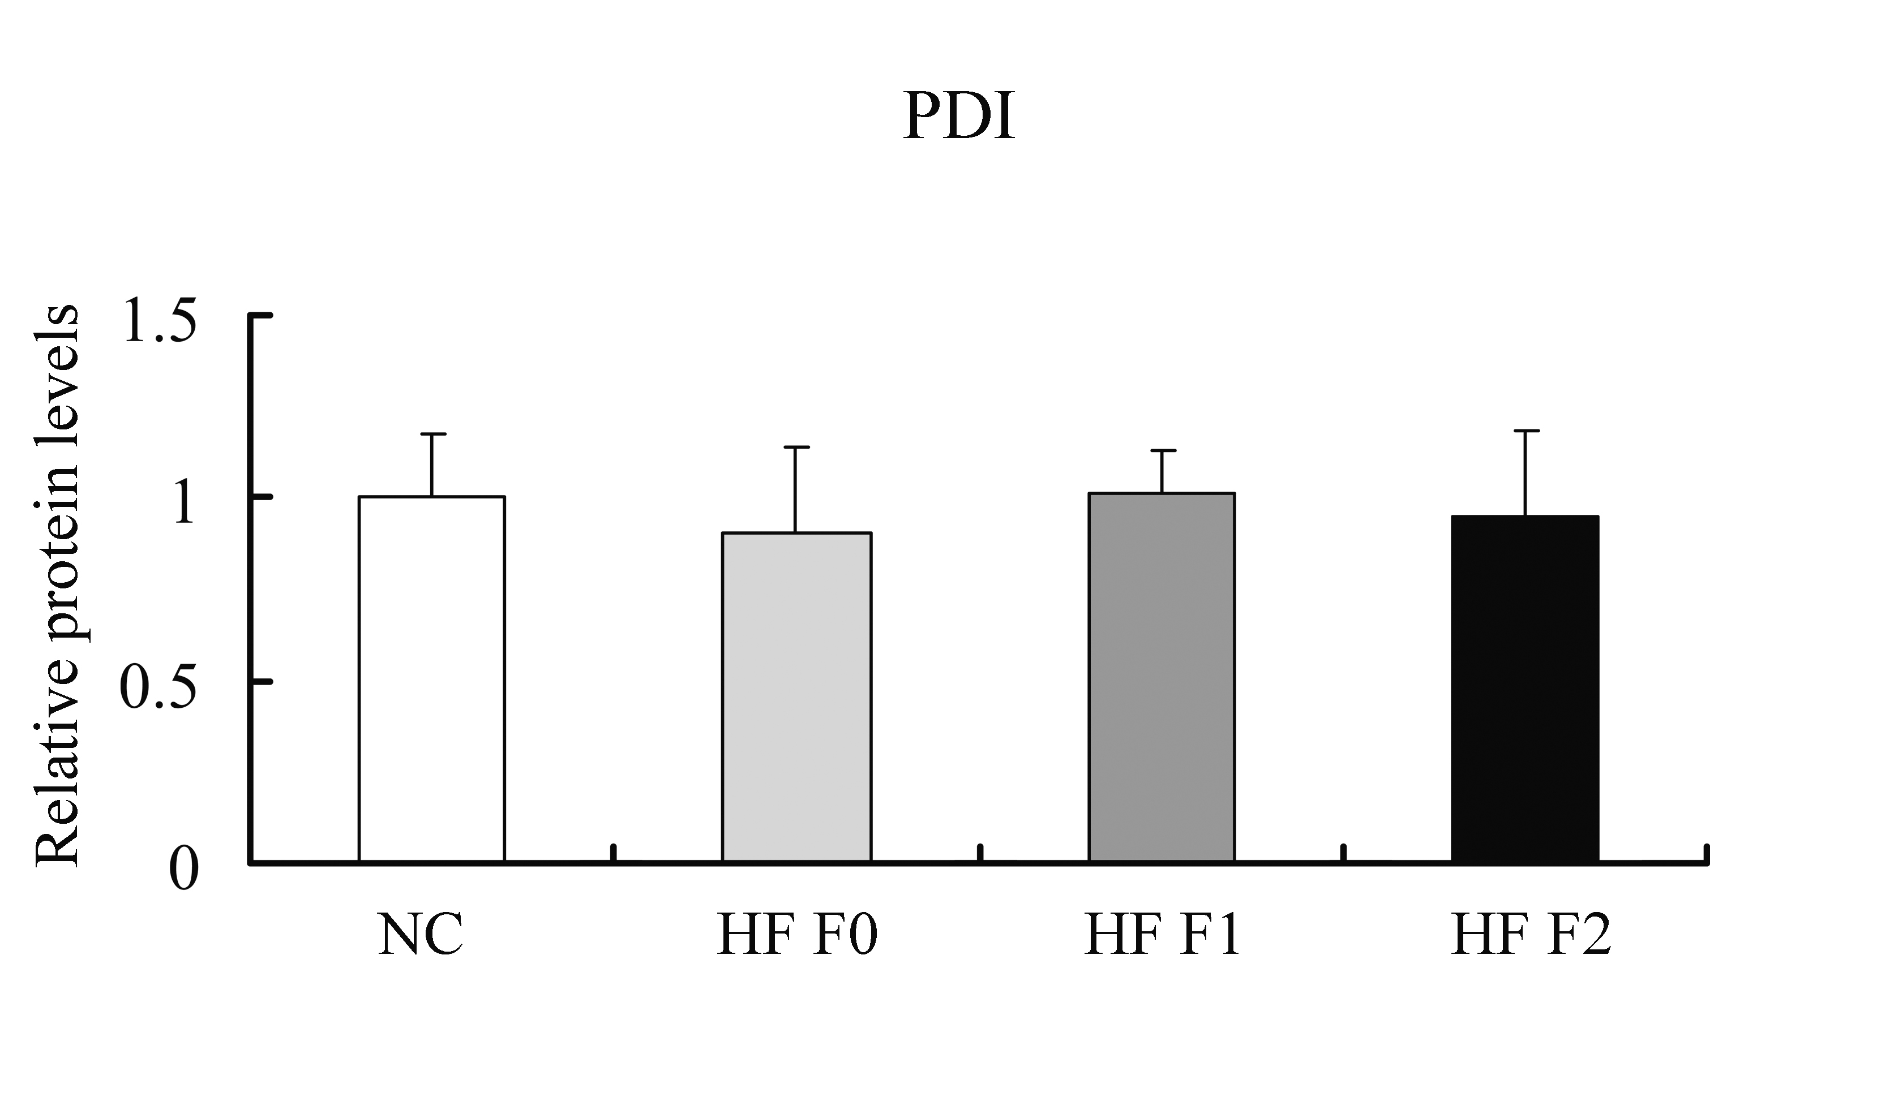
Supplementary Fig. 1. Quantitative results of relative protein levels of PDI in different experimental groups. White bar, NC mice, normal chow-fed mice; light gray bar, HF F0 mice, high fat diet fed mice F0 generation; dark gray bar, HF F1 mice, high fat diet fed mice F1 generation; black bar, HF F2 mice, high fat diet fed mice F2 generation.

