Apex Alpha – Launch 1
On the 22nd of October 2011, the ApexHAB team from Sutton Grammar School, Surrey, UK set off to launch their newest HAB payload; Apex Alpha. It was built entirely by students at the school between the ages of 15 and 17. The payload, created to be small and lightweight, was carried up into the skies by a Hwoyee 2000g latex weather balloon.
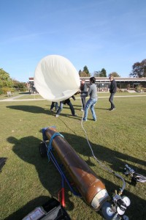
Filling in Windy Conditions
The launch was from CUSF’s launch site at Churchill College, Cambridge, UK. The payload was sealed, waterproofed and then strung up to a 40m nylon cord. At 10:45 UTC we began the filling process which was made slightly more difficult by the heavy winds. The 2000g balloon was filled with helium and was launched at 11:30 UTC. We used a release mechanism which meant that we could slowly reel out the balloon and payload with another cord until we were happy with the wind conditions. When the time was right, the cord was cut and Alpha began it’s ascent.
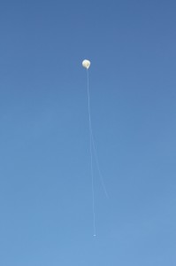
Apex Alpha Launched
The payload was predicted to land in the North Sea; however, it turned out very differently. As the afternoon progressed, the team and the UKHAS community saw the payload cross Europe via the Netherlands, then Germany and then Poland. By this time, it was exiting our radio range and as a result we were loosing the ability to decode. We called upon HAM users in Europe and also used Global Tuners to track the payload as it left our range. In our favour, we managed to find enough HAM users to track until the payload reached just North East of Lodz, Poland. Unfortunately, at 23:41 UTC on the 22nd of October we lost contact with Alpha as it left our listener’s range. Predictions on the payload’s current location range from Poland to Ukraine to Russia. (If it has still to burst, which is very unlikely, it could be as far as Kazakhstan!) The payload is marked with our contact details and is expected to be on land now.

It’s been a great weekend and although we didn’t beat the altitude record as we originally planned, we did manage to beat some other impressive UK records. These include 5th highest for latex weather balloon altitude, first for distance covered, first for duration and first for float duration! Full details here: http://ukhas.org.uk/general:uk_records.

Thanks to various members of UKHAS for the amazing tracking yesterday and early this morning. Without the huge network of members helping us, the flight we saw yesterday would not have been possible. We’d also like to thank those members who came online to track for the first time yesterday for us. (OZ1SKY, SP2HPD and DH1BDL) The additional range meant we could see Alpha go off into Poland.
Additionally, we would like to Cambridge University Spaceflight (CUSF) for the use of their launch site and filling equipment.
Together with UKHAS, many other records were broken as well. Over 10,000 packets were sent to the DL server and the IRC room had over 130 members in it at one point – more UKHAS records!. Additionally the Radio Range records for both 300 and 50 baud were broken. 678km at 300 baud by 2E0UPU and 776km at 50 baud by OZ1SKY.
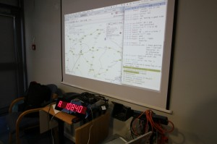
Live Tracking and Altitude
- Priyesh Patel (github)
- Daniel Saul
- Edward Branford
- Philip Warren
- Alex Landless
- Michael Woodgate
Many thanks to Jon Sowman, Matthew Brejza, Andrew Cowan and Ben Oxley for their assistance throughout the Alpha’s development.

The Alpha gallery is availble at: http://gallery.apexhab.org/index.php/Apex-Alpha
Data is available at: http://www.apexhab.org/alpha/launch-1-data/
Follow us on Twitter for more details: http://twitter.com/#!/apexhab

A full write-up is being written and will be posted here in the coming days.

Some external coverage of our launch:
- http://hackaday.com/2011/10/21/going-for-the-amateur-balloon-altitude-record/
- http://hab-howard.blogspot.com/
- http://arduinoist.com/2011/10/22/apex-alpha-hi-alt-balloon-soars-from-uk-over-germany/

