

three

www.apexhab.org

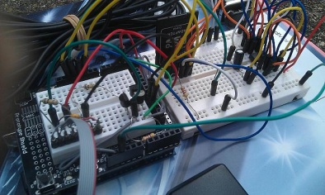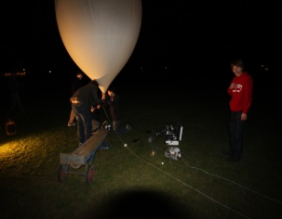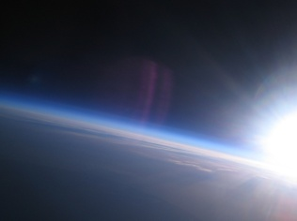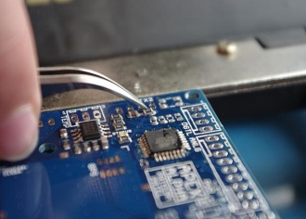The APEX team is a group of teenagers who are passionate about electronics, technology and engineering.

We design complex electronic payloads consisting of various sensors and cameras to collect interesting data and amazing photographs from high altitudes using large meteorological balloons.

The team was started at Sutton Grammar School in 2008 by a small group of students and since then have successfully had 3 launches. Now that the original team have all moved on to greater things, the current team have taken the helm and developed a “next-generation” payload – APEX III.

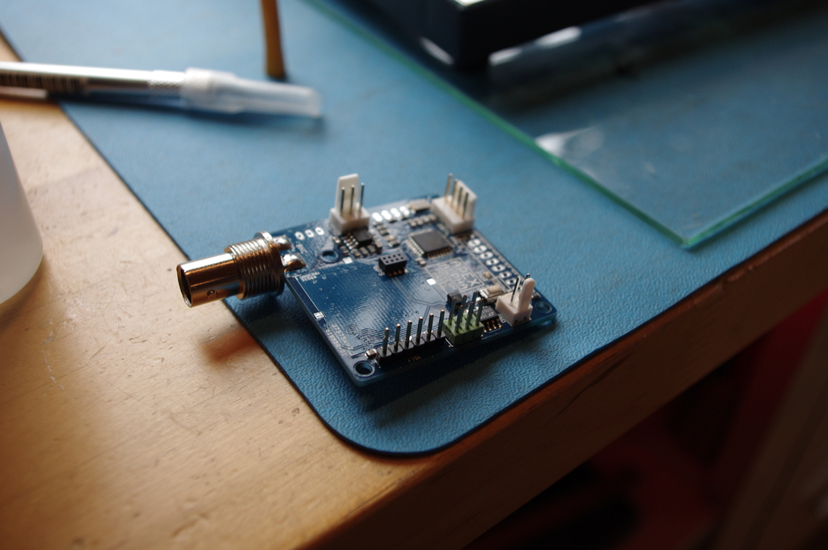

APEX III has been designed to be modular. Based on the Arduino microcontroller as opposed to PICAXE like APEX II, we have nicknamed the core module ‘Alpha’. Alpha is the bare minimum that can be launched and consists of a microcontroller, GPS, temperature sensors and radio all squeezed into a tiny 5cm x 5cm PCB. Alpha is to be launched on a 2000g balloon in October 2011 and we hope to reach 40km altitude – nearly 4 times the height which commercial aeroplanes fly.

The payload is attached to a large, meteorological balloon filled with helium. Obviously, since helium is less dense than the air around us the balloon rises and takes our payload with it. The electronics takes co-ordinates from the GPS and data from any other sensors and then transmits it back down to Earth where we track it on a live map in the back of our chase cars using amateur radio systems and decoding software. As the balloon increases in altitude, the air pressure decreases causing the balloon to expand in size due to internal pressure being much greater. The latex balloon eventually stretches to up to 25m in diameter before it bursts at which point the payload starts to fall, the parachute slowly opens and it descends at a safe speed until it hits the ground where we can safely recover it.

We can add further modules to Alpha: these include all sorts of sensors, cameras and cutdown devices. This makes up APEX III. We hope to successfully collect radiation data for the full duration of the flight for example - previous payloads always failed to do so due to pressure limitations with the Geiger-Muller tubes being used. We are once again going to include several cameras in hope of catching even sharper, daylight photos – our best photos currently are from the APEX II Dawn launch – and we will launch our brand new HD video camera too. Other modules include light sensors, various gas sensors such as CO2, an ash sensor which could collect interesting data in the event of another volcanic eruption affecting the UK, a pressure sensor and anything else we decide may be interesting.

APEX III has taught the whole team an awful lot, from electronic design to radio communication and complex C++ programming – everything has been developed from scratch to prove that the latest APEX team have what it takes too. We have faced many challenges along the way, from designing the electronic modules, to programming and then launching and then tracking the payload as it flies across the country.

APEX is a member of the UK High Altitude Society ([www.ukhas.org.uk](http://www.ukhas.org.uk)) – an umbrella organisation for the few projects there are in the UK of this nature. UKHAS brings together interested people to help launch and track payloads all over the country. As the hobby becomes more popular, the need for guidelines becomes more apparent – UKHAS tries to provide these guidelines, and it would be great if the government could support them.

**UPDATE:**

APEX Alpha, version 1 of the core module of APEX III, was successfully launched on Saturday 22nd October 2011 at 11am. Whilst not reaching our altitude target, it started to float at an altitude of 36km (118,000ft) and continued to move east, flying over the North Sea, the Netherlands, Germany and, by 11pm, into Poland.

Frantically, with UKHAS, we tried to raise radio amateurs in Eastern Europe but despite hundreds of retweets on twitter, no one came forward and the balloon floated beyond radio range of our last tracker in Denmark at 11:45pm.

We predict that the balloon burst at sunrise and fell somewhere between Poland, Ukraine and Russia. Whilst setting out for an altitude record, instead we came away with the largest distance covered by a latex balloon, longest duration for a latex balloon flight and longest float duration by a latex balloon and 5th highest altitude. It is also more than likely Alpha travelled further and longer than these records show.

We’d like to thank all the various members of UKHAS for the amazing tracking on Saturday and early Sunday morning. Without the huge network of members helping us, the flight we saw yesterday would not have been possible. We’d also like to thank those members who came online to track for the first time yesterday for us. (OZ1SKY, SP2HPD and DH1BDL) The additional range meant we could see Alpha go off into Poland.

The tracking map, as of 24th October, is still active at <http://www.spacenear.us/tracker> and you can clearly see where our last contact with Alpha was – you can also see where the signal was getting weak as it entered Poland and the GPS went slightly off.

