Apex II Technical Guide

04/04/2010

Matt Brejza
Jon Sowman
Ben Oxley
Systems Overview

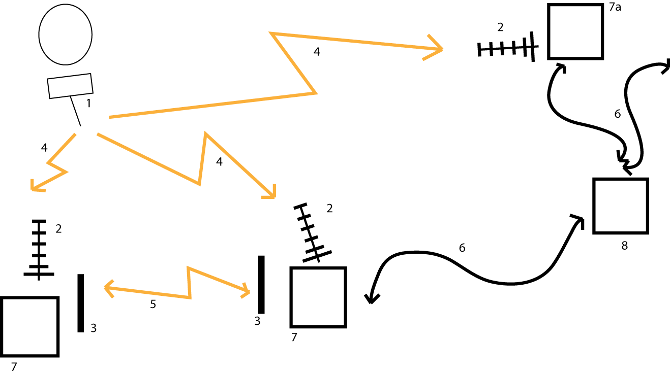

- Balloon 434 antenna
- Base station 434 antenna (usually yagi)
- 144 antenna
- 434 balloon link
- 144 APRS link
- Internet link (mobile broadband where appropriate)
- Balloon tracking station
  - Other client of the DL
- DL (distributed listener) server

The balloon transmits on 434.075MHz (1) and is received by base stations (2). The data is processed by the tracking station computer (7). The tracking stations operated by us will echo the data on 144.8MHz, the APRS ham frequency. This allows base stations to share data, for hams to listen to the balloons progress, and data is picked up by internet connected APRS basestations (iGates) which then display the data on sites such as findu.com

Other basestations listen on the 434 band for balloon launches (7a) and are part of the distributed listener for balloons (DL). These stations report to the DL server (8), along with any of our balloon trackers (7) with internet access through mobile broadband. These base stations are also able to retrieve data from the DL server and display the data along with our own received data, and that shared through the APRS link.

Data transmission modes

AFSK

Data is modulated so that ‘0’ is one tone, and ‘1’ is another. At the receiving end, the demodulator only looks at what is happening at the two frequencies, so noise outside of these frequencies is ignored

FSK

Serial data is fed directly into the transmitter data input, meaning data is represented by a shift in the frequency of the carrier wave. If transmitted and received with a FM radio, the data in is the same as that going out. If the data is transmitted on FM, and received on SSB (AM radio with suppressed carrier and one suppressed sideband), the SSB radio will output tones representing the difference between the centre frequency to which the radio is tuned, and that which is being received. The signal can then be decoded in the same way as AFSK. This is the mode used by DL clients

OOK

OOK – on/off keying. A ‘1’ is represented by sending a signal, while a ‘0’ is represented by nothing. This will be used to send data to the balloon, as the demodulator is simpler, and if a tone if sent for a ‘1,’ then is becomes less prone to noise.

Data Encoding

The data sent from the balloon will be in the UKHAS format so we can use the DL. See here for more details. In the <custom data> part will be sensor data, as well as checksums for each individual part of the packet. The actual format of this part of the packet is undecided, and will probably be based on APEXI. The Uplink format is also undecided.

The packet will be transmitted using RTTY, which uses the FSK radio mode as explained above. To be understood by the rest of the DL, 50baud, 8bits/char, no parity, 1 stop, although this is flexible. The upload will be OOK at a similar specification.

Balloon Payload

PIC
GPS
Transceiver
Out modem
In modem
RTC
Temp1
Temp2
Temp3
Radiation
FET 1
FET 2
(Pyro)
Flash
Light
ADC
Pressure
Batt voltage
1
2
2
1
3
3.3V
5V
5V
Humidity
V_{BATT}

- SPI bus (ADC shares CLK/MOSI with other SPI bus), the light sensor has extra signalling, and is not a SPI device, but shares the bus
- Serial link
- One wire bus

The colours of the boxes represent the voltages used to power the device and in the signalling by the device. The blue 5V devices are powered by a precision reference device

The FETs switch devices connected to the battery. The radiation units are on different PCBs to the remainder of the circuit.

In modem (demodulator) (balloon)

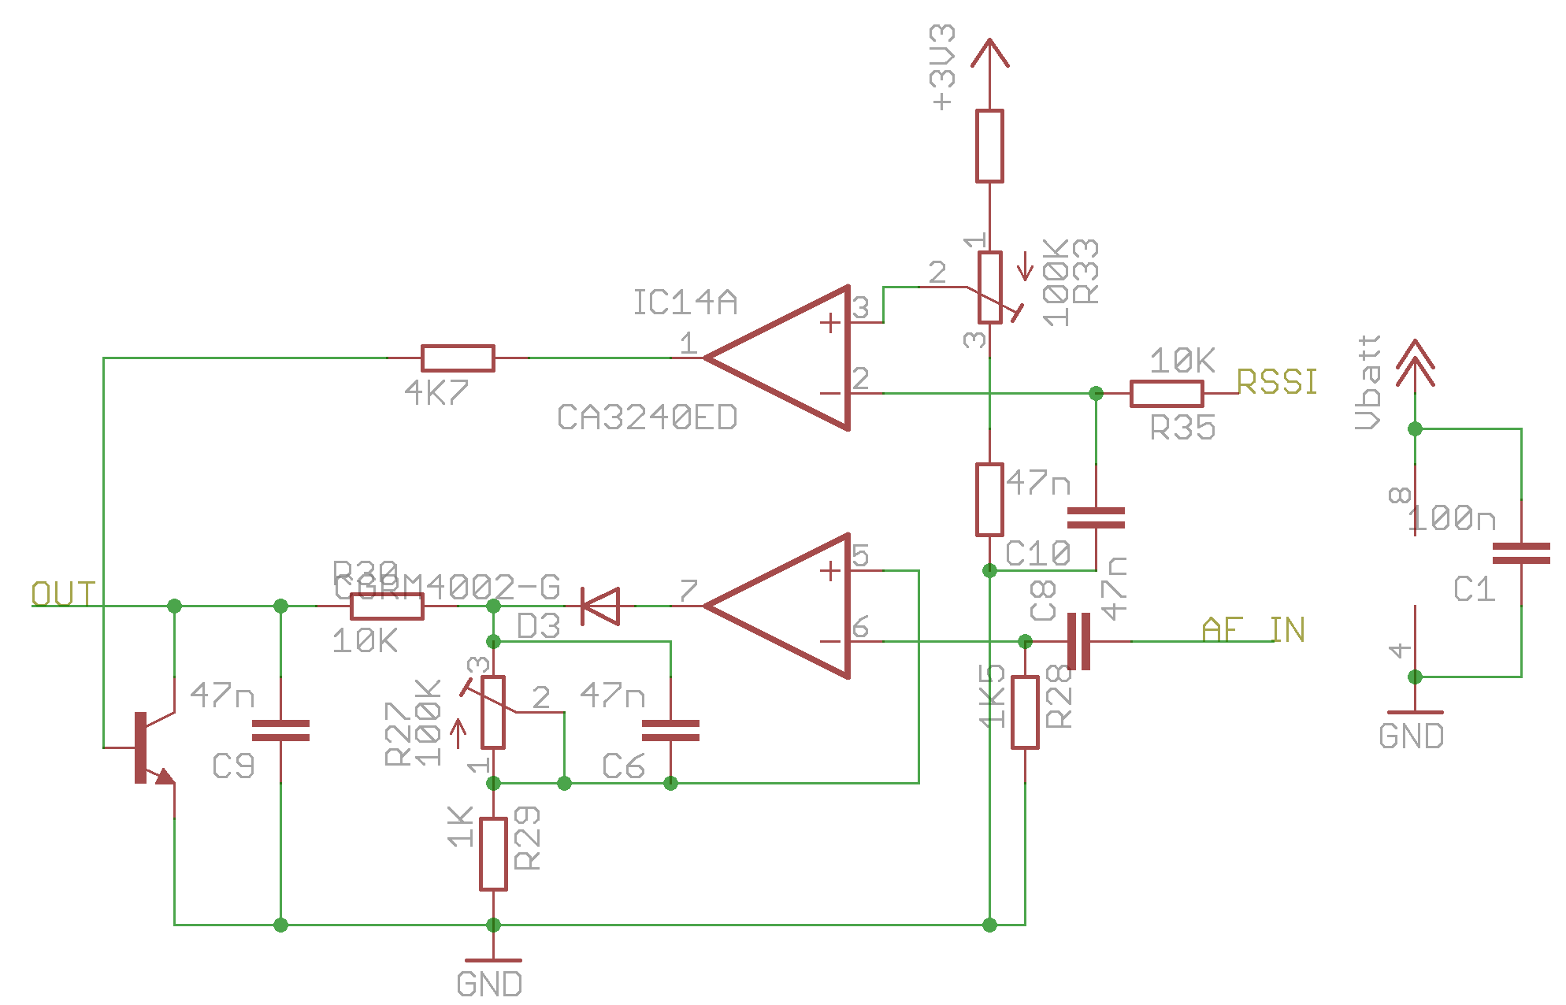
Opamps not necessarily CA3240, must be rail-to-rail O/P.

- The transmitter modem uses a tone (~2.5kHz) as 1, nothing for 0.
1
0
1
0
1

2

3

4,5
- After being transmitted and received, there is a DC component and low frequency components (~100Hz)
- These are removed by the RC high pass filter on the I/P
- This is then rectified (half wave), and amplified by the opamp.
- The low pass on the opamp O/P forms a envelope detector, which passes the red waveform to the PIC

The RSSI O/P of the receiver disables the demodulator O/P when there is no signal (squelch). Initially there is a low pass filter, then the signal is then compared against the threshold voltage by the other half of the opamp. When there is not a received signal, the transistor is turned on, which holds the O/P low.

The threshold of the squelch should be set at -120 -> -123 dBm, or 0.5-0.6V, see http://www.radiometrix.co.uk/products/nim2/nim2_rssi.gif

Out modem (modulator) (balloon) - RTTY

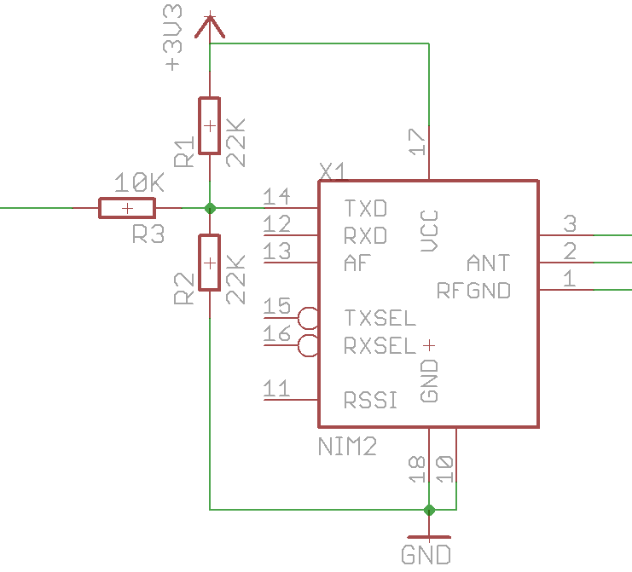

The three resistors R1-R3 set the two voltages, V_{LO} and V_{HI}, for RTTY. Resistors R1 and R2 set the centre voltage of V_{LO} and V_{HI} and the voltage can be calculated as a potential divider, however, the input of the radio has the equivalent of a 100K resistor to GND, which needs to be taken into account. The amount the two voltages drift from the centre frequency is set by R3. On the final PCB, these resistors may be changed to two variable resistors, one to set the centre frequency, and one for the deviation.

Cutdown Device

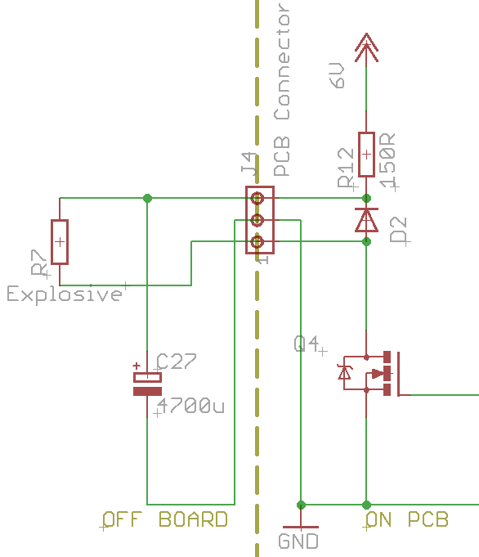

As with APEX I, although never used, the base station will have the ability to tell the payload to cut the balloon free and begin its descent (due to unexpected wind etc..). The chosen method this time is to use an explosive charge normally used to ignite rocket motors. We have not yet tried this (9/2009), and is something that is reported to work well, but needs testing ourselves. Information can be found here. When testing the device, it should be tested to see if it can be detonated from a 4700µF capacitor, as shown in the link. The FET circuitry is already present on the main board, although it can be also tested by just charging the capacitor against a 6V battery, then touching the terminals of the capacitor against the explosive’s wires. The capacitor should be connected to the explosive charge off board, as shown in the diagram.

Humidity sensor

The main board has provisions for a capacitive humidity sensor, wired as shown below.
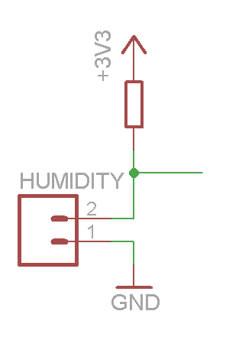
This circuit attaches to a PIC ADC pin, which also has the ability to be an output. The pin is held low, so the humidity sensor is discharged. Then the pin is turned into an analogue input, and so the capacitor can charge. The PIC either times how long the humidity sensor takes to charge to a certain level, or what the voltage is after a certain time. This value can then be translated to a value for humidity by the program on the ground.

Camera Control (CHDK)

Canon cameras are used, as their firmware can be replaced with custom firmware. We will be using CHDK as custom firmware, which allows for the camera to be easily controlled by sending pulses down the USB line. Whether the cameras are to be powered b their own batteries or a regulator on the main PCB are yet undecided.

Phone

A mobile phone will be on the payload as a backup, which will text the payloads position when about to land. The phone may also respond to texts. The phone should get no signal above 2-3km, but if possible, the radio of the phone should be turned off when in the air, either by turning off the entire phone, providing it can be turned back on through the interface, or by using AT commands to turn off just the radio. For simplicity, a phone with a serial UART is needed as they are much easier to interface with a PIC.

Light Sensor

A RGB light sensor will be used to measure light levels, and the levels of each of the primary colours. The sensor outputs a frequency proportional to light levels, which is scaled according to the inputs.

Balloon Tracking Station


PC
Radio
144 transceiver
Mobile internet
Basic diagram of the hardware connected to the computer

FLDigi
SSB receiver
FM transmitter
1
2
4
3
Balloon tracking radio arrangement
- 434 antenna
- Audio links
- RF link (only goes to one device at a time)
- Computer

The SSB radio receives signals from the balloon, and outputs two tones for 1 and 0, (RTTY), which get fed into the line in of the PC’s soundcard, where FLDigi processes the signal to get back the original data. (Note – if the PC only has MIC in, an attenuator, consisting of a potential divider to lower the voltage is needed).

The FM transmitter is only needed to send data to the balloon. (The SSB radio maybe able to both tasks). FLDigi will generate the OOK signal and send it out the soundcard which is then fed into the radio for transmission. As the FM transmitter is ground based, a higher power output can be used (up to 10W for the foundation amateur radio licence).

Radios
FLDigi
Packet Handler
Mappoint
agwpe
Hardware TNC (KPC3)
144 transceiver
1
2
3
3
4
5
5
5
5
PC
Internet (DL access)
5
- Serial link
- PC’s serial port
- Audio link
- PC’s soundcard
- TCP interface

This diagram shows how devices connect to the computer, and the internal structure of programs. The ‘Packet handler’ was known as ‘APRS hander’ on APEX I, and both programs will be similar, but with ‘Packet handler’ upgraded to accept data from different sources. Mappoint is the program that shows the balloon trace on a map, and so making it easy to see the track of the balloon. Agwpe handles the interface between various TNCs (which are modems for the APRS data format) and the other programs. Mappoint may connect directly to ‘Packet handler,’ or via agwpe, as shown on the diagram.

It may be remembered from APEX I that agwpe can directly generate tones for APRS communication through the serial port, however, inspection of the diagram shows the soundcard could be used by the SSB receiver input. However, as agwpe communicates through a TCP interface, another PC could be used for agwpe as shown below

Packet handler
agwpe
144 transceiver
PC 1
PC 2
1
2
3
LAN
- TCP connection
- Audio link
- PC’s Soundcard

This arrangement would work in the same way as above, with the only difference in ‘Packet handler’ would be the setting for the host IP of agwpe.

Alternatively an external USB soundcard could be used, so that the PC could have two soundcards, however, whether this is possible depends on how the software (FLDigi and agwpe) are configured

Antennas

The base station will use high gain yagi antennas, possibly a combination of this or this, with the smaller antenna possibly being attached to a moving vehicle. The balloon will have a 1/4 wave whip antenna with ground plane radials, constructed in a similar way to this.

PCBs
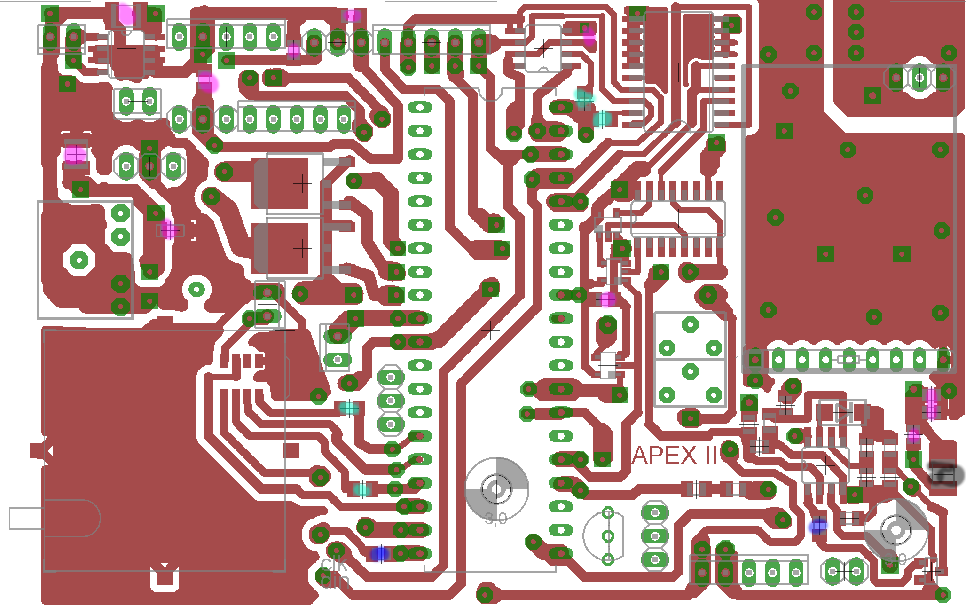

GPS – isolate from PCB
Batt in
On board temp
Other temps
‘Mode’
FET1
FET2/Pyro
Data in/out
GPS batt
USB
Radiation
Light
Unused expansion
4017
Flash
Dual opamp
LED
FSK presets
OR
AND
5V reg
TOP
Key to colours

Ferrite bead
10K
100K
Smoothing cap
1K
Transceiver
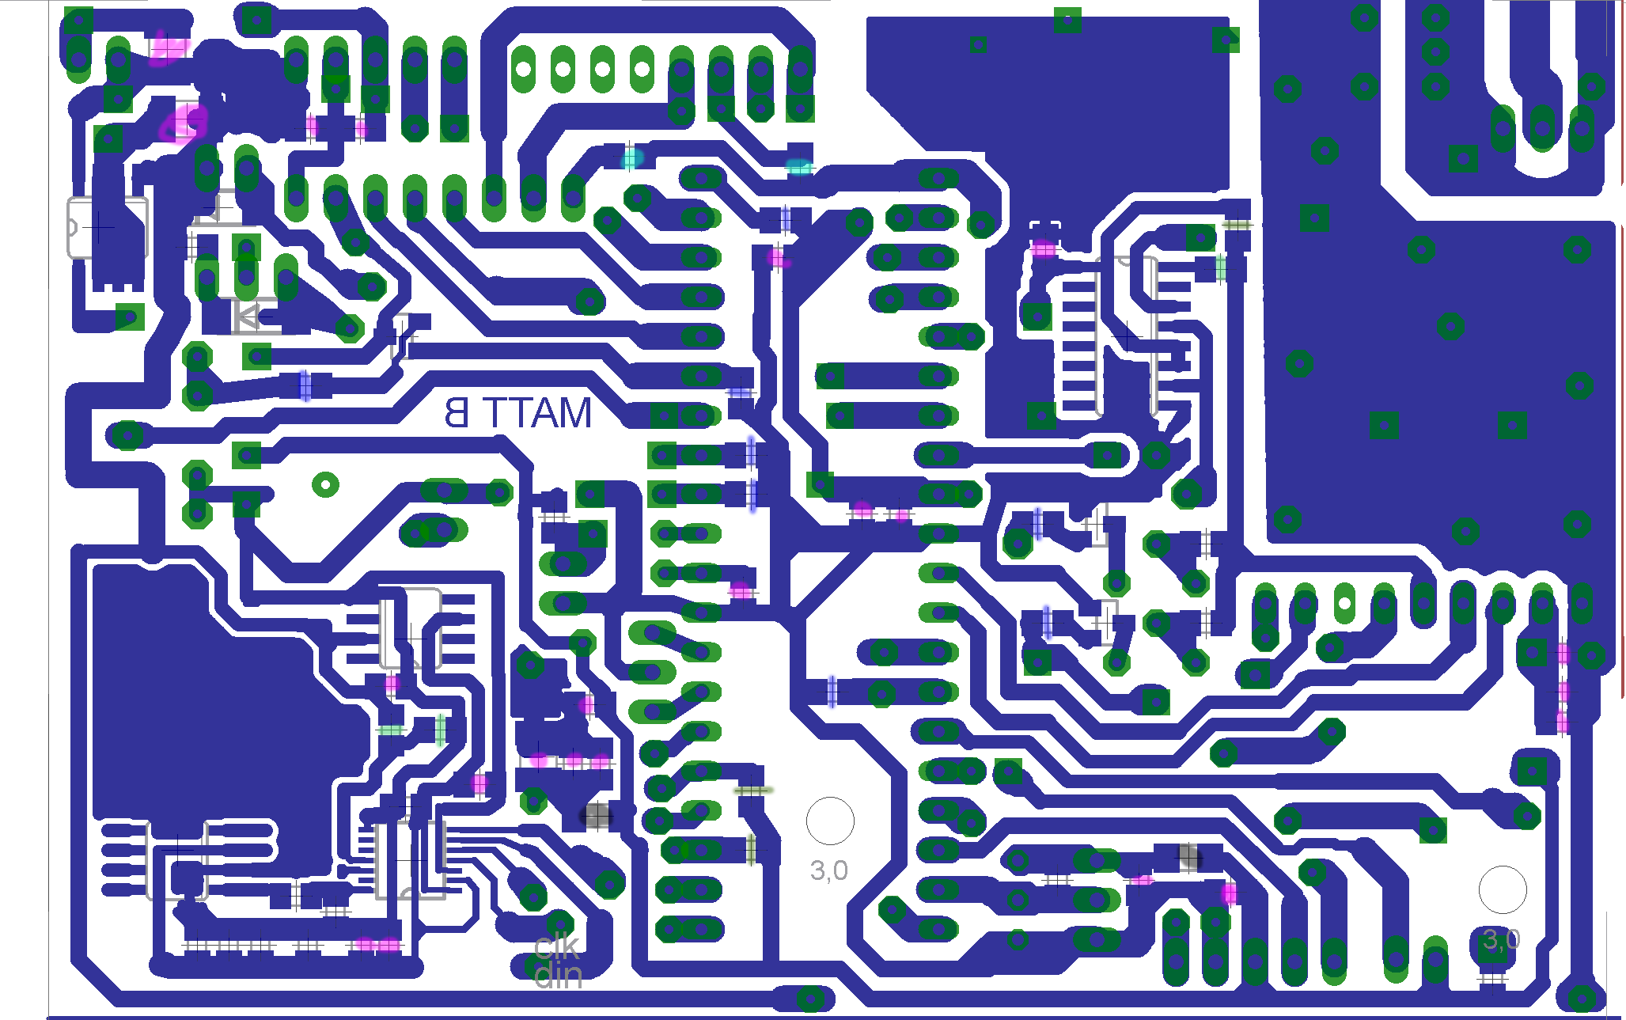
Antenna
4027
3.3V reg
Precision reg
Pressure
MCP3204
BOTTOM

Extra Values
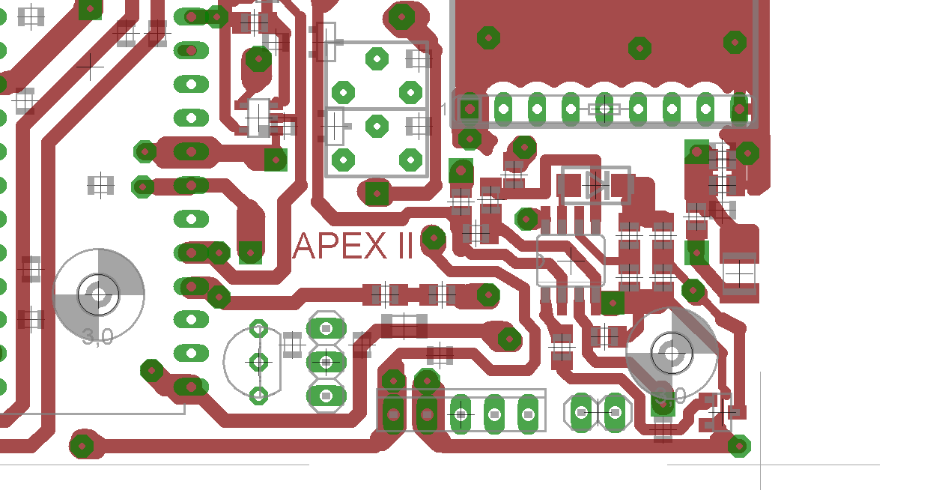
Signal Diode (SMD 1N4148)
Dual Opamp
LED 560
10K

22K; 100K(bottom)
(Squelch level)

FSK high/low level setting pots
Offset resistor
(bottom)
RSSI low
pass
Radio O/P
high pass
Opamp gain
1: 33K
2: 1K
Envelope low pass
1: 10K
2: 47n

1
2
2
1
Notes:

At time of writing, RSSI low pass and radio O/P high pass are already soldered, and I cannot remember the values I used

The FSK pots and resistors will not be soldered on until we have a SSB radio

Using the PCB
The following table lists the connectors on the PCB and their pinout. See the above images to see where each header is on the PCB. Figures in brackets is the pin name on the PIC
Power | 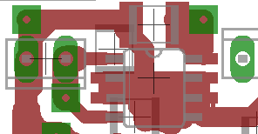  1 2 | 1: GND  2: 6V
FET 1/2 (pyro) | 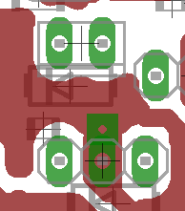  1 2  1 2 3  FET 1  FET 2 | FET1: (a.5)  1: +Vbat  2: GND (via FET)  FET2: (a.6)  1: Cap+/Pyro+  2: Cap-  3: Pyro -
Radiation | 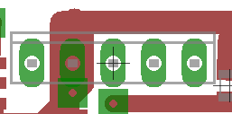  1 2 3 4 5 | 1: +Vbat  2: GND  3: +5V  4: IO1 (a.1)  5: IO2 (a.2)
USB | 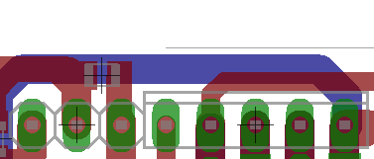  1 2 3 4 5 6 7 8 | 1: +5V  2: GND  3: +3.3V  4: IO1 (b.1)  5: MOSI (b.4)  6: MISO (b.7)  7: IO2 (b.2)  8: CLK (b.5)
Light | 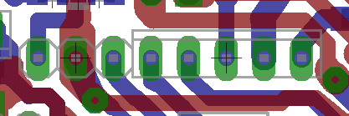  1 2 3 4 5 6 7 8 | 1: GND  2: +3.3V  3: IO1 (a.3)  4: IO2 (a.4)  5: IO3 (a.2)  6: CLK (b.5)  7: MOSI (b.4)  8: MISO (b.7)
GPS Batt | 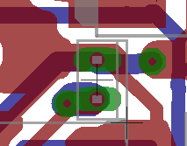  1  2 | 1: GND  2: Vbat
Humidity | 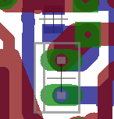  1  2  R1 | 1: Leg1  2: Leg2  R1: Sets the rate the humidity sensor will ‘charge’ at. Select suitable value for sensor’s capacitance
Temper-  ature | 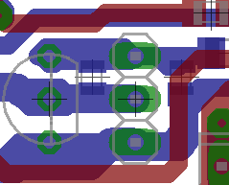  1  2  3 | 1: +3.3V  2: Data (d.3)  3: Gnd
Unused expansion | 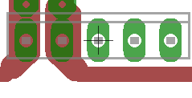  1 2 3 4 5 | 1: Vbat  2: GND  3: +3.3V  4: IO1 (d.2)  5: IO2 (d.4)

FET Channels

FET2 Pyro charging resistor
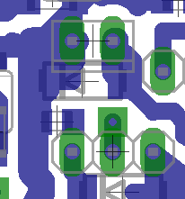
The resistor marked in red (underside of board) charges the capacitor (see the section above on the cutdown). This should be around 200-500 ohms. If this resistor is shorted across FET2 behaves in the same way as FET 2, with the outside two pins used to connect to the load.

If an inductive load is used on either channel, a diode needs to fitted in the available position (marked yellow)

Case

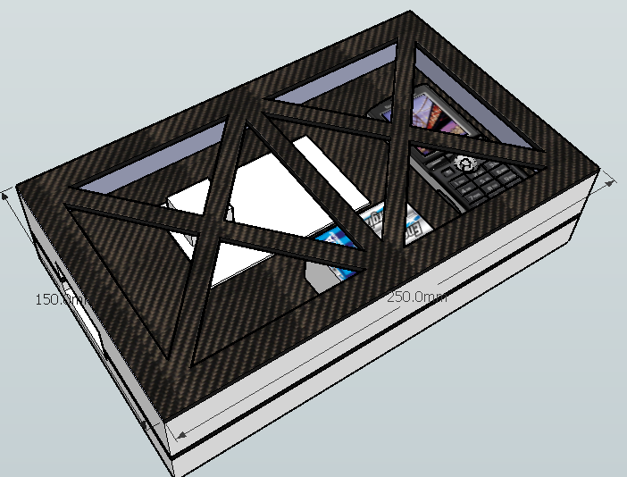

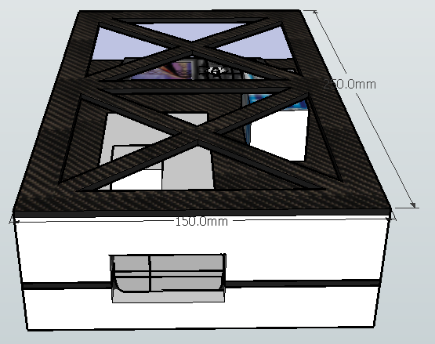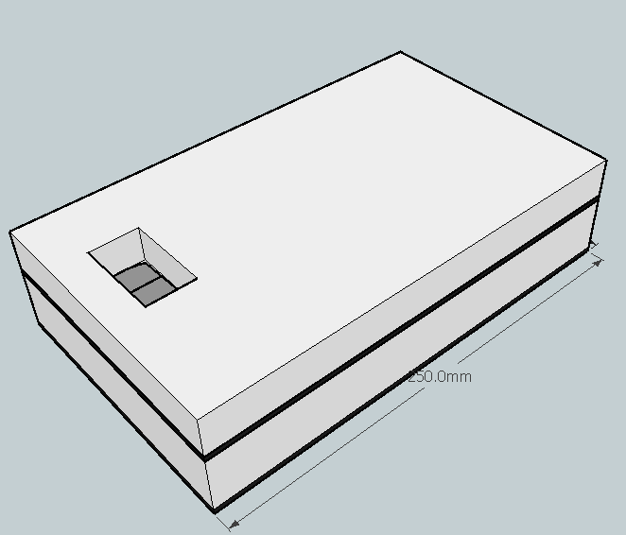

The structure is made from carbon fibre, which is CNC milled to shape (ask ben about the carbon fibre bit)

ToDo list

Balloon side
- Make, solder up and test PCB
- Buy balloon (random solutions/Kaymont)
- USB network for phones & programming – text when <2000ft
- PICAXE programming
- Build case and mount electronics
- Build 1/4λ whip with radials antenna
- Test pyrotechnic cutdown
Receiver
- Get SSB radios
- Antennas (Yagi) buy – small for car and large for minibus
- Build antenna mounts for minibus and car
- Build Packet Handler program
- Sort out 2m amateur inter-vehicle data/packet comms
- PMR446 or similar for voice comms
Misc
- Launch date
Testing
- Battery life tests (L91) & test phone Li-pos/ions in cold
  - May use main battery for phones
- GM tube test with radioactive materials (value for I-limiting charge resistor)

