
Project Apex II
Project Overview for Battery Force

Project Apex is a high altitude balloon project run by Sutton Grammar School in Sutton, Surrey. The project is based around the design, manufacture, testing and launch of electronic payloads on high altitude meteorological balloons. We aim for several things with the project:
- Design a successful tracking system to enable us to recover the payload after landing.
- To take images of the Earth from near space – an altitude of around 30km.
- Gather atmospheric and environmental data during the flight
We use low power unlicensed radio bands to transmit telemetry data from the balloon to the ground, where it is picked up and decoded by receiving stations. Telemetry contains GPS data, sensor data, and vital system parameters. We can also send commands to the balloon during flight, such as to tell the payload to cut the balloon free and begin descending.
Canon point-and-shoot cameras are used with custom firmware to automate the taking of pictures. These cameras are cheap and easy to program, and take very decent quality images whilst remaining low power and low weight – both of which are vital for payload hardware.
Apex II is the follow up to Apex I, which was unfortunately lost due to an error in the electronics, which we were unable to identify precisely as the payload was never found.
This new project has a payload completely re-designed from the ground up. We have added a mobile phone to send GPS coordinates of position via SMS on landing, and are making use of a distributed tracking network across the country, run by enthusiasts for balloon launches.
We will also be sending up two Geiger-Muller tubes to measure levels of ionising radiation throughout the atmosphere; these will be powered by a separate power pack. They will be sending their data as part of the radio telemetry. Additionally, we will be transmitting pressure, humidity, light, temperature and battery voltage data.
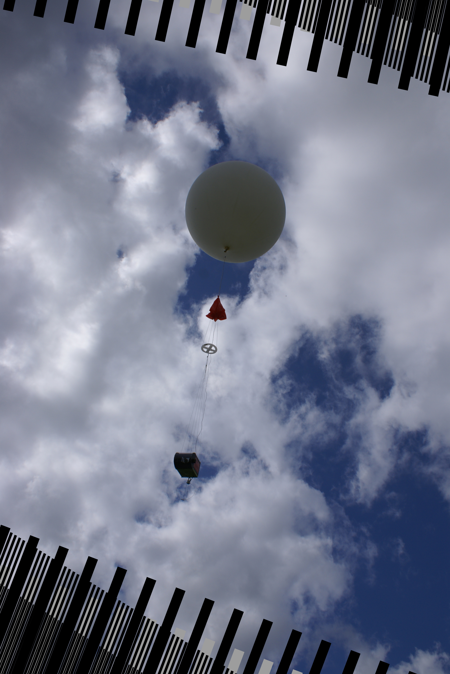

Links
- Website
http://www.hexoc.com/pages/apex/apex-ii.php
- Code repository
http://github.com/mattbrejza/APEX
- Image gallery
http://balloon.hexoc.com/gallery/apex-ii/
- Team mailing list (email address)
project-apex@googlegroups.com

