Post Flight Report
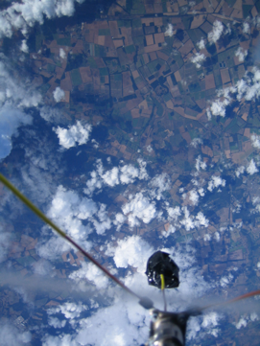
19KM above sea level
July 17th 2010

APEX II
Post Flight Report

Launching
At 9:15am on the 17th of July 2010 Altitude Photography Experiment II (APEX II) flew for the first time. Launched from Churchill College, Cambridge the payload flew for a total of 2 hours, 30 minutes before landing 30km away. The project was run by a group of students from Sutton Grammar School with direction from three former students involved in the launch of APEX I. The small 1.5kg payload reached a maximum altitude of 102,000 feet (31km) high before the balloon burst and the payload descended back to Earth.
The payload carried 2 Canon cameras, a Lassen iQ GPS module, a Radiometrix 434.075Mhz narrowband FM radio module, two Centronics ionising radiation detectors, 2 temperature sensors, 1 light sensor which constantly recorded data about the flight.
It is important to stress that this project has been run almost entirely by students still in Secondary Education and whilst this kind of project has been attempted before, it is rare that students of this age have achieved this kind of result.
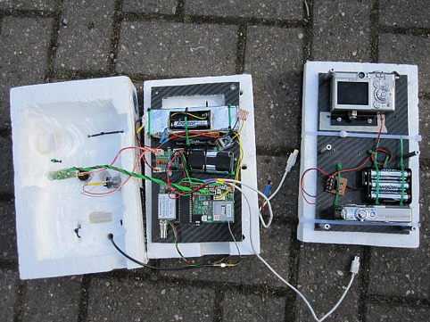

Sponsors
The APEX team would firstly like to thank its sponsors for their valued contribution to the project which allowed it to go ahead and gave a bright group of student the opportunity to achieve such a fantastic result.
- Battery Force (www.batteryforce.co.uk) for providing us with payload batteries which allowed us to run the main payload, two cameras and a high voltage ionizing radiation detector for the duration of the flight during which temperatures of up to -40 degrees were encountered.
- The Institute of Physics (IoP) for providing us with funding which allowed us to kit the payload out with ionizing radiation detectors which allows us to undertake experiments never before attempted in amateur ballooning.
- Dorking District Radio Society. As a local radio society their enthusiasm for the project and ongoing support from before the launch of Apex I has given us huge amounts of insight and understanding about the workings of radio systems and especially antennas. They have lent and trusted us with valuable and important equipment which has allowed us to complete the project to a degree of professionalism far beyond our budget.
- Virgin Galactic for their financial support during the creation and launch of APEX I and their inspirational talk about their own progress of vehicles for reaching the extremities of our atmosphere.
- The excellent electronics department at Sutton Grammar School, as one of the only school facilities of it’s kind in the country it has been the key to use developing the skills we have needed for the project as well as learning to use a wide range of machinery.

For more information including photos, technical information and flight data please see:
Homepage: http://hexoc.com/pages/apex/apex-ii.php
IMAGe gallery: http://balloon.hexoc.com/gallery/apex-ii
TECHNICAL INFORMATION: http://balloon.hexoc.com/media/apextech.pdf

