IT313

Software Engineering

Lab 7

Name: - Siddhant Ajay Meena

ID: - 202101273

Group: - 4

Question 1

Case Diagram: -

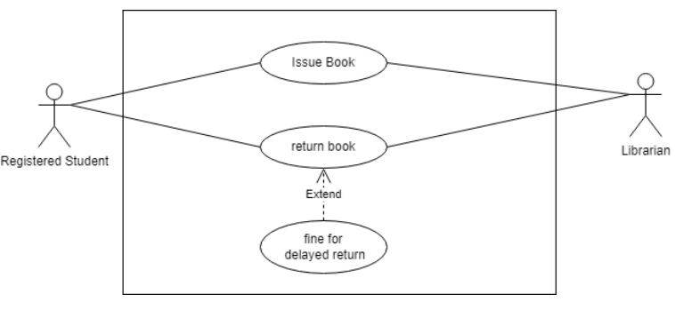

Description: - This system serves students, faculty members, and staff for borrowing books. Students have the option to borrow books that are currently in stock, with the responsibility of returning them. If a student fails to return a book by its due date, they are subject to paying a fine.

This section should provide a description of both the reason for using the use case and the expected outcome of the use case.

Actors: - Students, Librarian, Library

Preconditions: Student should register in the library.

Trigger: Student comes to library for issuing the book or returning a book

Postcondition: The entry of issued or returned book should be added to the database of library.

Flow: When a student wishes to borrow a book, they will approach the librarian, who will then verify the book's availability in the library. If the book is available, the librarian will proceed to lend the book to the student and document this transaction in the library's database.

Upon the book's return, the student will give it back to the librarian, who will inspect the due date. If the student is overdue, they will be required to pay a fine. The librarian will collect the fine, accept the returned book, and make the necessary updates in the database to ensure its accuracy.

Alternative Flow: If the book the student desires to read is not accessible, the librarian will promptly inform the student of its unavailability.

Question 2: Sequence Diagram 