

Assignment Cover Sheet

Student name: | Divine Eboigbe
Student number: | 3046155
Faculty: | Computing Science
Course: | BSCH |  |  | Stage/year:
Subject: | BSCH-ET
Study Mode: | Full time | x |  | Part-time
Lecturer Name: | Osama Abushama
Assignment Title: | Web IDE Final Project
No. of pages:
Disk included? | Yes |  |  | No
Additional Information: | (ie. number of pieces submitted, size of assignment, A2, A3 etc)
Date due: | 10th May, 2024
Date submitted: | 09th May, 2024
Plagiarism disclaimer:
I understand that plagiarism is a serious offence and have read and understood the college policy on plagiarism. I also understand that I may receive a mark of zero if I have not identified and properly attributed sources which have been used, referred to, or have in any way influenced the preparation of this assignment, or if I have knowingly allowed others to plagiarise my work in this way.

I hereby certify that this assignment is my own work, based on my personal study and/or research, and that I have acknowledged all material and sources used in its preparation. I also certify that the assignment has not previously been submitted for assessment and that I have not copied in part or whole or otherwise plagiarised the work of anyone else, including other students.
Signed: _____________________ Date: ______________________

Please note: Students MUST retain a hard / soft copy of ALL assignments as well as a receipt issued and signed by a member of Faculty as proof of submission.

Building and pushing the c compiler
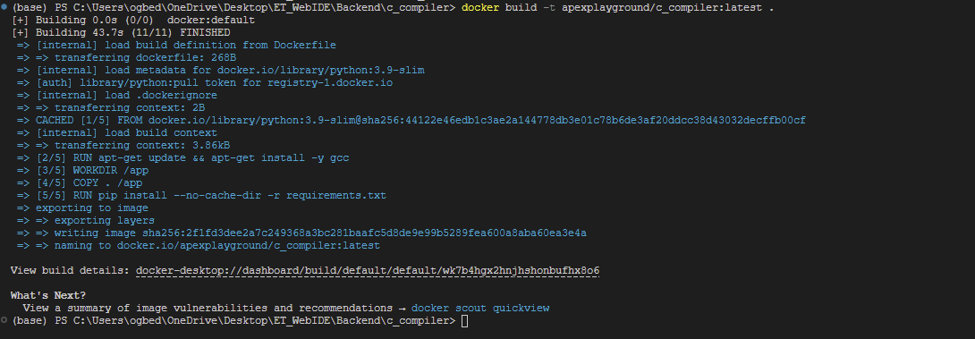
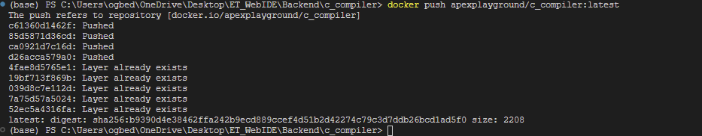

Building and pushing the Java compiler
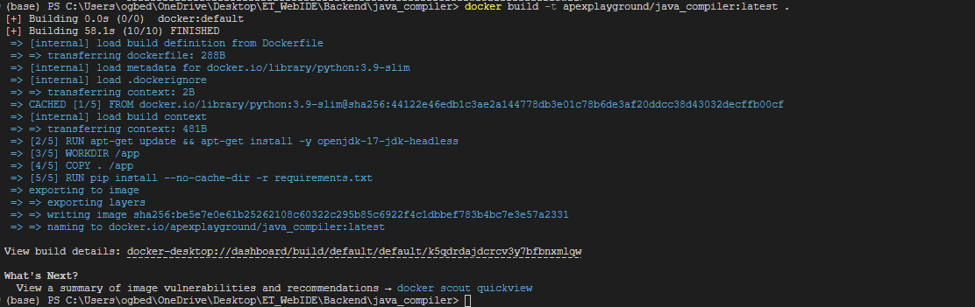
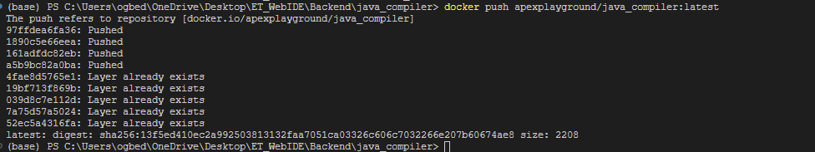

Building and pushing the Python compiler
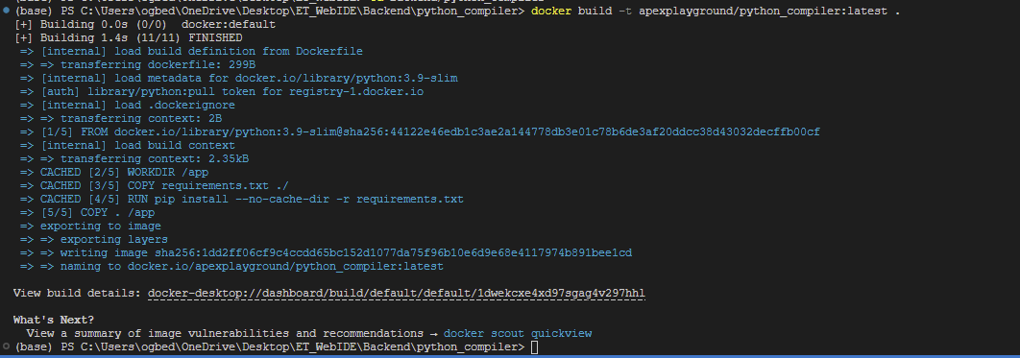

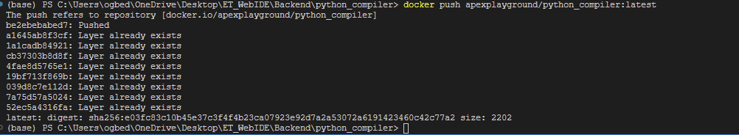

Frontend 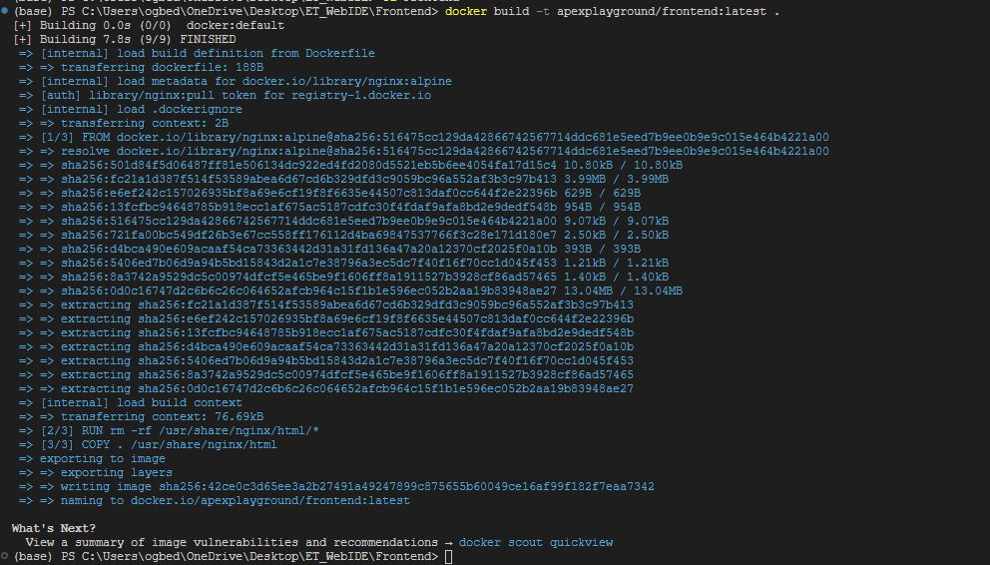

Deploying compose file
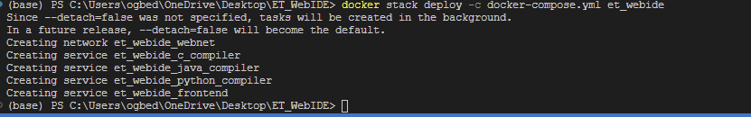

Monitoring deployment:
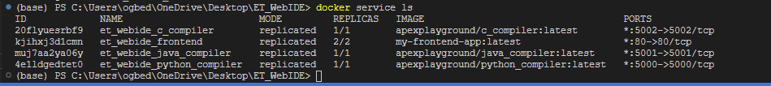

Docker Desktop:
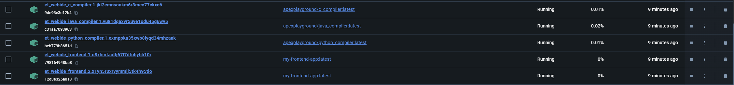

Web Test
C:
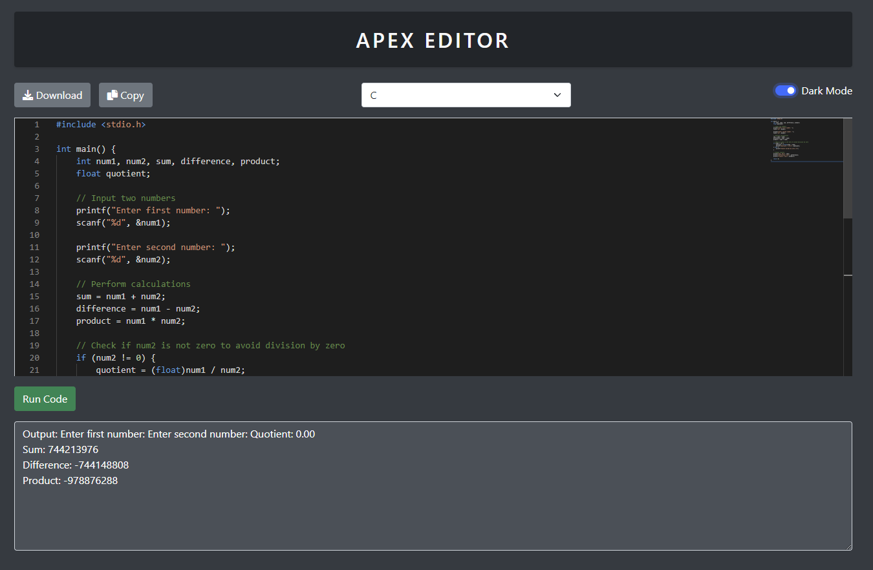

Java:
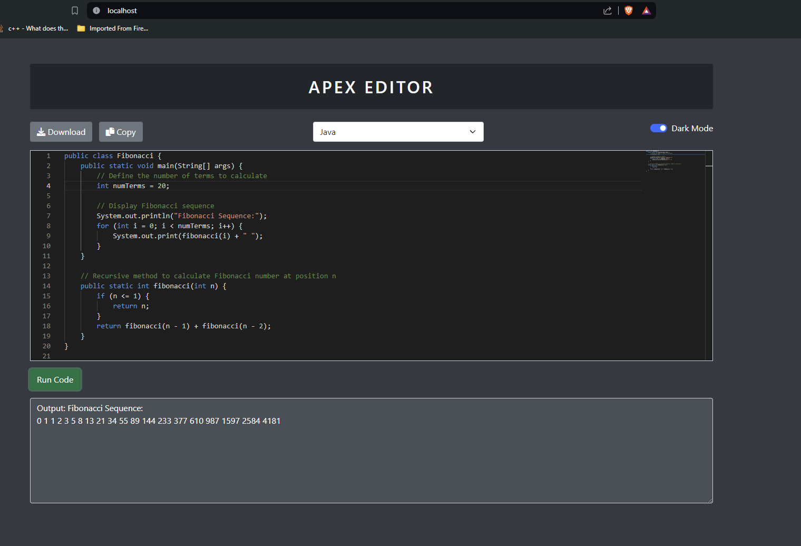

Python:
