**Project Report**

**On**

**“**E-Greetings**”**

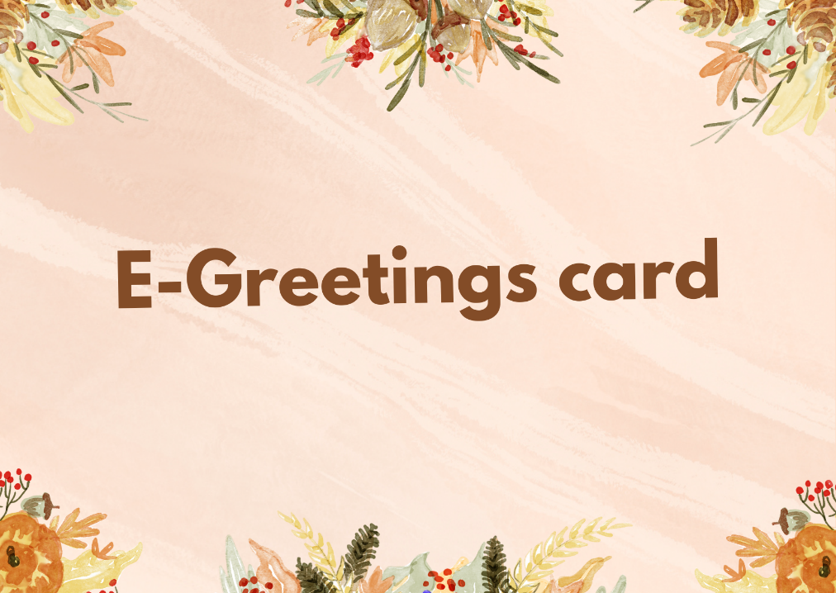

**Aptech Computer Education – MSG-Karachi**

**Submitted By:**

**Guided By:**

1. Abdullah Sir Zohaib Khan
2. Rizwan
3. Hassan
4. Ubaid

Teacher,

Aptech-MSG-Karachi

**CERTIFICATE**

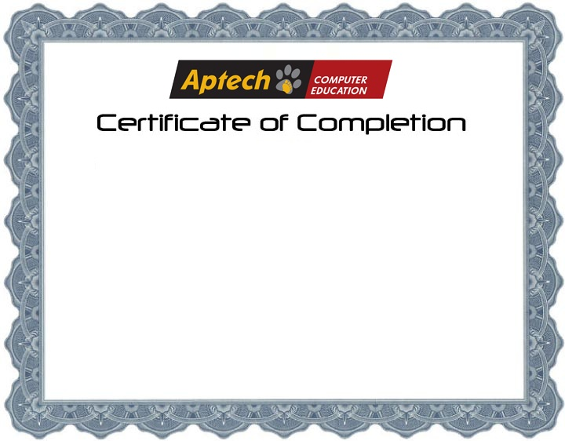

**This is to certify that Web Application**

**E-Greetings Card Sending System has been completed with all functionality by the students of**

**PR2-2023-09G**

**Abdullah**

**Rizwan**

**Hassan**

**Ubaid**

**Admin**

* **abdullahsheikhmuhammad21@gmail.com**
* **12345678**

**User**

* **User@gmail.com**
* **12345678**

**Introduction**

An e-greeting card website is an online platform where you can send digital greeting cards to friends, family, and colleagues. It offers a variety of customized e-cards for special occasions such as birthdays, festivals, anniversaries, and other celebrations. The website features a wide range of themes, designs, and messages to make your greetings even more special. This service provides a convenient, eco-friendly way to share your emotions, no matter the distance or time.

**Proposed Solution**

The proposed solution for the E-Greetings Card website is to create an intuitive and user-friendly platform that allows users to design, customize, and share digital greeting cards effortlessly. The website will feature a wide variety of templates, themes, and personalization options, catering to diverse occasions and audiences. With seamless integration of sharing options through email and social media, users can spread joy instantly. Additionally, the platform will incorporate responsive design and optimized performance, ensuring accessibility on all devices. This solution aims to offer a creative, eco-friendly, and efficient alternative to traditional greeting cards..

***Home Page***

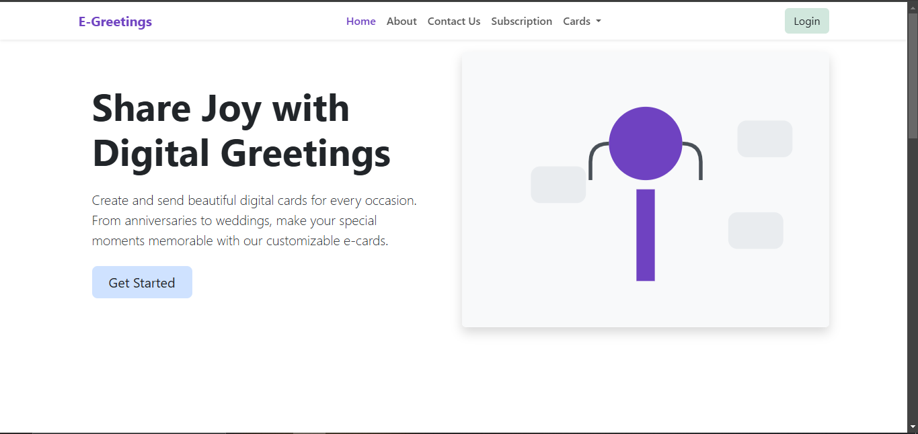

***About-us Page***

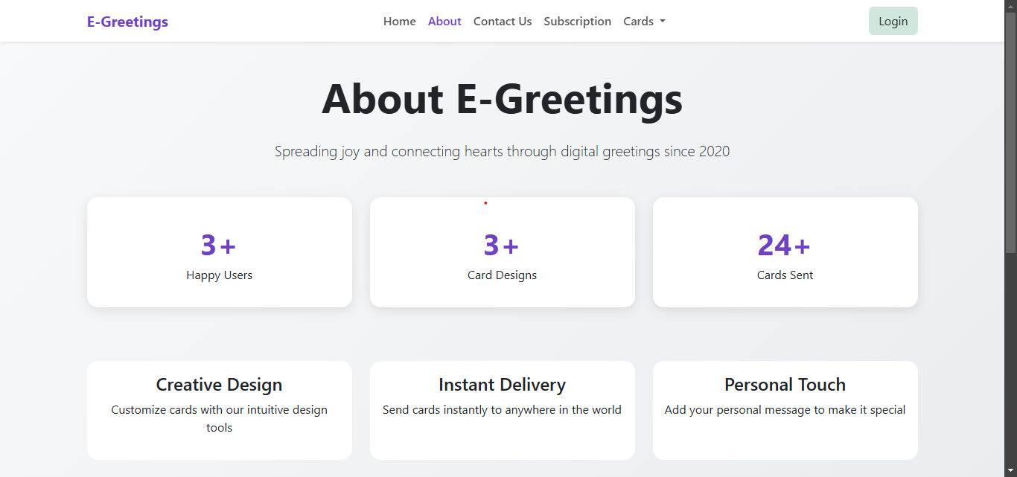

***Contact-us Page***

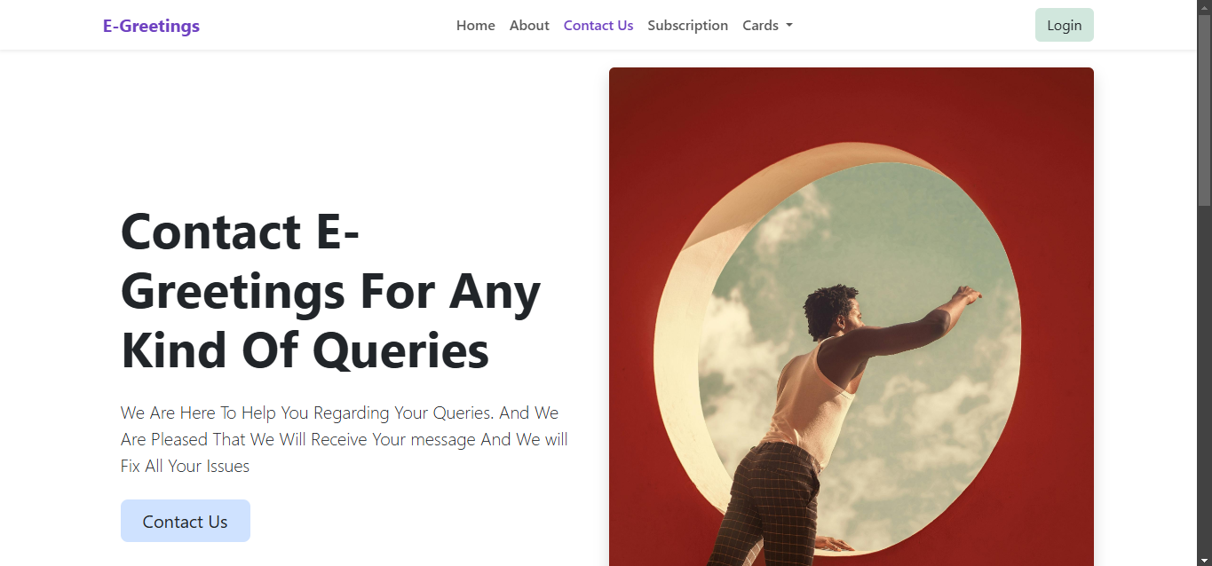

***Subscribtion Page***

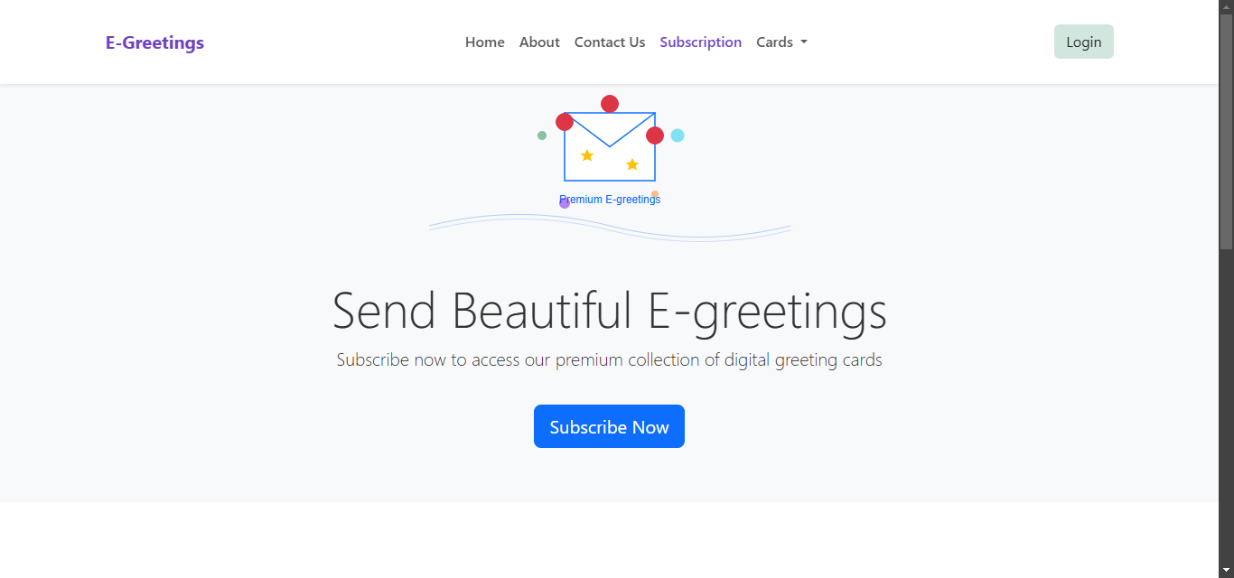

***Cards Page***

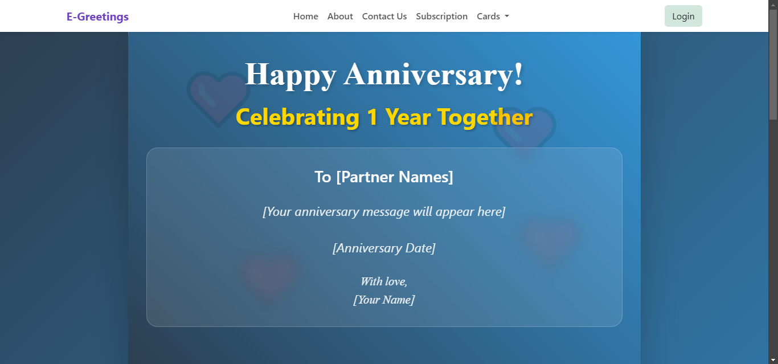

***Customize-card***

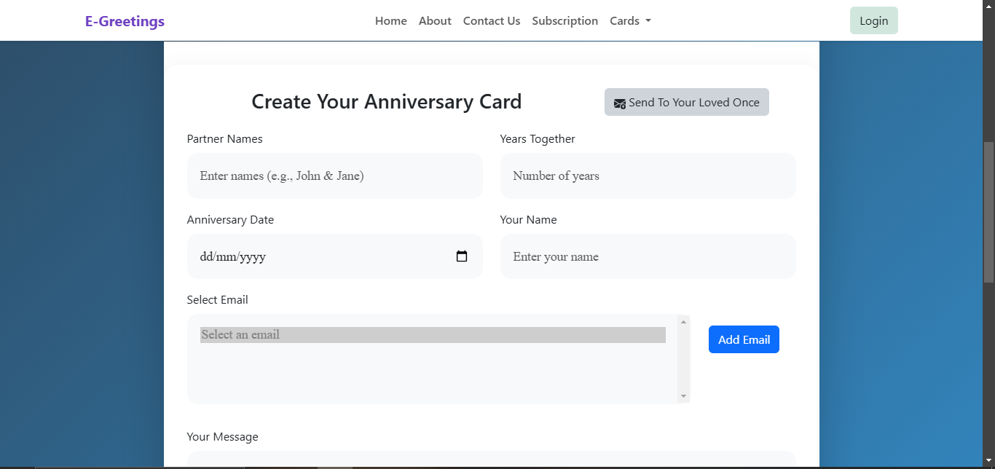

***Admin dashboard***

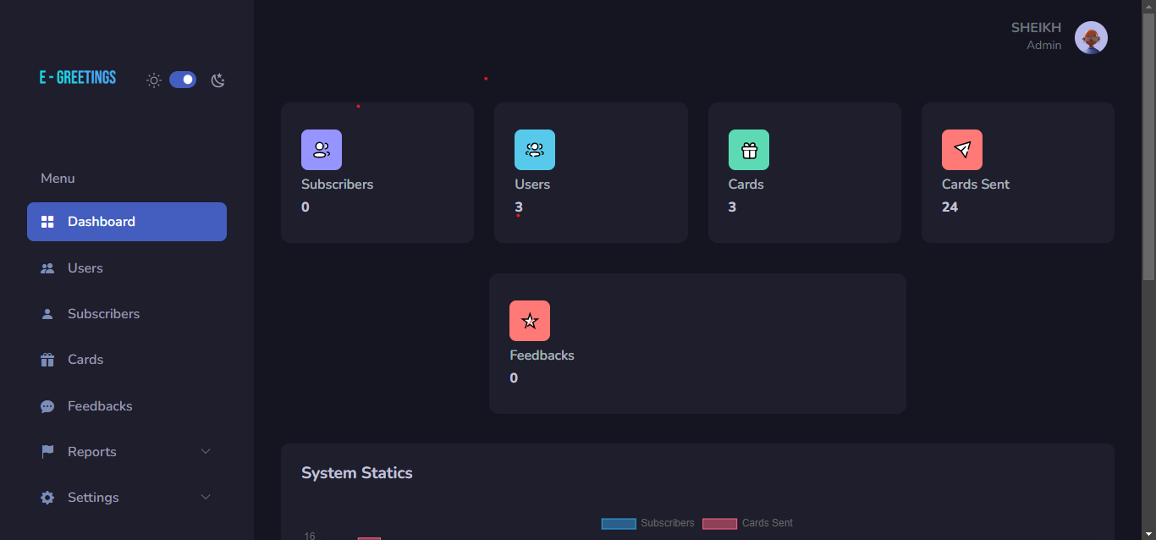

***USER***

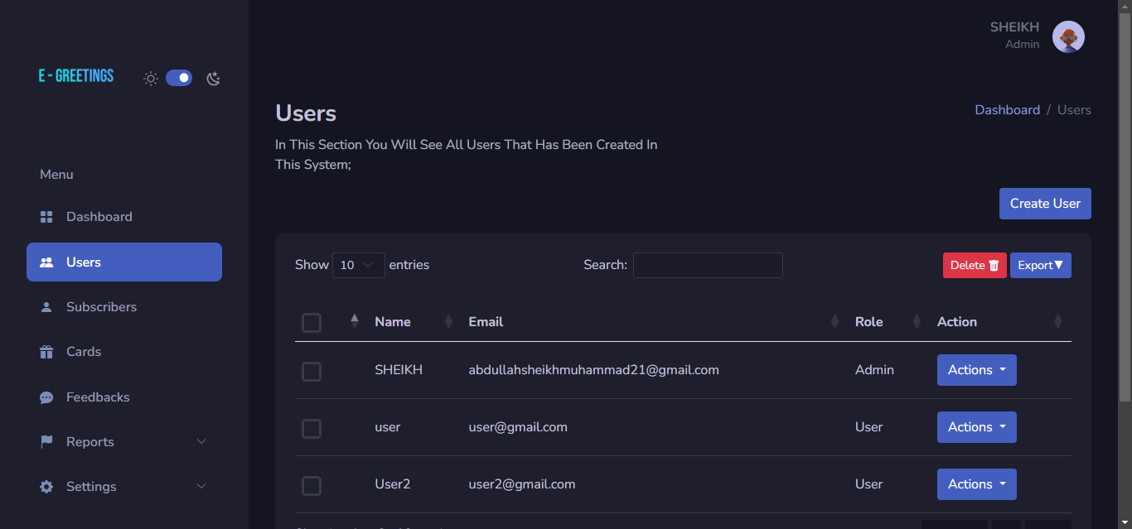

FAQ

1. **What is an e-greeting card?**  
   An e-greeting card is a digital version of a traditional greeting card, which can be personalized and sent online for any occasion.
2. **How do I send an e-greeting card?**  
   Simply choose a card design, customize it with your message, recipient details, and then send it via email or share the link.
3. **Can I schedule a greeting card to be sent later?**  
   Yes, our platform allows you to schedule your card to be sent at a specific date and time in advance.
4. **Are there any charges for sending cards?**  
   Our platform offers both free and premium cards. Premium cards may have additional features or designs, which come with a small fee.
5. **Can I customize the cards with my own images or videos?**  
   Yes, you can upload personal images, videos, and even animations to make the card truly unique.
6. **Is the website mobile-friendly?**  
   Yes, our website is optimized for both desktop and mobile devices, making it easy to send e-greetings from anywhere.
7. **What occasions can I find cards for?**  
   Our website offers cards for a wide range of occasions, including birthdays, anniversaries, holidays, festivals, congratulations, and more.

Top of Form

Bottom of Form

**THANK YOU**