***Getting Started With POS***

POS is a software that will help you to manage your inventory, accounting and hrm. We believe that this software is suitable for both wholesale and retail buisness model and an ideal product for any Super Shop. This user friendly software is fully responsive and has many features. Hope that this software will be helpful to manage your buisness inventory.

***POS Setup***

***1 :* Install Xampp :** [***https://www.apachefriends.org/download.html***](https://www.apachefriends.org/download.html)

***2 :* Intsall Composer :**[***https://getcomposer.org/download/***](https://getcomposer.org/download/)

***3 :* After installing both**, you need to follow the steps below.

* Firstly, Restart Your PC After Successful Installation
* Go to Xampp Folder That is Located in ‘ C ‘ Drive
* In Xampp Folder You will get php folder
* In php folder search “php.ini” You will Get this File 
* Now, paste the PHP file we provided into the project's public folder. Additionally, in the dbBackup folder, you will find a PHP file—move that file into the php folder.



4: **Now, you need to create a database** to run the POS system. You will find the database file in the same folder where you found the php.ini file. Once that's done, start the local server, and after launching XAMPP, you will see the interface. Below,

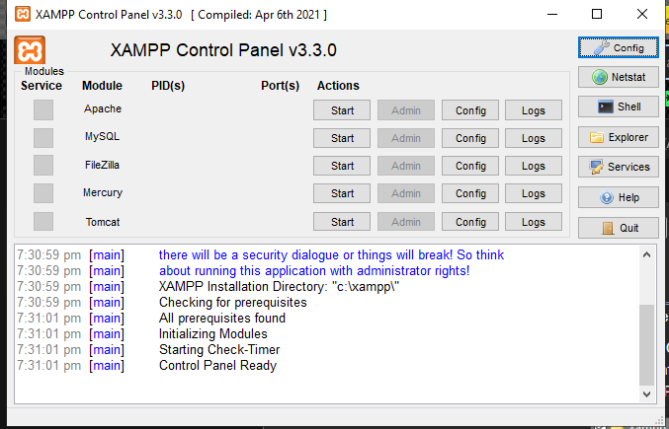

**5: Now Start The Server Like This:**

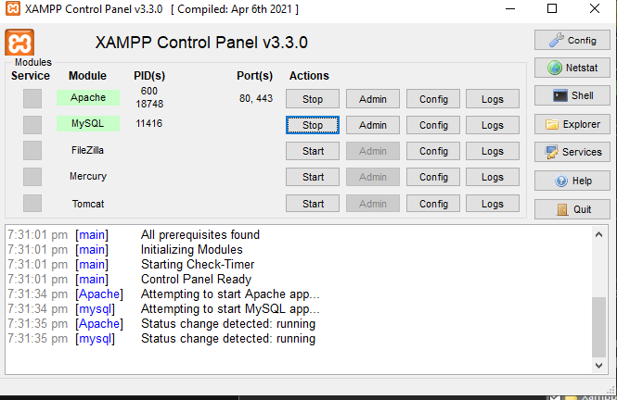

6: **Now You have To Go To Your Browser And Type:** localhost/phpmyadmin/

* You Will Get This Interface Below:

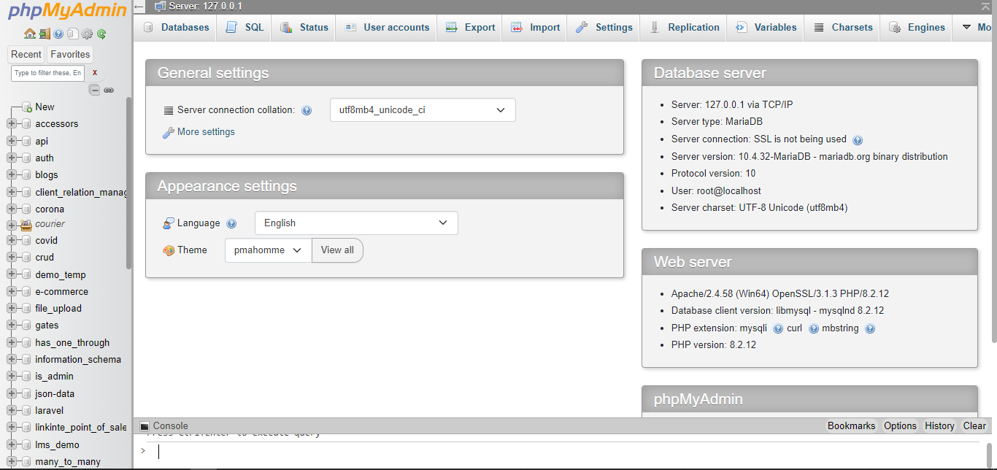

7: **Now You Have to Click On new Button:**

8: **Now You Have To Create a Database:** With Name Of ( pos)

9: **After Creating Database** Just Click on Database And Go to Import:



10: **Click on 'Import,**' then select the database file we provided. After importing the database, wait for a few seconds until the process is complete.

11: **Navigate to the project folder**, locate the 'Access Gainer' directory, and click on it



12: **In Access Gainer Directory** You Will Get Run_App .Bat File Now You Have To do is Right Click on Run_App File And Click On Edit:

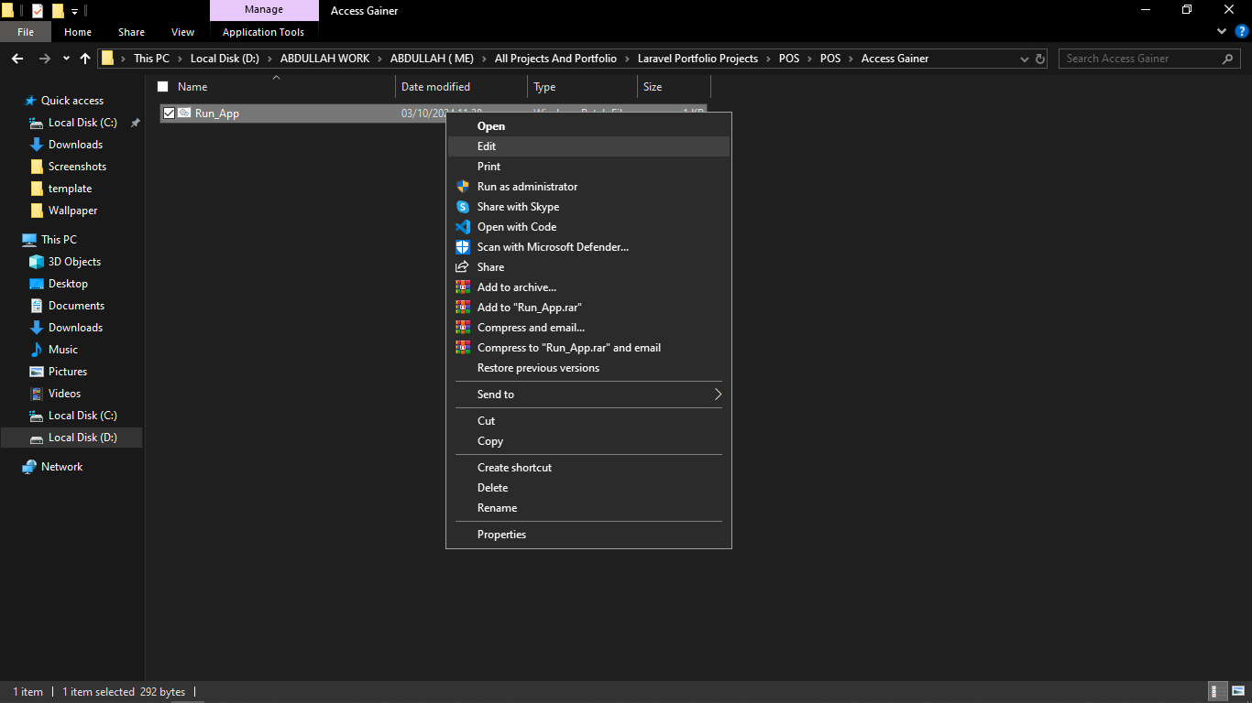

13: **After Clicking On Edit** You Will Get Notepad Like This:

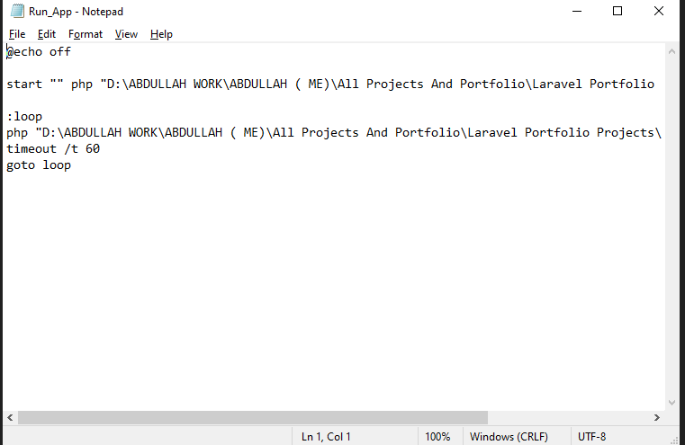

14: **As you can see,** some commands are written here. Your task is to remove the path between D: and just before \artisan in both places. After removing the path, navigate to your project directory, click on the address bar to copy the full directory path, and paste it into Notepad. Then, replace the removed path in the same way by inserting the copied directory path.



15: **Your project setup is now complete.** You can run the project, but before doing so, ensure that both your Apache and MySQL servers are running

***General Settings***

**You Will Set POS Setting**

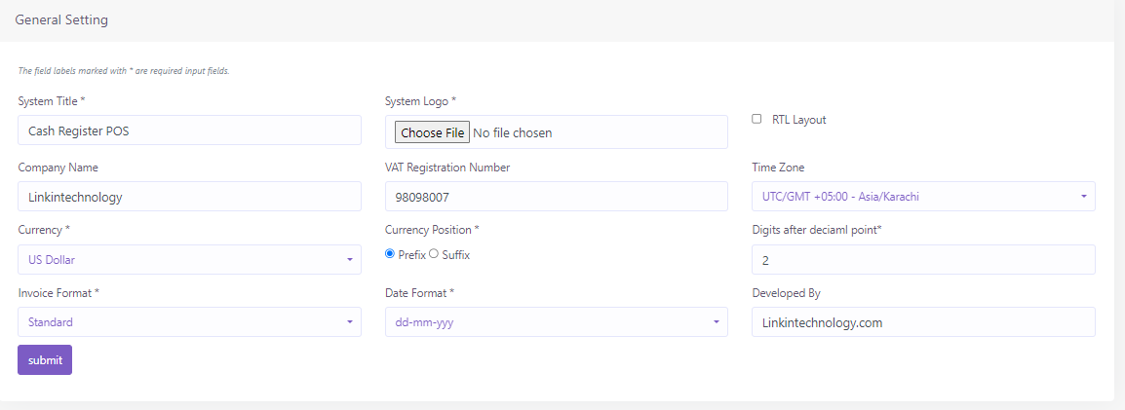

***POS Setting***

**In This Module You Will Set Your Sale Settings**

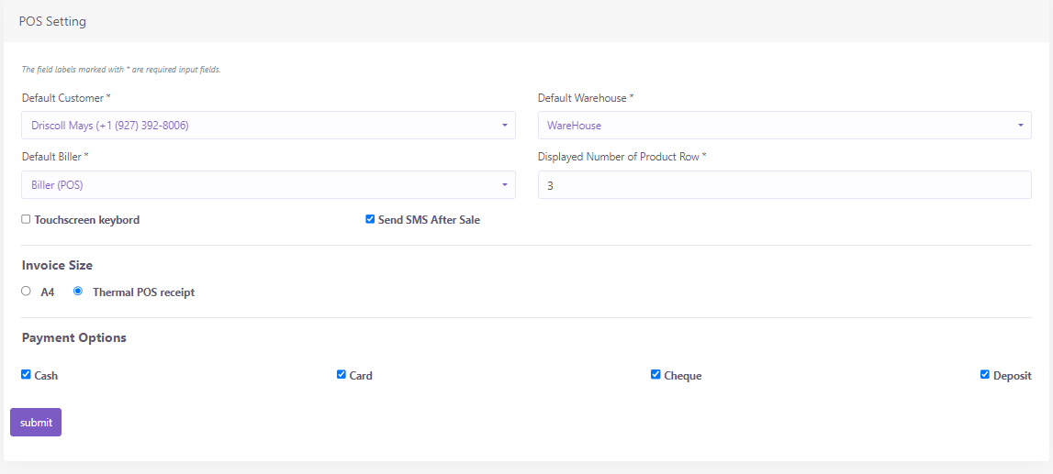

***Customer Group***

In the Settings module, you’ll find the Customer Group section. First, you need to create a customer group. If you wish to offer a discount to a specific group, you can enter the discount percentage in the designated section.

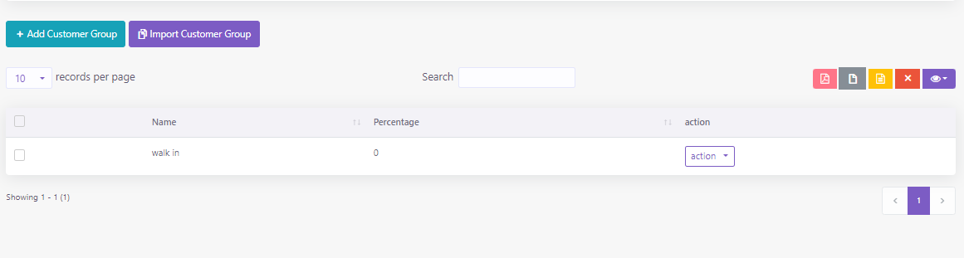

***Discount***

In the Settings module, you’ll find the Discount section. If You Want to Create Discount For Customers Than You Can create here

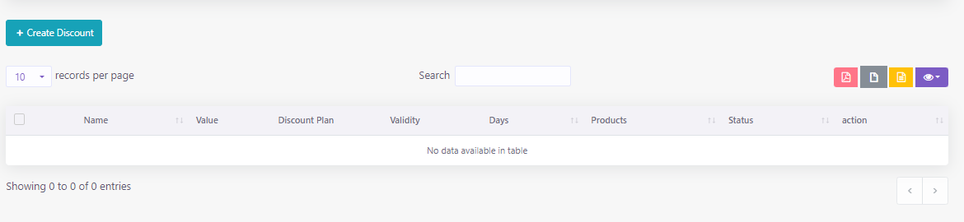

***Units***

In the Settings module, you’ll find the Units section. You Have to Create units For Products Before Adding Any Product

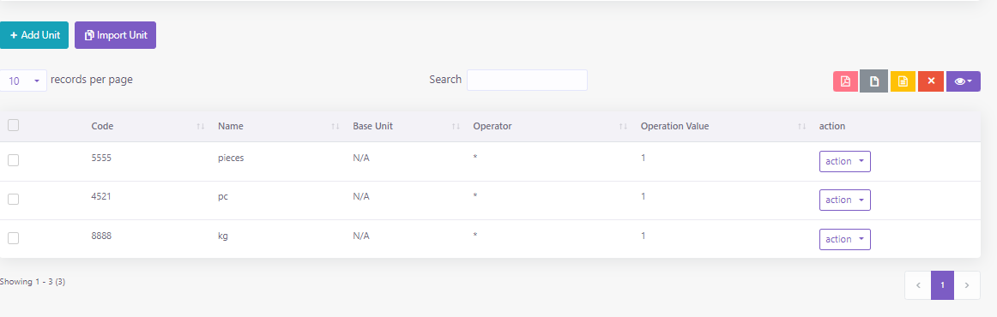

***Warehouse***

In the Settings module, you’ll find the Warehouse section. You Have to Create Warehouse Before Adding Any Stock And Products

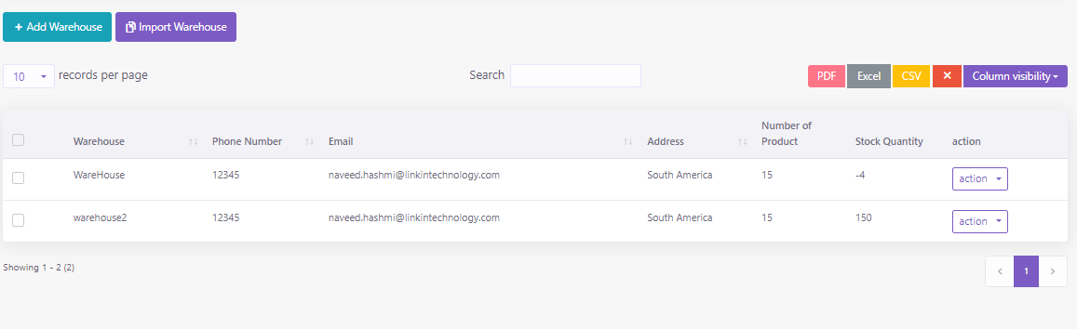

***Reward Point***

In the Settings module, you'll find the Reward Points section. Here, you can configure the reward point settings, such as specifying the sales threshold after which a customer will earn points.

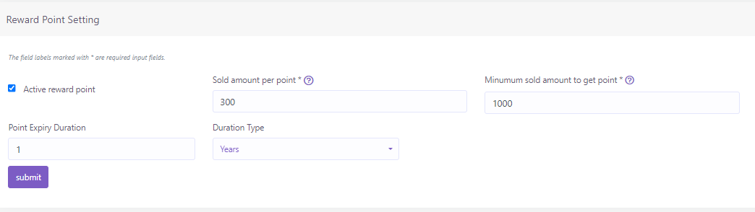

***People Module***

In the People module, you’ll find the This section Here You Can Make Customers and Add Billers and Add Suppliers, Users as Well.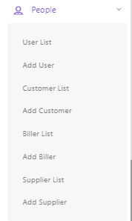

***Category***

You can add, edit and delete product category. You can also import category from CSV file and export table data to PDF, Excel, CSV

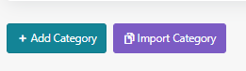

***Products***

You can add, edit and delete product Products. You can also import category from CSV file and export table data to PDF, Excel, CSV

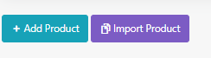

***Print Bar Code***

You can print barcode, The available paper sizes are 36mm, 24mm and 18mm. To print barcodes,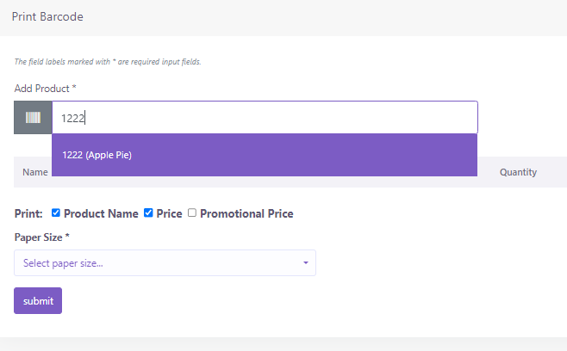

***Purchase***

* **Add Purchase**

You can create purchase in Purchase module. **By creating purchase the stock quantity of product will be increased.** .There are three purchase status: Recieved, Partial, Pending, Orderd. You can add product to order table by typing or scanning barcode of product

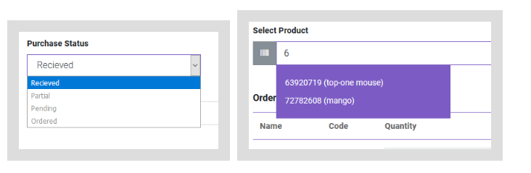

* **Payment**

You can make payment from Purchase table. You can make payment with Cash, Cheque, Credit card and Deposit.

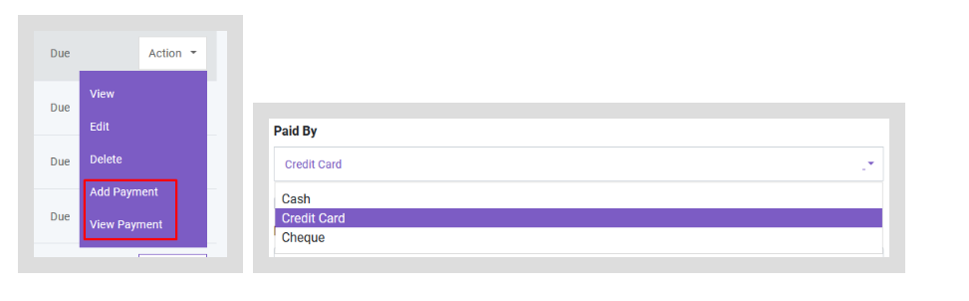

***Accounting***

In the Accounting module, you'll find These Sections below

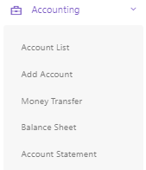

***Account***

You can create,edit and delete account to link all your transactions. You can also set default account for sale. All the payments must be done under an account.

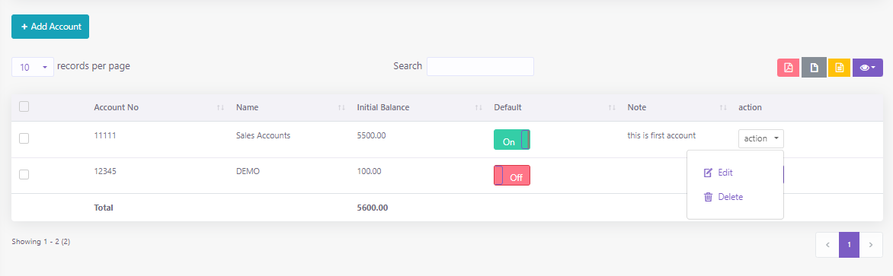

You can generate **Balance Sheet** of your accounts. You can also make **Account Statement** of an specific account to see all the transactions which has done with this account.

***Reports***

In Report Module You Will Find Your POS Reports as Shown Below

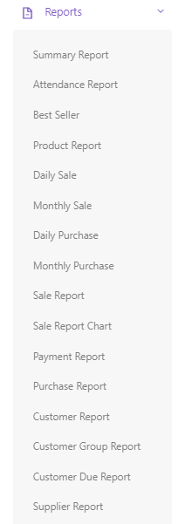

***HRM***

In this module, you’ll find the HRM management sections, including Departments, Employees, Attendance, Shift Management, and Payroll.

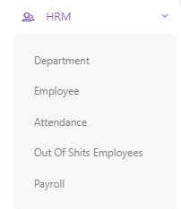

***Department***

In the HRM Module You Will Find Department Section Where You Can Make Departments,

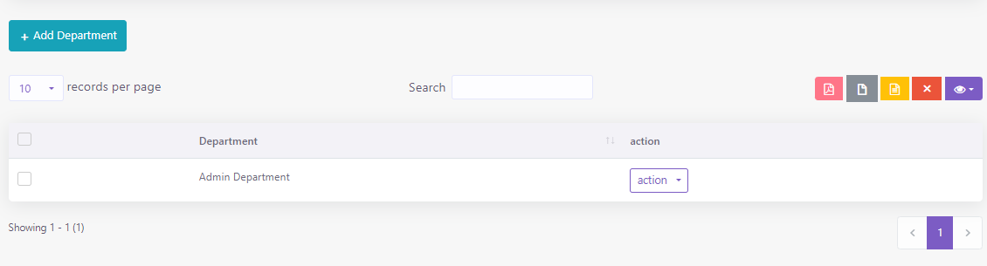

***Employees***

In the HRM Module You Will Find Employees Where you Can Add Employees And Manage Them Also You Can Give Shifts To Employees And Device In Which Device It Will Be Create

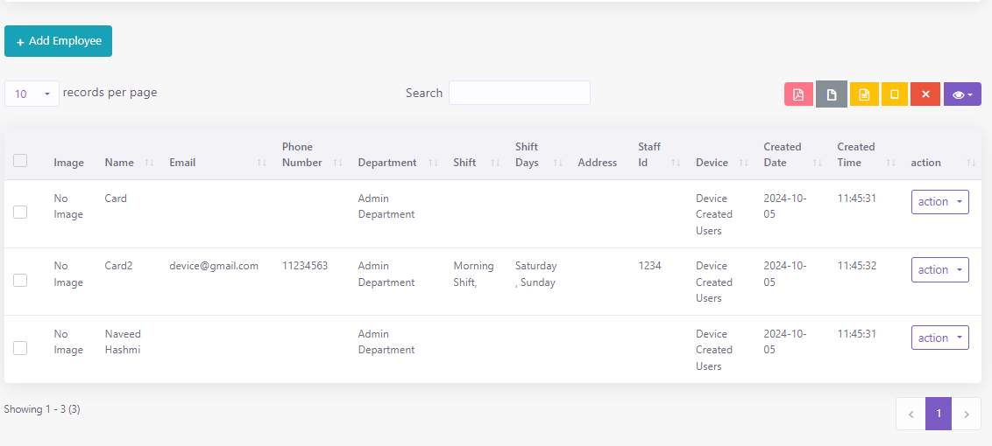

***Attendance***

In the HRM module, you’ll find the Attendance section, where you can easily mark attendance and track employees' presence and late flags. Additionally, the system supports marking attendance using devices like the ZKTeco Attendance Management Device. This device is fully integrated with the POS and works seamlessly.

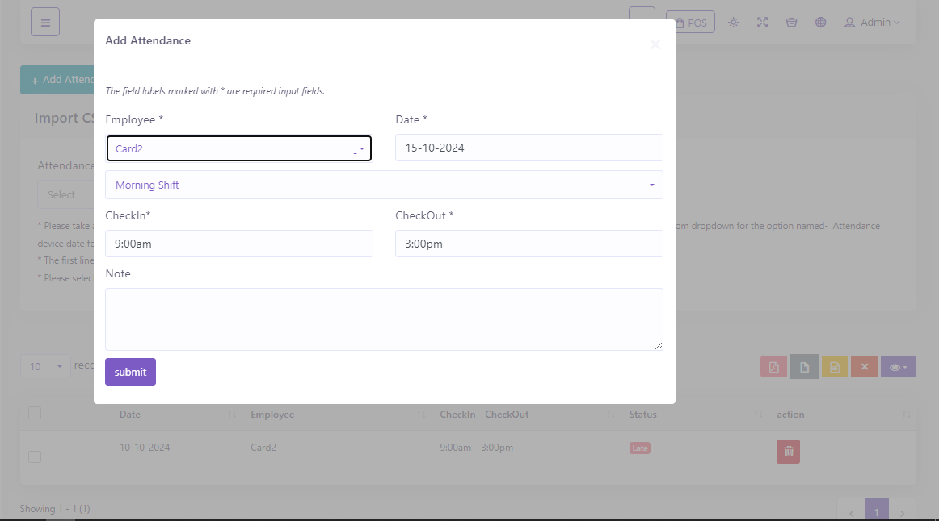

***Out Of Shifts***

In the HRM module, you'll find the Out of Shifts section, where you can track employees who are outside of their designated shifts. If an employee checks in before the shift starts or checks out after the shift ends, the system will capture this, and you’ll be able to view those employees in this section

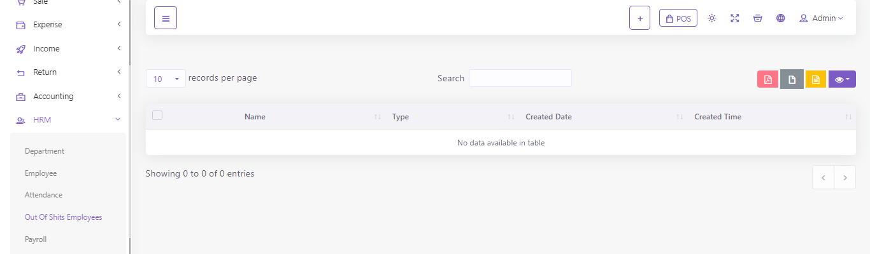

***Payroll***

In the HRM module, you'll find the Payroll section, where you can process employee salaries and track all related expenses.

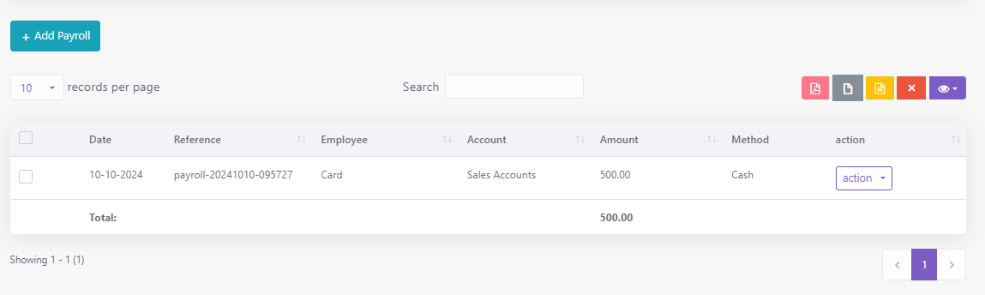

***HRM Setting***

In the Settings module, you'll find the HRM Settings section, where you can configure shifts for employees

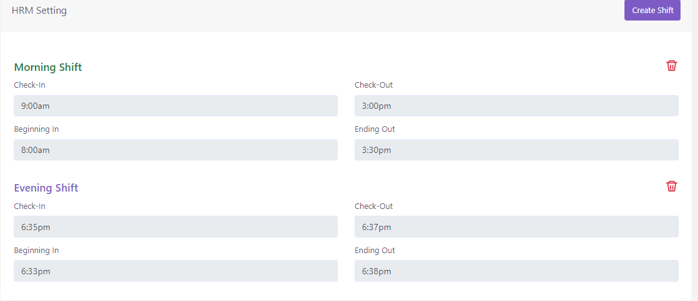

***ZkTeco Device Connection***

In the Settings module, you'll find the ZKTeco Configuration section, where you can connect multiple ZKTeco devices. These devices will automatically integrate with your POS system. When creating a device, you need to provide a device name and IP address. Once connected, a 'Connected' flag will be displayed. If the device is not connected, a 'Not Connected' flag will appear

