**Composite Cryogenic Fuel Tank**

ME 492 Capstone- Project Contract

Team Lead: Alex Farias

Team Members: Neil Benkelman, Russell Berger, Francesca Frattaroli, Weldon Peterson, Christopher Wilson

**Project Objective Statement**

Design, document, and build a lightweight composite cryogenic fuel tank for an open source rocket capable of reaching an altitude of 100 km between the months of January-June, 2017.

**Client/Market Requirements**

**Constraints**

* The tank must be able to contain liquid oxygen at 3 atm without leaking
* The tank must be significantly lighter than conventional aluminum tank, i.e. the 4 inch prototype must weigh no more than 2 lbs, and the 6 inch prototype must weigh no more than 3.5 lbs
* That tank must have an inner liner with a sufficiently low permeability to oxygen at working pressure and temperature that the LOX cannot react with the composite resin.
* The 4 inch prototype must have a working volume (90 percent of total volume) of at least 72 cubic inches
* The final 6 inch prototype must have a working volume of at least 194 cubic inches
* The tank must integrate with the LV4 rocket’s modular airframe design

The above constraints are *requirements* of the project in order for this composite tank design to be feasible as a flight-ready product. Due to the volatility of the fuel (liquid oxygen) being used in the tank, any leakage that occurs in the final design would lead to catastrophic failure. One of the most important goals of this composite fuel tank is a significant reduction in dry weight when compared with a conventional aluminum tank used in rocket applications. This factor is especially important when taken under consideration with the overall LV4 rocket design project by the sponsor, PSAS. Creating a composite fuel tank that meets the weight target will allow the rocket to carry heavier payloads to low earth orbit, as well as reduce overall fuel costs if heavier payloads are not required.

An additional challenge that must be considered is separation at the aluminum and carbon fiber interface. Carbon fiber has a negative coefficient of thermal expansion, which will cause the material to expand once the temperature begins to drop, and aluminum will contract, causing stress at the interface that may result in separation of these materials and rapid unscheduled disassembly of the tank. This constraint will be dependent on the design. If a design is selected that does not involve an aluminum component during the layup process, this issue has the potential to be avoided entirely.

**Success Measures**

* The tank cost less than $1000 to reproduce after development
* The tank has an operating pressure greater than 3 atm
* Documentation allows future teams to build an identical tank

An important measure of success for this project is the maximum amount of pressure this tank will be able to withstand before failing (minimum 3 atm), with a factor of safety of 1.5. The internal tank pressure will be dictated in part by the Electronic Feed System Capstone project. If the tank cannot maintain a sufficiently high pressure, the composite fuel tank becomes significantly less feasible, and will affect the feasibility of other aspects of the overall LV4 project.

Reproducibility in the design and project is strongly desired. This is a project geared toward determining the feasibility of a composite fuel tank being used in the LV4, and there is little point in creating a wonderful and functional design if when the work is passed along to another group and they are unable to duplicate and fabricate the design. The design must be able to be reproduced with a high level of consistency as this is an aerospace application, and even small variations in performance are undesirable. Two of the more important factors that play into the manufacturing consistency are time and cost. This is an open source project with an end goal of making this tank reproducible by hobby rocket enthusiasts and future student groups, so accomplishing this design with the lowest possible cost is preferable. Ideally we would like to contribute $6000 of our current $9000 budget to development, and $3000 on fabrication of tanks. We expect to have a final design that costs under $1000 for materials and machining. Additionally, providing accurate and extensive documentation of the project to future teams will be an integral measure of success for the project. The goal is to provide a future team with sufficient documentation to reproduce our design on their own.

**Stretch Goals**

**Produce a full scale flight ready tank** - An ideal stretch goal would be to present the sponsor (PSAS) with a fully functional flight ready tank consistent with the LV3 Rocket Module (current rocket design & testing platform).

**Project Deliverables**

**Design Artifacts**

* Bill of materials
* Scaled physical tank prototype
* Documentation of design decisions and manufacturing procedure
* Final report describing the execution of the project
* Digital archive of CAD drawings, test data, and subsequent analysis and evaluation of results
* Poster and presentation for Oregon Space Grant Consortium Student Symposium

**Measurements of Performance Targets**

|  |  |
| --- | --- |
| **Performance Measure** | **Measurement Technology and Techniques** |
| Tank Weight | Weight scale |
| Evidence of microcrack | Scanning electron microscope |
| Burst Pressure | Hydrostatic test pump |
| Tank Length and Diameter | Ruler, vernier caliper |
| External Tank Temperature | Thermocouple, data acquisition device |

**Planning Objectives**

*Table 1:* ***Key Milestones*** *(01/09/17 - 06/12/17)*

|  |  |
| --- | --- |
| 2/20 | Complete first ring, endcap, and liner design. |
| 3/20 | Complete 3rd iteration of ring, endcap, and liner design. CAD drawings are complete. Layup process design complete. Complete 3pt bending and tensile test of composite layers at cryogenic temperature. |
| 3/27 | FE model of entire tank assembly. |
| 3/30 | Order and machine subsystem parts. |
| 4/03 | First full prototype complete. |
| 4/10 | Hydrostatic test on first full prototype complete. |
| 4/17 | Second full prototype complete. |
| 4/24 | Cryogenic test on first full prototype. Hydrostatic test on second prototype. |
| 5/15 | Third full prototype complete. |
| 5/29 | Cryogenic test second full prototype. Test fill tank with liquid oxygen. |

**Detailed Project Timeline (see seperate Gantt Chart for visual representation):** 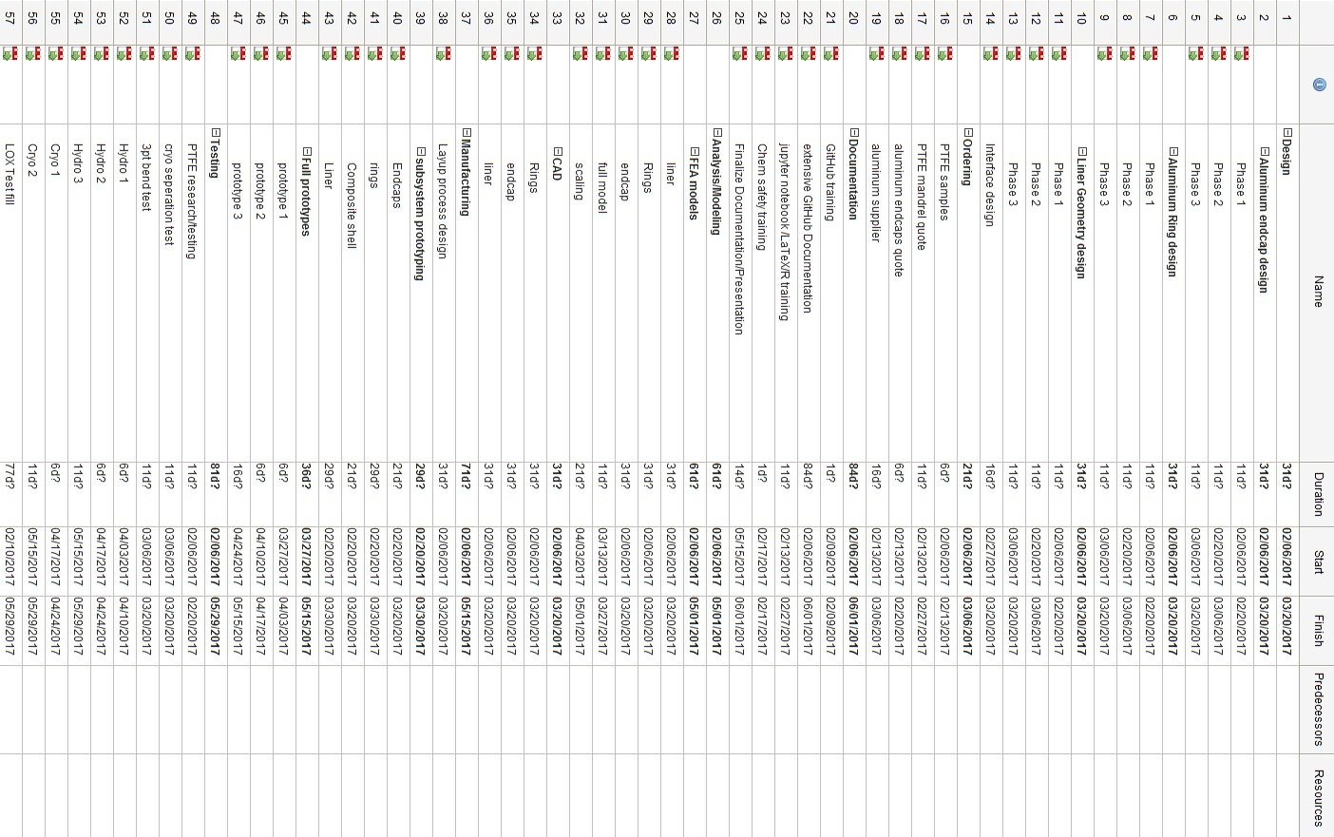

**Appendix**

Measurement Techniques and Procedures:

* Hydrotesting - to determine pressure at failure and leak points at room temp using water.
* ‘Hydrotesting’ with LN2 - to determine pressure at failure and leak points at operating temp.
* Coupon Tensile Tests: To determine strength of bonding adhesives at the interfaces between the proposed materials.
* Weighing (scale) of potential tank wall layup / total unit weight - to compare to equivalent aluminum tank.
* Multiple cycles of chill and fill process (with LN2) and post-test microfracture analysis - to determine structural soundness of tank and reusability/expected life of tank.