Go to stackedit.io, then click start writing

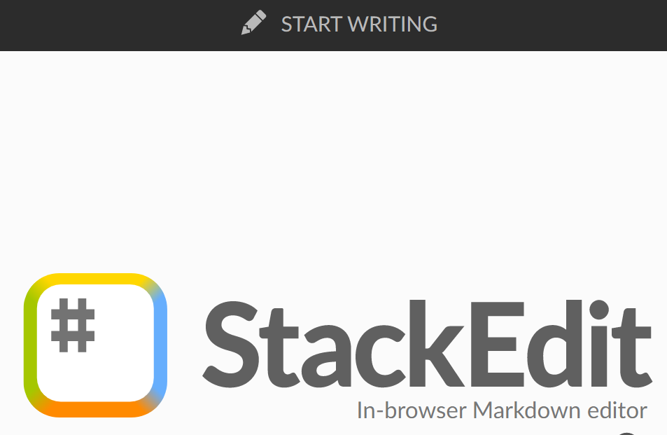

Click “toggle side bar” on the top right corner



Choose “Workspaces”

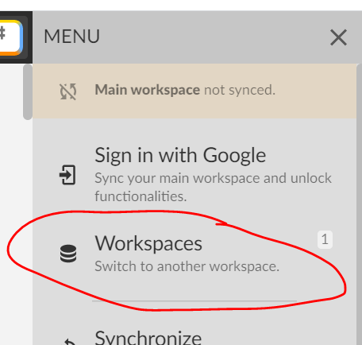

Add a “Github” workspace

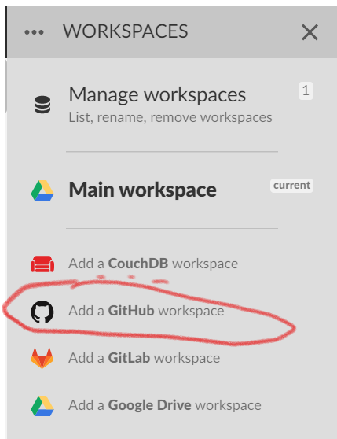

Use the following settings:

<https://github.com/AphelionSoftware/PhysioKB>

content/posts

abi

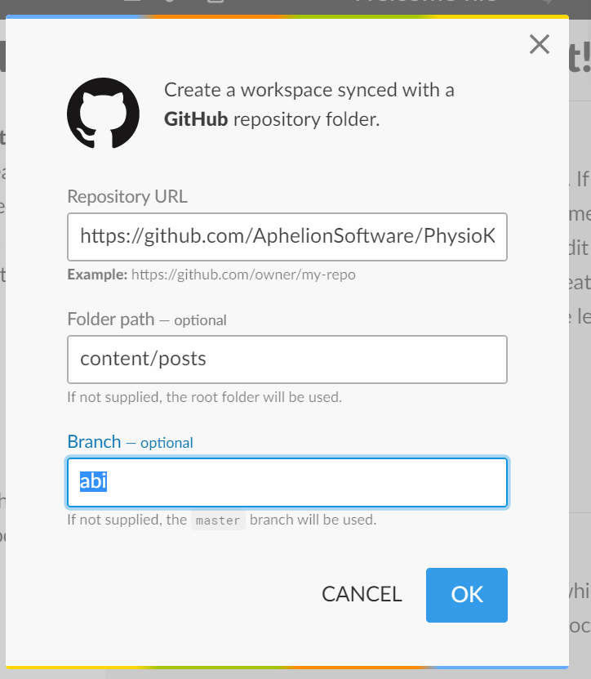

Enable access to github if the query comes up

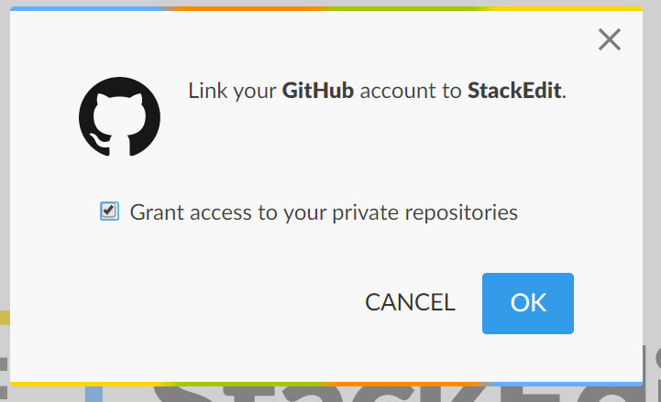

Tick the checkbox to grant access

You may need to login to Github